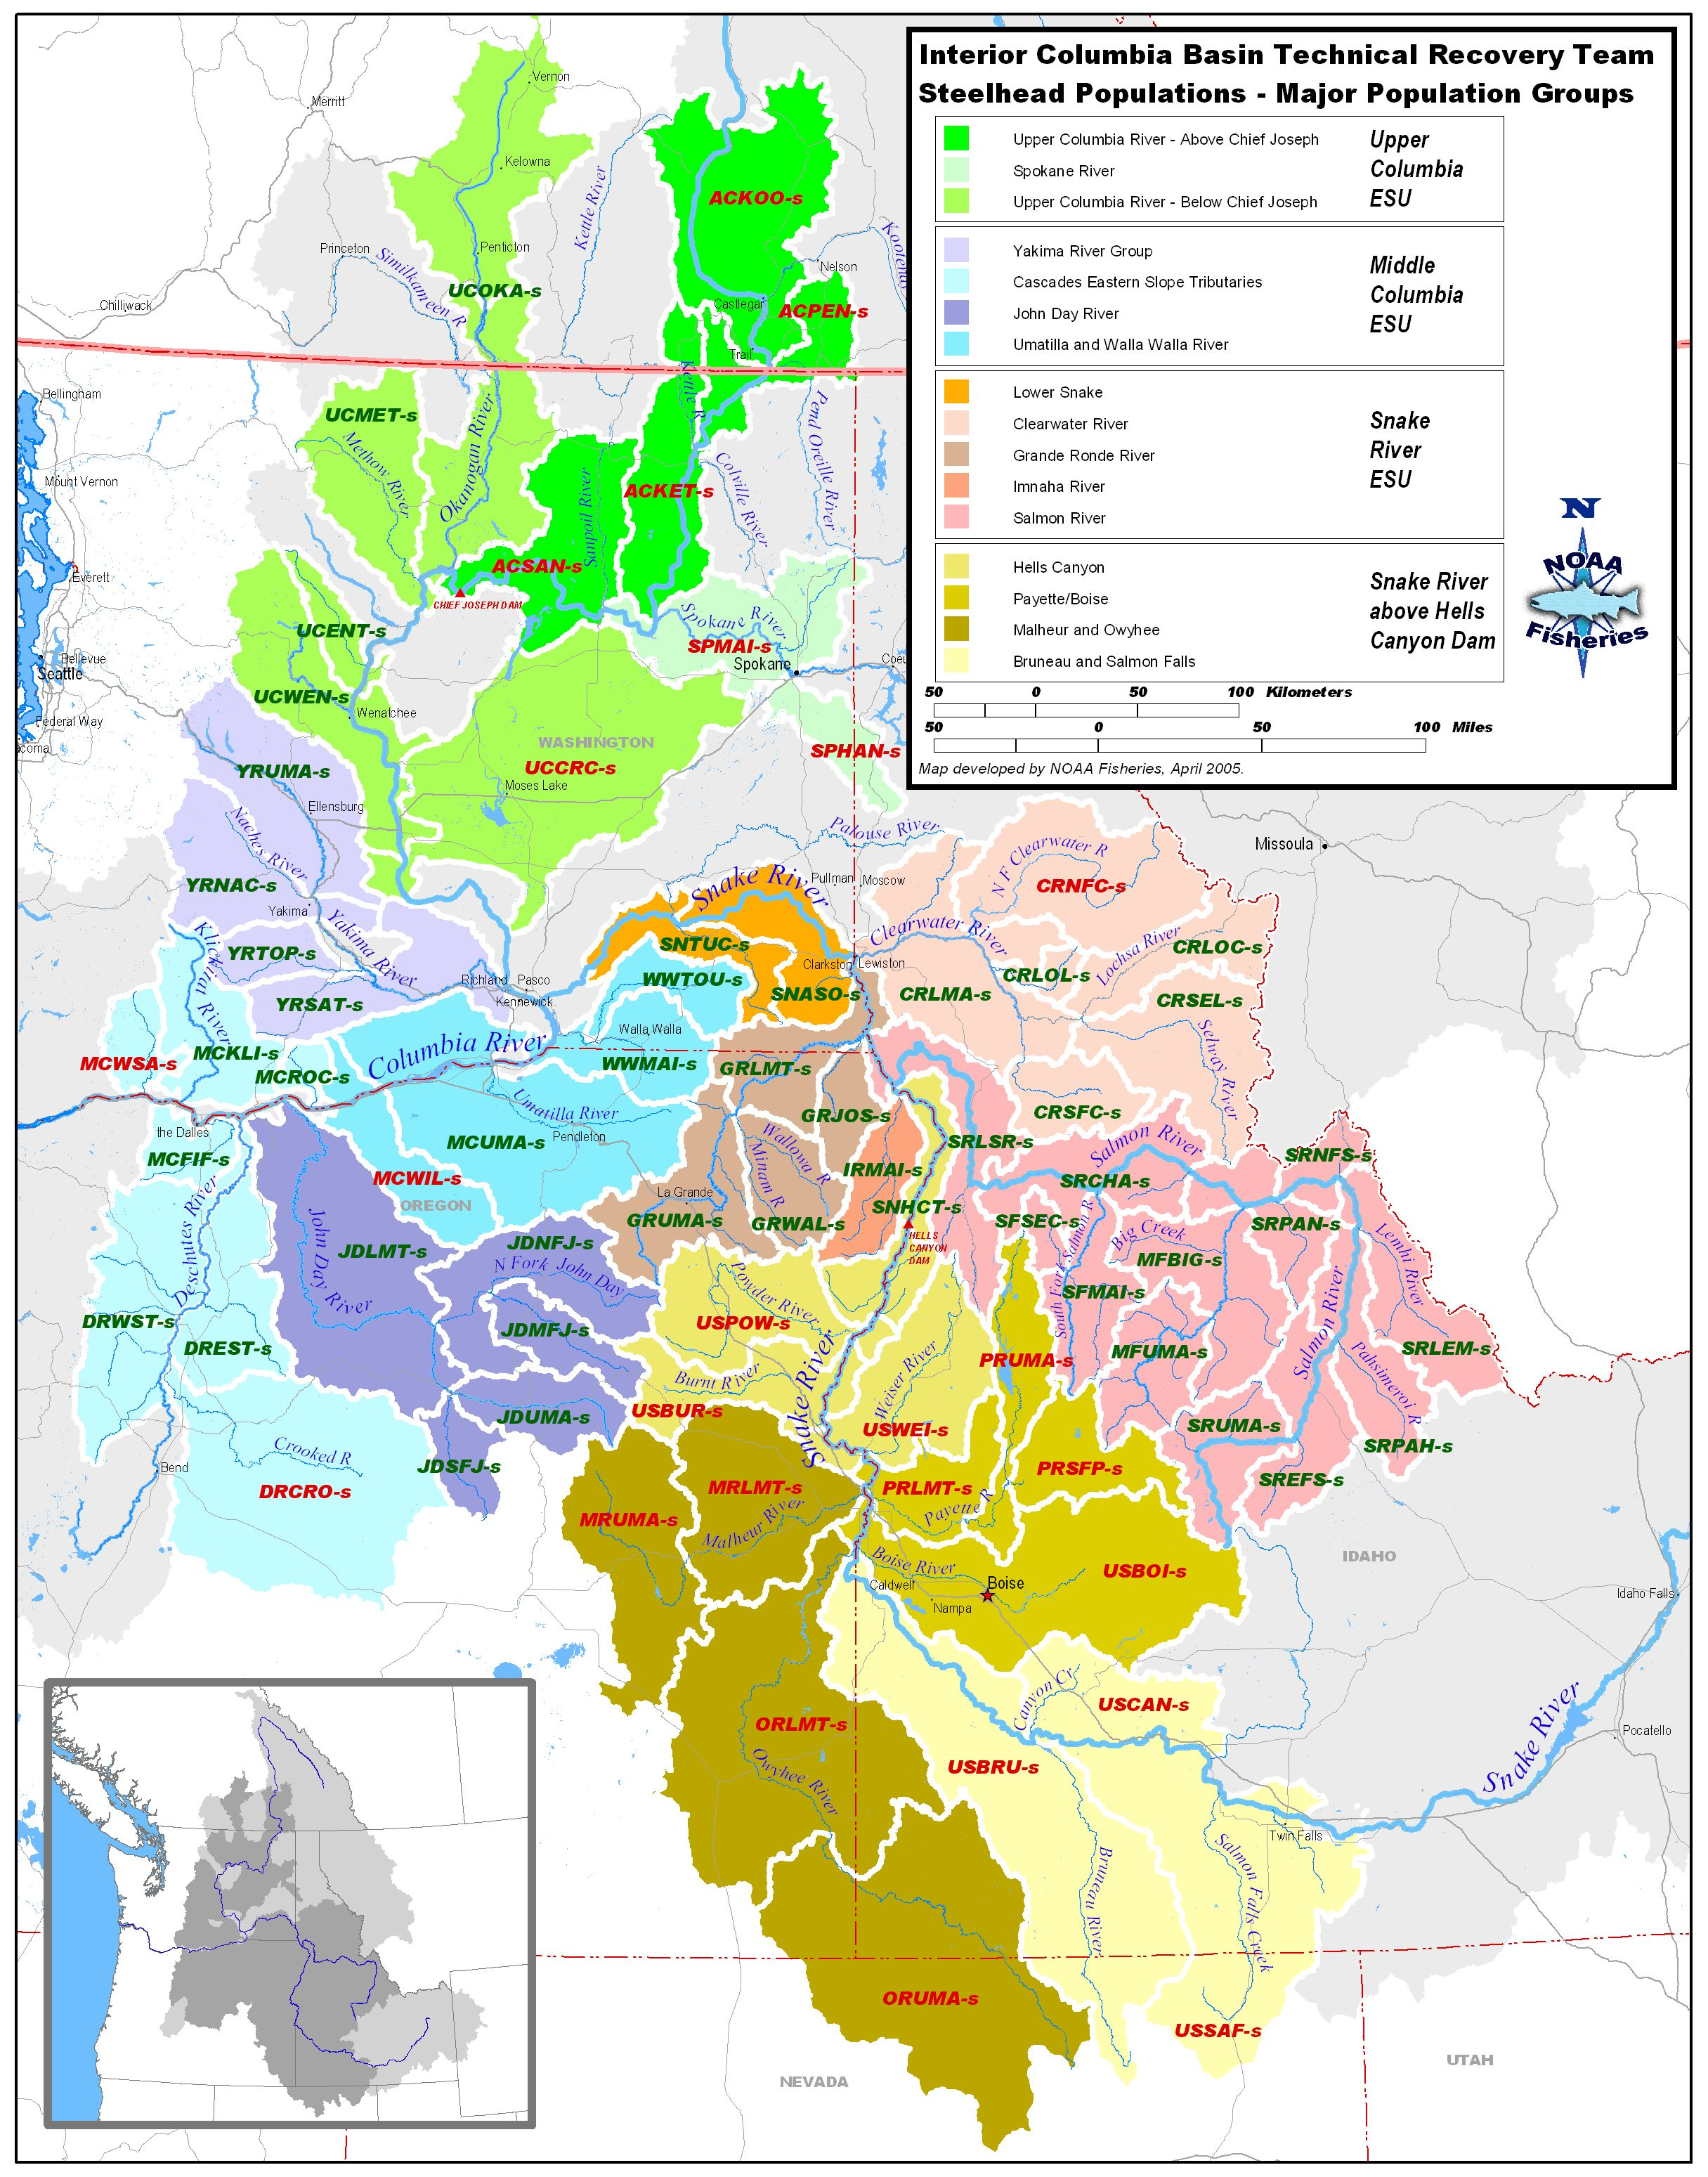
John Day MPG Mid Columbia Spring Chinook ESU – NOT LISTED
Following pages are an analysis of ongoing monitoring programs in the MPG by TRT identified population, an evaluation of the quality of the information, and an evaluation of what would be needed to improve the monitoring and to move toward meeting NOAA Fisheries Service monitoring guidance standards.
Evaluations shown in this document are drawn from the work completed by the Columbia River Fish and Wildlife Authority through the Collaborative Systemwide Monitoring and Evaluation Project and through direct participation of the fish co-managers, FCRP action agencies, Public Utilities, Forest Service and others.

This evaluation was especially influenced by the participation of the Oregon Department of Fish and Wildlife, Consolidated Tribes of the Umatilla Indian Reservation, Upper MF John Day IMW Study Design, and the CBFWA CSMEP Strength and Weaknesses document by Eric Tinus.

MPG Population | Primary Indicator | Desired Certainty | Monitoring Needed | Current Monitoring | Data Quality & Certainty | Data Improvement Actions Needed | RPA | Proposed New Monitoring
John Day Lower Mainstem | Adult Abundance | Annual population-level estimates with a CV value on average of 15% or less.  Power analysis calculated for data? | Natural-origin Spawner Abundance | - ODFW Uses index surveys of redds that are expanded using spawning distribution. Redd densities corrected based upon EMAP redd densities for 2004-05. Redds converted to fish by fish/redd developed from Deer Cr. 2.1  - ODFW has recently moved toward EMAP approach  - Single-pass ground spawning surveys have been conducted in index areas since 1959. Lindsay et al. (1986) conducted extensive investigations of John Day Basin spring Chinook salmon, 1978 – 1985, that included surveying multiple times and in areas beyond the index areas. Beginning in 1998, surveys of areas beyond the historical index areas and times were resumed. Contemporary surveys represent an area census of known spawning habitat, are conducted multiple times each year, and additional survey sites are randomly selected along the periphery of known spawning habitat (Wilson et al. 2008). | - ODFW has only a few years of comparative data between EMAP and fixed site index areas to test accuracy.  - EMAP 50 sample sites in John Day basin represents 2% of spawning distribution so abundance estimates at the population level are unlikely  - EMAP requires long term investment to reap benefits of good status trend information.  - No direct abundance measurements are done in the John Day Basin because spring Chinook salmon populations are managed as wild populations with no artificial production. The wild Deschutes River population is managed in tandem with an integrated hatchery program, and abundance of natural-origin fish is monitored at an efficient adult trap near the down-most extent of natural spawning habitat. | - With no trapping facilities for natural origin spring Chinook in the John Day Basin there is uncertainty in the appropriate fish per redd expansion multiplier. Mark recapture methods, such as PIT tags, could be evaluated as a potential method to provide this information.  - The EMAP sampling program for juvenile abundance, distribution, and habitat condition needs to continue and be better supported in the John Day Basin.
John Day Lower Mainstem | Adult Productivity | Adult/Adult ratio with low σ² | - Sex ratio  - Hatchery %  - Cohorts  - Harvest | - PNOS = 0.9  - Hatchery wild calculated from spawner observations  - Age derived from scale readings from creel surveys from 89s  - Hatchery strays follow similar pattern to Deschutes  - Age structure is determined by analyzing scales collected from carcasses during spawning ground surveys. Information from PIT tag interrogations at main stem Columbia dams could also be used to estimate age structure. Lengths of carcasses are measured and recorded at the population level.  - Seining has been used to sample juvenile out-migrants since 1999 downstream of the confluence of the North Fork and the mainstem John Day River. This sampling is not population-specific. Unless fish were previously marked upstream, the information collected represents the three populations in aggregate. |  | - Need to CWT all hatchery fish not marked with an external mark | 50.7 | CRITFC has been provided $400K/yr as part of BiOp Accord MOA to reprogram and construct John Day artificial production.
John Day Lower Mainstem | Juvenile Productivity | Annual population-level estimates with a CV value on average of 15% or less.  Power analysis calculated for data? | - Juvenile Migrant Abundance  - Smolt/Adult ratio | - ODFW Smolt migrant trap exists in lower mainstem that aggregates abundance of upstream populations funded under BPA #199801600 $1,082,000/yr  - Juvenile out-migrants in the John Day Basin have been PIT tagged since 1998 at sufficient levels (average 4,200 per year) to calculate smolt-to-adult return rates (SARs) for three populations in aggregate.  - Starting in 2007-2008, PIT tag detection arrays were installed near the mouth of the lower John Day River.
John Day Lower Mainstem | Spatial Distribution | Periodic distribution estimates with ability to detect a 15% change with 80% certainty. | - Adult redd distribution  - Juvenile parr distribution | - Current adult spawning distribution used for species distribution  - ODFW EMAP used for juvenile distribution
John Day Lower Mainstem | Species Diversity | - Short term collection of phenotypes  - Long term collection of genotypes | - Age  - Sex ratios  - Size  - Cohort structure  - Run Timing  - DNA
John Day NF | Adult Abundance | Annual population-level estimates with a CV value on average of 15% or less.  Power analysis calculated for data? | Natural-origin Spawner Abundance | Single-pass ground spawning surveys have been conducted in index areas in the Granite Creek system (tributary to North Fork John Day River) since 1959 and in the mainstem of the North Fork since 1964. Lindsay et al. (1986) conducted extensive investigations of John Day Basin spring Chinook salmon, 1978 – 1985, that included surveying multiple times and in areas beyond the index areas. Beginning in 1998, surveys of areas beyond the historical index areas and times were resumed. Contemporary surveys represent an area census of known spawning habitat, are conducted multiple times each year, and additional survey sites are randomly selected along the periphery of known spawning habitat (Wilson et al. 2008).
John Day NF | Adult Productivity | Adult/Adult ratio with low σ² | - Sex ratio  - Hatchery %  - Cohorts  - Harvest | - PNOS = 0.92  - Age structure is determined by analyzing scales collected from carcasses during spawning ground surveys. Information from PIT tag interrogations at main stem Columbia dams could also be used to estimate age structure for the three populations in aggregate. Lengths of carcasses are measured and recorded at the population level. |  | - Need to CWT all hatchery fish not marked with an external mark | 50.7 | CRITFC has been provided $400K/yr as part of BiOp Accord MOA to reprogram and construct John Day artificial production.
John Day NF | Juvenile Productivity | Annual population-level estimates with a CV value on average of 15% or less.  Power analysis calculated for data? | - Juvenile Migrant Abundance  - Smolt/Adult ratio | - ODFW operates a rotary screw trap under BPA #199801600 $1,082,000/yr  - Juvenile out-migrants were sampled and PIT tagged in 2006 at rkm 26. |  | - None
John Day NF | Spatial Distribution | Periodic distribution estimates with ability to detect a 15% change with 80% certainty. | - Adult redd distribution  - Juvenile parr distribution | - Snorkel and electrofishing surveys have been conducted following an EMAP sampling protocol since 2004 (James et al. 2007)  - All of these Mid Columbia spring Chinook populations have redd surveys that cover the known spawning habitat that will allow for status assessments of the spatial structure metrics. The historical and recent information should be adequate to assess the number and spatial arrangement of spawning areas; the spatial extent or range of the populations; and any increase or decrease in gaps or continuities between spawning areas. | - these unlisted populations, major and minor spawning areas have not been formally defined as was done by the ICTRT for ESA-listed salmon and steelhead populations in the Interior Columbia Domain  - Continuation of the EMAP sampling of juvenile fish and their habitat in the John Day Basin will provide information for this metric. Implementing this approach and making effective use of recent monitoring data require a sustained commitment to annual monitoring over a long term. | - None
John Day NF | Species Diversity | - Short term collection of phenotypes  - Long term collection of genotypes | - Age  - Sex ratios  - Size  - Cohort structure  - Run Timing  - DNA | Carcass sampling in the John Day Basin yields CWT or other tag information on the rate of straying by hatchery fish, as long as the juvenile external mark rate (clipped adipose or other fins) is sufficiently high. The observed rate of straying in the John Day Basin is very low (less than 1-2% over past multiple generations).
John Day MF | Adult Abundance | Annual population-level estimates with a CV value on average of 15% or less.  Power analysis calculated for data? | Natural-origin Spawner Abundance | - Steelhead redd counts conducted by ODFW at index sites since mid 1960s  - Currently developing EMAP sampling for MF and building on current design that samples entire basin.  - 30 sites to be monitored for spawner abundance, 15 annually | - Once EMAP is implemented, data should be excellent  - 95% CI ≤ 25% of annual mean |  | 50.4
John Day MF | Adult Productivity | Adult/Adult ratio with low σ² | - Sex ratio  - Hatchery %  - Cohorts  - Harvest | - PNOS = 0.92  Trends in abundance have been monitored through spawning ground surveys. Index spawning ground surveys have been conducted since 1960. Surveys were expanded both spatially and temporally, 1978 – 1985, and again since 1995. Results of recent surveys are considered to represent a complete redd count. All know spawning habitat is surveyed multiple times and peripheral areas are randomly surveyed annually. A direct count of spawning adults is unavailable because hatchery weirs are not used in the John Day Basin. Previous stock-recruitment assessments have assumed a three fish per redd average expansion factor or variable fish per redd rates from other populations in the Snake River Basin or in the Deschutes River (e.g., Lindsay et al. 1986; Jonasson and Albaladejo, 1999; Schultz et al. 2008; Wilson et al. 2008). Redd densities (redds per mile) have also been used to track abundance and productivity (ODFW 2005). Trends in recruitment rely on carcass sampling during spawning ground surveys to determine age and hatchery fraction. Abundance monitoring of redds is considered good. Spawner abundance relies on out-of-basin or assumed fish per redd ratios. PIT tagging has provided SAR estimates that could be used to adjust spawner to spawner estimates, but the time series is relatively short. |  | - Need to CWT all hatchery fish not marked with an external mark | 50.7 | - CRITFC has been provided $400K/yr as part of BiOp Accord MOA to reprogram and construct John Day artificial production.
John Day MF | Juvenile Productivity | Annual population-level estimates with a CV value on average of 15% or less.  Power analysis calculated for data? | - Juvenile Migrant Abundance  - Smolt/Adult ratio | - ODFW Rotary screw trap at Ritter RKM 24 since 2004 BPA #199801600 $1,082,000/yr  - PIT tags also used for mark recapture and SAR estimates  - Upper MF designated as IMW Treatment reach by OWEB and ODFW. Funded by NOAA through PSMFC $390K/yr |  |  | 50.4
John Day MF | Spatial Distribution | Periodic distribution estimates with ability to detect a 15% change with 80% certainty. | - Adult redd distribution  - Juvenile parr distribution | - Spatial distribution of spawners will be monitored using EMAP sampling which will improve older redd index site information |  |  | 50.4
John Day MF | Species Diversity | - Short term collection of phenotypes  - Long term collection of genotypes | - Age  - Sex ratios  - Size  - Cohort structure  - Run Timing  - DNA | - Scale samples used to determine age  - Traps used for run timing, size, etc. |  |  | 50.4
John Day SF | Adult Abundance | Annual population-level estimates with a CV value on average of 15% or less.  Power analysis calculated for data? | Natural-origin Spawner Abundance | - SF designated as IMW Control reach by OWEB and ODFW. Funded by NOAA through PSMFC $390K/yr  - Steelhead redd counts conducted by ODFW at index sites since mid 1960s  - Currently developing EMAP sampling for SF and building on current design that samples entire basin.  - 13 sites to be monitored for spawner abundance annually |  |  | - 50.4
 |  |  |  | - ISEMP John Day Pilot uses SF as Control for Bridge Cr. IMW study and conducting juvenile monitoring BPA # 200301700 $1.8 million/yr
John Day SF | Adult Productivity | Adult/Adult ratio with low σ² | - Sex ratio  - Hatchery %  - Cohorts  - Harvest | - PNOS = 0.92 |  | - Need to CWT all hatchery fish not marked with an external mark | 50.7 | CRITFC has been provided $400K/yr as part of BiOp Accord MOA to reprogram and construct John Day artificial production.
John Day SF | Juvenile Productivity | Annual population-level estimates with a CV value on average of 15% or less.  Power analysis calculated for data? | - Juvenile Migrant Abundance  - Smolt/Adult ratio | - Rotary screw trap operated by ODFW since 2004 BPA #199801600 $1,082,000/yr  - ODFW trapping and PIT tagging steelhead smolts at four trap sites and one seine site each year BPA #199801600 $1,082,000/yr ISEMP John Day Pilot uses SF as Control for Bridge Cr. IMW study and conducting juvenile monitoring for density, movement, survival, growth BPA # 200301700 $1.8 million/yr  - Parr to smolt survival estimated using PIT tagging |  |  | - 50.4
John Day SF | Spatial Distribution | Periodic distribution estimates with ability to detect a 15% change with 80% certainty. | - Adult redd distribution  - Juvenile parr distribution | - EMAP spawner surveys will measure adult distribution  - ODFW Juvenile snorkel surveys will measure juvenile parr distribution BPA #199801600 $1,082,000/yr
John Day SF | Species Diversity | - Short term collection of phenotypes  - Long term collection of genotypes | - Age  - Sex ratios  - Size  - Cohort structure  - Run Timing  - DNA | - Scale samples used to determine age  - Traps used for run timing, size, etc. |  | - Access to more naturally produced steelhead at Wells dam.
John Day Upper Mainstem | Adult Abundance | Annual population-level estimates with a CV value on average of 15% or less.  Power analysis calculated for data? | Natural-origin Spawner Abundance | Single-pass ground spawning surveys have been conducted in index areas since 1959. Lindsay et al. (1986) conducted extensive investigations of John Day Basin spring Chinook salmon, 1978 – 1985, that included surveying multiple times and in areas beyond the index areas. Beginning in 1998, surveys of areas beyond the historical index areas and times were resumed. Contemporary surveys represent an area census of known spawning habitat, are conducted multiple times each year, and additional survey sites are randomly selected along the periphery of known spawning habitat (Wilson et al. 2008). In recent years, permission to access privately owned spawning habitat has been denied, making it difficult to estimate the season total level of spawning activity.
John Day Upper Mainstem | Adult Productivity | Adult/Adult ratio with low σ² | - Sex ratio  - Hatchery %  - Cohorts  - Harvest | - PNOS = 0.92  - Age structure is determined by analyzing scales collected from carcasses during spawning ground surveys. Information from PIT tag interrogations at main stem Columbia dams could also be used to estimate age structure. Lengths of carcasses are measured and recorded at the population level. |  | - Need to CWT all hatchery fish not marked with an external mark | 50.7 | CRITFC has been provided $400K/yr as part of BiOp Accord MOA to reprogram and construct John Day artificial production.
John Day Upper Mainstem | Juvenile Productivity | Annual population-level estimates with a CV value on average of 15% or less.  Power analysis calculated for data? | - Juvenile Migrant Abundance  - Smolt/Adult ratio | - Starting in 2007-2008, PIT tag detection arrays were installed near the mouth of the lower John Day River.  - Two rotary screw traps have been operated on the upper mainstem of the John Day River since 2004 at rkm 352.  - Egg-to-smolt survival could be estimated from egg deposition and out migrating smolts, 1978-1982 and 1999 to present  - Seining has been used to sample and PIT tag juvenile out-migrants since 1999 downstream of the confluence of the North Fork and the mainstem John Day River. This sampling is not population-specific. Unless fish were previously marked upstream, the information collected represents the three populations in aggregate.
John Day Upper Mainstem | Spatial Distribution | Periodic distribution estimates with ability to detect a 15% change with 80% certainty. | - Adult redd distribution  - Juvenile parr distribution | - Snorkel and electrofishing surveys have been conducted following an EMAP sampling protocol since 2004 (James et al. 2007).
John Day Upper Mainstem | Species Diversity | - Short term collection of phenotypes  - Long term collection of genotypes | - Age  - Sex ratios  - Size  - Cohort structure  - Run Timing  - DNA

