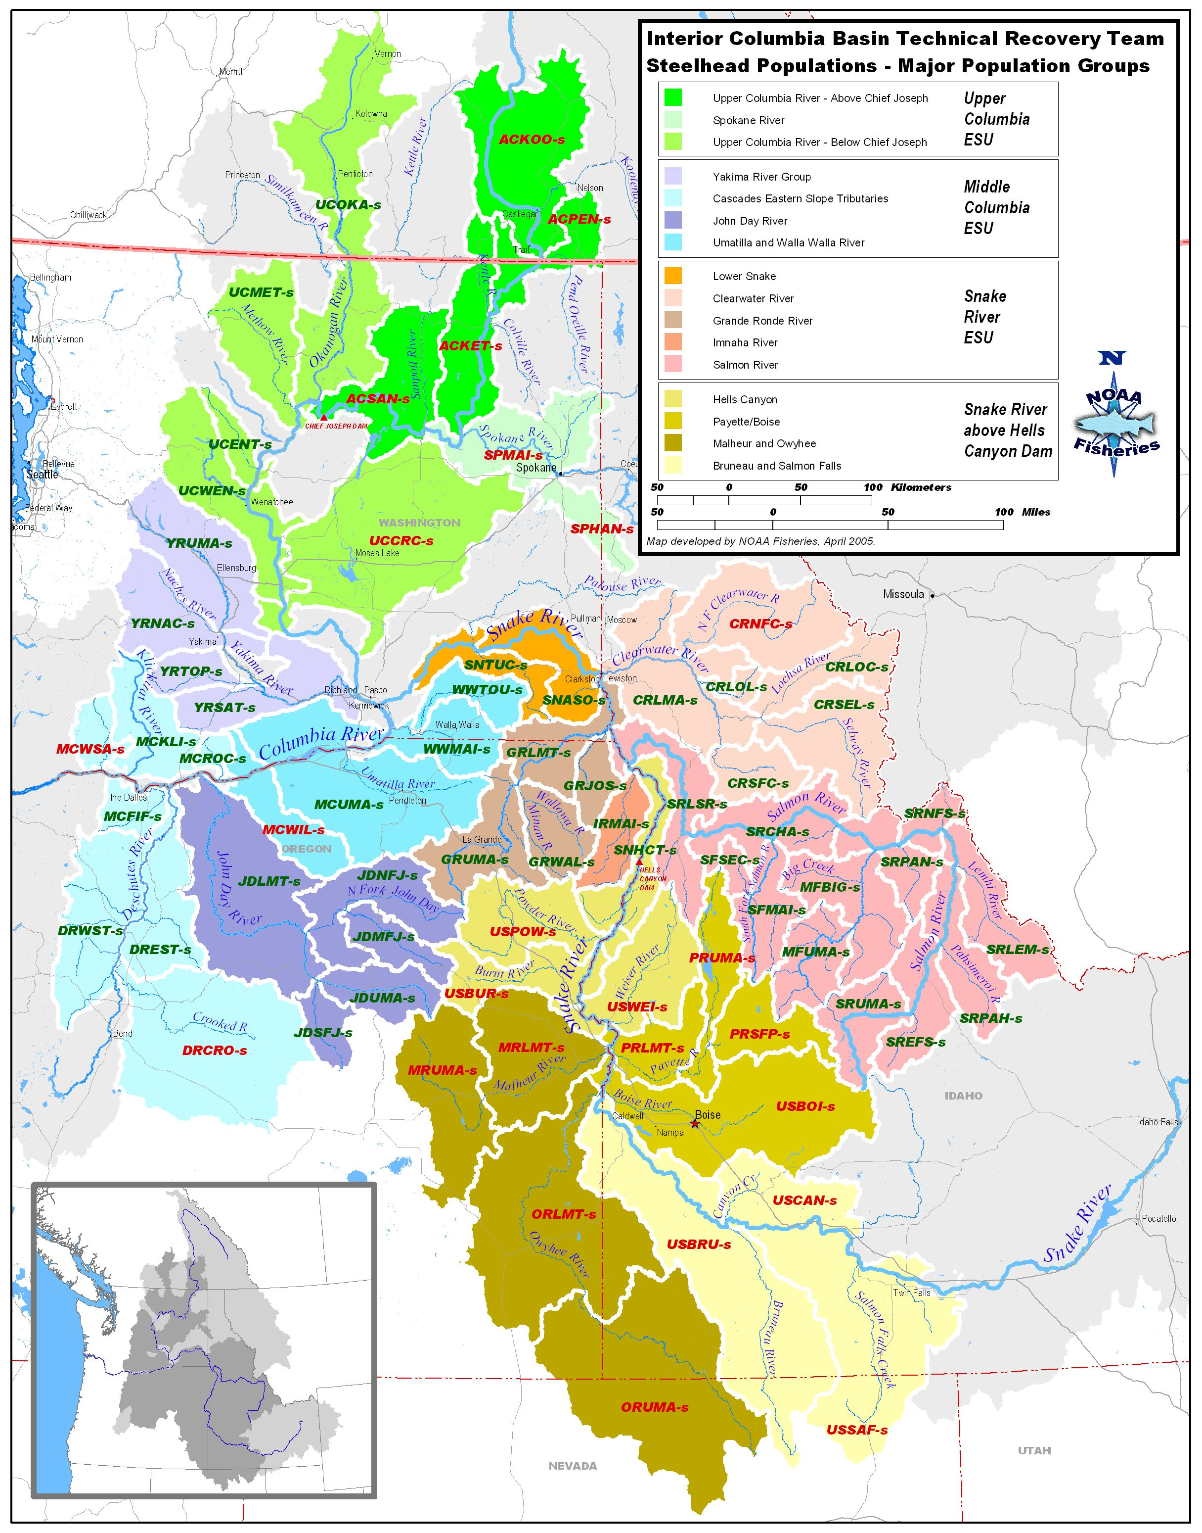
Umatilla/Walla Walla MPG Mid Columbia Steelhead DPS
Following pages are an analysis of ongoing monitoring programs in the MPG by TRT identified population, an evaluation of the quality of the information, and an evaluation of what would be needed to improve the monitoring and to move toward meeting NOAA Fisheries Service monitoring guidance standards.
Evaluations shown in this document are drawn from the work completed by the Columbia River Fish and Wildlife Authority through the Collaborative Systemwide Monitoring and Evaluation Project and through direct participation of the fish co-managers, FCRP action agencies, Public Utilities, Forest Service and others.
This evaluation was especially influenced by the participation of the Oregon Department of Fish and Wildlife, Washington Department of Fish and Wildlife, Confederated Tribes of the Umatilla Indian Reservation, and the CBFWA CSMEP Strength and Weaknesses document by Eric Tinus and Dan Rawding.
The following edits have been entered into this master copy of current VSP monitoring and are a result of a workshop held at Eastern Oregon University on March 17 to review VSP monitoring tables:
- Rich Carmichael, ODFW, 3/16/09
- Contor and Mahoney, CTUIR, 3/12/09
- Glenn Mendel, WDFW, 3/12/09

MPG Population | Primary Indicator | Desired Certainty | Monitoring Needed | Current Monitoring | Data Quality & Certainty | Data Improvement Actions Needed | RPA | Proposed New Monitoring
Umatilla River | Adult Abundance | Annual population-level estimates with a CV value on average of 15% or less.  Power analysis calculated for data? | Natural-origin Spawner Abundance | - CTUIR Passage Project and ODFW monitor adults at. 3 mile falls dam ladder at RM 3.7 BPA #198902401.  - ODFW Abundance estimated from complete counts at dam. Uses electronic counter & video  - permanent PIT tag detection system w/in the adult fish ladder at TMFD | - Data is one of best in Mid Columbia DPS  - Unknown CV estimate
Umatilla River | Adult Productivity | Adult/Adult ratio with low σ² | - Sex ratio  - Hatchery %  - Cohorts  - Harvest | - Age determined from scales of naturally produced adults. |  | - Need to CWT all hatchery fish not marked with an external mark | 50.7
Umatilla River | Juvenile Productivity | Annual population-level estimates with a CV value on average of 15% or less.  Power analysis calculated for data? | - Juvenile Migrant Abundance  - Smolt/Adult ratio | - ODFW Umatilla Juvenile Salmonid Outmigration and Survival Project (BPA #198902401) reinstated in September 2008 to estimate abundance of natural steelhead smolts at Three Mile Falls Dam and estimate SAR.  - Smolts monitored using PIT tagging for Meacham Creek Subbasin.  - Three Mile Falls Dam Juvenile Bypass Facility situated within West Extension Canal; RM 3.7  - Steelhead smolts are PIT-tagged annually to supplement efforts conducted by the Umatilla Natural Production M&E project (6,000 PIT tags for natural STS from Meacham Creek/ year) and the BOR (9,500 tags for hatchery STS, 500 tags for McKay Creek natural STS) and by ODFW at Three Mile Falls (3,000 tags/yr) to estimate SAR | - Umatilla River juvenile migrant abundance estimates 1999 – 2007. Average CV = 81% for 1999-2007 estimates.  - Not enough PIT tags for SAR estimates  - The Bootstrap method with 1,000 iterations will be used to obtain a variance. | - ODFW and CTUIR would like to restore funding for trapping and abundance estimation at 3 mile $300K  - Capital improvement needed to operate bypass at maximum efficiency  - Need additional PIT tag funding
Umatilla River | Spatial Distribution | Periodic distribution estimates with ability to detect a 15% change with 80% certainty. | - Adult redd distribution  - Juvenile parr distribution | - CTUIR BPA # 199000501 Conduct STS spawning surveys for habitat effectiveness monitoring only. Funding not available for basin-wide EMAP protocols. Specific experimental design in development through Habitat projects.  - No continuing juvenile parr distribution monitoring. However, historical data exits for steelhead spawning and parr distributions. |  | - CTUIR may implement GRTS habitat status/trend monitoring to follow Accord implementation. This will also track distribution |  | - CTUIR BiOp Accord MOA agrees to continue funding for BPA # 199000501 at $420K/yr  - CTUIR BiOp Accord MOA agrees to expand funding for BPA # 199000501 at $354K/yr
Umatilla River | Species Diversity | - Short term collection of phenotypes  - Long term collection of genotypes | - Age  - Sex ratios  - Size  - Cohort structure  - Run Timing  - DNA | - Length, age, weight, condition, health and smolt status will be collected on hatchery and natural spring Chinook salmon, fall Chinook salmon, coho salmon and summer steelhead to monitor life history characteristics,  - CTUIR Quantify age, growth and cohort diversity of Umatilla Basin salmonids in collaboration with ODFW  - CTUIR injecting strontium into adult hatchery fish to measure reproductive fitness of offspring BPA #200203000 $176,333/yr |  |  |  | CTUIR BiOp Accord MOA agrees to continue funding for BPA # 200203000 at $297K/yr
Acclimation Facilities  CTUIR  BPA #198343500  $912,166/yr | PNOS Integ  PNOS Seg  % marked at release  PNI | - 66%  - 95%  - 100%  - ≥ 0.7 | - Hatchery brood stock  - marks  - Spawner surveys | - CTUIR Facilities acclimate juvenile salmon and steelhead prior to release in the Umatilla Basin. Collect, hold, and spawn steelhead, coho, and chinook salmon and provide eggs to ODFW and other hatcheries for incubation, rearing, and later release in the Umatilla Basin.  - The Three Mile Dam adult holding/spawning facility is located on the lower Umatilla River at approximately RM 3.  - The Bonifer juvenile acclimation/release facility is located adjacent to Meacham Creek at RM 2.  - Thornhollow juvenile acclimation/release facility is located on the upper Umatilla River at RM 73.5.  - Imeques C-mem-ini-kem juvenile acclimation/release facility is located on the upper Umatilla River at RM 79.5  - Pendleton juvenile acclimation/release facility is located on the Umatilla River at RM 56.  - Minthorn juvenile acclimation/release and adult holding/spawning facility is located on Minthorn Springs Creek, near the mouth at Umatilla RM 63.8.  - CTUIR BPA #198802200 provides adequate passage for juveniles released by project BPA #198343500 and collects and transports broodstock to satellite facilities operated by project 198343500. |  |  |  | - CTUIR BiOp Accord MOA maintains existing BPA #198343500 at $948,466/yr  - CTUIR BiOp Accord MOA provides new funds for Walla Walla Steelhead supplementation Hatchery O&M at $69,500/yr
Umatilla Hatchery  ODFW  BPA #198903500 | PNOS Integ  PNOS Seg  % marked at release  PNI | - 66%  - 95%  - 100%  - ≥ 0.7 | - Hatchery brood stock  - marks  - Spawner surveys | - Rear 603k subyearling fall Chinook, 586k spring Chinook, 156k summer steelhead, and transferred 480k yearling fall chinook from Bonneville, 210k spring Chinook from Little White, 1.5 million Coho from Cascade & Oxbow to acclimation sites on Umatilla River  - PNOS =0.64  - PNI= Not available  - BPA Project 199000500 obtains information on migration success & performance of hatchery -produced fish & uses it to identify the most effective hatchery practices.
Walla Walla River | Adult Abundance | Annual population-level estimates with a CV value on average of 15% or less.  Power analysis calculated for data? | Natural-origin Spawner Abundance | - 1993-2001 trap counts with mark recapture at Nursery Bridge  - 2002-08 WDFW, ODFW and CTUIR collect adult escapement information using video monitoring and physical enumeration from Nursery Bridge Ladder, weir  - Annual abundance estimates developed from nursery bridge estimate expanded for unsampled areas in remainder of population. Sample expansion developed based on ratio of productivity and capacity from EDT model.  - BPA #200003900 $500K/yr[ CTUIR expends ~ $28k per year on adult enumeration WE; CTUIR total WWM & E is ~ 700 K/yr of 900k/yr; WDFW is project collaborator for ~ 200K/yr] .  - Permanent PIT tag detection system w/in the adult fish ladder at Burlingame, Mill Creek, and Nursery Bridge . Instream PIT-detection arrays @ Bear Creek, Harris Park, Yellowhawk Creek, upper Mill Creek, and lower Walla Walla River  - WDFW performs redd surveys in Coppei and Mill Creeks and a weir was used in Coppei Cr in 2005 [New weir Coppie weir and new ladder & trap in Dayton]  - CTUIR operate adult bypass traps at 4 sites BPA # 200003300 $129,234. [CTUIR O/M project maintains 4 fish ladders: LWWR, NBD, BGD, & GCII]  - CTUIR proposed EMAP type surveys to estimate adult spawner escapement BPA #200003900 $500K/yr; BPA did not fund. CTUIR conducted STS indexed spawner surveys in Couse Creek, but these have been discontinued in lieu of adult ladder counts. | - Short data sets  - CTUIR NBD ladder counts 2000-09; Mill Creek 2005-09. Data quality is high at NBD.  - Need better relationship of NBD counts to rest of basin  - Video efficiency has varied 2004 missing  - WDFW Mill Cr. Has 5 yrs redd count data but does not give spatial and temporal coverage or good information about redd detect ability and escapement  - Coppei Cr has potential to collect good data if weir is used annually along with redd counts.  - Need to evaluate spawner abundance downstream of Nursery bridge and how it relates to overall watershed production. | - WDFW needs annual weir placement in Coppei Cr.  - Lower Walla Walla weir to enumerate total adult return  - Adult EMAP sampling in areas other than above NBD or census  - Need to determine if adult information collected at Bennington Dam |  | - WDFW proposes to monitor and evaluate aquatic habitat conditions to compliment work under BPA 200003900 $200K/yr  - CTUIR BiOp Accord MOA agrees to continue funding for BPA # 200003900 at $714K/yr to 1.4M/yr 20008-2017;
Walla Walla River | Adult Productivity | Adult/Adult ratio with low σ² | - Sex ratio  - Hatchery %  - Cohorts  - Harvest | - CTUIR PHOS estimated from video counts  - ODFW Age data limited to 1993-95 brood years  - 1993-present annual estimated based on natural and hatchery adults at Nursery Bridge weir.  - Average age composition from 1993-1995 adult scale samples at Nurdery Bridge.  - Harvest information is from catch record cards in WA, plus past creel checks. | - PHOS not reliable because origin not observable in video counts at NBD  - No current updated age information and | - Need to CWT all hatchery fish not marked with an external mark | 50.7 | - CTUIR BiOp Accord MOA agrees to continue funding for BPA # 200003900 at $714K/yr to 1.4M/yr 20008-2017; includes WDFW ~200k/yr
Walla Walla River | Juvenile Productivity | Annual population-level estimates with a CV value on average of 15% or less.  Power analysis calculated for data? | - Juvenile Migrant Abundance, survival and run timing  - Smolt/Adult ratio | - Smolts monitored using PIT tagging  - CTUIR /WDFW smolt trapping and PIT tagging in Walla Walla, South Fork Walla Walla, Mill and Pine Creek, CTUIR/WDFW operates basin screw traps; CTUIR operates four screw traps: WW-headwaters, WW mouth; Mill @ mouth, and Yellowhawk @ mouth and PIT-tags 2-6K STS smolts per year; WDFW operates one screw trap in Touchet-headwaters in collaboration w/ CTUIR under BPA 200003900, Outmigration portion ~ 350K of 900K total CTUIR performed some electrofishing/PIT tagging in Pine Creek; discontinued . BPA 200003900 $ 22K]  - CTUIR Operates Little Walla Walla River juvenile screen and bypass as needed to provide safe passage conditions for downstream migrants. BPA # 200003300 $129,234 (trapping facility is an adult trap for future adult CHS trap & haul if needed) | - Smolt traps cover basin  - Short data series  - Smolt production estimate quality is still uncertain (too new yet). | - Need more PIT tags to help parse out production between traps  - Nursery bridge trap needs to be improved in design to produce reliable adult abundance estimates |  | - CTUIR BiOp Accord MOA agrees to continue funding for BPA # 200003900 at $714K/yr to 1.4M/yr 20008-2017; includes WDFW ~200k/yr
Walla Walla River | Spatial Distribution | Periodic distribution estimates with ability to detect a 15% change with 80% certainty. | - Adult redd distribution  - Juvenile parr distribution | - CTUIR conducted STS index surveys in Couse Creek and portions of upper Walla Walla; discontinued in 2008 (index surveys). BPA 200003900 formerly ~ 32k/yr (of ~ 500k)  - CTUIR conducted (EMAP) surveys of juvenile and resident fish and their habitat; discontinued in 2007 BPA #200003900 formerly $120k/yr of 500k  - WDFW continues to conduct some limited area spawning surveys after several years or exploratory spawning surveys (all BPA funded)  - Very limited spot checks on parr distribution after many years of exploratory surveys by WDFW – BPA funded | - WDFW Mill Cr. Has 5 yrs data but does not give spatial and temporal coverage or good information about redd detect ability and escapement | - EMAP sampling for distribution of adult redds.  - Need at minimum EMAP in areas not covered by NBD sampling
Walla Walla River | Species Diversity | - Short term collection of phenotypes  - Long term collection of genotypes | - Age  - Sex ratios  - Size  - Cohort structure  - Run Timing  - DNA | - Sampling funded in all populations of Walla Walla to collect DNA from juvenile parr sampled basinwide funded by NOAA 2006-08.  - Age, size, sex ratio, cohort structure and run timing data are collected at smolt traps and adult traps (Dayton for adult age, sex ratio, size).  - WDFW DNA samples have been archived and more are being collected in the Touchet  - Multiple populations identified in basin |  | - Need GSI information for basin spatial structure and potential hatchery introgression or hatchery risks, especially below Dayton and below Nursery dams
Habitat Monitoring |  |  |  |  |  | - Need EMAP habitat evaluation monitoring in the Walla Walla watershed
Lyons Ferry Hatchery | PHOS, PNI, Segregation and hatchery natural spawning success and smolt production |  | - quantification of natural spawning and production and effects on ESA listed fsh |  | - uncertainty about numbers and impacts of hatchery returns and spawning or production below Nursery Bridge and Dayton, or in Coppei Creek or other tributaries like Mill Creek | - Need to conduct counting/trapping at Burlingame Dam or lower in the Walla Walla River to examine % hatchery fish returning/spawning naturally and some evaluation of amount of smolt production from hatchery spawners, or introgression |  | - WDFW has proposed increased monitoring under BPA MOA
Walla Walla Hatchery  CTUIR | PNOS Integ  PNOS Seg  % marked at release  PNI | - 66%  - 95%  - 100%  - ≥ 0.7 | - Hatchery brood stock  - marks  - Spawner surveys | - Complete the 3-Step Master Planning process to construct hatchery facilities to assist in the Walla Walla Subbasin spring chinook restoration program. |  |  |  | - CTUIR BiOp Accord MOA agrees to continue funding for NEOH BPA # 200003800 at $353K/yr
Touchet River | Adult Abundance | Annual population-level estimates with a CV value on average of 15% or less.  Power analysis calculated for data? | Natural-origin Spawner Abundance | - WDFW relies upon index redd count surveys. Indices were established in the North Fork, South fork, and Robinson Fork.  - Based on index expansion design where indes sites are walked every week for duration of spawning Index sites are 20% of total spawning area  - A trap with a counter is operated near Dayton in a fish passage structure | - Does not provide total returns and total escapement  - Many areas remain unsurveyed on an annual basis, or cannot be surveyed because it is impractical to survey  - Dayton trap cannot currently account for all passage as it is not known how many steelhead bypass the trap.  - Returns and spawning in the Mainstem Touchet downstream of Dayton Dam are uncertain. | - Weir near the mouth to enumerate all spawners or improved weir system at Dayton and in Coppei, or below the mouth of Coppei Creek  - CTUIR and WDFW are leading an effort in the basin to coordinate with others and make modifications or additions to improve adult accounting throughout the basin as part of the BPA funded RME project. Currently, there is no way to account for total adult returns to either steelhead population in the basin.
Touchet River | Adult Productivity | Adult/Adult ratio with low σ² | - Sex ratio  - Hatchery %  - Cohorts  - Harvest | - WDFW Dayton trap used to collect age, size, and scales for PHOS Sex and age information are available for Touchet steelhead trapped for endemic broodstock , plus % hatchery returns, at Dayton Dam  - Harvest information is from catch record cards in WA, plus past creel checks. | - PHOS estimates are not reliable or available, especially below Dayton | - Dayton trap and ladder was recently modified, but needs further improvements  - Need to CWT all hatchery fish not marked with an external mark This is currently being done for all hatchery steelhead (LFH or endemic stock) released in the Touchet or Walla Walla | 50..7
Touchet River | Juvenile Productivity | Annual population-level estimates with a CV value on average of 15% or less.  Power analysis calculated for data? | - Juvenile Migrant Abundance  - Smolt/Adult ratio | - WDFW operates a smolt trap in the Touchet River as part of the BPA and WDOE funded project, CTUIR operates a smolt trap in the Walla Walla R downstream of the Touchet River. PIT tags are inserted into smolts for migration timing, survival and SARs. | - Uncertain, new trap | - Migrant trap near the mouth to monitor SAR A migrant trap below the Touchet is in place an operated by CTUIR  - WDOE funding for smolt trapping is being terminated so current BPA funding level will be inadequate
Touchet River | Spatial Distribution | Periodic distribution estimates with ability to detect a 15% change with 80% certainty. | - Adult redd distribution  - Juvenile parr distribution | - WDFW Uses adult spawner surveys coupled with additional non index segments with both LSRCP and BPA funding  - Very limited spot checks on parr distribution after many years of exploratory surveys by WDFW – BPA funded |  | - Not all areas are surveyed on an annual basis and many areas are no longer scheduled for surveys.  - BPA will no longer fund more than very limited spot checks or salvage operations for juvenile distribution
Touchet River | Species Diversity | - Short term collection of phenotypes  - Long term collection of genotypes | - Age  - Sex ratios  - Size  - Cohort structure  - Run Timing  - DNA | - DNA Analysis ongoing  - Multiple populations identified in basin  - Age, size, sex ratio, cohort structure and run timing data are collected at smolt traps and adult traps (Dayton for adult age, sex ratio, size).  - DNA samples have been archived and more are being collected in the Touchet  - Age, sex ratio, size, cohort structure and run timing are collected by WDFW at the Dayton Dam trap and smolt trap |  | - Need GSI information for basin spatial structure and potential hatchery introgression or hatchery risks, especially below Dayton dam |  | - WDFW has proposed funding from BPA MOA for continuing smolt trapping
Willow Creek | Adult Abundance | Annual population-level estimates with a CV value on average of 15% or less.  Power analysis calculated for data? | Natural-origin Spawner Abundance
Willow Creek | Adult Productivity | Adult/Adult ratio with low σ² | - Sex ratio  - Hatchery %  - Cohorts  - Harvest
Willow Creek | Juvenile Productivity | Annual population-level estimates with a CV value on average of 15% or less.  Power analysis calculated for data? | - Juvenile Migrant Abundance  - Smolt/Adult ratio
Willow Creek | Spatial Distribution | Periodic distribution estimates with ability to detect a 15% change with 80% certainty. | - Adult redd distribution  - Juvenile parr distribution
Willow Creek | Species Diversity | - Short term collection of phenotypes  - Long term collection of genotypes | - Age  - Sex ratios  - Size  - Cohort structure  - Run Timing  - DNA | - Data collected from dam counts and trapping operations  - Hatchery strays from other rivers |  | - Access to more naturally produced steelhead at Wells dam.

