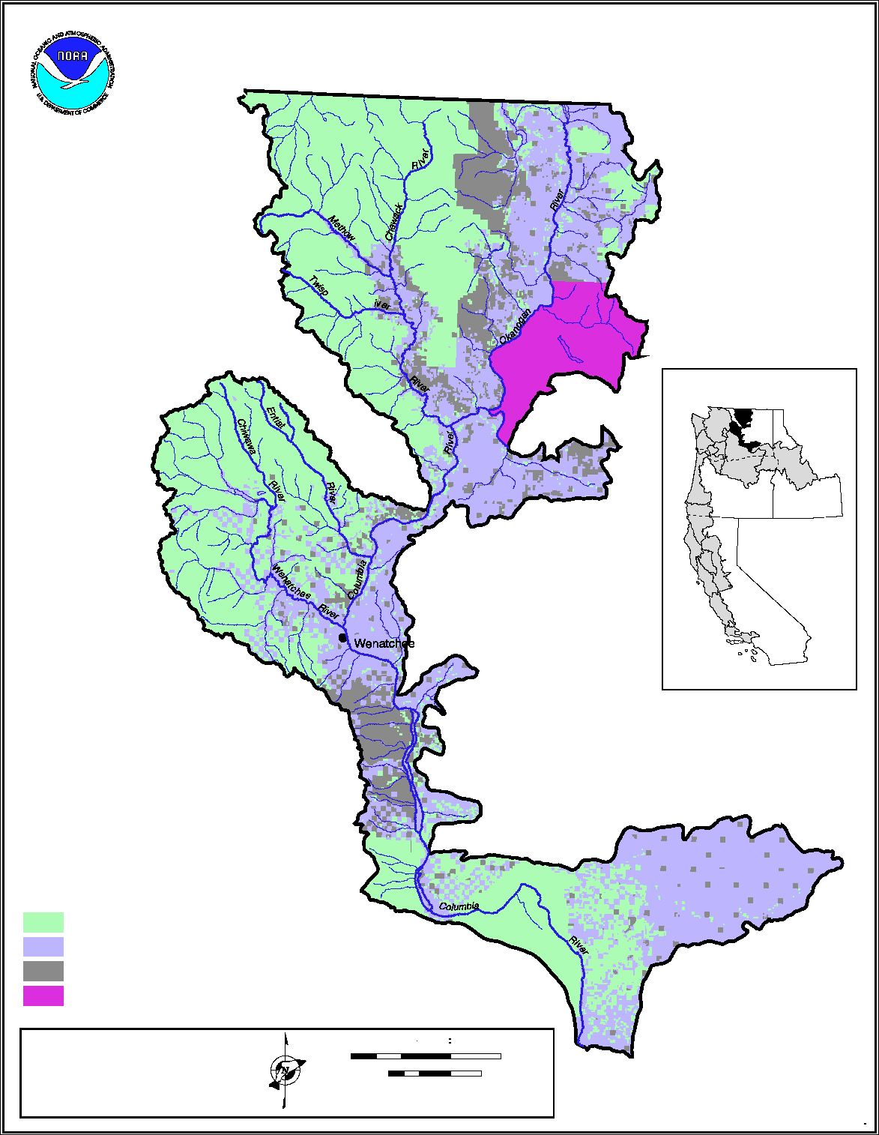

Cascade Slope MPG Upper Columbia Spring Chinook ESU

Following pages are an analysis of ongoing monitoring programs in the MPG by TRT identified population, an evaluation of the quality of the information, and an evaluation of what would be needed to improve the monitoring and to move toward meeting NOAA Fisheries Service monitoring guidance standards.

Evaluations shown in this document are drawn from the work completed by the Columbia River Fish and Wildlife Authority through the Collaborative System-wide Monitoring and Evaluation Project and through direct participation of the fish co-managers, FCRP action agencies, Public Utilities, Forest Service and others.

This evaluation was especially influenced by the participation of the Washington Department of Fish and Game, Colville Confederated Tribe, Chuck Pevan, Tracy Hillman, and Michael Newsome, Bureau of Reclamation.

MPG Population | Primary Indicator | Desired Certainty |  |  | Monitoring Needed |  | Current Monitoring |  |  | Data Quality & Certainty |  |  | Data Improvement Actions Needed | RPA Eligible | Proposed Projects
Methow Spring Chinook | Adult Abundance | Annual population-level estimates with a CV value on average of 15% or less.  Power analysis calculated for data? |  |  | Natural-origin Spawner Abundance |  | - WDFW conducts Census at Wells Dam, but the trap is not operated 24/7  - Index survey sites throughout known spawning area  - Counting weir also on Twisp River  - Funded by Douglas , Chelan, and Grant PUDs |  |  | - Trap avoidance is apparent.  - Redd observation conditions are good and estimates are assumed to be accurate.  - Certainty Not Calculated  - Power analysis not calculated |  |  | - Radio telemetry to determine pre-spawn mortality.  - Need to adjust all carcass data for bias  - Need to determine observer efficiency. | RPA 50.4 | WDFW proposes to supplement work under HCP in order to meet NOAA accuracy and precision standards ($220k/yr)
Methow Spring Chinook | Adult Productivity | Adult/Adult ratio with low σ² |  |  | - Sex ratio  - Hatchery %  - Cohorts  - Harvest |  | - Data from broodstock collection efforts at Wells Dam.  - CR Compact estimates  - Funded by Douglas , Chelan, and Grant PUDs  - PNOS = 0.71  - PNI = 0.7 |  |  | - Need better estimates of natural population harvest  - Assume no natural production from Okanogan |  |  |  | RPA 50.4
Methow Spring Chinook | Juvenile Productivity | Annual population-level estimates with a CV value on average of 15% or less.  Power analysis calculated for data? |  |  | - Juvenile Migrant Abundance  - Smolt/Adult ratio |  | - Trap at rkm 2  - Trap at rkm 11 2003-2008  - Egg-to-smolt survival estimated from egg deposition and out migrating smolts  - Trap CV =  - Age structure estimated from scale analysis  - Funded by Douglas , Chelan, and Grant PUDs |  |  | - Short time frame for trap data  - Trap CV is high? |  |  | - Funding for flow efficiency models | RPA 50.4 | YIN propose to build acclimation ponds on Methow, twisp, and Chewuch as part of Three Treaty tribes Accord Agreement.  $300K BPA
Methow Spring Chinook | Spatial Distribution | Periodic distribution estimates with ability to detect a 15% change with 80% certainty. |  |  | - Adult redd distribution  - Juvenile parr distribution |  | - Adult Index sites  - Juvenile surveys using snorkeling and electrofishing are not random.  - Funded by Douglas , Chelan, and Grant PUDs |  |  | - Assume that expanded index areas do cover 100% of spawning distribution  - Juvenile surveys using snorkeling and electrofishing are not random and sample size is too small. |  |  | Validate that spring Chinook are not spawning outside the expanded index areas.  Increase effort and add probabilistic design to juvenile snorkel surveys. | RPA 50.4
Methow Spring Chinook | Species Diversity | - Short term collection of phenotypes  - Long term collection of genotypes |  |  | - Age  - Sex ratios  - Size  - Cohort structure  - Run Timing  - DNA |  | - Data for 1-5 from dam counts spawner carcass surveys and juvenile traps.DNA covered by DPUD M&E plan for the HCP. |  |  | - Data is heavy to hatchery origin adult spawners. More natural adult data needed |  |  | - Access to more naturally produced spring Chinook at Wells dam. | RPA 65 | WDFW proposes to evaluate the relative reproductive success of NOS and HOS (est. $165K/yr)
Winthrop NFH  USFWS | PNOS Integ  PNOS Seg  % marked at release  PNI |  | - 66%  - 95%  - 100%  - ≥ 0.7 | - Hatchery brood stock  - marks  - Spawner surveys |  |  |  | - USFWS produces spring chinook and steelhead  - Part of Leavenworth Complex
Eastbank Satellites  (Chewuch , Carleton, Twisp Pds) | PNOS Integ  PNOS Seg  % marked at release  PNI |  | - 66%  - 95%  - 100%  - ≥ 0.7 | - Hatchery brood stock  - marks  - Spawner surveys |  |  |  | - WDFW operated |  |  |  |  |  | - 40, 42, 51, 52, 63, 64 | - WDFW proposes funding a position to oversee implementation of HSRG in upper Columbia MPG. BPA $128K/yr
Entiat Spring Chinook | Adult Abundance | Annual population-level estimates with a CV value on average of 15% or less.  Power analysis calculated for data? |  |  | Natural-origin Spawner Abundance |  | - Only index surveys are conducted regularly,  - no probabilistic sampling of other areas that could / might have spawning (i.e. Silver Falls and Upper Mad), |  |  | - Certainty Not Calculated  - Power analysis not calculated  - Assume that index sites cover 100% of the spawning area. |  |  | - Observer efficiency study (Methow results may be applicable here).  - Add additional survey areas or probabilistic design to non-index areas. | RPA 50.4
Entiat Spring Chinook | Adult Productivity | Adult/Adult ratio with low σ² |  |  | - Sex ratio  - Hatchery %  - Cohorts  - Harvest |  | - Carcass surveys, scale analysis  - Carcass surveys, scale analysis  - Carcass surveys, scale analysis  - CR Compact estimates |  |  | - Need better estimates of natural population harvest |  |  |  | RPA 50.4
Entiat Spring Chinook | Juvenile Productivity | Annual population-level estimates with a CV value on average of 15% or less.  Power analysis calculated for data? |  |  | - Juvenile Migrant Abundance  - Smolt/Adult ratio |  | - Trap at rkm 2  - Trap at rkm 11 2003-2008  - Egg-to-smolt survival estimated from egg deposition and out migrating smolts  - Trap CV =  - Age structure estimated from scale analysis  - Supplemented by ISEMP Project |  |  | - Short time frame for trap data  - Trap CV?  - Trap power Analysis? |  |  | - Need flow model to calibrate trap efficiency | RPA 50.4
Entiat Spring Chinook | Spatial Distribution | Periodic distribution estimates with ability to detect a 15% change with 80% certainty. |  |  | - Adult redd distribution  - Juvenile parr distribution |  | - Adult Index sites  - Pit tag detection arrays  - Juvenile surveys using snorkeling and electrofishing associated with effectiveness monitoring.  - Some systematic juvenile surveys by USFS |  |  | - Need to convert systematic juvenile panel sites to random panel sites.  - Untested assumption that index areas do cover 100% of spawning distribution. |  |  | - Add more sites and a random probabilistic design to juvenile snorkel surveys.  - Supplement index sites with randomly selected reaches outside the index areas. | RPA 50.4
Entiat Spring Chinook | Species Diversity | - Short term collection of phenotypes  - Long term collection of genotypes |  |  | - Age  - Sex ratios  - Size  - Cohort structure  - Run Timing  - DNA |  | - Data for 1-5 from spawner carcass surveys and juvenile traps |  |  |  |  |  | - Genetic monitoring of Entiat spring Chinook is not conducted as part of any ongoing, funded, monitoring programs.  - Additional effort to remotely tag natural origin parr will most likely be needed in order to obtain adequate sample size to evaluate phenotypic traits and life history characteristics. | RPA 50.4
Entiat NFH  USFWS | PNOS Integ  PNOS Seg  % marked at release  PNI |  | - 66%  - 95%  - 100%  - ≥ 0.7 | - Hatchery brood stock  - marks  - Spawner surveys |  |  |  | - satellite of Leavenworth NFH. Produces spring Chinook.
Turtle Rock Hatchery  WDFW  Funded Grant PUD | PNOS Integ  PNOS Seg  % marked at release  PNI |  | - 66%  - 95%  - 100%  - ≥ 0.7 | - Hatchery brood stock  - marks  - Spawner surveys |  |  |  | - raises summer Chinook and steelhead
Okanogan Spring Chinook | Abundance | Annual population-level estimates with a CV value on average of 15% or less.  Power analysis calculated for data? |  |  | Natural-origin Spawner Abundance |  | - Colville Tribe Collection of adult escapement data at Wells Dam, Omak Creek, Bonaparte Creek, Inkaneep Creek, and Zosel Dam.  - BPA Contract 200302200  - FCRPS Accord funding at 1,245K per year  - Data collected at the sub-watershed traps is considered highly applicable to spawner abundance  - Census spawner surveys for Okanogan and tribs |  |  | - 100% Certainty  - Power analysis not calculated |  |  | - Power analysis
Okanogan Spring Chinook | Adult Productivity | Adult/Adult ratio with low σ² |  |  | - Sex ratio  - Hatchery %  - Cohorts  - Harvest |  | - BPA Contract 200302200  - FCRPS Accord funding at 1,245K per year  - Pit tag/ dam counts  - PNOS = 0.45 PNI = 0.5  - CR Compact estimates |  |  | - Only hatchery fish are currently being pit or CWT tagged.  - Need better estimates of natural cohort structure  - Need better estimates of natural population harvest |  |  | - Currently it is not believed to be nay natural production in the Okanogan, but eventually those fish will need to be handled closer to the Okanogan
Okanogan Spring Chinook | Juvenile Productivity | Annual population-level estimates with a CV value on average of 15% or less.  Power analysis calculated for data? |  |  | - Juvenile Migrant Abundance  - Smolt/Adult ratio |  | - Colville Tribe operates trap at Mallot WA & trap at Omak Creek  - BPA Contract 200302200  - FCRPS Accord funding at 1,245K per year  - Egg-to-smolt survival estimated from egg deposition and out migrating smolts  - Trap CV =  - Age structure estimated from scale analysis |  |  | - Short time frame for trap data  - Trap CV?  - Trap power analysis  - Differentiating yearling summer Chinook from spring Chinook has proven to be difficult because of the very small number of naturally produced yearling Chinook. |  |  | - None
Okanogan Spring Chinook | Spatial Distribution | Periodic distribution estimates with ability to detect a 15% change with 80% certainty. |  |  | - Adult redd distribution  - Juvenile parr distribution |  | - Adult census data  - Juvenile probabilistic random surveys using snorkeling and electrofishing per OBMEP protocols and EMAP approach  - CCT BPA # 200302200 Accord at 1,245K per year |  |  | - Data appear to be good with exception of better natural spawner information NOS/HOS ratios |  |  | - None
Okanogan Spring Chinook | Species Diversity | - Short term collection of phenotypes  - Long term collection of genotypes |  |  | - Age  - Sex ratios  - Size  - Cohort structure  - Run Timing  - DNA |  | - Scales and length data collected sporadically at Omak Creek trap since 2004. sample sizes are too small to provide for meaningful analysis.  - Sex ratios could be calculated from Omak Creek trap since 2004 but have not been calculated because consistent data collection has not occurred, and due to a very small sample size.  - CCT BPA # 200302200 Accord at 1,245K per year  - DNA ?? |  |  | - Data is heavy to hatchery origin adult spawners. More natural adult data needed |  |  | - Currently it is not believed to be any natural production in the Okanogan, but eventually those fish will need to be handled closer to the Okanogan
Cassimer Bar Hatcheries  Colville Tribe | PNOS Integ  PNOS Seg  % marked at release  PNI |  | - ≥66%  - ≥95%  - 100%  - ≥ 0.7 | - Hatchery brood stock  - marks  - Spawner surveys |  | - PNI = 0.1
Omak Trout Hatchery  WDFW | PNOS Integ  PNOS Seg  % marked at release  PNI |  | - ≥66%  - ≥95%  - 100%  - ≥ 0.7 | - Hatchery brood stock  - marks  - Spawner surveys |  | - WDFW Omak Trout Hatchery
Well Hatchery  WDFW  Funded by Douglas PUD | PNOS Integ  PNOS Seg  % marked at release  PNI |  | - ≥66%  - ≥95%  - 100%  - ≥ 0.7 | - Hatchery brood stock  - marks  - Spawner surveys |  | - Raises steelhead
Chelan Hatchery  WDFW  Funded by Chelan PUD | PNOS Integ  PNOS Seg  % marked at release  PNI |  | - ≥66%  - ≥95%  - 100%  - ≥ 0.7 | - Hatchery brood stock  - marks  - Spawner surveys |  | - Raises steelhead and trout
Wenatchee Spring Chinook | Adults Abundance | Annual population-level estimates with a CV value on average of 15% or less.  Power analysis calculated for data |  |  | Natural-origin Spawner Abundance |  | - WDFW census at Tumwater Dam has been ongoing for many years and the hatchery monitoring programs (CPUD funded) should be covering 100% census counts at Tumwater Dam for the length of their license (May eventually include GPUD).  - WDFW redd surveys in index and expanded index areas  - Funding ISEMP |  |  | - Tumwater census is run escapement, not spawn escapement  - Certainty Not Calculated  - Power analysis not calculated  - Observer efficiency is not known |  |  | - May need to develop better method than current, since current method appears to be overestimating prespawn mortality.  - Observer efficiency studies | RPA 50.4
Wenatchee Spring Chinook | Adult Productivity | Adult/Adult ratio with low σ² |  |  | - Sex ratio  - Hatchery %  - Cohorts  - Harvest |  | - Pit tag/ dam counts/carcass  - Pit tag/ dam counts/carcass  - Pit tag/ dam counts/carcass  - CR Compact estimates  - Funding ISEMP |  |  | - Need better estimates of natural population harvest |  |  |  | RPA 50.4
Wenatchee Spring Chinook | Juvenile Productivity | Annual population-level estimates with a CV value on average of 15% or less.  Power analysis calculated for data? |  |  | - Juvenile Migrant Abundance  - Smolt/Adult ratio |  | - Smolt traps are operated in the lower Wenatchee (RM 7), Nason Creek, Chiwawa River, White River, and in the Upper Wenatchee River just below the Lake.  - Egg-to-smolt survival estimated from egg deposition and out migrating smolts  - Trap CV =  - Age structure estimated from scale analysis  - Funding ISEMP  - PIT tags BPA #200303900 |  |  | - Short time frame for trap data(Nason and White R.)  - Trap CV?  - Trap power analysis |  |  | - Need flow model to calibrate trap efficiency | RPA 50.4 | YIN propose to build acclimation pond on Peshastin, Creek as part of Three Treaty tribes Accord Agreement.  $100K BPA
Wenatchee Spring Chinook | Spatial Distribution | Periodic distribution estimates with ability to detect a 15% change with 80% certainty. |  |  | - Adult redd distribution  - Juvenile parr distribution |  | - Spring Chinook redd surveys have been conducted by Chelan PUD and WDFW in index areas since the 1950s. Surveys were expanded to cover ~ 100% of potential spawning areas in the late 1980s.  - PIT tag detection arrays have recently been installed in Peshastin Creek, Tumwater Canyon, two in the Chiwawa River, and two in Nason Creek.  - Carcass surveys have been conducted along with redd surveys and consistently recover greater than 20% of the spawn escapement.  - Juvenile parr surveys are conducted as part of USFS monitoring in some areas. ISEMP expanded that effort in 2004 and includes both fixed and random sites. Chelan PUD/BioAnalysts have conducted extensive snorkeling surveys in the Chiwawa since the early 1990s. |  |  | Data appear to be good |  |  | - None | RPA 50.4
Wenatchee Spring Chinook | Species Diversity | - Short term collection of phenotypes  - Long term collection of genotypes |  |  | - Age  - Sex ratios  - Size  - Cohort structure  - Run Timing  - DNA |  | - Data for 1-5 from dam counts spawner surveys and juvenile traps  - Tumwater Dam has provided mark identification on 100% of the spring Chinook and is planned to continue via the HCP hatchery monitoring programs. Chiwawa weir also provides information for one MaSA.  - DNA has been collected by WDFW and analyzed as part of the BPA funded reproductive success study BPA #200303900. |  |  | - Data appear to be good |  |  | - None | RPA 50.4
Leavenworth NFH  USFWS | PNOS Integ  PNOS Seg  % marked at release  PNI |  | - 66%  - 95%  - 100%  - ≥ 0.7 | - Hatchery brood stock  - marks  - Spawner surveys |  |  |  | - Spring Chinook and summer steelhead  - PNI = 0.4
Eastbank Hatchery Satellites  (Lk Wenatchee net pens, Chiwawa and Dryden Pond)  WDFW |  |  |  |  |  |  |  | - Raise spring/summer Chinook, sockeye, and steelhead

CSMEP strength and weakness evaluation Casey Baldwin and John Arterburn

