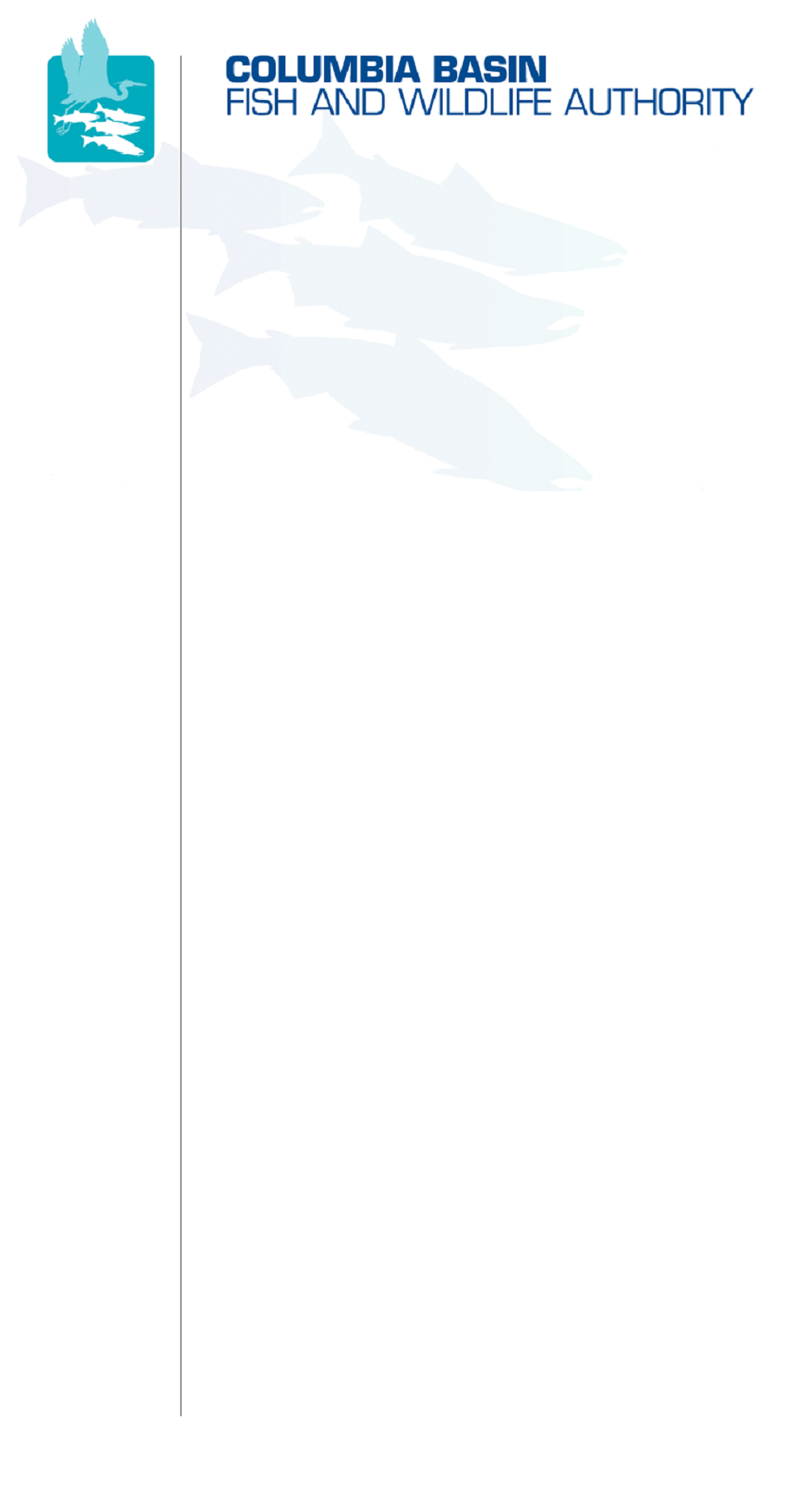
851 SW Sixth Avenue, Suite 260 | Pacific First Building | Portland, OR 97204-1339
Phone: 503-229-0191 | Fax: 503-229-0443 | Website: www.cbfwa.org

Coordinating and promoting effective protection and
restoration of fish, wildlife, and their
habitat in the
Columbia River Basin.

The Authority is comprised of the following tribes and fish and wildlife agencies:

Burns Paiute Tribe

Coeur d’Alene Tribe

Confederated Salish and Kootenai Tribes
of the Flathead Reservation

Confederated Tribes
of the Colville Reservation

Confederated Tribes
of the Umatilla Indian Reservation

Confederated Tribes
of the Warm Springs Reservation

Confederated Tribes and Bands of the Yakama Nation

Idaho Department
of Fish and Game

Kootenai Tribe
of Idaho

Montana Department
of Fish, Wildlife and Parks

National Marine Fisheries Service

Nez Perce Tribe

Oregon Department
of Fish and Wildlife

Shoshone-Bannock Tribes of Fort Hall

Shoshone-Paiute Tribes of Duck Valley

U.S. Fish & Wildlife Service

Washington Department of Fish
and Wildlife

Coordinating Agencies

Columbia River
Inter-Tribal Fish Commission

Upper Columbia
United Tribes

Compact of the Upper Snake River Tribes

DATE: | July 5, 2007
TO: | Anadromous Fish Advisory Committee (AFAC)
FROM: | Doug Taki, Chair
SUBJECT: | July 13, 2007 AFAC Meeting Draft Agenda

Anadromous Fish Advisory Committee Meeting
Friday July 13, 2007
9:00 a.m. – 12:00 p.m. PDT
@
CBFWA – Portland, Oregon
Teleconference (503) 229-0449 ID: 828049

Draft Agenda

ITEM 1: | Approve Action Notes From May 8, 2007 and June 11, 2007 AFAC Meetings
ITEM 2: | Election of New AFAC Vice-Chair  Doug Taki’s last day in his current term as Chair will be September 30; Brad Houslet will move from Vice-Chair to Chair effective October 1. The AFAC will need to elect a new Vice-Chair during its meeting on August 22. AFAC members should consider the possibility of becoming the next Vice-Chair.
ITEM 3: | Logistics for August 22-23 Work Session  The AFAC has decided to have a two-day meeting in the Pendleton, Oregon area on August 22-23, 2007. In general, the meeting will include a work session on August 22, a social activity the evening of August 22, and site visits on August 23. Logistics, including lodging and meeting venues, and site visit locations and transportation need to be discussed.
ITEM 4: | Draft Amendment Template  The AFAC will review and discuss the draft template for developing Program Measures based on the completed database. An example has been developed for most populations of Mid-Columbia steelhead (most are in the Columbia Plateau Province). The AFAC should discuss the template format, and how to “roll up” individual populations to the MPG (subbasin) and ESU/Province levels.  The Mid-Columbia steelhead examples will need further details for the draft measures, which need to be provided by the appropriate co-managers (ODFW, CTWSR, CTUIR).  The template is limited primarily to within-subbasin habitat factors and measures. The AFAC should discuss inclusion of out-of-subbasin factors and RM&E, as well as measures addressing parameters other than adult abundance (productivity, spatial structure, diversity, juvenile survival, etc.)  The AFAC should agree to recommend a format (either the current template or a modification thereof) and “roll up” method for consideration by the MAG at the July 24-25 Amendment strategy Workshop.
ITEM 5: | Progress on AFAC Database  AFAC members have had the opportunity to populate the database since March 19, 2007. Further progress on the amendment template relies on the database being populated.
ITEM 6: | Prepare for July 24-25 Amendment Strategy Workshop  The AFAC should discuss and agree on highlights of a presentation to be given at the workshop, a recommendation on how to move forward (the template), and how to make progress on any assignments given at the workshop (August 22 work session as a start).

/tmp/in/input.doc

