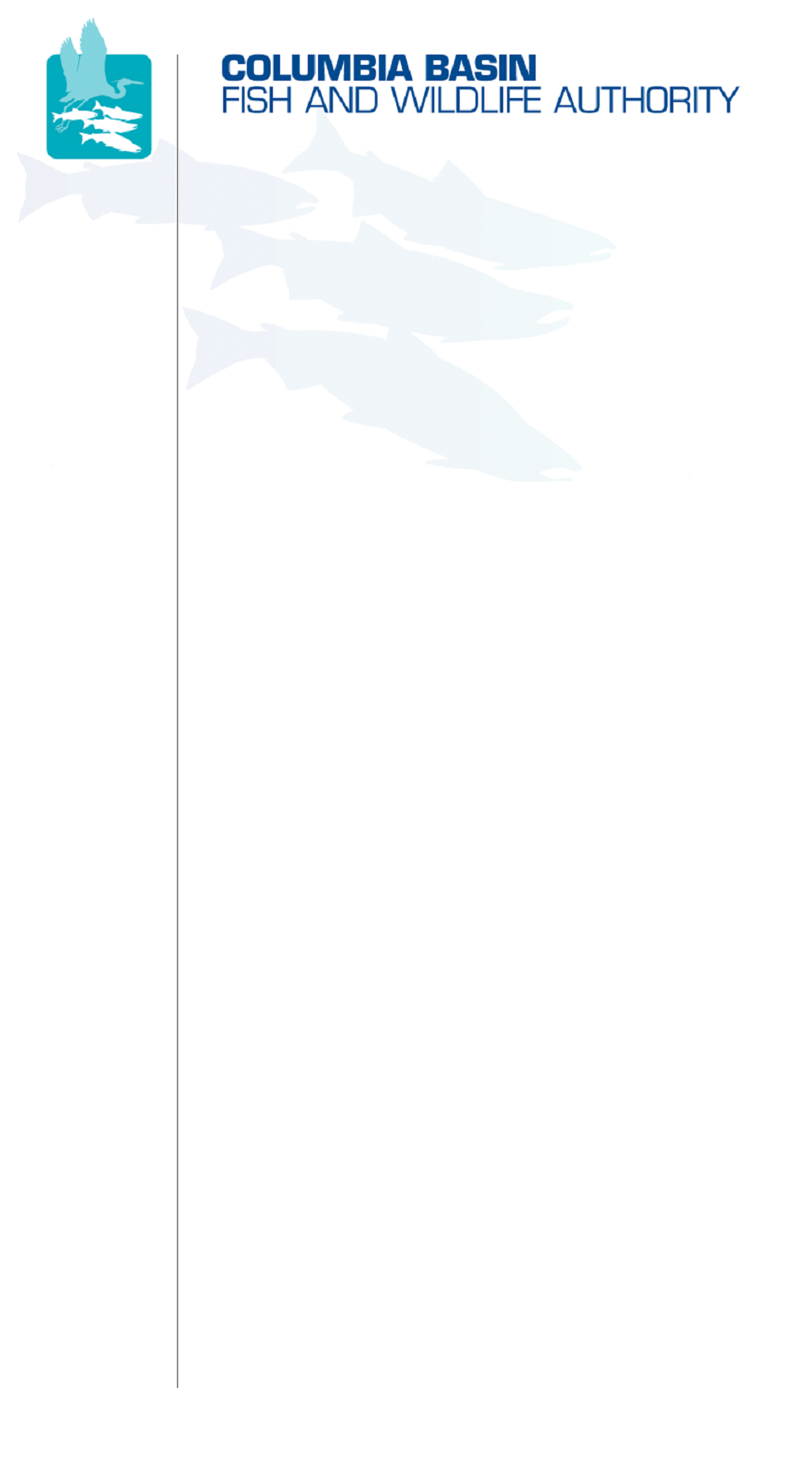
851 SW Sixth Avenue, Suite 300 | Pacific First Building | Portland, OR 97204-1339 | Phone: 503-229-0191 | Fax: 503-229-0443

May 29, 2008
Coordinating and promoting effective protection and
restoration of fish, wildlife, and their
habitat in the
Columbia River Basin.

The Authority is comprised of the following tribes
and government agencies:

Burns Paiute Tribe

Coeur d’Alene Tribe

Confederated Salish and Kootenai Tribes
of the Flathead Reservation

Confederated Tribes
of the Colville Reservation

Confederated Tribes
of the Umatilla Indian Reservation

Confederated Tribes
of the Warm Springs Reservation

Confederated Tribes and Bands of the Yakama Nation

Idaho Department
of Fish and Game

Kootenai Tribe
of Idaho

Montana Fish, Wildlife & Parks

National Marine Fisheries Service

Nez Perce Tribe

Oregon Department
of Fish and Wildlife

Shoshone-Bannock Tribes of Fort Hall

Shoshone-Paiute Tribes of Duck Valley

U.S. Fish & Wildlife Service

Washington Department of Fish
and Wildlife

Coordinating Agencies

Columbia River
Inter-Tribal Fish Commission

Upper Columbia
United Tribes

TO: | Anadromous Fish Advisory Committee (AFAC)
FROM: | Brad Houslet, Chair and Dave Ward, CBFWA Staff
SUBJECT: | Revised June 5, 2008 AFAC Teleconference Draft Agenda

Anadromous Fish Advisory Committee Teleconference Meeting
Thursday June 5, 2008
9:00 AM to Noon (PDT)
@
CBFWA – Portland, Oregon

*Note New Dial-in Number and WebEx Link*

Teleconference 503-229-0449 Id: 349502

WebEx has been arranged for this meeting:
Select: Quick Access to WebEx Logon
Log in first: Enter your name and email address.
Click "Join Now" and follow prompts.
Meeting password: afac (lower case)

ITEM 1: | Approve Action Notes From December 10, 2007 AFAC Meeting  Even though we had a lot of AFAC activity during the first part of 2008 (AHA workshops), we haven’t had an official AFAC meeting since December.
ITEM 2: | Assignment from MAG linking Subbasin Objectives to Basinwide Goals  On their May 7 teleconference, the Members directed the AFAC to “develop linkages between the population (subbasin) level objectives and the programmatic level objectives contained within the Program. The AFAC would report to MAG on May 20th and then on to the Members for consideration on June 4th to comment to the NPCC.”  Deferring the AFAC meeting until June 5 poses a problem with the timely completion of this assignment. To that end, Dave Ward has drafted and distributed a start to this assignment. The draft is a spreadsheet that includes, for each subbasin/species, columns for natural spawner, broodstock, and harvest objectives, as well as a column for estimated mortality during upstream migration between Bonneville Dam and subbasin of origin. These values are totaled to derive an estimate of the numbers of fish at Bonneville Dam needed to achieve subbasin objectives.  Because the assignment is due to be completed for the June 4th Members meeting, the AFAC needs to review and revise the draft spreadsheet before then. Each AFAC member should review the information for their subbasins and send revisions to Dave Ward by May 30th.
ITEM 3: | Next steps in the Amendment Process  The AFAC will review discussions/assignments from the May 20th MAG meeting and June 4th Members meeting.
ITEM 4: | Lamprey Updates  Lamprey Summit II was held in Portland on May 15. In addition, the USFWS has requested that the Lamprey Technical Workgroup develop a white paper on lamprey translocation and artificial propagation.
ITEM 5: | Schedule Next AFAC Teleconference

/tmp/in/input.doc

