Judi Danielson  Chair  Idaho | 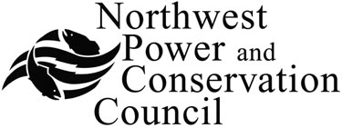 | Melinda S. Eden  Vice-Chair  Oregon
Jim Kempton  Idaho  Frank L. Cassidy Jr.  “Larry”  Washington  Tom Karier  Washington |  | Gene Derfler  Oregon  Ed Bartlett  Montana  John Hines  Montana

October 4, 2004

To: Fish and Wildlife Committee

From: Doug Marker, Director
Fish and Wildlife Division

Subject: Issues for defining project selection procedures for FY 2006 and beyond

State and central staff have had several discussions to organize issues for discussion with the Committee and Council about initiating a new project selection process once subbasin plans are implemented. The purpose of our discussion at the October fish and wildlife committee meeting is to review an outline of issues and seek guidance from committee members. We also need to discuss important consultations with involved regional parties.

Background

The Council initiated a three-year sequential provincial review process in 2000 that solicited project proposals by province and provided three-year project funding recommendations to the Bonneville Power Administration. The initial round was completed in 2003 when the Council adopted recommendations for the Mainstem/Systemwide projects. The initiation of another round of project selection has awaited the completion of subbasin plans so that the adopted plans will be used as a basis for project selection. The implementation of the initial round of project selection recommendations was also complicated by Bonneville’s financial crisis of 2003 and changes in Bonneville’s accounting for project budgets that have extended the original recommendations until FY 2005 and 2006.

The 2000 Fish and Wildlife Program defined project solicitation, review and selection based on needs identified at the provincial and subbasin scale. Future provincial project selection processes were to be sequenced over several years to better focus on a limited number of provinces and subbasins each year and allow for a more in-depth review of proposed projects. With the first subbasin plans scheduled for adoption this coming December, the staff has discussed issues for beginning a new selection process to implement the subbasin plans.

Consultation on a new selection process

The staff has considered specific alternatives for how a new provincial review process could be organized if approved by the Council. For example, this might include specifically focusing on the habitat and production strategies in subbasin plans on a new sequence of province-by-province review; perhaps three provinces at a time. Mainstem projects and projects that are systemwide in nature or application might follow as a group.

There is extremely high interest in the region, however, to provide suggestions and comment to the Council on the design of the next project selection process. The staff does not intend to foreclose alternatives for discussion or comments on a schedule for project selection by offering this memo. In addition to staff discussions with the Council, there are a number of parties who will want to contribute to the design of the next selection process. These include:

- The ISRP has asked to offer suggestions based on their role in the last process.

- Bonneville has implementation and participation needs, including project management information that will be used in their PISCES project database and ESA implementation requirements. Bonneville is also seeking procedures for expedited review of project proposals for Biological Opinion implementation.

- NOAA and FWS seek to integrate ESA requirements and support recovery planning.

- Subbasin planning Level 2 groups may seek to adapt the subbasin planning structure to inform project selection recommendations.

- The Regional Coordinating Group can assist in reviewing subbasin plan implementation issues and providing comments to the Council.

- The roles of and support from the state, federal and tribal fish and wildlife management recommendations. Tribal staff have emphasized the importance of consulting with the tribes on the design of the project selection process.

- There may be information and process coordination opportunities with the Pacific Coastal Salmon Recovery Fund funding processes.

Convening the Regional Coordinating Group could serve to help organize comments and suggestions for several of the above purposes. The Columbia Basin Fish and Wildlife Authority has asked to work with staff on issues surrounding the use and implementation of subbasin plans in the next few weeks.

Expectations for the next process

To this point, the Council and staff’s discussions of the next project selection process have described objectives for implementing the program based on completed subbasin plans. The staff discussed the importance of the Council’s stating overall objectives for the next project selection process, particularly for the use of subbasin plans. For example, the Council could state the objective of emphasizing funding of habitat and production strategies of subbasin plans balanced among resident fish, wildlife and anadromous fish measured by the biological objectives of the 2000 Program. The objectives should speak to the continued funding of currently productive past investments as demonstrated by the subbasin plans. The incorporation of relevant Biological Opinion requirements is another objective. In consultation with other parties, will need to resolve objectives for the next process. The staff has identified several significant issues:

Timeline for initial implementation of new projects: With subbasin plans nearing adoption and previous provincial review recommendations expiring, should we be trying to begin implementation in FY 2006? Reasons for doing so include demonstrating the value of subbasin plans as soon as possible and resuming a review of ongoing projects to confirm their priority in the subbasin plans. At the same time, FY 2006 is the closing year of the current funding agreement and we don’t yet know how much funding can be reallocated to new work in 2006 or that will be available in 2007 and beyond. Options for freeing up funds for new work include evaluating costs committed and obligated by BPA, with all other funding utilized to implement subbasin plans; subjecting all new and ongoing work to review and prioritization under a new solicitation process; or funding new work only as new funds become available.

Another issue the staff has discussed is whether or not there should be a process to confirm goals and objectives at the provincial scale before prioritizing among subbasin plans. There has been comment from some parties in the region that assembling subbasin plan goals and objectives at the province scale is needed to compare priorities between subbasins and to measure biological performance at province levels as was envisioned by the 2000 program.

Allocating implementation emphasis: The Program continues to call for allocating funding on a 70-15-15 percentage for anadromous projects, resident fish and wildlife, respectively, until amended. The Council has also sought to integrate specific ESA obligations of the hydrosystem into its selection process and the remanded Biological Opinion call for specific offsite mitigation projects, particularly in the Columbia Cascade province and the estuary. The currently funded projects fund the operation and maintenance of a considerable amount of projects invested in over the last 20 years.

The overall allocation for new habitat and production strategies in the subbasin plans will depend on the funding requirements for ongoing O&M as well as systemwide monitoring, research, coordination and mainstem requirements. The Council and the region should discuss where to emphasize effort program-wide with subbasin plans adopted. Geographic allocation is a considerably more difficult issue and requires more regional discussion.

Other allocation alternatives include specific strategic allocations (such as the water brokerage program); allocating by subbasin, as was done to develop subbasin plan planning budgets; to allocate by province for habitat and production work; or to maintain the status quo, with existing budgets allocated amongst provinces

In its recent report on implementation of the Council’s provincial review recommendations the Columbia Basin Fish and Wildlife Authority calculated the allocation of funding from 2001-2003:
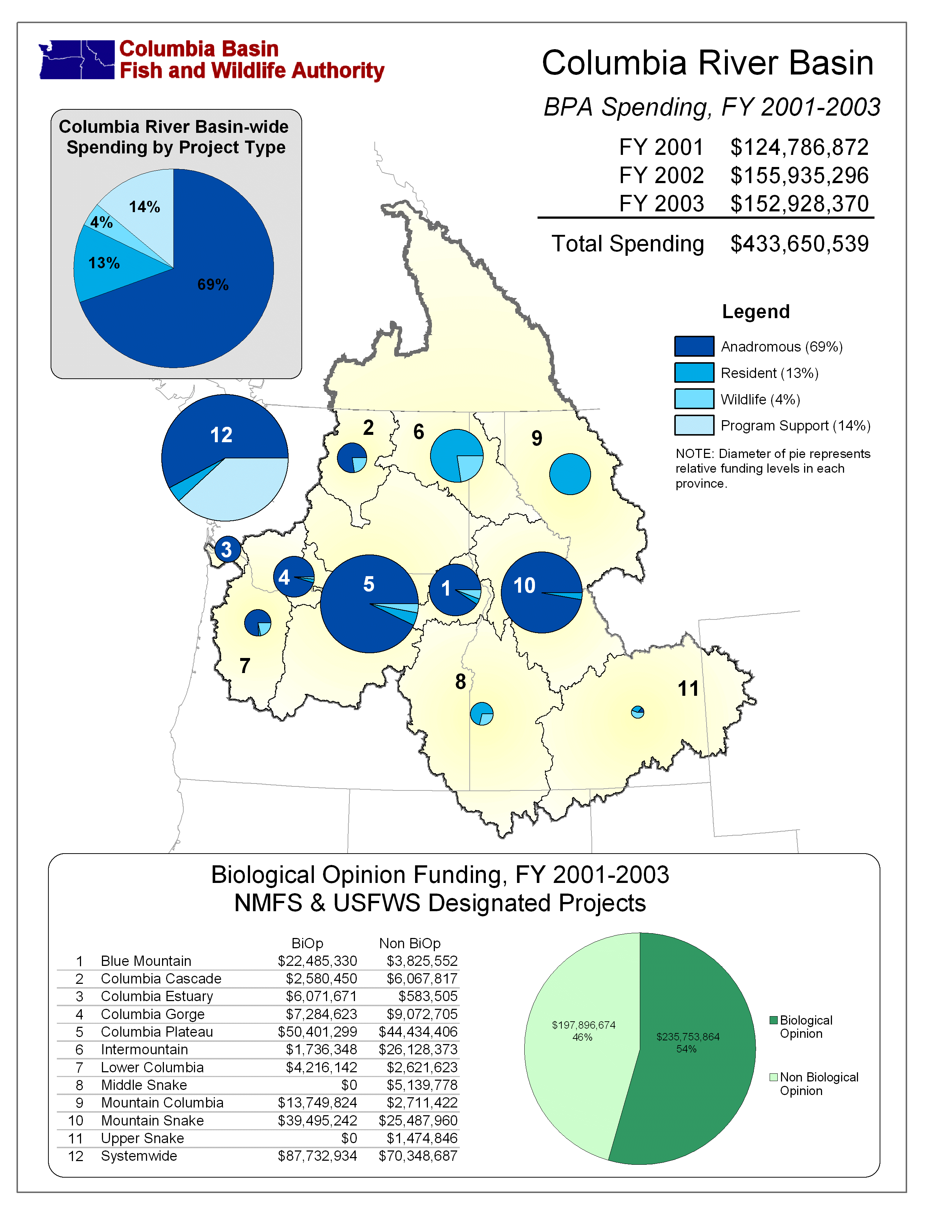

Process involvement: The Program and subsequent Council discussion (such as the issue paper circulated by the Council in 2002) contemplate expanded involvement of local governments, landowners, and other stakeholders with the fish and wildlife managers in informing the Council of funding priorities within subbasins. The structure of organization for subbasin planning varied around the region but could continue to be an organizing structure for subbasin habitat and production recommendations.

Some aspects of the currently funded program may be better reviewed at a regional scale. The mainstem/systemwide review was the final review of the first project selection process and prioritized funding for system monitoring, research, mainstem survival and coordination and information support. As the Council and the region look to integrate monitoring projects regionally, more of the specific monitoring elements of projects might be evaluated in a regional process.

Continued use of province-by-province review: The first round of provincial reviews was generally successful at providing a larger landscape of review for project proposals. Subbasin plans will provide clearer priorities for implementation strategies within subbasins but not, at least at present, for comparing priorities between subbasins. However, the province organization was generally efficient, in the staff’s opinion, and a one-time all basin review would be difficult to organize for review. The staff generally supports continuing a three-year budget timeframe as the product of provincial review recommendations. The budget uncertainties that affected the first round of provincial review recommendations are likely to be addressed by a new long-term funding agreement with Bonneville. Also, there may be some categories of projects that may be suitable for longer budget recommendations (such as operations and maintenance of previous investments) or shorter recommendations (such as research).

Alternatives to a province-by-province review include some different sequence of individual subbasins (such as the order of adoption) or function-by-function project review (habitat projects, production projects, then research, for example).

Review of ongoing and new projects: We have considered whether there would be immediate benefit in initiating review of ongoing projects based on subbasin plans before soliciting proposals for new work with available funds. There might be several ways to establish a preliminary review of ongoing projects prior to new project solicitations.

Challenges for the next process:

The staff recognizes that there are ongoing needs that make it difficult to begin swiftly a new “start from scratch” project selection process guided by subbasin plans. Some of these needs should be addressed in the next year or so but our discussion has focused on whether any are reasons to delay the initiation of a new funding process. These include, in no particular order of emphasis:

- The need to complete definition and design of an integrated regional monitoring program (currently being assisted by the Pacific Northwest Aquatic Monitoring Partnership (PNAMP) but requiring continued regional management and policy involvement).

- The next steps of the Artificial Production Review and Evaluation (APRE) anticipate review and prioritization of hatchery modifications and upgrades and improved linkages with subbasin plan goals and objectives. As the staff is outlining in continuing discussions with the Council and the region, these discussions are likely at the province and basin scale.

- Uncertain future funding commitment and requirements from Bonneville (being developed through ongoing future funding agreement discussions for the rate period that begins in Fiscal Year 2007).

- Lack of provincial scale goals and objectives (envisioned by the 2000 Program as a basis for comparing strategic priorities between subbasins).

- ESA requirements (the draft revised 2000 Biological Opinion is receiving public comment and proposes offsite mitigation requirements for the federal hydro system and also targets for survival improvements for listed stocks).

- Opportunities to coordinate with other funding sources (such as PCSRF and other federally appropriated programs) and their funding processes.

Logistical considerations:

The project selection process itself requires preparation and scheduling involving Bonneville, the ISRP, Council staff, regional parties and others. A few of these are:

  - Solicitation form confirmed by BPA, Council and ISRP - consult CBFWA
  - Meeting and travel support (CBFWA supported this last time)
  - ISRP scheduling and capacity - lead time and review schedules
  - Proposal development, solicitation and processing support (BPA and CBFWA staff last time)
  - Ongoing project information (past annual reports, performance reports, etc.)
  - The Council project selection decision-making including consideration of ISRP reports and public comments.

Conclusion

The above set of issues and considerations are not meant to be exhaustive but to be a framework for discussion and resolution. The October Committee meeting can help the staff by giving general responses and, very importantly, other ideas to consider. We do need to expand this discussion to the other entities involved and then confirm a way to proceed for FY 2006 and beyond with the Committee and the Council.

APPENDIX

Summary of 2000 Program province-based project review process (pp. 46-47):

1. Province meetings to explain and organize review process; lead groups selected to review adopted subbasin plans for fish and wildlife project needs

- Fish and wildlife needs (from plans) made widely available and Bonneville solicits project proposals

- Sponsors of ongoing projects submit project renewal proposals that include plans for the next three years. Ongoing projects submit all relevant planning, research and background documents.

- Sponsors of new projects submit proposals. All projects “must be tied to the approved subbasin plan”.

- Reimbursable programs that are within that province provide similar information

- Bonneville reviews proposed projects and budgets for regulatory needs and other implementation purposes; appropriateness of proposed budgets and performance issues of ongoing projects.

- ISRP reviews proposals in context of subbasin plans and the Fish and Wildlife Program.

- ISRP conducts province/site visits

- ISRP produces draft report on proposals for comment and revisions by sponsors

- Project sponsors respond to ISRP draft report

- ISRP issues final report to Council

- Council considers ISRP report, “other statutory and programmatic considerations” and makes final funding recommendations to Bonneville. The Council also makes recommendations on funding of reimbursable projects to Congress and the relevant federal agencies.

- Systemwide projects reviewed as a separate unit within the review schedule
_______________________________________

w:\drm\next project selection 10-04packetdm.doc H:\worksubbasinplanning\Frameworkworkgoup\NPCCIssuesforClarifying selections.doc

