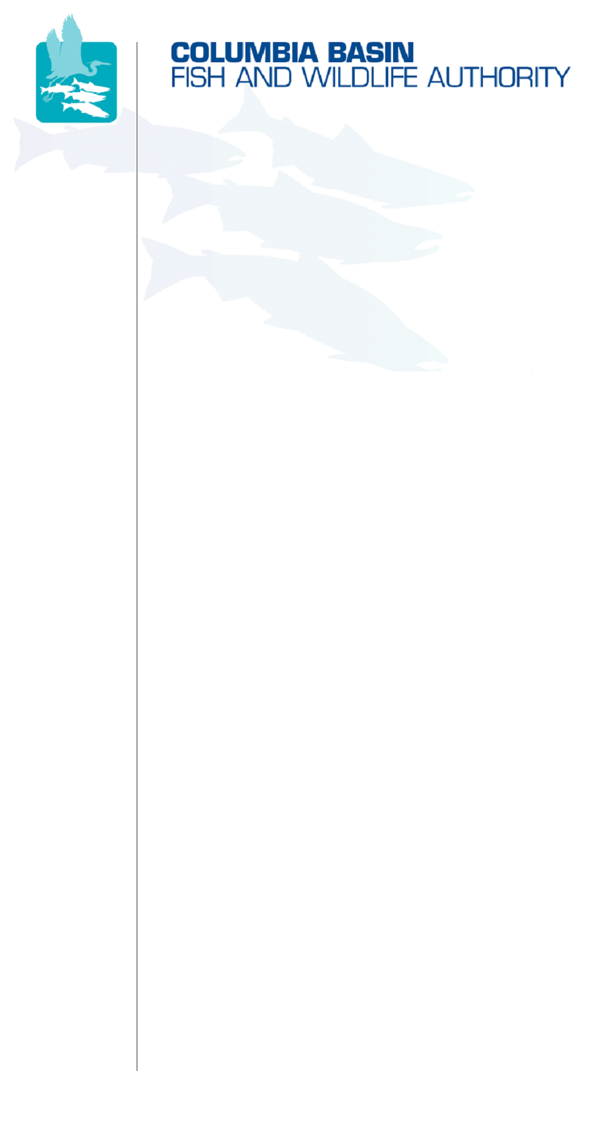
851 SW Sixth Avenue, Suite 260 | Pacific First Building | Portland, OR 97204-1339 | Phone: 503-229-0191 | Fax: 503-229-0443

March 12, 2007
TO:  Coordinating and promoting effective protection and  restoration of fish, wildlife, and their  habitat in the  Columbia River Basin.  The Authority is comprised of the following tribes  and government agencies:  Burns Paiute Tribe  Coeur d’Alene Tribe  Confederated Salish and Kootenai Tribes  of the Flathead Reservation  Confederated Tribes  of the Colville Reservation  Confederated Tribes  of the Umatilla Indian Reservation  Confederated Tribes  of the Warm Springs Reservation  Confederated Tribes and Bands of the Yakama Nation  Idaho Department  of Fish and Game  Kootenai Tribe  of Idaho  Montana Department  of Fish, Wildlife and Parks  National Marine Fisheries Service  Nez Perce Tribe  Oregon Department  of Fish and Wildlife  Shoshone-Bannock Tribes of Fort Hall  Shoshone-Paiute Tribes of Duck Valley  U.S. Fish & Wildlife Service  Washington Department of Fish  and Wildlife  Coordinating Agencies  Columbia River  Inter-Tribal Fish Commission  Upper Columbia  United Tribes | Members Advisory Group (MAG)
FROM: | Nate Pamplin (WDFW and Ken MacDonald (CBFWA)
SUBJECT: | Analysis of 07 BPA Wildlife Funding Decisions

The Wildlife Advisory Committee was asked by the MAG to review the final BPA funding decisions for the 2007-2009 periods and compare those decisions to:

- the manager's recommendations,
- the Council recommendations and,
- BPA's decisions.

The WAC representatives were asked to provide Nate Pamplin and Ken MacDonald any comments they may have regarding funding decisions for specific projects. Few additional comments were received therefore we summarized the projects by province. The attached spreadsheet, sorted by province, includes the project request, Council recommendation and the BPA decision. We had some difficulty assessing the information because some Capital projects appear to have been included in the Expense budget. Chart 2 displays the Council recommendations and BPA’s decisions by province.

In summary, 12 projects were funded at 100% of the Council's recommendation; 5 projects were fully funded per Council recommendations in 07 but below the recommended level on 08-09; 5 projects were funded below the Council recommendation; 2 projects were funded by BPA but not recommended by the Council and; 6 projects were funded above the recommended level.

Potential issues:
- Almost all projects included comment R18; budgets for FY 07, 08, 09 are draft pending the outcome of ongoing regional O&M discussions.
- Several projects included comment R8 regarding resolution of in lieu issues.
- One project sponsored by the Shoshone Pauite was not funded due to questions regarding BPA responsibility to mitigate above Hells Canyon unless there are affects attributed to Black Canyon, Anderson Ranch, Boise Diversion, Minidoka, or Palisades Reservoirs.

/tmp/in/input.doc

