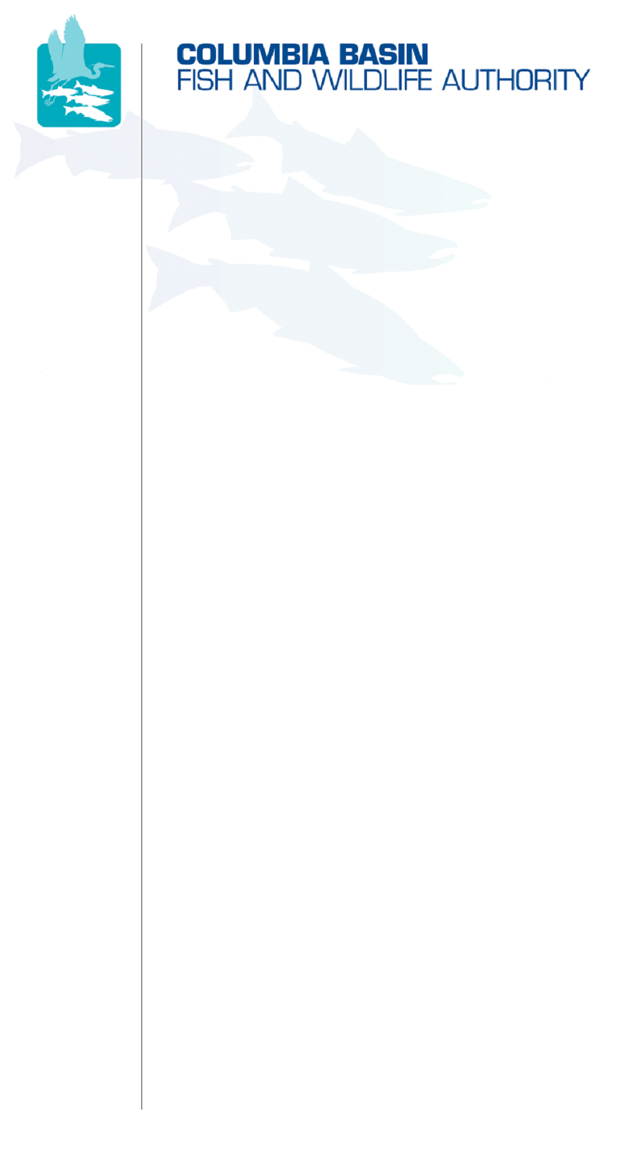
851 SW Sixth Avenue, Suite 260 | Pacific First Building | Portland, OR 97204-1339 | Phone: 503-229-0191 | Fax: 503-229-0443

DATE: | April 23, 2007
TO:  Coordinating and promoting effective protection and  restoration of fish, wildlife, and their  habitat in the  Columbia River Basin.  The Authority is comprised of the following tribes and fish and wildlfie agencies:  Burns Paiute Tribe  Coeur d’Alene Tribe  Confederated Salish and Kootenai Tribes  of the Flathead Reservation  Confederated Tribes  of the Colville Reservation  Confederated Tribes  of the Umatilla Indian Reservation  Confederated Tribes  of the Warm Springs Reservation  Confederated Tribes and Bands of the Yakama Nation  Idaho Department  of Fish and Game  Kootenai Tribe  of Idaho  Montana Department  of Fish, Wildlife and Parks  National Marine Fisheries Service  Nez Perce Tribe  Oregon Department  of Fish and Wildlife  Shoshone-Bannock Tribes of Fort Hall  Shoshone-Paiute Tribes of Duck Valley  U.S. Fish & Wildlife Service  Washington Department of Fish  and Wildlife  Coordinating Agencies  Columbia River  Inter-Tribal Fish Commission  Upper Columbia  United Tribes | Data Management Framework Subcommittee
FROM: | Tom Iverson, CBFWA staff
SUBJECT: | Draft Bullets for April 24, 2007 MAG Update

- The Data Management Framework Subcommittee (DMFS) was established by the Members Advisory Group (MAG) to provide short-term FY07 guidance to the StreamNet Steering Committee on data priorities for their FY07 statement of work. The committee determined that FY07 should be considered a transition year for StreamNet, with no major modifications in its work plan, and that the committee should continue to meet to define a data management framework for the upcoming program amendment process (which should guide longer term priorities for StreamNet).
- The DMFS agreed that the committee should focus on two aspects of data management: 1) the discrete data needs at the regional scale (for the Fish and Wildlife Program), and 2) what projects are necessary to support regional (Program) reporting of the data.
- Under category 1, the committee agreed that they should proceed with two basic steps: 1) validate that the fish and wildlife data called for in the SOTR (population ID and abundance indicators) and recovery plans (VSP parameters) are the base fish data, and 2) work towards identifying a few high level indicators from the PNAMP white paper for identifying the base habitat data necessary for regional reporting.
- For category 2, the DMFS is discussing a draft conceptual diagram (attached) showing the separation of the data management and monitoring frameworks. Although these two frameworks are intricately related, they are applied differently when identifying project tasks and activities.
- A third question the DMFS is pondering is whether or not to provide project funding recommendations for data management project for FY08-09. The Council’s FY07-09 recommendations only provided interim funding recommendations for the data management projects, with the expectation that longer term data management needs would be discussed and determined during FY07. The DMFS should consider developing FY08-09 data management project funding recommendations but would need MAG approval.

/tmp/in/input.doc

