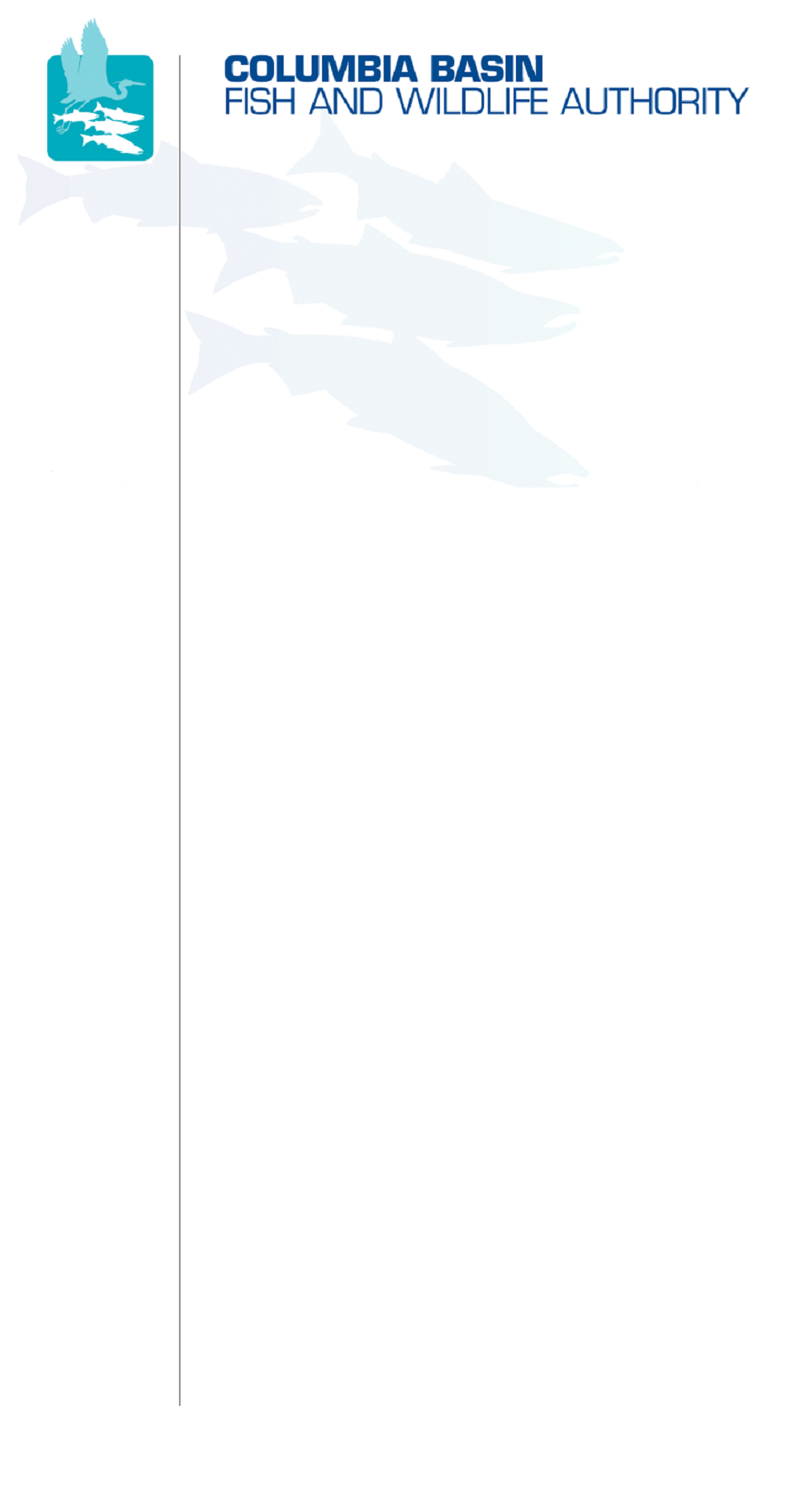
851 SW Sixth Avenue, Suite 260 | Pacific First Building | Portland, OR 97204-1339 | Phone: 503-229-0191 | Fax: 503-229-0443

DATE: | September 13, 2007
TO:  Coordinating and promoting effective protection and  restoration of fish, wildlife, and their  habitat in the  Columbia River Basin.  The Authority is comprised of the following tribes  and fish and wildlife agencies:  Burns Paiute Tribe  Coeur d’Alene Tribe  Confederated Salish and Kootenai Tribes  of the Flathead Reservation  Confederated Tribes  of the Colville Reservation  Confederated Tribes  of the Umatilla Indian Reservation  Confederated Tribes  of the Warm Springs Reservation  Confederated Tribes and Bands of the Yakama Nation  Idaho Department  of Fish and Game  Kootenai Tribe  of Idaho  Montana Department  of Fish, Wildlife and Parks  National Marine Fisheries Service  Nez Perce Tribe  Oregon Department  of Fish and Wildlife  Shoshone-Bannock Tribes of Fort Hall  Shoshone-Paiute Tribes of Duck Valley  U.S. Fish & Wildlife Service  Washington Department of Fish  and Wildlife  Coordinating Agencies  Columbia River  Inter-Tribal Fish Commission  Upper Columbia  United Tribes | CBFWA Members and MAG
FROM: | CBFWA staff
SUBJECT: | Data management project funding recommendations and proposed actions for September 18-19, 2007 Members Meeting in Polson, Montana

At the Polson meeting, the Members of the Columbia Basin Fish and Wildlife Authority (CBFWA) will be asked to provide funding recommendations for data management projects in the Fish and Wildlife Program (Program) for FY08-09. The last review of these projects occurred during the Mainstem and Systemwide Review Team analysis during the Fiscal Year (FY) 2007-09 project selection process. Since that review, CBFWA members and staff have been engaged in an ongoing discussion regarding these projects.

In September 2006, CBFWA sponsored a facilitated Data Management Workshop to help determine data needs and priorities within the Program. The results of that workshop indicated that projects such as StreamNet should 1) improve data timeliness; 2) improve coordination of data with tribes; 3) assess how data services support subbasin planning, high level indicators, the Status of the Resource Report and other regional monitoring and evaluation programs; and 4) focus on obtaining population-scale fish abundance indicators.

In December 2007, the StreamNet project requested assistance from CBFWA in setting their 2007-09 data priorities. The Members Advisory Group (MAG) created a subcommittee to review the short-term priorities for StreamNet (FY2007) and asked the Anadromous Fish Advisory Committee and the Resident Fish Advisory Committee to review the long-term data management needs. A larger data management structure was needed to set the long-term priorities for StreamNet and other data management projects. In January the MAG created the Data Management Framework Subcommittee (DMFS) to develop a work plan for creating a data management framework to be considered in the upcoming Program amendment process. At the April MAG meeting, the DMFS was assigned to develop data management project funding recommendations for FY07-09. In May, the DMFS teamed with a NED subcommittee to draft a Strategy for Managing Fish, Wildlife, and Habitat Data for the Program. This document was created, partially, to provide the context and justification for data management project funding within the Program and to show the connection to larger data management efforts within the Pacific Northwest region.

Proposed Action: The CBFWA members will be asked to support the continued development of the data management strategy document.

Data Priorities:

The DMFS provided input to StreamNet on priority types of data from the CBFWA perspective, with primary emphasis on the data needed for the Status of the Resources (SOTR) report. The DMFS focus is to provide data valuable to recovery planning at a population scale, with initial priority on listed fish species and then on the focal species designated through the subbasin plans. Long-term priorities relate to the VSP parameters by population for salmon, but only the abundance parameters are measured directly, so those were deemed to be the immediate priorities (see StreamNet SOW).

The Wildlife Advisory Committee provided input to the Northwest Habitat Institute’s statement of work and prioritized their list of objectives to support IBIS, ongoing support for establishing protocols for wildlife operational loss assessments, habitat data and mapping for subbasin planning and the SOTR, and improved crediting methodologies.

The data management funding decisions are closely linked to the CSMEP project. BPA has funded CSMEP at approximately one-half of the Council’s recommended FY08 budget. CSMEP combined with data management strategy are key components to facilitate the development and implementation of a comprehensive monitoring and evaluation plan to be defined during the Program amendment process.

It is anticipated that these recommendation will provide the necessary support to maintain the data provided in the SOTR as well as other high priority data requirements within the Program.

Proposed Action: The CBFWA Members will be asked to support the following funding recommendations:

- StreamNet funding for $2,55,708 (see attached SOW)
- Northwest Habitat Institute funding for $552,181 (see attached SOW and Appendix F in the Data Management Strategy document)
- Identify a strategy to pursue the recommended FY08 CSMEP funding level

Data Gaps-

The SOTR was the most recent attempt within the Program to comprehensively gather abundance data for focal fish populations in the Columbia River Basin. The primary source of data was through internet access to the StreamNet project. For this data, CBFWA staff was able to provide an internet link to the data; however, about half of the data presented in the SOTR report was acquired as a result of CBFWA staff contacting individuals within fish and wildlife management entities. This data was acquired and maintained at CBFWA during the production of the SOTR report. This is not the desired strategy for supporting the SOTR in the future. It is important that a data management structure be developed that provides a list of the priority data needs for the region and helps support individual agencies and tribes making their data available via the internet. The intent of the CBFWA is not for the SOTR website to become an additional data warehouse in the Columbia River Basin but rather a web service application or portal that provides immediate access to data via links within the SOTR web pages.

It is important that a comprehensive data management framework be developed for the region to provide an opportunity for entities that are not affiliated with the Program to participate in providing data that can feed into the SOTR.

Proposed Action: The CBFWA Members will be asked to support the following pilot study or project enhancements to support data management for the Program.

- A Fish and Wildlife Program channel steward position added to CBFWA (data coordinator) for $175,000 (see Appendix G in the Data Management Strategy document)
- Two tribal data management FTEs added to the StreamNet work plan for $230,000 (two years, see Appendix E in the Data Management Strategy document)
- Executive data summit for $6,000 (one time, see Appendix C in the Data Management Strategy document)
- Capture and integrate hatchery reform data for $70,413 (one time, see Appendix D in the Data Management Strategy document)

It is anticipated that these recommendations will be provided to the Northwest Power and Conservation Council at their October meeting in Missoula, Montana.

Detailed information is provided in the attachments referenced here and available on the CBFWA website and within the meeting packets for the September Members meeting. If you have additional questions regarding these recommendations, please contact Tom Iverson at (503) 229-0191.

/tmp/in/input.doc

