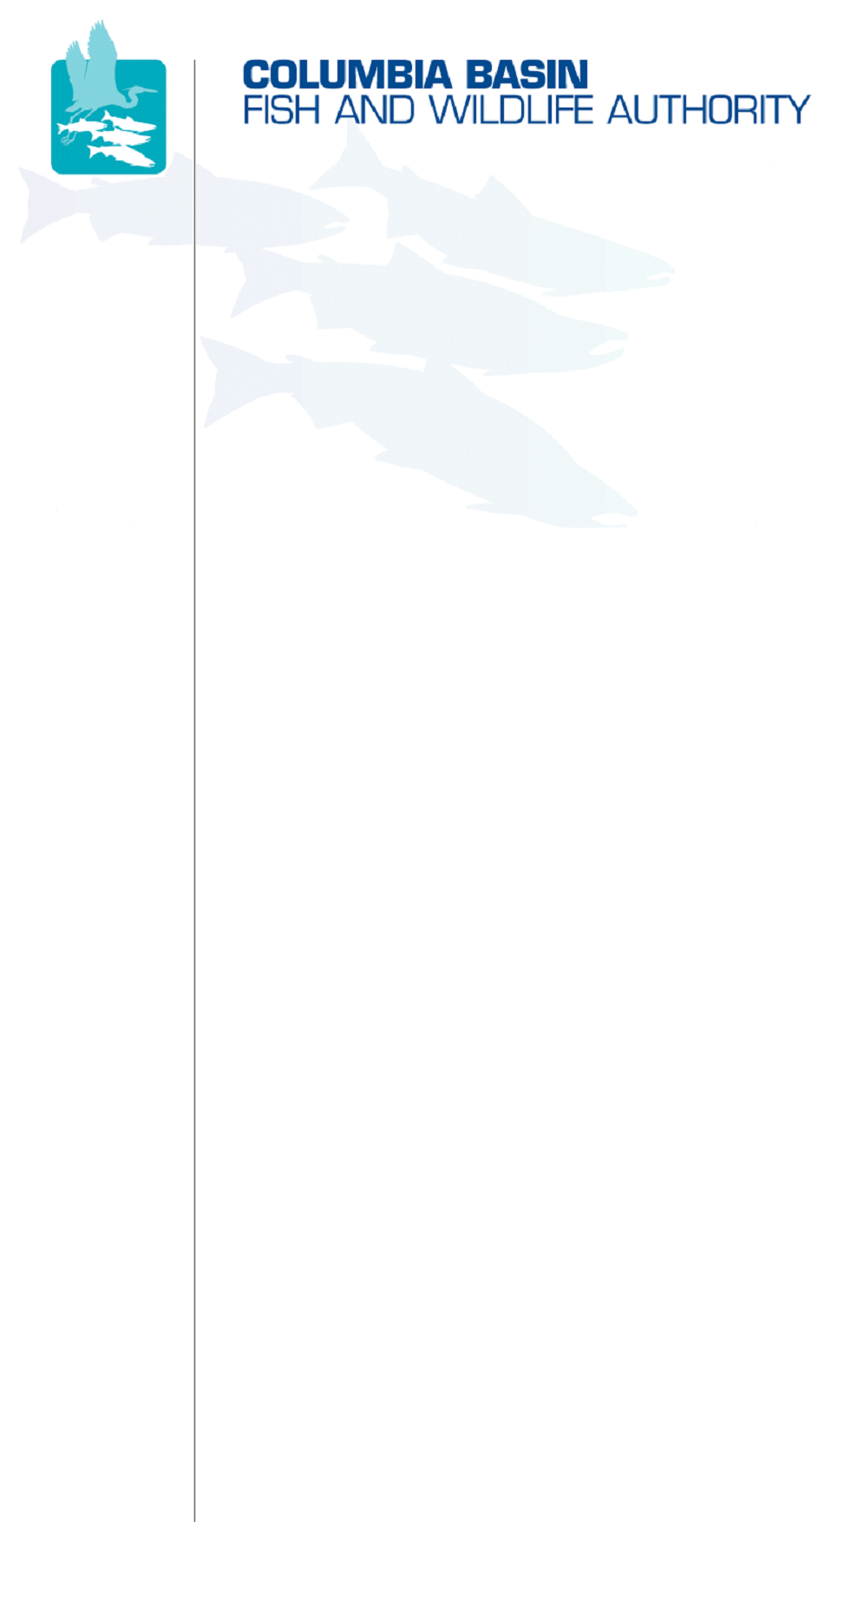
851 SW Sixth Avenue, Suite 260 | Pacific First Building | Portland, OR 97204-1339 | Phone: 503-229-0191 | Fax: 503-229-0443

DATE: | October 19, 2007
TO:  Coordinating and promoting effective protection and  restoration of fish, wildlife, and their  habitat in the  Columbia River Basin.  The Authority is comprised of the following tribes  and fish and wildlife agencies:  Burns Paiute Tribe  Coeur d’Alene Tribe  Confederated Salish and Kootenai Tribes  of the Flathead Reservation  Confederated Tribes  of the Colville Reservation  Confederated Tribes  of the Umatilla Indian Reservation  Confederated Tribes  of the Warm Springs Reservation  Confederated Tribes and Bands of the Yakama Nation  Idaho Department  of Fish and Game  Kootenai Tribe  of Idaho  Montana Department  of Fish, Wildlife and Parks  National Marine Fisheries Service  Nez Perce Tribe  Oregon Department  of Fish and Wildlife  Shoshone-Bannock Tribes of Fort Hall  Shoshone-Paiute Tribes of Duck Valley  U.S. Fish & Wildlife Service  Washington Department of Fish  and Wildlife  Coordinating Agencies  Columbia River  Inter-Tribal Fish Commission  Upper Columbia  United Tribes | Members Advisory Group (MAG)
FROM: | CBFWA staff
SUBJECT: | Program Amendment Outline and Potential Recommendations

CBFWA staff has reviewed the current 2000 Fish and Wildlife Program, 2003 Mainstem Amendment, and the 2004-2005 Subbasin Plans in the context of how significant the potential CBFWA amendment recommendations may be. The current Program can be characterized as having a significant amount of background and context information that will need to be rewritten and edited to reflect current conditions, with very little in the way of specific measures and actions. The CBFWA submittal is envisioned to have three volumes: I) Programmatic framework description and measures, II) Mainstem operations and measures, and III) Subbasin linkage and measures. CBFWA staff has provided below a very general list of example ideas that CBFWA members may consider in developing their joint recommendations.

A significant rewrite of the background and context sections may be required to update the Program to current conditions; much of the text is dated and no longer relevant. A reference to the adaptive management framework should be included. This effort should probably be done in collaboration with Northwest Power and Conservation Council staff to ensure consistency with their expectations and acceptance as the framework for measure submissions. Assistance from CBFWA Members will be necessary to complete the large amount of writing and editing.

Anticipated measures can be characterized in two ways: 1) general measures to implement strategies (i.e., use artificial production to supplement impaired fish runs) and 2) specific measures tied to subbasins (i.e., supplement 500,000 spring Chinook in the Muddy Subbasin). There are several measures that will be programmatic in nature such as the Mainstem and Systemwide actions that will require regional work groups to develop (e.g., Coordination, M&E, data management, etc.). It is anticipated that the checklist at the end of this memo will be completed for each measure recommended by CBFWA.

If you have additional questions, please contact Brian Lipscomb or Tom Iverson at (503) 229-0191.

/tmp/in/input.doc

NORTHWEST POWER PLANNING COUNCIL
2000 COLUMBIA BASIN FISH AND WILDLIFE PROGRAM
OUTLINE

Executive Summary

Should we edit and add language describing the adaptive management process envisioned with our amendment recommendations?

Introduction

A. The Northwest Power Planning Council

B. A New Program Structure

C. The Framework Concept

D. Implementation During a Period of Transition

Update this section to describe current vision for implementation decision making?

Basinwide Provisions

A. Vision for the Columbia River Basin

1. The Overall Vision for the Fish and Wildlife Program

2. Specific Planning Assumptions

Specific reference to adequate funding for M&E should be listed as a planning assumption?

B. Scientific Foundation and Principles

1. Purpose of the Scientific Foundation

2. Scientific Principles

C. Biological Objectives

1. Overarching Objectives

2. Basin Level Biological Objectives

Should we express a desire to maintain the basin level objectives as an expression of the magnitude of impact caused by the construction and operation of the FCRPS? We could be explicit about how we would report against these objectives.

3. Further Development of Biological Objectives at the Basin Level

4. Significance of Objectives and Strategies

Description of the M&E framework we envision for the program?

D. Strategies

1. Introduction

2. Linkage of General Biological Objectives w/ Strategies

Link biological objectives to hydrosystem responsibilities and offsite mitigation actions. Linkages for specific populations will occur at the subbasin scale in Volume III of the CBFWA recommendations.

3. Habitat Strategies

Identify how habitat strategies will be prioritized? Resident Fish Substitution should be its own strategy equal to habitat, AP, harvest and others?
GENERAL MEASURE – Implement SBPs to accomplish habitat strategy.
Specific habitat measures in subbasin templates?

4. Artificial Production Strategies

Identify assumptions used for AHA analysis for anadromous populations? Identify AP as a strategy for resident fish substitution and mitigation.
GENERAL MEASURE – Implement hatcheries consistent with SBPs, US v OR, BiOp Remand, and other existing management plans.
Specific AP Measures – list specific hatchery programs with reference to SBPs and other management plans for support.

5. Harvest

Identify US v OR harvest assumptions for the next 10-15 years? Baseline for AHA analysis.

6. Hydrosystem Passage and Operations

This section will be moved to Volume II of the CBFWA recommendations? There are several areas for improvement in language and descriptions in this section including a description of the BiOp operations assumptions?

7. Wildlife

Add wildlife committee input on better oversight of this strategy implementation? Introduce “paradigm” shift towards a more ecological approach to the Wildlife program, provide guidance for developing next phase of wildlife mitigation – operational losses.
GENERAL MEASURE – implement land acquisition strategy to accomplish HU ledger ASAP.
GENERAL MEASURE – develop operation loss assessments to quantify BPA obligation.
Specific Wildlife Measures – crediting, RM&E, O&M implement ongoing wildlife land management plans, etc.

8. Ocean Conditions

Update descriptive language? ID Measures?

9. Research, Monitoring, and Evaluation

This section needs cleaning up. Describe function of objectives and how we will monitor and report against them? Describe purpose of SOTR, vision for data management, other reporting products. Provide project level guidance for insuring monitoring is consistent with Programmatic requirements. Synthesize Research Plan and incorporate priorities? Add F&W Manager Coordination as a strategy in this section?
General and Specific Measures based on Regional, Province, and Subbasin objectives.

Ecological Provinces

A. Geographical Structure

B. Province Visions, Objectives, and Strategies

Provide objectives that link to subbasins and regional goals?

C. Ocean

Subbasins

A. Subbasin Plans

Update this section now that we have a full suite of SBPs?

1. Required Elements of Subbasin Plans

Identify basic elements consistent with biological objectives, limiting factors, threats, strategies and measures?

2. General Principles for Subbasin Plans

Consistency with Recovery Plans? Local stakeholder involvement?

3. Subbasin Assessment

Future assessments should be consistent with CBFWA amendment strategy to build and learn for future iterations of SBPs?

4. Inventory of Existing Activities

Clarify purpose of this section under current assumptions?

5. Management Plan

This is currently consistent with the CBFWA templates? May need tweaking.

6. Developing Plans at the Subbasin Level

Discuss how SBPs will be updated in the future?

7. Scientific Review of Subbasin Plans

Describe scientific review of work plans rather than of individual projects?

Implementation Provisions

A. Project Implementation, Project Selection, and Management

Reconstruct this section based on meetings and interactions with BPA and Council staff and outcomes from BiOp remand negotiations?

1. Deadlines for Reports

2. Project Selection — Basic Requirements and Roles

3. Project Selection — Province-based Project Review Process

4. Project Funding Priorities

5. Coordination with Other Regional Programs

6. Project Management

7. Annual Report to Governors and the Region

8. Funding Agreement for Land and Water Acquisitions

B. Independent Scientific Review

1. The Independent Scientific Review Panel

2. The Independent Scientific Advisory Board

3. Administration of the Independent Scientific Review Panel, the Scientific Peer Review Groups, and the Independent Scientific Advisory Board

Preservation of Trust and Treaty Rights and Water Rights

A. Recognition of Tribal Role

B. Water Rights

C. Role of Fish and Wildlife Agencies

Schedule for Further Rulemakings

Delete this section? Describe future amendments, when expected, how evaluated, etc.?

A. Mainstem Coordination Plan

B. Objectives for Basin Level Environmental Characteristics

C. Province Level Goals, Objectives, and Strategies

D. Subbasin Plans

Transition Provisions

May change this section name to describe implementation of 10-year agreements?

Appendix

These all need review?

A. Glossary

B. Hydroelectric Development Conditions

C. Wildlife Provisions

D. Provisional Statement of Biological Objectives for Environmental Characteristics at the Basin Level

E. Findings on the Recommendations Submitted to the Council in 2000 for Amendments to the Fish and Wildlife Program

Technical Appendix

Fish and Wildlife Program Amendments Checklist
Draft – September 15, 2007

I. General Information

Description of the Program Measure recommendation:

Applicable basin and province level objectives for the measure:

Time Requirements to Implement:

Expected capital cost:

Expected annual cost:

Availability of supporting data for the measure:

II. Checklist Questions

1) How does this measure, at the programmatic level, relate to the adequacy, efficiency, economics and reliability of the region’s power supply? (Sec. 4(h)(5))
2) How does this measure complement the existing and future activities of the fish and wildlife management entities? (Sec. 4(h)(6)(A))
3) Is the measure based on -- and supported by – the best available scientific knowledge? (identify supporting documentation) (Sec. 4(h)(6)(B))
4) What are the existing (or proposed) biological objectives for this measure? (Sec. 4(h)(6)(C))
5) Are there equally effective alternative means to achieve the same biological objective and, if so, does this measure represent the alternative with the minimum economic cost? (Sec. 4(h)(6)(C))
6) Is this measure consistent with the legal rights of appropriate Indian tribes? (Sec. 4(h)(6)(D))
7) Is the measure consistent with applicable provincial visions, objectives and strategies?
8) Is the measure consistent with applicable subbasin plan strategies and priorities?
/tmp/in/input.doc

