To Do Notes:
Glossary of Terms (Life of Project, Secondary Losses, Operational Losses, HEP, HU, ….)

Wildlife

Primary strategies: The 2008 Program introduces a new paradigm emphasizing management for ecological function as supported by the subbasin plans. This Program will 1) continue to mitigate for construction and inundation losses; 2) encourage the development of long-term agreements that provide adequate funding for management and monitoring and evaluation; and 3) accelerate the quantification of and mitigation for operational and secondary losses as an integrated part of habitat protection and restoration.

I see no verbiage about the construction and inundation losses will be completed, first, then operational losses addressed.

The 2008 Program builds on the eight scientific principles identified in the 2000 Program to introduce a new paradigm that emphasizes management for ecological function supported by the subbasin plans. In general, the subbasin plans identified focal habitats which, along with federal, state, and tribal wildlife management plans, serve as the collective foundation for project sponsors to develop wildlife project management plans. These wildlife project management plans will establish specific ecological objectives for the protected focal habitats. The ecological objectives will be the basis for determining management needs, building a monitoring and evaluation framework, and determining and tracking enhancement credits.

In previous Council programs, the wildlife habitat losses associated with construction and inundation impacts have received the most attention. These impacts to wildlife were assessed using the Habitat Evaluation Procedure (HEP) to determine the habitat lost, expressed as habitat units (HUs), and published in loss assessments. The loss assessments were adopted in previous Council programs (i.e., Council’s 2000 Fish and Wildlife Program: Table 11-4) to create a ledger and serve as a starting point for wildlife mitigation measures.

The ecological impacts to wildlife populations due to the loss of fish and operational losses of the hydro system have not been assessed. The Columbia Basin has suffered the loss of marine-derived nutrients associated with the return of adult anadromous fish. The implications of this nutrient loss impact, while not yet clearly defined or quantified in terms of wildlife, must be mitigated. HEP does not adequately reflect management priorities or characterize ecological conditions. The 2008 Program supports investigation of alternative habitat assessment methodologies to HEP. These alternatives represent a paradigm shift away from HEP to ecologically based assessment methods that better represent ecological functions and conditions. The 2008 Program also increases emphasis on addressing wildlife losses resulting from operation of the hydrosystem and the need to assess and mitigate for wildlife impacts due to changes in ecological function including the loss of anadromous fish.

Will this halt our existing efforts until a new crediting methodology is adopted? Language needed to Bolster current efforts in parallel with new development of crediting methodology.

The rapid increase in human population, and associated land values in the Northwest necessitates the expeditious acquisition of habitats to minimize cost to BPA ratepayers. With further delays, implementation costs increase and the extent and quality of available habitat is diminished. Managers also need the capacity to secure mitigation properties opportunistically and timely as they are operating in a highly competitive real estate market. This capacity can be increased via settlement agreements between fish and wildlife managers and BPA.

Given the vision of this program, the strong scientific case for a more comprehensive, ecosystem-based approach, and the shift to implementation of this program through provincial and subbasin plans, the Council believes that the wildlife mitigation projects should complement fish mitigation projects to the extent practical.

The program also called upon the parties to reach agreement on how wildlife mitigation projects and fish mitigation projects should be credited toward identified losses.

Crediting

The 2000 Fish and Wildlife Program called for Bonneville and the Fish and Wildlife Managers to complete mitigation agreements that, in combination with existing projects, equaled 200 percent of the habitat units identified in the loss assessments (NWPCC 2000 Fish and Wildlife Program: Table 11-4). The doubling of the losses was done in part to address the significant annualized impacts that have accrued since construction. This decision assumed Bonneville received full credit for existing habitat values on permanently protected lands and those impacts covered under past settlement agreements (e.g. Dworshak and State of Montana, Brian?) do not need to be revisited.

Consistent with the provisions of the 2000 Program, Table 1 reflects the current status of Bonneville’s obligation for construction and inundation losses.

Bonneville, the Council, and the fish and wildlife managers shall establish a ratepayer funded forum to develop a regional protocol for establishment and maintenance of a crediting ledger documenting progress towards achieving mitigation obligations. This crediting ledger shall be formally included in the Program. The forum will track crediting of mitigation actions and will address disputes, inconsistencies, and other issues related to application of credit against wildlife losses. This forum is to be in place by no later than one year after the adoption of the 2008 program

The development of the above mentioned procedures and protocols must not be considered a prerequisite to continuing wildlife mitigation efforts. New and on-going wildlife mitigation projects will continue during the development and review of crediting protocols. The above paragraph unclear. Are “the above” procedures and protocols or just sideboards for a process to be developed? Not sure that a separate forum is warranted to address and track the crediting ledger. Why would the tribes want additional oversight and general purview over their program? The development of a Regional forum lends power away from the members into a separate body….who are the forum members? Whom do they represent? We already have cbfwa, why not utilize what already exists rather than adding layers?

Habitat enhancement credits will be provided to Bonneville when habitat management activities funded by Bonneville lead to a net increase in habitat value when compared to the baseline habitat inventory. This determination should be made through the periodic monitoring of the project site. Bonneville shall be credited for habitat enhancement efforts at a ratio of one habitat unit credited for every habitat unit gained.

Outside funding for mitigation projects may be secured to supplement the ratepayer monies provided by BPA. These funds may be used to expand the project area, enhance or restore habitat or to support operations and maintenance of the project. The extent to which these funds may result in improvements in habitat suitability relative to ratepayer funding is difficult to quantify, complicating crediting against the mitigation debt. Therefore, Bonneville, the Council, and the fish and wildlife managers shall work through the crediting forum to develop an appropriate crediting methodology to avoid in-lieu funding from non-hydro sources and to assure BPA receives mitigation credit proportional to the ratepayer contribution.

For a project to be credited against construction and inundation losses it shall meet the following criteria:

- Project areas must be permanently protected and dedicated to wildlife benefits through covenants, easements, fee title acquisitions or other appropriate agreements for the life of the hydroelectric project,
- Projects must benefit priority wildlife habitat, species, or populations as defined by federal, state, tribal wildlife management plans or subbasin plans.
- A project area management plan must be completed.
- A long-term funding agreement adequate to support implementation of the management plan has been adopted.

Off-site mitigation actions may be implemented in response to limited availability of on-site opportunities or to address recognized high priority regional wildlife needs. Where these actions move mitigation benefits from the jurisdiction of impact to another jurisdiction (e.g. between states boundaries or tribal territories), care must be given to assure affected fish and wildlife agencies and tribes are consulted. May want to include the subbasins in relation to the Hydrofacility in the loss table in order to make it clear where the credits are going.
This paragraph may not work but is a good start. When would a tribal territory apply in any instance i.e. Pend Oreille is in the Coeur d’alene aboriginal territory but the Indian claims act has that area as the Kalispel. Would that then mean the Federal recognition of that claim supersedes any aboriginal claims??

If settlement agreements (e.g. Dworshak and Montana) are reached between affected managers and Bonneville for a specific hydro project or projects, then the regional crediting protocol may not apply. Such settlement agreements are the preferred strategy to complete Bonneville’s wildlife mitigation responsibilities for the construction and inundation impacts.

Long Term Funding Agreements:

Long term funding agreements are necessary to provide the flexibility and surety required to optimize wildlife benefits and cost efficiencies. They must also be sufficient to address changing needs on the landscape and address known and unforeseen external threats (e.g. invasive species, wildfires, etc). These agreements for on-going and future projects must include provisions for adequate management funding to sustain the ecological functions and the minimum credited habitat values for the life of the project. Funding of these long-term agreements must occur prior to formally assigning mitigation credit to the ledger.

Consistent with the Council’s 2000 Fish and Wildlife Program, the project sponsor and Bonneville Power Administration shall propose for Council consideration and recommendation a long-term funding agreement(s) adequate to sustain minimum credited value and maintain ecological functions for the life of the hydroelectric project impact.

Bonneville shall enter into long-term funding agreements for existing and future mitigation projects that:
- Assure continuity of funding for the life of the hydroelectric project impact.
- Assure sufficient funding levels to implement the habitat management strategies and monitoring and evaluation needs identified in project area management plans.
- Provide flexibility to address uncertainties and unforeseen events.
- Provide adjustment for annual inflation.

Research, Monitoring and Evaluation:

The purpose of monitoring and evaluation is to affirm, adjust, and improve management actions based on scientific principals. Bonneville Power will fund research, monitoring and evaluation of wildlife mitigation projects adequately to assure tracking of crediting, to evaluate trends in ecological functions of managed ecosystems, and provide managers the ability to assess the effectiveness of their strategies by evaluating species and habitat responses.

The program has used HEP to evaluate and credit properties and easements acquired with mitigation funding. HEP is also used to evaluate and credit enhancements on these projects. The Council’s 2008 program supports the transition from HEP to a new ecologically-based paradigm where assessments of ecological functions are used to guide management decisions.

The level of RM&E shall be based on the ecological objectives described in site specific management and subbasin plans. RM&E funding must be sufficient to allow project sponsors to track trends in ecological functions, to provide data to assess the effectiveness of management actions, and to effectively implement principles of adaptive management. Fundamental to the RM&E program is the establishment and measure of reference sites to address changing conditions (unforeseen events) or longer term objectives.

Where appropriate, project level RM&E will complement and be consistent with larger scale efforts including but not limited to State Conservation Strategies through use of compatible protocols and data sharing. Data summaries from each project should link to region-wide databases. Compatible protocols (across the Basin) should be developed and used to determine baseline wildlife and habitat conditions.
Bonneville will perhaps support monitoring and evaluation, but I am not sure about the research component in the realm of a ledger based program.

Operational Losses

Hydropower operational impact assessments are needed to determine the extent and directions of ecological alteration (direct and indirect) and institute a standard, rigorous, transferable, and regionally accepted assessment methodology to describe and quantify ecological losses attributable to the FCRPS.

The NPCC F&W Program (2000) initially defined operational loss as “the direct wildlife losses caused by the day-to-day fluctuations in flows and reservoir levels resulting from the operation of the hydrosystem”. This definition does not adequately describe the full extent of the ecological impacts due to the operation of the hydroelectric system. Assessment of operational losses must incorporate concepts of river ecology accepted scientific and ecological principles, along with appropriate indices of biological or ecological integrity.
The 2008 Program will complete operational loss assessments using methods that provide a systematic approach to characterize active physical and biological processes in watersheds and describes spatial distributions, histories and linkages among important ecosystem components.

Ecosystem management should maintain or recover the biological integrity of the system.
To determine parameters needed to address ecological integrity, the NPCC, wildlife managers, and BPA will adopt a framework that can: (1) identify and isolate operational impacts from other basin changes, (2) assess operations-based influences on downstream physical processes, (3) link physical, biological, and ecological processes (4) account for natural floodplain dynamics, and (5) be used in a predictive capacity. Unclear. Define predictive capacity.

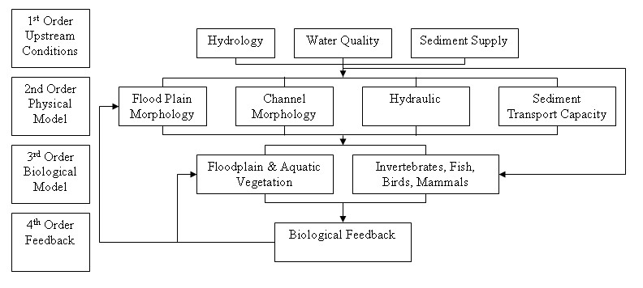
Figure 1. Order of Impacts (From Jorde et.al. 2005)

Ecosystem management should maintain or recover the biological integrity of the system. (Which system? Mainstem impacts, mitigation areas for impacts?Determining the extent to which ecological systems are experiencing anthropogenic disturbance and change in structure and function is critical for long term conservation or restoration of biotic diversity in the face of changing and compromised landscapes and land use.

Bonneville shall fund assessments of ecological impacts to wildlife from the reduction or loss of anadromous fish as part of the operational loss assessment. The assessments need to evaluate an array of core ecological parameters (e.g., biological/biotic and physical/abiotic) with the understanding that habitats, communities, and processes are ecologically linked (Figure 2). The results of these assessments shall be the basis for quantification of operational impacts and subsequent mitigation obligation. Existing and future habitat actions implemented to benefit anadromous fish may be suitable mitigation for some of these impacts. Where these impacts have already been addressed in an existing wildlife settlement agreement, the terms of that agreement will apply Unclear.

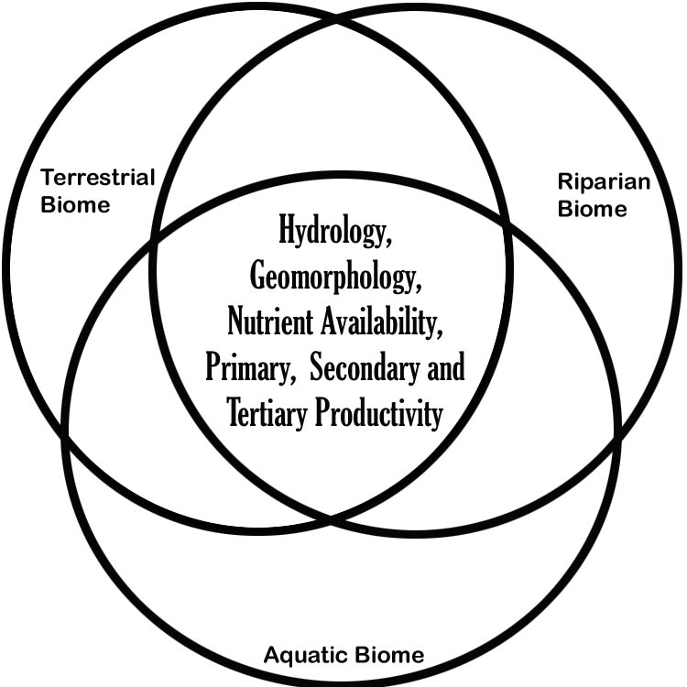

Figure 2. Integration of watershed/basin environmental parameters and ecological functions (e.g., aquatic, riparian, and terrestrial biomes) as part of an operational assessment framework.

Table XX.XX replaces Table 11-4 in the Council’s 2000 Fish and Wildlife Program and identifies Bonneville’s mitigation obligation for the losses due to hydropower construction at federal dams in the Columbia River Basin. Add subbasins that mitigate per hydrofacility

Table XX-X: Amended Losses Due to Hydropower Construction
Species by Hydropower Facility | Total Habitat Units
Albeni Falls (pend orielle, Coeur d’alene, Kootenay Spokane (hangman)  • Mallard Duck  • Canada Goose  • Redhead Duck  • Breeding Bald Eagle  • Wintering Bald Eagle  • Black-Capped Chickadee  • White-tailed Deer  • Muskrat | -11,970  -9,398  -6,758  -9,016  -8,730  -4,572  -3,360  -3,512
Lower Snake Projects  • Downy Woodpecker  • Song Sparrow  • Yellow Warbler  • California Quail  • Ring-necked Pheasant  • Canada Goose | -729.8  -575.2  -1,854  -41,016  -5,293.6  -4,079.6
Anderson Ranch  • Mallard  • Mink  • Yellow Warbler  • Black Capped Chickadee  • Ruffed Grouse  • Blue Grouse  • Mule Deer  • Peregrine Falcon  * Acres of riparian habitat lost. Does not require purchase of any lands. | -2,096  -3,464  -722  -1,780  -1,838  -3,960  -5,378  -1,222 acres*
Black Canyon  • Mallard  • Mink  • Canada Goose  • Ring-necked Pheasant  • Sharp-tailed Grouse  • Mule Deer | -540  -1,304  -428  -520  -1,064  -484
Deadwood  • Mule Deer  • Mink  • Spruce Grouse  • Yellow Warbler | -4,160  -1,974  -2,822  -618
Palisades  • Bald Eagle  • Yellow Warbler  • Black Capped Chickadee  • Elk/Mule Deer  • Waterfowl and Aquatic Furbearers  • Ruffed Grouse  • Peregrine Falcon*  * Acres of riparian habitat lost. Does not require purchase of any lands. | -11,882 Breeding  -37,130 Wintering  -1,436 scrub-shrub  -2,716 forested  -4,908  -11,406  -4,662  -3,354 acres forested wetlands  -1,664 acres scrub-shrub wetland
Willamette Basin Projects  • Black-tailed Deer  • Roosevelt Elk  • Black Bear  • Cougar  • Beaver  • River Otter  • Mink  • Red Fox  • Ruffed Grouse  • California Quail  • Ring-necked Pheasant  • Band-tailed Pigeon  • Western Gray Squirrel  • Harlequin Duck  • Wood Duck  • Spotted Owl  • Pileated Woodpecker  • American Dipper  • Yellow Warbler | -34,508  -30,590  -9,628  -7,706  -8,954  -4,816  -4,836  -5,180  -22,290  -5,972  -3,972  -6,974  -2,708  -1,102  -3,894  -11,422  -17,380  -1,908  -4,710
Grand Coulee  • Sage Grouse  • Sharp-tailed Grouse  • Ruffed Grouse  • Mourning Dove  • Mule Deer  • White-tailed Deer  • Riparian Forest  • Riparian Shrub  • Canada Goose Nest Sites | -5,492  -65,446  -33,004  -18,632  -54,266  -42,724  -3,264  -54  -148
McNary  • Mallard (nesting)  • Western Meadowlark  • Canada Goose  • Spotted Sandpiper  • Yellow Warbler  • Downy Woodpecker  • Mink  • California Quail | -13,918  -6,938  -6,968  -2,726  -658  -754  -2,500  -12,628
John Day  • Great Blue Heron  • Canada Goose  • Spotted Sandpiper  • Yellow Warbler  • Black-capped Chickadee  • Western Meadowlark  • California Quail  • Mallard  • Mink | -6,372  -16,020  -6,372  -2,170  -1,738  -10,118  -12,648  -14,798  -2,874
The Dalles  • Great Blue Heron  • Canada Goose  • Spotted Sandpiper  • Yellow Warbler  • Black-capped Chickadee  • Western Meadowlark  • Mink | -854  -878  -1,068  -340  -366  -494  -660
Bonneville  • Great Blue Heron  • Canada Goose  • Spotted Sandpiper  • Yellow Warbler  • Black-capped Chickadee  • Mink | -8,600  -4,886  -5,534  -326  -2,044  -3,244
Minidoka  • Yellow Warbler  • River Otter  • Mule Deer  • Sage Grouse | -684  -5,986  -6,826  -7,510
Chief Joseph  • Sharp-tailed Grouse  • Mule Deer  • Spotted Sandpiper  • Sage Grouse  • Mink  • Bobcat  • Lewis’ Woodpecker  • Ring-necked Pheasant  • Canada Goose  • Yellow Warbler | -4,580  -3,984  -2,510  -2,358  -1,840  -802  -572  -478  -426  -116
Note: Credits (against this losses ledger) assume BPA’s current crediting policy of full credit for existing values on properties permanently protected by Bonneville and/or as stated in project MOA’s with managers. Losses associated with Dworshak, Hungry Horse and Libby
hydro facilities are addressed through the Dworshak and Montana Settlement Agreements and are not included in this table

/tmp/in/input.doc

