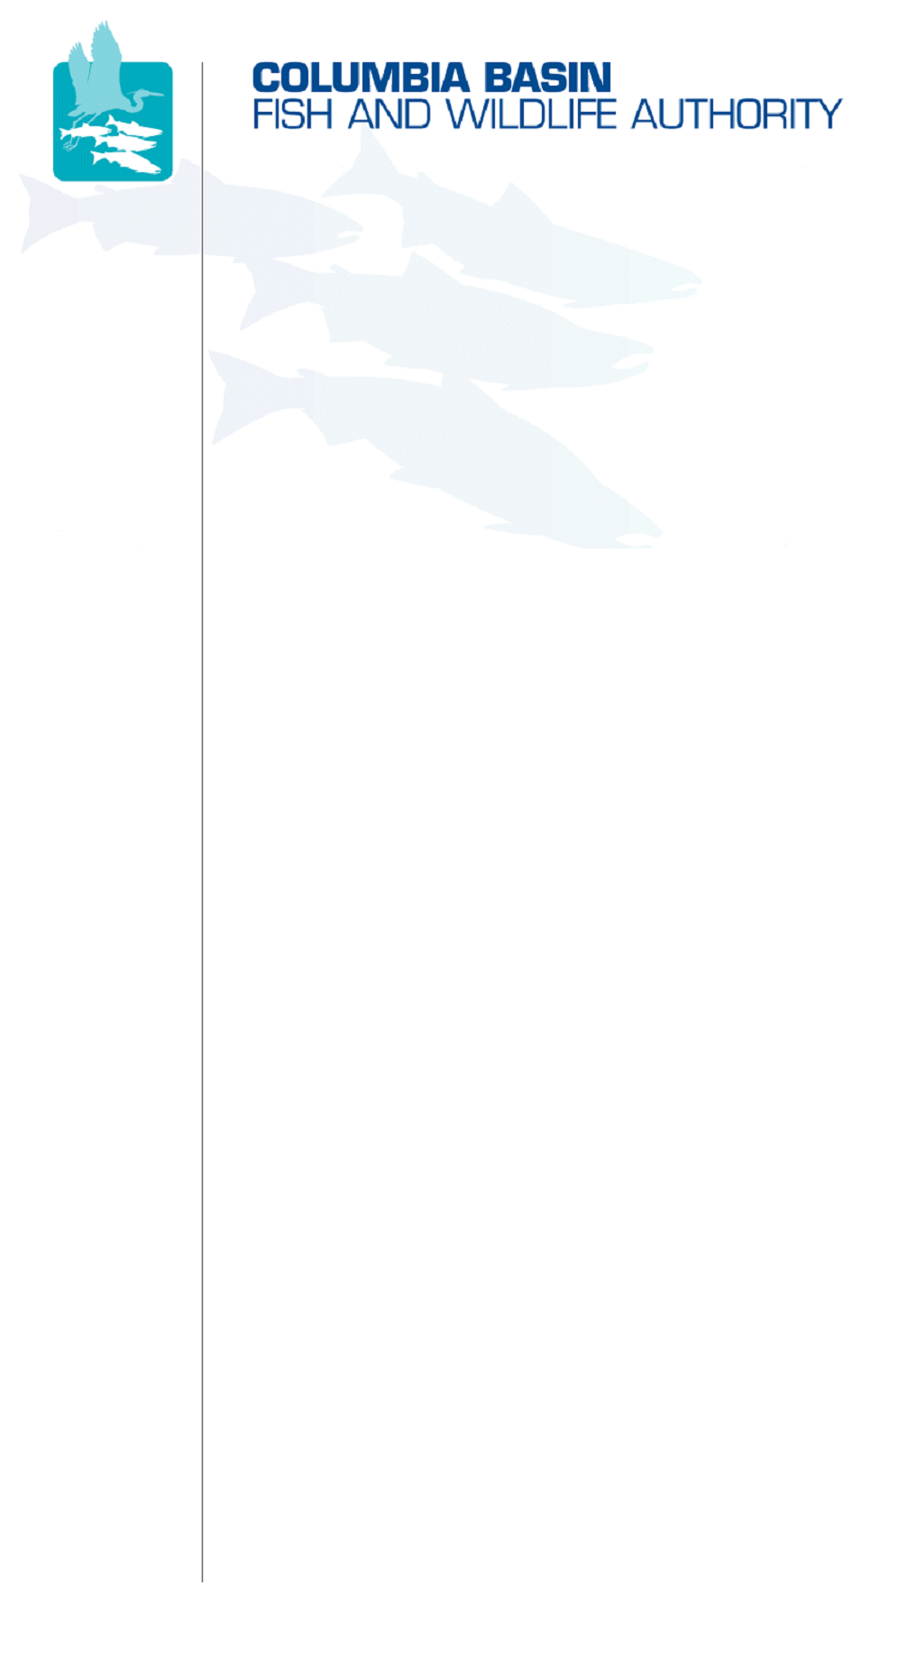
851 SW Sixth Avenue, Suite 300 | Pacific First Building | Portland, OR 97204-1339
Phone: 503-229-0191 | Fax: 503-229-0443 | Website: www.cbfwa.org

Coordinating and promoting effective protection and
restoration of fish, wildlife, and their
habitat in the
Columbia River Basin.

The Authority is comprised of the following tribes and fish and wildlife agencies:

Burns Paiute Tribe

Coeur d’Alene Tribe

Confederated Salish and Kootenai Tribes
of the Flathead Reservation

Confederated Tribes
of the Colville Reservation

Confederated Tribes
of the Umatilla Indian Reservation

Confederated Tribes
of the Warm Springs Reservation

Confederated Tribes and Bands of the Yakama Nation

Idaho Department
of Fish and Game

Kootenai Tribe
of Idaho

Montana Department
of Fish, Wildlife and Parks

National Marine Fisheries Service

Nez Perce Tribe

Oregon Department
of Fish and Wildlife

Shoshone-Bannock Tribes of Fort Hall

Shoshone-Paiute Tribes of Duck Valley

U.S. Fish & Wildlife Service

Washington Department of Fish
and Wildlife

Coordinating Agencies

Columbia River
Inter-Tribal Fish Commission

Upper Columbia
United Tribes

Compact of the Upper Snake River Tribes

DRAFT PRESS RELEASE
NOT FOR DISTRIBUTION
FOR IMMEDIATE RELEASE
April 8, 2008
Contact: Brian Lipscomb, CBFWA Executive Director
Phone: 503-229-0191
Mobile: 971-221-6962
FISH & WILDLIFE AGENCIES AND TRIBES AGREE ON REQUIRED CHANGES TO COLUMBIA RIVER BASIN FISH & WILDLIFE PROGRAM
(Portland, Ore) – The Columbia Basin’s federal and state fish and wildlife agencies and Tribes have submitted consensus recommendations on how to improve the Northwest Power and Conservation Council’s Columbia River Basin Fish and Wildlife Program. Bonneville Power Administration must expend its fish and wildlife funds consistent with the Program to protect, mitigate and enhance fish and wildlife affected by the Columbia River hydropower system.

The fish and wildlife agencies and Tribes have collaborated for 15-months to develop and submit a scientific framework to implement adaptive management. “This represents a significant and historic piece of work and shows a sincere dedication to working collaboratively for the resources we all collectively manage,” stated Larry Peterman, CBFWA chair and Chief of Operations for Montana Department of Fish, Wildlife and Parks. This consensus document comprises the most comprehensive and detailed Fish and Wildlife Program amendment recommendations submitted to date by the basin's fish and wildlife managers.

The Northwest Power Act of 1980 established the Northwest Power and Conservation Council and directed the Council to develop a program to protect, mitigate, and enhance Columbia Basin fish and wildlife resources to the extent they are affected by hydroelectric development in the Basin. Congress recognized that the Basin’s hydropower system was a major factor in the decline of salmon and steelhead runs. The Power Act requires the operators of the hydro-system to provide “equitable treatment” for fish and wildlife, on par with other uses of the Columbia River. The Act also directs the Council to give due weight to the recommendations of the fish and wildlife agencies and Tribes. The recommendations can be found on the Council’s website at www.nwcouncil.org.

The Columbia Basin Fish and Wildlife Authority (CBFWA) is an association of seventeen of the Columbia River Basin’s federal and state fish and wildlife agencies and Tribes. CBFWA facilitates discussion among the fish and wildlife managers to establish restoration priorities and to report on status and trends of fish and wildlife populations in response to mitigation activities. Information on the organization can be obtained at www.cbfwa.org and information on status and trends of fish and wildlife populations and restoration actions can be found at www.cbfwa.org\sotr.
###
DRAFT – NOT FOR DISTRIBUTION
/tmp/in/input.doc

