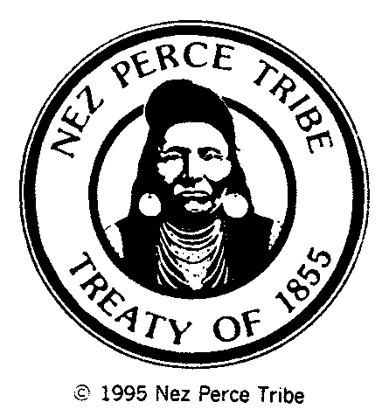
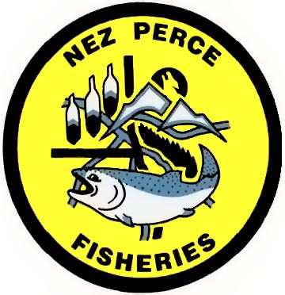NEZ PERCE TRIBE
Department of Fisheries Resources Management
Administration • Enforcement • Harvest • Production • Research • Resident Fish • Watershed

RESIDENT FISH DIVISION
3404 Highway 12 • Orofino, ID 83544
Phone: (208) 476-7417 • Fax: (208) 476-0719

February 10, 2009

Brian Lipscomb, Executive Director
851 SW Sixth Avenue, Suite 300
Pacific First Building
Portland, Oregon 97204

Re: NPT contract add-on request

Dear Brian:

Please consider this request for a $5,000 add-on to the Nez Perce Tribe's FY 2008 (April 1, 2008 - March 31, 2009) CBFWA contract. As of January 31, 2009, there was an unspent balance of $1,415.44 available from the original $50,000 contract budget. The remaining funds are anticipated to be depleted well prior to the March 31 end date.

Intensive efforts early in the contract year, primarily associated with the Northwest Power and Planning Council's Fish and Wildlife Program amendment process, accelerated expenditures. Based on previous monthly expenditures for travel and time, it is estimated that an additional $5,000 will allow CBFWA participation through March 31, 2009.

Please include this item on the February 17, 2009, MAG meeting agenda. Consideration of this request by you and the CBFWA membership is appreciated.

Sincerely,

\David P. Statler\

Director
Resident Fisheries

Cc: Elmer Ward, Chairman, CBFWA
Brad Houslet, Chairman, CBFWA MAG
Kathie Titzler, CBFWA Financial Director

/tmp/in/input.doc

