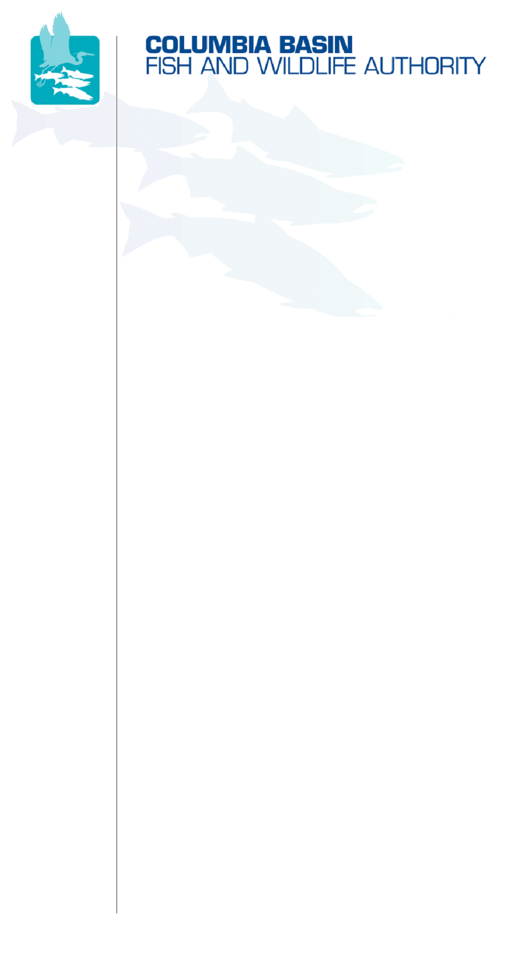
851 SW Sixth Avenue, Suite 300 | Pacific First Building | Portland, OR 97204-1339 |
Phone: 503-229-0191 | Fax: 503-229-0443 | www.cbfwa.org

DATE:  Coordinating and promoting effective protection and  restoration of fish, wildlife, and their  habitat in the  Columbia River Basin.  The Authority is comprised of the following tribes  and government agencies:  Burns Paiute Tribe  Coeur d’Alene Tribe  Confederated Salish and Kootenai Tribes  of the Flathead Reservation  Confederated Tribes  of the Colville Reservation  Confederated Tribes  of the Umatilla Indian Reservation  Confederated Tribes  of the Warm Springs Reservation  Confederated Tribes and Bands of the Yakama Nation  Idaho Department  of Fish and Game  Kootenai Tribe  of Idaho  Montana Fish, Wildlife and Parks  National Marine Fisheries Service  Nez Perce Tribe  Oregon Department  of Fish and Wildlife  Shoshone-Bannock Tribes of Fort Hall  Shoshone-Paiute Tribes of Duck Valley  U.S. Fish & Wildlife Service  Washington Department of Fish  and Wildlife  Coordinating Agencies  Columbia River  Inter-Tribal Fish Commission  Upper Columbia  United Tribes  Compact o the Upper Snake River Tribes | May 14, 2009
TO: | Members Advisory Group (MAG)
FROM: | Fish Screening Oversight Committee (FSOC) and CBFWA Staff
SUBJECT: | Mitchell Act Funding Needs for Fish Screens

At their January 21-22, 2009 meeting in Boise, the Members assigned the FSOC to work with the MAG to develop strategies to maximize likelihood of full and continued Mitchell Act funding for fish screens. The first step is to estimate full annual funding needs for O&M of existing screens and installation of new and replacement screens. Estimates provided by Idaho, Washington, and Oregon for FY 2010 follow:

State | Personnel | O&M | Capital | Overhead | Total
Idaho | $1,003,870 | $346,200 | $160,000 | $287,565 | $1,797,635
Washington | $157,267 | $104,845 | $65,000 | $81,778 | $408,890
Oregon | $1,370,000 | $628,640 | $220,000 | $641,360 | $2,860,000

Funding needs in 2010 total just under $5 million.
More complete information provided by each state is attached. Thorough summaries of Mitchell Act funding trends, accomplishments, and repercussions of reduced or eliminated funding were provided in a memo from FSOC to MAG in October 2008.
Idaho Mitchell Act Funded Program
Fully Funded Needs Assessment
February 2009

The Idaho Department of Fish and Game’s Anadromous Fish Screen and Passage Program operates and maintains 241 gravity intake fish screens, 319 pump intake fish screens, 21 permanent and semi-permanent fish passage structures. Eight to ten new fish screens are installed each year following comprehensive water conservation measures. Many new screens and passage structures funded by Bonneville Power Administration are being operated and maintained by Mitchell Act funds. In order to enable the Idaho Fish Screen & Passage Program to perform services at the same level as 1996, the program would need to receive the Mitchell Act funding that was cut in 1997, 2006, and 2009. Additionally, some funds would be needed for inflation that occurred during those years. The numbers below reflect 1996 dollars adjusted for past funding cuts as well as inflationary increases. Some details regarding the impacts to the program and measures taken to accommodate these issues have been noted below.

FY2010 Minimum Required Annual Budget

Total Annual Personnel $1,003,870

Total Operating $346,200

Total Capital Outlay $160,000

Contract Overhead 21.3% $ 287,565

Budget Total $1,797,635

FY2011 to FY2015
Budget Total FY10 plus Inflation Est. 3% per year

Limited Funding Impact on Idaho Program

- Mitchell Act funding for the Idaho Screen Program decreased by $200k in FY1997.
- In FY2006, funding was reduced by 1%.
- In FY2009, funding was reduced by another $177k.
- One full time (FTE) utility craftsman position was eliminated due to the decrease of funding and the need to shift that position to engage in permitting for projects.
- In FY 2004, a temporary Fisheries Technician position engaged in monitoring and evaluating the effectiveness of the Mitchell Act program was moved to BPA funding.
- In FY2006, an Engineer Technician temporary position was eliminated from the Mitchell Act budget. To accommodate the workload and provide inspection services on Idaho Public Works fish screen and passage projects, the Staff Engineer began performing more of the contract inspection tasks and contract engineering services were obtained with BPA funds to provide designs on habitat projects that would ultimately be funded by BPA.
- Several Federal actions, such as listing of threatened or endangered species required a shift in personnel positions from lower paid non-professional staff, such as utility craftsmen, to higher paid professional staff in order to cope with complex biological issues and comply with regulatory procedures.
- Mitchell Act funding cuts forced managers to transfer some FTE positions to Bonneville Power Administration funding. Until 2004, there were no full time personnel on BPA funded budgets. As operating costs increased on Mitchell Act budgets, more personnel time was shifted to BPA. At present time, four full time positions are funded six months per year and four temporary positions are funded all year by BPA budgets.
- BPA funds are not utilized for fish screen and fish passage O&M. Only personnel positions directly involved in BPA funded projects are covered in BPA budgets.
- Transportation and equipment costs have risen from around $80k in 2001 to approximately $125k today. Mitchell Act once paid for the equipment and vehicle rental time on shared projects. A portion of those rentals have been shifted to BPA budgets.
- The cost of steel rose nearly 50% in the past two years alone. Steel products comprise nearly 40% of our entire operating budget. Steel and steel products are used in both fish screens as well as fish passage structures.
- All fish screens and passage facilities built with BPA funds are operated and maintained by Mitchell Act funding. To date, no BPA funding has been acquired or expended on O&M.
Washington State Dept of Fish and Wildlife
Mitchell Act Fully Funded Estimate 2010

The Washington’s Mitchell Act fishways budget provides for regular inspection of Mitchell Act fishways (40 sites), and for minor maintenance necessary to keep these facilities functional and in compliance with state and federal requirements. These Mitchell Act fishways provide adult and juvenile salmonid access to 396.4 miles of upstream habitat.
Washington’s Mitchell Act fish screen operation and maintenance funding on water diversions (17 sites) preclude juvenile salmonid mortality loss from 168.5 miles of upstream salmonid habitat. These sites are only 13% of the total (130 sites) gravity diversion located within the Columbia River Basin and its tributaries. Of the 130 sites there are 28 that are funded by BPA through the Yakima Basin Phase II program. The remaining 85 sites have no funding source for assistance with maintaining their screens. These 85 sites are included in this budget estimate along with an estimation of 3 new sites being added each year.
WDFW historically received an additional Mitchell Act allotment for capital construction or improvements to new and existing fish protection facilities in the middle and upper Columbia River basin. There continues to be a need for these funds to provide assistance to private irrigators and to participate in partnerships with local salmon recovery groups.
Washington State MA Fishway Inspection
Year | FY 2010 | FY 2011 | FY 2012 | FY 2013 | FY 2014
 | $87,112 | $89,290 | $91,522 | $93,810 | $96,155
Washington State MA Fish Screen Inspection
Year | FY 2010 | FY 2011 | FY 2012 | FY 2013 | FY 2014
# of Sites | 102 | 105 | 108 | 111 | 114
 | $175,000 | $184,522 | $194,282 | $204,286 | $214,540
Washington State MA Fish Screen Capital Construction
Year | FY 2010 | FY 2011 | FY 2012 | FY 2013 | FY 2014
 | $65,000 | $66,625 | $68,291 | $69,998 | $71,748
Washington State MA Overhead @ 25%
Year | FY 2010 | FY 2011 | FY 2012 | FY 2013 | FY 2014
 | $81,778 | $85,109 | $88,524 | $92,024 | $95,611
Washington State MA Total
Year | FY 2010 | FY 2011 | FY 2012 | FY 2013 | FY 2014
Total: | $408,890 | $425,546 | $442,619 | $460,118 | $478,054

Fully Funded Oregon Fish Screening and Passage Mitchell Act Program

February 2009

The Oregon Department of Fish and Wildlife operated with a fully funded Mitchell Act screening and passage program in the early 1990’s. At that time, ODFW received $2.24 million annually in Mitchell Act funds. This allowed the department to conduct routine inspections and maintenance of fish screens and passage facilities as well as construct or replace 20-30 additional projects. Today ODFW has over 750 fish screens and 71 passage structures that may lose their ability to protect fish without adequate Mitchell Act funds.

ODFW estimates that $2.86 million will fully fund the Mitchell Act program to provide an appropriate level of fish protection and service to cooperating water users.

/tmp/in/input.doc

