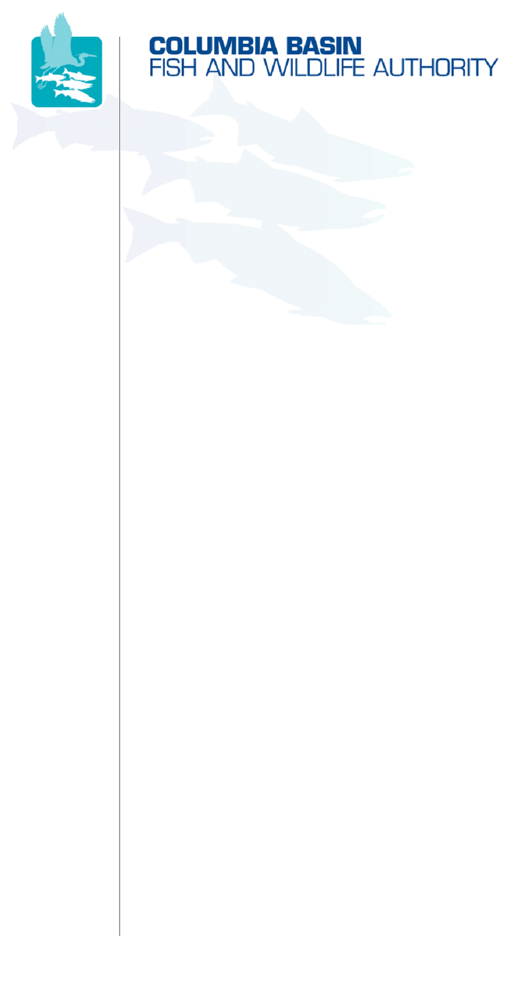
851 SW Sixth Avenue, Suite 300 | Pacific Center Building | Portland, OR 97204-1339
Phone: 503-229-0191 | Fax: 503-229-0443 | Website: www.cbfwa.org

Coordinating and promoting effective protection and
restoration of fish, wildlife, and their
habitat in the
Columbia River Basin.

The Authority is comprised of the following tribes and fish and wildlife agencies:

Burns Paiute Tribe

Confederated Salish and Kootenai Tribes
of the Flathead Reservation

Confederated Tribes
of the Umatilla Indian Reservation

Confederated Tribes
of the Warm Springs Reservation

Confederated Tribes and Bands of the Yakama Nation

Idaho Department
of Fish and Game

Kootenai Tribe
of Idaho

Montana Fish, Wildlife and Parks

National Marine Fisheries Service

Nez Perce Tribe

Oregon Department
of Fish and Wildlife

Shoshone-Bannock Tribes of Fort Hall

Shoshone-Paiute Tribes of Duck Valley

U.S. Fish & Wildlife Service

Washington Department of Fish
and Wildlife

Coordinating Agencies

Columbia River
Inter-Tribal Fish Commission

Upper Columbia
United Tribes

Compact of the Upper Snake River Tribes

CBFWA MAG Meeting of the Salmon Managers
Wednesday, April 21, 2010
8:00a.m. to 12:00p.m. (PDT)
@ CBFWA Offices Portland, Oregon

GOAL: To finalize expected outcomes and pre-work items and confirm schedules and participants for workshops, building from the Anadromous Salmonid Monitoring Strategy workshops held last fall in Skamania, to develop coordinated ongoing assessments for Anadromous Salmonids in the Columbia River Basin.
PURPOSE: The agencies and Tribes have directed CBFWA to focus coordination efforts on supporting and participating in ongoing assessments and to report those assessments in the Status of the Resource (SOTR). To accomplish this, it is recognized that a monitoring strategy must be in place to provide the necessary data to inform the assessments. The Anadromous Salmonid Monitoring Strategy has accomplished this for Anadromous Salmonids. In order to clarify and memorialize ongoing assessments for this monitoring strategy, the CBFWA staff, working with others in the region, has developed the attached proposal for a series of workshops at the regional and sub-regional scales. The purpose of this meeting is verification of this proposal including the table describing the workshops and expected outcomes, the timeline for the workshops, and the list of participants.
Please see attached document “Coordinated Assessments for Salmon and Steelhead” and contemplate the following questions:
- Do the proposal and workshop outlines clearly characterize the expected goals and outcomes?
- Is the full suite of workshops essential to accomplish the goal?
- Are the workshops characterized correctly relative to assessment and data management that is needed to facilitate ongoing assessments into the future?
- Is the timeline appropriate to accommodate the Members participation throughout the course of the summer and into early Fall?
Proposed Agenda
- Review attached “Coordinated Assessments for Salmon and Steelhead” document and finalize:
  - Description of effort
  - Workshop description
  - Timeline
  - Participants
- Discuss and confirm other assessment efforts underway and their relationship to this effort.
  - NOAA 5-year check in
  - CRITFC data management effort for Accords
- Next steps

/tmp/in/input.doc

