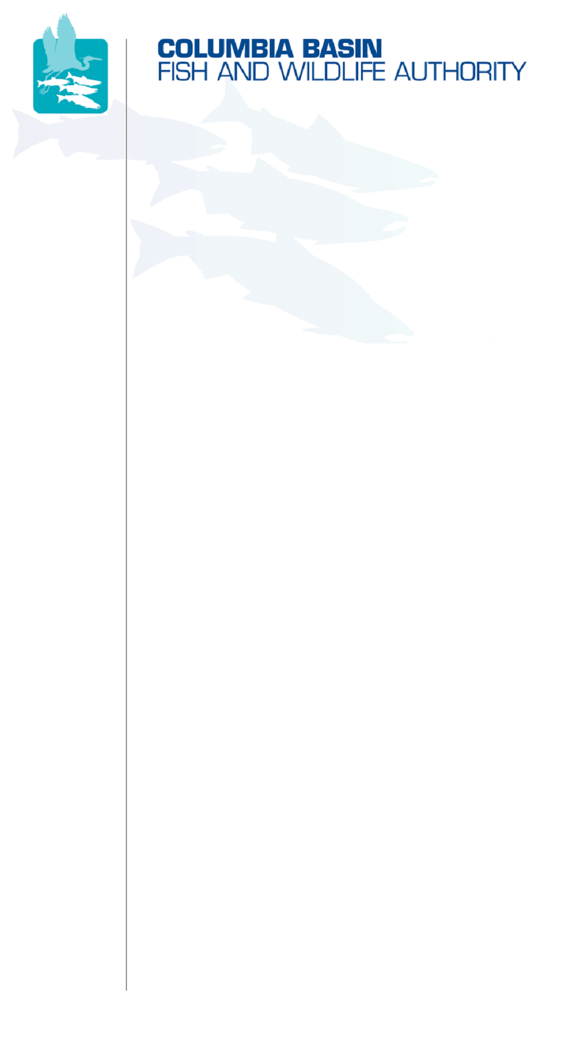
851 SW Sixth Avenue, Suite 300 | Pacific First Building | Portland, OR 97204-1339
Phone: 503-229-0191 | Fax: 503-229-0443 | Website: www.cbfwa.org

Draft – Internal for MAG Review
Coordinating and promoting effective protection and
restoration of fish, wildlife, and their
habitat in the
Columbia River Basin.

The Authority is comprised of the following tribes
and government agencies:

Burns Paiute Tribe

Confederated Salish and Kootenai Tribes
of the Flathead Reservation

Confederated Tribes
of the Umatilla Indian Reservation

Confederated Tribes
of the Warm Springs Reservation

Confederated Tribes and Bands of the Yakama Nation

Idaho Department
of Fish and Game

Kootenai Tribe
of Idaho

Montana Fish, Wildlife & Parks

National Marine Fisheries Service

Nez Perce Tribe

Oregon Department
of Fish and Wildlife

Shoshone-Bannock Tribes of Fort Hall

Shoshone-Paiute Tribes of Duck Valley

U.S. Fish & Wildlife Service

Washington Department of Fish
and Wildlife

Coordinating Agencies

Columbia River
Inter-Tribal Fish Commission

Upper Columbia
United Tribes

Compact of the Upper Snake River Tribes

DATE: | February 10, 2011
TO: | Members of Columbia Basin Fish & Wildlife Authority
FROM: | Jann Eckman, CBFWA
SUBJECT: | Draft Agenda for March 10, 2011 Members Meeting in Boise, Idaho

Columbia Basin Fish & Wildlife Authority Members Meeting
Thursday, March 10, 2011
Time Tentative 8:00 a.m. - 2:10 p.m. (MST)
@
Hilton Garden Inn Boise Spectrum
The Garden West Room
7699 West Spectrum Street, Boise, ID 83709
Call Room Reservations 1-208-376-1000
Request Columbia Basin Fish & Wildlife Authority for $85 room rate
(Cut Off date 2/28/2011)

WebEx w/Integrative Teleconference has been arranged for this meeting:
Select: Members March 10 WebEx w/Integrative Teleconference
Log in first: Enter your name and email address.
Click "Join Now" and follow prompts to dial into the teleconference.
Meeting password: members (lower case)
Members Webpage

Draft Agenda

8:00-8:05am | Welcome and Opening Remarks
8:05-8:10am | Invocation
ITEM 1:  8:10-8:15am | Introductions, Roll Call, and Approve Agenda
Recommended Action: | Approve draft agenda.
ITEM 2:  8:15-8:20am | Approve as Final: Draft Action Notes from the September 28, 2010 Members Face-to-Face Meeting
Recommended Action: | Approve September 28, 2010 Members Face-to-Face draft action notes as final.
ITEM 3:  8:20-8:30am | Pass the Gavel to the New CBFWA Officers & Appoint CBFWA Committee Designees for Next Year
The Chair gavel will be passed to a SBT Member representative and the Vice-chair gavel will be passed to an IDFG Member representative.
Confirm your Agency or Tribes’ CBFWA committee representatives and contact information by completing and sending the request form to Trina.Gerlack@cbfwa.org.
ITEM 4:  8:30-9:00am | Pending Application Verification  Presentation by Fort McDermitt Paiute & Shoshone Tribe (FMPST) - 30min
ITEM 5:  9:00-9:30am | Pending Application Verification  Fort McDermitt Paiute & Shoshone Tribe Membership Discussion - 30min  According to the Charter Section 407 (B)(4) - Member Decision Process:”Members will review the request and will take action to either deny, grant admission, or table the application. If there are objections to the application, they must be explained.”  A legal opinion of the FMPST request will be provided by Joe Mentor, CBFWA/F legal counsel.
ITEM 6:  9:30-10:15am | CBFWA Charter Changes - 45min
Charter revisions necessitated by changes in membership and objectives (potential and realized) for Member review and discussion are:
- The modifications to the quorum definition language in the consensus decision making section regarding the withdrawal of the Washington Department of Fish and Wildlife (WDFW) and the Oregon Department of Fish and Wildlife (ODFW) as Members of CBFWA.
- The addition of the Fort McDermitt Paiute & Shoshone Tribe as a member of CBFWA.
- The language modifications to support the 2010 Policy Directives.
Recommended Action: | Approve the deletion of WDFW and ODFW as CBFWA members and associated modifications to change quorum requirements.
Recommended Action: | Approve addition of Fort McDermitt Paiute & Shoshone Tribe as a Member of CBFWA.
Recommended Action: | Approve language modifications to support 2010 Policy Directives.
10:15-10:30am | Break - 15min
ITEM 7:  10:30-11:00am | Satisfaction Survey Results - 30min
 | Review CBFWA survey results as context for considering future options for regional coordination.
ITEM 8:  11am-12:30pm | 2012-2017 Regional Coordination Funding Alternatives - 90min
- Discuss assumptions and context for regional coordination funding.
- Discuss the three alternatives presented in white paper developed by MAG.
 | - Discuss timeline for regional coordination decisions.
Recommended Action: | Provide guidance to MAG by selecting an alternative from the proposed options or defining guiding principles and objectives for development of another alternative for future consideration.
12:30-1:30pm | Working Lunch Provided - 60min
ITEM 9:  1:30-2:00pm | 2010/11 CBFWA Annual Work Plan Check-in - 30min
ITEM 10:  2:00-2:10pm | Next Meeting - 10min
2: 10pm | Meeting Adjourn

/tmp/in/input.doc

