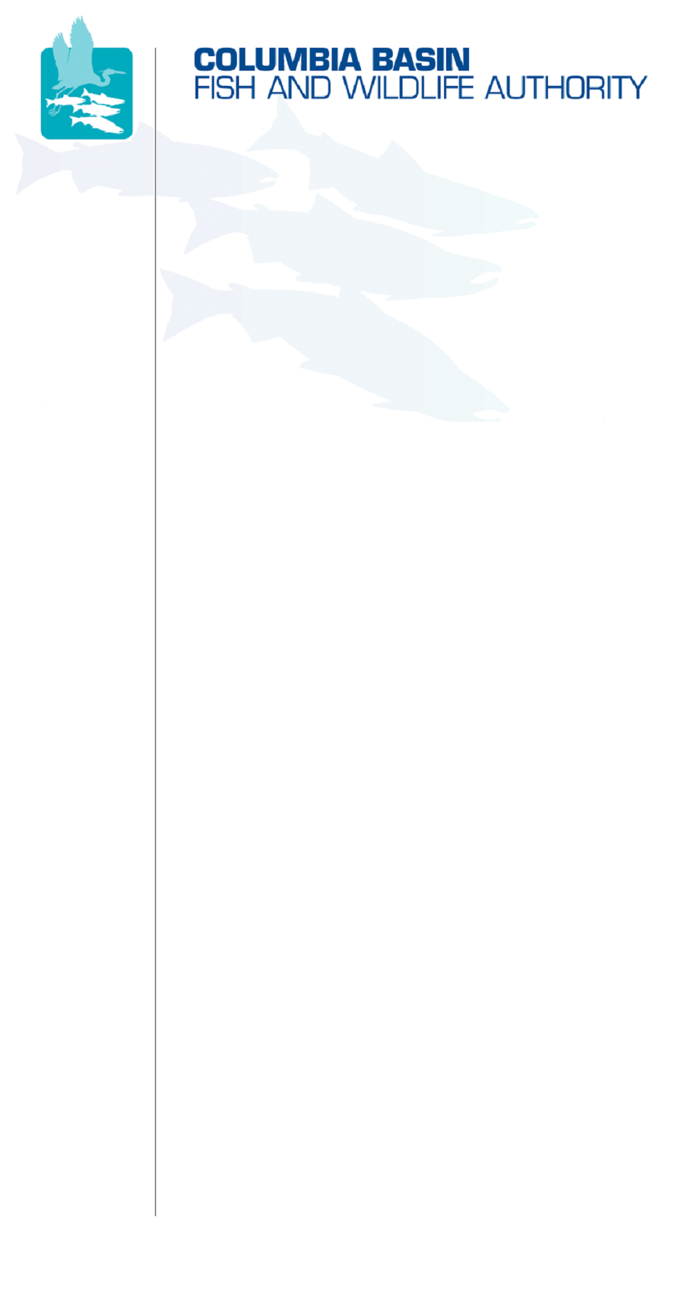
851 SW Sixth Avenue, Suite 300 | Pacific First Building | Portland, OR 97204-1339
Phone: 503-229-0191 | Fax: 503-229-0443 | Website: www.cbfwa.org

Internal Draft MAG Review
Coordinating and promoting effective protection and
restoration of fish, wildlife, and their
habitat in the
Columbia River Basin.

The Authority is comprised of the following tribes
and government agencies:

Burns Paiute Tribe

Confederated Salish and Kootenai Tribes
of the Flathead Reservation

Confederated Tribes
of the Umatilla Indian Reservation

Confederated Tribes
of the Warm Springs Reservation

Confederated Tribes and Bands of the Yakama Nation

Fort McDermitt Paiute-Shoshone Tribe of Nevada and Oregon

Idaho Department
of Fish and Game

Kootenai Tribe
of Idaho

Montana Fish, Wildlife & Parks

National Marine Fisheries Service

Nez Perce Tribe

Shoshone-Bannock Tribes of Fort Hall

Shoshone-Paiute Tribes of Duck Valley

U.S. Fish & Wildlife Service

Coordinating Agencies

Columbia River
Inter-Tribal Fish Commission

Compact of the Upper Snake River Tribes

Upper Columbia
United Tribes

DATE: | July 12, 2011
TO: | Members of Columbia Basin Fish & Wildlife Authority
FROM: | Nathan Small, Chair
SUBJECT: | Draft Agenda for August 24, 2011 Members Meeting in Coeur d’ Alene, Idaho

Columbia Basin Fish & Wildlife Authority Members Meeting
Wednesday, August 24, 2011
9:00 a.m. - 3:00 p.m. (PST)
@
Best Western Plus, Coeur d’ Alene Inn
506 W Appleway, Coeur d' Alene, ID 83814
Call Room Reservations 1-800-251-7829
Request Columbia Basin Fish & Wildlife group block for $105 room rate plus tax/fees. (Release date 8/8/2011)

WebEx w/Integrative Teleconference has been arranged for this meeting:
Select: Members August 24 WebEx w/Integrative Teleconference
Log in first: Enter your name and email address.
Click "Join Now" and follow prompts to dial into the teleconference.
Meeting password: members (lower case)
Members Webpage

Draft Agenda

9:00-9:05am | Welcome and Opening Remarks
9:05-9:10am | Invocation
ITEM 1:  9:10-9:20am | Introductions and Approve Agenda
Recommended Action: | Approve draft agenda.
ITEM 2:  9:20-9:30am | Draft Action Notes from the March 10, 2011 Members Face-to-Face Meeting
Recommended Action: | Approve the March 10, 2011 Members Meeting draft action notes as final.
ITEM 3:  9:30-9:45am | CBFWF Business Updates  - FY 2010  - FY 2011
ITEM 4:  9:45-10:30am | Status Reports From Each CBFWA Technical Committee Chair  - Wildlife Advisory Committee (WAC) – Scott Soults, KTOI  - Resident Fish Advisory Committee (RFAC) – Mike Faler, USFWS  - Lamprey Technical Work Group (LTWG) – Christina Luzier, USFWS; Dave Ward
10:30-10:45am | Break
Continue ITEM 4:  10:45-11:30am | Status Reports From Each CBFWA Technical Committee Chair  - Fish Screening Oversight Committee (FSOC) - Lynn Stratton, IDFG; Dave Ward  - Anadromous Fish Monitoring Strategy - Dave Ward  - Coordinated Assessments Work Plan for Anadromous Fish - Tom Iverson
ITEM 5:  11:30-11:45pm | Discuss Status of the Resources (SOTR) Report and Future Direction
ITEM 6:  11:45-1:00pm | Columbia River Treaty Presentation and Lunch Discussion  - Working Lunch Provided
ITEM 7:  1:00-2:50pm | FY 2012 and Beyond CBFWA Work Plan and Budget
Recommended Action: | Approve FY 2012 and Beyond CBFWA Work Plan and Budget
ITEM 8:  2:50-3:00pm | Next Members Meeting
Recommended Action: | Select date and location.
 | Meeting Adjourn
H:\WORK\MBRS\2011_0824\Agenda_24August2011_MbrsMtg_Draft_InternalForMAGreview.doc

