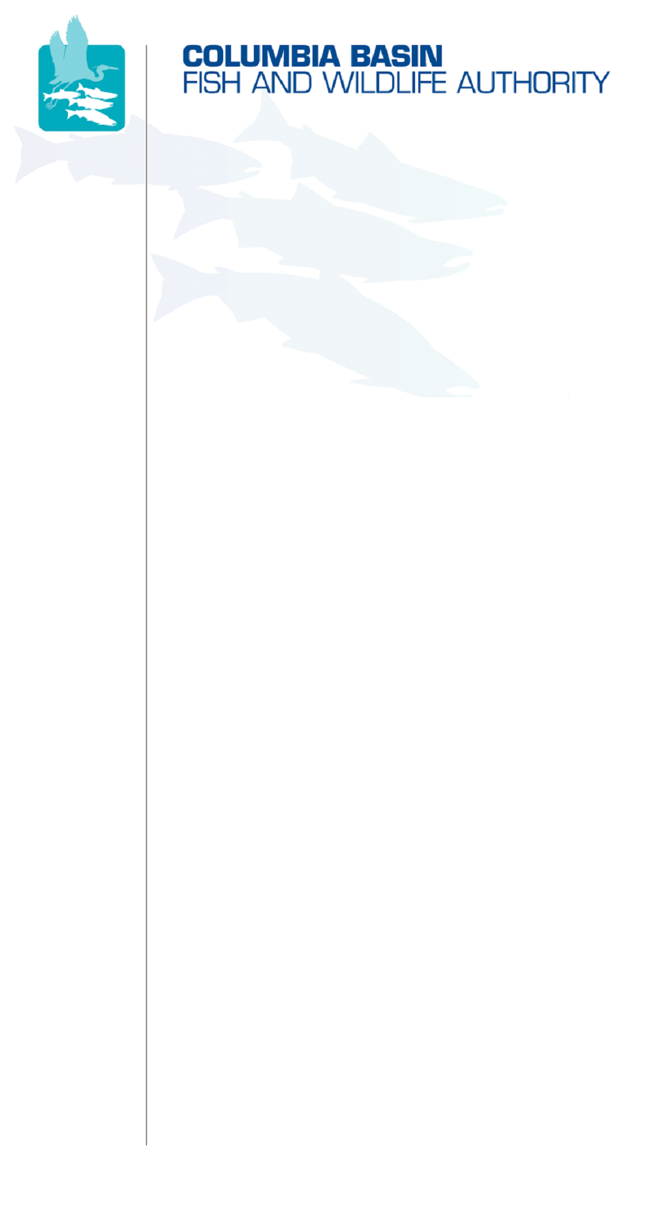
851 SW Sixth Avenue, Suite 300 | Pacific First Building | Portland, OR 97204-1339 |
Phone: 503-229-0191 | Fax: 503-229-0443 | www.cbfwa.org

April 1, 2008

TO:  Coordinating and promoting effective protection and  restoration of fish, wildlife, and their  habitat in the  Columbia River Basin.  The Authority is comprised of the following tribes  and fish and wildlife agencies:  Burns Paiute Tribe  Coeur d’Alene Tribe  Confederated Salish and Kootenai Tribes  of the Flathead Reservation  Confederated Tribes  of the Colville Reservation  Confederated Tribes  of the Umatilla Indian Reservation  Confederated Tribes  of the Warm Springs Reservation  Confederated Tribes and Bands of the Yakama Nation  Idaho Department  of Fish and Game  Kootenai Tribe  of Idaho  Montana Department  of Fish, Wildlife and Parks  National Marine Fisheries Service  Nez Perce Tribe  Oregon Department  of Fish and Wildlife  Shoshone-Bannock Tribes of Fort Hall  Shoshone-Paiute Tribes of Duck Valley  U.S. Fish & Wildlife Service  Washington Department of Fish  and Wildlife  Coordinating Agencies  Columbia River  Inter-Tribal Fish Commission  Upper Columbia  United Tribes  Compact of the Upper Snake River Tribes | Members
FROM: | CBFWA Staff
SUBJECT: | Proposed Modifications to Section 3 of CBFWA Amendment Recommendations

Two paragraphs have been added to Section 3 at the recommendation of some members:

First, at the beginning of Section 3, a paragraph has been inserted that briefly summarizes the intent of Section 3, with text indicating that the subbasin-specific objectives are not comparable (or additive) to the basin-wide objectives for a number of reasons. This addition was discussed previously by MAG and Members.

Second, Dan Diggs, USFWS, requested that a paragraph be added to Section 3.9, Pacific Lamprey, stressing the importance of the USFWS lamprey conservation initiative, and stressing that efforts in addition to those of the Program are needed for success.

The paragraphs were both added for review and discussion at the April 2 Members conference call. These additions are summarized in the attached table.

If you have questions or concerns, please contact Dave Ward or Brian Lipscomb.

/tmp/in/input.doc

Suggested Addition to Section 3 - 4/1/08

Issue | Question | Requested Addition | CBFWA Staff Suggested Response
3.0 | Add paragraph to explain that subbasin objectives are not directly comparable to basin-wide objectives. | This section includes, for most provinces, a subbasin by subbasin summary of objectives, current status, limiting factors and threats, and recommended strategies and measures for anadromous fish in the Columbia River Basin. Objectives are those defined in subbasin plans and/or recovery plans where available. Although some information on productivity is available, objectives are often limited to adult returns to the subbasin, and are usually for naturally-produced fish only. These adult-return objectives are not directly comparable to basin-wide objectives, because they do not generally incorporate returns of hatchery fish, broodstock needs, mainstem harvest, or unexplained losses between Bonneville Dam and subbasin of origin. Current returns are given as a range or average of returns over the most recent 5 years for which data are available. Limiting factors and threats are summarized from those provided in more detail in subbasin plans and recovery plans. Strategies and measures are designed to provide a general framework that supports more specific actions to address threats. | CBFWA staff drafted and inserted the paragraph
3.9.3 | Lamprey conservation initiative and efforts needed for success | Insert paragraph:  Key to implementing the following proposed measures will be the development of a collaborative lamprey conservation strategy (Strategy 3.9.3.4) that identifies critical uncertainties related to lamprey status, biology, and conservation. The plan should help guide priorities of actions and measures to implement in addition to the immediate actions taken to improve passage within the FCRPS. The following strategies and measures will require the collective actions and efforts of tribes, state, and federal agencies in addition to those funded through the NPCC Fish and Wildlife Program. | Slightly revised paragraph inserted for discussion by Members:  Key to implementing the following proposed measures will be the development of a collaborative lamprey conservation strategy (Strategy 3.9.3.4) that identifies critical uncertainties related to lamprey status, biology, and conservation. The plan should help guide priorities of measures to implement in addition to the immediate actions taken to improve passage and restore habitat. The following strategies and measures will require the collective actions and efforts of tribes, state, and federal agencies in addition to those funded through the Program.

