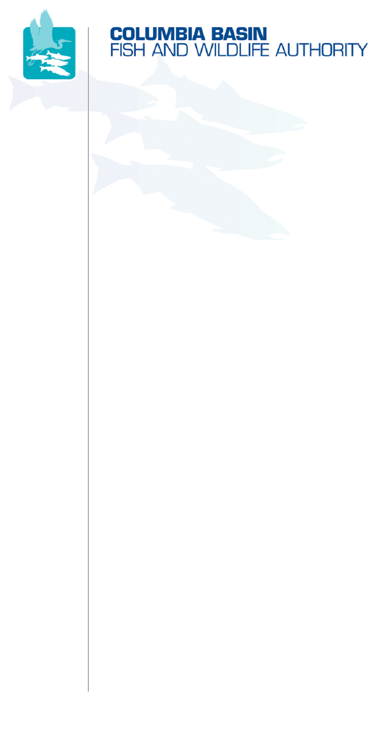
851 SW Sixth Avenue, Suite 300 | Pacific First Building | Portland, OR 97204-1339
Phone: 503-229-0191 | Fax: 503-229-0443 | Website: www.cbfwa.org

Draft
Coordinating and promoting effective protection and
restoration of fish, wildlife, and their
habitat in the
Columbia River Basin.

The Authority is comprised of the following tribes
and government agencies:

Burns Paiute Tribe

Coeur d’Alene Tribe

Confederated Salish and Kootenai Tribes
of the Flathead Reservation

Confederated Tribes
of the Colville Reservation

Confederated Tribes
of the Umatilla Indian Reservation

Confederated Tribes
of the Warm Springs Reservation

Confederated Tribes and Bands of the Yakama Nation

Idaho Department
of Fish and Game

Kootenai Tribe
of Idaho

Montana Fish, Wildlife & Parks

National Marine Fisheries Service

Nez Perce Tribe

Oregon Department
of Fish and Wildlife

Shoshone-Bannock Tribes of Fort Hall

Shoshone-Paiute Tribes of Duck Valley

U.S. Fish & Wildlife Service

Washington Department of Fish
and Wildlife

Coordinating Agencies

Columbia River
Inter-Tribal Fish Commission

Upper Columbia
United Tribes

Compact of the Upper Snake River Tribes

DATE: | June 3, 2008
TO: | CBFWA Members
FROM: | Brian Lipscomb, CBFWA
SUBJECT: | Draft Agenda for the June 25-26, 2008 Summer Members Meeting

Summer Members Meeting – Warm Springs OR
June 25-26, 2008
@
Kah-Nee-Ta Resort
6823 Highway 8
Warm Springs, OR 97761
541-553-1112
Toll-Free 541-800-554-4786
http://kah-nee-ta.com/lodging

A block of rooms have been reserved under CBFWA
for June 24th (for those who prefer to travel the day before the meeting starts) and June 25th
*Reservation cut-off date is June 9th*

Day One: Wednesday, June 25, 2008
10:00 a.m. - 5:00 p.m. (PST)

Dinner Details: TBA

Day Two: Thursday, June 26, 2008
8:00 a.m. – 12:00 p.m. (PST)
Field Trips 12:00 – 4:00 p.m.

(Schedule WebEx\Integrated Teleconference)

Support material will be posted on the Members webpage at http://www.cbfwa.org/committee_main.cfm.

Draft Agenda

Day One – Wednesday, June 25, 2008
 | Welcome and Opening Remarks
 | Invocation and Welcoming by Ron Suppah, Chairman Warm Springs Tribe
ITEM 1: | Introductions, Roll Call, and Approve Agenda
ITEM 2: | Approve as Final: Draft Action Notes from the June 4, 2008 Members Teleconference
Recommended Action: | Approve June 4, 2008 Members Teleconference draft action notes as final.
ITEM 3: | Updates from Northwest Power and Conservation Council (Council) - Working with Bill Booth on who can do this from the Council  - What the Council envisions for amending the Program in light of recommendations, comments, MOA's, and BiOp, etc., and what the Agencies and Tribes might expect in the form of interactions with the Council to accomplish this vision.  - High Level Indicators (HLI) developed by the Council and a verification of how these tie into the Status of the Resource Report and Program Amendment.  - What the Agencies and Tribes should be thinking about to assist in making the Wildlife Solicitation Review a success and how this effort is linked to the Program Amendment process.  - Tentative Item: How the Council anticipates participating in the FY10 and FY11 BPA budget setting process.
ITEM 4: | Status of the Resource Report for an Amended Program
Item 5: Working Lunch Presentation | Climate Security Act briefing  - Joe Mentor, Joe Mentor, Mentor Law Group, PLLC  - Doug Howell, National Wildlife Federation, Regional Executive Director, Western Natural Resource Center
ITEM 6: | Member Discussion and Potential Actions for the Remainder of the Program Amendment Process  - Technical Committee Reports – RFAC, AFAC, WAC
ITEM 7: | Blanket Modification for Members Contracts – Joe Mentor, Mentor Law Group, PLLC
ITEM 8: | BOG Process Changes Update – Tom Iverson, CBFWA
Day Two – Thursday, June 26, 2008
ITEM 9: | Introductions and Recap of Day One Meeting
ITEM 10: | Umatilla/Walla Walla Success Story Brochure – Gary James, CTUIR  - Review brochure
ITEM 11: | Update from BPA on FY09 & FY10 & FY11 Integrated Program Review (IPR) -Greg Delwiche Invited
ITEM 12: | Member Discussion and Potential Actions for the Remainder of the IPR Process
ITEM 13: | Review of CBFWA Website Changes  - Presentation and review new website changes
ITEM 14: | WebEx Meetings Review and Budget Implications  - Review report on the implications of WebEx meetings and provide feedback on its effectiveness
ITEM 15: | Members Winter Meeting Location and Date
ITEM 16: | Fish and Wildlife Activities of the Warm Springs Tribe and Oregon Department of Fish and Wildlife, and Concluding with Field Trips

/tmp/in/input.doc

