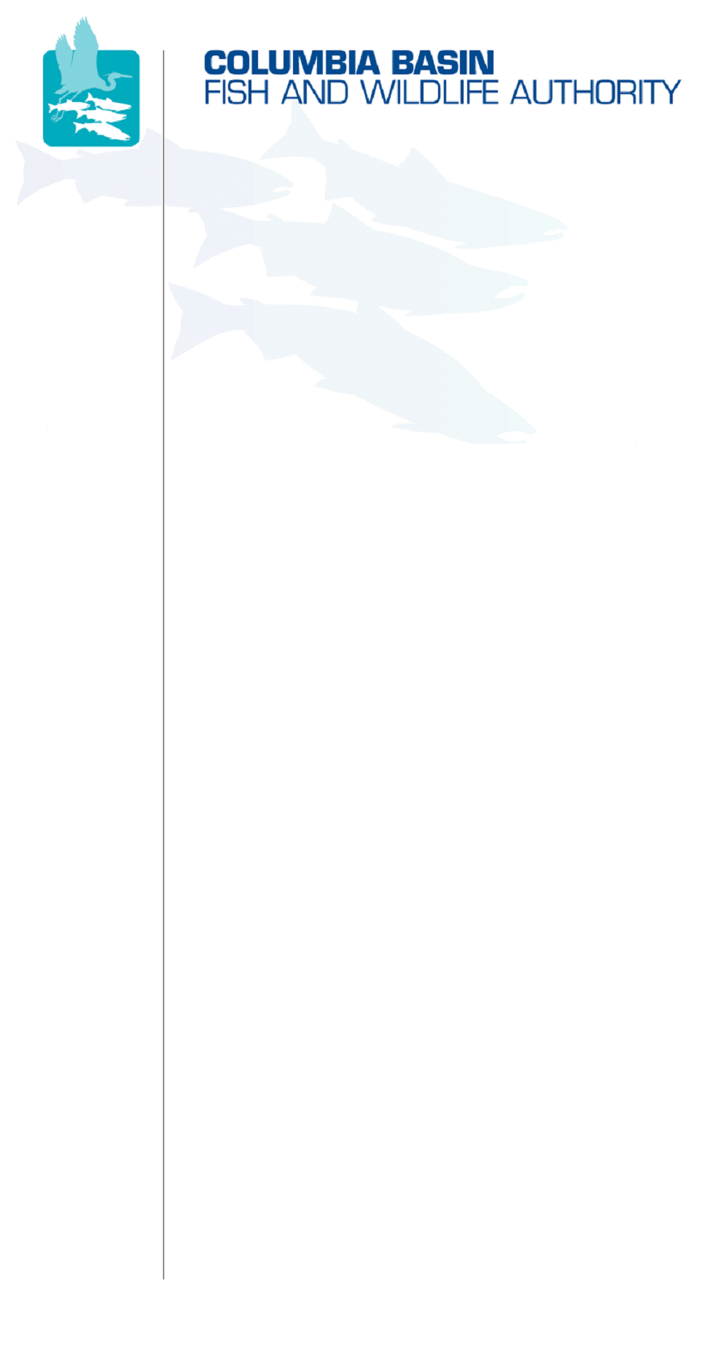
851 SW Sixth Avenue, Suite 300 | Pacific First Building | Portland, OR 97204-1339
Phone: 503-229-0191 | Fax: 503-229-0443 | Website: www.cbfwa.org

Coordinating and promoting effective protection and
restoration of fish, wildlife, and their
habitat in the
Columbia River Basin.

The Authority is comprised of the following tribes and fish and wildlife agencies:

Burns Paiute Tribe

Coeur d’Alene Tribe

Confederated Salish and Kootenai Tribes
of the Flathead Reservation

Confederated Tribes
of the Colville Reservation

Confederated Tribes
of the Umatilla Indian Reservation

Confederated Tribes
of the Warm Springs Reservation

Confederated Tribes and Bands of the Yakama Nation

Idaho Department
of Fish and Game

Kootenai Tribe
of Idaho

Montana Fish, Wildlife & Parks

National Marine Fisheries Service

Nez Perce Tribe

Oregon Department
of Fish and Wildlife

Shoshone-Bannock Tribes of Fort Hall

Shoshone-Paiute Tribes of Duck Valley

U.S. Fish & Wildlife Service

Washington Department of Fish
and Wildlife

Coordinating Agencies

Columbia River
Inter-Tribal Fish Commission

Upper Columbia
United Tribes

Compact of the Upper Snake River Tribes

On June 23, 2008, the Montana piscicide committee offered additional revisions to the draft Antimycin letter.

DRAFT - NOT FOR DISTRIBUTION
July XX, 2008

Eric Wagner, President
Western Division of the American Fisheries Society
Fisheries Experiment Station
1465 West 200 North
Logan, UT 84321

Dear Mr. Wagner:

For decades, rotenone and antimycin have been important tools for fisheries management and native fish restoration. In many circumstances, the use of these piscicides is the only viable method for removing introduced nonnative fishes and the threat they pose to native aquatic species. Despite their widespread use, there is still considerable public misconception about these chemicals.

In 2007, the EPA completed reregistration for antimycin and rotenone and licensed both products for use in piscicidal applications. To date, there are three manufacturing-use product registrants for rotenone; however, Fintrol (Aquabiotics Corporation) is the only registered antimycin product. In the past, there have been problems with variable toxicity levels among batches of Fintrol and currently Aquabiotics is uncertain whether the production of this product will continue in years to come.

Remote backcountry and roadless watersheds often serve as the last remaining refugia for native trout. Conservation of these populations is a top priority for management agencies, yet restoration projects in these areas are logistically challenging. Antimycin has certain physical properties that make it more feasible to use in remote watersheds. For example, the volume required to achieve toxicity is much less than that for rotenone and, as such, antimycin can more easily be transported to remote roadless areas by packstock. Additionally, under natural conditions antimycin detoxifies more rapidly than rotenone. This property makes it an attractive tool in situations where a lake population is targeted for eradication and downstream populations are not. Rapid neutralization also greatly reduces the length of time that motor-powered detoxification stations need to be operated. Finally, the chances of achieving a complete fish kill with a single treatment may be greater with antimycin in situations with groundwater influence. Antimycin is usually not detected by fish, making it less likely that fish will survive by seeking groundwater upwelling or spring areas during treatments, which sometimes occurs with rotenone.

Antimycin is an important tool in native fish management and its potential lack of availability poses a threat to the success of many fishery conservation programs, especially those with projects located in remote areas. Efforts to secure the future reregistration and production of antimycin should be a priority among fisheries management agencies and the American Fisheries Society.

The American Fisheries Society sponsors the Rotenone Stewardship Program, which includes a website posting the latest information on rotenone use, manuals and brochures on rotenone risks and benefits, and a list of expert contacts. A similar program for antimycin would be valuable to raise awareness of these issues among fisheries professionals and help dissolve public misconception about the use of antimycin.

Sincerely,

Larry Peterman, Chairman
Columbia Basin Fish and Wildlife Authority

cc: CBFWA Members

/tmp/in/input.doc

