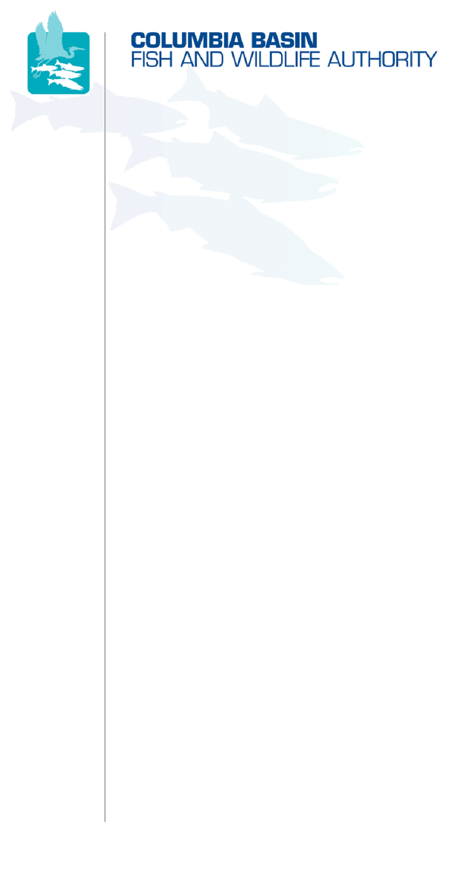
851 SW Sixth Avenue, Suite 260 | Portland, OR 97204-1339
Phone: 503-229-0191 | Fax: 503-229-0443 | www.cbfwa.org

June 3, 2008

TO:  Coordinating and promoting effective protection and  restoration of fish, wildlife, and their  habitat in the  Columbia River Basin.  The Authority is comprised of the following tribes  and government agencies:  Burns Paiute Tribe  Coeur d’Alene Tribe  Confederated Salish and Kootenai Tribes  of the Flathead Reservation  Confederated Tribes  of the Colville Reservation  Confederated Tribes  of the Umatilla Indian Reservation  Confederated Tribes  of the Warm Springs Reservation  Confederated Tribes and Bands of the Yakama Nation  Idaho Department  of Fish and Game  Kootenai Tribe  of Idaho  Montana Department  of Fish, Wildlife and Parks  National Marine Fisheries Service  Nez Perce Tribe  Oregon Department  of Fish and Wildlife  Shoshone-Bannock Tribes of Fort Hall  Shoshone-Paiute Tribes of Duck Valley  U.S. Fish & Wildlife Service  Washington Department of Fish  and Wildlife  Coordinating Agencies  Columbia River  Inter-Tribal Fish Commission  Upper Columbia  United Tribes  Compact of the Upper Snake River Tribes | Members Advisory Group (MAG)
FROM: | CBFWA staff
SUBJECT: | Budget Oversight Group Process Changes Adopted by Northwest Power and Conservation Council

At their May 13-14, 2008 meeting in Walla Walla, the Northwest Power and Conservation Council (Council) revised the Budget Oversight Group (BOG) process for managing within-year budget adjustment requests. In addition to the current guidelines provided on the CBFWA website at http://www.cbfwa.org/mods/FY07Process.cfm, the Council made the following changes:
- Only true emergencies (defined in the BOG process as Category 1) will be handled through an expedited process. “Urgent” (but not “Emergency”) should no longer be a criterion for getting expedited treatment outside of the quarterly sequence.
- Requests denied by the Council and Bonneville Power Administration (Bonneville) may not be brought forward again for reconsideration during the current funding cycle unless; (1) significant and compelling information is first presented by the sponsor to Bonneville and the Council, and (2) a minimum of two members of the Council's Fish and Wildlife committee agree to reconsider the request for funding.
- Threshold for contract management - if the BOG determines the sponsor’s project budget adjustment request is within the scope of the recommended project and is within 10 percent of the approved budget and is less than $75,000, the adjustment can be made at Bonneville’s discretion. This threshold would only be applied once for a project during the funding recommendation cycle. If a request does qualify for the use of this criterion, notice would be provided to the Council and approval would be reviewed by the BOG Management Group.
The role of the BOG will be maintained during the FY2009 budget cycle. However, with the signing of the Columbia River Basin Fish Accords, the BOG role may be changing slightly. Those changes are still not clear and additional information will be provided as the Program begins implementation of the agreements.
/tmp/in/input.doc

