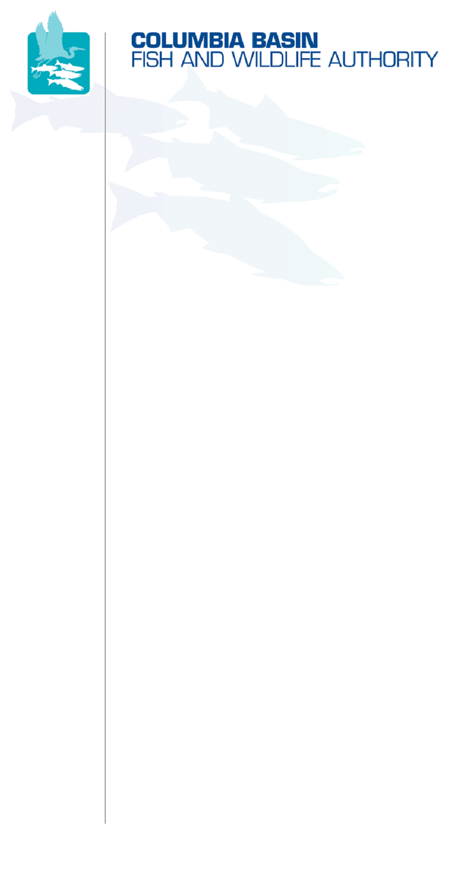
851 SW Sixth Avenue, Suite 300 | Pacific First Building | Portland, OR 97204-1339
Phone: 503-229-0191 | Fax: 503-229-0443 | Website: www.cbfwa.org

Coordinating and promoting effective protection and
restoration of fish, wildlife, and their
habitat in the
Columbia River Basin.

The Authority is comprised of the following tribes and fish and wildlife agencies:

Burns Paiute Tribe

Coeur d’Alene Tribe

Confederated Salish and Kootenai Tribes
of the Flathead Reservation

Confederated Tribes
of the Colville Reservation

Confederated Tribes
of the Umatilla Indian Reservation

Confederated Tribes
of the Warm Springs Reservation

Confederated Tribes and Bands of the Yakama Nation

Idaho Department
of Fish and Game

Kootenai Tribe
of Idaho

Montana Fish, Wildlife and Parks

National Marine Fisheries Service

Nez Perce Tribe

Oregon Department
of Fish and Wildlife

Shoshone-Bannock Tribes of Fort Hall

Shoshone-Paiute Tribes of Duck Valley

U.S. Fish & Wildlife Service

Washington Department of Fish
and Wildlife

Coordinating Agencies

Columbia River
Inter-Tribal Fish Commission

Upper Columbia
United Tribes

Compact of the Upper Snake River Tribes

October 3, 2008

Public Comment Processing
Attention: 1018-AT50
Division of Policy and Directives Management
US Fish and Wildlife Service
4401 North Fairfax Drive, Suite 222
Arlington, VA 22203

To Whom It May Concern:

The Columbia Basin Fish & Wildlife Authority (CBFWA) is an organization whose memberships consists of the four state and two federal fish and wildlife management entities and eleven Indian Tribes of the Columbia River Basin. As members of the CBFWA, whose mission is to protect, mitigate, and enhance the fish and wildlife resources and the ecosystems on which they depend, we want to submit our comments on the new regulations proposed by the Department of Interior (DOI) on August 15, 2008 that would modify the consultation requirements under section 7 of the Endangered Species Act (Act).

The Act was designed to protect critically imperiled species from extinction as a “consequence of economic growth and development untendered by adequate concern and conservation,” and to protect species and “the ecosystems upon which they depend.” The Act also provides a regulatory framework that guides consultations. The DOI indicates that the new modifications to the Act are proposed to: 1) provide greater clarity and certainty to the consultation process and, 2) respond to the new challenges presented with regard to global warming and climate change. However, the proposed changes potentially eliminate the need for concurrence from the U.S. Fish and Wildlife Service (FWS) or the National Marine Fisheries Service (NMFS) jeopardizing the scientific oversight to determine if listed species will be harmed by activities such as logging, mining, or filling of wetlands.

The proposed rule includes explicit language under “Government-to-Government Relationship with Indian Tribes” section that the regulatory changes ‘apply only to Federal agencies, not Indian Tribes.’ That ‘the regulations are intended to streamline the administration of the Act; not change any substantive requirements concerning protection of listed species, so any indirect effect would be minimal.’ The Members of CBFWA would argue that these proposed rule changes do affect Tribal resources and that Tribal consultation is warranted. Listed species do not recognize geographical boundaries and proposed Federal actions that affect populations in areas where Tribal lands are involved require DOI to comply with the Federal-Tribal trust responsiblities.

The fish and wildlife managers of CBFWA request that DOI initiate the consultation process with the Tribes on these proposed modifications to the Act and that the consultation be completed prior to the adoption of the regulations.

Sincerely,

Larry Peterman, Chairman
Columbia Basin Fish & Wildlife Authority

cc: CBFWA Members

/tmp/in/input.doc

The U.S. Fish and Wildlife Service (USFWS), National Oceanic and Atmospheric Administration/National Marine Fisheries Service (NOAA/NMFS), and Idaho Department of Fish and Game (IDFG) are members of Columbia Basin Fish and Wildlife Authority; however, the USFWS, NOAA/NMFS, and IDFG did not participate in the development of this letter, take no position on the content, and have abstained.

