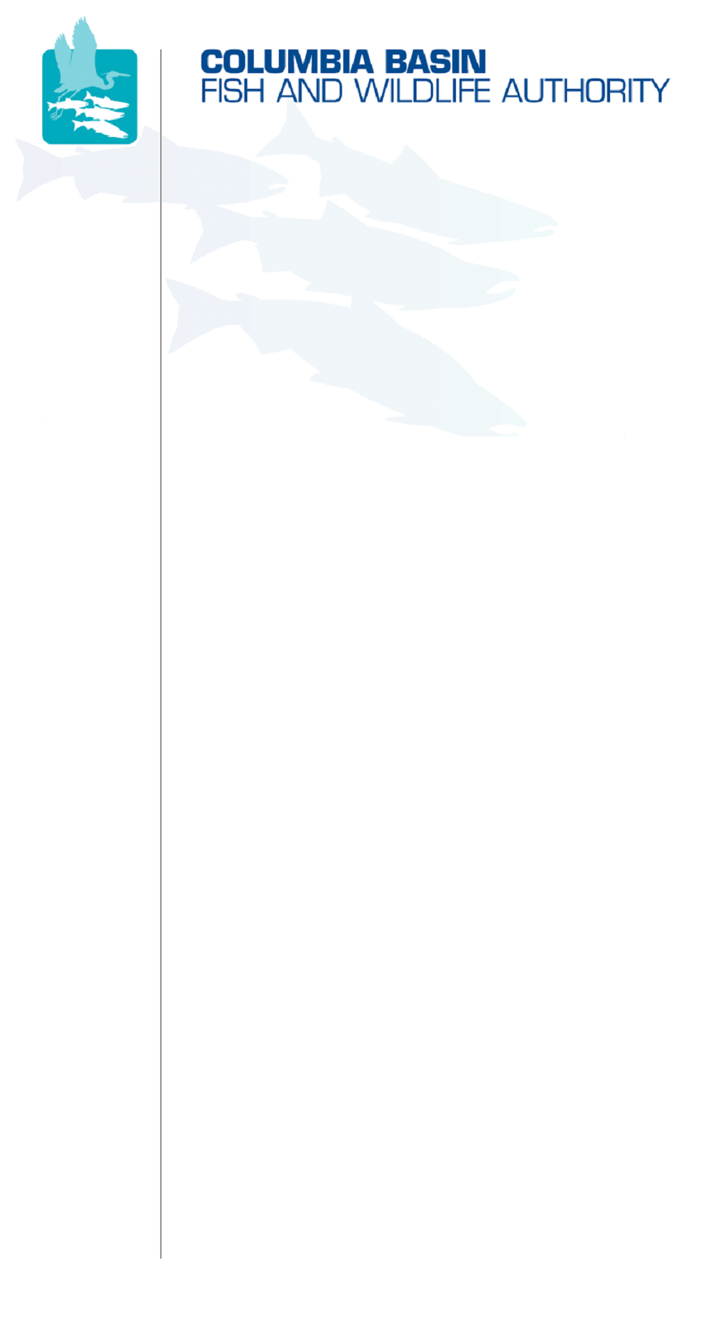
851 SW Sixth Avenue, Suite 300 | Pacific First Building | Portland, OR 97204-1339
Phone: 503-229-0191 | Fax: 503-229-0443 | Website: www.cbfwa.org

DATE: | November 12, 2008
TO:  Coordinating and promoting effective protection and  restoration of fish, wildlife, and their  habitat in the  Columbia River Basin.  The Authority is comprised of the following tribes  and government agencies:  Burns Paiute Tribe  Coeur d’Alene Tribe  Confederated Salish and Kootenai Tribes  of the Flathead Reservation  Confederated Tribes  of the Colville Reservation  Confederated Tribes  of the Umatilla Indian Reservation  Confederated Tribes  of the Warm Springs Reservation  Confederated Tribes and Bands of the Yakama Nation  Idaho Department  of Fish and Game  Kootenai Tribe  of Idaho  Montana Fish, Wildlife & Parks  National Marine Fisheries Service  Nez Perce Tribe  Oregon Department  of Fish and Wildlife  Shoshone-Bannock Tribes of Fort Hall  Shoshone-Paiute Tribes of Duck Valley  U.S. Fish & Wildlife Service  Washington Department of Fish  and Wildlife  Coordinating Agencies  Columbia River  Inter-Tribal Fish Commission  Upper Columbia  United Tribes  Compact of the Upper Snake River Tribes | CBFWA Members’ Agencies and Tribes (A/T)
FROM: | Jann Eckman, Assistant Director
SUBJECT: | Request for Designated CBFWA Representatives and Communication Protocols

At the winter meeting of the Members, it is customary for each Member to appoint designees and alternates to serve on the groups and committees of CBFWA for the next year. We have developed the following template for you to complete and bring to the January 21 & 22, 2009 Members Meeting.

Please fill in all the requested information and return the completed form to CBFWA staff, so we can ensure our records are accurate and up-to-date. Please also indicate what your preferred method of communication is: Email___ Phone____ Fax____

Print Name___________________________________Title____________________________

Signature_____________________________________Date____________________________

Agency or Tribe (A/T):__________________________________________________________

Committee  Representative | Email  Address | Phone  Number | FAX #
Members - Policy
Name of Designee:
Alternate:
Office Assistant:
Members Advisory Group – Senior Managers
Name of Designee:
Alternate:
Office Assistant:
Anadromous Fish Advisory Committee
Name of Designee:
Alternate:
Office Assistant:
Resident Fish Advisory Committee
Name of Designee:
Alternate:
Office Assistant:
Wildlife Advisory Committee
Name of Designee:
Alternate:
Office Assistant:
Fish Passage Advisory Committee
Name of Designee:
Alternate:
Office Assistant:

Based on your selected preference for external communications from CBFWA to your A/T, if we are unable to contact your designee or alternate, please designate the individuals that must be contacted by email/phone/fax.______________________________________________________________________________________________________________________________________________________________________________________________________________________________________________________________________________________________________________________________________________

In order to guarantee timely improvement of our support service to you, we request that this information be submitted to our office no later than March 6, 2009. Please notify the CBFWA staff of any changes to your A/T designated CBFWA representatives and/or communication protocols that may occur throughout the year.

If you have any questions about this request, please feel free to contact me at (503) 229-0191 or email at jann.eckman@cbfwa.org.

H:\work\MBRS\CBFWAdesigneesCommunicationRequestSurvey12Nov2008.doc

