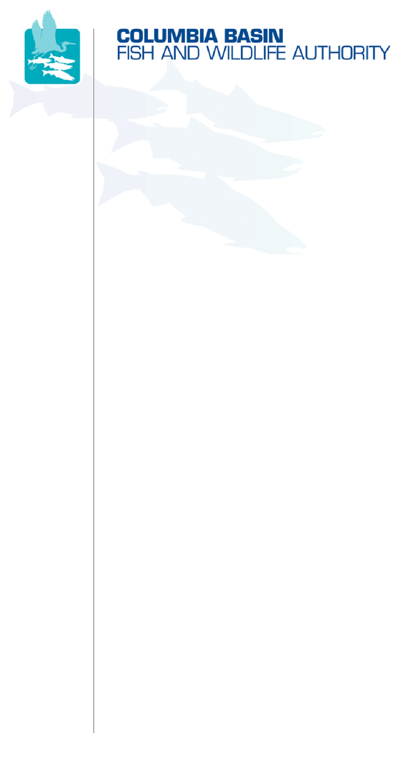
851 SW Sixth Avenue, Suite 300 | Pacific First Building | Portland, OR 97204-1339
Phone: 503-229-0191 | Fax: 503-229-0443 | Website: www.cbfwa.org

Coordinating and promoting effective protection and
restoration of fish, wildlife, and their
habitat in the
Columbia River Basin.

The Authority is comprised of the following tribes and fish and wildlife agencies:

Burns Paiute Tribe

Coeur d’Alene Tribe

Confederated Salish and Kootenai Tribes
of the Flathead Reservation

Confederated Tribes
of the Colville Reservation

Confederated Tribes
of the Umatilla Indian Reservation

Confederated Tribes
of the Warm Springs Reservation

Confederated Tribes and Bands of the Yakama Nation

Idaho Department
of Fish and Game

Kootenai Tribe
of Idaho

Montana Fish, Wildlife and Parks

National Marine Fisheries Service

Nez Perce Tribe

Oregon Department
of Fish and Wildlife

Shoshone-Bannock Tribes of Fort Hall

Shoshone-Paiute Tribes of Duck Valley

U.S. Fish & Wildlife Service

Washington Department of Fish
and Wildlife

Coordinating Agencies

Columbia River
Inter-Tribal Fish Commission

Upper Columbia
United Tribes

Compact of the Upper Snake River Tribes

January xx, 2009 DRAFT

Senator :

The fish and wildlife Agencies and Tribes of the Columbia Basin Fish and Wildlife Authority (CBFWA) strongly support reauthorizing the Fisheries Restoration and Irrigation Mitigation Act of 2007 (FRIMA), S. 1522/H.R. 3830. The members of CBFWA are the legally recognized managers of the fish and wildlife resources of the Columbia River Basin, and include four state and two federal fish and wildlife management entities and eleven Indian Tribes.
FRIMA was enacted in 2000 to create a program that focuses on screening and passage improvements at water diversions where both fish and irrigated agriculture are important economic and social resources. Fish screens and fishways provide an immediate benefit to fishery resources while maintaining the supply of water valued by agricultural and other users. Screens effectively prevent the loss of millions of fish and other aquatic species annually in the four states considered by FRIMA. Providing fish passage at diversion dams instantly opens up additional habitat for spawning and rearing by local fish populations. Projects implemented through the FRIMA program continue to help support sustainable fisheries and sustainable agricultural practices.
Since funding for FRIMA began in 2002, 106 projects have been completed with a total FRIMA contribution of over 9 million dollars and a non-federal partner match of over 11 million dollars. FRIMA legislation required a local partner cost-share of at least 35%; however, partner cost share has averaged over 56% for all projects approved. This large investment by applicants and other partners has allowed the limited funding available to be distributed to additional projects and has increased the project ownership by local water users.
The region-wide support and importance of this program is evident by the co-sponsorship of this legislation by all eight Senators from the Pacific Northwest. The CBFWA requests your support in reauthorizing FRIMA, allowing water users in the Columbia River Basin to continue to implement fish screening and passage projects for the benefit of fish and agriculture.

Sincerely,

Elmer Ward, Chairman
Columbia Basin Fish & Wildlife Authority

cc: CBFWA Members
/tmp/in/input.doc
/tmp/in/input.doc

The USFWS and NOAA Fisheries abstain.

