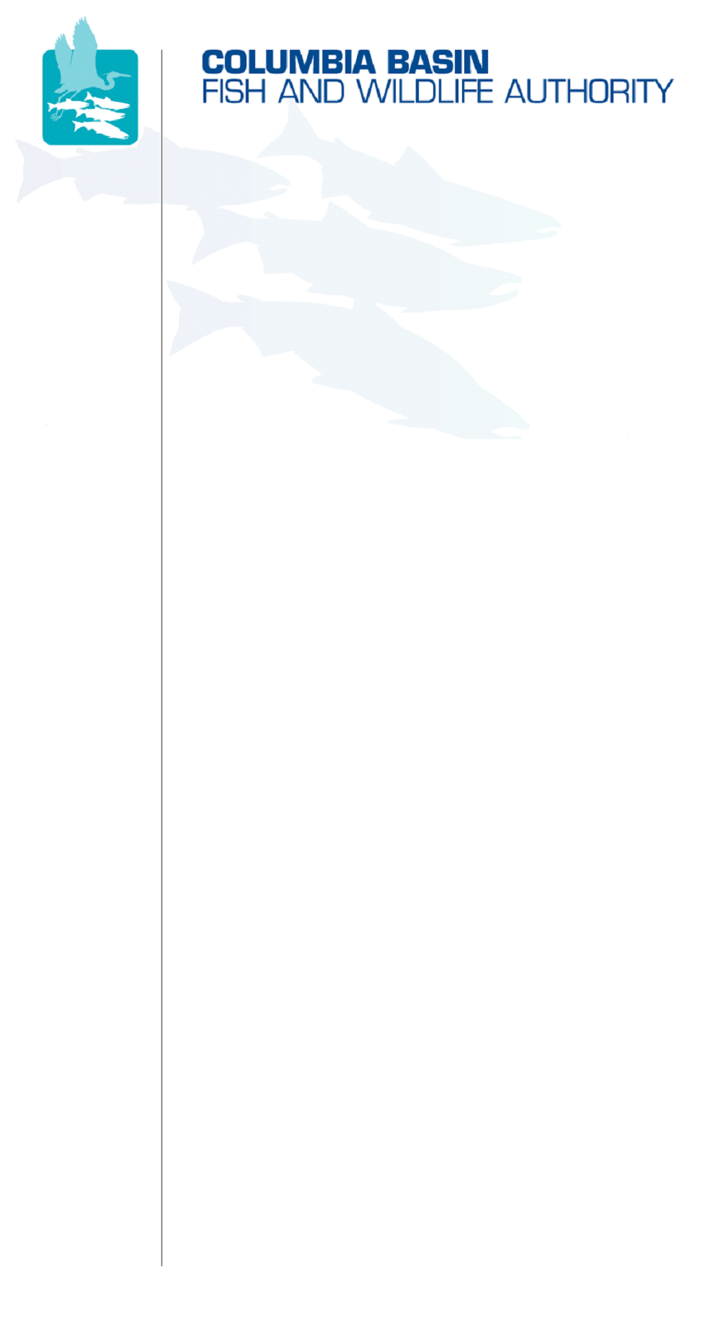
851 SW Sixth Avenue, Suite 300 | Pacific First Building | Portland, OR 97204-1339
Phone: 503-229-0191 | Fax: 503-229-0443 | www.cbfwa.org

DATE: | November 13, 2009
TO:  Coordinating and promoting effective protection and  restoration of fish, wildlife, and their  habitat in the  Columbia River Basin.  The Authority is comprised of the following tribes  and government agencies:  Burns Paiute Tribe  Coeur d’Alene Tribe  Confederated Salish and Kootenai Tribes  of the Flathead Reservation  Confederated Tribes  of the Colville Reservation  Confederated Tribes  of the Umatilla Indian Reservation  Confederated Tribes  of the Warm Springs Reservation  Confederated Tribes and Bands of the Yakama Nation  Idaho Department  of Fish and Game  Kootenai Tribe  of Idaho  Montana Fish, Wildlife and Parks  National Marine Fisheries Service  Nez Perce Tribe  Oregon Department  of Fish and Wildlife  Shoshone-Bannock Tribes of Fort Hall  Shoshone-Paiute Tribes of Duck Valley  U.S. Fish & Wildlife Service  Washington Department of Fish  and Wildlife  Coordinating Agencies  Columbia River  Inter-Tribal Fish Commission  Upper Columbia  United Tribes  Compact of the Upper Snake River Tribes | Members Advisory Group (MAG)
FROM: | Sheri Sears, Chair, Resident Fish Advisory Committee
SUBJECT: | Northwest Power and Conservation Council’s October 13, 2009 Response to CBFWA Resident Fish Loss Assessment Letter

The Issue:
On October 13, 2009, the CBFWA received a letter from Stephen Crow, Executive Director of the Northwest Power and Conservation Council (Council), in response to a recent letter from Chairman Elmer Ward, CBFWA, dated October 8, 2009, regarding the development of a method for calculating the amount of resident fish habitat lost due to inundation associated with the construction of the Federal Columbia River Power System (FCRPS).

In his letter, Director Crow acknowledged that the Council’s Amended Fish and Wildlife Program (Program) calls for the assessment of resident fish losses attributable to the FCRPS, yet the Program does not specifically describe a method to use or a process by which a methodology is to be developed; however, Director Crow indicated that “the Council intends to develop a methodology in a public process that will include independent scientific review of what we assume will be various proposed methodologies.”

The Resident Fish Advisory Committee (RFAC) finds Director Crow’s response to be disheartening. He indicated that the Council intends to initiate a process “to develop a [resident fish loss assessment] methodology.” Furthermore, Director Crow indicated that the Council’s “Fish and Wildlife Division staff is working with Council members to determine our next steps in this process”; however, recent Council Fish and Wildlife Committee and Council meetings have been void of such discussions.

Background Information:
Following the release of the Program, the RFAC developed a methodology for the assessment of resident fish losses due to inundation caused by the construction of the FCRPS. This methodology is consistent with that used by the Montana Fish, Wildlife and Parks (MFWP) and Idaho Department of Fish and Game (IDFG) to quantify inundated resident fish habitat. The MFWP’s assessment has been adopted and subsequently implemented through the Program. The RFAC believes its methodology framework is useful by providing a template for fish and wildlife managers across the Columbia River Basin to consistently quantify resident fish and habitat losses.

Potential Outcomes and Recommendations:
The RFAC requests that the MAG consider the following recommendations be forwarded to the Members for comment to the Council:
- The Council should provide a description of the process for the methodology development, public review, and associated timeline by the end of the calendar year.
- The review process should begin in January 2010.
- The public review process should be clarified. Currently, the RFAC intends to prepare two methodologies for which public review and input will be needed (i.e., resident fish habitat loss methodology and resident fish losses due to inundation methodology; the latter is currently ongoing).

/tmp/in/input.doc

