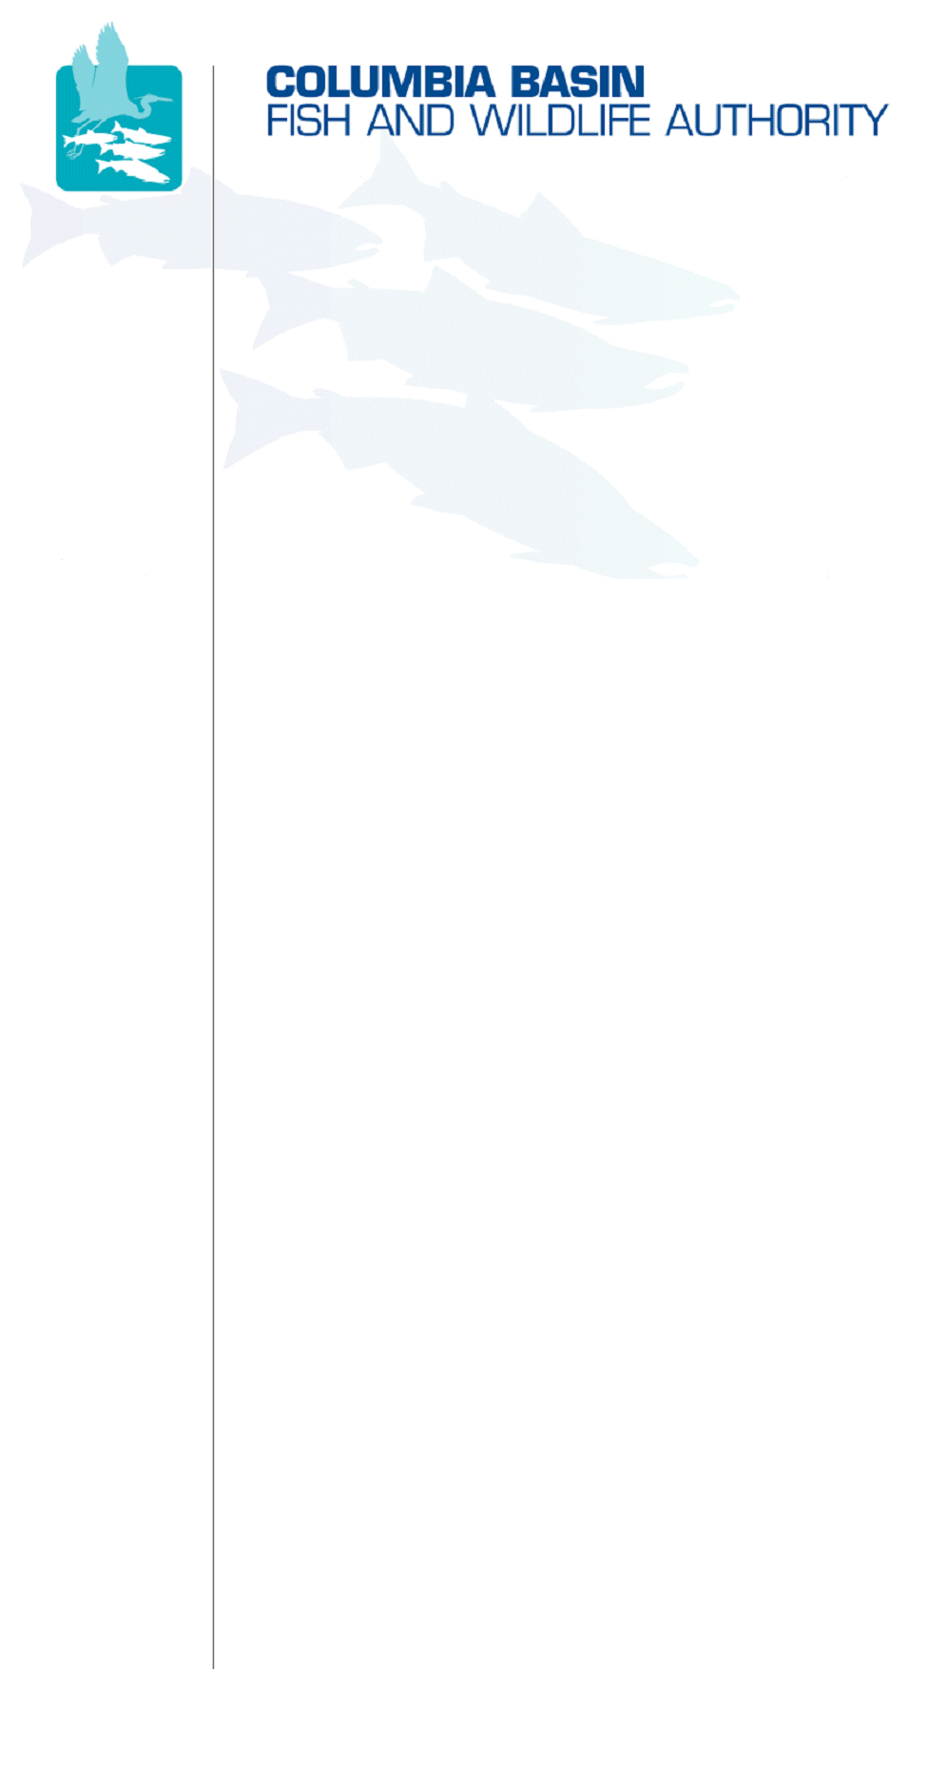
851 SW Sixth Avenue, Suite 300 | Pacific First Building | Portland, OR 97204-1339 | Phone: 503-229-0191 | www.cbfwa.org

Coordinating and promoting effective protection and
restoration of fish, wildlife, and their
habitat in the
Columbia River Basin.

The Authority is comprised of the following tribes
and government agencies:

Burns Paiute Tribe

Confederated Salish and Kootenai Tribes
of the Flathead Reservation

Confederated Tribes
of the Colville Reservation

Confederated Tribes
of the Umatilla Indian Reservation

Confederated Tribes
of the Warm Springs Reservation

Confederated Tribes and Bands of the Yakama Nation

Idaho Department
of Fish and Game

Kootenai Tribe
of Idaho

Montana Department
of Fish, Wildlife and Parks

National Marine Fisheries Service

Nez Perce Tribe

Oregon Department
of Fish and Wildlife

Shoshone-Bannock Tribes of Fort Hall

Shoshone-Paiute Tribes of Duck Valley

U.S. Fish & Wildlife Service

Washington Department of Fish
and Wildlife

Coordinating Agencies

Columbia River
Inter-Tribal Fish Commission

Compact of the Upper Snake River Tribes

DATE: | March 1, 2010
TO: | Ad hoc White Sturgeon Workgroup
FROM: | Neil Ward
SUBJECT: | Draft Agenda for the March 1, 2010 Ad hoc White Sturgeon Meeting

Ad hoc White Sturgeon Meeting
Monday, March 1, 2010
1:00 a.m. – 2:00 p.m. (Pacific)

WebEx w/Integrative Teleconference: Go to the CBFWA website
Select: Ad hoc White Sturgeon WG 3/1/2010 WebEx Logon w/Interactive Teleconference
Login First: Enter your name and email address
Session password: wswg (lower case)
Click "Join Now" and follow prompts to dial into the teleconference/online session.

Draft Agenda
ITEM 1: | Review Agenda
ITEM 2: | Review of the NPCC’s Categorical Review
ITEM 3: | Review of the CBFWA’s Work Plan White Sturgeon Deliverable
ITEM 4: | Developing a Columbia Basin Monitoring Strategy for White Sturgeon: Workshop Process, Sideboards, and Products
ITEM 5: | Timelines and Deliverables
ITEM 6: | Next Meeting

/tmp/in/input.doc

