Bonneville Reservoir and The Dalles Reservoir - White Sturgeon Populations

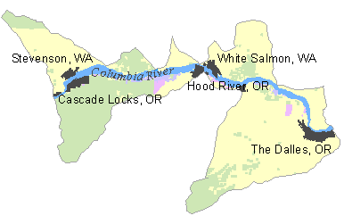Presented on the following pages are ongoing white sturgeon monitoring programs in Bonneville and The Dalles reservoirs, an evaluation of the quality of the information, and an evaluation of what would be needed to improve the monitoring.

Evaluations shown in this document are drawn from the work completed by the Columbia River Fish and Wildlife Authority through the Columbia Basin White Sturgeon Workgroup.

Population | Primary Indicator | Desired Certainty | Monitoring Needed | Current Monitoring | Data Quality & Certainty | Data Improvement Actions Needed | Proposed Projects
Bonneville Reservoir | Adult Abundance
 | Adult Productivity
 | Juvenile Productivity
 | Spatial Distribution
 | Species Diversity

