Bonneville Reservoir and The Dalles Reservoir - White Sturgeon Populations

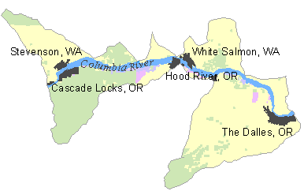Presented on the following pages are ongoing white sturgeon monitoring programs in Bonneville and The Dalles reservoirs, an evaluation of the quality of the information, and an evaluation of what would be needed to improve the monitoring.

Evaluations shown in this document are drawn from the work completed by the Columbia River Fish and Wildlife Authority through the Columbia Basin White Sturgeon Workgroup.

Population | Primary Indicator | Desired Certainty | Monitoring Needed | Current Monitoring | Data Quality & Certainty | Data Improvement Actions Needed | Proposed Projects
Bonneville Reservoir | Adult Abundance | Currently, no desired level exists or has been proposed, unlike other upstream reservoirs, BN reser. Seems to have sufficient numbers of adult spawners, although there is no estimate of what the numbers are from survey to survey. | It would be useful to understand more about the pop. Dynamics of the adult comp. of this population. This population like other surveyed popul., has been unable to estimate the abundance of adult fish due to the lack of sufficient (or any) recaptures during survey periods. | This reservoir receives annual survey efforts to document age 0+ recruitment each fall. Sampling is done with overnight small-mesh (2” stretched mesh) sets. Metrics are the number of positive (with age 0+ sturgeon) sets. This reservoir has the most consistent recruitment, as measured by the number of years with measurable recruitment compared to other sampled reservoirs (TD, JD, McN). | Data quality and certainty rate high with regard to the positive identification that collected fish are indeed age 0+ white sturgeon and they were likely produced in BN reservoir. Where there is no certainty is the estimated number of age 0+ produced in that sample year or any previous year. However, the logistical effort necessary to determine the abundance of 0+ sturgeon would likely be exceedingly expensive and hard on the fish. | Cannot think of anything at the moment, other than increasing the sampling rate to increase our resolution and accuracy in our population estimates. | Broodstock estimation proposal using the technology from the lower river broodstock studies.
 | Adult Productivity | Goal would be the 5 kg/hec/year as quoted for the unimpound reach of the lower Columbia downstream of BN dam. | Ongoing monitoring is likely sufficient for the time being. | See answer above | As good as it gets for the current funding level. | Additional funding would give more opportunities to understand and quantify the numbers of adult fish present in the reservoir and extrapolate what is possibly occurring in other Z6 reservoirs. | Investigations that would allow greater insight in the remarkable shifts in population density and productivity in the reservoir in a period of 3 years.
 | Juvenile Productivity | See above | See above | See above | See above | See above | See above
 | Spatial Distribution | Not necessary at this time | can be derived from existing efforts | Can be derived from existing efforts. | n/a | n/a | n
 | Species Diversity | n/a | n/a | Yields some information regarding sd | n/a | n/a | n/a

