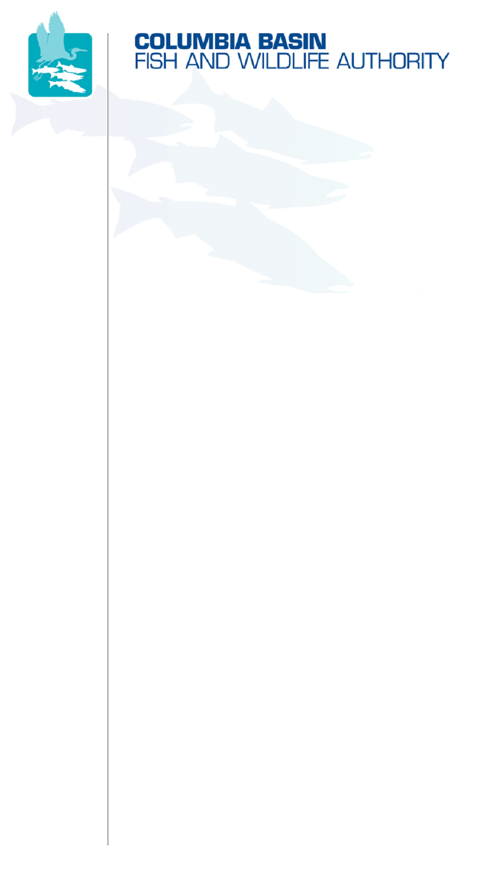
851 SW Sixth Avenue, Suite 260 | Pacific First Building | Portland, OR 97204-1339
Phone: 503-229-0191 | Fax: 503-229-0443 | Website: www.cbfwa.org

Coordinating and promoting effective protection and
restoration of fish, wildlife, and their
habitat in the
Columbia River Basin.

The Authority is comprised of the following tribes
and fish and wildlife agencies:

Burns Paiute Tribe

Coeur d’Alene Tribe

Confederated Salish and Kootenai Tribes
of the Flathead Reservation

Confederated Tribes
of the Colville Reservation

Confederated Tribes
of the Umatilla Indian Reservation

Confederated Tribes
of the Warm Springs Reservation

Confederated Tribes and Bands of the Yakama Nation

Idaho Department
of Fish and Game

Kootenai Tribe
of Idaho

Montana Department
of Fish, Wildlife and Parks

National Marine Fisheries Service

Nez Perce Tribe

Oregon Department
of Fish and Wildlife

Shoshone-Bannock Tribes of Fort Hall

Shoshone-Paiute Tribes of Duck Valley

U.S. Fish & Wildlife Service

Washington Department of Fish
and Wildlife

Coordinating Agencies

Columbia River
Inter-Tribal Fish Commission

Upper Columbia
United Tribes

Compact of the Upper Snake River Tribes

DATE: | October 12, 2007
TO: | Wildlife Advisory Committee (WAC)
FROM: | Ken MacDonald, CBFWA
SUBJECT: | October 24-25, 2007 WAC Meeting Draft Agenda

October WAC Meeting and Amendment Workshop

October 24-25, 2007
9:30 AM – 4:30 PM October 24
8:00 AM – 2:00 PM October 25
@
CBFWA Office - Portland, OR
Teleconference Line October 24: 503-229-0449 ID: 643203
Teleconference Line October 25: 503-229-0449 ID: 695257

The support material and reference documents for the meeting are posted at
http://www.cbfwa.org/committees/Meetings.cfm?CommShort=WAC&meeting=next

Draft Agenda

ITEM 1: | Review and Approve October Agenda
Discussion: | Please review the agenda prior to the meeting to facilitate quick closure on this item.
Recommended Action: | Approve Agenda.
ITEM 2: | Review and Approve August 22, 2007 Action Notes
Discussion: | Please review the notes prior to the meeting to facilitate quick closure on this item.  http://www.cbfwa.org/Committees/WAC/meetings/2007_1024/082207_WAC_ActionNotes.pdf
Recommended Action: | Approve Action Notes.
ITEM 3: | Elect New Vice Chair
Discussion: | Michael Pope’s term as WAC chair is over. Angela Sondenaa will take over the role of Chair and we need to elect a new Vice Chair.
Recommended Action: | Nominate candidates and elect a new Vice Chair.
ITEM 4: | Status of the Resource Report
Discussion: | Review the “final” SOTR template and discuss steps for completion including individual WAC member participation.
Recommended Action: | None unless there are suggestions for minor changes that can be incorporated.
ITEM 5: | CHAP Letter
Discussion: | A letter to the NPCC has been drafted to encourage Council support for exploring Habitat Appraisal and Barter (HAB) and Combined Habitat Assessment Protocols (CHAP) and other ecologically based alternative methodologies to Habitat Evaluation Procedures (HEP) for assigning wildlife credits and future assessments.  http://www.cbfwa.org/Committees/WAC/meetings/2007_1024/CHAP_Letter_from_WAC%20082707rev2(NHI)draft.doc
Recommended Action: | WAC review the letter and decide whether to recommend the letter to MAG for Member consideration as written, with revisions, or not recommend further action.
ITEM 6: | IEAB Task 116
Discussion: | The Independent Economic Analysis Board (IEAB) has completed a draft report for IEAB Task 116. Discuss any concerns and opinions and discuss potential next steps.
Recommended Action: | None, pending discussion
ITEM 7: | Review Bill Booth’s letter to Bonneville and CDAT Response
Discussion: | Information - http://www.cbfwa.org/Committees/WAC/meetings/2007_1024/CDAResponseLtrtoBPABillBooth.pdf
Recommended Action: | Pending Discussion
ITEM 8: | Review BPA Cost Share Letter
Discussion: | Information - http://www.cbfwa.org/Committees/WAC/meetings/2007_1024/CostShareLtrFromBillMaslenBPA_100507.pdf
Recommended Action: | Pending Discussion
ITEM 9: | Wildlife Amendments
Discussion: | The remainder of the meeting, continuing October 25, will be devoted to drafting wildlife program amendments language. The members have approved the wildlife proposed approach and we need to add the details.
Presentations: | Wildlife Amendments Presented to MAG - http://www.cbfwa.org/Committees/WAC/meetings/2007_1024/Wildlife_Amendments_Presentation_MAG_072107_Revised_Final.ppt  Wildlife Amendments Presented to Members - http://www.cbfwa.org/Committees/WAC/meetings/2007_1024/Wildlife_Amendments_Presentation_Member_0918-1907_Final.ppt
Recommended Action: | Draft Wildlife amendment language and identify process to complete by January 31, 2008.

/tmp/in/input.doc

