Proposal ID 20547

PART II - NARRATIVE

Section 7. Abstract

The Yakama Indian Nation has eight ongoing watershed projects in the Yakima Subbasin that are intended to fulfill a common objective: implementing a normative freshwater ecosystem by protecting and restoring habitat for all life stages of anadromous fish. This objective is being carried out by (1) identifying limiting factors for natural fish production (underlying causes) through watershed assessment, (2) developing appropriate tools to protect existing habitat and restore damaged habitat, (3) applying these tools in an efficient manner (i.e. treating causes at the watershed level rather than symptoms), and (4) using knowledge gained in the process to modify our approaches.

Section 8. Project description

a. Technical and/or scientific background

The Yakima River is 214 miles long and drains a watershed of 6,155 square miles (Fig. 1). The river defines the east boundary of the Yakama Reservation. By some estimates, more than 500,000 anadromous salmonids returned to the Yakima River prior to development of the Yakima Subbasin. The river occupied a broad floodplain with a diversity of habitats supporting all freshwater life stages of chinook, coho, sockeye and steelhead. A century of irrigation projects and floodplain development has compromised this natural productivity, but significant opportunities remain for acquiring and actively restoring salmonid habitat. The most critical mainstem reaches are upstream from the Yakama Reservation, where water temperature is conducive to year-round rearing of chinook, coho and steelhead. The Yakama Nation is taking the lead with projects aimed at restoring major components of this ecosystem. This work builds on the Yakima River Basin Water Enhancement Project’s investments in the subbasin, including screening of all major irrigation diversions and the current development of water conservation plans to enhance Yakima River flows.

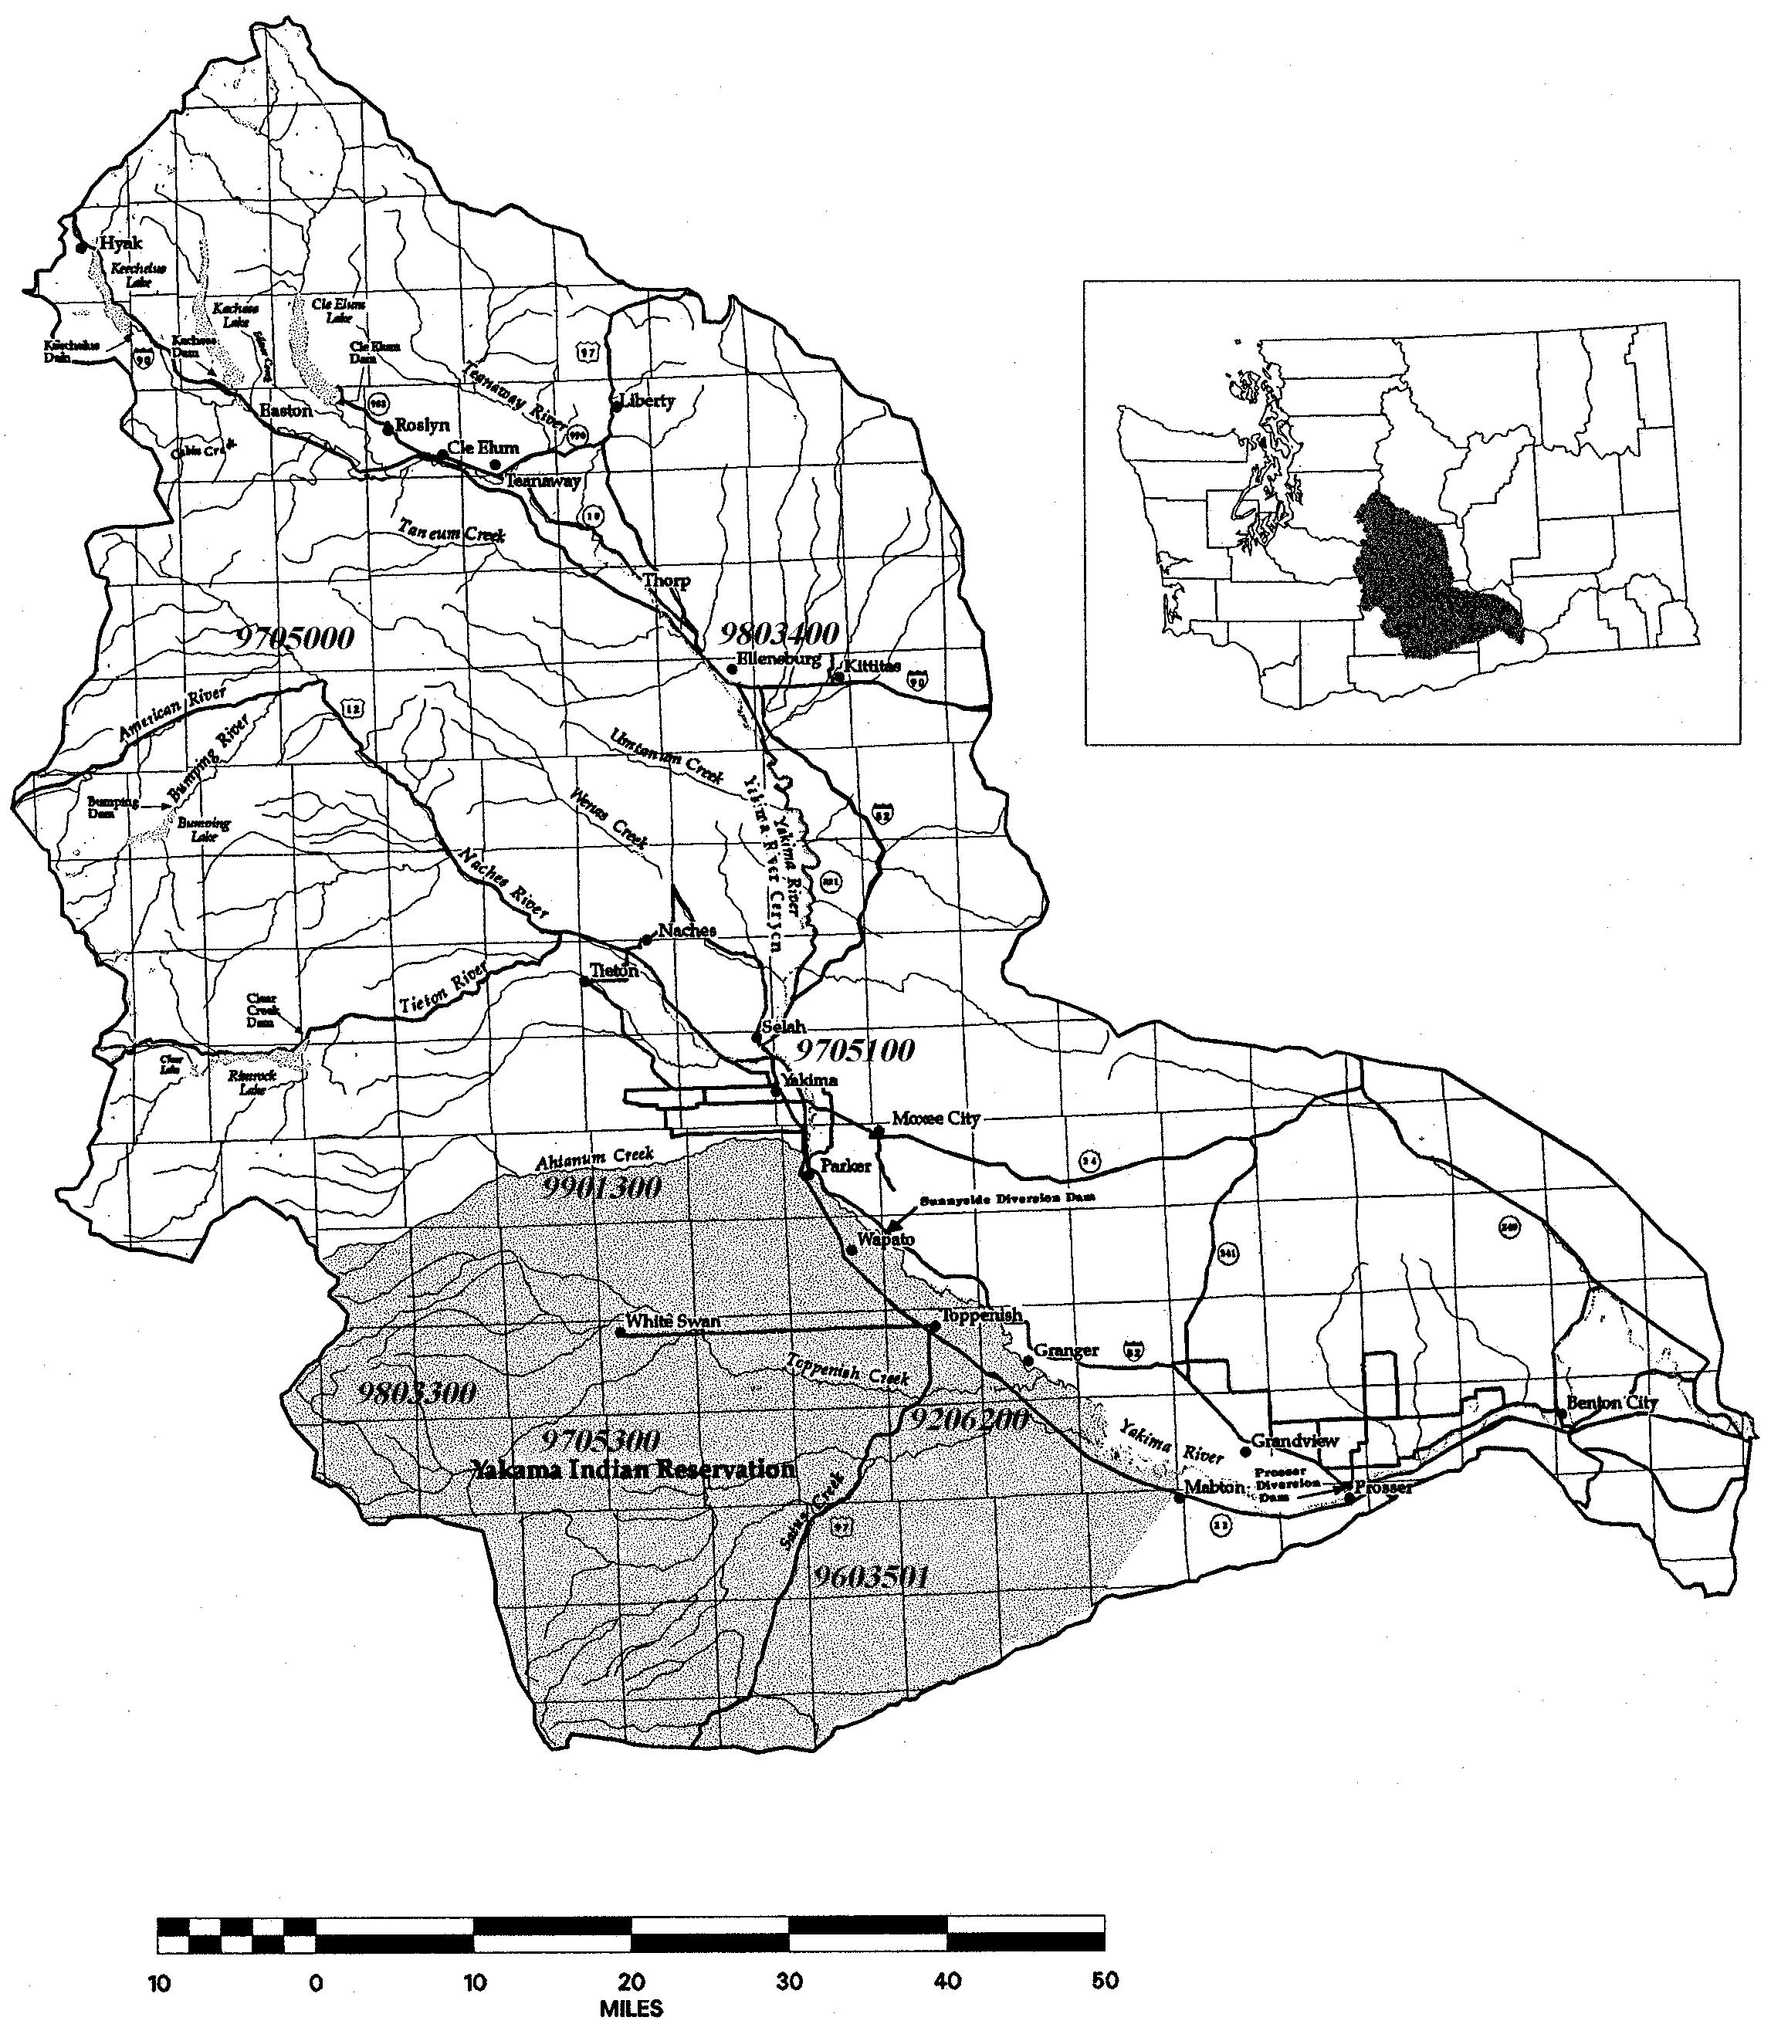

Figure 1. Yakima Subbasin, with general project locations identified by number.
Modified from Yakima River Basin Water Enhancement Project, Washington: Draft Programmatic EIS. USDOI-BOR, 1998.

Since 1979 the Yakama Nation has been investigating fish populations in Yakama Reservation streams, particularly Satus and Toppenish creeks. The Satus and Toppenish watersheds are the second and third largest watersheds tributary to the Yakima River. Each watershed comprises slightly more than 10 percent of the Yakima Subbasin area.
Satus and Toppenish creeks are also the lowermost tributaries of the Yakima River that currently support natural salmonid populations. Salmonid habitat in the two watersheds is affected by low summer flow and high temperature, and by degradation of channel structure and riparian function. Toppenish Creek and its tributaries are diverted for irrigation, and receive sediment-laden return flows. Despite these problems, the two watersheds appear to account for half or more of the current natural production of summer steelhead in the Yakima Subbasin. Satus and Toppenish creeks are therefore a critical resource for recovery of Yakima steelhead (part of the mid-Columbia ESU).
Most of the remaining Yakima River tributary habitat has been lost for anadromous fish production through irrigation development. Some tributaries still maintain adequate flow to support salmonid production, but artificial barriers at or near their confluences with the Yakima River prevent passage. (Passage barriers in Ahtanum Creek have been addressed, although instream flow remains insufficient). Modifying diversions that currently serve as barriers will facilitate upstream and downstream migration of chinook, coho and steelhead and reopen many miles of spawning and rearing habitat.
The Yakama Nation’s current watershed projects were first developed using limiting factor information resulting from 20 years of fisheries evaluations in the Yakima Subbasin. Our experience led to primary authorship of the Yakima Subbasin Plan and leadership of the YKFP. Assessment components were built into these habitat projects to supplement existing data, prior to the latest basin-wide emphasis on watershed assessment.

b. Rationale and significance to Regional Programs

The NWPPC in Section 7 of the Fish and Wildlife Program stresses coordination between habitat actions and artificial production, while acknowledging that coordination will take time to develop. The Yakama Nation has taken a leadership role in both artificial production and habitat protection/restoration in the Yakima Subbasin, and recognizes the two categories of actions as complementary and interdependent.
Subsection 7.1 addresses the importance of genetic diversity. are based on the need to maintain what remains of the original metapopulations of salmon and steelhead, with their inherent diversity. Rearing conditions, for example, are highly variable across the Yakima Subbasin; metapopulation recovery depends on maintaining the diversity resulting from this geographic variability. This need is reflected in our efforts to improve habitat throughout the subbasin.
In Subsection 7.6 the Council states the need to maintain currently functional habitat, then enhance existing but unproductive habitat, then reconnect inaccessible areas. Our efforts covered by this umbrella began in more productive locations, e.g. Satus Creek, and are progressing toward less productive or inaccessible habitat.
Subection 11.3 deals with wildlife measures. The Yakama Nation is stressing coordination between fish and wildlife projects, hence the inclusion of our wildlife mitigation project under this umbrella. This project fits our current strategy to resolve complex fish habitat issues in the Yakima River mainstem and the lower reaches of Reservation tributaries by securing riparian lands.
The Columbia River treaty tribes’ document Wy-Kan-Ush-Mi Wa-Kish-Wit lays out ten recommended actions for the Yakima Subbasin. Actions 3 through 6 are related to structural habitat needs as opposed to water management and artificial production issues. Action 3 states the need for retention or reintroduction of large woody debris. Action 4 calls for protection and rehabilitation of floodplains. Action 5 deals with livestock grazing and construction construction activities in riparian zones. Action 6 reminds managers that many tributary blockages still remain. Each of the eight ongoing projects under this umbrella is targeted at one or more of the four habitat actions called for in the tribes’ planning document.

c. Relationships to other projects

Habitat protection and restoration are interdependent with supplementation as employed under the Yakima-Klickitat Fisheries Project (YKFP). The core hypothesis of the YKFP is that supplementation can increase natural production. Natural production inherently depends on functional habitat, and the YKFP’s hypothesis assumes that suitable but underutilized habitat will be available to supplementation fish returning to the Yakima Subbasin. The projects covered here carry out the complementary functions necessary to fulfilling the YKFP goal.

d. Project history (for ongoing projects)

The Yakama Nation Riparian/Wetlands Restoration Project was funded in 1992 after the Yakama Nation submitted a wildlife mitigation plan to BPA. After completing an implementation plan and environmental assessment in 1994, we began acquisition and management activities resulting in 11,000 acres acquired to date.
The Satus Watershed Restoration Project was one of a few early-implementation watershed projects funded by BPA in 1996. Additional funding in 1996 by the Bureau of Indian Affairs enabled us to secure watershed-monitoring equipment and launch a watershed analysis. The Satus Project was followed in 1997 and 1998 by the six other ongoing projects listed here. Please refer to the individual proposals for historical details on each project.

e. Proposal objectives

Please refer to the descriptions under Methods below, and to the individual proposals.

f. Methods

Ongoing Watershed Projects in the Yakima Subbasin

9603501 Satus Watershed Restoration
Satus Creek, contained entirely within the Yakama Indian Reservation, is the most productive steelhead stream in the Yakima River Subbasin, although steelhead numbers have generally declined since monitoring began a decade ago. The Satus Watershed Restoration Project was conceived as a long-term effort to develop, apply and evaluate cost-effective methods for restoring fish habitat degraded by impaired watershed functioning. Restoration activities also favor riparian dependent wildlife species and reestablishment of coho and spring chinook. The project also makes use of several state and federal funding sources outside BPA. Since its inception in 1996 the project has relocated roads along Satus Creek and two tributaries to upslope locations, eliminated cattle grazing on nearly 200,000 acres of rangeland bordering Satus Creek and major tributaries, and applied a variety of techniques to restore stream channel complexity and riparian vegetation. A watershed analysis was completed in 1998.

9803300 Restore Upper Toppenish Creek Watershed
Toppenish Creek, like Satus Creek, is contained entirely within the Yakama Indian Reservation. The greatest single impact on the productivity of Toppenish Creek is a lack of summer flow. This is partly due to the inability of the upper watershed to store runoff. The project began in late 1998 and is currently in the assessment phase.
In the 2000 project year we intend to use our assessment data to begin restoring the retentiveness of the upper watershed in areas such as meadows and floodplains that have been damaged by road construction and cattle trails. This will include actions that will re-aggrade downcut channels and reconnect alluvial stream reaches with their floodplains. These actions will reduce peak flows and increase base flows, which in turn will allow for better ecosystem function. The project makes use of techniques and equipment from the Satus Watershed Project (9603501) to save money and enhance effectiveness.

9705300 Toppenish-Simcoe Instream Flow Restoration and Assessment
This project focuses on the middle reach of Toppenish Creek, which is currently affected mainly by diversion of instream flow for irrigation purposes. Despite these problems, Toppenish Creek has maintained a steelhead population, one of the few identifiable populations remaining in the Yakima Subbasin.
The project is completing the first season (1998) of assessment, and has succeeded in (1) describing the dynamics of natural and diverted flow through an irrigation season, (2) determining the distribution of juvenile steelhead in the area affected by irrigation, and (3) mapping hydrography and land use in much of the project area.
In the 2000 project year, we will use assessment findings to create a plan to reduce irrigation system inefficiencies and limit summertime diversions while avoiding hardship on local landowners. To do this we are mapping water use by irrigators and defining surface/groundwater dynamics in localized areas. Using this information we will restore instream flows in affected reaches by purchase or lease of irrigated lands, and lease or substitution of water.
We may be able to tailor future diversions to mimic the historic distributary runoff regime, allow recharge of shallow aquifers and promote increased base flow. This will connect the upper and middle reaches of the watershed (see 9803300 above). This project complements the Reservation portion of the Bureau of Reclamation’s Yakima River Basin Water Enhancement Project, which will address irrigation return flows farther downstream in Toppenish Creek.

9206200 Yakama Nation Riparian/Wetlands Restoration
This project was designed to restore wetlands and riparian habitats along the lower reaches of anadromous fish-bearing streams on the Yakama Indian Reservation, mainly the Yakima River, Toppenish Creek and Satus Creek. Overall goals include the protection, restoration and management of 27,000 acres of floodplain lands along the Yakima River, Satus and Toppenish Creeks. Direct mitigation is being realized for wildlife losses identified in the 1994 Columbia Basin Fish and Wildlife Program relating to the construction of the lower Columbia and Snake River Dams. Extensive partnership and cost-share components provide savings to this project.
Land securing methods include purchase, easement, or long-term lease depending on the nature of the land ownership and the cost-effectiveness of the activity. Approximately 2,000-3,000 acres are secured each year, for a total of 11,000 acres to date. Restoration activities seek to restore historic conditions. Native vegetation reestablishment, and a return to the historic hydrologic regime are the goals for individual restoration sites. Restoration efforts are designed to be as self-sustaining as possible to minimize the expense of maintaining habitat function.

9705100 Yakima Basin Side Channels
One of the major hurdles faced by salmon and steelhead juveniles in the Yakima River is the lack of sufficient rearing habitat. The main channel in much of the Yakima River has excessive velocities and fatal or near-fatal temperatures during much of the year. Much of the off-channel habitat in the Yakima has been lost to development in the floodplain.
The Side Channels project focuses entirely on habitat protection and restoration in the Yakima River mainstem, as opposed to the other projects under this umbrella, which focus on tributary systems. This project was conceived to protect functioning off-channel rearing habitats, reconnect currently inaccessible floodplain habitats, and restore off-channel rearing habitat function. Project staff are focusing on reaches with suitable summer temperature, and where off-channel habitat needs protection or can be restored. This project is vital in that it will provide necessary habitat to support YKFP supplementation. Accomplishments to date include appraisals and surveys for pending purchase of a 70-acre parcel, restoration of habitat on a degraded alcove, setting up a temperature monitoring network in target reaches, and outreach to private landowners.

9705000 Little Naches River Riparian and In-Channel Habitat
Federal and state watershed analyses have concluded that past land management including riparian logging and roadbuilding, exacerbated by floods, have damaged salmon and steelhead spawning, rearing and adult holding habitat in some segments of the Little Naches River. We used these analyses to design a monitoring and restoration project.
To date, we have (1) conducted an intensive survey of channel condition, pool area, canopy cover and large woody debris; (2) planted about 3,000 deciduous cuttings on unstable banks, (3) planted 600 conifer seedlings for future LWD recruitment, and (4) submitted a plan for creating velocity refuges with LWD and boulders in the channel for environmental permitting. The Forest Service completed a federal Environmental Assessment and Biological Opinion. With this project we expect to increase the quantity of low-velocity rearing habitat immediately, stabilize banks and filter runoff in two to ten years, and improve canopy cover and LWD loading in 20 to 100 years.

9803400 Reestablish Safe Access Into Tributaries Of The Yakima Subbasin
Diversion dams now block many small tributaries to the Yakima River that formerly served as winter refuges for juvenile salmon and steelhead. Some of these now-inaccessible tributaries nevertheless maintain requisite temperatures, instream flow and water quality throughout the entire year. YKFP participants have found relatively high densities of spring chinook and steelhead below these barriers. A preliminary survey of ten tributaries targeted under this proposal indicates that only 5 percent of historic anadromous fish habitat remains accessible.
This project is designed to assess barriers, remove or replace barriers and screen any unscreened diversions. The added habitat areas will be fenced and revegetated where appropriate. The project is also purchasing land, habitat conservation easements and fencing in order to protect currently functioning habitat.

9901300 Ahtanum Creek Watershed Assessment
Ahtanum Creek was historically important for production of salmon and steelhead. While spring chinook and coho are found in small numbers today, and bull trout inhabit the upper watershed down to the first major irrigation diversion, production is greatly depressed. The major impacts to the watershed in the lower, largely agricultural portion of the watershed include water withdrawals, diking and channelization, adverse grazing impacts, and residential development in the floodplain. A state-sponsored watershed analysis for the upper, forested portion of the watershed is nearing completion.
This project began at the end of 1998. Through the 2000 project year we will be mapping irrigated lands and water delivery systems, measuring water discharge and temperature, and comparing water diversion to on-farm use. Additionally, we are gathering historic and current data on stream channel condition, riparian function and salmonid populations. This information will guide us in how to best manage water use and restore riparian function in the lower portion of the watershed in order to restore salmon and steelhead populations.

New Project

Yakima River Subbasin Assessment
This proposal is a response to the Northwest Power Planning Council’s intention to rely more heavily on watershed assessments for setting restoration priorities and coordinating projects. We propose to perform an assessment of the Yakima River sub-basin, with the goal of providing a framework for future fisheries restoration activities. We will: compile existing information on past and present watershed functioning, fisheries resources, and land and water use; subdivide the watershed by groundwater subbasins; subdivide the subbasins by climate/vegetation factors into watershed units; identify watershed units with high existing or anadromous fishery potential; identify factors limiting fish production. Following field verification, we will synthesize the information to prioritize protection and restoration of habitat, reestablishment of passage, and further analysis needs. A report summarizing the assessment results will be completed in September, 2000.

g. Facilities and equipment

Please refer to the individual proposals for descriptions of facilities and equipment in use or needed by projects.

h. Budget

Please refer to the individual proposals for budget justification narratives.

Section 9. Key personnel

Please refer to the individual proposals for personnel information.

Section 10. Information/technology transfer

Individual projects share information, equipment and staff expertise within the Yakama Nation, and participate in inter-tribal and BPA-sponsored forums. For details please refer to the individual proposals.

