Bonneville Power Administration

2001 Action Plan For Fish in Response to Power System Emergency Solicitation of Proposals

PART 2 of 2. Narrative

Title: LP Ranch Acquisition

Section 3. Project description
Provide project detail for headings a through g.

a. Abstract

The acquistion of the LP Ranch property and associated senior water rights addresses a need for providing additional instream flow in East Birch Creek in 2001 and subsequant years. Purchasing this property creates the rare opportunity to demonstrate the compatablility of similtaneous restoration projects benefitting agriculture, fish and wildlife. Current public opinion indicates this is an unnatural alliance.

This proposal will acquire 1,887 acres of timbered rangeland, .27 cfs of surface water rights, .575 cfs of groundwater rights, 1.5 miles of East Birch Creek habitat and 1 mile of Pearson Creek habitat. The LP Ranch is located 25 miles south of Pendleton, Oregon near Rivermile 11.

Of all the private land holdings along East Birch Creek, past spawinging surveys conducted by the ODFW found the largest number of summer steelhead (ESA listed, Mid Columbia) redd densities per stream mile on the LP ranch property. ODFW considers this "key" Mid Columbia ESU summer steelhead spawning and rearing habitat. Additional fish habitat restoration could be addressed on approximately 1 mile of Pearson Creek(also a Mid-Columbia ESU stream for summer steelhead spawing/rearing) which abuts the western portion of the property(Blakely, ODFW, Pendleton Office).

The purchase of the LP Ranch would provide .27 cfs (with a duty of 3 acre ft./acre per year) of additional instream flow for the Birch Creek system. The existing 1875 surface water right would be leased to Oregon Water Trust to be left instream beginning summer 2001.

The LP Ranch land acquisition will provide additional summer 2001 flow into the Birch Creek system, and create a opportunity to restore approximately 100 acres of riparian/flood plain habitat for summer steel head, non-listed salmon, resident fish and wildlife.

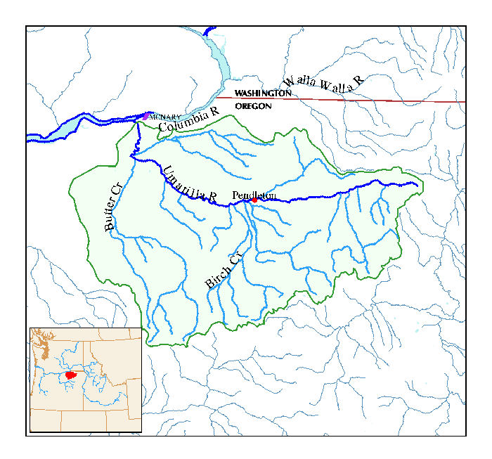

b. Justification as 2001 Action Plan For Fish in Response to Power System Emergency Solicitation of Proposals

Salmonid species in East Birch Creek include summer steelhead and redband trout. These fish are classified as “wild” and are managed for natural production. Birch Creek summer steelhead are part of the Mid-Columbia Evolutionary Significant Unit (ESU) that are presently listed as threatened under the Federal Endangered Species Act. Efforts to protect and enhance salmonid populations throughout the Umatilla River Basin, Birch Creek in particular, have been ongoing for the past several decades. Current flow data indicates Birch Creek flowing at 80% of normal average flow(WRD,Pendleton, May) Reduced flow may have a negative impact on the survival of juvenile steelhead this year.

Past land ownership negotiations did not produce a cooperative ODFW/BPA fish habitat project for this property. Under current requirements, ODFW is unable to purchase this property as a state agency. However, the Umatilla County SWCD through its charter can purchase and hold property. This may be a one time chance to purchase and co-manage, what ODFW considers “key” Mid Columbia ESU summer steelhead spawning and rearing habitat areas.

c. Rationale and relationship to criteria for 2001 Action Plan For Fish in Response to Power System Emergency Solicitation of Proposals

#1 Tributary Flow Increase

Acquisition of the property will provide .27 cfs of additional instream flow through the summer by leasing the surface water right. Upon purchase of the property, the Umatilla SWCD will enter into contract with Oregon Water Trust to lease the existing water rights for summer 2001. In addition to instream flow increases, the irrigation pump will not utilize electrical power in summer 2001.

Juvenile steelhead particularly within tributary watersheds such as Birch Creek move throughout the system to avoid deleterious environmental conditions such as excessive water temperatures, anchor ice formations, flood water, etc. (Contor et al. 1994-2000) Spot electro fishing throughout the year in Birch Creek watershed indicates this kind of movement pattern occurs (ODFW in-house data) ODFW has observed juvenile steelhead and resident trout in the lower portions of the watersheds during the fall and winter and almost none in the same areas during the summer months. Non-smolting juveniles that moved down-system in the winter months must return to the headwater stream in the summer months to avoid excessive and/or lethal water temperatures in the lower reaches (ODFW, Pendleton). Juvenile trapped in the lower part of the basin likely parish.

East Birch Creek is listed as water quality limited for temperature and habitat modification on Oregon’s 1998 303(d) list. The listing for water temperature is based on exceedence of the statewide standard for salmonid rearing (64º F). The listing for habitat modification is based on habitat surveys conducted by ODFW in 1993 and deficiencies identified by comparison to ODFW habitat benchmarks for typical Eastern Oregon streams Table 1. A Total Maximum Daily Load (TMDL) and Water Quality Management Plan (WQMP) were written for the Umatilla River Basin, including Birch Creek, which should lead to water quality improvements over the long term (ODEQ et al 2000).

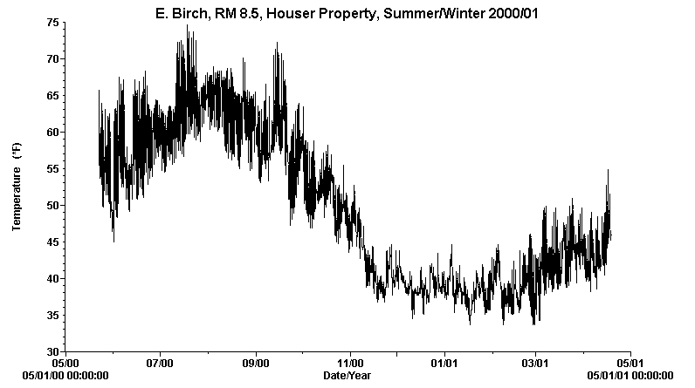

Water temperature data collected from the Houser reach illustrates the importance of East Birch Creek to juvenile rearing salmonids, especially during the summer months (Figure 2).

Data has been collected from the Houser property for the past 11 years with last year’s data (2000/01) illustrated graphically below. The upper lethal limit for steelhead has been reported as 75.02º F with the preferred temperature range of 50º-55.4º F (Bell, M. C., 1986). The lethal limit was established by acclimating steelhead to 68º F water and finding the temperature at which 50% mortality occurred within a 1000-minute (16.6 hr) period. As the graph below illustrates, mean average summertime temperatures are well above the preferred range, however the absolute and the mean average maximum temperature does not exceed the lethal 75º F limit. Habitat improvement could help bring temperatures closer to the preferred range(.BIOLOGICAL ASSESSMENT Middle Houser & Brogoitti Properties East Birch Creek (Umatilla River Basin Tributary) (((\\\

#2 Tributary Habitat Passage Improvements

Upon purchase of the LP Ranch the Umatilla SWCD and ODFW will begin the assessment and design to remove the existing irrigation structure in 2002.

d. Relationships to other projects

(Replace this text with your response in paragraph form)

e. Proposal objectives, tasks and methods

Objectives

R(eplace this text with your response in paragraph form)

Tasks and Methods

(Replace this text with your response in paragraph form)

f. Facilities and equipment

(Replace this text with your response in paragraph form)

g. References

Section 4. Key personnel

(Replace this text with your response in paragraph form)

Attached Photos:
186_2.jpg
186_4.jpg
186_5.jpg

