Project ID: 21014

Title: Mitigate Streambank Sediment Sources in Fifteenmile Watershed using Bioengineering Techniques

Section 9 of 10. Project description

a. Abstract

This project will use bioengineering techniques to address seven active erosion sites on four properties in the Fifteenmile Watershed. The project designs will add structure to the stream, routing high flows away from the erosive banks and dissipating excess hydrologic energy of the stream. Hardening of the banks will be avoided, where possible. All sites will include revegetation of the banks using locally adapted willow cuttings. Six sites will use deflectors or upstream barbs to dissipate and redirect energy. Four sites will replace riparian fencing damaged by erosion. At the two most critical sites, which are quickly eroding tilled fields, banks will be reshaped and strengthened using toe rock and biodegradable geotextile fabric lifts planted with an ODFW-approved native grass mix and locally-adapted willows. All instream work will be accomplished in the instream work window. Private landowners will provide cost-share for all practices, either in cash or in-kind. Reduction of sediment loading from eroding streambanks will benefit winter steelhead and other species.

b. Technical and/or scientific background
The Fifteenmile Creek Subbasin Summary identifies seasonal temperature extremes, turbidity and sedimentation as water quality limitations (p12). The Summary notes that stream channel shifts have occurred during frequent high runoff events (p12). Fifteenmile Creek was extensively channelized in the 1970’s in order to protect valuable cropland and infrastructure. Before and since that time, the stream has suffered from rapid flows, lack of instream structure or habitat diversity, and intense bank erosion. In the past, where bank erosion threatened valuable assets or roads, private landowners and public road crews typically attempted to stabilize the creek using large rock rip-rap, an approach that prevents revegetation of the banks, and does little to dissipate stream energy.
The bulk of the turbidity and sediment issues in Fifteenmile can be traced to either upland agricultural erosion or to excessive streambank erosion. Upland sediment sources are being addressed through on-going SWCD cost-share programs to help farmers convert to no-till and install best management practices. Long-term riparian health is being addressed through efforts by ODFW to lease and fence the stream corridors (199304000) and through USDA/SWCD efforts to implement riparian buffer systems under the Conservation Reserve Enhancement Program.
This proposal complements the upland efforts and the ODFW stream corridor efforts by treating seven high priority streambank erosion sites in a manner that avoids permanent hardening of the banks, dissipates stream energy, contributes to habitat diversity, encourages riparian revegetation, and retains the stream's connection to its flood plain. These sites were chosen because they are contributing high amounts of sediment to the stream and are eroding too quickly to stabilize and revegetate naturally. Bioengineering methods will be used to redirect stream energy away from the eroding banks, reducing erosional pressure, while locally adapted riparian trees and geotextiles will be used selectively to stabilize and revegetate the raw banks. Where erosion has compromised existing fences, they will be replaced further from the stream.
The bioengineering sites are located on four separate properties owned by private landowners. The landowners are concerned by the sediment being contributed to the stream, and in some cases by the threat to valuable cropland or farm structures. The landowners will provide 25% cost-share in the form of either cash or in-kind services.

Figure 1: Bioengineering Site Locations
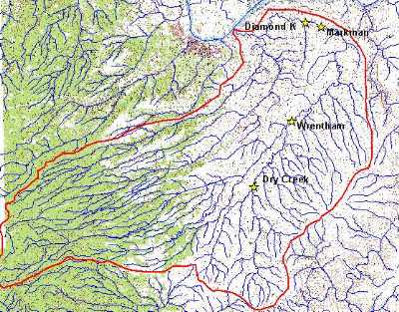
Diamond K: Further erosion at this site on Lower Fifteenmile threatens to contribute massive flushes of sediment to the stream. While the bank will not be hardened at this site, streamflow will be redirected away from the eroding bank with 1 deflector and 1 upstream barb. 300 feet of streambank will be planted with locally adapted willow cuttings to accelerate natural revegetation.

Diamond K Site:
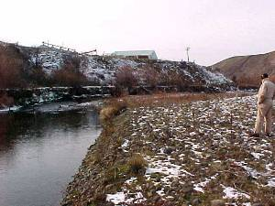
Markman Site 1: While not eroding as quickly as some other sites, the vertical bank at this site has shown very little natural revegetation. 150 feet on the south bank of Lower Fifteenmile will be planted with locally adapted willow cuttings.

Markman Sites 1 and 2
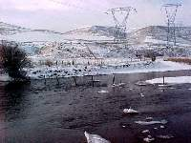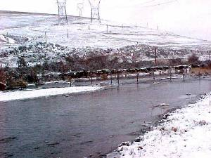
Markman Site 2: Further erosion at this site threatens hillside cropland. While no hardening of the bank is necessary here, redirecting flows and planting cuttings will enhance natural revegetation and stabilization. 550 feet on the north bank across from and upstream of Site 1 will be treated with 4 upstream barbs, willows, and fencing. The fencing at this site will replace fence riparian fence unearthed and left hanging by erosion.
Markman Site 3: This site requires 1 upstream barb to curve stream flow away from an area that has already been treated and planted.
Dry Creek: 240 feet of bank on Dry Creek, a major tributary to Fifteenmile, will be treated with 3 upstream barbs and willows. Fencing will be replaced where it has been compromised by erosion.

Dry Creek Site
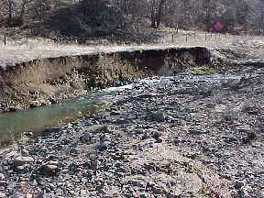
Wrentham: Both Wrentham sites are eroding directly into a crop field. Because the stream is actively eroding tilled soil, it has the potential to erode very quickly, permanently destroying valuable cropland as well as contributing many tons of sediment to the stream. Because of the urgency in these sites, it is crucial to prevent any further movement. For this reason, these banks will be stabilized using bioengineering methods that will produce a dense revegetated riparian area in the long run. Biodegradable, organic fabric material will degrade over time, leaving the riparian vegetation to provide long-term bank stability.
Wrentham Site 1: 250 feet on the south bank of Lower Fifteenmile will be treated with 2 upstream barbs, toe rock and soil-filled fabric lifts, willows and fencing. The biodegradable fabric lifts will be planted with grass seed and willow cuttings.

Wrentham Site 1 and Site 2
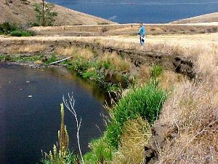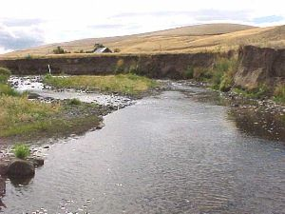
Wrentham Site 2: 475 feet of Lower Fifteenmile directly downstream of Site 1 on the north bank will be treated with 3 upstream barbs, toe rock, soil-filled fabric lifts, willows and fencing. The biodegradable fabric lifts will be planted with grass seed and willow cuttings. The farm operator at this site has agreed to provide a wider riparian buffer in conjunction with this treatment.

c. Rationale and significance to Regional Programs

This proposal will directly contribute to meeting the goals of the following regional salmonid recovery plans.
The Fifteenmile Basin Fish Habitat Improvement Implementation Plan (ODFW and US Forest Service, 1987) identifies lack of channel stability as a limiting factor for fish production in Fifteenmile (p7). The latter plan calls for a goal of less than 20% eroding stream banks, to be achieved by riparian vegetation enhancement and structural treatments (objective 5, p15).
The Columbia Basin Fish and Wildlife Program (1994) calls for maintaining greater than 90% bank stability (section 7.6D, p 7-37).
Wy-Kan-Ush-Mi Wa-Kish-Wit (Columbia River Intertribal Fish Commission, 1995) calls for protection and enhancement of aquatic and riparian habitat and increase of streambank cover (Fifteenmile Subbasin Plan, actions 6 and 9, Volume II, p35).

Protecting and Restoring Watersheds: A Tribal Approach to Salmon Recovery (Columbia River Intertribal Fish Commission, 1999) mentions bioengineering as one form of beneficial active restoration (p40).
The Lower Deschutes Agricultural Water Quality Management Area Plan (Lower Deschutes Local Advisory Committee, 2000), which covers the Lower Deschutes, Fifteenmile and Eastern Columbia Gorge tributaries, sets the goal of reducing active streambank erosion to natural background levels by 2010.
The Draft Fifteenmile Creek Subbasin Summary (Fifteenmile Creek Subbasin Team, 2000) identifies seasonal temperature extremes, turbidity and sedimentation as water quality limitations (p12). The Summary notes that stream channel shifts have occurred during frequent high runoff events (p12). This project corresponds to Action 2.3 in the Subbasin Summary: “Continue instream and riparian habitat restoration efforts in the subbasin”. Left alone, these sites would contribute excessive sediment to the stream for many years. The proposed systems would serve several functions in that they would stabilize the streambanks, restore riparian vegetation, dissipate stream energy, and create some fish habitat.
The project sponsors consulted with the ODFW district fish biologist on these sites. Originally, ten sites were proposed for treatment. The ODFW biologist expressed the opinion that the other three sites were showing sufficient recovery through natural processes and should be left alone. The current proposal is the result of this consultation.

d. Relationships to other projects

Several other projects are proposed or on-going in the Fifteenmile Watershed. The ODFW-sponsored habitat projects (199304000 and the new ODFW proposal, Fifteenmile Creek Riparian Fencing / Physical Stream Survey Project) are designed to allow long-term healing of the riparian corridor and stream habitat. This proposal contrasts with them, but compliments them by bringing immediate improvement to several sites which show little sign of healing naturally and have an intense negative effect on the water quality of their downstream areas. Wasco SWCD has consulted with ODFW on these projects, and has come to agreement with ODFW, as noted in section c, above.
Since 1997, the Fifteenmile Watershed Council (WC) and Wasco County Soil and Water Conservation District (SWCD) have worked to mitigate upland erosion and runoff sources. The two groups have assisted in the conversion of 5,809 acres of conventional wheat-fallow cropland to no-till and 892 acres to strip cropping. The USDA Environmental Quality Incentives Program has funded the conversion of 8,600 acres to no-till. Wasco SWCD and USDA have also assisted the installation of erosion control structures, such as terraces, in many more acres over many years.
The US Forest Service has been implementing a policy of watershed restoration in the headwaters of Fifteenmile and its tributaries, using forest health treatments, road closings, and large woody debris placements.
Wy’East Resource Conservation & Development, a non-profit foundation that works for conservation and economic development in a six county area in North- Central Oregon, has submitted a proposal this year to install weather stations throughout the orchard district of Northern Wasco County. These weather monitors would assist the orchardists in timing of Integrated Pest Management practices, thus reducing the amount of spray applied, and reducing its off-site drift. While the orchard district overlaps somewhat with the Fifteenmile Watershed, the Wy’East proposal more directly affects the Columbia River tributaries between Fifteenmile Watershed and Hood River Watershed.
Taken together, the proposals and other efforts of these partners represent an integrated approach to watershed restoration which addresses the uplands, riparian area, and the stream, and addresses both long-term and immediate needs.
The bioengineering project will require collaboration and coordination between several agencies. All practices will be designed to NRCS Field Office Techical Guide standards, with input from ODFW. Consultation with National Marine Fisheries Service will be required, as well as a Removal/Fill permit from Division of State Lands and Army Corps of Engineers. All work will be accomplished during the late summer instream work window beginning July 1 as specified by ODFW. ODFW may provide some fencing material, input during implementation, and assistance with plantings. Volunteer groups, such as 4H, local schools, or scout troops, will be utilized as much as possible in post-construction planting.

e. Project history (for ongoing projects)
The proposed projects take their inspiration from a bioengineering demonstration project on Lower Fifteenmile Creek coordinated by Wasco County SWCD in 1997 and 1998.
The project treated a 580-foot section of the creek which was rapidly eroding, threatening valuable agricultural lands, and was not revegetating on either bank. The creek flowed westerly, making a sharp, northward curve and creating an 8-foot high unvegetated cutbank on the south side. The opposite bank was a large gravel bar, which was not recovering due to lack of soil and seed source. Near the upper end of the treatment area, a headcut appeared to be migrating upstream.

10-23-97: Fifteenmile Bioengineering Demo, prior to bank stabilization.
Stream has been rerouted in preparation for earthmoving.
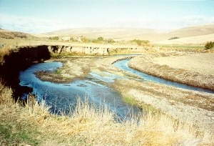
Interfluve, Inc., in consultation with Wasco County SWCD, ODFW, and US Fish and Wildlife Service, and NRCS provided designs that addressed the needs of both banks and the stream channel.
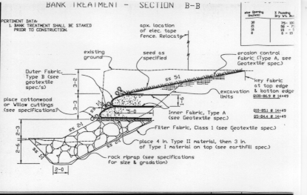During the instream work window of 1997, the headcut was stabilized with large rock, and the south bank was stabilized. Toe rock was placed at the foot of the bank. Above the toe rock, the bank was sloped back at a 2:1 slope, and stabilized with biodegradable geotextile fabrics shaped into soil-filled “lifts”, which were then planted with grass/forb seed and willow cuttings. A fence was also installed.

11-6-97: Fifteenmile Bioengineering Demo, following bank stabilization.
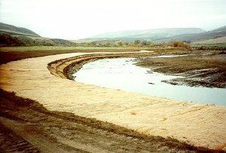
The following spring, volunteer groups assisting the SWCD technician planted the gravel bar on the north bank with several hundred willows. The formerly barren gravel bar now serves as an overflow channel and sediment filter for Fifteenmile Creek, dissipating stream energies and collecting sediment among the planted willows.
5-6-98: Fifteenmile Bioengineering Project, after 10 months.
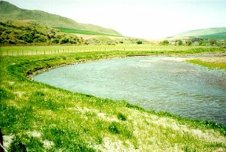
By summer 1998, the fabric lifts were no longer visible under the grass and forbs growing through the weave of the fabric. Willow survival on the south bank was greater than 90%. Survival on the north bank (gravel bar) was virtually 100%.
5-11-00: Fifteenmile Bioengineering Demo, after 3 years.
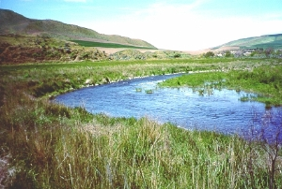

f. Proposal objectives, tasks and methods

Objective 1: Prepare for implementation.
Task a) Prepare and obtain landowner agreements, to provide for access, cost share, and maintenance. Task b) Detailed Design by NRCS/SWCD staff. Designs for rock barbs, fences and plantings will follow NRCS standards and specifications. Bank shaping and fabric lifts will be accomplished according to specifications developed during the Fifteenmile Bioengineering Demonstration Project. Task c) Obtain necessary permits. The SWCD Project Manager will be responsible for obtaining permits. A Removal/Fill permit will be required from Division of State Lands and Army Corps of Engineers. Task d.) An environmental checklist will be completed to assist in NEPA consultations which will be required with National Marine Fisheries Service.
Task e) Cultural resources survey will be conducted at each site. We expect to be able to schedule support from the NRCS Cultural Resource Specialist. Task f) Contract bid packages will be developed to include all materials necessary to solicit bids on the projects. Task g) Contract reviews will be conducted by the SWCD Contract Review Board with assistance from Oregon Dept. of Agriculture to ensure contracts comply with Oregon Contract Law. Task h.) Site shows will be conducted to explain work needed to interested contractors as part of the bid solicitation process. Task i.) Following a formal bid opening, contract will be awarded to the lowest qualified bidder.

Objective 2: Stabilize and revegetate 1,965 feet of actively eroding streambank in Lower Fifteenmile Creek and Dry Creek.
Task 2a) Deflect flow from 1,350 feet of streambank in six locations using 14 upstream barbs and 1 deflector. Shape banks, install toe rock, and biodegradable fabric lifts and seed 725 feet of streambank in 2 separate locations. Detailed construction sequencing will be provided to the contractor. The general procedure is as follows: Stream is temporarily diverted away from eroding bank to minimize turbidity during construction. Bank is temporarily cut back with bulldozer. Toe rock is keyed in along the base of the bank bank. A layer of soil is placed on the toe rock with willow cuttings. Fabric lifts are then added with a layer of soil and willows between. Each fabric lift is filled with soil and grass seed added to the top of the lift. Fabric is then pulled back over soil like a taco shell, enclosing soil and seed. Fabric is anchored with earth staples several feet back from bank. A layer of soil and willow cuttings are laid down. A second fabric lift is laid over willow cuttings, set back from first so as to create a 2:1 slope. Process is repeated until bank is rebuilt. Soil is spread over top lift and sloped back at 10:1, seeded and covered with a light-weight biodegradable geotextile. Stream is released to original channel.
Task 2b) Seed disturbed areas and plant 1,965 feet of streambank with willows or other locally-adapted tree species. Willows are placed at 1-2 foot spacing in soft cutbanks with planting bar.
Task 2c) Install 1,350 feet of fencing in 4 locations. Landowners may build fence themselves or hire contractors. Fences are built to NRCS specifications. ODFW may provide some materials. Landowners submit bills to SWCD. SWCD or NRCS personnel inspect fences. Upon approval of inspection, landowners are reimbursed for a portion of their expenses by SWCD.
Task 2d) Monitor construction while in progress, conduct final inspections for acceptance of contracted work. Construction monitoring includes tracking quantities of material used, adherence to design specifications, and ensuring permitted turbidity limits are not exceeded.
Objective 3: Enhance instream structure in 14 locations.
Task 3a) Install 14 upstream barbs to absorb and redirect stream energy, and to gather sediment and seed source for riparian vegetation (see task 1b).
Objective 4: Maintain sites for at least 10 years.
Task 4a) Prior to implementation, landowners sign agreement accepting all maintenance responsibility for 10 years. The only elements requiring maintenance are fence and riparian vegetation. Upstream barbs which cause flows to curve away from erosion prone banks need to be inspected annually for the first few years until bank vegetation is sufficient to control erosion.
Objective 5: Monitor recovery.
Task 5a) Semiannual photomonitoring. SWCD technician will take photopoints in spring and late summer each year for five years.
Objective 6: Submit required reports
Task 6a) Annual project reports detailing progress will be submitted with a final report upon project completion.

g. Facilities and equipment
Most of the instream work described in this proposal will be accomplished by contractors using their own equipment. Local sources of rock will be utilized. In some cases, rock is available on-site.
Bank shaping and laying of fabric lifts at Wrentham is a heavier task, but will also be accomplished with the contractor’s equipment.
Fencing materials may be available from ODFW, or will be purchased locally.
Willow cuttings can be collected from the Wasco County SWCD Conservation Nursery, located at Boyd Triangle, one mile north of Dufur, Oregon. Native Grass Seed mix is available from local feed stores or from Round Butte, and is commonly used by ODFW for restoration projects.

h. References

Reference (include web address if available online) | Submitted w/form (y/n)
Columbia River Intertribal Fish Commission. Wy-Kan-Ush-Mi Wa-Kish-Wit. 1995 | No
Columbia River Intertribal Fish Commission. Protecting and Restoring Watersheds: A Tribal Approach to Salmon Recovery, 1999 | No
Lower Deschutes Local Advisory Committee. Lower Deschutes Agricultural Water Quality Management Area Plan. 2000
Nelson, Leslie; Fifteenmile Creek Subbasin Team. Draft Fifteenmile Creek Subbasin Summary. 2000 | No
Northwest Power Planning Council. Columbia Basin Fish and Wildlife Program. 1994 | No
ODFW and US Forest Service. Fifteenmile Basin Fish Habitat Improvement Implementation Plan. 1987 | No

Section 10 of 10. Key personnel

Resumes:
Ron Graves
Education: - BS Oceanography, University of Washington 1977
- MS Meteorology and Oceanography,
Naval Postgraduate School Monterey 1982
Employer: Wasco County Soil and Water Conservation District
May 1990 to present
Duties: District Manager with responsibilities for all aspects of District Operations, Administration, Project Management
Recent United States Navy
Employment
1966-1977 Naval Communications Technician
1977-1990 Naval Surface Warfare Officer
Expertise:
Extensive leadership and management experience in the U.S. Navy combined with operational planning experience. High visibility project management experience at Naval Weapons Center, China Lake as project manager for the NATO Anti-Air Warfare System where the Center was Missile Design Agent. Systems engineering was the watchword for that program, where direction was provided to 21 scientists and engineers at the Center and efforts of 5 other nations and 3 U.S. laboratories were coordinated.

Ten years experience in planning and implementing full-scale, holistic watershed health improvement projects using a variety of funding sources.

Recent project completions include the first 6 of 8 Buck Hollow project phases most recent of which was Phase 6, completed in July 1999; a combined Oregon Dept. of Agriculture Planning and Implementation Grant and DEQ Water Quality (319) grant to implement best management practices to reduce erosion and runoff in the Fifteenmile Watershed completed in June 1997; a bio-engineering demonstration project on lower Fifteenmile Creek using multiple funding sources, completed in November 1997; FEMA funded Hazard Mitigation Project completed Oct. 1999; two Oregon Watershed Enhancement Board grants in Fifteenmile Watershed (one completed in 1999 and one in 2000); and two additional DEQ 319 grants in Fifteenmile Watershed, both completed during 1999.

Ryan Bessette
Education: - BS Rangeland Resources, Oregon State University
with minor in Natural Resources, 1992
Employer: Wasco County Soil and Water Conservation District
November 1996 to present
Duties: District Technician, assigned to Buck Hollow, Bakeoven and Fifteenmile Watershed Projects with responsibilities, in planning, implementation, monitoring.
Recent - United States Forest Service
Employment 4/93 - 11/96 Range Technician Mt. Hood NF
6/92 - 2/93 Range Technician Malheur NF 6/91 - 9/91 Range Technician Mt. Hood NF
- Oregon State University
6/90 - 9/90 Research Assistant

Expertise: Has a wealth of experience relating to range and riparian systems. Has experience conducting stream surveys for vegetative cover and stream bank stability. Surveyed mountain streams for fish habitat and livestock impacts. Conducted juniper debris loading operations on various streams. Coordinated several range projects on Mt. Hood NF and Columbia Gorge Scenic Area. Has worked on watershed analysis for White River and Environmental Assessments for various grazing allotments. Supervised and managed cattle grazing activities and monitored vegetative conditions of grazing allotments. Has supervised Youth Conservation Corps, Youth Forest Camp, and Americorps crews in fence construction and provided oversight and inspector duties on fencing contracts and bio-engineering contracts. Has supervised Americorps crews in riparian planting and grass seeding activity. Collected data on research plots of various seeded grasses. Has collected baseline and monitoring data on water quality, flows, and stream geomorphology. Plant identification of forbs, grasses, trees and shrubs.

