Project ID: 21027

Title: Inventory and Assess Amphibian Populations in the Klickitat Subbasin

Section 9 of 10. Project description

a. Abstract

We propose to conduct an initial 5-year inventory and assessment of amphibians primarily within the Yakama Reservation portion of the Klickitat subbasin, with emphasis on tailed frogs (Ascaphus truei) and spotted frogs (Rana pretiosa and Rana luteiventris). Amphibian species richness, relative abundance and density will be estimated through surveys at breeding sites and larval sampling within streams (Heyer et al. 1994). These data will help identify limiting factors and critical habitat areas, may serve as components of ecosystem health assessment, and will establish a baseline for long-term effectiveness monitoring of restoration efforts. Given the lack of amphibian surveys in this subbasin, and potentially very rich herpetofauna, this project is also likely to refine the known range and distribution of several species (Memo from R.B. Bury, November 1997). Baseline data on distribution and abundance of spotted frogs and tailed frogs in particular will be used to determine the potential for more detailed investigations of these species’ habitat relationships and responses to various management actions.

b. Technical and/or scientific background

The Ecosystem Diagnosis and Treatment (EDT) approach calls for assessment of overall ecosystem health by focusing on appropriate “diagnostic” species, and quantifying the effects of habitat attributes on these species at each life stage (NWPPC 1999). This approach holds great promise, but must move beyond focusing on salmon alone in order to better gauge health of the entire ecosystem. Other species groups are particularly valuable in providing independent indicators of specific aspects of habitat quality, without the confounding factors of harvest and multiple habitat influences (as confronted by anadromous fish in their migrations). We propose to initiate the gathering of baseline data needed to monitor watershed health by expanding the EDT concept to other appropriate diagnostic species.

Amphibians are a logical species group to focus on for their direct relationships with riparian habitats, and their sensitivity to hazards in both aquatic and nearby terrestrial environments (USDA, USDI 1993). Amphibians may be the dominant vertebrate predator in many Northwestern streams (Bury et al. 1991), while larval amphibians can comprise the majority of herbivore biomass (Hawkins et al. 1988), and both larvae and adults can serve as the major food source for other species (Walls et al. 1992).

The tailed frog is a highly aquatic amphibian that is extremely sensitive to increased stream temperature and sedimentation (Leonard et al. 1993). This sensitivity is particularly pronounced due to the fact these frogs spend 2 to 4 years as tadpoles, and are highly aquatic, long-lived adults. Of Northwestern frog species, the tailed frog is probably most likely to be affected by degradation and loss of riparian old growth habitats (Blaustein et al. 1995). Further investigation of the effects of logging on this species is urgently needed according to many herpetologists (Nussbaum et al. 1983, Bury et al. 1991). While tailed frogs are excellent indicators of in-stream conditions, data on occurrence and abundance of other, more terrestrial frogs and salamanders are complementary in indicating quality of aquatic and terrestrial conditions combined.

Spotted frogs are also highly aquatic, but are more indicative of pond and wetland conditions. These frogs are in dramatic decline, having been possibly extirpated from the west side of the Cascade Range (McAllister and Leonard 1990). The former spotted frog species has recently been split into the Oregon spotted frog (Rana pretiosa), which is listed as a Federal Candidate species and Washington State Endangered species, and the Columbia spotted frog (Rana luteiventris). These species cannot be differentiated morphologically, and both are likely to occur within the Klickitat subbasin (Dvornich et al. 1997, R.B. Bury memo, November 1997). The Oregon spotted frog is known to occur on the Conboy National Wildlife Refuge (Fig. 1), within the subbasin. The main contributors to the decline of these frogs are believed to be wetland destruction, and introduction of bullfrogs and non-native fish species (Leonard et al. 1993, Nussbaum et al. 1983), all of which have direct impacts on salmon as well. As with all amphibians, the distribution of bullfrogs on the Yakama Reservation is unknown.

The potential causes of spotted frog declines listed above are only a few of the factors suspected in the poorly understood declines of amphibian populations world-wide. Another alarming trend has been in the increased observations of deformed amphibians, which may be caused by parasites, pesticides, fertilizers, or increased ultraviolet radiation penetration due to ozone thinning (North American Reporting Center for Amphibian Malformations http://www.npwrc.usgs.gov/narcam). In October 1999, the Yakama Nation Wildlife Resource Management Program received a report that several frogs missing limbs or parts of limbs had been observed in the upper Klickitat subbasin. The report came just before snow began accumulating in the area, so no immediate follow-up was possible. As part of this project, we would like to survey the upper Klickitat area for deformed frogs and (if substantiated) conduct preliminary investigation of possible causes.

c. Rationale and significance to Regional Programs

This amphibian assessment project will provide baseline data for monitoring, evaluation, and investigation of management activity impacts on important riparian indicator species. These data may aid expansion of the EDT model (the NWPPC’s preferred ecosystem assessment model) to amphibians, as appropriate diagnostic species for building a complete assessment of watershed health. This is consistent with the NWPPC 1994 Fish and Wildlife Plan’s (FWP) systemwide goal of a healthy Columbia Basin (section 2.1), and would be an integral part of assessing ecological health of the Columbia River Basin (section 2.1.A.1). Management recommendations and restoration actions building on this effort would implement the FWP goal of supporting native species in native habitat (section 2.2.A), and would benefit numerous other fish and riparian/aquatic wildlife species. Substantial areas of amphibian habitat were lost all along the Columbia River when the mainstem dams were built. Thus, any restoration and effectiveness monitoring programs that build on these baseline data would be consistent with the FWP wildlife program goal of fully mitigating for wildlife losses from hydropower in the Columbia River Basin.

The inventory and assessment of amphibians are consistent with Program Goals listed by NMFS in their Biological Opinion (All-H paper). The goals of (1) conservation of species, (2) ecosystems and the (3) balancing of needs of other species will be served by this data-gathering effort. Assessment of current distribution and abundance amphibians is needed if we are to identify limiting factors and proceed with restoration and monitoring efforts needed for conservation.

This project falls under the Klickitat Subbasin Summary’s goal A, to “increase the information base necessary to manage fish, wildlife, and habitats”. It is specifically tied to objectives A2: to obtain a “complete inventory of fish and wildlife habitat baseline”, and A3: to “assess population status, habitat relationships and geographic distribution of species about which little is known”. By identifying critical habitat areas for amphibians, this project contributes toward Klickitat subbasin summary objective C3: to “prioritize habitats for protection and restoration for wildlife species”. Although most of the amphibian survey work is to occur on the Yakama Reservation, off-Reservation lands under consideration for acquisition would be surveyed as appropriate (i.e. those with habitats shown to be amphibian-rich by the on-Reservation work). This would support objective C3: to prioritize lands for protection, and would provide baseline data for meeting objective C7: to “monitor restoration and protection activities and evaluate effectiveness to guide adaptive management”.

d. Relationships to other projects

This amphibian assessment project would support the ongoing Yakima Klickitat Fisheries Project Monitoring and Evaluation component (#199812025) as another method of evaluating restoration benefits and effectiveness. Amphibian assessment would also serve this function for the Lower Klickitat Riparian and In-Channel Habitat Enhancement Project (#9705600).

The proposed Inventory and Restore Beaver and Beaver Habitats project and Inventory and Assess Amphibians projects would assist each other in identifying habitats for inventory. Collecting baseline amphibian inventory data would allow for monitoring the beaver project’s effectiveness at creating and improving amphibian habitat. The amphibian project would aid the proposed Klickitat Watershed and Habitat Enhancement Project in identifying key wildlife habitats for acquisition and/or restoration, and would provide amphibian baseline data for effectiveness monitoring.

e. Project history (for ongoing projects)

This is a newly proposed project. No previous amphibian survey work has been conducted on the Yakama Reservation, and very little has occurred within the Klickitat subbasin as a whole.

f. Proposal objectives, tasks and methods

The overall objective of this project is to conduct an assessment of amphibian populations primarily within the Yakama Reservation portion of the Klickitat subbasin (Fig. 1). These data will help refine species’ ranges, identify limiting factors and critical habitat areas, may serve as a component of ecosystem health assessment, and will establish a baseline for long-term effectiveness monitoring of restoration efforts. Determining distribution and abundance of spotted frogs and tailed frogs are primary objectives due to their declining populations and value as indicator species. Clarification of these species’ habitat relationships and responses to various management actions will be an appropriate objective if they are found in adequate abundance. Habitat restoration and maintenance activities targeted specifically at amphibians are not part of the current proposal, but will likely follow as data provide guidance and a means for evaluation of such efforts.

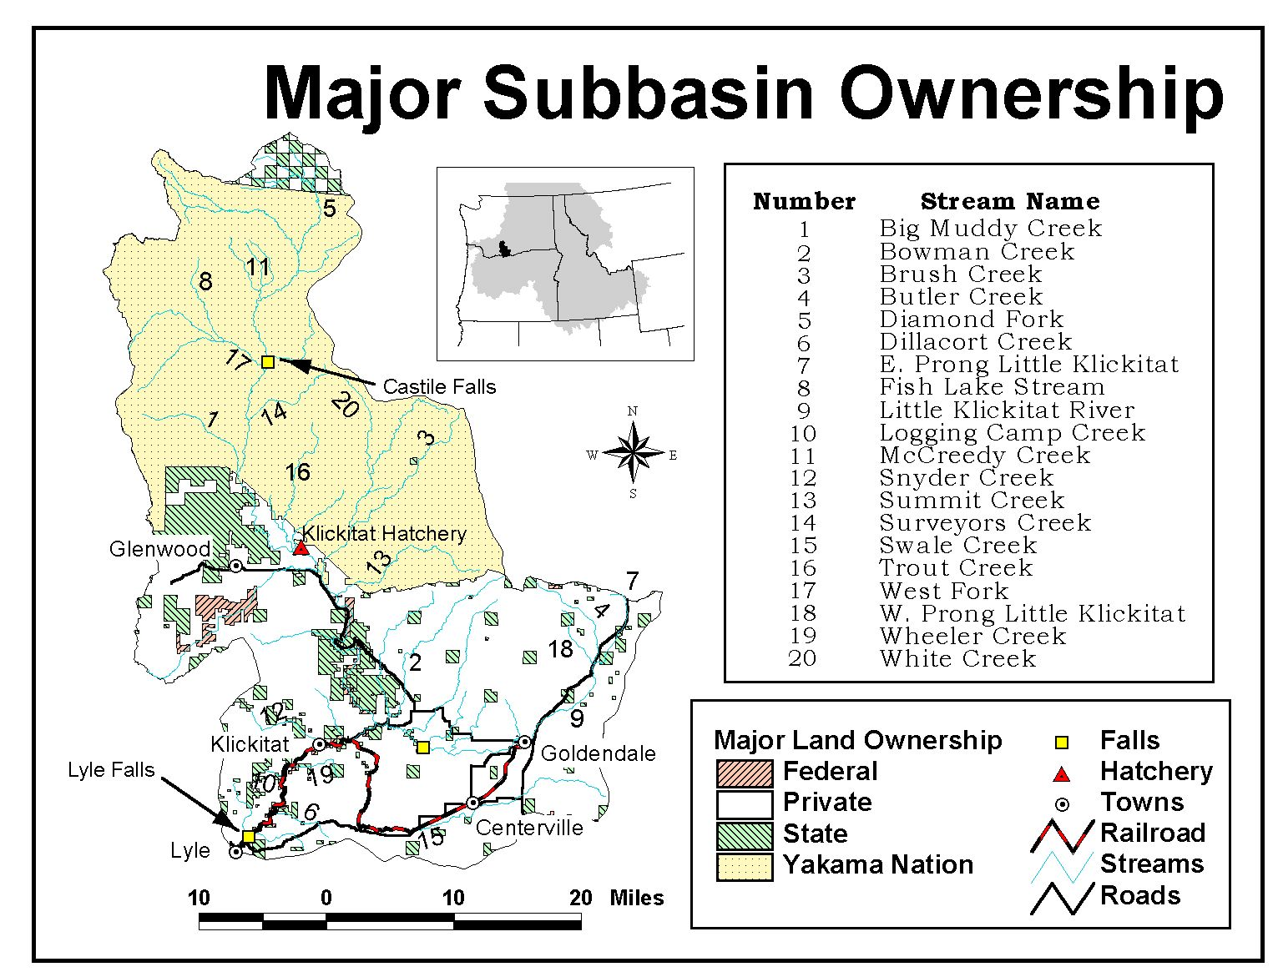
Figure 1. Land ownership within the Klickitat subbasin. The federal parcel south of Glenwood is the Conboy National Wildlife Refuge referred to in the text.

Specific objectives:
1. Develop complete sampling plan
Tasks:
- Define and map breeding sites and stream reaches to be sampled.
Results can be extrapolated only to habitats comparable to those sampled, so careful definition of habitat types is essential to interpretation of the data. In the first year, high-quality tailed frog habitat and spotted frog habitat are to be sampled. Permanent, fast flowing streams in intact forest are to be sampled to maximize potential for detecting tailed frogs (Blaustein et al. 1995). Perennial ponds and lakes edged with marshes, and sluggish streams with thick algal growth comprise potential spotted frog habitat (Nussbaum et al. 1983).
Once these areas are identified, sampling sites can be randomly selected within them. For those species detected at adequate rates in the initial year’s survey effort, sampling may be expanded to enable comparison of species occurrence between additional classes of habitats (e.g. tailed frog occurrence at stream reaches within recently harvested timber sales vs. unlogged areas).
Sites to be sampled must be selected annually (except for those sites designated for monitoring all 5 years). The definitions of habitats to be sampled may be refined in response to habitat relationships that become apparent in the data.
- Define detailed, consistently repeatable sampling protocols for adults and larvae.
The protocols are to include such information as timing of surveys, distance from stream or pond to be sampled for adult amphibians, method for randomizing transect or quadrat placement, type of data to be produced by each method for each species group (e.g. relative abundance for salamanders and density estimates for most frogs), habitat variables to be measured, etc. Regional experts in amphibian sampling will be consulted in developing these protocols, and the Corvallis office of the USGS Biological Resources Division has previously expressed willingness to aid us in study design (Bury memo, November 1997). Protocols are to ensure the sampling method does not significantly degrade sampled habitat, or affect survivorship of detected animals. The exception to this rule may be in the collection of voucher specimens, which are necessary for verifying amphibian species identification data (Heyer et al. 1994). Photographs and tissue samples may have to suffice for verification of very rare species.
2. Train personnel and refine protocol
Tasks:
- Conduct trial runs to test protocol and train Yakama Nation personnel in methods and species identification.
A herpetologist knowledgeable in local species will be contracted to lead the training. The contractor will accompany sampling crews periodically throughout the first two seasons to minimize protocol and identification errors.
- Refine protocol to address local conditions and any problems identified in trial runs.
For instance, variations in weather and seasonal timing substantially influence detection rates of amphibians, and protocols must reflect appropriate timing for the sampling sites (e.g. high elevation sites reach desired conditions later than low elevation sites).

3. Implement sampling plan to conduct initial surveys and begin monitoring
Tasks:
- Conduct initial field surveys.
Conduct sampling within randomly selected sites utilizing the protocol developed under objectives 1 and 2. There may be “initial field surveys” every year, as new sites may be selected annually.
- Conduct repeated sampling to monitor amphibians.
Repeat sampling at sites where amphibian populations are to be monitored over time. These should include sites where no changes in management are anticipated in the near future (to function as a control group), and comparable sites where future activities have the potential to degrade or restore habitats. If possible, surveys should begin at least 2 years before anticipated management actions, in order to establish an adequate baseline.

4. Analyze data and report findings
Tasks:
- Enter, analyze, and summarize data
Summarize species richness by site and across habitat type (e.g. species richness at Yakama Reservation ponds). Summarize relative abundance of species by habitat type. For each species, provide density estimates per site and by habitat type. For sufficiently abundant species occurring at a wide range of observed densities, investigate relationship between density and key habitat variables. Tailor subsequent sampling efforts toward clarifying species-habitat relationships for these species. If tailed and/or spotted frogs are encountered, investigate differences between sites where they were present vs. absent (and target subsequent years’ data collection toward clarification of factors influencing distribution).
- Prepare reports and solicit review
Annual reports are to be sent to regional amphibian experts and other scientists for review, in order to solicit recommendations for further data analyses, interpretation, and subsequent data collection efforts. After multiple years of data gathering, findings may be prepared for presentation at scientific meetings and publication.

5. Expand sampling to potential acquisition sites
Tasks:
- Identify amphibian habitat sites for potential acquisition or restoration.
On lands under consideration for acquisition under the proposed Restore Klickitat Watershed Habitats Project, identify areas likely to support high amphibian densities or rare amphibian species, and areas appearing likely to serve these functions with management changes. These are to be identified utilizing known habitat associations refined using the first year’s data from the Yakama Reservation and any additional Klickitat subbasin data available from the U.S. Fish and Wildlife Service’s spotted frog surveys on the Conboy National Wildlife Refuge. (No amphibian surveys have yet been conducted in this subbasin by the Washington Dept. of Fish and Wildlife [David Anderson, personal communication]). Some of the planning and design expenses projected for FY02-FY05 on the budget form are for this work, although this task is not specifically listed because it begins in FY02.
- Identify appropriate protocol for each site.
Some sites would be surveyed simply to assess species richness and possible presence of sensitive species, in order to prioritize these lands for purchase or restoration. Where purchase or restoration are better assured, a more rigorous protocol would be appropriate, in order to establish a baseline for monitoring. As above, some of the planning and design expenses projected for FY02-FY05 on the budget form are for this work.
- Conduct amphibian surveys on selected properties
Survey selected properties by protocol selected under 5B. Landowner permission will need to be obtained for properties the Nation does not yet own, and Washington state permits will be needed for work involving handling or collection of amphibians outside of the Yakama Reservation.

g. Facilities and equipment

The Yakama Nation employs one of the largest tribal natural resource programs. The Wildlife Resource Management Program employs 8 professional wildlife biologists, a planner, an archaeologist, 20 permanent technicians, a large number of trained seasonal technicians, and a competent administrative staff. The Program has a large number of leased and tribally owned vehicles, and any additional vehicles necessary for the project can be leased through GSA. The Nation provides a large infrastructure of administrative support and facilities, including a well-equipped and highly skilled Geographic Information Systems program.

h. References

Reference (include web address if available online) | Submitted w/form (y/n)
Blaustein, A.R., J.J. Beatty, D.H. Olson, and R.M. Storm. 1995. The Biology of Amphibians and Reptiles in Old-Growth Forests in the Pacific Northwest. USDA Forest Service Gen. Tech. Rep. PNW-GTR-337. Portland, Oregon. 98 pp.  Bury, R.B., P.S. Corn, K.B. Aubry, F.F. Gilbert, and L.L. Jones. 1991. Aquatic amphibian communities in Oregon and Washington. In Wildlife and Vegetation of Unmanaged Douglas-fir Forests. Ruggiero, L.F., K.B. Aubry, A.B. Carey, M.H. Huff, tech. cords. USDA Forest Service Gen. Tech. Rep. PNW-GTR-285. Portland, Oregon. 533 pp.  Bury, R.B. memo to Eric Hanson of Yakama Nation Wildlife Program, November 18, 1997.  Dvornich, K.M., K.R. McAllister, and K.B. Aubry. 1997. Amphibians and reptiles of Washington State: Location data and predicted distributions. Volume 2 in Washington State Gap Analysis – Final Report (K.M. Cassidy, C.E. Grue, M.R. Smith, and K.M. Dvornich, eds.). Seattle Audubon Society Publications in Zoology No. 1, Seattle, 538 pp. http://salmo.cqs.washington.edu/~wagap/herps/index.html  Hawkins, C. P., L. J. Gottschalk and S. S. Brown. 1988. Densities and habitat of tailed frog tadpoles in small streams near Mt. St. Helens following the 1980 eruption. J. N. Am. Benthol. Soc. 7 (3): 246252.  Heyer, W.R., M.A. Donnelly, R.W. McDiarmid, L.C. Hayek, and M.S. Foster, eds. 1994. Measuring and Monitoring Biological Diversity: Standard Methods for Amphibians. Smithsonian Press, Washington DC. 364 pp.  Leonard W.P., H.A. Brown, L.L. Jones, K.R. McAllister, and R.M. Storm. 1993. Amphibians of Washington and Oregon. Seattle Audubon Society, Seattle, Washington. 168 pp.  McAllister, K.R. and B. Leonard. 1990. 1989 progress report: past distribution and current status of the spotted frog in western Washington. WA Dept. of Wildlife Non-game Program Report, Olympia, Washington. 16 pp.  Northwest Power Planning Council (NWPPC). 1999. The EDT approach, August 1999 draft. http://www.nwframework.org/overview.html  Nussbaum, R.A., E.D. Brodie, and R.M. Storm. 1983. Amphibians and reptiles of the Pacific Northwest. University Press of Idaho, Moscow, Idaho. 332 pp.  USDA Forest Service and USDI Bureau of Land Management. 1993. Draft supplemental environmental impact statement on management of habitat for late-successional and old-growth forest related species within the range of the northern spotted owl (Northwest Forest Plan). USDA Forest Service, USDI Bureau of Land Management, Portland, OR.  Walls, S.C, A.R. Blaustein, and J.J. Beatty. 1992. Amphibian diversity of the Pacific Northwest with special reference to old-growth stands. The Northwestern Environ. J. 8:53-69. | Y (BuryMemo.doc)

Section 10 of 10. Key personnel

Gina M. King – Forest Wildlife Biologist/Spotted Owl Project Leader
Employed by the Yakama Nation since 1990
Certified Wildlife Biologist, the Wildlife Society, 1999

University of Washington- Seattle, WA
B.S.- Zoology, 1988 (magna cum laude)

University of California- Berkeley, CA
M..S. - Wildland Resource Science, 1992
Thesis: “Habitat characteristics of northern spotted owls in eastern Washington”

Jeffrey S. Feen – Wildlife Biologist
Employed by the Yakama Nation since 5/97
Certified Wildlife Biologist, the Wildlife Society, 1999

The Pennsylvania State University – State College, PA
B.S. – Forest Science, 1990
Minor - Wildlife & Fisheries Science

Oregon State University – Corvallis, OR
M.S. – Forest Science, 1997
Minor - Wildlife Science

Will Conley – Habitat Restoration Specialist
Employed by the Yakama Nation since 6/2000

University of Maine – Orono, ME
B.S. – Wildlife Ecology, 1996

University of Wyoming – Laramie, WY
M.S. – Rangeland Ecol. & Watershed Mgmt. - Water Resources Option, 2000
Minor - Soils

