Bonneville Power Administration

FY 2001 High Priority Project Proposal Review

PART 2 of 2. Narrative

Title: Klickitat Subbasin Key Habitat Acquisition

Section 3. Project description
Provide project detail for headings a through g.

a. Abstract

This project is designed to preserve and protect in-channel, riparian and associated upland habitats along anadromous fish bearing streams in the Klickitat Subbasin. Long-term protection, restoration and management of large habitat acreages within the subbasin are required to meet the needs and goals of a healthy watershed.

Existing steelhead spawner survey data and Ecosystem Diagnosis and Treatment Model (EDT) analysis demonstrates that the lands for immediate acquisition support steelhead populations, and demonstrate high stream preservation potential.

The initial phase of this project will protect in perpetuity riparian corridor and associated uplands that support “threatened” Klickitat steelhead (summer and winter run) and other salmonids. This proposal identifies 959 acres (Appendix A) for immediate purchase with remaining funds used for future purchases and one FTE to develop the administrative support to implement purchase of important habitat elsewhere in the subbasin.

Logging Camp Creek land acquisition is the fee simple purchase of 380 acres, which provide 4,620 liner feet of stream frontage. Logging Camp Canyon is a west bank tributary, which enters the Klickitat River at River Mile 9.5. The Canyon creek has 2.5 miles of quality spawning and rearing habitat accessible to anadromous fish stocks. Logging Camp Canyon provides one of the last best vestiges of quality habitat in the lower basin.

Dillacort Canyon acquisition is the fee simple purchase of 579 acres of land including 6,000 linear feet of Dillacort Creek and 6,500 feet of Klickitat River. Dillacort is an east bank tributary, which enters the Klickitat River at River Mile 5½.

Future land securing methods are envisioned to include purchase, easement, or long-term lease depending on the nature of the land ownership and the cost-effectiveness of the activity. Potential restoration efforts will be designed to be as self-sustaining as possible to minimize the O&M needed to maintain habitat values.

Extensive partnership and cost-share components will provide savings to this project.

b. Justification as high priority

As identified in the Northwest Power Planning Council’s (Council) 2000 Columbia River Basin Fish and Wildlife Program Report this proposal addresses the action to “preserve habitats that are intact and restorable”.

This proposal will benefit ESA “threatened” Klickitat River summer and winter steelhead. Additionally, rearing and migratory habitat will be protected for spring and fall chinook, coho and resident fishes, by securing these lands through acquisition. Upland wildlife species will also benefit from preservation of oak woodlands, which are identified by Washington Department of Fish & Wildlife (WDFW) as a high priority habitat for preservation.

Land acquisition for conservation eliminates the need for restoration “triage” forever. The Columbia Land Trust (CLT) and Yakama Nation Fisheries Program (YNFP) mission and purpose is to manage land for habitat and conservation in perpetuity. This proposal would acquire these lands containing important salmon habitat at a 30% reduced cost. Protecting a large single-ownership parcel now is much cheaper than acquiring multiple parcels subsequent to subdivision. If subdivision of these property occurs it will seriously diminish if not completely extinguish steelhead re-colonization.
The Logging Camp Creek and Dillacort parcels watersheds are located in a portion of the county which is experiencing rapid subdivision and domestic development. Klickitat County’s Critical Area Ordinance is currently under appeal. It is being challenged for not adequately protecting riparian and floodplain habitats. This project will secure a large area of land in perpetuity to protect lower basin steelhead habitat.

Recently completed EDT analysis for Klickitat steelhead identifies Reach 3A (Lyle Falls –2.2 to Swale-RM 17.2) as a very high priority for preservation (Fig. 1.). This reach ranked 2 out of 44 reaches modeled. Reach 3A is the primary migration corridor for all steelhead production within the basin. Additionally, reach 3A provides key summer and winter rearing for progeny from mainstem spawners as well as the progeny from lower basin tributaries. Both Logging Camp and Dillacort Creek feed into this reach of the mainstem at rivermiles 9.5 and 5.5 respectively. It is the contention of YN fisheries professionals that the majority of annual production from lowers basin tributaries (Logging Camp, Dillacort, Wheeler, Swale Creeks) emigrates to rear in this portion of the mainstem. A smaller portion of the steelhead juveniles do remain in the upper and middle reaches of these lower basin tributaries if they can find adequate rearing habitats. Preservation of this portion of the Klickitat mainstem and these lower basin tributaries should be of the highest priority.

Preservation Benefit - Klickitat Steelhead EDT Analysis
 | Combined Ranking |  | Diversity Index |  | Productivity |  | Abundance
Reach | Benefit  Category | Rank | Rank | DI | Rank | Productivity | Rank | New
Columbia R: Cowlitz R-Bonneville Dam | A | 1 | 1 | 37.6% | 1 | 34.8% | 1 | 59.7%
Klickitat-3A | A | 2 | 2 | 25.3% | 3 | 17.6% | 2 | 36.7%
Columbia R: Bonneville Dam-Klickitat R | A | 3 | 3 | 19.6% | 2 | 18.0% | 3 | 31.7%
White Creek-1 | A | 4 | 5 | 9.9% | 4 | 17.2% | 5 | 20.2%
Klickitat-4 | A | 5 | 6 | 9.4% | 9 | 8.6% | 4 | 23.9%
Surveyors-1 | A | 7 | 8 | 9.0% | 5 | 13.9% | 8 | 14.4%
Columbia R: RM 49-Cowlitz R | A | 7 | 7 | 9.3% | 7 | 9.8% | 7 | 16.9%
Trout-2 | A | 8 | 10 | 8.6% | 6 | 11.5% | 9 | 11.4%
Klickitat-5 | B | 9 | 11 | 8.0% | 10 | 7.8% | 6 | 17.1%
Little Klickitat-5 | B | 10 | 4 | 10.9% | 12 | 6.1% | 14 | 7.5%
Trout-1 | B | 11 | 14 | 5.2% | 8 | 9.0% | 11 | 9.8%
Little Klickitat-2 | B | 12 | 12 | 6.6% | 12 | 6.1% | 12 | 8.1%
Little Klickitat-6 | B | 13 | 9 | 8.7% | 13 | 5.3% | 18 | 6.1%
Klickitat-10 | B | 14 | 17 | 3.9% | 16 | 4.9% | 10 | 10.3%
Little Klickitat-4 | B | 15 | 13 | 5.3% | 16 | 4.9% | 15 | 7.2%
Klickitat-3B | B | 16 | 15 | 5.0% | 20 | 3.7% | 13 | 8.1%
Little Klickitat-1 | B | 17 | 16 | 4.1% | 20 | 3.7% | 19 | 5.3%
Bowman-1 | B | 18 | 21 | 2.4% | 16 | 4.9% | 20 | 4.9%
Summit-1 | C | 19 | 19 | 3.4% | 17 | 4.1% | 22 | 3.9%
Swale-1 | C | 20 | 20 | 3.3% | 26 | 1.2% | 17 | 6.2%
Little Klickitat-3 | C | 21 | 18 | 3.7% | 22 | 2.0% | 24 | 3.5%
Bear Cr-1 | C | 22 | 24 | 2.0% | 20 | 3.7% | 23 | 3.5%
Klickitat-9 | C | 23 | 30 | 1.1% | 23 | 1.6% | 16 | 7.1%
Klickitat-8 | C | 24 | 24 | 2.0% | 22 | 2.0% | 25 | 3.2%
Outlet-1 | C | 25 | 22 | 2.1% | 26 | 1.2% | 28 | 2.1%
Klickitat-1A | C | 26 | 25 | 1.9% | 26 | 1.2% | 27 | 2.6%
Klickitat-11 | C | 27 | 30 | 1.1% | 29 | 0.8% | 21 | 4.2%
Klickitat-1B | C | 28 | 26 | 1.7% | 29 | 0.8% | 29 | 2.1%
Klickitat-13 | C | 29 | 30 | 1.1% | 29 | 0.8% | 26 | 3.2%
Klickitat-12 | C | 30 | 31 | 0.6% | 30 | 0.4% | 34 | 0.8%
Little Klickitat-7 | C | 31 | 27 | 1.4% | 55 | 0.0% | 33 | 1.1%
West Fork Klickitat-1 | C | 32 | 34 | 0.1% | 55 | 0.0% | 30 | 1.4%
Swale-2 | D | 33 | 34 | 0.1% | 55 | 0.0% | 32 | 1.2%
Diamond-2 | D | 34 | 34 | 0.1% | 55 | 0.0% | 43 | 0.1%
Fish Lake-1 | D | 35 | 55 | 0.1% | 55 | 0.0% | 31 | 1.3%
Klickitat-16 | D | 36 | 54 | 0.0% | 55 | 0.0% | 35 | 0.5%
Diamond-1 | D | 37 | 54 | 0.0% | 55 | 0.0% | 36 | 0.5%
Klickitat-18 | D | 38 | 54 | 0.0% | 55 | 0.0% | 37 | 0.4%
Klickitat-15A | D | 39 | 54 | 0.0% | 55 | 0.0% | 38 | 0.3%
Klickitat-17B | D | 40 | 54 | 0.0% | 55 | 0.0% | 39 | 0.3%
Klickitat-15B | D | 41 | 54 | 0.0% | 55 | 0.0% | 40 | 0.2%
Klickitat-17A | D | 42 | 54 | 0.0% | 55 | 0.0% | 41 | 0.2%
Huckleberry-1 | D | 43 | 54 | 0.0% | 55 | 0.0% | 42 | 0.1%
McCreedy-1 | D | 44 | 54 | 0.0% | 55 | 0.0% | 44 | 0.1%
Figure 1.

It is widely accepted by many fishery professionals that intermittent streams or streams with extreme summer low flow (like Dillacort) tend to produce anadromous over resident life histories for O. mykiss. While resident trout may not be able to endure the low summer flows, steelhead populations can.
This is a function of sub lethal maximum water temperatures and poor flow conditions, which results in increased metabolism (daily caloric intake) and decreased food intake due to reduced drift. Hubble (1992) documented a body condition for age 1+ steelhead in the Status basin from spring to fall, which was attributed to increased metabolism and decreased caloric intake due to high water temperatures and low flows. These harsh environmental conditions favor anadromous (steelhead) because they spend less time residing under these conditions. Dillacort Creek is an intermittent/low summer flow tributary. This creek favors the recolonization of steelhead.

Section 3c

Has the proposed strategy been broadly recognized as achieving direct fish and wildlife benefits?

As identified in the Council’s 2000 F&W the proposed approach is to preserve habitats that are intact and restorable, as all immediately available properties within this proposal are. This strategy is reiterated by the Washington State Salmon Recovery effort to “protect the best and restore the rest”.

What permitting and/or landowner agreements are required to begin this work?

For properties identified in their proposal, a landowner agreement has been developed between the property owner and CLT.

Will all required permits or agreements be completed by September 30, 2001? Identify the date you anticipate work to commence?

Land Acquisition projects do not require permitting. It is anticipated that the project can begin immediately.

c. Rationale and relationship to criteria for high priority projects adopted in the 2000 Fish and Wildlife Program

The Klickitat River is currently the only totally unencumbered free-flowing salmonid-bearing river in the Columbia Gorge Province. The uniqueness of this makes it an ideal experiment to test management strategies in a pristine situation compared to those found in more degraded systems. Because of this, the need for habitat protection and restoration in the Klickitat Basin is well documented (Sharp 2000, WSCC 1999, CRITFC 1995a,b). Supplementation actions, though very successful in maintaining a fishery over the course of many years, must be supported by habitat if the long-term potentials of the Basin are to be realized (CRITFC 1995b).

The prioritization of potential habitat protection and restoration areas will occur the first year of project implementation. The prioritization process will identify areas that are important or potentially important for fish and wildlife needs. Geological, hydrological and vegetative processes will be identified and used to establish priorities. Areas will be identified which will provide the highest potential for reestablishing floodplain function, riparian connectivity, and the restoration of normative hydrologic processes. Evidence of historic and present use of areas by anadromous fish and important wildlife species will be utilized as well (Example, Fig. 2). Restoration potential of a property will be determined by examining the cost and effort associated with meeting the needs identified for the priority area. For example, those areas within which floodplain reconnection can occur through the removal of a levee or other obstruction often represent high restoration potential. Cost-effectiveness and long-term maintenance issues will comprise important components of the prioritization process. A list of prioritization issues is provided in Figure 3.

Plans will be completed to restore native habitats in a manner consistent with each property’s physical, biological and cultural landscape contexts. This will provide the sustainable benefits to multiple species needs for the least overall cost in the long-term (CBFWA 1998). It is anticipated that much of the restoration activities will be performed with cost-share funds. The YN Wetlands and Riparian Restoration Project (No. 9206200), the methods of which much of this project will be based upon, conducts nearly all of its annual restoration activities with funding sources other than BPA. Cost share possibilities include: USDA Conservation Reserve Enhancement Program (CREP), USDA Wetlands Reserve Program (WRP), USFWS North American Wetlands Conservation Act (NAWCA), BOR Wetlands Restoration Program, Washington State Salmon Recovery Board, as well as many small grant opportunities (Hames 2000).

Preliminary estimates based on land availability and market value suggest the possibility of securing 300-800 acres per year. This will increase as the project priorities are established and land securing funds established. Proposed methods include purchase, easement or long-term lease according to the need of the priority area and particular land being secured.

Future land securing efforts will conform to those established by the Council's amendment process. These will likely take the place of the above-mentioned approach when it is implemented Basin-wide. A fund to facilitate purchases throughout the Klickitat Basin involving multiple entities could result from this effort.

Long-term management and monitoring efforts will be conducted in the context of ongoing activities outlined in the Klickitat Subbasin Summary (Sharp 2000, pgs. 45-46). Though restoration activities will emphasize sustainability, property management will always be necessary to ensure that the restored conditions are maintained (Tenenbaum 2000). Wildlife and cultural resource monitoring activities will occur according to protocols patterned after the YN Wetlands and Riparian Restoration Project (Hames 2000). Specific monitoring needs will also be developed during the restoration prioritization process.

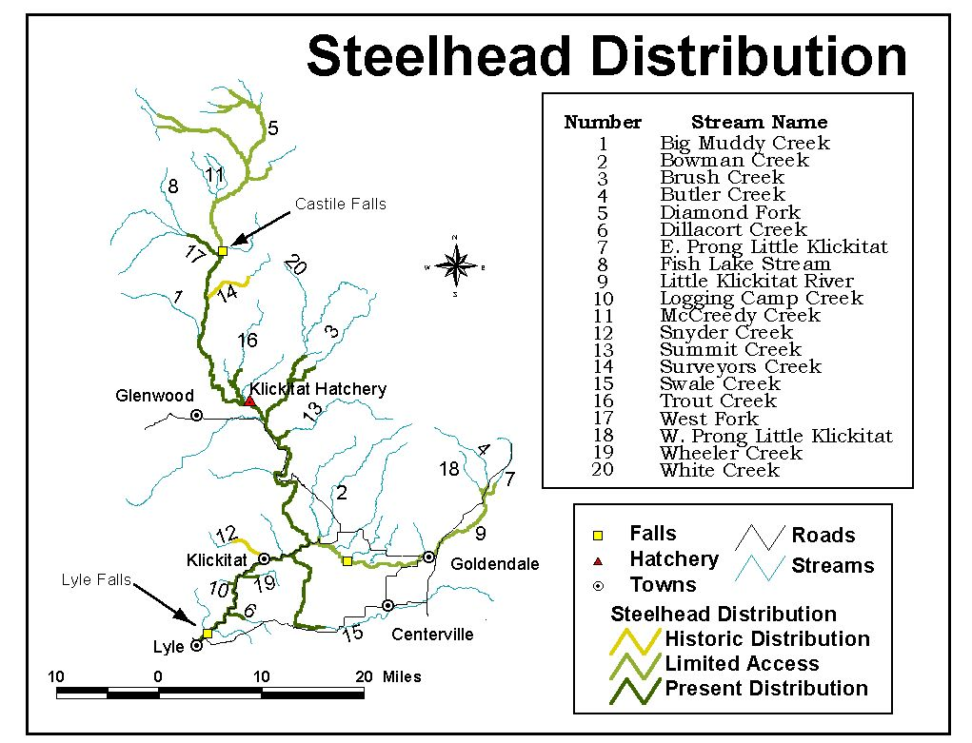
Figure 2. Example of historic and present steelhead use of the Klickitat Basin.

Criteria for Land Purchase Prioritization

- Is it within an identified priority area for the watershed?
- Is it within the geomorphic floodplain of the river?
- Is the hydrology easily restorable (by removing levee or reconnecting channel, etc)?
- Could the property provide spawning, wintering or migration habitat for salmonids?
- Is the landscape intact, or has it been leveled?
- How important is the creek or river for the salmon resources of the subbasin?
- Is the area within an upwelling zone of the river?
- Is the project (purchase, restoration and operation) cost-effective?
- Are there partners or other entities that could provide cost savings to the project?
- Will there be wildlife as well as fish benefits?
- Will the project protect or help restore listed species?
- How is the project connected to other properties within the watershed?
- What is the long-term management potential of the property?
Are there important cultural or archaeological resources on the property?
Figure 3.

Does the proposal produce largely self-sustaining habitat after activities are completed?

This project will protect in perpetuity large tracts of habitat that are in most cases bordered by exiting state or tribal lands under similar preservation strategies.

Logging Camp Creek Acquisition:

Logging Camp Canyon land acquisition proposal is the fee simple purchase of 380 acres of land, which provide 4,620 linear feet of stream frontage. Logging Camp Canyon is a west bank tributary, which enters the Klickitat River at River Mile 9.5 in Klickitat County. The Canyon creek has 2.5 miles of quality spawning and rearing habitat accessible to anadromous fish stocks. Logging Camp Canyon provides one of the last best vestiges of quality habitat. It has a dense forest canopy and suitable water temperatures. Purchase of this property will ensure that steelhead spawning and rearing habitat will be protected from development and degradation. Wild Klickitat River steelhead (summer and winter run) are federally “threatened” stocks which have limited tributary spawning and rearing opportunities in this portion of the basin. This proposal will complement the following habitat restoration activities currently underway within Logging Camp Canyon: 1) Klickitat County-sponsored Logging Camp Canyon Passage Improvement Grant (Salmon Recovery Funding Board (SRFB) funded 1999), 2) Yakama Nation/Bonneville Power Administration (BPA) projects (#97-BI-61835 and #9506800). The BPA/Yakama Nation projects will conduct riparian plantings in conjunction with the SRFB Passage Project and project monitoring via Timber Fish & Wildlife (1994 TFW Ambient Monitoring Manual) habitat inventory methodology, spawner surveys and snorkel counts. The willing seller would like to complete this land sale during 2001.

Dillacort Creek and Klickitat River Mainstem Acquisition:

Dillacort Canyon acquisition proposal is the fee simple purchase of 579 acres of land including 6,000 linear feet of Dillacort Creek and 6,500 feet of Klickitat River. Dillacort is an east bank tributary, which enters the Klickitat River at River Mile 5½.

Dillacort provides spawning and rearing habitat for anadromous fish stocks, primarily steelhead and coho. In 1996, a new culvert allowed the first successful fish passage and spawning in Dillacort since 1974. Wild Klickitat River steelhead are federally “threatened” and have limited tributary spawning and rearing opportunities in this portion of the basin.

This proposal ensures that two miles along the Klickitat River and Dillacort Creek will be conserved for steelhead spawning and rearing habitat and protected from degradation. Dillacort is just five miles from the town of Lyle and faces increasing development pressures. It is accessible, with beautiful views and therefore highly threatened by road and house construction.

The proposal includes the acquisition of 382 acres and a donation of 197 acres. Combined with existing Washington Department of Fish and Wildlife land, this proposal would conserve more than 1½ miles of Klickitat River and riparian habitat in perpetuity. The proposal would continue to allow limited grazing rights on the uplands to the seller.

Does the proposal has measurable, quantitative biological objectives and will result in clear benefits to species survival?

This proposal will protect habitat from ill-conceived development. While quantitative biological objectives cannot specifically be measured, adjacent land development pressures can be used to demonstrate feasibility. A paired watershed study (protected versus developed habitats) can be implemented measuring key environmental attributes and subsequent biological response.

Does the proposal have immediate, measurable benefits to ESA-listed species?

This project will be securing lands in perpetuity for ESA listed summer and winter steelhead. This project lies completely within the working framework of both the Councils and SRFB (Klickitat Technical Advisory Group) philosophy of “protect the best and restore the rest.” Acquisition of this land will secure this reach as habitat refugia where threatened Klickitat River wild steelhead can begin to rebuild populations through natural production.

Does the proposal connect patches of high-quality habitat or extend habitat out from a core area?

Logging Camp Creek Acquisition will secure 383 acres of land, which portions adjoining a 320 parcel held by Washington State Department of Natural Resources (WDNR).
Dillacort Creek acquisition will secure 579 acres of land that adjoins an additional 430 acres of WDFW lands managed for the preservation of fish and wildlife habitat.

Does the proposal improve conditions in a 303d water-quality limited stream?

No tributary stream identified within this proposal is identified on the 303d list for Klickitat County.

Does the proposal address a habitat enforcement issue and result in the protection of fish or wildlife habitat (including marine habitats of anadromous species)?

Does the proposal fulfill more than one of the above criteria?

Yes.

Does the proposal share some of the cost of the action with other entities?

Cost shared with Private Land owner, Yakama Nation Fisheries (YKFP-M&E), YN Land Enterprise (property purchase administration), Columbia Land Trust (property purchase administration),

As identified in the Councils 2000 F&W the proposed approach is to preserve habitats that are intact and restorable, as all immediately available property within this proposal are.

Does the proposal is part of a collaborative effort with other entities or have synergistic effects with actions implemented by other entities.

Dillacort Creek Acquisition will secure 579 acres of land adjacent that adjoins an additional 430 acres of WDFW lands managed for the preservation of fish and wildlife habitat.

Is the proposal recommended by an action plan derived from a science-based assessment?

EDT analysis was used to identify areas of high restoration and preservation potential.

Does the proposal implement high-priority actions approved by a tribal or state governmental authority with fish and wildlife protection responsibility and identified by a tribal or state plan as necessary to protect or rebuild fish and/or wildlife in the Columbia River Basin?

Identified by the Council, Columbia River Intertribal Fish Commission’s Tribal Restoration Plan and the Washington State Salmon Recovery effort.

Does the proposal either collects or identifies data that are appropriate for measuring biological outcomes identified in the objectives?

Habitat and fisheries inventory data exists within each tributary and portions of the mainstem identified in this proposal. This baseline data will be used with established monitoring points to identify trends to determine effectiveness of habitat protection.

d. Relationships to other projects

Yakima/Klickitat Fisheries Project (YKFP)
The YKFP, an element of the NWPPC Fish and Wildlife Program, will be the main production program measure in the Klickitat River. The project co-managers, WDFW and the Yakama Nation (as lead agency), have proposed to supplement all of the stocks of anadromous salmonids (spring chinook and steelhead) historically present in the Klickitat River, with continued production for harvest of fall chinook and coho. YKFP activities will be phased over a number of years. The YKFP has initiated use of the EDT model as the primary tool to guide future supplementation efforts in the basin. The habitat protection and restoration activities of this project will directly compliment the activities of YKFP.

1990 Subbasin Plan
The Northwest Power Planning Council's (NWPPC) Columbia River Basin Fish and Wildlife Program called for long-term planning for salmon and steelhead production. In 1987, the council directed the region's fish and wildlife agencies and Indian tribes to develop a system-wide plan consisting of 31 integrated subbasin plans for major river drainages in the Columbia Basin.

The Klickitat Subbasin Plan was one of the 31 subbasin plans that comprise the system planning effort (Yakama Nation 1990). The basin's agencies and tribes have used these subbasin plans to develop the Integrated System Plan, submitted to the Power Planning Council in late 1990. The System Plan guided the adoption of future salmon and steelhead enhancement projects under the Northwest Power Planning Council's Columbia Basin Fish and Wildlife Program.

In addition to providing the basis for salmon and steelhead production strategies in the System Plan, the subbasin plans attempted to document current and potential production. The plans also summarized the agencies' and tribes' management goals and objectives, including protection and restoration, documented current management efforts, identified problems and opportunities associated with increasing salmon and steelhead numbers and presented preferred and alternative management strategies.

2000 Tribal Restoration Plan
In early 2000 the Yakama Nation (YN) updated Wy-Kan-Ush-Mi Wa-Kish-Wit (the Tribal Restoration Plan) as part of recommended actions to the Northwest Power Planning Council Fish and Wildlife Program for the Phase I Amendment Process. Recommendations for fish and wildlife resources in the Klickitat basin were submitted as one of nine subbasin plans within the YN “ceded area” (CRITFC 2000). Habitat protection and restoration efforts were identified in this plan.

1999 Little Klickitat Watershed Analysis
Boise Cascade Corporation initiated a Level 2 Watershed Analysis under the Forest Practice Act (WAC 222-22-040(3)) in the upper reaches of the Little Klickitat River located in Klickitat County. The watershed analysis area includes the combined Watershed Administrative Units of Brooks, Butler and East Prong creeks. Watershed analysis is an optional regulatory process for state and private lands in the State of Washington adopted to address the cumulative effects of forest practices on three areas of public resources: fish habitat, water quality and public works (public roads, bridges, hatcheries and other public capital improvements) (Boise Cascade 1999). This project will compliment the activities called for in this analysis.

2000 Washington State Conservation Commission Limiting Factors Analysis
This limiting habitat factors analysis was conducted pursuant to RCW 75.46 (Salmon Recovery). The purpose of this analysis was "to identify the limiting factors for salmonids" where limiting factors are defined as "conditions that limit the ability of habitat to fully sustain populations of salmon." It was intended that a locally based habitat project selection committee use the findings of this analysis to prioritize appropriate projects for funding under the state salmon recovery program. This analysis may also be used by local organizations and individuals interested in habitat restoration to identify such projects (Washington State Conservation Commission 2000). This project will build directly upon the results of the limiting factors analysis.

Federal Caucus Salmon Recovery Strategy (All-H Process)
The strategy, planning and implementation process identified for this project is directly based upon the goals and actions called for in the All-H Paper. All actions under this project will seek to accomplish the following goals (Federal Caucus 2000, Exec. Summ. Pg.4):
- Conserve Species
- Conserve Ecosystems
- Assure Tribal Fishing Rights
- Balance the Needs of other Species
- Minimize adverse Effects on Humans
- Protect Sensitive Indian Cultural Resources.

Klickitat Wildlife Area and Conboy National Wildlife Refuge
Current management areas and protected habitat refuges will be included in the prioritization processes outlined in this project. Current plans (ex. WDFW 1994), acquisitions needs and restoration goals will be complimented by this project.

Put your project into the context of other work funded under the fish and wildlife program. Indicate how your proposed project relates to, complements or includes collaborative efforts with other proposed or existing projects, specifically those in your watershed, subbasin and province.
If the proposed project requires or includes collaboration with other agencies, organizations or scientists, or any special permitting to accomplish the work, such arrangements should be fully explained. If the relationship with other proposals is unknown or is in conflict with another project, note this and explain why.

Property protection complements Logging Camp Creek Passage Improvement project (SRFB 1999), which will enable adult upstream migration and juvenile out-migration from this protected stream reach. Bonneville Power Administration (BPA) funded and Yakama Nation administered Lower Klickitat Riparian and In-Channel Restoration Project (#97-BI-61835) funds to augment existing SRFB funds for bank stabilization and riparian condition improvements. BPA funds may be used within the purchased land boundaries if assessment indicates restoration opportunities. The BPA funded and Yakama Nation administered Yakima Klickitat Fisheries Project (YKFP) (#9506800) research arm will be used to monitor project success, phyical habitat condtions and responses of the fisheries resource.

e. Proposal objectives, tasks and methods

Objectives

Objective 1. Purchase 959 acres of high priority in-channel, riparian and associated upland habitats to ensure permanent protection from development and resultant habitat degradation.

Objective 2. Acquire priority high-quality habitats for long-term management (300 - 800 acres per year).

Objective 3. Protect, restore and/or enhance secured lands to realize a net increase in fisheries and wildlife habitat values.

Objective 4. Adaptively manage properties in collaboration with CLT to ensure permanent habitat values.

Objective 5. Monitor fisheries and wildlife habitat conditions to ensure the desired levels are reached and maintained.

Tasks and Methods

Task 1.a – Purchase 959 acres of riparian and upland habitat

Collaborate with CLT and willing seller on parcels identified within this proposal. Much of the “legwork” has been completed between CLT and the seller.

Task 2.a – Develop long-term acquisition priorities
Methods: This planning effort will utilize information from a wide variety of sources to identify areas within the Klickitat Basin that are in need of protection and/or restoration. Completed plans and assessments such as the Klickitat River Subbasin Plan (CRITFC 1995b), the Klickitat Subbasin Summary (Sharp 2000) and the Klickitat Watershed Habitat Limiting Factors Report (WSCC 1999) will guide the course prioritization of important river reaches and tributaries. Geologic, landscape, and hydrologic factors will be used to set the context for protection and restoration. Fish, wildlife and cultural resources needs will be identified to further refine the prioritization. The EDT project referred to above will be used throughout the prioritization process. Disturbance factors affecting the restoration potential of areas will be mapped within each priority zone. Floodplain hydrologic reconnection, riparian connectivity, and large-scale wetland functionality issues will determine the specific areas targeted for protection and restoration. Self-sustaining lands will be emphasized to ensure project success and cost-effectiveness. The relationship of currently protected lands to those deemed at risk for disturbance will also be considered in the prioritization process.

The end result will be a plan outlining areas within which protection and restoration activities will occur. This will facilitate the land securing process by guiding the appropriate activities to the appropriate areas. The development of a multi-layered prioritization plan will also allow for a variety of land purchase options. This can be very useful in purchase negotiations because the project will not be tied into a single property.

Task 2.b – Conduct annual planning and pre-acquisition activities
Methods: Biologists and Yakama Nation realty specialists will identify opportunities for purchase as they arise. All land securing activities will involve willing landowner participants. Planning activities will include prioritization plan compliance, landowner negotiation, fair market appraisal, and other realty activities.

Task 2.c - Secure lands in perpetuity
Methods: The methods employed will be similar to those developed by the YN Wetlands and Riparian Restoration Project. All lands included in the project will be dedicated to fish and wildlife management in perpetuity. This is accomplished through a Government to Government document between YN and BPA for each property inclusion. The actual securing of the lands which leads to the Government to Government agreement depends on the original ownership of the property in question. If the parcel is owned in Fee Title by an entity other than YN, Fee purchase of the property is required. Federal appraisals are used to ensure cost-effectiveness. If the parcel is held in Trust for an individual Yakama Tribal member, the property can be purchased or a long-term lease can be utilized depending on the cost comparison between the 2 methods and the desires of the landowners. If the property is held in Trust for the Yakama Nation, an easement for the assessed purchase price of the property, or a long-term lease can be used depending on the cost-effectiveness of the action. Cost effectiveness of purchase/easement versus long-term lease is measured by comparing the purchase price of the property to the development of a perpetual trust fund the interest from which will be used to pay annual lease dues. Currently the trust fund approach has reduced the land securing cost of Tribal land by 50% compared to the purchase price of the properties in the Yakima Basin (Hames 2000).

Task 3.a – Develop site-specific Restoration Plans
Methods: After a property is secured, a site-specific restoration plan is developed. This document guides the restoration activities on the property. The planning process includes cultural and archaeological surveys to ensure that these resources are protected or enhanced when possible. Historical information is used to obtain an indication of predevelopment conditions. Land disturbing activities are only used on areas that have been altered in the past to such an extent that earth moving is needed to return the functional processes necessary for habitat restoration. Engineering surveys and designs are developed at this stage if the plans call for landscape alteration. Vegetation plantings or restoration activities are usually identified at this time, however they may be changed according to the implementation of the restoration activities. All restoration plans are subject to interdisciplinary review by the Natural Resource Programs of YN.

Task 4.a – Develop site-specific operation and management plans
Methods: These plans are developed after the restoration activities are completed. They include annual schedules for vegetation or water manipulation, fence repair, or other annual activities necessary to maintain the habitat benefits realized by the restoration activities. O&M activities are designed to be as non-intrusive as possible because these activities can often cause disturbance to the fish and wildlife populations.

Task 4.b - Manage habitats according to O&M plans
Methods: Habitat crew meetings are conducted biweekly to set schedules and plan activities. Because the properties are often separated from each other by several miles, coordination among crew members and property activities is paramount. A well organized O&M schedule can save money and time.

Task 4.c - Adjust management according to monitoring results
Methods: O&M activities are only as good as the habitats they are maintaining. Feedback from habitat crew members regarding the success or failure of certain activities is an important component of management. The results of habitat and population monitoring activities described in Task 4 are used to adjust annual O&M activities. Flexibility in management is critical when managing dynamic habitats such as wetlands and river corridors.

Task 5.a – Record baseline habitat conditions
Methods: After each property is included into the Project, but before the initial restoration activities have begun, baseline analyses are performed to measure the initial habitat acreage and values. These may include cover type mapping, a cultural resources inventory, fish and wildlife surveys, and a baseline HEP. EDT activities will also be incorporated into this effort. Future benefits due to restoration and O&M activities will be compared to the baseline analyses.

Task 5.b – Develop site-specific habitat response monitoring
Methods: The site specific restoration plans contain habitat goals to be achieved through restoration and O&M activities. The progress toward these goals will be monitored annually. Methods employed will vary according to habitat type and property. Habitat type acreage, vegetation composition, hydrologic characteristics necessary to maintain specific habitats, grassland density and height, cavity availability and riparian vegetation health are examples of parameters measured. EDT activities will also be incorporated into this effort. All habitat monitoring is specifically tied to restoration goals and future management.

Task 5.c – Document fish and wildlife use of habitats
Methods: Because this Project is designed to restore habitat types impacted by the development of the Columbia River hydropower system, wildlife population monitoring is not as high a priority as habitat monitoring. The restoration of habitats, however, is much less meaningful if not put in a fish and wildlife population perspective. YKFP and wildlife monitoring activities will be used to measure use of protected and restored areas. Site-specific management plans may suggest further surveys as deemed necessary.

f. Facilities and equipment

The YN employs one of the largest tribal natural resources programs in the nation. Office space, administrative support and facilities available are extensive. Vegetation restoration equipment including tractors, seeders, mowers, discs, and sprayers are available from the YN wildlife, weed control and facilities management programs. Equipment that is used rarely or that is too large to justify from a cost-effective perspective is leased or the activities are contracted.

Habitat and fisheries inventory equipment is available to this project as a cost-share through BPA project # 9506800.

g. References

Reference (include web address if available online)
Bich, J., T. Hames, S. McCorquodale, J. Reichel, and B. Bradley. 1991. The Yakima Indian Nation wildlife mitigation plan. Prepared for the Northwest Power Planning Council, Portland, Or. 62pp.

Boise Cascade Corporation. 1999. Upper Little Klickitat Watershed Analysis. pp. 1-9.

Bonneville Power Administration. 1994. Lower Yakima Valley Wetlands and Riparian Restoration Project final environmental assessment. DOE No. 0941, Portland, Or. 58pp.

Columbia Basin Fish and Wildlife Authority. 1998. Enhancement, restoration, operation and maintenance of Columbia Basin wildlife mitigation projects. Guidelines for project management. Developed by the CBFWA Wildlife Working Group, Portland, Or. 64pp.

Columbia River Inter-tribal Fish Commission. 1995a. Wy-Kan-Ush-Mi Wa-Kish-Wit, Spirit of the salmon. Vol. 1. Portland, Or.

_____. 1995b. Klickitat River subbasin plan. Wy-Kan-Ush-Mi Wa-Kish-Wit Vol. 2, Portland, Or.

_____. 2000. WY-KAN-USH-MI WA-KISH-WIT Spirit of the Salmon. The Columbia River Anadromous Fish Restoration Plan update.

Federal Caucus. 2000. Conservation of Columbia Basin Fish. Draft basin-wide salmon recovery strategy, Executive Summary, Portland, Or. 12pp.

Hames, T. 1999. Fiscal year 1998 annual report of the Yakama Nation Wetlands and Riparian Restoration Project. Contract No. 96-BI-93554. Prepared for the Bonneville Power Administration, Portland, Or.

_____. 2000. Fiscal year 1999 annual report of the Yakama Nation Wetlands and Riparian Restoration Project. Contract No. 96-BI-93554. Prepared for the Bonneville Power Administration, Portland, Or.

Sharp, B. 2000. Klickitat subbasin summary. Prepared for the Northwest Power Planning Council. Portland, Or. 60pp.

Tenenbaum, D. 2000. Land trusts: a restoration frontier? Ecological Restoration 18(3):167-172.

Washington Department of Fish and Wildlife. 1994. Klickitat Wildlife Area management plan. Olympia, Wa. 93pp.

Washington State Conservation Commission. 1999. Salmonid habitat limiting factors – Klickitat watershed. 55pp.

Yakama Nation. 1990. Klickitat River Subbasin: salmon and steelhead production plan.

Yakama Nation. 1994. Yakama Indian Nation Lower Yakima Valley Wetlands and Riparian Restoration Project predesign management plan. Prepared for the Bonneville Power Administration, Portland, Or.

Section 4. Key personnel

Because this is a new project, personnel will be hired to fill the necessary positions. These positions and general recruiting requirements will include:

Habitat Biologist
Minimum of Masters Degree required.

or

Realty Specialist
Minimum of a bachelors degree or three years experience required.

Appendix A

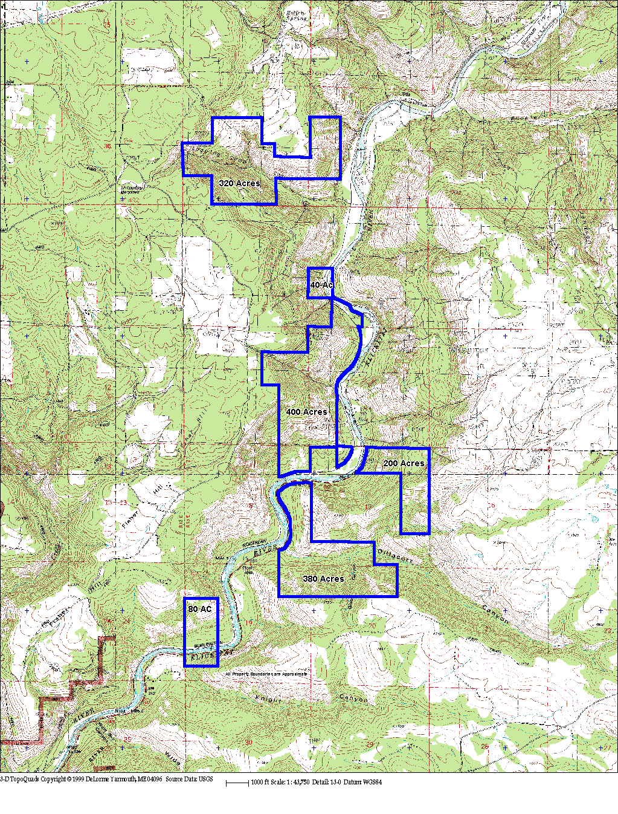

Preservation: Is a measure of the relative importance (under patient conditions) of a particular stream reach to the overall basin productivity, abundance or diversity index. (The question being asked is, "If I do nothing and let this reach get nuked (don't preserve it) what effect will it have on overall basin production?"
Life History Diversity: Measures the percent of available life history patterns that are successful for that time-space landscape; meaning their productivity is at least 1.0 (replacement).
Productivity: a density-independent measurement. Measures the reproductive success of a particular life history pattern for the entire life cycle. Is expressed in terms of adult recruits per spawner or the number of smolts produced per spawner. For EDT output the productivity value has been integrated across all life history patterns.
? Abundance: Is the equilibrium abundance for that population. This represents greatest reproductive rate (it's the tangent point on the spawner-recruit curve) for a particular life history pattern. Again the EDT model integrates all the abundance values across all life history patterns to generate a single output value.

