Bonneville Power Administration

FY 2001 High Priority Project Proposal Review

PART 2 of 2. Narrative

Title: Return Spawning/Rearing Habitat to Anadromous/Resident Fish within the Squaw Creek to Papoose Creek Analysis Area Watersheds

Section 3. Project description
Provide project detail for headings a through g.

a. Abstract
This project proposal is a critical component of an already on-going watershed restoration effort, Protecting and Restoring the Squaw Creek to Papoose Creek Analysis Area Watersheds. Working towards the re-establishment of healthy self-sustaining populations of key fisheries species (spring Chinook salmon, steelhead, bull trout, and westslope cutthroat trout) through increasing habitat in all life stages, is the main goal. The completion of this project would replace ten barrier (either adult or juvenile) culverts, seven through this proposal and three from a cost sharing opportunity with the Clearwater National Forest. These replacements would extend fisheries habitats 20 miles (or 35% of the total stream lengths), allowing the passage of all aquatic species to the entire length of every mainstream and tributary of the analysis area. This project will increase success of an on-going research project in the area, Idaho Salmon Supplementation Studies.

The replacement of these culverts will be performed utilizing an existing experienced inter-disciplinary team of fisheries biologists, hydrologists, and engineers. Natural streambed simulation will be the goal of each culvert design, using the guidance of several recently published documents. Squash pipe (pipe-arch) structures will most likely be used with a small baffling system in the bottom to aide in the retention of substrate throughout the length of the culverts. Design will embed each culvert, size for the active channel width or 100-yr. flood event (whichever is larger), allow for substrate throughout the culvert bottom, and natural sediment movement by the road crossing location. Successful design and installation will permit the passage of all aquatic species. An additional interdisciplinary team has been set up to peer review all aspects of the project.

Monitoring and evaluation (M&E) will be completed for three years after project completion. M&E will include aquatic organism passage for key fisheries species and physical condition surveys at all project locations. Success criteria would be the documentation of at least one redd in returned habitats and stream bottom contact, with substrate occurring throughout the culvert.

b. Justification as high priority

Restoration Area Location.
The Squaw Creek to Papoose Creek Analysis Area is located in the Upper Lochsa River basin within the ceded territory of the Nez Perce Tribe (NPT) and the Clearwater National Forest (CNF). The streams within the analysis area include Squaw Creek with two major tributaries, Doe Creek and West Fork of Squaw Creek, Papoose Creek with a major tributary Parachute Creek, Badger Creek, and Wendover Creek. These streams drain into the Upper Lochsa River, which flows into the Clearwater River, and into the Snake River. The total acreage for each streams watershed is listed in table 1.

Watershed | Acreage
Doe (Squaw tributary) Creek | 6,183
Squaw Creek | 10,812
Wendover/Badger Creeks | 7,890
Papoose Creek | 7,415
Parachute (Papoose tributary) | 6,938
Entire Analysis Area | 39,238
Table 1: Acreage for each watershed within the analysis area.

Justification for Restoration Area Location.
The Squaw Creek to Papoose Creek Analysis Area is a high priority area for several reasons, including the presence of at risk species, available spawning, rearing, migration, and over-wintering habitat, and the number or restoration projects in the area. The analysis area streams provide habitat for a variety of anadromous and resident fish, and for this reason addresses multiple species. The anadromous stocks include spring Chinook salmon and steelhead. Resident fish include westslope cutthroat and bull trout, as well as dace and sculpin species (CNF and NPT, 1998). The CNF rates Squaw and Papoose Creeks as second and third for fisheries values through their prioritization for EAWS (Ecosystem Analysis at the Watershed Scale) scheduling. Table 2 lists ICBEMP and Inland West ratings for bull trout, westslope cutthroat trout, steelhead, and spring Chinook salmon for each of the streams within the analysis area. Squaw Creek is rated as stronghold for bull trout, the only one within the Lochsa River drainage and only one of thirteen within the four hundred and twenty-two sub-watersheds (6th field HUC’s) of the Clearwater Sub-basin. All streams within the analysis area are rated as strongholds for westslope cutthroat. Spring Chinook salmon and steelhead are listed as depressed throughout the analysis area. Protection and restoration of these watersheds is critical to expanding and converting streams to strongholds for the restoration of key species within the Lochsa River drainage and the Clearwater River Sub-basin.

Squaw Creek
Species | ICBEMP 2000 | Inland West (2000)*
Bull Trout | Depressed | Stronghold
WS Cutthroat | Stronghold | Stronghold
Steelhead | Depressed | Depressed
Sp. Chinook | Depressed | Depressed
* Inland West applies only to US Forest Service lands.

Papoose Creek
Species | ICBEMP 2000 | Inland West (2000)
Bull Trout | Depressed | Depressed
WS Cutthroat | Stronghold | Stronghold
Steelhead | Depressed | Depressed
Sp. Chinook | Depressed | Depressed

Badger/Wendover Area (HUC also includes portions of the mainstem
Lochsa and an unnamed tributary south of the mainstem)
Species | ICBEMP 2000 | Inland West (2000)
Bull Trout | Migration/  overwintering | Depressed
WS Cutthroat | Migration/  overwintering | Stronghold
Steelhead | Depressed | Depressed
Sp. Chinook | Migration/  overwintering | Absent
Table 2: ICBEMP and Inland West rankings for the key species within the analysis area.

The Squaw Creek to Papoose Creek Analysis Area is within the boundaries of one agency (Clearwater National Forest), with the exception of the Papoose Creek Watershed, which has
approximately thirty percent of its acreage owned by Plum Creek Timber Company. Having one ownership allows for easier communication and control over activities within its boundaries.
Current management direction for the analysis area includes restoration activities only. Negotiations are underway with Plum Creek Timber Company on a cost share partnership for restoration activities within their boundaries.

Squaw and Papoose Creeks are treatment streams, under the Salmon Supplementation Studies in Idaho Rivers research project funded through BPA (see Section 3d. relationships to other projects). These streams were chosen because their water quality is high with minimal contaminants and ideal water temperatures. Habitat quality is relatively pristine with some localized riparian degradation and sedimentation (Bowles and Leitzinger, 1991). In order for this project to be successful, habitat within the study area needs to be accessible to fish species. This project complements and increases the chances for successful salmon supplementation.

It is for the reasons stated above, the NPTFWP is pursuing restoration activities within the Squaw Creek to Papoose Creek Watersheds Analysis Area. In 1998 the NPTFWP and the CNF completed a watershed assessment of the analysis area. This assessment recommended restoration actions, which included road obliteration and culvert replacements as high priorities. Since 1996, our program has teamed up with the CNF, under a cost share partnering agreement, for watershed restoration activities within the analysis area (see Section 3d. relationships to other projects). To date, approximately 135 miles of road have been obliterated and three culverts replaced for fish passage. The replacement of seven culverts though this proposal and three cost share culverts by the CNF complements and extends the watershed/fisheries restoration and research work in this area greatly.

1. Identify species at risk.
Steelhead and bull trout populations are currently listed as “Threatened” under the Endangered Species Act (ESA), and westslope cutthroat trout has been petitioned for listing. Spring Chinook salmon and westslope cutthroat trout are currently on the Regional Forester’s Sensitive Species list. The National Marine Fisheries Service, in addition, has petitioned to put spring Chinook salmon on the listing as an endangered species (CNF and NPT, 1998).

What is the nature of the imminent risk that would be addressed by this proposal?
Due to the analysis area’s road network, many streams are crossed multiple times by roads. The permanent system roads of the analysis area greatly affect the quality and continuity of aquatic ecosystems by interrupting the flow of water and material throughout the length of the stream. Thirteen culverts (2 – Squaw Creek, 5 – Papoose Creek, 2 – Badger, 3 – Wendover) were identified that would return access to the entire length of each mainstream and tributary (see figure 1) by a watershed analysis and a draft culvert assessment and prioritization project. In FY2000, three culverts, one on the West Fork of Squaw Creek, one on Badger Creek, and one on Wendover Creek were replaced for aquatic passage. The West Fork of Squaw Creek culvert replacement was completed cooperatively with the CNF, and Badger and Wendover Creek culvert replacements were accomplished under a partnering agreement between the CNF, Idaho Department of Transportation, and NPTFWP. This proposal is for the price and installation of the remaining top seven culverts identified as top priorities. Through a cost sharing opportunity with the CNF, an additional three culverts will be replaced (see cost-share in Part 1 of 2). The replacement of the ten culverts would return access to approximately twenty miles of historic fisheries habitat within the analysis area. Table 3 lists the ten culverts proposed for replacement, reason for replacement, the amount of habitat above the culvert, and priority ranking.

Please refer to the budget section for a break down of the seven culverts through this proposal regarding culvert cost and installation. Please refer to section 1 of 2, cost sharing, for the three culvert cost share estimates covered by the CNF.

Streams within the analysis area boundaries depend on naturally occurring landslides for the recruitment of material such as wood and gravel. These materials are critical in creating spawning and rearing habitats for fish and other aquatic organisms. Roads and culverts act like dams that constrict stream flows through a single narrow area (an undersized culvert) often preventing the transportation of material downstream. These constriction points also cause gravel buildup (substrate deposition) and channel widening at the culvert inlet. Wide, shallow channels do not provide quality habitat for aquatic organisms. The channels below culvert outlets are typically downcut and scoured by the high velocity water caused by the constriction. These appear as small to large waterfalls at culvert outlets.

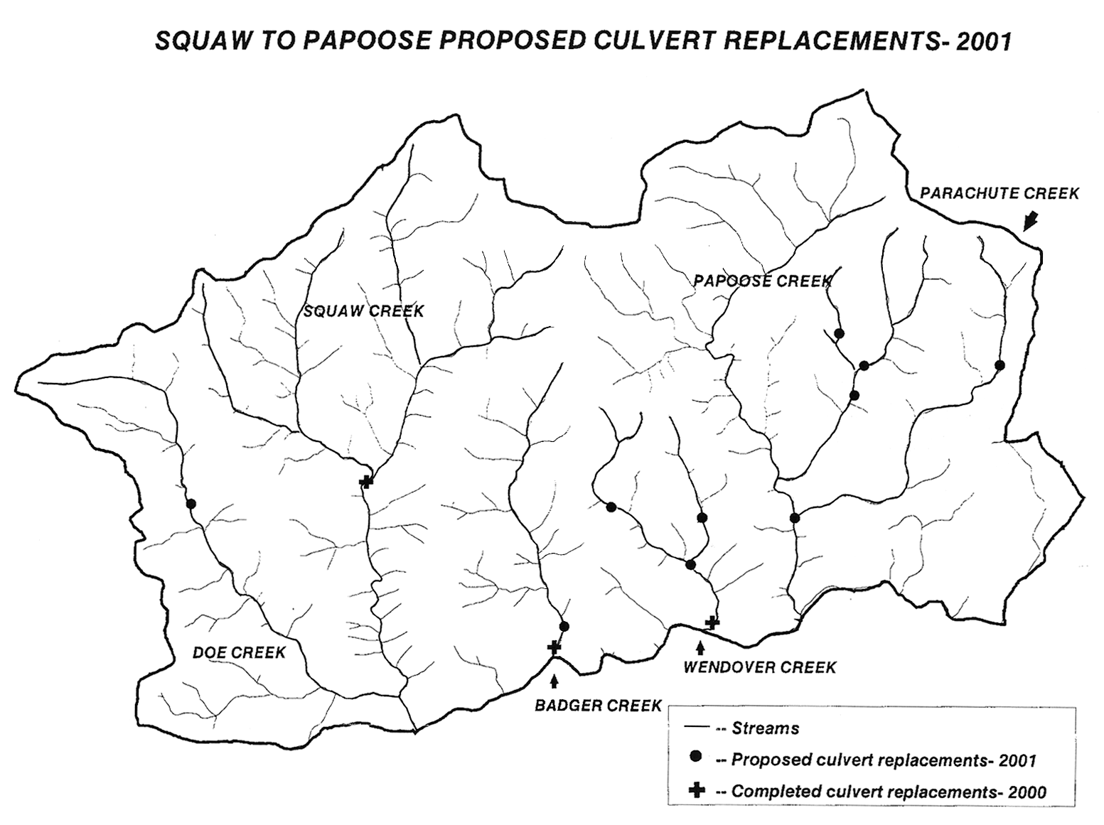
Figure 1: Proposed culverts for replacement in 2001
and three completed culvert replacements in 2000.

Priority # | Culvert Name | Reason for Replacement | Miles of Habitat Above
1 | Badger | Limited fish passage; undersized; Just replaced culvert under Highway 12 1/8 of a mile below this one | 3
2 | Doe (Squaw tributary) | Juvenile fish barrier due to log weirs below culvert; undersized | 3
3 | Parachute (Papoose tributary) Mouth | Barrier due to gabion weir below and outlet spill height; undersized | 3
4 | Wendover Lower | Limited fish passage; undersized; would dovetail with recently completed replacement near mouth (@ Hwy. 12) | 1.5
5 | Wendover Upper | No fish passage; undersized; would dovetail with recently completed replacement near mouth (@ Hwy. 12) | 1
6 | W.F. Wendover | Limited fish passage; undersized; would dovetail with recently completed replacement near mouth (@ Hwy. 12) | 1
7 | Parachute (Papoose tributary) Upper | No fish passage; undersized | 1
8 | E.F. Papoose Lower | Limited fish passage; undersized | 1
9 | E.F. Papoose Upper #1 | Limited fish passage; Juvenile fish barrier due to log weirs below culvert; undersized | 4
10 | E.F. Papoose Upper #2 | No fish passage; undersized | 1
Table 3: List of ten culverts proposed for replacement.

Roads and undersized culverts have been shown to function as barriers to the upstream movement of many fish and wildlife (amphibian, insect) species. Culvert outlets not in contact with stream bottoms (i.e. those with waterfalls) do not allow for access since many organisms have no jumping abilities or are too small to negotiate the height of the falls (see figure 1). Undersized culverts constrict flows and increase water speeds creating high velocity barriers and eliminating substrate from culvert bottoms. Substrate, such as gravel and rocks, provide low velocity areas for organisms to rest on their upstream migration. The presence of barriers can isolate small populations, limiting or preventing genetic exchange between populations, and preventing the re-colonization of historic or recovering habitats.

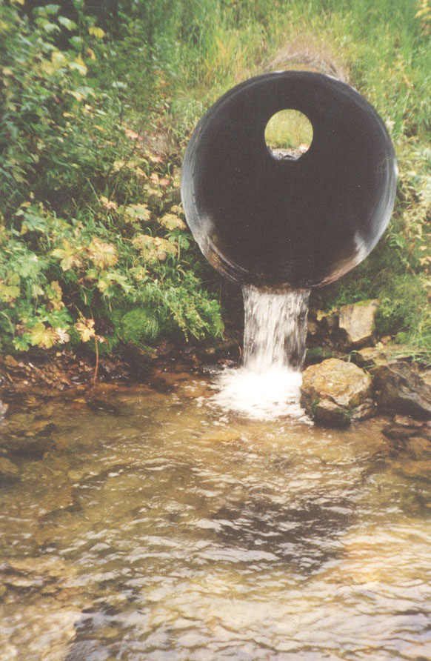
Figure 1: Example of a culvert to be replaced by the proposal due to no fish
passage resulting from an undersized and misplaced pipe (Parachute upper).

In addition, as a result of culverts being undersized and perched above natural stream grade, three of the ten culverts proposed for replacement had weirs placed below the culverts (see figure 2 and 3). These weirs were an attempt to stair-step aquatic species through the culvert. However, due to down cutting over years, these weirs themselves have become barriers. In replacing these culverts, the weirs will be removed and the new culverts placed slightly below natural stream grade for the recruitment of substrate throughout the culvert length.

Culverts also limit or prevent seasonal upstream movement by fish. Juvenile salmon and trout living in large rivers or streams often seek refuge in small tributary streams during high water events. Without access to refuge habitats, fish may be washed downstream into poor quality or overcrowded habitats. This could reduce the chances for survival for both individuals and for populations, including those already on the Endangered Species list.
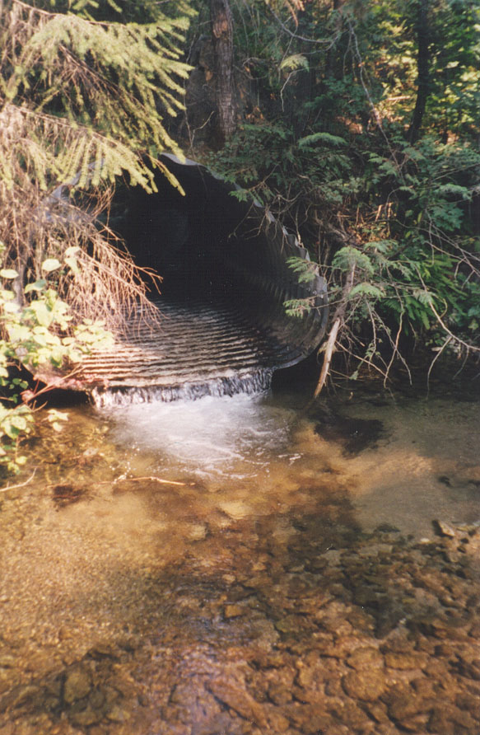
Figure 2: Parachute mouth existing culvert that is undersized, perched
at the outlet, and no bottom contact with substrate.

Figure 3: Existing gabion weir barrier located 50 feet downstream of the
Parachute mouth culvert in figure 2.

In addition to biological concerns, many culverts are in need of replacement to reduce the risk of road fill failure and subsequent addition of sediment into streams. Historically, most culverts were sized to pass 25 to 50 year storm events. In many cases, this sizing is not adequate to handle water and wood movement during large flood events. Culverts sized for a 100-year storm event are the same width as the stream channel and are able to easily pass the water and most debris associated with a large event.

a. How the opportunity to address the risk to the species may be lost if the proposal is not implemented in 2001.
Project funding in future years is always unsure. FY2001 offers the opportunity for cost sharing with the CNF. Without our partnership, the CNF may not receive funding for culvert replacements.

Currently, a cooperative research project, Idaho Salmon Supplementation Studies (funded through BPA) is on going, and in order for this project to be successful, habitat within the study area needs to be accessible by fish species. This project will return access to these species, along with all other aquatic species, benefiting the outcome of this research project. Any delay in this project implementation will delay anadromous and resident fisheries restoration.

b. How the proposed strategy has been broadly recognized as achieving direct fish and wildlife benefits.
Fish and wildlife will benefit directly by regaining access to historic habitats through replacement of these culverts. For example, the West Fork of Squaw Creek culvert replacement, in the summer of 2000, showed almost immediate positive results. Within an hour of the diverting the stream into the new culvert, two large (20”) bull trout entered into, and passed through the site unobstructed. Future monitoring will likely show similar results for target species at the seven proposed and three cost share culvert replacement sites.

2. What permitting and/or landowner agreements are required to begin this work?
- NEPA
- Consultation with Fish and Wildlife Service
- Consultation with National Marine Fisheries Service
- Standard In-Stream Work Permit – Army Corps of Engineers

Will all required permits be completed by September 30, 2001?
All required NEPA, consultation, and permits will be completed by July 1, 2001.

Identify the date you anticipate work to commence.
Commencement of culvert installation work will be begin July 1, 2001 and run through August 15, 2001, as required for in-stream work through permitting.

c. Rationale and relationship to criteria for high priority projects adopted in the 2000 Fish and Wildlife Program

RESPONSES TO CRITERIA DEFINED IN THE PROGRAM.
The proposal will produce largely self-sustaining habitat after activities are completed.
Yes. The culverts design will mimic the natural steam channel. The design calls for the new culverts to be sized for the width of the active channel and checked for a 100-year flood event. Pipe arches (squash) will most likely be used. These squash pipes are nearly flat on the bottom, mimicking stream channel shape. The culverts are embedded such that the bottoms of these pipes actually become covered in gravel and rocks. Appropriate sizing prevents inlet constriction, thus water velocities in the pipe are representative of the velocities in the stream. The final result creates a stream hydraulically and biologically connected above and below a road crossing. A Clearwater National Forest biologist rates the returned habitat in good condition (Karen Smith, personal communication) and consequently, we anticipate aquatic biota to move in immediately. The culverts have a life expectancy of approximately 50 years. Because the analysis area is within CNF boundaries (except a small portion of the Papoose drainage) and any future management activities will be subject to current federal stream protection measures.

The proposal has measurable, quantitative biological objectives and will result in clear benefits to species survival.
Aquatic organism passage will be evaluated for the two years following installation. Spawning surveys for bull trout, steelhead trout and Chinook salmon will be used for evaluation, as the redds (egg deposit sites) are easy to detect. The total number of redds will be counted 3 times during the spawning season for each species present. Success criteria will be the documentation of at least one redd in returned habitats.

For all culverts, and in streams where adult fish currently have passage but a barrier exists for juvenile fish, physical condition surveys will be documented. These will be completed one year after installation to allow for gravel movement into the culvert. Conditions noted will include whether or not the culvert outlet is in contact with the stream bottom and the percentage of the interior culvert bottom with substrate in it. If stream bottom contact exists and substrate occurs throughout the culvert, stream channel conditions will have been mimicked with the re-establishment of natural hydraulic and biotic connections. It is assumed that if this mimicking and reconnection is achieved, passage will be possible for all aquatic organisms.

The proposal has immediate, measurable benefits to ESA-listed species.
ESA listed species are stated in section 3b under “identify species at risk.” Upon installation of the culverts, immediate passage will be returned to target (ESA-listed) species for spawning, rearing, migration, and over-wintering. The monitoring, as stated above will confirm success for passage.

The proposal will connect patches of high-quality habitat or extend habitat out from a core area.
By implementation of this proposal, approximately 14 miles of good condition habitat will be extended to target species. In addition, successful implementation of this proposal makes possible cost share opportunity, which will extend another 6 miles of habitat. Completion of the project results in access to the entire length of each mainstem and two of the three major tributaries to Papoose Creek and Squaw Creek (west fork of Squaw Creek culvert replacement was completed in FY2000). The following table compares the existing available miles with the miles of habitat to be gained through completion of the proposed project (including the CNF cost share opportunity).

 | Total Stream Length (miles) | Present Accessibility (miles) | Habitat Returned (miles) | Percent of Stream Habitat Returned
Doe Creek (Squaw tributary) | 9 | 6 | 3 | 33%
Squaw Creek | 19 | 19 | 0 | 0%
Papoose Creek | 16 | 10 | 6 | 38%
Parachute Creek (Papoose tributary) | 4 | 0 | 4 | 100%
Badger Creek | 5 | 1 | 4 | 80%
Wendover Creek | 4 | 1 | 3 | 75%
Totals | 57 | 37 | 20 | 35%

The proposal will improve conditions in a 303d water-quality limited stream.
Squaw, Doe (Squaw tributary), Papoose, Parachute (Papoose tributary), and Badger Creeks were all listed on the 303d water-quality limited stream list for sediment in 1996. As per review by the Idaho Division of Environmental Quality, the streams were de-listed from the 1998 303(d) list (Bugosh, 1999). This proposal will work towards reducing risk of sediment to streams and keeping the above mentioned streams from being re-listed in the future.

Historically, most culverts were sized to pass 25 to 50 year storm events. In many cases, this sizing is not adequate to handle water and wood movement during large flood events. Our design calls for culvert sizing to the active stream channel or the 100-year storm event (which ever is larger) that is more able to pass the water and most debris associated with a large event. For this reason, there will be a decrease in risk of road failure causing additional sediment.
The proposal addresses a habitat enforcement issue and results in the protection of fish or wildlife habitat (including marine habitats of anadromous species).
N/A

d. Relationships to other projects

This project proposal strongly complements and enhances two on-going projects within the analysis area funded by BPA. The first is a research project, the Idaho Salmon Supplementation Studies, Project Number #8909802, and second is a watershed restoration project, Protecting and Restoring the Squaw Creek to Papoose Creek Analysis Area Watersheds, Project Number 199607709. In addition, a collaborative cost-share approach with the Clearwater National Forest will be utilized for this project proposal.

The Idaho Salmon Supplementation Studies (Project Number #89098) is a research project with the purpose of helping to determine the utility of supplementation as a potential recovery tool for decimated stocks of spring and summer Chinook salmon in Idaho. The goal is to assess the use of hatchery Chinook to restore or augment natural populations, and to evaluate the effects of supplementation on the survival and fitness of existing natural populations (Bowles and Leitzinger, 1991). This is a cooperative on-going research project between the Idaho Fish and Game, the NPT, Shoshone-Bannock Tribes, and the U.S. Fish and Wildlife Service that began in 1991 and is projected to year 2007 and possibly 2015. Squaw and Papoose are both treatment streams within this study. In order to increase the chances for this project to be successful, fisheries habitat must to be accessible for spawning, rearing, migration, and over-wintering. Replacing culverts will complement this research project by returning access to habitats required by these species.

Protecting and Restoring the Squaw Creek to Papoose Creek Analysis Area Watersheds (Project Number 199607709) is an on-going watershed restoration effort, which began 1996. Returning 14 miles of habitat through this proposal and 6 more through cost sharing with the CNF would greatly help this project attain its goal of restoring anadromous/resident fish populations through stream and watershed restoration. This project was initiated to address watershed problems for the benefit of the ISS project stated above. The restoration activities through this project have been guided by a completed watershed assessment for the Squaw Creek to Papoose Creek Analysis Area Watersheds. This assessment identified excessive roads, due to legacy jammer roads, and impassible culverts as high priorities (CNF and NPT, 1998). In 1997, the NPFWP teamed up with the CNF under a partnering agreement to begin road obliteration activities. To date, approximately 135 miles of road have been obliterated with approximately 150 remaining. In 2000, a partnering agreement between the CNF, Idaho Department of Transportation, and NPFWP to replaced two barrier culverts on Badger and Wendover Creeks. In addition, the NPTFWP worked in collaboration with the CNF in replacing another impassible culvert on the West Fork of Squaw Creek (see figure 3).

This project proposal, in its entirety, will be accomplished collaboratively with the CNF. Both the NPFWP and the CNF are committed to the restoration of the analysis area. For the three culverts replaced in 2000, the NPFWP and the CNF worked together on survey, design, permitting, staking, contracting, and project inspection. Post project monitoring and evaluation will also occur collaboratively. The same approach will be used for this proposed project.

e. Proposal objectives, tasks and methods

Objectives

Ultimate goal: The ultimate goal of this project is to increase access to habitat for all fish life history stages (spawning, rearing, migration, and over-wintering). Access to 20 miles of historic habitats throughout Squaw to Papoose Creek Analysis Area will be returned to key fish species.

Regional management objectives and strategies: This project follows direction given by the Columbia River Basin Fish and Wildlife Program, section 7.6D, Habitat Objectives (NPPC, 1994). Within the roads section, directives are to provide and maintain fish passage at all road crossings of existing and potential fish-bearing streams.

Project Objectives:
1. Return 3 miles of fisheries habitat to target species within the Squaw (Doe) Creek Watershed.
2. Return 4 miles of fisheries habitat to target species within the Papoose Creek Watershed.
3. Return 3 miles of fisheries habitat to target species within the Badger Creek Watershed.
4. Return 4 miles of fisheries habitat to target species within the Wendover Creek Watershed.
5. Return an additional 6 miles of habitat through cost sharing with the CNF.

Products: Seven culverts through this proposal and three cost-share culverts installed for all aquatic species passage, with each having the following characteristics:
- Sized to pass a 100-yr. flood event.
- Placed slightly below natural stream grade.
- Substrate retained throughout culvert length.
- Passage for all aquatic species.

Purpose: The purpose of replacing these barrier culverts is to provide passage of all aquatic species and the restoration of stream morphology at these locations.

Tasks and Methods

The following is a complete list of the tasks and methodology necessary to complete the above stated objectives. An experienced interdisciplinary team will be utilized for all stages of the project. The team includes biologists, hydrologists, and engineers (see section 4, key personnel). For clarification, the budget for this proposal is for the cost of seven culverts and the cost for installation. All of the other costs associated with the tasks listed below are cost-shared with the Protecting and Restoring the Squaw Creek to Papoose Creek Analysis Area Watersheds Project, and with the Clearwater National Forest (see Section 1 of 2, cost sharing).

Task 1: Develop a partnering agreement with the Clearwater National Forest.
Methodology: The partnering agreement for culvert replacements in 2001 will be a modification of the agreement used in 2000. This agreement will cover cost sharing (see cost-sharing, section 1 of 2) and agency responsibilities to include survey, design, permitting, contracting, contract administration, and monitoring and evaluation. This agreement will be completed pending the results of this proposal, although work is currently being performed by both agencies so that the project will be ready for implementation upon being fully funded.

Task 2: Survey ten project locations.
Methodology: The culvert surveys will be jointly performed with the CNF. A complete survey of the existing areas will be performed for each of the project locations. Each survey will be taken approximately 200 ft. up and down the stream thalwag or until the stream grade has been unaffected by the road crossing. The survey distance up and down the stream will be important in establishing the invert elevations for the new culvert placements. Three of the ten culvert surveys have been completed to date with the remaining seven sites to be surveyed as soon as snow melt occurs, probably in April or May.

Task 3: Design the ten culvert project areas.
Methodology: Design of each project location will be done in cooperation with the CNF. The same interdisciplinary team used for culvert design in FY2000 will design these projects. This experienced team includes biologists, hydrologists, and engineers (see section 4, key personnel). References used include the Oregon Road/Stream Crossing Restoration Guide (Allen, M., A. Mirati, and E.G. Robison, 1999), Designing for Stream Simulation @ Road Crossing (Porior, D., 2000), Fish Passage Through Culverts (Baker, C.O., and F.E. Votapka, 1990) and Fish Passage Design at Road Culverts (WDFW, 1999) documents. Peer review of culvert designs will be performed Don Porior (Coos Bay BLM District Engineer), Nick Gerhart (Nez Perce National Forest Hydrologist), Pete Minard (CNF Engineer) and Thanos Papanicolaou (Washington State University Hydraulic Engineer).

Each culvert will be sized first for the active stream channel and checked for the 100-yr. flood event, which are almost always very similar. When sizing the culvert, consideration will be given to embedding the culvert and the substrate that will fill the bottom of the culvert. According to active channel width measurements taken this summer, each site will be replaced using a pipe-arch (squash) culvert. Each squash pipe will be retrofitted with an 8-inch high baffling system to aide in retaining substrate for natural channel simulation. This baffling system has been successfully used in the Coos Bay BLM area for retaining substrate within the culvert length. Culvert inlet and outlet invert elevations will be embedded approximately 20% of the rise or 18 inches (below natural stream grade), which ever is greater, to allow for natural streambed simulation (Robison et al., 1999).

Task 4: Complete all necessary permitting.
Methodology: Permitting will be the primary responsibility of the CNF with NPTFWP over-site. The CNF will perform the required NEPA and consultation with NMFS and Fish and Wildlife Service. In addition, they will apply for the Standard In-Stream Work Permit through the Army Corps of Engineers. NEPA is currently underway with the scooping letter sent out, as of 12/11/00. Consultation will occur within the NEPA process. The Standard In-Stream Work Permit will be applied for pending the results of this proposal.

Task 5: Contract development and awarding.
Methodology: Contract development and awarding will be the primary responsibility of the CNF with NPTFW over-site. The contractor will be responsible for the purchase and installation of the culverts. They will meet the design specifications as noted in the Forest Service Specifications for Construction of Roads and Bridges.

Task 6: Contract administration of culvert installations.
Methodology: Contract administration will be the responsibility of both the NPTFWP and the CNF. Contract administration will be performed to ensure project specification and design criteria are being met and permit requirements are fulfilled. The contract administrator will evaluate culverts during installation to ensure that gradient and stream bottom contact requirements are met.

Task 7: Monitoring and evaluation.
Methodology: M&E will be performed by both the NPTFWP and the CNF. M&E funding for out-years will come from the NPTFWP M&E project funds for that area, Protecting and Restoring the Squaw Creek to Papoose Creek Analysis Area Watersheds. CNF would supply personnel for M&E on this project for out-years.

Aquatic organism passage will be evaluated for the two years following installation. Spawning surveys for bull trout, steelhead trout and Chinook salmon would be used for evaluation, as the redds (egg deposit sites) are easy to detect. The total number of redds would be counted 3 times during the spawning season of each species present. Success criteria would be the documentation of at least one redd in returned habitats.

For all culverts, and in streams where adult fish currently have passage but a barrier exists for juvenile fish, physical condition surveys will be documented. These will be completed one year after installation to allow for gravel movement into the culvert. Conditions noted will include whether or not the culvert outlet is in contact with the stream bottom and the percentage of the interior culvert bottom with substrate in it. If stream bottom contact exists and substrate occurs throughout the culvert, stream channel conditions will have been mimicked with the re-establishment of natural hydraulic and biotic connections. It is assumed that if this mimicking and reconnection is achieved, passage will be possible for all aquatic organisms.

Task 7: Project reporting.
Methodology: Project reporting will be the primary responsibility of the NPTFWP. A detailed report will be provided upon project completion. M&E reports will be provided for three years after project completion.

f. Facilities and equipment

The NPTFWP in cooperation with the CNF have all the necessary facilities and equipment to fulfill this proposal. The CNF will provide the survey equipment needed. The NPTFWP and the CNF have the necessary vehicles, computers, and software (AutoCAD) to perform all tasks, with the exception of installation. All equipment required for installation will be the responsibility of the contractor.

g. References

Allen, M., A. Mirati, and E.G. Robison. 1999. Oregon Road/Stream Crossing Restoration Guide.

Baker, C.O., and F.E. Votapka. 1990. Fish Passage Through Culverts. USDA. Report No. FHWA-FL-90-006.

Bowles, E., and E. Leitzinger. 1991. Salmon Supplementation Studies in Idaho Rivers. Portland, OR.

Bugosh. 1999. Lochsa River Subbasin Assessment. Idaho Division of Environmental Quality. Lewiston, ID.

CRITFC. 1995. WY-KAN-USH-MI WA-KISH-WIT, Spirit of the Salmon. Vol. I and II. Portland, OR.

CNF, NPT. 1998. A Watershed Analysis for the area from Squaw to Papoose Creeks. Powell, ID.

NPPC. 1994. Columbia River Basin Fish and Wildlife Program. Portland, OR.

Porior, D. 2000. Designing for stream simulation @ road crossings. Bureau of Land Management. Coos Bay Oregon.

USDA. 1996. Forest Service Specifications for Construction of Roads and Bridges. Washington office.

WDFW. 1999. Fish Passage Design at Road Culverts: A Design Manual for Fish Passage at Road Crossings. Washington Department of Fish and Wildlife, Habitat and Lands Program, Environmental Engineering Division.

Section 4. Key personnel

NAME: Emmit E. Taylor Jr.
TITLE: Civil Engineer
AGENCY: Nez Perce Tribal Fisheries/Watershed Program
HOURS: FTE

EDUCATION: B.S. Civil Engineering, Colorado State University, CO, 1995

CURRENT RESPONSIBILITIES: Project leader; road obliteration inspector; culvert prioritization; culvert survey, design, contract administration and construction inspection; gathering, analyzing, and interpreting watershed data; represent program in various inter-disciplinary teams; assist in surveying project areas; aide in assessing water resources/quality; knowledge of current computer software programs; design of civil engineering projects; supervise field crews; co-coordinate program projects.

RELEVANT TRAININGS:
- Applied Fluvial Geomorphology, 1998, Wildland Hydrology
- AutoCAD R14 Fundamentals, 1998, PacifiCAD Inc.
- Fish Passage Design Workshop, 1999, USFS
- Public Works Contract Administration Training, 1999, USFS
- Riparian Proper Functioning Condition Training, 1998, Bureau of Land Mgmt.
- River Morphology & Applications, 1999, Wildland Hydrology
- Road Obliteration Training, 1998, USDA Forest Service

DUTIES ON PROJECT: Mr. Taylor will be the project leader for all activities of this proposal. As project leader, Mr. Taylor will manage all tasks of this project to final completion and monitoring and evaluation. He will be responsible for coordinating time schedules, project budget, crewmembers, and all activities with the Clearwater National Forest (CNF). Mr. Taylor will be an inspector and contract administrator for culvert installation.

PREVIOUS EMPLOYMENT:
- August 1997 – present: Nez Perce Tribal Fisheries/Watershed
Civil Engineer
- October 1995 – August 1997: Womer and Associates Engineering and Architecture Firm
Civil Engineer-In-Training
- May 1993 – October 1995: Colorado State University Tribal Tribal Transportation Program Engineering Aide

EXPERTISE: Emmit E. Taylor Jr.’s background is in Civil Engineering with an emphasis in hydrology. Mr. Taylor’s analysis, design, and construction work concentrates on stream rehabilitation, stream morphology, water quality, road obliteration, in-stream structures, and fish passage improvements.

RELEVENT JOB COMPLETIONS:
1) Inspector on West Fork of Squaw Creek bottomless arch culvert installation, 2) Inspector on installation of Badger and Wendover Creek culvert installations, 3) Survey and design of Badger and Wendover Creek culvert replacements, 4) Road obliteration project leader and inspector, 1997-present, and 5) Geiger Boulevard Environmental Analysis.

NAME: Karen A. Smith
TITLE: Fisheries Biologist

AGENCY: USFS - Clearwater National Forest

HOURS: FTE – 1.0

EDUCATION: B.S. degree in Fisheries, Humboldt State University, California, 1986

CURRENT RESPONSIBLITIES:
- Focus on analyzing and reducing the effects of Forest Service projects on the fisheries resource through the NEPA process.
- Identifying of culverts that limit or prevent upstream migration of aquatic organisms.

DUTIES ON PROJECT:
- Site identification and assessment for aquatic organism passage;
- Assisting in site surveys;
- Leading and participating in the interdisciplinary team for completing NEPA documentation and ESA consultation;
- Resource advisor during culvert replacement;
- Post-project monitoring to assess whether project objectives are met.

PREVIOUS EMPLOYMENT:
- 1998 – present: Clearwater National Forest
Fisheries Biologist
- Currently Chairperson of the American Fisheries Society- Idaho Chapter Stream Hydraulics Comm.
- 1989 – 1998: BLM, Coos Bay, Oregon
Fisheries Biologist

QUALIFICATIONS SPECIFIC TO THE PROJECT:
I was the district lead for identifying and assisting with culvert replacement projects for the BLM between 1993 and 1998. We replaced approximately 30 large culverts in that time period. Additional culverts were identified and prioritized for later replacement. I have done the same for the Forest Service for the last 2 years and am currently working on a proposal to develop a Forest-wide culvert replacement program. In the fall of 1999 I coordinated the replacement of 2 major culverts along US Highway 12. The project was a joint effort between the Forest Service, Tribe, and Idaho Transportation Department. I also requested and received a grant for the project through the National Fish and Wildlife Foundation.

NAME: Anne Hall Connor, P.E.
TITLE: Watershed Restoration Engineer/Hydrologist
AGENCY: USFS, Clearwater National Forest
POSITION/HOURS: GS 11 / FTE

DUTIES ON PROJECT: Program manager for the road obliteration program and other watershed restoration engineering projects on the Clearwater National Forest. This involves providing technical expertise and training to the program, serving as a contracting officer's representative (COR) and overseeing the budget and management of the program. Has worked with the Nez Perce Tribe since 1997 on cost share projects involving watershed restoration. Has provided the hydrologic and hydraulic design on several large culverts including two major pipe arches on US Highway 12 installed to allow for fish passage.

DEGREES: M.S. in Civil Engineering, University of Idaho, December, 1991
B.S. in Forest Management, West Virginia University, May, 1983

CERTIFICATION STATUS: Professional Civil Engineer. Has construction certification through the Forest Service in roads, buildings, aggregate base and surfacing, and administration of public works contracts.

CURRENT RESPONSIBILITIES: Manages the road obliteration and watershed restoration program on the Clearwater National Forest. Co-ordinates with the Nez Perce Tribe and others on cost share projects.

PREVIOUS EMPLOYMENT: Anne has worked for the U. S. Forest Service from 1987 to present in engineering including road design and maintenance, contract preparation and construction inspection. Anne has run a growing watershed restoration and road obliteration program since 1993.

EXPERTISE: Major emphasis in graduate program was water resources engineering with thesis on Hydraulic Design of Fish Habitat Structures. Other training has included: Instream Flow Incremental Methodology, Applied Fluvial Geomorphology, Basic Road Design, Native Grass Workshop, Contract Administration.

NAME: LaMonte Joersz

TITLE: Civil Engineering Technician
AGENCY: USFS – Clearwater National Forest

HOURS: FTE – 1.0

CURRENT RESPONSIBILITIES:
- Survey, design, contract preparation, and contract administration in the areas of road construction and reconstruction.
- Project leader, presently assisting the BLM in the construction of a campground. This project includes a 48" culvert, water and sewer lines, building structures, and aggregate and asphalt surfacing.

CERTIFICATION STATUS: Construction certification issued by the USFS in roads, administration of public works and timber sales, and aggregate base and surfacing.

RELEVANT TRAINING/EXPERIENCE:
- Worked under the guidance of professional engineers, in the design of major culvert type structures and trail bridges;
- Developed major contracts for the USFS including all drawings, specifications, cost estimates, and other related contract documents in both the areas of timber sales and public works contracts.
- Worked on the survey and design of two major pipe arches on US Highway 12 to allow for fish passage;

PREVIOUS EMPLOYMENT: Thirty-four years experience in the field of civil engineering with the USFS.

NAME: Carol A. Smith
TITLE: Grants and Agreement Specialist
POSITION/HOURS: GS9 Detail/ FTE
AGENCY: USFS, Clearwater National Forest

DUTIES ON PROJECT: Coordinates and develops grants and agreements for the Clearwater National Forest. Has worked with the Challenge Cost Share Agreement for watershed restoration projects with the Nez Perce Tribe since 1997.

PREVIOUS EMPLOYMENT: Served as the Clearwater National Forest’s Grants and Agreements Coordinator for two years (1997 – 1999). Was a Procurement Assistant for the Clearwater National Forest from 1989-1997.

NAME: Ira Jones
TITLE: Clearwater Sub-basin Focus Coordinator / Habitat/Watershed Manager
AGENCY: Nez Perce Tribal Fisheries/Watershed Program
HOURS: FTE

CURRENT RESPONSIBILITIES: Nez Perce Tribal Fisheries/Watershed Program director; coordinate restoration activities among various agencies; analyze programs, laws, policies related to watershed management; facilitate development of criteria to identify critical fisheries habitat; prepare and plan documents for watershed habitat coordination; provide educational presentation and workshops for watershed management and proposal development; and provide assistance in proposal development, implementation, monitoring and evaluation.

DUTIES ON PROJECT: Mr. Jones will facilitate and oversee all activities within this project. He will coordinate with the Clearwater National Forest on the cost-share partnering agreement. Mr. Jones will oversee all project tasks for completion and quality of work.

PREVIOUS EMPLOYMENT:
- March 1997 – present: Nez Perce Tribal Fisheries/Watershed
Habitat/Watershed Manager
- June 1986 – March 1997: United States Forest Service, Region 1
Tribal Government Program Manager
- December 1980 – June 1986: United States Forest Service, Region 1
Facilities Manager
- July 1974- October 1979: United States Forest Service, Region 1
Fire Cache Work Leader

RELEVENT JOB COMPLETIONS:
1) Coordinated National, Multi-Regional, and Regional Civil Rights Conferences, 2) Facilitated treaty rights workshops with host tribes and multi-governmental agencies, 3) Organized and conducted Tribal Relations Training primarily for management level from the U.S. Forest Service, Tribes, Bureau of Land Management, and bureau of Indian Affairs, 4) Introduced, implemented, and managed the Inter-tribal Youth Practicums for career in natural resources and leadership within the Forest Service Regions 1, 5, 9, and 10. 5) Developed an intergovernmental Personnel Act (IPA) position to work with the Salish Kootenai College to teach environmental science courses and develop a four-year natural science curriculum at the college. This three-year position and the program developed into a four-year accredited degree program in the fall of 1996.

Definitions are all generally similar to those used by ICBEMP: Stronghold; 1) all life history stages historically present are currently present, 2) stable or increasing population and the local population is likely to be at half or more of its historic size and 3) the population or metapopulation within the subwatershed or within a larger region of which the subwatershed is a part probably contains at least 5,000 individuals or 500 adults. Depressed; 1) a major life history component has been eliminated, 2) numbers are declining or the population occurs in less than half of its historic habitat or numbers are less than half of what was supported historically, 3) population has been seriously hybridized with an introduced species or subspecies, 4) total abundance within the subwatershed or within a larger region of which the subwatershed is a part is less than 5,000 individuals or 500 adults or the fish are isolated by distance or barriers from other populations that would collectively exceed these numbers. Migration; Habitats that do not support spawning or rearing and function as routes, staging, and/or overwintering areas.

