Bonneville Power Administration

FY 2001 High Priority Project Proposal Review

PART 2 of 2. Narrative

Title: Purchase Perpetual Conservation Easement on Holliday Ranch and Crown Ranch Riparian Corridors and Uplands

Section 3. Project description

a. Abstract

The Holliday Ranch is located within the John Day River Basin (Figure 1) two miles east of John Day, Oregon on Highway 26 (Figure 2), proposes to purchase the neighboring Crown Ranch and sell a perpetual conservation easement on both properties to the Natural Resources Conservation Services of the Department of Agriculture. Such easement would allow an existing riparian fence corridor, currently under 15 year lease, on 4.4 miles of mainstem John Day River to be converted to perpetual easement. An additional mile of fence would be constructed on both sides of the mainstem and 9.5 miles of tributaries, including Pine Creek, Indian Creek, Dog Creek, Grub Creek and Castle Creek. The mainstem corridor would be measured 300 feet from the center, the tributaries measured 150 feet from centerline. The Grantee shall oversee design, contracting, and construction of the fence. The Grantor, inheritors, or assignees shall maintain the fence in perpetuity.

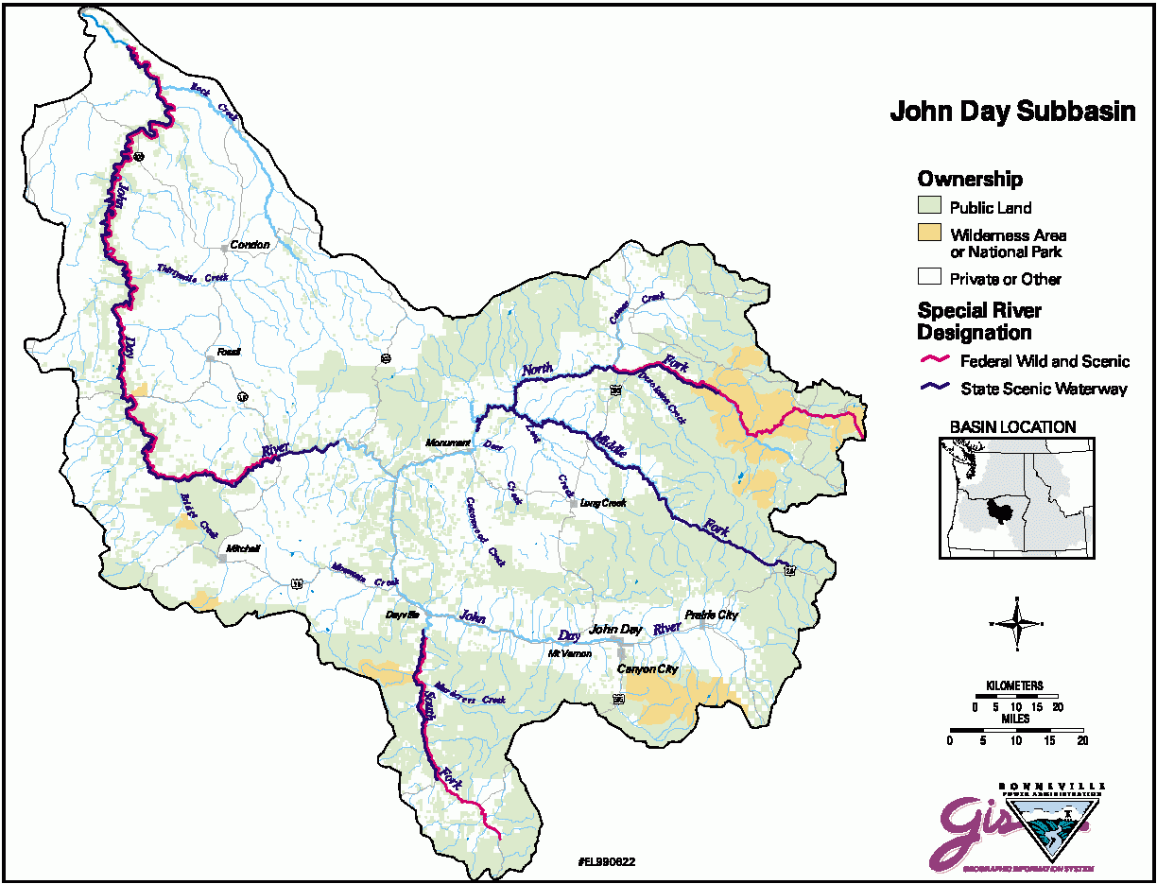
Figure 1. Map of John Day Subbasin.

The Conservation Easement shall also protect all uplands on both ranches outside of the riparian corridors from development, subdivision, and all prohibited and non-permitted uses as set forth in the easement.

Steelhead trout and bull trout, both federally-listed threatened species, several species of neo-tropical birds, Rocky Mountain elk, mule deer, antelope and California quail are some of the species that would benefit from this proposal.

b. Justification as high priority

Grub Creek, Pine Creek and Indian Creek are important steelhead rearing habitat. Grub, Dog, Indian, and Pine Creek are all Department of Environmental Quality 303(d) listed streams (ODEQ, 1999) due to water temperatures, and mainstem John Day for fecal coliform bacteria, flow modification, dissolved oxygen, and water temperature. Bull trout use the mainstem for migration and rearing during winter months.

Table 1. Fish species and use of the Holliday and Crown ranches.

Location Species/Life stage Season of Use Type of Use

John Day River chinook/adult May, June Upstream migration
chinook/juvenile Nov.-April Downstream migration/rearing
westslope cutthroat/all Oct-June Rearing/migration
redband trout/all Oct-June Rearing/migration
steelhead/adult Feb-May Upstream migration/spawning
steelhead/juveniles Oct-June Rearing/downstream migration
lamprey/adults March-April Upstream migration
Non-game Yearlong Rearing/spawning

Grub Creek steelhead/adult April-May Spawning/upstream migration
steelhead/juvenile Yearlong Rearing/downstream migration Non-game Yearlong Rearing/spawning

Pine Creek steelhead/adult April-May Upstream migration/spawning
steelhead/juvenile Yearlong Rearing/downstream migration
chinook/juvenile June-Sept. Rearing
Non-game Yearlong Rearing/spawning

Indian Creek steelhead/adult April-May Upstream migration/spawning
steelhead/juvenile Yearlong Rearing/downstream migration
chinook/juvenile June-Sept. Rearing
Non-game Yearlong Rearing/spawning

Dog Creek steelhead/adult April-May Upstream migration/spawning
steelhead/juvenile Yearlong Rearing/downstream migration
westslope cutthroat/all Yearlong Rearing/spawning
Non-game Yearlong Rearing/spawning

Dissel Creek None

Dean Creek None

Castle Creek None

Deep Gulch None

Table 2. Common wildlife species found on the Holliday and Crown ranches

Species Estimated Number Type of Us
Elk 225 Summer and winter range
Deer 200 Winter range
Deer 50 Summer range
Pronghorn 120 Summer and winter range
Bald eagle 10 Winter roosts
California quail 250 Year long
Chukar partridge 30-50 Year long
Hungarian partridge 25-30 Year long

The portion of the ranch on the south side of Highway 26 has relatively high potential for residential development, which would have a profound impact on deer and elk winter range. Adjoining properties have been developed into mini-ranches where the county land use plan allows 80 acre minimum lot size on those properties zoned for exclusive farm use or forestry. There are also numerous “lots of record” which allow smaller parcels to be developed, even down to one-half acre or smaller. Higher density residential areas reduce the winter range carrying capacity in several ways: increased traffic, reduced quality forage, increased harassment from pets, and human activity all contribute to degradation of winter habitat

Riparian fencing is widely recognized as a highly significant restoration technique that reestablishes streamside vegetation and shading which in turn reduces the water temperature of target streams and rivers. Warm water temperatures have been identified as one of the major limiting factors for anadromous fish production in the John Day River system (CTUIR, 1983). The majority of spring chinook spawning habitat is located approximately 10 miles upstream from the easternmost boundary of the property. Corridor fencing projects have been ongoing on private lands since 1983, with a goal of decreasing water temperatures and extending the cool water plume downstream. These projects have been funded by BPA through the ODFW John Day Fish Habitat Program, which seeks to fence significant waterways on private lands to benefit salmon and steelhead.

c. Rationale and relationship to criteria for high priority projects adopted in the 2000 Fish and Wildlife Program

The project would be self-sustaining, as responsibility for ongoing fence maintenance falls on the Grantor, the Hollidays. Benefits would accrue from protection from livestock grazing in the riparian corridor, and development restrictions on the uplands. Improved riparian conditions and more efficient irrigation practices on Pine Creek and Indian Creek could result in increased useable summer habitat in both streams. Irrigation withdrawals and flood irrigation from upstream reaches virtually dries up several miles of these streams. Improved conditions on these streams could increase flow and extend cooler water downstream and into the John Day River. Other tributaries would benefit from improved riparian conditions even more, because they do not have as large a proportion of flows diverted for irrigation. Reduction of water temperatures in tributaries and mainstem will contribute to steelhead smolt survival and enhance seasonal use by bull trout (ODFW et.al. 1990). Thermographs will be installed at strategic locations. Riparian vegetation will be measurable through establishment of photopoints. Increased nesting habitat will provide neotropical bird nesting opportunity in proportion to available acreage as new vegetation matures inside the corridors.

Protection of 15,532 acres of uplands from subdivision or other development will guarantee deer and elk from the Strawberry Wilderness Area and those from the Northside Wildlife Management Unit winter feeding areas safe from future subdivision and development. Approximately 125 pronghorn antelope are year-round residents on both ranches and surrounding area. All three species utilize meadows in both ranches to some extent during all seasons of the year. Additional human disturbance would force deer and elk to dislocate to areas already supporting populations, straining landowner tolerance.

Potential for enrollment of riparian corridors into the CREP program will be investigated.

d. Relationships to other projects

Several ongoing Oregon Department of Fish and Wildlife projects in the upper John Day Basin are well-established and deeply invested, including the BPA Fish Habitat and NMFS/BPA Fish Screening Programs. In the upper John Day Basin, 39 landowner fencing agreements have been developed since 1985, protecting 63.4 miles of spring chinook and summer steelhead rearing streams by constructing and maintaining 106 miles of riparian fence. Past and present research projects include bull trout and westslope cutthroat trout radio-tagging and tracking/monitoring, designed to determine habitat preferences, life history, relative abundance, and distribution. The fish screening program is currently funded at $556,000. BPA funds are available for 20-25 Mitchell Act replacement screen facilities. NMPS also funds approximately $500,000 for screen maintenance. There are a total of 314 screens in the John Day Basin to the mouth of the Columbia River. An additional $600,000 of OWEB funds are available for fish screen replacement and fish passage.

The John Day Basin Council in1992 identified elevated water temperature and the effect on anadromous fish as the major problem in the basin. The draft stream restoration program prepared by the Bureau of Reclamation and the Oregon Water Resources Department identified major goals as increased wild anadromous fish populations, increased soil stability, and enhancement of the local economy. Specific objectives included stream temperature moderation, increased summer flows, improved fish passage, reduced soil erosion, improved streambank stability, and maintenance of agricultural production (BOR, 1992).

The Confederated Tribes of the Warm Springs of Oregon (CTWRSO) have submitted a package of habitat enhancement proposals under the NWPPC solicitation for early action projects, focusing on habitat acquisition and easements for the protection and enhancement of salmon, steelhead and bull trout in the Middle Fork and upper mainstem John Day River. This project would complement the CTWSRO proposal for the protection and enhancement of steelhead, salmon and bull trout habitat, with the added benefit of upland habitat protection for deer, elk, antelope, upland birds, raptors, and numerous neotropical and other bird species in perpetuity.

e. Proposal objectives, tasks and methods

Objectives

- Purchase Conservation Easement in perpetuity on the Holliday and Carter Ranches, mainstem John Day River properties, to restore riparian habitat important for steelhead trout rearing and bull trout seasonal habitat, and protect upland habitat for deer, elk, antelope, and upland birds.

- Exclude livestock from riparian areas.

Task 2.1 Purchase fence materials
Task 2.2 Remove old fence on seven miles
Task 2.3 Construct 21.4 miles of riparian fence
Task 2.4 Purchase off-site water development materials
Task 2.5 Construct off-site water developments

- Monitor riparian vegetation response

Task 3.1 Establish photopoints
Task 3.2 Install thermographs to measure water temperature response

f. Facilities and equipment

No additional facilities or equipment are requested.

g. References

Bureau of Reclamation [BOR], 1992. Upper John Day Water Optimization Study, Oregon. Prepared for the John Day Basin Council. Boise, Idaho. 26p.

Confederated Tribes of the Umatilla Indian Reservation [CTUIR] et.al, 1983. Summary Report, Salmon and Steelhead Habitat Improvement Initiatives.

Oregon Department of Fish and Wildlife [ODFW], Confederated Tribes of the Umatilla Indian Reservation [CTUIR], Confederated Tribes of the Warm Springs Reservation of Oregon [CTWSRO]. 1990. John Day Subbasin Salmon and Steelhead Production Plan. Portland, Oregon. 116 p.

Oregon Department of Environmental Quality [ODEQ], 1999. Oregon’s Final 1998 Water Quality Limited Streams-303(d)List

