Bonneville Power Administration

FY 2001 Innovative Project Proposal Review

PART 2 of 2. Narrative

Title: Renaturalize Functional Floodplain Habitat within the Portland Reach of the Lower Willamette River

Section 3. Project description
Provide project detail for headings a through g.

a. Abstract
This proposal is to implement a river renaturalization project in the Portland reach of the lower Willamette River, Oregon. Approximately 1300 linear feet along the west bank of the river will be modified by the addition of river alluvium to form a gravel bar-floodplain area suitable for development of floodplain/riparian vegetation. LWD will also be placed in areas of densely spaced cut off wood pilings to simulate log jam and debris accumulation conditions. The project objectives are: 1. Restore diverse floodplain/shallow water fish and wildlife habitat at various river elevations; 2. Restore a variety of floodplain/shallow water substrate types; 3. Establish habitat that supports a diversity of aquatic invertebrates; 4. Establish habitat that supports a greater diversity and abundance of riparian and aquatic wildlife than presently exists on the site; 5. Establish appropriate topography and alluvial substrates for development of a lower-riparian vegetation community; 6. Demonstrate the feasibility of using in-channel floodplain creation (i.e. replacement) for channelized, regulated large urban streams and rivers; 7. Demonstrate a method for capping contaminated river sediments in a way that provides functional fish and wildlife habitat; and 8. Provide habitat that improves properly functioning condition for juvenile salmonids in a highly disturbed riverine setting.

The project has several innovative aspects, among which is the concept of working within the active channel to renaturalize conditions towards a normative condition, rather than removing fill from historic floodplains. This is a critical aspect of the success of the project in this highly urbanized and ecologically altered ecosystem. A five year monitoring program is also proposed to document the project and the development of more normative conditions at the site. The success of this project will provide a demonstration for many other sites in the Columbia Basin.

The site, owned by ZRZ Realty, one of the Zidell Companies, is a filled historic floodplain immediately up-river from downtown Portland that has been used for heavy industry since the early 1900’s. Zidell is committed to this project as part of their long-range redevelopment plans, working in partnership with the City of Portland to create the North Macadam District urban renewal area.

b. Technical and/or scientific background

Project Description

This project proposes to “renaturalize” approximately 1300 linear feet of the Willamette River in the Portland reach, at what we refer to as the Zidell North Macadam site, located on the west bank between the Marquam (Interstate 5) and Ross Island Bridges (RM 13.5 and 14) (Figure 1). The method of renaturalization or rehabilitation involves adding alluvial material to the active channel in a shallow, depositional nearshore area to create a gravel bar-floodplain area typical of those that were common in the lower Willamette prior to urbanization. Nothing like this project has been tried in the lower Willamette River or, as far as we can determine, on any large, low-gradient river in the region. The project is innovative because it proposes to apply basic river/floodplain ecological principles to a highly urbanized river reach using a private-public partnership to achieve funding and regulatory approvals. Additional innovative aspects of the project are described Section 3e.

The Zidell North Macadam reach of the Willamette River typifies the degraded conditions often found along large floodplain rivers where these traverse a heavily urbanized landscape. Banks are high, steep and covered with dumped rock and demolition debris, now largely grown over with non-native blackberry thickets. The top of this bank roughly conforms to the regulatory (100-year) floodplain elevation. The shallow shoreline zone seasonally exposed during the low water period is likewise highly simplified, with this area consisting of a continuous strand of sand- and mudflats of low relief interrupted by lines of old piles and occasional derelict harbor structures. Even the most recent fill comprising the riverbank here has been in place for several decades. This is now contaminated in places with materials potentially toxic to aquatic organisms. While this material does not now appear to be migrating to the river, this bank cannot, for all practical purposes, be excavated. This makes functional floodplain reconstruction through bank excavation impractical at this site.

Fortunately, the larger planform of the channelized river makes this (west) margin of the river in the project reach amenable to local habitat rehabilitation through channel filling. The thalweg in this reach is on the east side of the river, with the west bank shoreline consisting of a broad shoaling area, or large lateral bar. This overall morphology is very apparent on the NOAA navigational chart for this part of the river (Figure 2).

A critical design criterion of the Zidell North Macadam project is to meet the FEMA no-net-rise requirements for flood elevations. A HEC-2 hydraulic model of the lower Willamette River was obtained by the project team from FEMA and converted (updated) to HEC-RAS. A surveyed cross section near the midpoint of the project site was added to the hydraulic model to better characterize the project area and serve as the basis for design iterations. The hydraulic geometry of the project section was altered within the model to produce a backwater just under the allowable limit of 0.01 feet of flood rise during the 100-year return interval flood. This exercise demonstrated that the cross sectional area of the modeled cross section could be modified with fill to form a frequent flood-prone surface without significantly affecting the flood water surface of the 100-year return interval flood. The hydraulic model for the altered geometry was also queried for output on velocity and shear stress. The results of this query demonstrate that flood forces during the 100-year return interval flood are anticipated to be below forces that healthy vegetation with good ground coverage can resist. Additional hydraulic modeling work remains to be done on a detailed conceptual plan to confirm that hydraulics of the design components remain within the parameters of the initial model run.

This reach of the Willamette River has been significantly modified hydraulically since European settlement to control flooding and increase the area of human inhabitable land. One of the side effects of these alterations is that the conveyance of sediment load, within the now channelized reach of the project, is more efficient than under historic conditions. Evidence supporting this observation can be observed in the structure of the stream morphology or stream bed characteristics of the channelized reach. Extremely efficient transport of sediment results in (or is a product of) uniform channel boundaries and planar-bed channel characteristics with little expression of pool and bar streambed forms. Inefficient transport of sediment on the other hand, is characterized by numerous pool and bar stream bed forms and highly complex channel boundary characteristics. While recent stream channel bathymetry investigations of the project reach do not describe a completely planar-bed stream bed condition, stream bed forms are very simple with only a few simple pool-bar forms readily apparent. One of the most significant of these stream bed forms occurs at the project site manifested as a submerged lateral bar form.

Enhancement of habitat within the confines of a channelized reach of river is more often successful when the existing channel morphology is recognized and efforts are directed at complementing the hydraulics at work that result in the observed channel-bed forms. The Zidell North Macadam project site is adjacent to a poorly developed lateral bar form and efforts for enhancement of this site should focus on the enhancement of this hydraulic feature. Placement of fill materials in this location to promote diversity of this form and increase the elevation of this feature are complementary to the existing hydraulics and under some specific conditions could conceivably form under natural hydraulic events. Under more complex channel boundary forms, this lateral bar could conceivably become pronounced elevationally and more dissected with channels including backwater sloughs visible during periods of low water. Enhancement efforts that used this geomorphic condition as a goal would likely function more completely within the existing hydraulic conditions of the site than other approaches.

These overall site conditions and modeling results summarized above indicate that the form of rehabilitation proposed is imminently feasible from a construction standpoint. The proposed approach to floodplain reconstruction works within the existing large-scale morphology of the river and within the constraints imposed by its location within the heart of the city.

Filling to increase the height of the broad lateral bar and create an elongated area of functional floodplain will restore geomorphic diversity to this portion of the river (Figure 3). The fill will largely consist of coarse clastic sediment (gravel/cobble), which will enhance substrate conditions from a biological standpoint compared to the mineral fines which currently cover most of the area (Gore and Shields 1995). In addition, we anticipate installing stable accumulations of large woody debris (LWD) along landward portions of the floodplain (Figure 4). The imported LWD would be intertwined with and anchored to the extensive network of old log piles which line the shoreline of the project site (not visible on the drawings but evident on site photos). These wood pieces will likewise diversify substrate conditions compared to those currently prevailing and will also enhance cover within the reconstructed floodplain area. Thus, varying the height and areial extent of the fill along the shoreline (see www. fishenserv.com /Zidell) will result in a seasonal progression of inundation and exposure for a wide variety of substrate and hydraulic conditions. This interfingering of different substrates, water levels and hydraulic conditions along the active river channel margin will recreate some of the environmental heterogeneity typical of natural floodplain habitats and so valuable to aquatic organisms (Stanford et al. 1996, Bayley 1995, Gore and Shields 1995, Large and Petts 1994).

It is anticipated that the constructed floodplain will provide an appropriate fluvial surface for the largely natural regeneration of enhanced floral diversity in the rehabilitation area (Gore and Shields 1995). We currently anticipate performing some deliberate planting on the upper parts of the fill. This will mainly consist of woody riparian species such as willow, cottonwood and ash and native herbaceous emergent species (such as sedges, rushes and hydrophytic grasses) down to a somewhat lower elevation. Deliberate planting, potentially using different strategies in terms of density and outplanting technique, will be part of the experimental aspect of the project and will necessitate careful initial maintenance and monitoring. We nevertheless anticipate that, over time, volunteer vegetation will make up a large percentage of the vegetation assemblage colonizing the filled area. Vegetation colonization will create another dimension of structural diversity during higher flow periods. This will also directly supply detrital material to the floodplain, improving nutrient supply in the immediate area.

Vegetation establishment and detrital (nutrient) accumulation is likely to be somewhat self-reinforcing in this low energy zone of the river. Vegetation will help to stabilize the floodplain surface and will directly supply particulate organic matter to the substrate. Plant stems and the constructed floodplain microrelief (as initially installed) should promote the local accretion of both mineral fines and detritus derived from upriver sources. These effects will serve to enhance the nutrient capitol of this area over nearby areas of the river (Stanford et al. 1996, Bayley 1995).

The footprint of the fill illustrated in Figure 3 represents an initial, conceptual level design developed mainly to gauge the quantity of fill required to create some area of floodplain at the site (in this case 24,000 cubic yards, or 18,350 cubic meters). (This amount of fill is substantially less than the quantity that modeling suggests would be permissible.) What emerged from this exercise is that the quantity of fill required to create a substantial area of floodplain in this area was not all that great. This is a function of the relative shallowness of the zone in which the fill would be placed. Since river depth decreases downriver (to the north), substantially more floodplain area could be achieved by extending the fill area northward of where it is currently shown.

What is also not fully revealed in the conceptual design drawing is the diversity of floodplain microrelief that would actually be obtained as different water levels intersect the filled area during different seasons. The actual fill topography would be more irregular than that depicted in the conceptual design (Figure 3). However, even the basically linear system depicted, which varies in elevation along the length of the treated area, creates a ridge and shoreline swale, providing a protected slackwater area which will be inundated during a large part of the year. This will be linked to the main channel by openings (low areas in the ridge), the size and depth of which will vary seasonally. Within the constraints of this permanently channelized reach of river, this constructed topography begins to mimic some of the geomorphic diversity characteristic of natural alluvial river floodplains (Lewin 1992, Schumm 1977, Leopold et al. 1964).

The proposed work is innovative from an engineering perspective. Typical bank revetment has until recently consisted of removing old material from the bank and placing new material to stabilize the slope; ecological bank restoration has typically been an afterthought. The proposed work consists of maintaining as much of the slope as possible to protect the potentially contaminated materials and capping them in place with a layer of soil , gravel and/or rock. For the in-channel portion of the work, additional fill is to be provided above the cap to reach an elevation that can support plant life.

This approach is the latest concept in a series of low impact rehabilitations that have been taking place in the lower Willamette. Each year over the past several years increasingly progressive engineering designs have been implemented along the river in the Portland reach. Some of these designs, including work at South Waterfront Park, adjacent downstream to this project site, incorporated minor elements such as the use of smaller rip-rap and the first application of “dirty” rip-rap. This allows for plants to establish, over time, within the bank improvements. The level of planted vegetation was also lower than what was typically seen on other Willamette riverbank improvement projects.

Across the river from the site is the most progressive in a sequence of implementation projects at the Eastbank Park. This project incorporated many concepts that will be applied at the Zidell site. The project consisted of removal of 750 LF of steep rip-rap and replaced it with bio-engineering using 100% natural material. This project also included a modified engineering design which provided more sloping beach area in the shallow zone, and flatter slopes with lower construction costs. Other cutting edge project elements included installation of Large Woody Debris (LWD) using anchoring techniques that will be applied at Zidell. Limited cases exist of LWD installation on larger rivers, thus construction details will be refined based on success of the demonstration project.

The Eastbank Park Project was a cooperative effort within the City and with State and Federal agencies to demonstrate the types of engineering designs that could be implemented in the most constricted and most challenging sites on the Willamette river. Lessons learned in design and construction will be applied to the Zidell work to ensure a successful implementation and rehabilitation effort.

Project Setting and History

The city boundaries of Portland, Oregon encompass the lower 27.5 km of the Willamette River. This lowest reach of the river, the Portland reach, is the most densely developed for urban uses. Along most of the Portland reach riparian vegetation is limited to a thin strand of trees, shrubs and weedy herbaceous species on the slope or at the top of the riverbank. Red alder and black cottonwood are the most frequent of these tree species; however, non-native Himalayan blackberry is the dominant plant. This thin strip of green is “riparian’s last strand” on the Portland reach, and it is for the most part not a functional floodplain/riparian area. Opportunities to create or restore functional floodplain/riparian areas are severely limited by existing and planned development, and the accompanying fill (some now contaminated) and armored banks. The riverbank and in-channel areas are typically the only opportunity areas; this proposal is for a project that will demonstrate in-channel floodplain replacement.

Before Euro-American settlement, the active channel of the lower Willamette River consisted of a broad meandering channel which occupied a broader floodplain with extensive bars, shoals, and backwater side channels. Bottomland wetland forests and shrub thickets were extensive and both channel margin and off-channel areas were clogged with large quantities of wood debris. During the period 1853 to 1972, approximately 257 hectares of river and 391 hectares of bottomland were filled in the Portland reach of the lower Willamette River (SRG, 1973). The 1888 survey chart for the lower Willamette River shows a river with a meandering active channel with adjacent areas of marsh, forest, oxbow lakes and sloughs; thalweg depths averaged between 3m and 9m (OCS, 1999 – view at:

ftp://anchor.ncd.noaa.gov/views_pc/GIF/CHART/CP2007c.gif - the Zidell North Macadam site is at the very bottom of the map, near the tip of Ross Island). Today the same reach has been straightened and is bordered by filled floodplains and backwaters, piped tributaries, and no large wood; thalweg depths are now on the order of 9m to 18m (Figure 2 ).

Pacific salmon have been an important component of this system for millennia. These species evolved over several million years under conditions of continuous geologic and climatic change; however, environmental conditions were fairly consistent for several thousand years prior to the 17th century era of non-indigenous human settlement (Lichatowich, 1999). The lower Willamette River provided an environment of great spatial and temporal habitat diversity that had certain seasonal rhythms. Connectivity between the river and its floodplain habitats provided the unique ecological characteristics and flood pulse dynamics described by Junk et al. (1989) and Bayley (1995). Salmon were well adapted to these conditions. The human-induced changes that have occurred over the past two centuries have resulted in an environment that barely resembles the pre-settlement condition. The edge of the river is no longer a dynamic zone of the river-floodplain ecosystem as described by Bayley (1995). The river=s edge is now an elevated, mostly hardened engineered feature with little or no vegetation and very low habitat diversity.

An examination of lower Willamette River bathymetry reveals that the Willamette River thalweg still meanders between armored banks (Figure 5). This meander pattern creates alternating areas of deposition and scour, providing opportunities to mimic some of the characteristics of the river-floodplain system within the limits established by diking and filling. The proposed project recognizes this pattern, and provides design concepts based on the bank and channel morphology of the Zidell North Macadam site.

Restoration vs. Rehabilitation

The theoretical restoration goals for the lower Willamette River would include reconnecting the river to its floodplain and the re-creation of fringing marsh and floodplain forest habitats (Figure 5). These options are not likely to be pursued in most of the urban core where floodplains have been filled, contaminants have been buried, and urban infrastructure has been built. The costs of restoration to pre-European settlement conditions certainly outweigh the benefits in the short-term, and very likely in the long-term. The most realistic goals are therefore focused on the riverbanks, the near-shore area, and the immediately adjacent uplands, and fall into the category of habitat rehabilitation and renaturalization rather than restoration.

The concept of ecological “restoration” to conditions prevailing prior to European settlement is obviously impossible in this location (NRC 1992). What we can do, however, is partially “rehabilitate” this highly impacted river reach. Rehabilitation can generally be defined as the partial recovery of pre-disturbance biophysical structure and function, and is often the only practical alternative in intensely humanized landscapes (Brookes et al. 1996, Gore and Shields 1995, NRC 1992). Because of channel dredging for navigation, the Zidell North Macadam site is the last potential area for floodplain rehabilitation for many miles downstream (see Figure 2).

Riverbank designs also need to recognize that the shore has zones with different characteristics of inundation frequency and duration, and that this zonation influences vegetation type. The Willamette Riverbank Design Notebook (City of Portland 2000) identifies three shore zones (Table 1). This elevation pattern has been used in the design of the proposed project.

TABLE 1. Design Shore Zones of the Lower Willamette River in Portland, Oregon (Fishman and Abbate 2000)

SHORE ZONE | FISH UTILIZATION | VEGETATION TYPE | APPROXIMATE ELEVATION (m)
Upper shore zone | Periodically available to fish; lower portion (below Ordinary High Water) typically inundated during winter and spring freshets | Perennial vegetation, including woody species | +2.6 to +8.7 MSL
Lower Shore Zone | Seasonally available to fish; typically not inundated during late summer/autumn | Annual vegetation; below the level of persistent woody species | +0.5 to +2.6 MSL
Aquatic Zone | Continually available to fish; inundated year-round | Aquatic vegetation only; below Ordinary Low Water | -3.5 to +0.5 MSL

Scientific Framework

An initial goal of the Willamette Riverbank Design Notebook project (see Fishman and Abbate’ 2000) was to use the best available information about river and fish ecology as the basis for riverbank design criteria. The team initiated a 1-day workshop in June 1999; State of the Science on Fish Ecology in Large Low Gradient Streams. Part of the workshop focused on what constitutes Aproperly functioning condition@ (PFC), a concept used by the National Marine Fisheries Service (NMFS). PFC defines the freshwater spawning and rearing conditions needed for the long-term survival of Pacific salmon populations (McElhany et al. 2000). One of the analytical tools used by the NMFS to evaluate the effects of specific actions is the Matrix of Pathways and Indicators (Matrix)(NMFS 1996). The Matrix was developed for high gradient streams in forested landscapes, and workshop participants developed a draft set of modifications to the existing Matrix to make it applicable for large, low gradient rivers such as the lower Willamette. The Apathways@ are sets of parameters within which actions can have effects on salmonids and their habitat; Aindicators@ within each pathway are criteria to which site conditions can be compared to evaluate the degree to which they provide PFC. The Matrix pathways identified by the workshop include: water quality, habitat access, habitat elements, channel condition and dynamics, flow and hydrology, watershed conditions, species interactions and active floodplains (see section 3c for more details). Quantitative indicators within each pathway have not yet been developed for large, low gradient rivers such as the lower Willamette.

These pathways were used by the Willamette Riverbank Design Notebook team as a foundation for developing lower Willamette River riverbank design objectives (Fishman and Abbate’ 2000). Additional design objectives were added for the social/cultural functions of the riverbank in the context of urban land uses. The following seven Design Objectives were developed for the Design Notebook: 1) conserve, protect and restore a diversity of instream and riparian habitats; 2) create habitats that support native species interactions while minimizing impacts of introduced species; 3) protect and improve water quality; 4) protect fish and wildlife access to tributaries, floodplains and other off-channel habitats; 5) provide stable riverbanks where needed to protect development, infrastructure, industrial and commercial use, significant natural resources and public safety; 6) provide public access to the top of bank and to the edge of water, where appropriate; 7) enhance the aesthetic quality of the riverbank. These design objectives were used by the project team to develop the concepts at the Zidell North Macadam site.

One of the key ecological principles for this project is the concept, summarized in Return to the River (ISG 2000), which states that complex habitats support salmonid life history diversity, and that life history diversity is the key to salmonid population recovery and sustainability. The ISG describes a “normative ecosystem” in which natural and cultural elements exist in a balance that allows salmon to thrive and many of society’s present uses of the river to continue. Improving some pieces so they are slightly better than now, while improving others so they are better or much better than now all contribute to restoration of normative river conditions.

The proposed project focuses on the river margin of a specific site in the Portland reach of the Willamette River. It is known that persistent shallow or slackwater habitats can be especially important to the survival of early life history stages of fishes that cannot survive in the stronger currents of the channel thalweg (ISG 2000). In intact systems, the floodplain riparian area provides fine organic detritus and wood debris that energize the riverine food web, provide cover for fish, and cause localized cut and fill; all of which contribute to habitat complexity.

The fish community in the Portland reach is comprised of at least 38 species, at least 20 of which are native (Johnson and Fishman 1999). Sampling at the Zidell North Macadam site during Spring, 2000 (FES unpublished) found the following13 fish species (I denotes introduced species): Chinook salmon (juvenile), coho salmon (juvenile), steelhead trout (juvenile), largescale sucker, chiselmouth, lamprey (ammocoetes), Northern pikeminnow, prickly sculpin, smallmouth bass (I), bluegill (I), carp (I), goldfish (I), yellow perch (I). Sampling at the Zidell site and others in the Portland reach during spring (April through June) found a variety of hatchery and apparently wild chinook salmon and steelhead trout juveniles (FES unpublished). Sub-yearling chinook were encountered very close to shore, while larger chinook and most steelhead juveniles were encountered both near- and off-shore. Diversity of life history types is an important factor in sustainability of chinook salmon populations (Healy 1991), and the presence of sub-yearling as well as yearling wild chinook in these recent samples is important evidence that improvement of near-shore habitat diversity is an important goal in the lower Willamette River.

c. Rationale and significance to Regional Programs

The proposed project has relationships to local, regional and basin-wide fish and wildlife programs. The project relates to the systemwide goals and policies of the Columbia Basin Fish and Wildlife Program of 1994 in several ways. It contributes to a healthier Columbia Basin by providing a greater diversity of shallow water habitat types for juvenile salmonids in the lower Willamette River and it meets the systemwide policies of the Program by addressing the “need to learn from implementation” policy. This policy states that “Congress directed the Council to use the best available scientific information and not to await scientific certainty prior to acting.”

The proposed Zidell North Macadam project uses the science of river/floodplain ecosystems as a basis for implementing a river margin renaturalization that will provide increased habitat diversity in the Lower Willamette River. While it is not possible to quantify the project results in terms of fish production, it is possible to link the project to established goals of the Fish and Wildlife Program and other frameworks.

The Independent Science Review Panel (ISRP), which is responsible for reviewing proposals for funding through CBFWP, stated in their annual review of the CBFWP (ISRP 1999) that “It is impossible to return to completely natural or pristine conditions, but there are means of restoring natural processes and features to more normative conditions that will provide a basis for sustained salmonid recovery and productivity. Such actions, taken in an ecosystem context, are likely to provide long-term benefits to resident fish and wildlife, as well as salmon and steelhead.”

The first critical element of the conceptual basis for restoration of Columbia Basin salmonids found in Chapter 3 of Return to the River (ISG 2000) states that “Restoration of Columbia River salmonids must address the entire natural and cultural ecosystem which encompasses the continuum of freshwater, estuarine and ocean habitats where salmonid fishes complete their life histories. This consideration includes human developments as well as natural habitats.” Restoration of floodplain habitat at the Zidell site and the lower Willamette River in general, represent an opportunity to re-establish habitat diversity in an urbanized reach of the river and establish a greater degree of connectivity between natal streams and estuarine and ocean habitats. The second critical element addresses “the importance of the network of complex and interconnected habitats which are created, altered, and maintained by natural processes in freshwater, the estuary and the ocean.” One objective of the Zidell North Macadam project is to restore habitat that provides/approaches properly functioning conditions for juvenile salmonid rearing in a highly disturbed section of the lower Willamette River by increasing habitat complexity.

This project is connected to subbasin level plans and programs such as the Willamette Basin
Floodplain Restoration Study which provides an opportunity for the Corps of Engineers
to work cooperatively with many other Federal, State and local agencies and entities that have
placed a high priority on restoring the health of the Willamette subbasin.

The following planning objectives have been identified for the Willamette Basin Floodplain Restoration Study: 1) develop an integrated, comprehensive framework plan for river management and floodplain restoration that assists in achieving the goals and objectives of the Willamette Restoration Initiative and the State of Oregon; 2) develop the floodplain management tools needed to identify cost effective, environmentally sensitive methods for reducing flood risks and flood damages through restoration of the natural storage functions of floodplains; 3) evaluate fish and wildlife habitat conditions in the Willamette River and its tributaries, and identify opportunities to restore aquatic and terrestrial habitat associated with their floodplains; 4) evaluate the hydrology of the Willamette Basin and identify opportunities to restore its hydrologic regime to a condition more resembling a ‘natural’ state and to restore the functions of the Willamette river and floodplain, the hydrological regime of the river system needs to be in a condition more resembling its ‘natural’ state; 5) evaluate the effects of past water resource development projects on the fluvial geomorphic functions of the Willamette River and identify opportunities to restore them to conditions more resembling a natural state; 6) identify opportunities and methods for restoring natural floodplain functions that are consistent and compatible with State goals to protect prime farmlands, maintain the viability of agriculture as a key sector of the economy of the Willamette Valley, and are based on active, willing participation by the agricultural community; and 7) enhance the quantity and aesthetic quality of landscape and recreation opportunities.

The Willamette Basin Floodplain Study makes it clear that floodplain restoration will: 1) help achieve multiple objectives related to watershed health and water resource problems, including flood damage reduction and ecosystem restoration; 2) help to restore critical habitat for several species either currently listed as threatened or endangered under the Endangered Species Act; 3)
is consistent with the Community's Plan of Action under the American Heritage River Program; 4) help to implement the objectives of the Pacific Northwest Forest Plan of 1996; and 5) be able to assist in meeting Clean Water Act standards for the Willamette Basin.

To our knowledge, projects similar to the proposed Zidell project have not been conducted, nor are any planned in the Columbia Basin. There are some examples of projects in the Fraser River that have some similarities; however, these used rip rap to create flood terraces instead of placing alluvial materials to simulate bar forms (G. Williams pers. comm.). This project also relates to other functional floodplain research being conducted further upstream in the Willamette Basin, such as floodplain restoration in off-channel habitat used for gravel mining (Bayley and Baker 2000).

On a local level, the project meets the objectives of the City of Portland’s Framework for a Portland Recovery Plan. The City of Portland is a cooperating partner in the Zidell North Macadam proposal. Section d, below, provides details of this relationship.

d. Relationships to other projects

Background on the Portland Recovery Plan.

In July 1998, the Portland City Council adopted a resolution to guide the City’s response to listings of chinook salmon and steelhead trout under the federal Endangered Species Act. The resolution called on the City to:

- Create an integrated, comprehensive city-wide approach;
- Work to support the recovery of native salmonids;
- Work proactively with the National Marine Fisheries Service and the U.S. Fish and Wildlife Service;
- Work with local, regional and state partners;
- Engage the community in the ESA response.

The City of Portland has established a process and organizational structure to respond to the needs of threatened steelhead and chinook salmon. The City evaluated existing programs and activities for their impact on fish and fish habitat, and developed and is implementing work plans to reduce negative impacts and improve habitat conditions and functions.

The City of Portland also has adopted a framework to define and implement its response to the Endangered Species Act and to the City Council’s resolution. The fundamental elements of the framework include:

- The Vision, which describes what the City of Portland is trying to accomplish with regard to ESA compliance, fish and wildlife and other desired benefits from the Willamette River and its tributaries within the City of Portland. The plan also will address ESA compliance for Portland’s drinking water supply system, located on the Bull Run River, which is part of the Sandy River Basin. The ESA vision will be integrated and coordinated with visions related to other Portland objectives (e.g., sustainability, livable neighborhoods, economic vitality, recreation, and wildlife).
- Watershed Goals, which describe more specifically what Portland is trying to achieve with its fish recovery efforts. Watershed Goals clearly define the desired characteristics of fish populations that the recovery plan is striving to restore within Portland’s watersheds. The goals also acknowledge and refer to other objectives Portland needs to meet as an urban center of a metropolitan region (e.g., jobs, growth management, affordable housing, and recreation). These goals have the potential to support or conflict with fish recovery goals, and it is only through explicit acknowledgement, analysis, and planning that opportunities can be found and potential conflicts can be resolved.
- Watershed Conditions, which define ecological characteristics needed to achieve fish recovery. These are based on scientific analysis of the habitat conditions required to support healthy salmon populations and the description of “properly functioning conditions” and “viable salmonid populations” from the National Marine Fisheries Service.
- Analysis and Planning is the process of evaluating the Watershed Goals and Watershed Conditions to define strategies for achieving the Vision. The evaluation will entail describing baseline environmental conditions, identifying and evaluating existing environmental protection efforts, identifying gaps in existing programs, resolving conflicts between fish recovery and broader goals, and prioritizing restoration and protection efforts. Portland has developed a preliminary Watershed Evaluation Method to help prioritize assessment parameters and recovery actions. The method is tailored to urban conditions. Initial application of the method suggests that creating floodplain and off-channel habitat for juvenile salmonids is a high priority.
- Actions are the implementation procedures, guidelines and strategies that guide or describe the specific steps leading to the desired ecological conditions.

A scientific foundation will link the components of the framework, explaining why certain management actions are likely to result in particular watershed conditions. The scientific foundation also will provide an understanding of why changed watershed conditions will restore fish populations in each of the different watersheds. Portland is basing its scientific foundation on the work done by the staff of the Northwest Power Planning Council and the conceptual foundation described by the Council’s Independent Scientific Group in Return to the River 2000.

Portland is using the framework to develop more detailed information for each of the topics described briefly above and to incorporate that information into a final comprehensive recovery plan. Portland will work extensively with independent scientists, stakeholders and the public in developing, reviewing, implementing and monitoring the plan

As mentioned above, Portland will base its plan on science and include within it the incentives and regulations necessary to ensure habitat restoration. The plan will not apply identical approaches to each parcel of land, but instead will focus on how the fish use, or need to use, a particular stretch of the river or stream during each life stage and provide for customized approaches based on that information.

Portland will use the framework to ensure its plan fits effectively into regional and state plans such as the anticipated plan from the Willamette Chapter of the Oregon Plan (the Willamette Restoration Initiative), the plan recently adopted by the Northwest Power Planning Council (Columbia River Basin Fish and Wildlife Program), and work underway at Metro.

The plan will provide increased protection in some areas and restoration in others. From a geographic perspective, the City’s efforts will focus on three geographic areas: the mainstem Willamette, the tributary streams into the mainstem Willamette, and the Sandy River Basin, where Portland’s primary water source is located. The City’s upland approach will take form in programs that address vegetative cover and composition, stormwater, erosion control, and impervious surface limitations and reductions.

The Mainstem Willamette. In June 1999, in cooperation with the National Marine Fisheries Service, the City of Portland sponsored a State of the Science workshop with leading regional fish biologists and other scientists. The purpose of the workshop was to establish baseline information about how salmonids use large low-gradient rivers such as the lower Willamette River and to identify indicators of stream health.

Participants at the workshop largely agreed that during flooding, fish typically make extensive use of floodplains for feeding and for refuge from flood flows (Sedell and Frogatt 1984, Brown and Hartman 1988, Benke 1990, Bayley 1995). Most large low gradient rivers, including the lower Willamette, have been channelized, diked, or otherwise altered and constrained (Kaczynski and Palmisano 1993, Gore and Shields 1995). Critical floodplain functions are lost or diminished when access to the floodplain is permanently blocked.

Participants discussed the development of “Active Floodplain indicators” that would help the City of Portland and others address critical functions that floodplains provide when large rivers rise and fish can access upland areas for feeding and refuge during flood stages. The indicators discussed include:
- Frequency and Duration of Inundation - As stated in the description of the Active Floodplain pathway, large rivers rarely access their floodplains. The "flood pulse" process (Junk et al. 1989) is critical to the health of rivers, riparian areas, and salmon (Levy and Northcote, 1982; Brown and Hartman, 1988; Bayley, 1995). This indicator addresses the loss of that critical interaction.
- Floodplain Quantity - The floodplains of low gradient rivers have been extensively developed. Historically these are the lands on which major urban and industrial areas develop (e.g., Portland, Seattle), or have been converted to intensive agriculture. This development has greatly reduced the amount of floodplain vegetation, soil, and wetlands available to interact with a river and its biota when it does access its floodplain.
- Habitat Quality (including types of food availability, cover) - Even in situations or locations where large rivers connect to their floodplains, the quality of habitat available in floodplains is typically degraded. Impervious surfaces or cleared and managed landscapes are typically prevalent in these former floodplains, replacing active riparian forests and wetlands. These land uses provide few of the habitat functions that riparian forests and wetlands provide, such as feeding, refuge, sediment and nutrient cycling, and water quality enhancement (Gregory et al. 1991).
- Toxic Chemicals - Impervious surfaces and highly urbanized land uses within the floodplain accumulate toxic contaminants to which salmon are exposed when rivers rise and interact with the floodplain
- Nutrient Recycling - wetlands in the riparian zone provide oxidation/reduction processes important to nutrient recycling. As riparian wetlands have been lost (Dahl 1990), these functions have been greatly diminished.

The workshop results indicate that restoration of flood plain or flood plain-like habitat should be a high priority for the City of Portland. The State of the Science Workshop also pointed to the need for more information about how fish currently use the lower Willamette. Portland is investing substantial resources into research on this topic. The primary investment is the Oregon Department of Fish and Wildlife Lower Willamette River Fish Use Study, which will identify bank conditions and the distribution, abundance, migration, and feeding of native and introduced fish. The study, which began this summer and is sponsored by the City of Portland, will run for a minimum of four years. A brief description of the study is provided as an appendix to this proposal.

Results from the study, as well as results from other Portland-sponsored or partnership research and implementation projects, will be shared through technically oriented science workshops at least once every six months. The most recent workshop was held in September. That session focused on the methodology of the ODFW fish use study

Based on the State of the Science Workshop, the ODFW study and other information, Portland is developing a comprehensive plan for the entire stretch of the Willamette within its jurisdiction. Portland is also coordinating its Willamette work so it is part of a regional and state response.

The plan will take a landscape view of the opportunities to improve conditions for ESA-listed fish. While applying uniform restoration standards in this highly developed section of the river is not realistic, Portland is committed to making substantial contributions to recovery by focusing on the larger geographic area and to customizing its approach to best fit local conditions and available incentives. The Zidell North Macadam property is of particular interest because it currently is in the midst of substantial redevelopment planning activity.

The plan will also package significant Portland programs that contribute to improving Willamette River conditions. These include efforts such as the Clean River Plan, the Combined Sewer Overflow Program, the Portland Harbor cleanup, improvements to land use planning, the Willamette River Greenway Plan, and the Parks and Recreation Master Plan.

The city’s ESA recovery plan is designed to place all of Portland’s Willamette River planning efforts into a unified package. Through these processes, Portland will evaluate opportunities to improve bank conditions; restore, protect and reconnect riparian areas associated with the river, reduce pollution runoff and sewage spills; and address severely contaminated areas.

The recovery plan also will identify connections to, and condition of, off channel fish habitats such as Smith and Bybee Lakes, Oaks Bottom, and tributary streams and sloughs. Efforts will be made to conserve and restore those that offer the best chance to assist with fish recovery and the city will work with our partners like the Zidell Company to improve existing bank treatments to provide floodplain-like habitat and other functional values.

The Zidell North Macadam project is a key component of the City of Portland’s overall recovery strategy. A top priority for the City of Portland is identifying and restoring formerly accessible floodplain and off channel habitats. The Columbia Basin Fish and Wildlife Authority also identified restoration of juvenile rearing habitat in the mainstem Willamette as a high priority (1999 Annual Implementation Workplan). Implementing the Zidell Project will provide an excellent opportunity to monitor the effects of restoring floodplain-like habitat along the lower Willamette and provide important data about the effectiveness of this experimental approach.

It is important to note that the location of the Zidell North Macadam project is near other potential restoration sites. In particular, the City of Portland is working with the Ross Island Sand and Gravel Company to restore Ross Island as off-channel habitat. In addition to Ross Island, the Zidell site also is near a site known as Oaks Bottom, which is in public ownership. Modifications to a water control structure there that limits fish access to off channel habitat are currently being assessed by the City of Portland. Currently, fish access is limited except during high water events.

Redesigning the water control structure to allow better fish access at Oaks Bottom, restoring Ross Island and implementing the Zidell project will create an effective juvenile fish sanctuary area in the midst of a heavily urbanized stretch of the lower Willamette. It is important to note that the reach of the lower Willamette in Portland is a reach that all anadromous fish from the second largest tributary to the Columbia River must pass on their migration to the ocean and on their return as adults.

Agency Coordination and Permitting

The proposed project will require permit authorization from the City of Portland (Willamette Greenway review), Oregon Division of State Lands (Removal/Fill permit), and US Army Corps of Engineers (Rivers and Harbors Act of 1898, Clean Water Act Section 404). The Project Team has initiated coordination activities with state and federal agencies for the project. We recently convened a meeting to discuss the project concepts; attendees included staff from the National Marine Fisheries Service, U.S. Fish and Wildlife Service, Oregon Department of Environmental Quality, Oregon Department of Fish and Wildlife, and City of Portland ESA Program. The proposed project received unanimous and enthusiastic support from the agency representatives. The proposed project has also received enthusiastic support from staff at Metro, Portland Parks and Recreation, and the Director of Portland Planning Bureau. A letter of support from City of Portland Commissioner Eric Sten is included with this application. The ODEQ staff working with Zidell on contaminant issues has also been briefed on the project concept, and has expressed initial support. Part of the proposed budget for the grant will support continuing permitting activities by the Project Team.

e. Proposal objectives, tasks and methods

Objectives

The goals of this project are to:
- restore a small area of functional floodplain within the severely degraded urban reach of the lower Willamette River to provide habitat value for juvenile salmonids and other fish and wildlife species;
- demonstrate and document that this innovative approach can be used effectively to improve habitat conditions in large channelized streams and rivers; and
- demonstrate that voluntary private/public partnering can provide important environmental, social and economic benefits, particularly within the context of Fish and Wildlife Program and Endangered Species Act goals.

The research and design work for this implementation project have been completed by the project team under contract to Zidell Company. The project is not a requirement of any regulatory action, but is a voluntary effort by the Zidell Company to improve the ecological and public values of their riverfront property as part of a larger urban redevelopment plan.

There are several innovative aspects to this project. First, we are not aware of any other projects in the region where floodplain restoration has been based on adding alluvial materials to the active channel, rather than removing fill material historically placed on floodplains for urban or industrial development. This specific project site was bottomland marsh and floodplain as late as the 1860’s and was filled for industrial and urban development. The site supported heavy industry, primarily metal recycling, and then ship dismantling after the Second World War, and commercial barge building since 1961. There are known areas of soil and sediment contamination within the filled floodplain and river substrate; these are being addressed through a voluntary agreement with ODEQ. Photographic images of present site conditions can be viewed at www.fishenserv.com/zidell

Removal of fill from the historic floodplain at the Zidell North Macadam site, or most sites in the Portland reach for that matter, would be prohibitively expensive. Additionally, areas such as North Macadam which are slated for urban renewal are important for meeting statewide land use planning goals that dictate increasing urban density to protect non-urban land resources.

Based on the constraints discussed above and in Section 3b, this project proposes a new approach to functional floodplain restoration: replacement of floodplain landforms within the confines of the urbanized river reach. This approach simulates, with obvious limitations, the floodplain forming processes described for the mid-Willamette River by Dykaar and Wigington (1998). The approach is not appropriate everywhere, based on FEMA no-net-rise flood elevation rules, navigational issues and others; however, we feel that there are numerous areas in the Portland reach of the Willamette River, and other confined large streams and rivers in the region, where this concept would work.

A second innovative aspect of this project is the partnering of public and private entities to work towards recovery of listed salmonids and general river health. The Zidell North Macadam site is similar to many urban riverfront sites in the Portland reach (and throughout the region) that have been severely altered from a natural state, and yet are armored and stable. Development or redevelopment of these sites often does not require restructuring of the riverbank for site stability or flood protection, so the banks remain as they are. There are often no requirements or incentives for property owners or developers to improve the ecological functionality of these banks; in fact, there are some major disincentives to do so: including cost and local, state and federal permit processes.

The project proposed for grant funding is part of a larger effort by Zidell Company to improve the ecological functionality of the riverbank and the near-shore zone. Zidell Company has worked closely with the City of Portland to develop the planning and development framework for the North Macadam District (the Framework Plan is online at http://www.portlanddev.org/about/pubs.html ) and voluntarily hired the consulting team led by Fishman Environmental Services to develop plans for the riverbank and greenway. The consultant team developed concepts for the riverbank that included the in-channel elements that are the subject of this proposal; the concept was accepted by Zidell Company with the recognition that this would be a significant improvement to fish and wildlife habitat. The City of Portland ESA Program, under the leadership of Commissioner Eric Sten, and managed by Jim Middaugh, has enthusiastically supported the proposed habitat work, and is a cooperating member of the project team.

The third innovative aspect of this proposal is related to the existence of contaminated river sediments at the Zidell North Macadam site. Zidell Company has been working with the Oregon DEQ to develop a cleanup plan for the site, and additional sediment testing and bioassays are presently being conducted for Zidell Company. One possible outcome of the cleanup plan is a requirement to cap contaminated sediments in-place with clean alluvial materials. ODEQ has been briefed on the habitat plans represented in this proposal, and there has been discussion that implementation of the habitat plan could also provide sediment capping, if this is required by the agency. It is possible, therefore, that the proposed floodplain restoration project could also provide compliance for contaminant cleanup, thus providing protection for fish and wildlife resources.

Project Objectives

Eight objectives have been developed for the proposed project. Each objective is listed below, with a brief summary of the rationale, and a discussion of monitoring and evaluation methods. A five year monitoring program is proposed. Project tasks are listed and described in the following section.

1. Renaturalize diverse floodplain/shallow water fish and wildlife habitat at various river elevations.

Rationale: The existing condition that prevails in the Portland reach of the Willamette River is a highly simplified channel cross section resulting from extensive dredging and diking. The typical cross section has little or no shallow water area except at the lowest river levels during late summer and autumn. Our riverbank inventory for the Willamette Riverbank Design Notebook (City of Portland 2000) found that 48% of Portland reach riverbanks are either rip rap, vertical seawall/bulkhead, or structures. The proposed project will provide a diversity of depths and bedforms at various river levels; this is particularly important for out-migrating and rearing juvenile salmonids during the spring freshet.

Monitoring and Evaluation: One of the critical elements for success of this project is the establishment of topography that will be appropriate for development of floodplain vegetation. The design is based on our determination of distinct vertical vegetation zones on the lower Willamette River (City of Portland 2000). The substrate elevations will determine the hydrologic regime on the created surfaces, which will dictate the vegetation types that establish. Monitoring will consist of topographic surveying to document the diversity and extent of floodplain and shallow water habitat. Surveys will be conducted by a professional surveyor, Chase Jones, Inc., contracted by Zidell Company. Chase Jones has completed all of the site surveying for the project to date. Surveys will be conducted during years 0 (as-built), 1, 3 and 5. We anticipate some changes in topography after the initial placement of bed materials, due to high water events, local scour and deposition. The site is in a depositional area, and we have determined through measurement that current velocities along shore are very low (there are current reversals on in-coming tides during low water periods). Survey results will be presented as plotted contour maps, and the FES GIS system will be used to illustrate changes in topography over time.

2. Renaturalize a variety of floodplain/shallow water substrate types (i.e. cobble, gravel, silt, organic/wood).

Rationale: Our experience on the lower Willamette has demonstrated that the predominant substrate type is silt/mud, with some areas of sand, and occasional areas of cobble or gravel. River banks are typically large class rip rap or other engineered hard surfaces. The proposed project will add river alluvial materials (cobble, gravel, sand) and large wood elements to form shoals and bars in an area that is presently a mud and debris bottom, with numerous old wood pilings.

Monitoring and Evaluation: Site substrates will be sampled and analyzed for grain size distribution, TOC and nitrates to document changes over time from initial conditions. Samples will be collected during summer low water to facilitate sampling effectiveness. Visual mapping will be used to locate substrate patterns, distribution of large wood, debris and detritus, substrate embeddedness and other factors. Sampling will be conducted during years 0 (as-built), 1, 3 and 5.

3. Establish habitat that supports a diversity of aquatic invertebrates.

Rationale: Recent reconnaissance-level benthic invertebrate sampling at the site (FES 2000) found a low diversity, low abundance invertebrate community dominated by oligochaete worms. This community is typical of the sand/silt substrates in the lower Columbia and Willamette Rivers (FES 1996). The addition of gravel, cobbles and large wood, the anticipated accumulation of wood debris and detritus in backwater areas of the planned installation, and the future presence of living vegetation will provide a diversity of substrates and niches for a greater diversity of invertebrates. This will provide an important food resource for many species of fish and wildlife, including juvenile salmonids.

Monitoring and Evaluation: Aquatic invertebrates will be sampled to determine diversity and abundance. A variety of sampling techniques will be utilized as appropriate for different substrate types (i.e. epibenthic sled, Van Veen grab, pipe dredge, kick net, dip net, etc.). Samples will be sorted, identified to the lowest practicable taxonomic level, and enumerated by FES staff. Sampling will be conducted during years 0 (pre-build), 1, 3 and 5.

4. Establish habitat that supports a greater diversity and abundance of riparian and aquatic wildlife than presently exists on the site.

Rationale: The proposed project will add complexity to the very simple cross section of this part of the river. The combination of topographic variability, substrate diversity and vegetation will result in water velocity diversity, in- and above-water structure, increased cover, and light diversity. These factors will support a greater diversity of wildlife, including riparian obligate species. Many of these species have limited habitat in the urban reach of the river due to channel deepening, bank steepening and limited vegetation.

Monitoring and Evaluation: Wildlife observations will be conducted during each of four seasons and various times of the day to document diversity, abundance and behaviors (i.e. feeding, roosting, nesting, etc.). Observations will be made from a distance using binoculars; the site will also be walked during low-water seasons to look for and document wildlife tracks, scat or other signs. Observations will be recorded on field data forms. Sampling will be conducted during years 0 (pre-build), 1, 2, 3, 4 and 5.

5. Establish appropriate topography and alluvial substrates for development of a lower-riparian vegetation community.

Rationale: Urbanization of the lower Willamette River has simplified river and riparian habitat, with the result that fish and wildlife diversity is locally limited. Recent trends in biotechnical engineering and soil bioengineering of riverbanks has resulted in some improvement to this condition. However, generally these efforts result in hard surfaces (usually large rip rap) low on the bank and some riparian species high on the bank where functional interactions between aquatic and terrestrial/riparian elements are limited or lacking. Typical soil bioengineering treatments often result in vegetation monocultures, usually one species of willow, in a limited vertical zone. Our work for the Willamette Riverbank Design Notebook identified three vertical shore vegetation zones: the upper zone supports persistent woody vegetation, the middle zone supports emergent non-woody vegetation, and the lowest zone is generally devoid of vegetation, although there is some potential for submersed aquatic plants. The proposed project focuses on the area at and riverward of the toe of bank, simulating natural fluvial conditions that are appropriate for a variety of riparian/floodplain plant species, such as several willows, Oregon ash, cottonwood and non-woody emergent species. Some plant materials will be planted during the construction year to expedite establishment of a vegetation matrix; however, we anticipate that nature will do much of the planting. Additional species will be added using cuttings, transplants or seed over the five year monitoring period as deemed appropriate by project team biologists. The resulting diverse vegetative community will support a greater variety of fish and wildlife species (including insects and aquatic invertebrates).

Monitoring and Evaluation: Information from Objective 2 monitoring will be used to determine distribution of alluvial surfaces. Photo monitoring points and vegetation transects will be established to document vegetative development, diversity and cover. These data will be related to elevation data obtained from site surveys (Objective 1). Aerial photographs will also be obtained from local sources to keep a visual record of site conditions and vegetation. This monitoring will be conducted during each of the five monitoring period years.

6. Demonstrate the feasibility of using in-channel floodplain creation (i.e. replacement) for channelized, regulated large urban streams and rivers.

Rationale: The vast majority of stream “restoration” projects have been conducted on smaller streams where salmonid passage, spawning and rearing habitat is the target. Efforts on the large urban river have been limited to different designs for stable riverbanks. There have been, and continue to be in some areas, a misapplication of stream/riparian ecosystem principles to river/floodplain ecosystems, such as the Portland reach of the Willamette River. The importance of in-channel bar formation in floodplain formation and maintenance has largely been ignored. The proposed project is innovative largely because of its simplicity – simulate bar and floodplain forming processes where they historically existed. The demonstration value of this project is critical to advancing the efforts to re-build functional habitat features in urban rivers region-wide.

Monitoring and Evaluation: Results of monitoring for Objectives 1-5 will be reviewed annually to document project progress. The monitoring information will be made available as data summaries, graphics and narrative on the FES web site, with a discussion of site conditions. The database at years 3 and 5 will be used to discuss the project costs and benefits to fish and wildlife. Additional information will be gathered throughout the monitoring period through interviews of river users, fish and wildlife agency staff, city planning, environmental, ESA and development staff, the site owner, and other persons to assess the perceived and realized values of the project (environmental, social, economic). Following completion of the year 5 monitoring, we will convene a meeting of interested government, science and community representatives to discuss the outcomes of the project, and its applicability to other sites. The results of this meeting will also be posted on the FES web site. The City of Portland ESA program will also include these results in their published information.

7. Demonstrate a method for capping contaminated river sediments in a way that provides functional fish and wildlife habitat.

Rationale: The recent listing of the Portland Harbor as a Superfund site raises some important and challenging questions in relation to ESA-listed fish species. (Note: the Zidell North Macadam site is not included in the Superfund area.) Cleanup efforts will need to be conducted in ways that do not constitute a take of listed species. The Zidell North Macadam project will be a demonstration of a method to cap contaminated sediments while at the same time providing improved fish and wildlife habitat.

Monitoring and Evaluation: The specifics of this monitoring component will probably be specified by the ODEQ as part of the cleanup program. We anticipate that placed substrate material will be analyzed for cap integrity and migration of contaminants. Analysis of samples from Objective 2 monitoring will be conducted for contaminants of concern that have been capped at specific locations.

8. Provide habitat that improves properly functioning condition for juvenile salmonids in a highly disturbed riverine setting.

Rationale: The ESA listings in the lower Columbia and Willamette Basins require efforts to improve conditions that will allow species’ population recovery. Federal agencies have only recently begun to examine the factors that constitute properly functioning condition for large, low-gradient rivers like the lower Willamette. It is intuitive that PFC in this setting includes the elements and dynamics of functional floodplains, and this is a primary principle of the proposed project.

Monitoring and Evaluation: This objective cannot be monitored effectively during the first five years of the project because development of significantly improved conditions could take longer. The time scale for development of mature trees is measured in decades. We will, however, review the data and findings of the current City of Portland ODFW Lower Willamette River Fish Use Study to determine what habitat types and factors the study finds are important for salmonid PFC. The City/ODFW study will include the Zidell North Macadam site for sampling if the timing of the two projects coincides.

Tasks and Methods

The tasks and methods for this project are designed to satisfy the eight objectives discussed in the previous section. Since many tasks apply to more than one objective, they are discussed here in the order of proposed completion, rather than per objective. Tasks are listed under each objective in the project budget, Part 1 of the application.

Preliminary and Final Design

The Project Team will move from conceptual design into preliminary and final design. This will involve additional hydraulic modeling by Inter-Fluve, using HEC-RAS; preparation of construction drawings and specifications by Watershed Applications, KPFF and GreenWorks; and cost estimating by KPFF, Watershed Aplications and GreenWorks.

The products of this task will be plans, specifications and estimates for construction of the project.

Pre-build Monitoring

Specific pre-build data were itemized in the previous section of this proposal. We will collect the following data: topographic survey (survey contractor); benthic invertebrate distribution, diversity and abundance (Fishman Environmental Services); and wildlife diversity, abundance and behaviors (Fishman Environmental Services). Aerial and ground-level photography will be used to document pre-build conditions. Samples have recently been collected for Zidell of sediments to document contaminant distribution and types.

Pre-build monitoring data will be compiled as a baseline data reference for the project. Subsequent monitoring will be analyzed in relation to the baseline information.

The products of this task will include a topographic survey map, benthic invertebrate baseline report, and wildlife baseline report.

Agency Coordination

The proposed project will need extensive coordination with many government agencies that have regulatory or stewardship responsibility for the Willamette River and it’s fish and wildlife resources, as well as land use and planning responsibilities. This coordination task has already begun, and additional briefings, meetings and reports are planned. One major goal for the coordination effort is to identify and resolve any issues that could come up during the permit process. Fishman Environmental Services will take the lead for this task, assisted by other team members.

The products of this task will be meetings and other communications with local, regional, state and federal agencies.

Permitting

Several layers of permits will be required for this project. Fishman Environmental Services, with assistance from team members, will prepare and submit the required applications and documents. Permit progress will be tracked, and requests for additional information will be filled.

The product of this task will be submitted permit applications, and the corresponding authorizations.

Construction

The construction task includes several elements: preparation of bidding documents; bid announcement; pre-bid meetings with interested contractors; bid opening and award; construction oversight and monitoring. KPFF, InterFluve and GreenWorks will be the key team members on this task. Watershed Applications and Fishman Environmental Services will also provide on-sight oversight during construction.

The construction specifications will be very specific regarding environmental protection measures to be applied during the construction period. Construction will only proceed during the approved work period by ODFW, and water quality and habitat protections will be built in to the methods. We envision that much of the construction will be field-directed by project team members with expertise in river margin work.

The product of this task will be construction of the in-channel elements of the project. This will take place in conjunction with the riverbank elements of the project, which are not part of the requested funding from BPA.

Post-build Monitoring and Maintenance

The previous section discussed monitoring tasks planned over a five-year period. The monitoring goal is to document changes or trends in site conditions, including morphologic, hydraulic, biologic, and contaminant containment. Monitoring tasks are scheduled for different years, as discussed in the previous section.

Site maintenance will also be programmed over the five year monitoring period. Maintenance activities will include planting and weed control, as necessary for the development of a naturalized site flora. Site cleanup will be needed if large amounts of urban debris accumulate on the site.

The product of this task will be annual monitoring reports, and on-going site maintenance.

Information Transfer

A major goal of the project is to share project information with all interested parties. This will be accomplished using the FES and City of Portland web sites, hard-copy reports prepared annually, briefing meetings, and stakeholder interviews. These tasks were also discussed in the preceding section.

The products of this task will be a steady stream of information documenting project progress, results and conclusions.

f. Facilities and equipment

The offices of the project team members are equipped to complete the project tasks, with the exception of the construction effort. Information about some of the project team member organizations can be found on the internet at the following sites:

Fishman Environmental Services www.fishenserv.com

KPFF Consulting Engineers www.kpff.com

Inter-Fluve, Inc. www.interfluve.com

City of Portland ESA Program www.fish.ci.portland.or.us

Appropriate equipment for the construction tasks will be provided by the selected contractor.

g. References

Bayley, P.B. 1995. Understanding large river-floodplain ecosystems. Bioscience 45(3): 153-158.

Bayley, P.B. and C.F. Baker. 2000. Floodplain restoration in off-channel habitat used for gravel mining in the Willamette River Basin: Fish population observations in Endicott and Truax Ponds. 1998/00 Report to Willamette River Gravel Removal Restoration Fund Program. June 2000.

Beak Consultants. 2000. Final Report, Ross Island and Lower Willamette River Fish Monitoring Study, 1999. Prepared for Ross Island Sand and Gravel, Landau Associates and Perkins Coie, LLP.

Brookes, A., J. Baker and C. Redmond. 1996. Floodplain restoration and riparian zone management. In: Brookes, A. and D.F. Shields Jr. (eds.) River Channel Restoration: Guiding Principles for Sustainable Projects. John Wiley and Sons, Chichester, pp. 201- 229.

Brown, T. G., and G. F. Hartman. 1988. Contribution of seasonally flooded lands and minor tributaries to the production of coho salmon in Carnation Creek, British Columbia. Transactions of the American Fisheries Society 117: 546-551.

City of Portland, 2000. Willamette Riverbank Design Notebook. March 6, 2000 Working Draft. Portland, Oregon, 77 pp.

Dykaar, B.B. and P.J. Wigington Jr. 1998. Floodplain formation and riparian ecosystem development on the Willamette River, Oregon, USA. Submitted to: Environmental Management.

Fishman, P.A. and M. Abbaté. 2000. A design notebook for enhancing urban riverbanks of the Willamette River in Portland, Oregon. International conference on riparian ecology and management in multi-land use watersheds. American Water Resources Association.

Gore, J.A. and F.D. Shields Jr. 1995. Can large rivers be restored? Bioscience 45(3): 142-152.

Gregory, S. V., F. J. Swanson, and W. A. McKee. 1991. An ecosystem perspective of riparian zones. BioScience 40: 540-551.

Gregory, S.V., D.W. Hulse, D.H. Landers, E. Whitelaw. 1998. Integration of biophysical and socioeconomic patterns in riparian restoration of large rivers. Hydrology in a Changing Environment 1: 231-247.

Healey, M.C. 1994. Variation in the life history characteristics of chinook salmon and its relevance to conservation of the Sacramento winter run of chinook salmon. Conservation Biology 8:876-877.

Independent Science Group (ISG). 2000. Return to the River: Restoration of Salmonid Fishes in the Columbia River Ecosystem. Northwest Power Planning Council, Portland, OR.

Independent Scientific Review Panel. 1999. Review of Columbia River Basin Fish and Wildlife Program for Fiscal Year 2000. ISRP 99-2.

Johnson, S.R. and P.A. Fishman. 1999. Draft Willamette River Downtown Fish Ecology Report. Prepared for Portland Development Commission and Portland Bureau of Environmental Services. May 1999.

Johnson, B.L., W.B. Richardson, and T.J. Naimo. 1995. Past, present and future concepts in large river ecology. Bioscience 45(3): 134-141.

Junk. W. J, P. B. Bayley and R. E. Sparks. 1989. The flood-pulse concept in river floodplain systems. Canadian Special Publications Fisheries and Aquatic Sciences 106: 110-127.

Kaczynski, V. W., and J. F. Palmisano. 1993. Oregon's Wild Salmon and Steelhead Trout: A Review of the Impact of Management and Environmental Factors. Oregon Forest Industries Council, Salem, OR.

Landau Associates. 2000. Ecological Survey: Fall 1999 & Spring 2000. Prepared for Perkins Coie LLP.

Large, A.R.G. and G.E. Petts. 1994. Rehabilitation of river margins. In: Calow, P. and G.E. Petts (eds.) The Rivers Handbook: Hydrological and Ecological Principles (volume 2). Blackwell, Oxford, UK, pp. 401-418.

Leopold, L.B., M.G. Wolman, and J.P. Miller. 1964. Fluvial Processes in Geomorphology. W.H. Freeman, San Francisco.

Levy, D. A., and T. G. Northcote. 1982. Juvenile salmon residency in a marsh area of the Fraser River Estuary. Canadian Journal of Fisheries and Aquatic Sciences. 39: 270-276.

Lewin, J. 1992. Floodplain construction and erosion. In: Calow, P. and G.E. Petts (eds.) The Rivers Handbook: Hydrological and Ecological Principles (volume 2). Blackwell, Oxford, UK, pp. 144-161.

Lichatowich, J.A. 1999. Salmon without Rivers: A History of the Pacific Salmon Crisis. Island Press, Washington, D.D. 317 pp.

McElhany, P, M. Ruckelshaus, M.J. Ford, T. Wainwright, and E. Bjorksted. 2000. Viable Salmonid Populations and the Recovery of Evolutionarily Significant Units. January 6 Draft Report, National Marine Fisheries Service, Northwest Fisheries Science Center, Seattle, WA, 165 pp.

National Marine Fisheries Service (NMFS). 1996. Coastal Salmon Conservation: Working Guidance for Comprehensive Salmon Restoration Initiatives on the Pacific Coast. Northwest and Southwest Regions, NMFS, Portland, OR, 23 pp.

National Research Council. 1992. Restoration of Aquatic Ecosystems: Science, Technology, and Public Policy. National Academy Press, Washington, D.C.

Office of Coast Survey (OCS). 1999. Columbia River Sheet No.6, Fales Landing to Portland. NOAA. 1888 Survey. Http://anchor.ncd.noaa.gov/states/or.htm#NC

SRG Partnership. 1973. Lower Willamette River Management Plan. Developed by Lower Willamette River Study Team. Portland, OR. 51 pp. and appendices.

Sedell, J. R., and J. L. Froggatt. 1984. Importance of streamside forests to large rivers: the isolation of the Willamette River, Oregon, U.S.A. from its floodplain by snagging and streamside forest removal. Internationale Vereinigung fur Theoretische und Angewandte Limnologie Verhandlungen 221: 828-1834.

Sedell, J.R., G.H. Reeves, F.R. Hauer, J. W. Stanford, C.P. Hawkins. 1990. Role of refugia in recovery from disturbances in modern fragmented and disconnected river systems. Environmental Management 14(5)711-724.

Sparks, R.E., P.B. Bayley, S.L. Kohler, L.L. Osborne. 1990. Disturbance and recovery of large floodplain rivers. Environmental Management, 14(5)699-709.

Stanford, J.A. and J.V. Ward. Management of aquatic resources in large catchments: Recognizing interactions between ecosystem connectivity and environmental disturbance. In: R.J. Naiman ed., Watershed Management. Springer-Verlag.

Stanford, J.A., J.V. Ward, W.J. Liss, C.A. Frissell, R.N. Williams, J.A. Lichatowich and C.C. Coutant. 1996. A general protocol for restoration of regulated rivers. Regulated Rivers: Research and Management, 12: 391-413.

Schumm, S. 1977. The Fluvial System. Wiley-Interscience, New York.

Ward, J. V. and Stanford, J. A. 1989. Riverine ecosystems: The influence of man on catchment dynamics and fish ecology. Pages 56-64 in D.P.Dodge ed., Proceedings of the International Large River Symposium (LARS). Canadian Special Publication of Fisheries and Aquatic Sciences. 106.
Ward, J. V. and Stanford, J. A. 1995. The serial discontinuity concept extending the model to floodplain rivers. Regulated Rivers 10: 15-168.

Section 4. Key personnel

The Zidell North Macadam Project Team, comprised of Steven Shain, Zidell Vice President, and a consultant team led by Fishman Environmental Services, has been working on the proposed project for the past year. City of Portland ESA Program staff are cooperating partners in the effort. The team also coordinates with another contractor to Zidell, Maul Foster and Alongi, Inc. which is working on the site contamination issues with Oregon DEQ.

Team personnel and their project involvement are presented below:

Zidell Companies Steven L. Shain, Vice President
Client Project Manager, overall coordination
Fishman Environmental Services, LLC Paul Fishman, Principal Ecologist
Consultant Project Manager, Principal Investigator
Steve Johnson, Senior Fish/Aquatic Ecologist
Ecological monitoring task manager
Watershed Applications, Ltd. Todd Moses, President, Biogeomorphologist
Site design, soil bioengineering
KPFF Consulting Engineers Andrew Jansky, P.E.
Site engineering, construction documents, oversight
Inter-Fluve Greg Koonce, Principal Fisheries Biologist
Hydraulic modeling, site design, oversight
GreenWorks Mike Abbate, Principal
Landscape architecture, site maintenance
Oregon State University Peter Bayley, Associate Professor
Site design, ecological oversight

Maul Foster & Alongi, Inc. Anna St. John, R.G.
Site contamination remediation, agency coordination
City of Portland, ESA Program James Middaugh, ESA Coordinator
Agency coordination

The consultant team members Fishman, Moses, Jansky, Koonce and Abbate’ have worked together on several lower Willamette River projects, including the Willamette Riverbank Design Notebook. Dr. Peter Bayley is presently working with Fishman Environmental Services on a fish predation study in the Willamette River Portland reach. Each of these professionals has extensive experience with river margin issues in the region.
Paul A. Fishman, Principal Ecologist Fishman Environmental Services, LLC
B.S. Zoology, 1965, University of Illinois
M.S. Animal Ecology, 1968, University of Illinois
Ph.D. Candidate Population and Environmental Biology, 1973, University of California, Irvine

Certified Environmental Professional, Environmental Assessment, Academy of Board Certified Environmental Professionals

Principal Ecologist and sole LLC Member, Fishman Environmental Services LLC: responsible for overall direction and administration of company; Project Manager and Principal Investigator on numerous projects.

Recent Previous Employment: founded Fishman Environmental Services in 1983.

Expertise and Experience: Paul’s experience is primarily in freshwater, estuarine and near-shore marine ecology, with a specialization in fish and invertebrates. He has managed a large number of projects, small and large, dealing with multiple aspects of aquatic and terrestrial ecology, natural resource planning and management, regulatory policy and permitting. Paul’s research focus over the past 10-15 years has been on the ecology of the fresh water tidal portions of the Columbia and Willamette Rivers. He has managed or participated in studies of juvenile salmonids, juvenile white sturgeon, and benthic macroinvertebrates. Most recently, he has been a key member of teams developing and implementing riverbank and riparian enhancement projects for public and private clients. Paul has worked to bring correct scientific principles of river/floodplain ecosystem ecology to these large-river projects.

Recent/relevant Publications and Job Completions:
Fishman, Paul A. and Michael Abbate. 2000. A Design Notebook for Enhancing Urban Riverbanks of the Willamette River in Portland, Oregon. In Wigington, Parker J. and Robert L. Beschta (Editors), 2000. Riparian Ecology and Management in Multi-Land Use Watersheds. American Water Resources Association, Middleburg, Virginia, TPS-00-2, 616 pp.

Willamette River East Bank Esplanade Fish Predation Study. 1998-2000. Portland Development Commission. Two-year research project on non-indigenous fish predation of juvenile salmonids at floating structures.

Environmental Studies of Dredged Material Rehandling Sites. 1995-1996. Port of Portland and US Army Corps of Engineers. Studied of candidate dredge rehandling sites: physical and chemical habitat characterization, population study of post-larval and juvenile white sturgeon, benthic invertebrate population study.

Willamette Riverbank Design Notebook. 1998-2000. Portland Development Commission. Developed design guidelines for riverbank treatments in the downtown Portland reach of the Willamette River.

Ashland Creek Flood Restoration Project. City of Ashland and Ashland Parks and Recreation Commission. 1997-2000. Several projects to restore fish and wildlife habitat following a destructive flood event. ESA coordination and permitting, habitat analyses, stream bank rehabilitation recommendations and design, facilitated extensive public process.

Steven R. Johnson, Senior Fish/Aquatic Ecologist Fishman Environmental Services, LLC

B.S. Biological Sciences, 1976, California State Polytechnic University, San Luis Obispo

Member American Fisheries Society

Recent Previous Employment: Oregon Department of Fish and Wildlife 1976-1978; Beak Consultants, Inc. 1978-1986; Fishman Environmental Services, LLC since 1987

Expertise and Experience: Steve=s experience is primarily in freshwater ecology including aquatic and fisheries biology and environmental planning. He specializes in large river ecology and ESA compliance issues particularly in the lower Columbia and Willamette Rivers. He has managed a wide range of aquatic ecology and natural resource management and planning. He has been involved in several City of Portland sponsored workshops on large river ecology issues.

Recent/Relevant Publications and Job Completions:

Willamette River East Bank Esplanade Fish Predation Study. 1998-2000. Portland Development Commission. Two-year research project on non-indigenous fish predation of juvenile salmonids at floating structures.

Environmental Studies of Dredged Material Rehandling Sites. 1995-1996. Port of Portland and U.S. Army Corps of Engineers. Studies of candidate dredged material rehandling sites: physical and chemical habitat characterization, population study of post-larval and juvenile white sturgeon, benthic invertebrate population study.

Longview Wharf Mitigation Project. 1995-1997. International Paper Company and Port of Longview. Designed mitigation and monitoring plans for created shallow water habitat for juvenile salmonids along dike structure at the mouth of the Cowlitz River.

Chemical Characterization of Sediments Adjacent to Storm Water Discharges in the Willamette River Near Portland, Oregon. 1994-1995. Port of Portland. Two year study provided preliminary chemical information on priority pollutants in sediments adjacent to storm drains entering the Willamette River in the vicinity of Portland Harbor.

West Hayden Island Aquatic Ecology Studies. 1994-1995. Port of Portland. Investigation of sediment and benthic invertebrate communities in near shore areas around West Hayden Island in the lower Columbia River.

Todd Moses, Biogeomorphologist Watershed Applications, Ltd.

B.A. Physical Geography (Natural Resources), 1978, San Francisco State University
M.A. Physical Geography (Geomorphology), 1982, University of Colorado, Boulder

Professional Affiliations: Society for Ecological Restoration, International Erosion Control Association

Recent Previous Employment: founded Watershed Applications in 1992.

President and sole corporate member of Watershed Applications, Ltd., Todd Moses brings multi-faceted training and more than 14 years of professional experience to environmental conservation and restoration projects. In addition to expertise in natural resource assessment and restoration design, Mr. Moses’ extensive on-the-ground experience in environmental construction, erosion control, and riparian area revegetation has proven invaluable to successful project implementation. Areas of specialization include instream aquatic habitat improvement, biotechnical riverbank stabilization, riparian area revegetation, and channel and floodplain reconstruction.

Recent Relevant Publications and Job Completions:

Moses, T. and S.E. Morris (1999) Urban stream restoration: a design and construction case study. Environmental Management 23(2): 165-177.

Moses, T. and S.E. Morris (1998) Environmental constraints to urban stream restoration (2 parts). Public Works 129(12): 45-48 and 129(13): 25-28.

Riverpark Condominiums Soil Bioengineering Project. For a private party, Portland, Oregon. Contact: Mark G. Wilson, restoration ecologist, 503-234-2233. This pilot project is the first known bona fide soil bioengineering application (i.e. involving no rock placement) attempted along the lower Willamette River. The project consisted of the installation of a willow brush mattress on a gravelly shoreline. Installed in 1999, the mattress is growing but is being monitored for the effects of beaver herbivory.

Brookside Wetland and Stream Enhancement Project. For the City of Portland Bureau of Environmental Services. Contact Daniela Brod, Watershed Manager, BES, 503-823-7226. The impetus for this large (25 acre) urban stream restoration project was passive flood storage through functional floodplain reconstruction on flood-prone Johnson Creek. As part of a multi-disciplinary team, T.M. provided both the design and construction oversight for inchannel habitat improvements and environmentally sensitive bank stabilization schemes incorporated in this project. Constructed in 1997.

Chewuch River Restoration Project. For The Pacific Watershed Institute, Seattle, Washington. Contact Jeanette Smith, PWI, 206-328-8814. T.M., Jeanette Smith and Tim Abbe designed unanchored large woody debris accumulations (engineered log jams) installed along 11 miles of this large alluvial river on Forest Service land in northern Washington. Constructed in 1996. The LWD structures have remained stable and monitoring has shown improved fish habitat conditions (including increased pool area and enhanced spawning gravel stability) in treated areas.

Andrew Jansky, Civil Engineering Manager KPFF Consulting Engineers

B. S. Civil Engineering, Oregon State University, 1989
M.S. Ocean Engineering, Oregon State University, 1993

Professional Affiliations: Oregon Public Ports Association; American Society of Civil Engineers

Recent Previous Employment: Joined KPFF in 1994; named as an associate of the firm in 1999.

As a civil associate at KPFF, Andrew Jansky is responsible for the administration, planning, design, permitting, agency coordination, and construction services for a variety of waterfront park engineering and boating facility improvement projects. Mr. Jansky specializes in waterfront development and improvement projects consisting of complex permitting requirements. Many of the projects he has managed have included upland infrastructure designs. This experience, along with his strong construction background, gives him the ability to produce efficient and effective end products.

Mr. Jansky also has extensive experience with waterway related permitting and agency coordination. His experience includes permitting for marinas, bank stabilization projects, utility crossings, and public facilities. Mr. Jansky brings valuable insight to any design that fosters timely water related permitting.

Recent Relevant Publications and Job Completions:

Willamette Riverbank Design Notebook. 1998-2000. Portland Development Commission. Developed design guidelines for riverbank treatments in the downtown Portland reach of the Willamette River.

Duncan Dam Improvements and Permitting, Skamania Landing, WA. Developed dam retrofit and salmon passage design concepts; obtained waterway permitting, including local shorelines, SEPA, HPA, and USACE permits; restored 2.5 linear miles of pristine fisheries habitat; and assisted in obtaining grants covering a majority of construction costs for owner.

City of Portland, Eastbank Riverfront Park Phases I, II, IIB, and III, Portland, OR. Waterfront redevelopment project, which provides a link along the east bank of the Willamette River from the Rose Quarter south to OMSI. Includes floating dock for excursion vessels and water taxis, 1,000-foot-long floating walkway from the Steel Bridge south to the Burnside Bridge, articulated gangways that provide full handicap accessibility over a 30-foot range in water level, a pedestrian ramp structure leading to the Burnside Bridge, and 600-foot-long cantilevered walkway supported by an existing seawall.

City of Portland, South Waterfront Park, Portland, OR. Extension project that includes over 900 linear feet of greenway trail improvements, riverbank design, fixed pier, floating dock, and gangway design. Coordination of all waterway permitting efforts with DSL, USACE, and fisheries agencies.

KPTV Station L, Riverbank Protection System, Portland, OR. Prepared a greenway trail plan and riverbank sections for planning bureau review and approval; a grading plan for early grading permit that showed spot elevations in the parking lots and service yard; and toe of fill embankments and grading for the greenway trail across KPTV’s frontage. Provided grading information for the bioswale located on the north property line of the property.

Gregory P. Koonce, Fisheries Biologist Inter-Fluve, inc.
B. S. Fisheries Biology, Humbolt State University, 1980
Certified Fisheries Professional

Professional Affiliations: Oregon Public Ports Association; American Society of Civil Engineers

Recent Previous Employment: A founding partner of Inter-Fluve, Greg Koonce has managed land and water resource restoration projects that focus on the repair of fish habitat since 1980. Greg specializes in the development of salmonid habitat designs that function within the altered characteristics and design constraints of urbanized stream systems.

Mr. Koonce combines his fisheries background with several years of work in fluvial geomorphology involving studies in stream channel form and process, including storm event related scour and deposition characteristics of natural channels and sediment transport dynamics. Greg frequently provides fisheries habitat and channel restoration expertise to large urban planning efforts involving aquatic resource. Greg’s communication skills and knowledge of fisheries issues are commonly used to facilitate the interaction between agencies, developers and citizen groups concerned with riparian areas, greenways and stream habitats. He has served in advisory positions on several large-scale riparian restoration projects, and now serves in a technical advisory role to Bonneville Power Administration (BPA) regarding salmonid recovery.

Recent Relevant Publications and Job Completions:
Fish Creek Channel and Fish Habitat Assessment – Mt. Hood National Forest, OR. Conducted flood damage assessment of fisheries habitat within an at-risk fisheries habitat on the Mt. Hood National Forest. Analysis of Pre- and Post-flood fisheries habitat data was used to determine the impact of an above-100-year flood. Habitat constituents were compared with historical air photos and post flood surveys to develop insight into possible geomorphic based response patterns. Recommendations were developed to assist USFS in developing restoration plans for the basin.

Storm Drainage Master Plan for Rock, Bronwon, and Willow Creeks - Portland, OR. Developed stream channel restoration designs within three highly urbanized drainages of the Portland metropolitan area. Special consideration was given to habitat and biological requirements of indigenous cutthroat trout population, duration/frequency of discharge events, sediment management, and relative levels of urban impact.

Hardy Creek Salmon Habitat Restoration – Pierce Wildlife Refuge, WA. Developed restoration designs for a significant salmonid spawning and rearing stream within a Federal wildlife refuge along the Columbia River. Flood flows severely damaged important spawning habitat and significantly impaired movement through a concrete arch culvert. Design criteria were developed, with the assistance of US Fish and Wildlife personnel, to restore the channel to pre-flood habitat conditions and to facilitate the movement of all life stages through the culvert. In-stream channel work was completed in the late summer of 1996 with successful coho and chum spawning observed every fall since 1996. Juvenile migrations continue to be monitored annually by the refuge personnel.

Picnic Point Creek Flood Damage Repair and Channel Enhancement – Seattle, WA. Developed fish passage and rearing habitat criteria for a flood damaged stream in suburban Seattle. The wet winter of 1996 caused a portion of a county highway to fail and slide into a significant steelhead, coho, and chum salmon spawning stream. Emergency road crews were mobilized to repair the highway and mitigate for the in-stream damages. The habitat enhancement and channel repair designs were developed within an extremely aggressive schedule, and supervision was provided by Inter-Fluve throughout all in-stream construction activities.

Nooksack River Monitoring Plan – Whatcom County, WA. Assisted in the development of a monitoring strategy for a large-scale river bank protection project. This project involved every major species of anadromous salmonid in the Northeaster Pacific and some non-migratory species as well. A fisheries habitat monitoring method was developed for rapid assessment of habitat based on life stage preference and measurements supplemented with visual estimates of physical conditions. The method emphasized measurements during specific hydrologic/hydraulic conditions of various seasonal uses by adults and juveniles.

Mike Abbate, Principal of Firm GreenWorks, PC
B.S. Landscape Architecture, 1985, California Polytechnic University.

Professional Affiliation: Registered Landscape Architect in the State of Oregon (1986) and Washington and CLARB.

Recent Previous Employment: Principal of Firm, GreenWorks, PC. Served as Design Coordinator for the USDA Forest Service interdisciplinary design team.

As one of the principals for the firm, Mike Abbate, ASLA, shares the responsibilities for firm management, project management, supervision of other project managers, consultant coordination, and public presentation. Prior to joining GreenWorks, Mr. Abbate served as Design Coordinator for the USDA Forest Service interdisciplinary design team. As an advocate of the principles of “Sustainable Design”, he has contributed to facilities which reflect and protect the natural character and processes of the landscapes in which they are built.

Recent/relevant Publications and Job Completions:

A Design Notebook for Enhancing Urban Riverbanks of the Willamette River in Portland, Oregon. Fishman, Paul A. and Michael Abbate, 2000. In Wigington, Parker J. and Robert L Beschta (Editors) 2000. Riparian Ecology and Management in Multi-Land Use Watersheds. American Water Resources Association, Middleburg, Virginia, TPS-00-2, 616pp.

Gresham Main City Park Master Plan – Gresham, Oregon
GreenWorks prepared a design program and master plan for Gresham’s most prominent park located at the foot of Main Street in downtown. Routine flooding of Johnson Creek which bisects the park combines with the need for a “town center” to create a unique project blending urban design and environmental issues.

North Macadam Parks, Greenway and Open Space Framework Plan – Portland, Oregon GreenWorks worked with the City of Portland, private property owners, neighborhood associations and public advocacy groups to craft a vision for this 100-acre Willamette riverfront area between the Marquam Bridge and John’s Landing. GreenWorks provided planning and design services for: Parks and Open Space development, Willamette Greenway standards, Creek and Stormwater Daylighting options, “Green Streets” design options and Willamette River Bank Treatment options.
Mt. Rainier Paradise Visitor Center. GreenWorks is providing site planning and design services for the Paradise Historic Landmark District on Mt. Rainier National Park. In addition to participating in a Cultural Landscape Workshop and report, we are assisting in the siting and design of a new 15,000 square foot Visitor Center, site plazas and trailheads, and evaluating the possibility of future alternative modes of transportation within the National Park. GreenWorks will also be preparing construction documents for all pedestrian amenities and site features in the area, including restoration of native alpine meadows.

Silver Falls State Park Historic Day Use Area Master Plan - Silverton, Oregon
The Historic Day Use Area at Silver Falls is the most popular portion of this 8,700 acre crown jewel of the Oregon State Park System. With visitation increasing dramatically, the day use area was redesigned to protect important natural and cultural resources while providing the type of recreation experience enjoyed by generations of Oregonians. To date, GreenWorks has prepared a design program, site master plan, vegetation management plan, using extensive GIS mapping, historic report and design development drawings for $2.8 million dollars in site improvements.

Peter B. Bayley, Fisheries Ecologist Oregon State University
Associate Professior, Department of Fisheries & Wildlife.

B.Sc.Chemical Engineering, Leeds University, Leeds, England, 1966
M.Phil. Geochemistry Leeds University, Leeds, England, 1968
Ph.D. Oceanography, Dalhousie University, Nova Scotia, Canada, 1983

Professional Affliliations: Editorial board member of Fisheries Management and Ecology (Blackwell, UK) 1994- ; Co-editor for Journal of Freshwater Biology special publication of the First International Workshop on Lowland Stream Restoration, Sweden. 1992.

Relevant Publications and Job Completions:
Associate Professor Department of Fisheries & Wildlife, Oregon State University, 1994- ; Professional Scientist, Illinois Natural History Survey, 1983-94;
Fisheries Researcher in Brazil (1976-79) Kenya (1972-75), Bolivia (1969-70), Biostatistician consultant in Canada 1975-76.

Thirty-five referred papers in primary journals, 13 other refereed publications, 2 book chapters, 31 final technical reports, 70 papers, posters, and seminars presented at conferences and universities (inc. 5 plenary presentations, 13 international meetings, 27 invited papers)

Bayley, P. B., K. O’Hara, and R. Steel. 2000. Chapter 19. Defining and achieving fish habitat rehabilitation in large, low-gradient rivers. Pages 279-289. In Management and Ecology of River Fisheries. I. G. Cowx, editor. Fishing News Books. Blackwell.
Bayley, P.B., and R.A. Herendeen. 2000. The efficiency of a seine net. Transactions of the American Fisheries Society 129: 901-923.
Larimore R.W. and P. B. Bayley. 1996. The fishes of Champaign County, Illinois, during a century of alterations of a prairie ecosystem. Illinois Natural History Survey Bulletin 35(2): 53-183.

Bayley, P.B., 1995. Understanding large river-floodplain ecosystems. Bioscience 45: 153-158.
Bayley, P. B. 1993. Quasi-likelihood estimation of marked fish recapture. Canadian Journal of Fisheries and Aquatic Sciences 50: 2077-2085.
Bayley, P. B. and L. L. Osborne. 1993. Natural rehabilitation of stream fish populations in an Illinois catchment. Freshwater Biology 29: 295-300.
Bayley, P. B. and H. W. Li 1992. Riverine fishes. pp 252-281 in P. Calow and G. E. Petts (Eds.) The Rivers Handbook, Hydrological and Ecological Principles, Vol. 1, Blackwell Scientific Publications, .
Bayley, P. B. 1991. The flood pulse advantage and the restoration of river-floodplain systems. Regulated Rivers: Research and Management 6: 75-86.
Junk, W.J., P.B. Bayley, and R.E. Sparks. 1989. The flood pulse concept in river-floodplain systems. Can. Spec. Publ. Fish. Aquat. Sci. 106:110-127.
Bayley, P.B. 1989. Aquatic environments in the Amazon Basin, with an analysis of carbon sources, fish production, and yield. Can. Spec. Publ. Fish. Aquat. Sci. 106:399-408.
Bayley, P.B., and M. Petrere, Jr. 1989. Amazon fisheries: assessment, current status, and management options. Can. Spec. Publ. Fish. Aquat. Sci. 106:385-398.
Bayley, P. B., and C. F. Baker. 2000. Floodplain restoration in off-channel habitats used for gravel mining in the Willamette River Basin: fish population observations in Endicott and Truax Ponds. 1998/00 Report to Willamette Gravel Group, Oregon. Fisheries & Wildlife Dept., Oregon State University, 104 Nash Hall, Corvallis, OR 97330, 29 p.

Jim Middaugh, Endangered Species Act Coordinator City of Portland, Oregon

B. S. Journalism, Political Science Emphasis, University of Oregon, 1984

Jim Maddaugh is currently responsible for creating and implementaion of a comprehensive, coofdinated, citywide response to listings of chinook and steelhead salmon under the Federal Endangered Species Act. Responsible for ensuring city compliance with the ESA and other Federa, state, regional, and local statutes and regulations. Mr. Middaugh manages and directs the efforts of city technical staff, consultants and interagency staff teams as well as developing and monitoring citywide ESA budget and finance strategies.

Mr. Middaugh works with elected officials, senior policy-makers, amangers, attorneys, scientists and economists to negotiate, plan, design, schedule, implement and communicate about fish, wildlife and development policies and planning procedures at the regional, state, and local levels.

Recent Previous Employment: Public Affairs Manager, Northwest Power Planning Council, Portland, Oregon, January 1995-March 2000; Public Information Coordinator, Tri-Met, Portland, Oregon, August 1994-November 1994; Communications Director, Oregon Natural Resource Council, Portland, Oregon, February 1993-August 1994; Independent Consultant, Portland Oregon, February 1992 - February 1993; Press Director, Environmental Defense Fund, Washington D.C., June 1989 - February 1992; Press Secretary, U.S. Rep. Peter DeFazio, Washington, D.C., January 1987 - June 1989

Recent/relevant Publications and Job Completions:

Development of a comprehensive framework for fish and wildlife recovery in the City of Portland.
Assisted with the development and implementation of an annual review, selection and management of $127 million in fish and wildlife projects for the NW Power Planning Council;
Assisted with the development and implementation of a state/federal/tribal/stakeholder-run project to analyze the effects of salmon recovery options (the Multi-Species Framework Project);
Assisted with the development and implementation of the NW Power Planning Council Independent Scientific Review Panel's work on the Columbia Basin Fish and Wildlife Program;
Assisted with the development and writing of congressionally requested reports on fish hatcheries and passage programs (the Artificial Production Review and other reports) for the Northwest Power Planning Council.

Expertise
Negotiating and coordinating with tribal, environmental, industry and government stakeholders;

Negotiating, writing and presenting testimony, speeches, statements and press releases;

Responding to policy-maker, stakeholder, media and public inquiries;

Applying watershed concepts to government policy development and implementation.

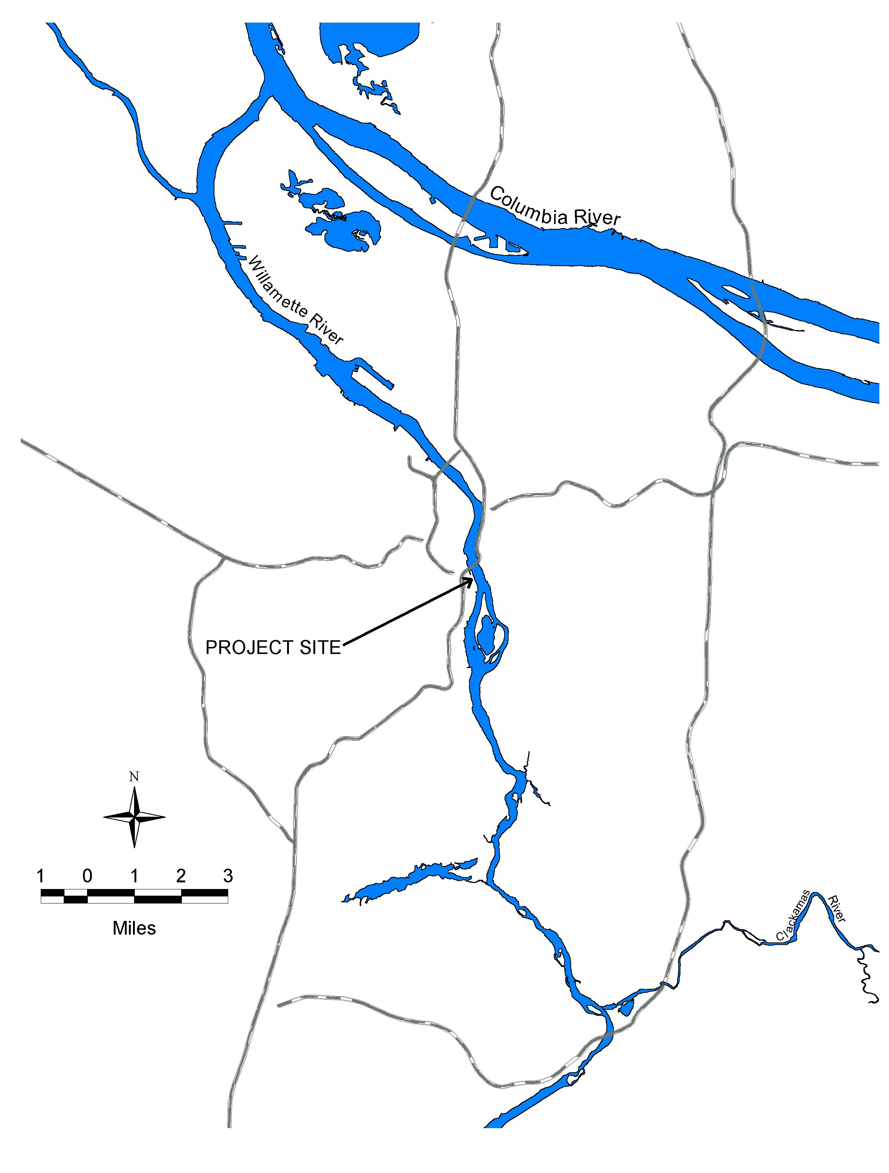
Figure 1. Project Location Map
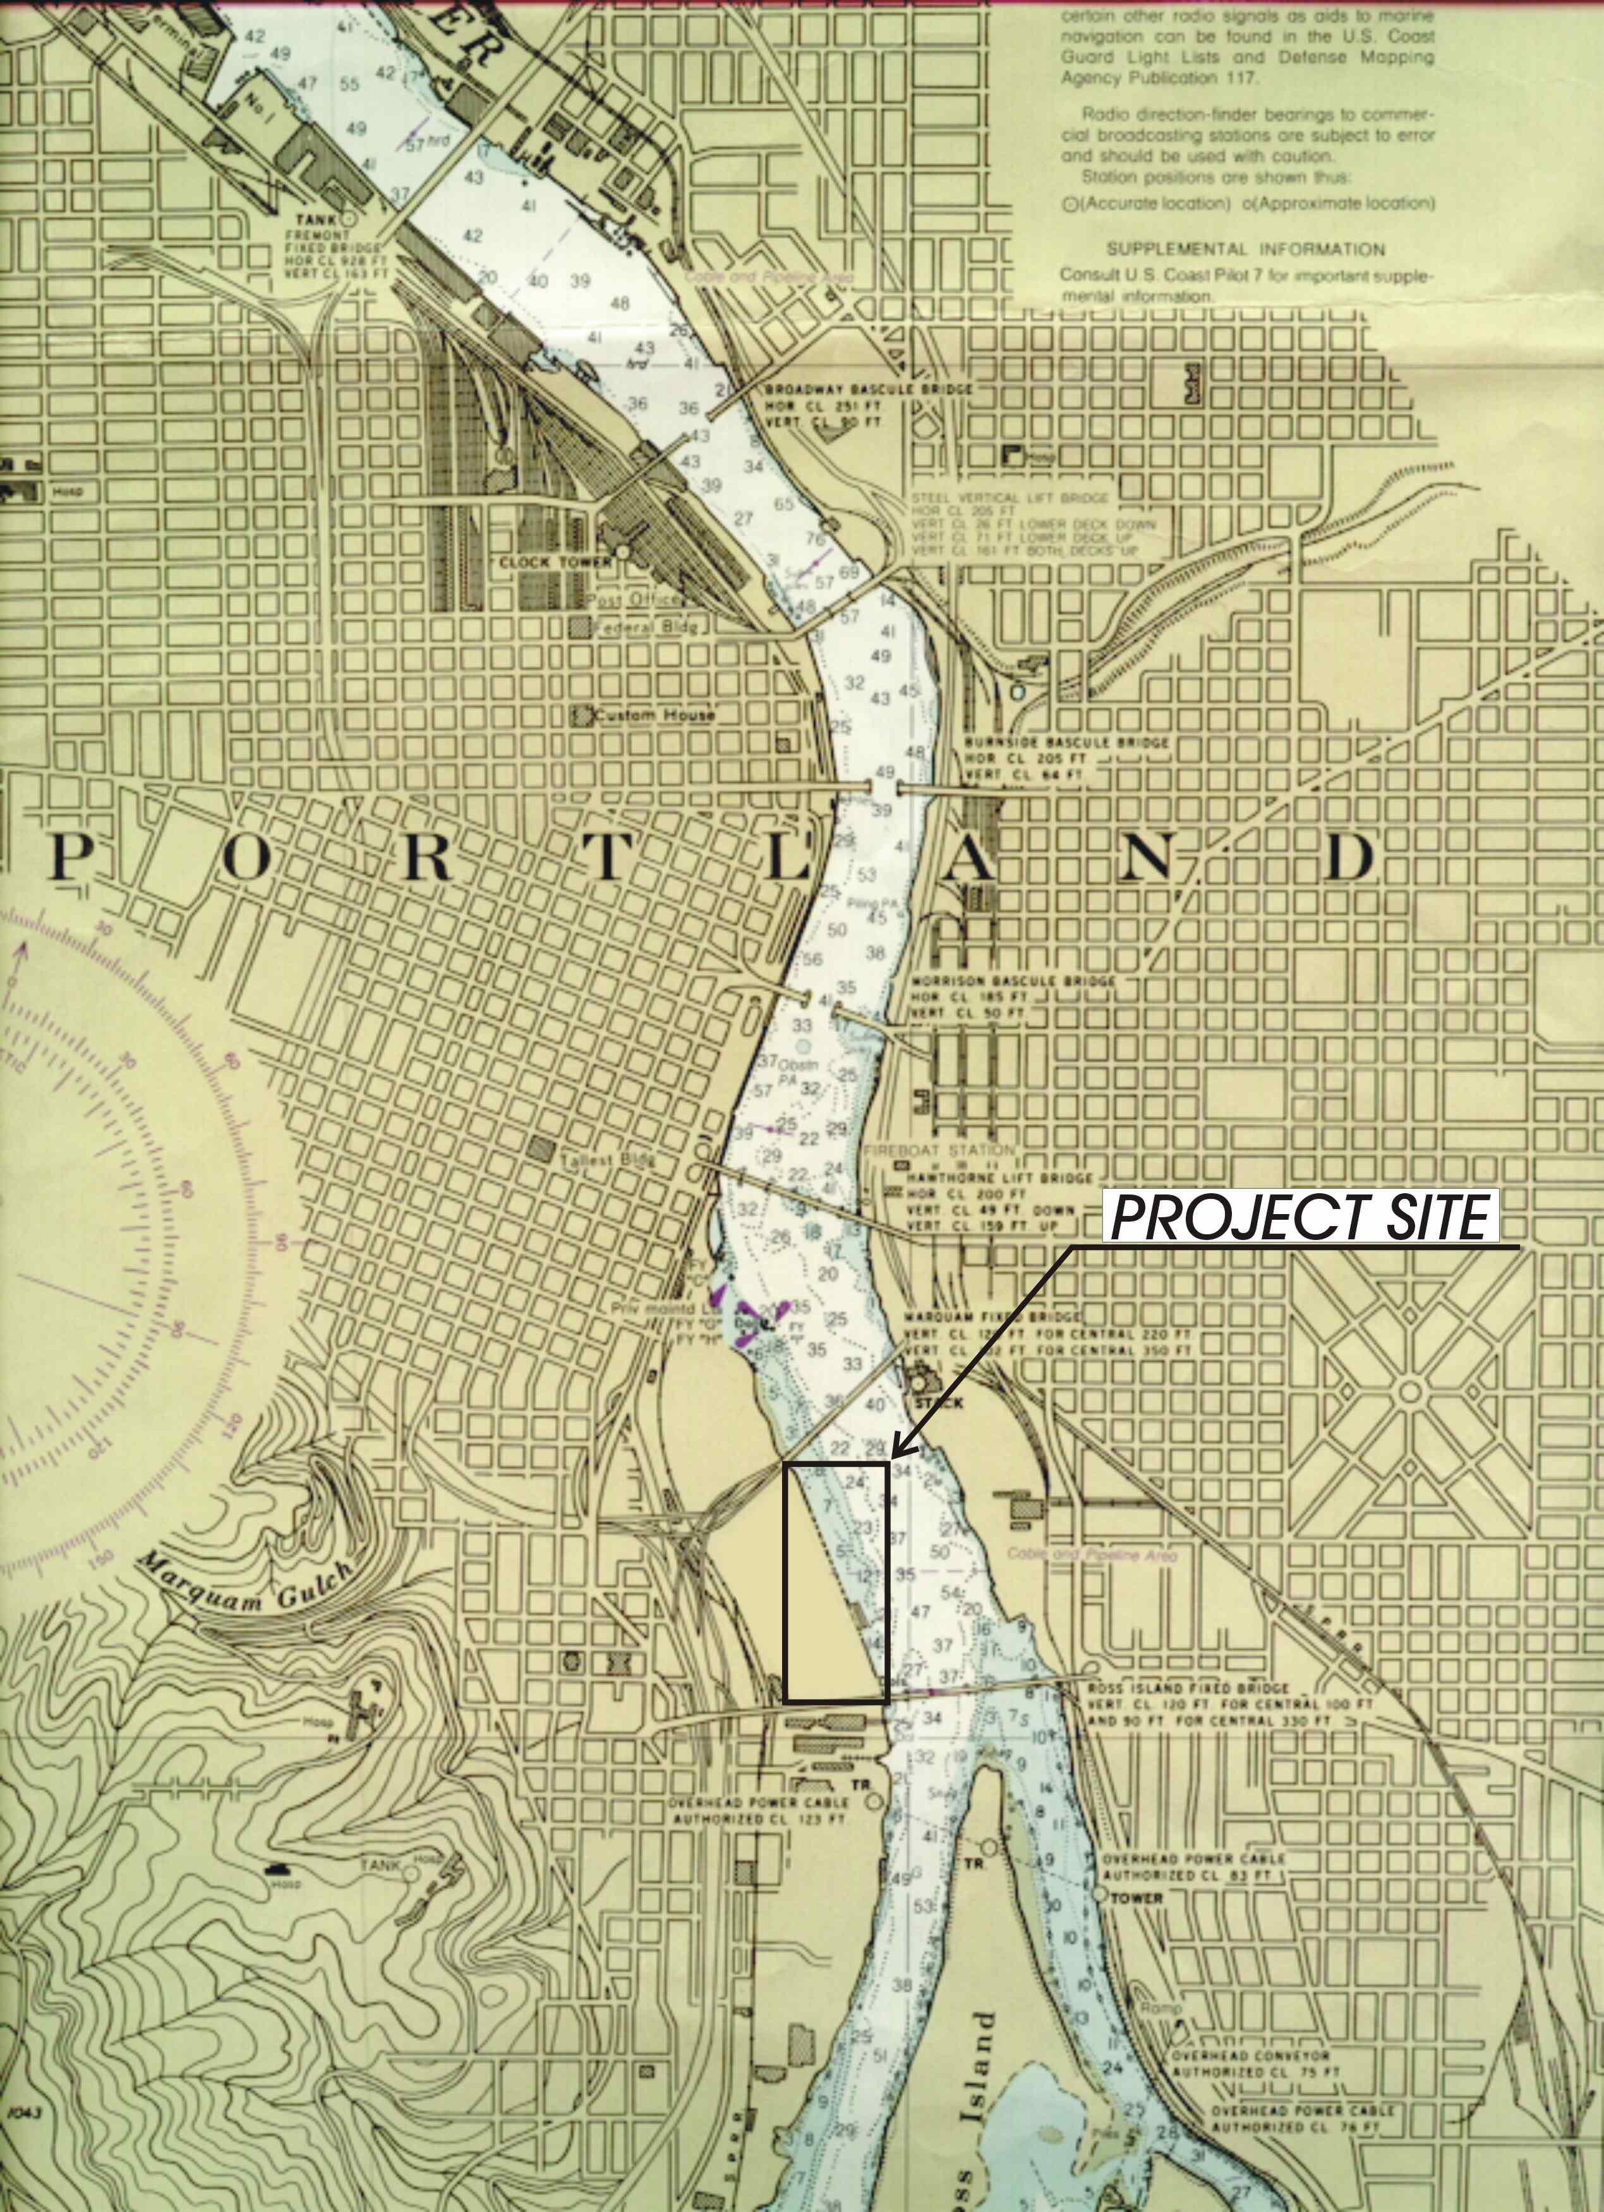
Figure 2. Navigation chart, Zidell North Macadam Project site. Source: NOAA Chart 18526, 1992.

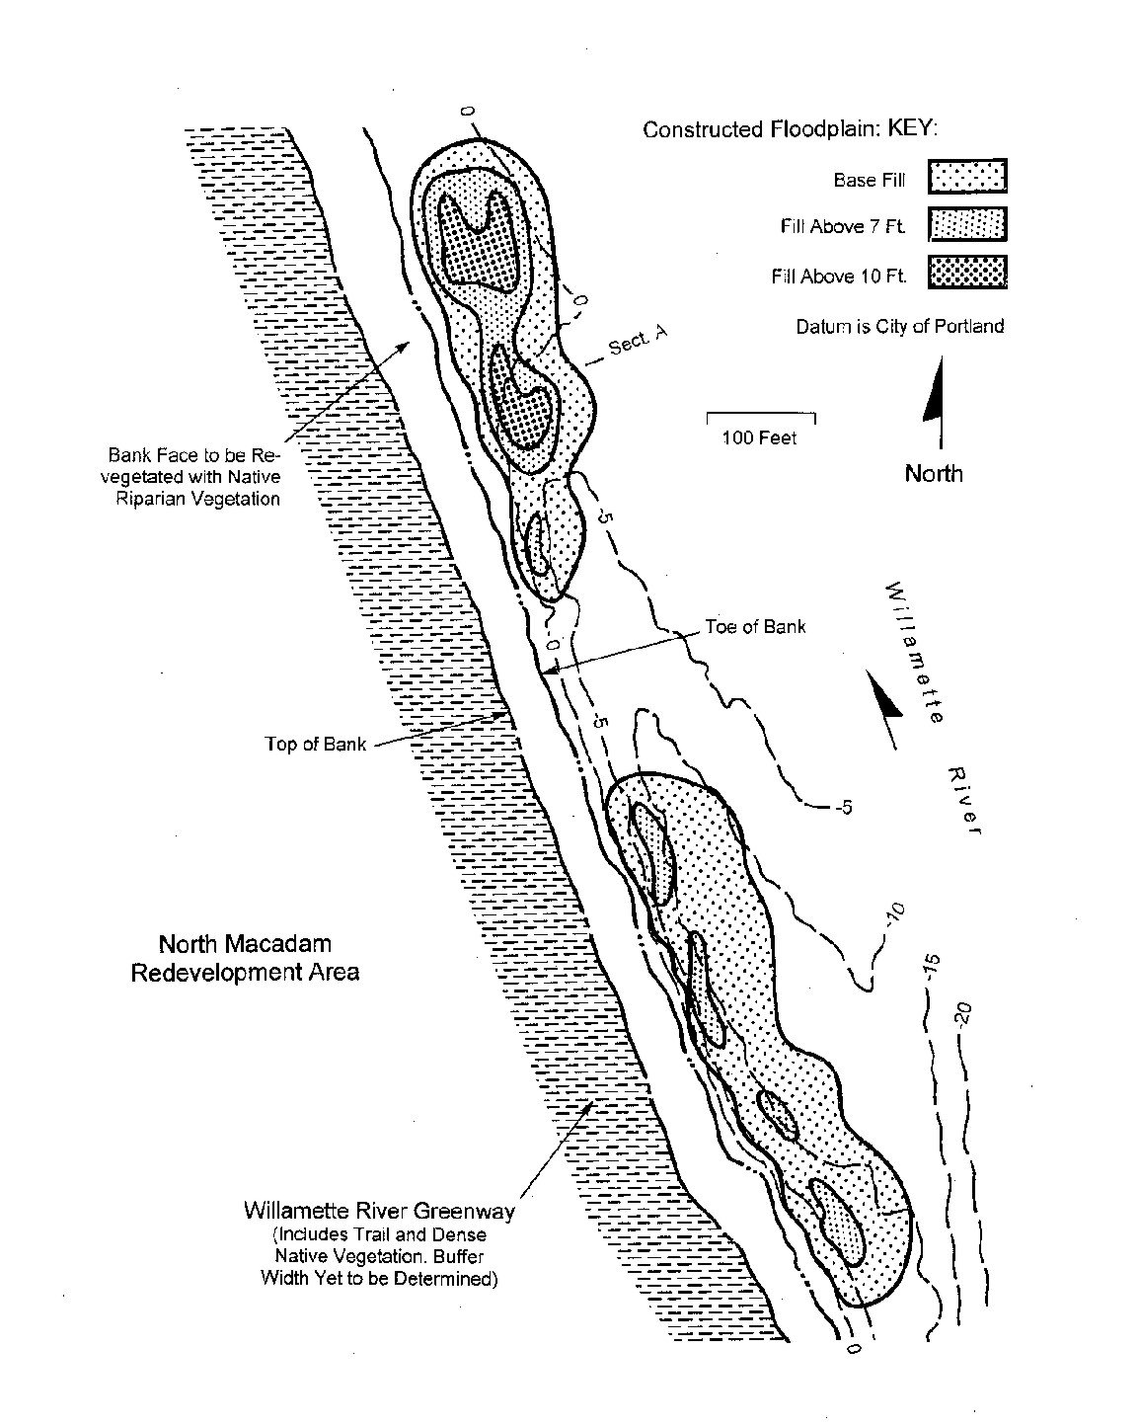
Figure 3. Conceptual level design of fill placement for floodplain re-creation along the Zidell North Macadam site shoreline.

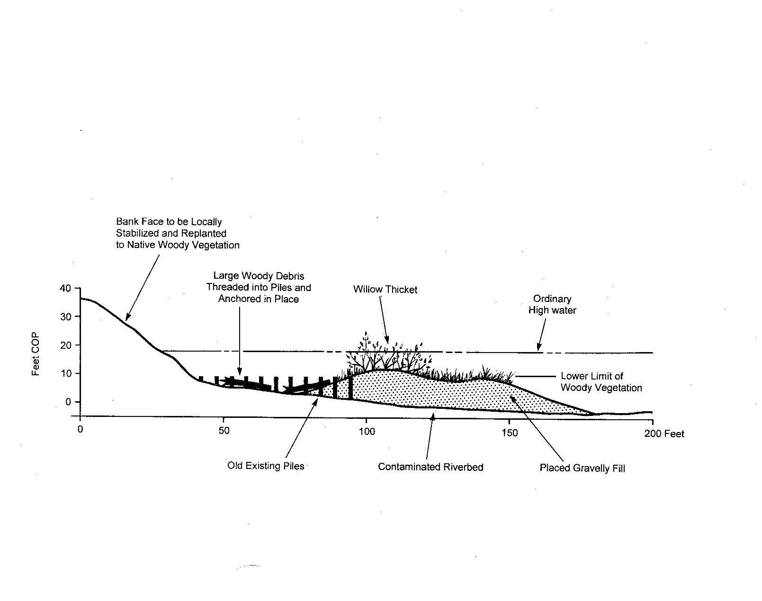
Figure 4. Typical section (Section A) through the floodplain re-creation zone. (Note section location in Figure 3.)

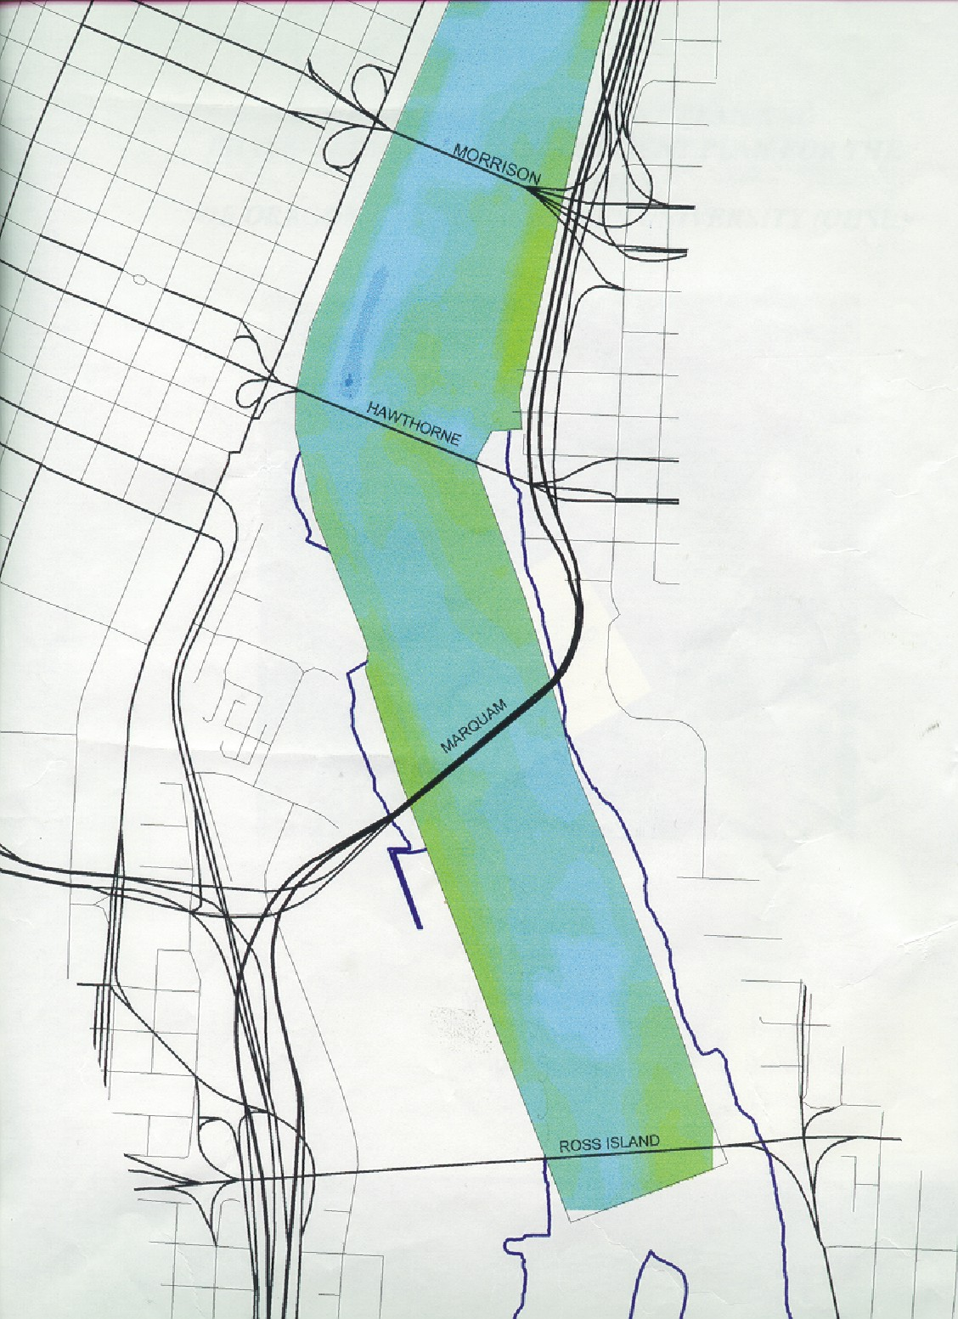
Figure 5. Lower Willamette River bathymetry. Water depth represented by light green (shallowest) to dark blue (deepest). Copyright Fishman Environmental Services, LLC. Data source: US Army Corps of Engineers.
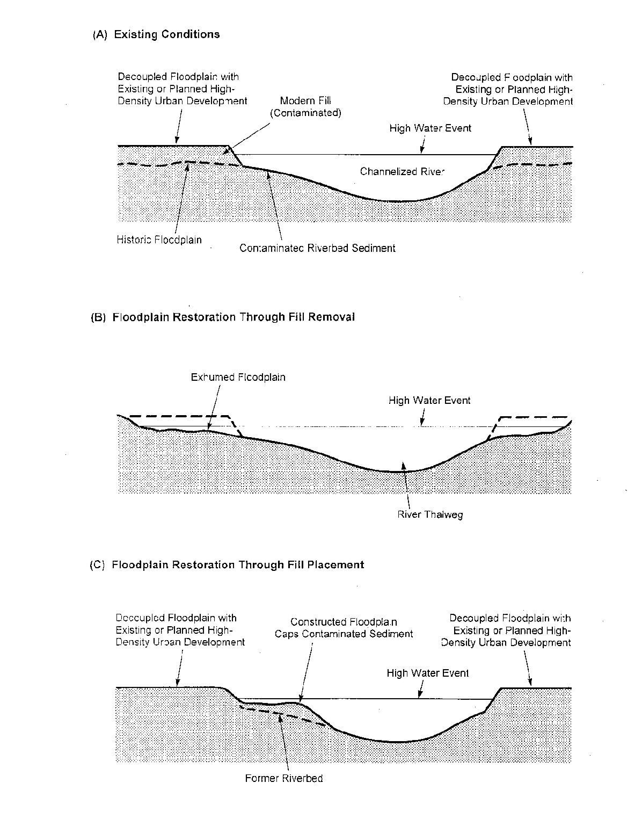
Figure 6. Diagrammatic section representations showing existing Willamette River conditions (A) in the vicinity of the Zidell North Macadam site (left side of diagram) and floodplain restoration through (B) fill removal, and (C) fill placement (proposed).

The property is owned by ZRZ Realty, one of the Zidell Companies.

