Bonneville Power Administration

FY 2001 Innovative Project Proposal Review

PART 2 of 2. Narrative

Title: Sources, Fate, and Biological Impacts of Sediments as Part of a Comprehensive Sediment Management Plan

Section 3. Project description
Provide project detail for headings a through g.

a. Abstract

Following the recommendations of the 1994 Fish and Wildlife Program, this plan aims at developing an innovative Source Fate Impact Methodology (SFIM) for rapidly identifying sources of sediments, quantifying sediment fate, and statistically analyzing impacts on fish habitat and aquatic biota. No such methodology currently exists. SFIM will be developed purely on a state-of-the art scientific basis by using an Acoustic Doppler Current Profiler (ADCP) for turbulent flow measurements, a sedimeter for sediment transport measurements, Isotope Tracer Technology (ITT) for identifying the source/origin of fine sediments within a stream, and state-of-the-art calibrated indices for biological integrity. SFIM is innovative because 1) it will improve our current understanding of the interdependence of the so called sediment “trilogy” processes, sources, fate, and impacts, 2) it will quantify for the first time, based on the stable Isotope technology, the degree to which sediments derived from different land uses impact a stream’s benthic fauna and spawning habitat, and 3) it will calibrate and use analytical methods to discern relationships between variables affecting fish and biota. SFIM is envisioned to have clear advantages over existing methods in accuracy, safety, speed, economy, robustness, modularity and, more importantly, range of flow and sediment measuring capabilities. This methodology will be applied to the Cottonwood Creek watershed, a tributary of the Clearwater River, Idaho. Results from this project will assist TMDL objectives for Cottonwood, will provide a framework for management practices targeted at reducing sediment loads to streams, and will provide a biological benchmark to monitor progress of fish habitat recovery efforts. The application of SFIM to the Cottonwood watershed will lead to methodological refinements which will be readily transferable to other watersheds in the Pacific Northwest.

b. Technical and/or scientific background

a. Technical background, history, location of the problem
Understanding the mechanisms triggering various sediment sources in complex landscapes, the fate of sediments in drainage basins, their input and in-stream fate, and finally their impact on aquatic ecosystems and organisms remains an open need in efforts to recover salmonids and other fish in the Pacific Northwest. Relatively few studies have considered watershed-wide effects of land use on stream ecosystems. The scarcity of studies has been largely due to methodological limitations. Consequently, there is a significant need to develop and apply new innovative methodologies to quantify sediment yields from several land uses, such as forestry, agriculture, mining, and urban development; to investigate transport, deposition and re-suspension of in-stream sediments; and ultimately to provide relationships between land use and management and stream habitat biota (Waters 1995). These methodologies would provide much needed information to guide restoration efforts to target best management practices.

The problem of excessive sediment loads is exacerbated in the Palouse region of eastern Washington and northern Idaho (Clearwater Basin), as a significant amount of the material found in stream beds and banks is polluted (e.g., with pesticides), thus affecting the stream water quality and ecology (Wagner and Roberts, 1998). The Palouse region is one of the most productive regions in the world for dryland farming, yet its average rate of erosion is one of the highest in the United States (Bussaca et al. 1993). An area of significant interest within that region is the Cottonwood Watershed. The Cottonwood Creek watershed has an area of 124,439 acres. The topography of the watershed encompasses steep forested lands in the headwaters, cropland at the Camas Prairie, and deep canyons and gullies where Cottonwood dissects the Camas Prairie in the eastern half of the watershed. Land uses consist of cropland (74%), pastureland (7%), rangeland (13%), forestland (6%), and urban/industrial (1%). Figure 1 below illustrates the different land uses in the Cottonwood watershed. Cottonwood Creek is a second order tributary of the South Fork Clearwater River located in Idaho County, Idaho. Cottonwood Creek flows from an elevation of 5,730 ft at Cottonwood Butte to an elevation of 1,332 ft at its confluence at the South Fork of the Clearwater River, near Stites, Idaho (figure 2). It flows roughly from west to east and the mainstem is about 30 miles long. The 5 major tributaries to Cottonwood Creek are Stockney Creek, Shebang Creek, South Fork of Cottonwood Creek, Long Haul Creek, and the Red Rock Creek.
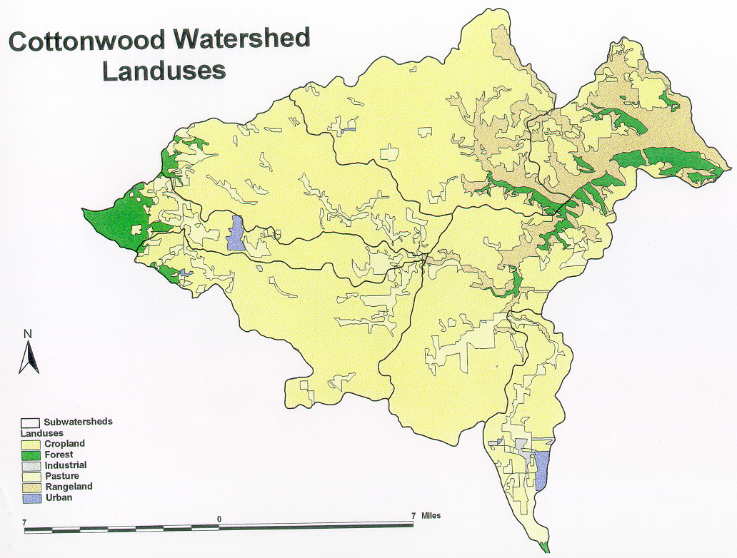
Figure 1. Different land uses in the Cottonwood watershed.
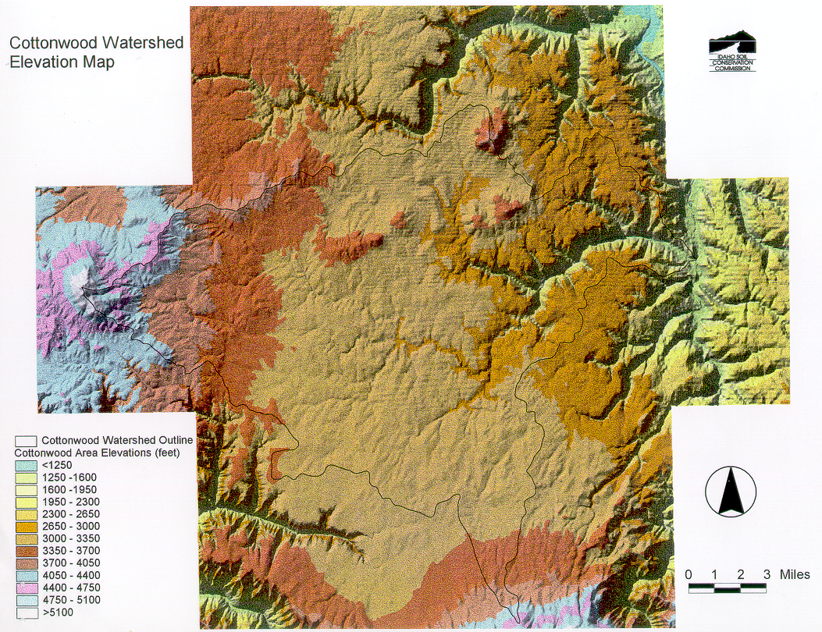
Figure 2. Elevation of the Cottonwood watershed.
We selected Cottonwood for our innovative research plan because in the years 1994, 1996, and 1998, Cottonwood Creek from its headwaters to the South Fork Clearwater was classified as a high priority water quality limited segment under 303(d) of the Clean Water Act. Three of the five tributaries to Cottonwood Creek were listed on the 1994 303(d) list; the two others were added on the 1998 303(d) list. The Idaho Water Quality Standards designated salmonid spawning, cold-water biota, and agricultural water supply as beneficial uses for Cottonwood Creek. The 1995 and 1996 beneficial uses studies indicated that Cottonwood Creek and its tributaries do not provide full support of beneficial uses because of macroinvertebrate population impairment and high loads of sediment. Cottonwood Creek provides spawning and rearing habitat for rainbow/steelhead trout. Steelhead trout were federally listed as threatened species on October 17, 1997. A full passage barrier at all flows for anadromous fish occurs at stream mile 9.0 in conjunction with a significant sediment deposition. According to Cottonwood TMDL (2000), out of 5 sample locations where macroinvertebrate data was collected along the mainstem, the only station at which high water taxa were documented was the station near Cottonwood Butte; the taxa documented at other stations were indicative of medium to poor water quality. The primary limiting factors to aquatic life include deposited sediments, embeddedness, elevated water temperatures, suspended sediments, and wide/shallow stream channels (Cottonwood Attainability Assessment UAA, 1999). For the South Fork Cottonwood alone, the input of fine sediments is 1,332 tons/year while the allowable load capacity is only 67 tons/year (Cottonwood Creek TDML, 2000). To meet the target set by the Total Maximum Daily Load (TMDL) management plan, which is 50 mg/l TSS monthly average during the critical period (January-May), a reduction of 95% is needed.

Since portions of Cottonwood lie within the Nez Perce Reservation, the tribe has encouraged and supported this innovative research project (see the commitment letter by Ira Jones). Similarly, several other people/agencies have highlighted the importance of monitoring, evaluating, and analyzing the data for Cottonwood including Rob Fredericksen from the Idaho USDA, Larry Swenson from the NMFS, Portland, OR, Dr. James Karr from the University of Washington, Dr. Rollin Hotchkiss from Washington State University, Dr. Chris Katopodis, Department of Fisheries and Oceans, Canada, Jim Schafer, Washington State Department of Transportation, Jed Volkman from the Confederated Tribes of the Umatilla Indian Reservation, Glen Mendell and Ken Bates from the Washington Department of Fish and Wildlife, Jill Ory from the Columbia River Intertribal Fish Commission, Terry Bruegman, Columbia Conservation District, Carolyn Wren from the Nez Perce Tribe, and Craig Johnson, Idaho Bureau of Land Management.

b. Scientific background
Watershed restoration efforts have been accelerated in recent years by mandates in the Clean Water Act, the Endangered Species Act, and increasing pressure from environmental groups (e.g., Waters 1995, Reiser et al.1988, Roberts and Church 1986, Nelson et al. 1995, Platts and Megahan, 1975, Tappel and Bjornn 1983, Platts et al. 1989). To address these mandates, water quality management plans and Total Maximum Daily Loads (TDMLs) have been or will be developed for surface waters, such as streams placed on the 303(d) list for beneficial use impairment (USEPA 1991). A common finding of these plans is that excessive fine sediment (primarily clay and silt with median diameter ranging from 0.24 to 62 μm) in streams injures the aquatic habitat and biota therein. To our knowledge, none of these plans address the interdependence of the so called sediment “trilogy,” sources, fate, and impacts within a conceptual watershed integrated approach. A Source Fate Impact Methodology (SFIM) is lacking (Meg 1988).

Sources of sediment resulting in an increased influx of fine sediments to streams are most often associated with land-use activities (Richards and Host 1994). Agricultural activities, for example, often increase sediment delivery to streams. Activities associated with agriculture are diverse (e.g., till and no-till farming, row-crop cultivation, land clearing) many of which can significantly increase erosion and sediment influx to streams. According to Brown (1984), and Ferro and Porto (2000), the world is currently losing 23 billion tons of soil from croplands in excess of new soil formation each year. Waters (1995) and Roseboom et al. (1990), among others, have indicated that sediments from agricultural practices are the primary cause of loss of fish species in western and mid-western streams.

Sediment fate is another important component of the so-called sediment “trilogy.” Thus, it should come as no surprise to learn that many efforts to restore aquatic life have failed because their designs did not account for sediment fate (National Research Council 1992). Sediment fate is controlled by the interaction of two processes: hydrology and geomorphology. Altered hydrologic processes can affect the level of that interaction and, as a result, the rate of sediment deposition and/or suspension within a stream (Reiser et al. 1989). Sediment deposition causes embeddedness (defined as the percent saturation of gravel intersticial space by fine material) and can have a negative effect on fish food sources, such as benthic invertebrates composition (Bjornn 1969, Bjornn 1978; Richards and Host 1994).

On the other hand, highly energetic turbulent events are responsible for the initial dislodgment of sediment and its resuspension (Clifford et al., 1991; Wei and Willmarth, 1991; Papanicolaou et al., 1999a; Papanicolaou et al., 1999b). According to Lyn (1992), Wang and Larsen (1992), Papanicolaou et al. (1999b), Papanicolaou et al. (2000), Papanicolaou and Maxwell (2000), highly energetic turbulent hairpin vortices (figure 3) enhance the capacity of the flow to transport suspended sediment. Suspended solids in high concentrations (in excess of 20,000 particles per million (ppm=mg/L)) can clog fish gills, as well as smother fish, insect eggs, and newly-hatched larvae (Bjornn 1969). In addition, suspended solids affect water clarity and increase water temperature as suspended particles absorb incoming sunlight. This absorption also causes a decrease in photosynthesis and both of these events cause oxygen levels to decline (Bjornn 1969). The combination of elevated suspended solids and low oxygen levels creates a polluted environment for fish.

The impact of sediment influxes on aquatic organisms has been assessed using macroinvertebrates (Rosenberg and Resh 1993, Rinne 1990, Barbour et al. 1992, Gregg and Stednick 2000). In the macroinvertebrate literature the relationship between macroinvertebrates and sediment in streams is incorporated into three major topics: (1) correlation between macroinvertebrate abundance and substrate particle size, (2) embeddedness of streambed substrates and loss of interstitial space, and (3) change in species composition with change in type of habitat. Almost all research published on the effect of sediments on macroinvertabrates does not address the problem of variability in measures of macroinvertebrate community structure by stream reach and stream class (Chutter 1969, Trotter, Bisson, and Frances 1993). Before potential impacts from land use activities can be assessed, definition of a reference condition and its natural variability in macroinvertebrate community is needed. The variability among reference sites needs to be examined on several levels: within one reach of a stream and between several reaches within one stream to provide some practical answers/guidelines on the number of macroinvertebrate samples necessary to adequately represent a stream reach.

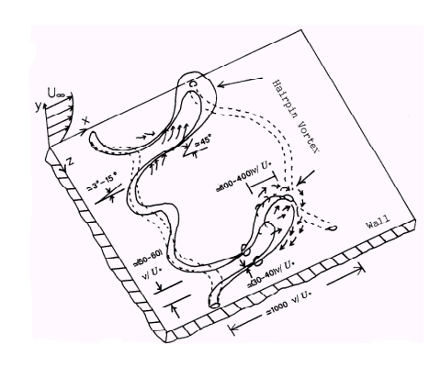

Figure 3. Turbulent hairpin vortex
- Research needs
Evaluating alternatives for sediment management within salmon recovery plans using the source, fate, impact (SFIM) conceptual framework described above makes evident the following research needs:
1). An important weakness in most sediment management programs has been a limited capacity to identify and focus sediment control efforts on critical source areas (Megahan and King 1985, Scarlatos and Mehta 1993, Trofs 1997, Dennett et al. 1998, Papanicolaou 1999, Papanicolaou et al. 2000, Dancey et al. 2000, Schuyler and Papanicolaou 2000, Hilldale and Papanicolaou 2001). Additional research is needed to identify and quantify the source of sediments found in streams. Innovative methodologies using stable isotope tracers and other fingerprinting techniques would help in these objectives.

2). The effect of flow on the fate of deposited and/or suspended sediments found in a stream is one of the last elements of watershed management that is addressed almost entirely from an empirical standpoint (Jennings 1990, Diplas and Papanicolaou 1997, McNeil et al., 1997, Zreik et al., 1998; Ravens and Gschwend 1999, Papanicolaou and Diplas 1999). This is attributed to the following factors: a) The characteristics of river turbulence are poorly understood not only because of the lack of appropriate physical models, but also because of a lack of reliable, detailed field measurements and b) Conventional sediment transport models do not differentiate between sediments originating from uplands vs. channel sources thus over-predicting sediment resuspension. Further research is required to quantify the in-stream fate of sediments and the interrelationship of sediment and turbulent flow. Methodologies such as predicting in-stream fate have not yet been applied in these studies (Papanicolaou et al. 2000).

3). The calibration of multimetric indexes of biological impact is needed for applications to watersheds throughout the Pacific Northwest (Karr 2000, personal communication). Examination of the natural variability in macroinvertebrate community and improvement in sampling methods is necessary to assess sediment impacts on stream ecology. The index of biotic integrity can be measured with at least three primary multimetric indexes: 1) The Invertebrate Community Index (ICI): Ohio EPA 1988, 2) the rapid bio assessment protocol (RBP: Plafkin et al. 1989), and 3) the benthic index of biological integrity (B-IBI: Kerans and Karr 1994). B-IBI has been tested in Washington and Oregon but not in Montana or Idaho where the Cottonwood watershed is located. The ICI has been extensively tested only in the Eastern United States. The PBP sampling methods and metrics have not been carefully evaluated in the Pacific Northwest (Gregg and Stednick 2000).

4).A comprehensive approach is needed to document relationships between land use and stream habitat and biota. Use of the best analytical tools available is not evident in current efforts. Classification of variables (e.g. turbulence, geomorphology, land uses) based on the degree of impact on stream habitat and biota is lacking. Current watershed management plans involve a limited use, if any, of appropriate statistical tools to draw a link between land uses and stream habitat and biota (Richards and Host 1994, NWPPC 1994 ftp://www.nwppc.org/nwppc/1994_fish_program/00-index.txt). Evaluation of the existing statistical tools is necessary for any future research and implementation plan.

d. Current work of key project personnel on related topics
The project PIs/PDs have recently received “seed” funding through the USGS statewide competitive program, the US Forest service, and the Nez Perce Tribe to foster regional collaboration by collecting field sediment and streamflow data and perform stable isotope tracer monitoring and macroinvertebrate analysis in Union Flat Creek, Washington, Lawyer Creek, Idaho, and Newsome Creek at the South Fork of the Clearwater, Idaho. Water quality monitoring has been performed by our group for Touchet River, at Dayton, WA. The PIs/PDs were involved in these projects to assist various State agencies and tribes to meet the requirements set by the Federal Clean Water Act (CWA). Currently, the PI’s are assisting the Cottonwood advisory board to carry out the TMDL by providing technical expertise when it is required.

c. Rationale and significance to Regional Programs

Following the recommendations of the 1994 Fish and Wildlife Program, our plan aims at developing an innovative Source Fate Impact Methodology (SFIM) for rapidly identifying sources of sediments, quantifying in-stream sediment fate, and statistically analyzing impacts on fish habitat and aquatic biota. No such integrated methodology has been previously applied. SFIM will be used for collecting flow and sediment information needed to create computer visualizations and hard copy maps, and for accurately predicting sediment fate under various flow conditions, and generating quantitative flow and sediment databases that can be used in real-time mode at the field level. SFIM will be applied based on purely state-of-the-art scientific methods such as the Acoustic Doppler Profiler for turbulent flow measurements, a sedimeter for sediment transport measurements, and the Isotope Tracer Technology (ITT) for identifying the source/origin of fine sediments within a stream. SFIM will be founded based on well sound hypotheses (as it is suggested in item 4). The application of SFIM to the Cottonwood watershed and associated data acquisition and methodological refinements will be readily transferable to other watersheds in the Pacific Northwest.

a. Description of the innovative approach as it relates to the NWPPC Fish and Wildlife Program
This project directly feeds into actions outlined by the Federal Caucus in the National Marine Fisheries Service’s Draft Biological Opinion (2000) for the recovery of anadromous stocks in the Columbia Basin. Recently, the NWPPC (Council) and BPA (Bonneville) have highlighted non-point sources such as sediments and nutrients along with its effects on aquatic systems as a top research priority in the latest request for innovative proposals. The proposed innovative project will complement the Council’s Columbia River Basin Fish and Wildlife Program (NWPPC 1994).

In summary, the 1994 Fish and Wildlife Program (NWPPC 1994) concludes that:
  - A significant change in the monitoring and evaluation aspects of the assessments is necessary.
  - Effort expended on data monitoring exceeds typically analysis and understanding of the collected data.
  - The analysis of the data should include development of measurable benchmarks.
  - Monitoring efforts do not always have explicit statement, rigorous examination of the evidence in support of those beliefs, framing of alternative hypotheses, and design of monitoring evaluation to fairly test all hypotheses.
  - The best analytical tools are not evident.

This proposed innovative project addresses items 2, 3, 4, and 5. Specifically, the proposed research development plan endeavors to integrate analytical tools and monitoring methods (items 4 and 5) to pioneer novel in-situ methodologies that are currently lacking for rapid and versatile site prediction of sediment sources. Application of SFIM will be based on sound hypotheses (as suggested in item 4). The critical hypotheses to be tested are:

    - In-stream sediments can be quantitatively traced to different sources and management practices.
    - Sediments from different sources have different fates and impacts within the aquatic system.
    - The stability of fine sediments in gravels will reflect the interaction between soil type (weight, size, cohesiveness) and turbulence.
    - Differences in the stability of sediments in embedded gravels will have differing impacts on biological productivity. Biota communities will reflect these differences.
    - Differences will be significant between headwater transport reaches and mainstem depositional reaches in terms of impacts of different soil types.
    - The subset of sediments that cause the most severe impact on fish production can be identified.
    - Project results can be generalized to enable economical prioritization of sediment sources and best management practices (BMP’s) for spawning grounds.

b.Why the innovative project is needed
Meg (1988), Coutant and Cada (1985), and NWPPC (1988) clearly stated “that a measure of success for the 1994 Fish and Wildlife program should not only be determined based on progress in monitoring but also on the ability to increase understanding of processes, decrease uncertainty, and develop analytical methods to discern relationships between variables affecting habitat population and health.” SFIM is necessary because 1) it will improve our current understanding of the interdependence of the so called sediment “trilogy” processes, sources, fate, and impacts and 2) it will allow the calibration and use of analytical methods to discern relationships between variables affecting fish and biota. “SFIM,” endowed with coupled flow and sediment quantitative measurements, is envisioned to have clear advantages over existing methods in accuracy, safety, speed, economy, robustness, modularity, statistical methods and, more importantly, range of flow and sediment measuring capabilities. Furthermore, SFIM will quantify for the first time, based on the stable isotope technology, the degree to which sediments derived from different land uses affect a stream’s benthic fauna and spawning habitat. The definition of a reference condition and its natural variability in macroinvertebrate community will be provided to assess sediment impacts on stream ecology. A priority index based on the above criteria will be developed in order to assess watershed management and implementation plans.

The proposed work will further goals of the fish and wildlife program by developing a unique SFIM with a wide range of measuring capabilities and sound methodologies for identification and protection of healthy core populations. SFIM will increase our understanding of processes, decrease uncertainty, and develop analytical methods to discern relationships between variables affecting habitat population and health. SFIM endowed with robust analytical tools can be incorporated into the existing Fish and Wildlife Program to predict metapopulation recovery and direct future research and fisheries management towards this direction.

d. Relationships to other projects

While the ongoing Cottonwood watershed TMDL constitutes the focal point of this project, many other watersheds throughout the region will benefit from the adoption of SFIM, providing unique information of the influences of watershed land use on habitat quality and biotic integrity.

Recent field studies in the Palouse region of eastern Washington and northern Idaho conducted by our group (Bussaca et al. 1993, Hilldale and Papanicolaou 2001) have involved the use of cesium-137 (Cs-137), a radioisotope created and dispersed by atmospheric nuclear weapons testing, principally between the years 1955 and 1965, to estimate agricultural erosion and sediment delivery. This Cs-137 method is not capable of identifying sediment sources. Our innovative Isotope Tracing Technology will be used to identify the sediment sources.

The proposed innovative methodology will assist other ongoing projects to meet the goals set by NMFS and NWPPC (1994). Recently, an interesting project concerning the effects of flow on salmon egg survival was conducted in Finney Creek. The Skagit System Cooperative (SSC) has placed artificial redds in Finney Creek to learn more about how high turbulence affects egg survival (Lorraine Loomis, Swinomish Fisheries Manager, Personal communication with Thanos Papanicolaou). The artificial redds are essentially open plastic boxes with grating able to contain gravel but allow in fine sediment. They are installed where salmon redds are present and are retrieved throughout the incubation period after peak flow events. Our innovative Isotope Tracing Technology will assist them to identify the sources of fine sediment trapped in the artificial redds (Eric Beamer, Senior Restoration Ecologist for SSC and lead project investigator).

e. Proposal objectives, tasks and methods

Objectives

The primary goal of this research is to develop and apply an integrated watershed management approach for Cottonwood watershed, coupling in-stream sediment fate with innovative approaches to distinguish between riverine and upland sediments, and providing quantitative measures of the impact of sediments on aquatic organisms. The proposed research aims at improving our understanding of the basic flow mechanisms involved in the in-stream fate of fine sediments, identifying land uses affecting sediment input to streams, and examining the impacts of sediments upon stream biota. The specific goals for Cottonwood are: 1) to help develop the sediment implementation plan and meet TMDL goals and 2) to improve the existing taxa “from poor to worse” quality (index of biological integrity IBI<30) to “from good to better” quality (IBI>50). The ultimate goal is to generalize the innovative methodological approach applied at Cottonwood watershed to enable economical prioritization of sediment sources and best management practices (BMP’s) for sediment reductions throughout the Pacific Northwest.

This research has field and laboratory components. Field data will be collected first to help prepare for laboratory analyses. The field and laboratory data will be coupled to provide a complete description of SFIM. The project PIs recognize that any research that relies on field measurements and involves complex processes has an element of risk. However, this is an area of research largely untouched; an area where we need to start filling in the gaps and making strides toward a comprehensive integrated research effort. The two-year duration of the project will decrease the risk involved in getting reliable field data. To address the research needs discussed earlier, the following specific objectives will be pursued:

Objective 1: Identification of sources of sediments found in streams. The innovative component of the Tasks required to address this objective is found on the use of stable isotopes to differentiate land uses.
Objective 2: Quantify in-stream fate of sediments and the interrelationships between sediments and turbulent flow.
Objective 3: Evaluate the impact of sediments on stream biota.
Objective 4: Classification of variables (e.g. turbulence, geomorphology, land uses, soil properties) based on the degree of impact on stream habitat and biota is lacking.
Objective 5: Disseminate the results

Tasks and Methods

Objective 1: Identification of sources of sediments found in streams. The innovative component of the Tasks required to address this objective is found on the use of stable isotopes to differentiate land uses.
- Task 1.1. Identification and characterization of the sampling area/study design
Method: Sites will be selected to reflect the range of land use and geomorphic conditions in Cottonwood based on existing ground surveys and available information (TMDL 2000). At the headwaters of Cottonwood the land use is predominantly forest while along the mainstem rolling cropland becomes the primary land use. Measurements at the headwater and mouth will work as reference points to differentiate soil characteristics between forest and crop land uses (Cottonwood TMDL 2000). Twelve monitoring stations (at an approximate distance of 2.5 miles apart) will be distributed along the mainstem of Cottonwood Creek from headwaters to mouth (30 miles long). Five upland locations will serve as reference points for sediment source identification, including different land uses such as cropland, pastureland, rangeland, forestland, and urban/industrial. The combination of the twelve mainstem stations and the five upland reference stations will provide a significant monitoring network. The mainstem stations will be chosen to correspond to straight, concave, and convex reaches of the stream to account for the effects of channel sinuosity on the type of sediment sources that will be collected.

- Task 1. 2. Survey of the stream geomorphic characteristics to assess physical habitat
Method: This will consist of the assessment of physical habitat characteristics during base flow along a 200-m reach at each mainstem station. Using variables that are typically employed to characterize physical habitats (Osborne et al. 1991; Richards and Host 1994), we will perform a number of habitat measurements at each station, including cross sectional characteristics, bank conditions, riparian conditions, woody debris, and hydraulic characteristics. The surveying will provide the bankfull conditions and water surface elevation, the percentage of shallow (percentage of wetted areas less than 10 cm in depth) and deep pools (pools with depth greater than 0.5 m), flood ratio (proportion of flood depth represented by summer low flow), stream power per unit width (Hotchkiss and McClenathan 1996), the percentage of fine sediments, the eroded canopy, and the macrophyte cover. Collection of these site characteristics is necessary to provide a correlation between physical habitat and geomorphic characteristics.

- Task 1.3. Collection of sediment samples
To obtain data that are statistically significant, 60 sediment samples of 20 mg each will be collected per cross section (Peart 1993), a total of 720 samples along the mainstem twice a year. Two sampling periods will be considered, in early Fall of 2001 and in Spring of 2002 (sampling will preferably be performed during a rainFall). Half of the sediment samples will be collected from the substrate and the other half from the water column. Substrate sediments will be collected with a grab sampler or a multicore device if the bed material is compacted. The top centimeter of the substrate sediments will be stored at –20 degrees Celsius until the commencement of the isotope analysis (Middelburg and Nieuwenhuize 1998). Suspended sediment in the water column will be collected on Teflon sheets following continuous flow centrifugation. Sufficient material will be obtained and further analyzed (see Task 1.4) to allow classification of sediment into various fractions varying in density, size, color, and rheological properties. Finally, 30 soil samples (twice per year) will be collected per upland reference site (a total of 150 samples per sampling period) to characterize the soil at the five reference stations and provide a base for comparison with the riverine sediment.

- Task 1.4. Soil classification based on the soil properties
The properties of the substrate and suspended sediments will be analyzed for particle size, bulk density, and rheology. Particle sizes will be determined using a counter-size analyzer; a Rheostress rheometer will be utilized to determine the strength of fine sediment, known as the yield stress. The sizing of fine particles will be carried out with the aid of a Coulter Counter, model seclv14. This particle size analyzer is capable of measuring particle size in the range of 0.5 to 4000 microns and will be operated by means of a personal computer. The rheological parameters such as yield stress will be determined with a Haake RS 75 Rheostress rheometer with a coaxial cylinder system running under a controlled stress mode of operation. The bulk density will be calculated according to the method of Hakansen and Jansson (1983). Analysis of soil properties is necessary to classify the soil samples based on their strength, size, density, and shape. This information is important in studying the fate of sediments in Cottonwood Creek as in any other Creek in the region with the same soil characteristics.

- Task 1.5. Stable isotope analysis of the soil samples to identify land uses
Method: Sediment sources will be identified using the latest technology in stable isotope tracing. Use of this technology is safe, economic, and straightforward and has been recently employed with a great success in the U.S. for similar types of applications (Peart, 1993, Oak Ridge National Laboratories 1999, University of Idaho Forestry Department 2000). Nowadays, it is widely accepted that carbon and nitrogen isotopic signatures can be easily detected by the existing instrumentation at a low cost of analysis due to their natural abundance in the environment (Bierman et al. 1998). In this proposed research the technology will be adopted to identify: (a) the organic carbon and nitrogen in sediments via an elemental analyzer (EA), and (b) the carbon and nitrogen isotopic composition via a continuous flow elemental analyzer/isotope ratio mass spectrometry (EA/IRMS) (Figure 4). The abundance of the stable isotopes carbon-13 (C-13) and nitrogen-15 (N-15) found in riverine sediment will be compared against the abundance found in the upland reference areas. Based on differences and similarities that will be found in isotope ratios, we will be able to draw links as to which land uses contribute significantly to sediment pollution along the 30-mile stretch of Cottonwood. For this purpose, the 720 samples collected at the field and the 150 samples collected at the upland (per sampling period), after being frozen and dried, will be hand packed in 15 mg foil cups (Costech Analytical Technologies. CA, USA) and processed for automated isotopic analysis. The automated analysis will be performed using continuous flow EA/IRMS with Finnigan’s ISODAT software. The analysis time is 500 seconds per sample and the cost $12 per sample. During the run, individual samples will be combusted at 1050 degrees Celsius. The Nitrogen and Carbon, products of this combustion, will be automatically introduced via the Finnigan interface to the IRMS where the isotopic ratios will be determined using the University of Idaho methodology (Stickrod and Marshall 2000).

- Timeline: samples will be collected during the first year of the project (Fall 2001, and early Spring of 2002). Analysis of the soil samples will occur immedaitely after the collection of the samples.
- Investigators contributing: Drs. Marshall, Papanicolaou, Busacca, and Stockle. Two graduate students will carryout the experiments while the soil samples will be collected with the help of the Nez Perce tribe personnel (Emmit Taylor and Felix McGowan) .

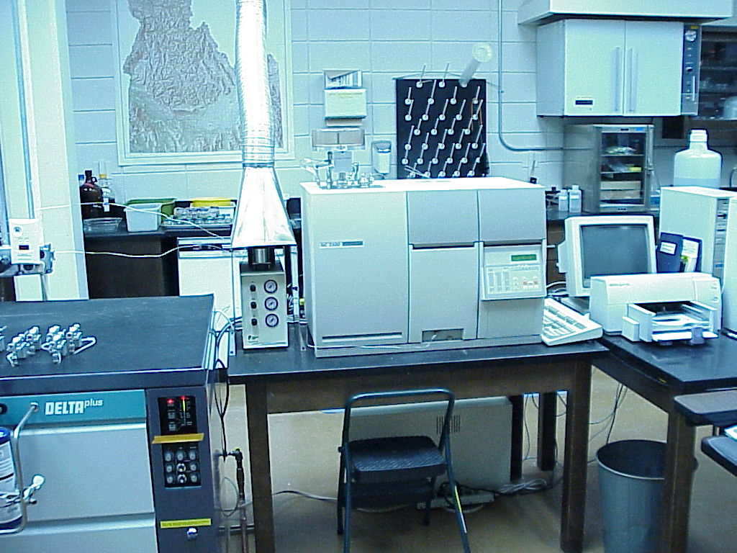

Figure 4. The University of Idaho Mass Spectrometer and Elemental Analyzer

Objective 2: Quantify in-stream fate of sediments and the interrelationships between sediments and turbulent flow.

- Task 2.1. Identification and characterization of the sampling area/study design
The sediment flow measurements will be performed at the exact same measuring stations identified in Task 1.1. The stream cross-sections (a total of 12; see Task 1.1) will be gauged following the USGS procedure.

- Task 2.2. Sediment-flow measurements
The aim of these measurements is to “map” the velocity flow along Cottonwood and evaluate the role of turbulence on sediment fate under various flow conditions. Flow measurements will be performed by means of a three–dimensional turbulence-resolving SonTek Acoustic Doppler Current Profiles (ADCP). Sampling dates include Fall of 2001, Spring and Fall of 2002, and Spring of 2003.

The flow measurements will be complemented with bed load and suspended load measurements using existing EPA and USGS certified methodologies. The bed load and suspended load measurements will be performed at the same locations and coordinated with the turbulent flow measurements to provide a linkage between flow and sediment flux. To ensure sediment measurements at the exact same locations a global positioning system (GPS) will be attached to the sediment instruments. Bed load sampling will be performed by using a BL-84 bed load sampler recommended by the USGS (Nelson 1999, personal communication). Suspended load will be measured with a sedimeter, a state-of-the-art instrument for measuring suspended load which measures erosion and accumulation of sediments with a resolution and accuracy of 0.1 mm and for water depths up to 50 m.

- Task 2.3. Correlation of turbulence and sediment
Analysis of the data will yield identification of the turbulent conditions initiating sediment motion and provide threshold criteria for sediment motion. The time series plots for sediment flux and turbulent stresses will be analyzed to identify if there is time lag between high peak flows and sediment fluxes. Turbulence spectra will be employed to obtain spatial information about the structure of turbulent bursts. According to Cao (1997), the area (i.e., spatial characteristic) of a turbulent burst and its frequency (i.e., temporal characteristic) affect the rate of sediment transported by the flow. Based on these recent findings, the PI's will estimate the river turbulence characteristics and their relationship to basic hydraulic characteristics. Relations that correlate the bursting area and frequency of turbulence with sediment flux will be developed (Papanicolaou et al. 2000). These relations will account for the first time for the depositional history of soils and their origin by differentiating between sediments originating from uplands vs. channel sources (using the information gathered in Tasks 1.4 and 1.5).
- Task 2.4. Sediment thresholds –probabilistic model
Analysis of the data will yield identification of the turbulent flow conditions initiating sediment motion and provide benchmark turbulent flow values for sediment motion. A probabilistic model developed by Papanicolaou (1999), which has been adapted by the US Army Corps of Engineers, Vicksburg, Mississippi, will be used to identify those conditions for the base and peak flows in Cottonwood. This model considers that the turbulent stresses are well described by a Gamma distribution. A verification of the validity of this model will be conducted prior to its use.

- Timeline
Sampling dates include Fall of 2001, Spring and Fall of 2002.

- Investigators contributing: Drs Papanicolaou, Stockle, Hotchkiss, two graduate students, and the Nez Perce tribe.

Objective 3: Evaluate the impact of sediments on stream biota.
- Task 3.1. Embeddedness
A traditional approach to assess the sediment impact on stream biota is to determine the substrate embeddedness. Because of the high variability associated with cobble embeddedness, levels of cobble embeddedness will be evaluated at the 12 stations every two months. Samples will be taken from a cobble-bottom riffle habitat and the two most commonly accepted approaches will be employed: 1. the percent Cobble Embeddedness (PCE) method (Skille and King 1989) and 2. the Intersticial Space Index (ISI) (Kramer 1989).

- Task 3.2. Macroinvertebrate variability and sampling methods
Three macroinvertebrate samples will be collected within each reach per stream cross section (for 12 cross sections, 36 total samples will be collected) (Gregg and Srednick 2000). To characterize macroinvertebrate assemblages, the EPA 10 methodology, applicable to the region, will be adopted. Macroinvertebrate samples will be collected via a D-net sample (1 mm mesh). For higher flows, a Hess sampler will be used (Merritt and Cummins 1996).

Macroinvertebrates will be collected and analyzed to the lowest practicable level (genus and species, if possible), and each macroinvertebrate taxon will be assigned to a functional feeding group (Merritt and Cummins 1996). Macroinvertebrates will be used to calculate 14 indices (after Resh and Jackson 1993): 1) number of macroinvetebrates/m², 2) total biomass g/m², 3) number of taxa represented per sample, 4) number of Ephemeroptera, Plecoptera, and Trichoptera (EPT) taxa represented per sample, 5) number of families per sample, 6) ratio of the number of EPT individuals to the number of Chironomidae, 7) ratio of the number of Diptera to the total number of individuals, 8) percent of the dominant taxa, 9) Shannon’s diversity index (SHAN) (Shannon 1948), 10) percent shredders, 11) percent predators, 12) percent collector-gathered-scrapers, 13) percent collector-filterers (CF), and 14) ratio of the percent collector-gathered-scrapers to the percent collector-filterers. According to Cregg and Stednick (2000 ) (from data collected in Wyoming for various streams), variability of these indices within a stream reach was detected for only 2 indices, SHAN, and CF. In this project the importance of the above indices will be evaluated for Cottonwood in order to determine if it is worthwhile to collect all fourteen indices. A blueprint will be developed to assist fish biologists in optimizing their sampling efforts.

In addition, the results of our analysis will be used to calibrate the three most prominent multimetric indices: 1) the benthic index of biological integrity (B-IBI: Kerans and Karr 1994), 2) the Invertebrate Community Index (ICI): Ohio EPA 1988 and 3) the rapid bio assessment protocol (RBP: Plafkin et al. 1989). It is expected that the calibration process will make the above indices of biological integrity applicable across the State of Idaho and Clearwater basin and regions of the same land use and geomorphic conditions.

- Timeline: Sampling dates include Fall of 2001, Spring and Fall of 2002 (the project is a two year project).
- Investigators contributing: Drs. Fred Rabe and Darin Saul, and one graduate student.

Objective 4: Classification of variables (e.g. turbulence, geomorphology, land uses, soil properties) based on the degree of impact on stream habitat and biota is lacking.

- Task 4.1 Develop relations between land uses and impacts
The different indices of physical and biological impact of in-stream sediments will be related to the different types of sediment and sources found along the Cottonwood Creek. This analysis will be conducted for each of the 12 stations along the mainstem, trying to isolate or integrate effects due to land use according to the position and area of watershed collection of each station. Based on the relationships found between source, fate, and impact, recommendations of avenues for the implementation of TMDLs and for best management practices in different areas of the watershed will be developed.

- Task 4.2. Classification of variables based on their degree of impact on stream habitat and biota
For each habitat and fish variable per sampling site, we will calculate their mean value and standard deviation. Then a score will be given to each resultant metric index (defined in Task 3.2) based on percent comparability to a reference station. The percentage value will be compared with scoring criteria and the scores will be totaled for the 14 metrics (defined in Task 3.2) from the impacted stream (Cottonwood) and reference streams (China Creek, Pony Creek and Goodrich Creek) (figure 5). According to Wisseman (1994) the following biological condition categories exist:
  - Stream Non impaired >80% of Total Reference Station Score
  - Slightly Impaired - ~60-79% of Total Reference Station Score
  - Moderately Impaired ~40-59% of Total Reference Station Score
  - Severely Impaired - <40% of Total Reference Station Score

Two statistical analyses will be used here to examine the degree of impact of land use activities on habitat or biotic integrity: the Pearson correlation analysis (SAS Institute 1990), and the redundancy analysis (RDA) (ter Braak and Prentice 1988). Specifically, a matrix of predictor variables (e.g., stream habitat variables) will be used to quantify variation in matrix of response variables (e.g., a community matrix). Distribution patterns of watershed land uses and stream habitat will be developed.
- Timeline
Spring 2002
- Investigators contributing
Drs. Papanicolaou, Stockle, Busacca, Rabe, and Saul

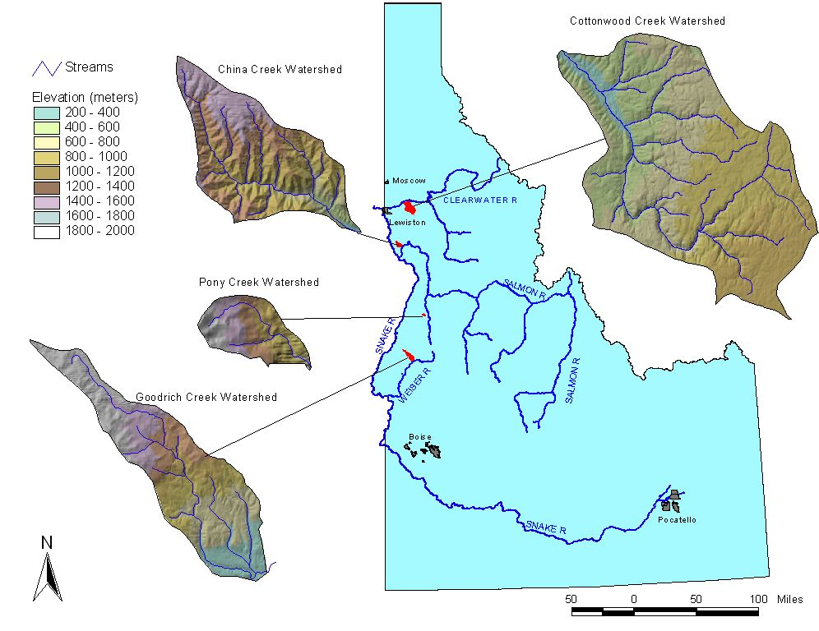
Figure 5. The different watershed areas in Clearwater Basin

Objective 5: Disseminate the results
Task: 5.1 Disseminate project results through educational activities
The dissemination component will include five activities: 1) Publish articles in scientific journals (e.g., ACE, AWARE, AUG, Amer. Soc. Fisheries); 2) Develop educational fact sheets to distribute to professional land managers explaining sediment, turbulence, impacts on aquatic function and project results; 3) Develop a website summarizing and disseminating research results and materials included in the fact sheets for further distribution; 4) hold nine educational workshops and 5) develop a module for a graduate-level course in Civil and Environmental Engineering.

- Timeline: The dissemination process will occur the second year of the project
Investigators contributing: This Task will be directed by Dr. Darin Saul, Director of the Center for Environmental Education at WSU. Dr. Papanicolaou and Dr. Saul will conduct the workshops, Dr Papanicolaou and the Ph.D. graduate student will prepare the conference presentation.

f. Facilities and equipment

Because of the strong emphasis upon laboratory and field studies, the Department of Civil and Environmental Engineering at WSU has well-equipped laboratory facilities. The Albrook Hydraulic Laboratory has a large work area for the construction of physical scale models along with a wide range of fluid pumping systems. A sediment core sampler is available, as is a flurometer. Laser Doppler Velocimeter systems and velocity probes are available for precise velocity measurements. Computational hydraulics and hydrology studies use a well-equipped workstation laboratory. Three water craft, outfitted for limnological and water quality studies, and a number of vehicles and monitoring trailors are routinely used for a variety of field study programs. The Albrook lab is also equipped with a state of the art flume and Acoustic Dopplers that can be used for field measurements.

The Department continues to update and improve the microcomputer laboratory now equipped with more than 20 microcomputers and an HP 9000 network server. Workstation laboratories with five HP9000/730 workstations, several auxiliary x-terminals, a Silicon Graphics workstation, and various peripherals are available for instruction and research. In addition, access plus free CPU time on the WSU mainframe IBM 3090 are available to all students, staff, and faculty. Excellent instrumentation shops and support staff are also available in the department and college. The Owen Science and Engineering Library is located two blocks from the Department. The library system at WSU maintains a completely computerized reference system for easy access to all library acquisitions from any terminal on campus. As repository to more than 3.5 million items, the WSU library system is an integral part of the educational resources at WSU.

The Idaho Isotopes Laboratory routinely performs continuous-flow stable isotopic analyses utilizing the Finnigan-MAT 'Delta-plus' isotope sample introduction systems. Solids are flash-combusted using CE Instrument's NC 2500 elemental analyzer (EA), interfaced through the Conflo II. Gasses are delivered via their innovative Precon system. Our accuracy and precision meets or exceeds current industry standards.

The availability of these advanced 'on-line' technologies greatly shortens analysis time and costs over traditional vacuum-line techniques.

g. References

- Barbour, M. and J. Plafkin, B Bradley, C. Graves, and R. Wisseman 1992. Evaluation of EPA’s Rapid Bioassessment benthic metrics; metric redundancy and variability among reference stream sites. Environm. Tox. Chem. 11:437-449.

- Bjornn, T.C. 1969. Embryo survival and emergence studies. Job No. 5, Federal Aid in Fish and Wildlife Restoration. Job Completion Report, Project F-49-R-7. Idaho Fish and Game Dept., Boise, Idaho. 11p.

- Bjornn, T.C. 1978. Survival, production, and yield of trout and chinook salmon in the Lemhi River, Idaho. Final Report. Federal Aid Fish. Restoration Project. F-49-R, Idaho Department of Fish and Game. 57p.

- Brown, L. R. 1984. Conserving soils. State of the world, L.R. Brown, ed., New York, 53-75.

- Busacca, A., C.A. Cook, and D.J. Mulla. 1993. Comparing landscape-scale estimation of soil erosion in the Palouse using Cs-137 and RUSLE. J. of Soil and Water Conservation, pp.361-367.

- Cao, Z. 1997 "Turbulent bursting -Based Sediment Entrainment Function" ASCE, J. Hydr. Eng. 123(3):233-236.

- Chutter, F. 1971. A reappraisal of Needham and Usinger’s data on the Variability of a stream fauna when sampled with a Surber sampler. Limn. Oceanogr. 17:139-141.

- Clifford, N. J., J. McClatchey, and J. R. French 1991. “Measurements of Turbulence in the Benthic Boundary Layer Over a Gravel Bed and Comparison Between Acoustic Measurements and Predictions of the Bedload Transport of Marine Gravels.” Sedimentology, Vol. 38, pp. 161-171.

- Cottonwood Attainability Assessment (1999), prepared for Cottonwood Creek Watershed Advisory Group.

- Cottonwood Creek TMDL (2000), prepared for Cottonwood Creek Watershed Advisory Group.

- Coutant, C.C. and G.F. Cada 1985. Analysis and development of a project evaluation process. Portland, BPA

- Dancey, C.L., Balakrishnan, M., Diplas, P., and Papanicolaou, A. 2000. The Spatial Inhomogeneity of Turbulence above a Fully-Rough, Packed-Bed in Open Channel Flow, Journal of Experiments in Fluids, Springer-Verlag 29-4 (October), pp. 402-410, 2000.

- Dennett, K, Sturm, T., Amirtharaja, A. and Mahmood, T. 2000. Effects of Absorbed natural organic matter on the erosion rates of kaolinite sediments. Water Environment Research, 70(30), 268-275.

- Diplas, P. and A. Papanicolaou. Batch analysis of slurries in zone settling regime. Journal of Environmental Engineering, ASCE, Vol. 123, No. 7, pp.659-667,1997.
- Ferro, V. and P. Porto 2000. Sediment Delivery Distributed (SEDD) Model. J. of Hydrologic Eng., ASCE, Vol. 5, No. 4, pp. 411-417

- Gregg, D. and J. Stednick 2000. Variability in measures of macroinvertebrate community structure by stream reach and stream class, JAWARA, 95-103.

- Hakansen, L. and Jansson, M.. 1983. Principles of Lake Sedimentology. Springer-Verlag, New York, N.Y.

- Hilldale, R. and Papanicolaou, A. Re-suspension of Cohesive Materials is Streams Due to Turbulent Structure, Abstract submitted to the Seventh Federal Interagency Sedimentation Conference, March 25-29, 2001.

- Hotchkiss, R.H., and McClenathan, J.T. 1996. Physical Processes of Cohesive Bed Erosion. Proceedings, Conference on Management of Landscapes Disturbed by Channel Incision, Oxford, Mississippi, May 20-22, 1997, p. 961-967.

- Jennings, M.D. 1990. Sustainability of Dryland Cropping in the Palouse: An Historical View. Journal of Soil and Water Conservation. 45.1. 75-80.

- Karr, J. 2000. Personal communication

- Kerans, B.L. and J.R. Karr. 1994. A benthic index of biotic integrity (B-IbI for rivers of the Tennessee Valley. Ecol. Appl. 4: 768-85.

- Kramer, D. 1989. Evaluation and revision of the hoop method for monitoring embeddedness. Unpub., 13 p.

- Lyn (1992). "Turbulence Characteristics of Sediment-Laden Flows" J. of Hydr. Eng. ASCE, Vol.118(7), 971-982.

- McNeil, J., Taylor, C., and Lick, W. 1997. Measurements of Erosion of Undisturbed Bottom Sediments with Depth. .Journal of Hydraulic Eng., 122, 6. Pp.316-324.

- Meg 1988. Staff Issue Paper: Salmon and Steelhead Research and Monitoring. Portland, NWPPC. Oregon.

- Megahan, W.F. and P.N. King. 1985. Identification of critical areas on forest lands for control of nonpoint sources of pollution. Environmental Management 9:7-18.

- Merritt, R. and K. Cummings 1996. An introduction to the aquatic insects of North America. Kendall/Hunt, Dubuque, Iowa, pp. 722

- Middelburg, J. and J. Nieuwenhuize 1998. carbon and Nitrogen stable isotopes in suspended matter and sediments from the Schelde estuary. Marine chemistry, 60, 217-225.
- National Research Council 1992. Restoration of aquatic systems: science, technology, and public policy. National Research Council Committee on Restoration of Aquatic Ecosystems, Washington, DC.

- Nelson, J., Personal communication, 1999.

- Nelson, J., R. L. Shreve, S. R, McLean, and T. G. Drake 1995. “Role of Near-Bed Turbulence Structure in Bed Load Transport and Bed Form Mechanics.” Water Resources Research, Vol. 31, No 8, pp. 2071-2086.

- NWPPC 1994 ftp://www.nwppc.org/nwppc/1994_fish_program

- Oak Ridge National Laboratories. 1999. Personal Communication.

- Ohio EPA 1988. Biological criteria for the protection of aquatic life volumes 1-3. Ecological assessment section, Division of Water quality monitoring and assessment, Ohio Environmental Protection Agency, Columbus

- Osborne, L. and M. Wiley 1988. Empirical relationships between land use/cover and stream water quality in an agricultural watershed. J. of Enviro. Management, 26:9-27.

- Papanicolaou, A. (1999). Pick-up Probability for Sediment Entrainment, Journal of Hydraulic Engineering, ASCE, Vol. 125, No. 7, p. 788.

- Papanicolaou, A. and Diplas, P. 1999. Numerical Solution of a Non - Linear Model for Self -Weight Solids Settlement, Journal of Applied Mathematical Modeling, Elsevier Science, Vol. 23, No. 5, p. 345.

- Papanicolaou, A., and Maxwell, A. 2000. Hydraulic Performance of Fish Bypass-Pools for Irrigation Diversion Channels, Journal of Irrigation and Drainage Engineering, ASCE, Vol. 33, No.2, p. 171.

- Papanicolaou, A., Diplas, P., Balakrishnan, M., and Dancey, C.L. 2000. The Role of Near-bed Turbulence Structure in the Inception of Sediment Motion, Journal of Engineering Mechanics, ASCE (IN PRESS-February Issue).

- Papanicolaou, A., P. Diplas, M. Balakrishnan, and C.L. Dancey. 1999a. Computer Vision Techniques for Sediment Transport. Journal of Computing in Civil Engineering, ASCE, Vol. 13, no.2, pp. 71-79.

- Papanicolaou, A., P. Diplas, M. Balakrishnan, and C.L. Dancey. 1999b. The Role of Near-bed Turbulence Structure in the Inception of Sediment Motion, accepted for publication to the Journal of Engineering Mechanics, ASCE.

- Peart, M.R. 1993. Using sediment properties as natural tracers for sediment basins with special reference to particulate phosphorous. pp 241-250. IN: Sediment Budgets. IAHS Publ. no. 174. Wallingford, Oxfordshire, UK.

- Plafkin, J. Barbour, M, Porter, K., S. Gross, R. Hughes 1989. Rapid Bioassessment protocols for use in streams and rivers: benthic macroinvertebrates and fish. EPA/440/4-89-001. Assessment and water protection division, US EPA, Washington DC.

- Platts, W.S. and thirteen coauthors. 1989. Livestock interactions with fish and their environments. IN: Meke (ed). pp 36-41.

- Platts, W.S. and W.F. Megahan. 1975. Time trends in riverbed sediment composition in salmon and steelhead spawning areas: South Fork Salmon River, IdahoTrans. N. Amer. Wildlife & Nat. Resourc. Conf. 40:229-239.

- Ravens, T. and P. Gschwend 1999. Flume measurements of Sediment Erodibility in Boston Harbor, J. of Hydraulic Engineering, Vol. 125, No. 10, 1999.

- Reiser, D.W., M.P. Ramey and T.A. Wesche. 1989. Flushing Flows. In: J. Gore and G. Petts (eds). Alternatives in regulated river management. CRC Press. Boca Raton, Florida. pp 91-135.

- Richards, C. and G. Host. 1994. Examining land use influences on stream habitats and macroinvertebrates: a GIS approach. Water Resources Bull. 30(4): 729-738.

- Rinne, J. 1990. The Utility of stream habitat and biota for identifying potential conflicting forest land uses: Montane Riparian Areas. Forest Ecol. Manag. 33/34: 363-383.

- Roberts, R.G. and M. Church. 1986. The sediment budget in severely disturbed watersheds, Queen Charlote Ranges, Brittish Columbia. Can. J. Forest Resour. 16:1092-1106.

- Roseboom, D., R. Sauer and D. Day. 1990. Application of a trout habitat improvement technique to Illinois warmwater streams. IN: The restoration midwestern stream habitat. Amer. Fish. Soc.

- Rosenberg, D. and V. Resh 1993. Introduction to Freshwater Biomonitoring and benthic Macroinvertebrates. In: Freshwater Biomonitoring and benthic Macroinvertebrates. D. Rosenberg and V. Resh (Editors). Chapman and Hall, New York, New York, p. 1-9.

- SAS, 1989. version 6.08. Statistical applications software institute, Cary, North Carolina.

- Scarlatos, P.D. and Mehta, A.J. 1993. Instability and Entrainment of Fluid Mud-Water Interface in: Nearshore and Estuarine Cohesive Sediment Transport, A.J. Mehta(ed.). Coastal and Estuarine Studies.

- Schuyler, A. and Papanicolaou, A. 2000. Image Analysis Technique to Track the Evolution of Sediment Clusters, Journal of Experimental Techniques, September/October 2000, Vol. 24, No. 5, SEM, pp. 31-36.

- Shannon, C. 1948. A mathematical theory of communication. Bell system Technical Journal 27: 379-423.

- Skille, J., and J. King, 1989. Proposed cobble embeddedness sampling procedure. Unpublished paper available from the USDA For. Serv., Intermount. Res. Sta. Boise, ID. 11p.

- Stickrod, R and J. Marshall 2000. On line nitrate extracted from groundwater determined by continuous flow elemental analyzer/isotope ratio mass spectrometry. Rapid Comm. Mass Spectrom. 14, 1266-1268.

- Tappel P.D. and T.C. Bjornn. 1983. A new method of relating size of spawning gravel to salmonid embryo survival. N. Amer. J. Fish Mgmt. 3:123-135.

- Ter Braak and I. Prentice 1988. A theory of gradient analysis. Adv. Ecol. Res. Vol. 8:271-317.

- Trofs, H., 1997. Erosion of Mixed Cohesive/Non-cohesive Sediments for Transport: in cohesive sediment, N. Burt, R. Parker and J. Watts (eds.), John Wiley: 245-252.

- Trotter, Bisson, and Franses NATO ASI series.; Series A,; Life sciences ; v. 248; 1993

- University of Idaho Isotopes Laboratory, http://www.its.uidaho.edu/isil/

- USEPA 1991. Guidance for water quality – based decisions: the TMDL process. Office of Water, Washington, DC, EPA 440/4-91-00, p.58.

- Wagner, R. and L. Roberts. 1998. "Pesticides and volatile organic compounds in surface and ground water of the Palouse subunit, Central Columbia Plateau, Washington and Idaho, 1993-1994. U.S. Geological Survey, Water Resources Investigations Report 95-4285.

- Wang, Z. and Larsen, P., 1992. "Turbulent Structure of Water and Clay Suspensions with Bed Load," J. of Hydraulic Eng. Vol. 120, 577-600.

- Waters, T.F. 1995. Sediment in streams: sources, biologcal effects and control. Amer. Fish Soc. Monograph 7.

- Wei, T., and W. W. Willmarth 1991. “Examination of V-Velocity Fluctuations in a Turbulent Channel Flow in the Context of Sediment Transport.” Journal of Fluid Mechanics, Vol. 223, pp. 241-252.

- Wiseman, B. 1994. Benthic invertebrate bioassessment. Aquatic Biology Associates, Corvallis, Oregon, p. 15.

- Zreik, D., Krishnappan, B., Germaine, J. Madsen, O.,Ladd, C. 1998. "Erosional and Mechanical Strengths of Deposited Cohesive Sediments", J. of Hydraulic Eng. 124, pp. 1076-1085.

Section 4. Key personnel

Dr. Thanos Papanicolaou 0.4 FTE

Dr. Claudio Stockle 0.3 FTE

Dr. Alan Busacca 0.2 FTE

Dr. Rollin Hotchkiss 0.2 FTE

Dr. Darin Saul 0.2 FTE

Dr. John Marshall 0.1 FTE

Dr. Fred Rabe 0.2 FTE

Dr. James Karr 0.05 FTE

Drs. Papanicolaou and Stockle will be responsible for the overall management of the project. All collaborators and Co-investigators will have an active role in this multidisciplinary effort. Drs. Papanicolaou and Stockle will be responsible for the technical component of this project while Dr. Saul will be responsible for the dissemination component.

Drs. Papanicolaou and Hotchkiss will be responsible for the turbulent flow measurements, sediment transport measurements, and statistical analysis. Drs Bussacca , Stockle, and Marshall will conduct the analysis of the isotope tracers. Both graduate students will participate in all aspects of the project.

Macroinvertebrate assessment will be supervised by Drs. Fred Rabe and James Karr, with student participation.

Drs. Papanicolaou and Saul will conduct the workshops in collaboration with WSU Cooperative Extension Agents. Dr. Papanicolaou and Stockle will present project results at one national level conference.

The Nez Perce tribe will provide existing data in the Cottonwood watershed and the assistance of one EIT engineer and one fish biologist. The tribe will assist in the overall monitoring effort and field activities.

The vita of Principal Investigators and collaborators are presented in the following pages.

THANOS N PAPANICOLAOU, Ph.D, EIT
Assistant Professor
101 Sloan Hall, Pullman, WA 99164-2910
e-mail: apapanic@wsu.edu

EDUCATION
Ph.D. Virginia Tech, Department of Civil and Environmental Engineering 1997
M.S. Virginia Tech, Department of Civil and Environmental Engineering 1993
B.S. AUT, Department of Civil Engineering 1990

CERTIFICATION STATUS
EIT Engineer in the USA
Professional Engineer in the EU

PROFESSIONAL EXPERIENCE
August 1997 – Present Assistant Professor Department of Civil and Environmental Engineering Washington State University
August 1990 – August 1997 Research Assistant, Virginia Tech
August 1989- August 1990 Civil Engineer – Waste Water Treatment Facility

AREAS OF EXPERTISE
Dr. Papanicolaou has more than ten years' experience in hydraulics, fish passage, and sediment related to natural waterways. He has led research teams in field projects, laboratory experiments, physically-scaled model studies, and computer modeling efforts. Field expertise includes experience in measuring stream velocity, discharge, sediment bedload and suspended load, and in evaluating stream bank stability. Field work also includes applying nondestructive testing techniques such as ground penetrating radar and electrical resistivity. Dr. Papanicolaou has coauthored more than 60 articles and has been honored with prestigious awards from the USGS, NATO, and ONASSIS foundations.

RELEVANT PUBLICATIONS

- Papanicolaou, A., and Maxwell, A. (2000). Hydraulic Performance of Fish Bypass-Pools for Irrigation Diversion Channels, Journal of Irrigation and Drainage Engineering, ASCE, Vol. 33, No.2, p. 171
- Papanicolaou, A. and Diplas, P. (1999). Numerical Solution of a Non - Linear Model for Self -Weight Solids Settlement, Journal of Applied Mathematical Modeling, Elsevier Science, Vol. 23, No. 5, p. 345.
- Papanicolaou, A., Diplas, P., Balakrishnan, M., and Dancey, C.L. (1999). Computer Vision Techniques for Sediment Transport, Journal of Computing in Civil Engineering, ASCE, Vol. 13, No.2, p. 71.
- Papanicolaou, A. (1999). Pick-up Probability for Sediment Entrainment, Journal of Hydraulic Engineering, ASCE, Vol. 125, No. 7, p. 788.
- Papanicolaou, A., Diplas, P., Balakrishnan, M., and Dancey, C.L. (2000). The Role of Near-bed Turbulence Structure in the Inception of Sediment Motion, Journal of Engineering Mechanics, ASCE (IN PRESS-February Issue).

Claudio O. Stöckle

Education
Ph.D., Soil Physics, minor in Agricultural Engineering, Washington State University, 1985.
M.S., Engineering, Washington State University, 1986.
M.S., Soil Physics, Washington State University, 1983.
Five-year degree plus thesis (Agricultural Engineering), University of Chile, 1972.

Professional Record
Jul 99-Present Director, State of Washington Water Research Center
Jul 98-Present Professor, Biological Syst. Eng., Washington State University.
Jul 94 - 98 Associate Professor, Biological Syst. Eng, Washington St. Univ.
Sep 89-Jun 94 Assistant Professor, Biological Syst. Eng, Washington St. Univ.
1987- 89 Assistant Professor, Texas Agricultural Experiment Station.
1982 - 86 Graduate Research Assistant/Associate, Washington State University.
1973 - 81 AssistantAssociate Professor, Department of Agricultural Engineering and Soils, University of Chile.
1976 - 81 Consulting Engineer (part-time). Regional and farm-level irrigation and drainage projects in Chile.

Research Interests
- Development and application of computer-based analytical tools (crop simulation models, weather generators, watershed models, geographical information systems, and risk analysis software) to study the effect of soil, weather, land use, and management (e.g., water, nutrients, pesticides, salinity, residue, and tillage) on crop growth, crop productivity, and the environment (erosion and chemical pollution) at the field and watershed levels.
- Field and simulation studies of water and nitrogen management interactions.

Publications and Presentations
a) Technical papers (refereed) 43
b) Technical papers (non-refereed) 52
c) Invited presentations and workshops 17
d) Computer models 11

Selected Publications:

Stockle, C.O., R.I. Papendick, K.E. Saxton, G.S. Campbell, and F.K. van Evert. 1994. A framework for evaluating the sustainability of agricultural production systems. American Journal of Alternative Agriculture 9:46-51.
Pannkuk, C.D., C.O. Stockle, and R.I. Papendick. 1998. Validation of CropSyst for Winter and Spring Wheat under Different Tillage and Residue Management Practices in a Wheat-Fallow Region. Agricultural Systems 57:121-134.
Stockle, C.O., R. Nelson, J. Boll and S. Chen. 1999. Assessing Agricultural Water Management Using a Model for Small Rural Watersheds. American Society of Agricultural Engineers, Paper No. 99-2165. St. Joseph, MI.

Alan Busacca

ADDRESS:
Department of Crop and Soil Sciences E-Mail: busacca@wsu.edu
Department of Geology home:
Washington State University 300 West Mohr St.
Pullman, WA 99164-6420 Palouse, WA 99161
(509) 335-1859 (509) 878-1298
APPOINTMENT AND SPECIALIZATION:
Professor and Soil Scientist, Department of Crop and Soil Sciences; 50 percent teaching - 50 percent research; appointed 10 September 1982; Adjunct Professor, Dept. of Geology, WSU; Visiting Professor, Royal Holloway University of London

Pedology; Wind and Water Erosion; Paleopedology; Quaternary Geology
EDUCATION:
B.S. Earth Science 1973 University of California, Santa Cruz
M.S. Soil Science 1979 University of California, Davis
Ph.D. Soil Science 1982 University of California, Davis.
PROFESSIONAL EXPERIENCE:
1974 - 1977 Physical Science Technician, U. S. Geological Survey, Menlo Park, CA
1978 - 1982 Graduate Research Assistant, Department of Land, Air, and Water Resources, University of California, Davis, CA, and Associate in Soil Science (Summer Instructor of Field Course), University of California, Berkeley and Davis, CA
1982 - 1987 Assistant Professor, Assistant Soil Scientist, Department of Crop and Soil Sciences, Washington State University, Pullman, WA; 1986 - 1987; Adjunct Assistant Professor of Geology, Department of Geology, Washington State University, Pullman, WA
1990 - 1991 Visiting Scientist, Laboratoire des Sols et Hydrologie, INRA Centre de Grignon, Thiverval-Grignon, FRANCE; Dipartimento di Scienze della Terra, Università degli Studi di Milano, ITALY
1988 - 1995 Associate Professor of Soils, Associate Soil Scientist, Department of Crop and Soil Sciences; Adjunct Associate Professor of Geology, Department of Geology, Washington State University, Pullman, WA
1995-present Professor of Soils, Soil Scientist, Department of Crop and Soil Sciences; Adjunct Professor of Geology, Department of Geology, Washington State University
1998-present Visiting Professor, Quaternary Studies Centre, Royal Holloway University of London
SELECTED RECENT PUBLICATIONS:
Richardson, C. A., E. V. McDonald, and A. J. Busacca. 1999. A luminescence chronology for loess deposition in Washington State and Oregon, USA. Zeitsch. für Geomorph. 116: 77-95.
Montgomery, J. A., D. K. McCool, A. J. Busacca, and B. E. Frazier. 1999. Quantifying tillage translocation and deposition rates due to moldboard plowing in the Palouse region of eastern Washington, USA. Soil and Tillage Research 51:175-187.
McCool, D. K., and A. J. Busacca. 1999. Measuring and modeling soil erosion and erosion damages. pp. 23-56, In E. L. Michalson, R. I. Papendick, and J. E. Carlson (eds.) Conservation Farming in the United States. CRC Press, New York.

John D. Marshall

Academic and Professional History:
Jul. 1995-present Associate Professor, Department of Forest Resources, University of Idaho
May-June 1998 Consultant, Winrock International, New Delhi, India
Jan. 1990-Jul. 1995 Assistant Professor, Department of Forest Resources, University of Idaho
1988-Dec. 1989 Post-doctoral Fellow, University of Utah, Advisor: J.R. Ehleringer
Jan.-Apr. 1988 Instructor, Oakland Community College, Auburn Hills, Michigan.
1985-1988 Senior Research Scientist, General Motors Research Laboratories.
1981-1985 Ph. D. Forest Science, Oregon State University, Advisor: R.H. Waring.
1978-1980 M. S. in Forestry, Michigan State University, Advisor: J. B. Hart.
1974-1978 B. S. in Forestry, Michigan State University.

Student training:
Completed two Ph.D. and four M.S. students. Two Ph.D and three M.S. in progress.

Research Interests:
Application of mass balance and stable isotope methods to analysis of the mechanistic basis of forest production and water and carbon budgets. Focus on species and population differences in physiological and morphological traits controlling production.

Current and pending support:
2000. Establishment of Ratioing Mass Spectrometer facility. McIntire-Stennis. $87,922
1999-2000. Generalizing simple process-oriented models for prediction of forest growth in stands with multiple ages and species and rich forest structure. USDA Forest Service. $8000.
2000-2002. Parameterizing physiological models of a forest ecosystem. McIntire-Stennis . $108,936.
2000-2002. Dietary limitations of overwintering hare populations. McIntire-Stennis . $148,000.
2000-2002. A carbon-budgeting approach to the analysis of forest fertilization. USDA Forest Service. .$353,400

Most relevant publications:
Zhang, J., J. D. Marshall, and B. C. Jacquish. 1993. Genetic differentiation in carbon isotope discrimination and gas exchange in Pseudotsuga menziesii: A common garden experiment. Oecologia 93:80-87.
Marshall, J. D., J. R. Ehleringer, E.-D. Schulze, and G. D. Farquhar. 1994. Carbon isotope composition, gas exchange, and heterotrophy in Australian mistletoes. Funct. Ecol. 8:237-241.
Marshall, J. D., and J. W. Zhang. 1994. Carbon isotope discrimination and water-use efficiency in native plants of the north-central Rockies. Ecology 75:1887-1895.
Marshall, J. D., and R. A. Monserud. 1996. Homeostatic gas-exchange parameters inferred from 13C/12C in tree rings of conifers during the twentieth century. Oecologia 105:13-21.
Hultine, K.R., J.D. Marshall. 2000. Altitude trends in conifer leaf morphology and stable carbon isotope composition. Oecologia 123:32-40.

Darin Saul

EDUCATION
Ph.D. English and American Literature. August 1996. Washington State University.
Master of Arts English and American Literature. 1991. Portland State University.
Bachelor of Arts English Literature and Language. 1987. University of Washington.
with Honors

PROFESSIONAL EXPERIENCE
Director, Center for Environmental Education. Directed environmental education and environmental restoration programs. Coordinated interdisciplinary research and outreach projects. Wrote grants, reports, and managed finances for the Center. Washington State University. 1996-Present.

Program Director, Outreach and Education, Washington Water Research Center, Washington State University. Developed and directed outreach programs. 1999-Present.

TEACHING EXPERIENCE
Assistant Professor. American Studies, Washington State University, Pullman, Washington. 1997-Present. Taught AmSt 496/596 Cultures and Environments and AmSt/English 472 Ecological Issues and American Nature Writing.

Instructor and Teaching Assistant. Five years experience teaching English for the English Department, Washington State University, Pullman, Washington and Walla Walla Community College, Washington. 1990-95.

RESEARCH INTERESTS
Regional-scale problem-solving methodologies, watershed and subbasin environmental assessment methodologies, salmonid restoration, public education strategies, cultural aspects of environmental problems, strategies for working with agricultural communities, rural culture and land use, water rights and irrigation, language, power and environmental issues, critical thinking, and culture.

PUBLICATIONS
- A Next Step for Environmental Education: Thinking Critically, Thinking Culturally. The Journal of Environmental Education. Winter 2000.
- Intercultural Identity in James Welch’s Fools Crow and The Indian Lawyer.” American Indian Quarterly. Winter 1996, 1-6.
- Four other publications on environmental education in community newspapers or newsletters.
- Salmonid Assessment and Restoration Planning in the Clearwater River Subbasin in Idaho. 2000 Joint Conferences on Water Resource Engineering and Water Resources Planning and Management. August 2000.
- “Cultural Assessment, Watershed Assessment and Diversity.” College of Agriculture Symposium. University of Idaho. March 2000.
- “Culture, Outreach and Salmon Restoration.” Columbia Basin IV Conference. Stevenson, WA. March 2000.

ROLLIN H. HOTCHKISS, Ph.D., P.E.

EDUCATION
Ph.D. University of Minnesota, Department of Civil and Mineral Engineering 1989
M.S. Utah State University, Department of Civil and Environmental Engineering 1979
B.S. Brigham Young University, Department of Civil Engineering 1976

PROFESSIONAL EXPERIENCE
August 1998 – Present Associate Professor and Director, Albrook Hydraulic Laboratory
Department of Civil and Environmental Engineering
Washington State University
August 1989 – August 1998 Associate and Assistant Professor, Department of Civil Engineering
University of Nebraska-Lincoln
September 1985 - July 1989 Research Assistant, St. Anthony Falls Hydraulic Laboratory
University of Minnesota
August 1979 - August 1985 Civil Engineer - Flood Protection Branch
Tennessee Valley Authority, Knoxville, Tennessee

AREAS OF EXPERTISE
Dr. Hotchkiss has more than twenty years' experience in hydraulics and hydrology related to natural and managed watersheds, waterways, and reservoirs. He has led research teams in field projects, laboratory experiments, physically-scaled model studies, and computer modeling efforts. Field expertise includes experience in measuring stream velocity, discharge, sediment bedload and suspended load, and in evaluating stream bank stability. Field work also includes applying nondestructive testing techniques such as ground penetrating radar and electrical resistivity. Dr. Hotchkiss has performed physical model studies to evaluate dam safety, streambed stability, and sediment ingestion at nuclear power plants. He has also incorporated and tested sediment transport algorithms into a 3-D computer code, CH3D, for the U.S. Army Corps of Engineers.

RELEVANT PUBLICATIONS
Saul, D., and Hotchkiss, R.H. 2000. Salmonid Assessment and Restoration Planning in the Clearwater River Sub-basin in Idaho. Proceedings, 2000 Joint Conference of Water Resources Engineering and Water Resources Planning and Management, R.H. Hotchkiss, and M.N. Glade, Editors, ASCE, Minneapolis, MN, 2000 (CD-ROM)
Papanicolaou, T., and Hotchkiss, R.H. 1999. Critical Review of the Existing State of the Art Sediment Transport Models. Final Report 99-02, Pacific Northwest National Laboratory, Contract No. 269492-A-B8
Maxwell, A., Papanicolaou, T., Schafer, P., Powers, P., Barnard, B., Barber, M., and Hotchkiss, R. 1999. Fish Passage Design Criteria Through Culverts. Proceedings, AWRA Annual Water Resources Conference, Watershed Management to Protect Declining Species, Dec. 5-9-, Seattle, WA (CD-ROM).
Drain, M.A., Hotchkiss, R.H., Hendrickson, M., and Holloway, R.E. “Hydraulic Model Investigation of Submerged Vanes for the Intake Structure at Fort Calhoun Station.” Proceedings, ASCE Water Resources Engineering Conference, v. 2, p. 1234-1238, San Antonio, Texas, August, 1995.
Engel, J.J., Hotchkiss, R.H., and Hall, B.R. “Three-Dimensional Sediment Transport Modeling Using CH3D Computer Model.” Proceedings, ASCE Water Resources Engineering Conference, v. 2, p. 628-632, San Antonio, Texas, August, 1995.

