Project ID: 27008

Title: Grande Ronde River Riparian Restoration

Section 9 of 10. Project description

a. Abstract

The area of focus for this project is BLM managed land along the Wallowa and the lower Grande Ronde Rivers in Wallowa County, Oregon and Asotin County, Washington. Along the Wallowa River, the focus is on the reach from Minam downstream to the confluence with the Grande Ronde River near Rondowa. The focus on the Grande Ronde River is from Rondowa downstream to the confluence with the Snake River.

Since 1993, the Vale District Bureau of Land Management (BLM) has acquired a significant amount of acreage and river frontage along the Wallowa and Grande Ronde River. In addition to the land that was already managed by the BLM, over 7400 acres of acquired land is now managed by the BLM. This additional land also includes approximately 6.1 miles of river frontage along the Wallowa River and approximately 11.3 miles of river frontage along the lower Grande Ronde River. Much of this acreage is old homestead areas with historic grazing and/or agricultural use. The goal of the BLM is to restore these areas, as well as other areas in the vicinity that the BLM manages, with native tree, brush, and grass species. This can be accomplished by eradication of noxious weeds, planting and seeding of native species, and exclusion of livestock grazing in the riparian areas of the rivers and their tributaries. Restoration of the riparian areas will reduce the amount of bare streambanks which are currently contributing sediment to the rivers, provide a source of future large woody debris, and increase shade along the rivers and tributaries. In addition, the BLM would implement a stream restoration project in Little Courtney and Courtney creek, tributaries to the Grande Ronde. Large woody debris placement in Little Courtney creek, and seeding of the riparian areas of Little Courtney and Courtney creek with native grasses and sedges would occur.

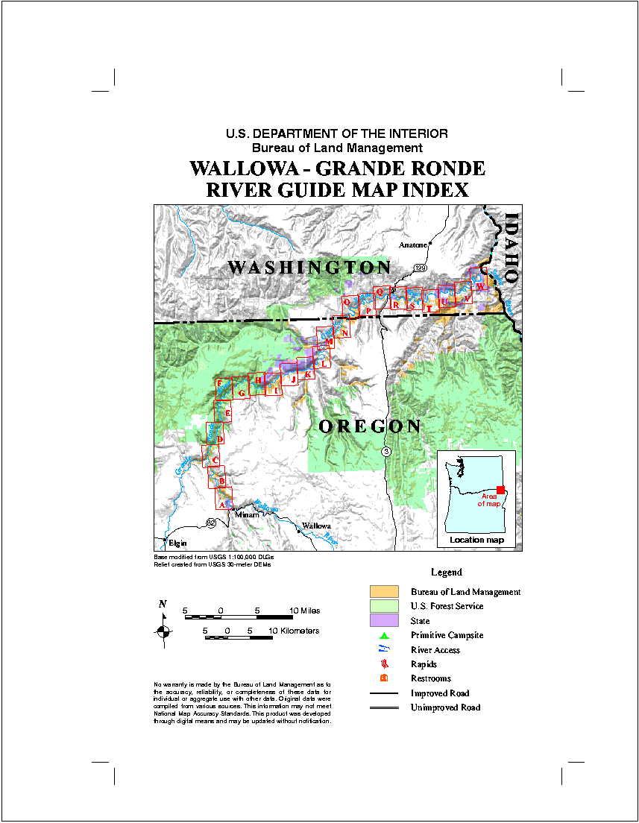

This project would take place on BLM managed lands along the Wallowa and Grande Ronde Rivers. The majority of these lands are within the red boxes outlined in the map above. “A” is on the Wallowa River at Minam, “C” is the confluence of the Wallowa and Grande Ronde Rivers, and “W” is the mouth of the Grande Ronde at the confluence with the Snake River.

b. Technical and/or scientific background

Many riparian areas along the Wallowa and Grande Ronde rivers have been impacted by anthropogenic activities in the past. These impacts include grazing, clearing of land for homesteads and farming, roading, timber harvest, etc. These activities have led to a less than desired condition on some riparian areas. Streambanks with little or no vegetation are contributing increased sediment into the rivers and tributaries. This streambank erosion can also lead to increased width/depth ratios and affect the number, spacing, and size of the pool habitat.

Conifers and other tree species have been removed from some areas, decreasing or eliminating the potential for large woody debris recruitment, which also can lead to increased erosion and decreased pool habitat. Removal of vegetation along riparian areas can also lead to increased stream temperatures. Heavy use in some areas has led to noxious weed problems in the riparian areas as well as the uplands. Noxious weed infestation crowds out or eliminates native species, which are more adapted to the area and can withstand extreme climatic events. Areas dominated by noxious weeds can lead to increased erosion and sedimentation because they do not hold the soil as well as native species.

The Wallowa river is currently listed on the Oregon 303 (d) list for bacteria, flow modification, habitat modification, pH, sedimentation, and temperature. The Grande Ronde river, in the project area, is also listed on the Oregon 303 (d) list for habitat modification, sedimentation, and temperature (DEQ, 1998).

Wallowa County and the Nez Perce Tribe have developed the Salmon Habitat Recovery Plan With Multi-Species Habitat Strategy (Wallowa County, 1999). The above listed plan has identified problems in the Grande Ronde and Wallowa rivers within the project area. The Grande Ronde was broken into two reaches: 1. Rondowa to Wildcat Creek, and 2. Wildcat Creek to the state line. In reach 1, high priority water quality problems that were identified were temperature and excessive fine sediments. In reach 2, temperature, excess fine sediments, and large woody debris were the high priority problems that were identified. In addition, problems such as ice flows, excess nutrient loading, weeds/erosion, feedlots, compaction, and riparian vegetation were identified as lower priority problems (Wallowa County, 1999). In the Wallowa River within the project area, problems that were identified included excess fine sediments, weeds/erosion, stream temperature, and compaction along the riparian areas.

Oregon Department of Fish and Wildlife (ODFW, 2000) conducted stream surveys in Courtney and Little Courtney creek in 1999. These stream surveys indicated that large woody debris was insufficient and active bank erosion was occurring due to lack of streambank vegetation. The BLM completed an Environmental Assessment in 2001 for a forest health project in the Courtney creek area which included the proposed stream restoration involving adding large woody debris to Little Courtney creek and seeding of native grasses and sedges in Courtney and Little Courtney creek riparian areas.

The Draft Grande Ronde Subbasin Summary (GRSS, 2001) identified riparian habitat degradation as one of the most serious problem in the subbasin. Approximately 379 miles of stream have been identified as having degraded riparian habitat in the Grande Ronde subbasin (GRSS, 2001).

Excess fine sediment in the water can stress fish, smother eggs, reduce aquatic insect production, fills intergravel hiding spaces, and increase cobble embeddedness. Loss of riparian vegetation leads to accelerated surface runoff and erosion. Loss of vegetation also increases solar insolation, elevating water temperatures in summer or reducing the tempering of water temperature in winter (GRSS, 2001). Loss of riparian vegetation also reduces large woody debris input, which can lead to loss of channel structure.

The restoration of riparian areas along the Grande Ronde and Wallowa Rivers will focus on reducing sediment from these disturbed areas, returning native vegetation to the streambanks to reduce streambank erosion, provide shade, and provide a source of future large woody debris to the area, all of which will improve riparian and instream habitat.

c. Rationale and significance to Regional Programs

Restoring riparian vegetation and controlling noxious weeds along the Wallowa and Grande Ronde rivers and tributaries in the project area will result in beneficial cumulative impacts of decreased sedimentation, increased shade, improved riparian and in-stream habitat, and provide a source of future large woody debris.

This project’s goals are related to numerous objectives listed in the Draft Grande Ronde Subbasin Summary under general riparian area management and watershed and habitat restoration. Existing goals, objectives, and strategies outlined in the subbasin summary that are addressed by this project are included under multiple subbasin cooperator headings. Goals, objectives, and strategies listed for federal agencies are many times the same as those listed by state, tribal, and private or non-profit agencies. Examples of objectives and strategies outlined in the subbasin summary that are related to this project include: 1. Enhance riparian condition (vegetation, function) by re-vegetating streambanks and riparian zones, and construction of riparian livestock fencing, 2. Improve in-stream habitat diversity for salmonid spawning and rearing by adding large woody component to mainstem streams and tributaries, and implementing riparian tree planting, 3. Reduce stream sedimentation by revegetating streambanks, 4. Improve upland watershed condition and function by treating and containing noxious weeds, and enhance vegetative cover by seeding (GRSS, 2001).

This project also addresses some water quality problems that have been identified by the State of Oregon. As stated above, both the Wallowa river and the Grande Ronde river are listed on Oregon’s 1998 303 (d) List of Water Quality Limited Water Bodies (DEQ, 1998). The project proposal and design of establishing riparian vegetation will decrease sediment from streambanks over what is currently occurring, as well as increase shade and prevent increases in the width/depth ratio of the streams, which can lead to loss of pool habitat. Conifer planting will help provide for future large woody debris. Treatment of noxious weeds will help to re-establish native vegetation in the riparian areas as well as uplands. While these treatments may not cause the rivers to be removed from the 303(d) list, they should provide for beneficial cumulative impacts of increasing shade, reducing sedimentation, increasing large woody debris, and improving instream and riparian habitat; all of which are reasons that the Wallowa and Grande Ronde rivers are currently listed as water quality limited (DEQ, 1998).

The objectives and strategies of this project also correspond to those listed in the Wallowa County – Nez Perce Tribe plan (Wallowa County, 1999). For the Grande Ronde River, one of the plan goals is to provide riparian shading by planting new shrubs and trees, as well as protecting existing shade to deal with stream temperature concerns. Fencing of riparian areas is one strategy listed to deal with the sediment concern, which is a high priority in the plan (Wallowa County, 1999). Also listed as strategies for dealing with identified problems are: 1. adding and preserving large woody debris, 2. Establish a good riparian plant community to provide a source of future large woody debris, and 3. Plant/protect conifers in riparian areas to keep thermal cover in winter and plant deciduous trees and shrubs to provide habitat diversity (Wallowa County, 1999).

d. Relationships to other projects

This project is related to the Grande Ronde Model Watershed Program (GRMWP). The GRMWP is one of the main entities involved in restoration within the Grande Ronde subbasin. The BLM has participated in meetings and coordination groups with the GRMWP. The BLM is currently involved in the Grouse Creek stream restoration project, which was partially funded with BPA funds through the GRMWP. Wallowa County is also a partner in this stream restoration project, which is planned to be completed this summer. In addition to the Grouse Creek project, the BLM is gathering information on previous restoration projects implemented by the BLM to include in the GRMWP database.

This project is similar to other projects that the GRMWP has recommended for funding, as well as projects implemented by the U.S. Forest Service, Wallowa County, and Asotin County. Asotin County, Washington is currently planting rooted hardwoods and conifers in riparian areas similar to those proposed in this project.

e. Project history (for ongoing projects)

While this is not an ongoing project funded by BPA, the BLM has been conducting some of the restoration activities outlined in this project. For the last two years, the BLM has applied for and received Clean Water Action Plan (CWAP) funds for conifer planting on the flats adjacent to the Grande Ronde River. The BLM has also implemented noxious weed treatments, riparian planting of hardwoods, and collection of native seed to be grown at the nursery with the help of CWAP money. In addition, the BLM has been a Challenge Cost Share partner with the local schools in Baker City, OR. These schools have helped germinate seed collected by the BLM as well as to help with the planting.

The BLM has helped fund a weed coordinator position with Wallowa Resources as well as providing money and personnel to inventory and treat noxious weed sites.

f. Proposal objectives, tasks and methods

Objectives:
1. The main objective of this project is to restore riparian habitat along the Wallowa and Grande Ronde rivers and their tributaries. This restoration of riparian habitat will ultimately increase streambank stability, decrease sediment, increase shade, provide for a supply of future large woody debris available to the streams, and improve riparian and instream habitat. In addition, large woody debris is planned to be input into Little Courtney creek.

Specific project goals include gathering of hardwood cuttings, native grass seed, and native sedge seed from the Grande Ronde subbasin and have these cuttings and seed grown in the BLM nursery or by a contractor. The grass and sedge seed will be grown for increased seed production so that the BLM will have a source of locally adapted native seed readily available. The hardwoods would be grown and planted as rooted stock. Native shrub seed would be collected each year for dispersal. The collection and growing of the above plants will enable us to seed 500 to 600 acres of ground each year with native seed. For FY 2002 and 2003, this seed will be bought commercially as the seed will not be ready from the nursery until FY 2004. Planting of approximately 6000 to 7000 hardwoods would also occur along the shorelines, which would be grown from cuttings each year.

Some hardwood cuttings have already been collected in this area by the BLM, which are currently being grown at the BLM nursery. This will provide for planting of approximately 3000 hardwoods along the Grande Ronde shoreline this fall in a project funded by the BLM.

For the past two years, the BLM has been planting conifers along riparian areas of the Grande Ronde River. This project would expand on that and plant approximately 20 to 30 acres of flats along the Grande Ronde River with conifers. The BLM has already collected seed from conifers and has seed at the nursery to grow for this purpose.

2. A float trip with spray contractors would be conducted each year to treat inaccessible areas of the Wallowa and Grande Ronde rivers for noxious weeds, primarily Dalmation toadflax and leafy spurge. Approximately 40 miles of river would be floated and treated from Minam downstream to Wildcat Creek.

3. Finally, the last major objective of this project would be to restrict access to livestock along riparian areas adjacent to the Wallowa and Grande Ronde Rivers and their tributaries. Approximately 3 miles of fence would be constructed each year.

Tasks and Methods:

1.A. In relation to Objective 1 above, the first task would be to complete an Environmental Assessment (EA) for restoration activities. BLM personnel would make up the Interdisciplinary (ID) Team to write staff reports and complete the EA. The BLM fisheries biologist would initiate consultation with NMFS and USFWS. The BLM has previously completed NEPA documentation and consultation relative to noxious weed treatments and the proposed restoration treatments in the Courtney Creek area; therefore this EA would only involve the planting, seeding, and fencing proposals.

B. The ID team would visit proposed planting and seeding sites as well as proposed areas for fencing. During field review, noxious weed treatment areas would also be reviewed and identified. These sites would be identified and mapped for use with planting, seeding, and fencing contracts.

C. Protection of conifer seedlings previously planted by the BLM would be initiated. The BLM has used tubes on the seedlings to protect from big game browsing, however the trees are now too big for the tubes, and need better protection. This protection would involve the use of wire cages placed around the trees and big game repellant. The wire cages could be re-used after the trees are big enough to survive the heavy browsing during the winter that this area receives. BLM personnel would conduct this task, which includes maintenance and protection each year as more areas are planted.

D. Planting of conifer seedlings, approximately 20 to 30 acres/year, starting in FY 2003. The BLM has previously collected seed, which is at the nursery; however, seedlings will not be large enough to plant until 2003. BLM would prepare a contract for this work. BLM would be the contract administrator. Costs per acre are fairly high for this work since it involves transporting trees, supplies, and tree planters across the river in some areas to plant areas inaccessible by road.

E. Planting of rooted hardwoods grown at nursery along Grande Ronde River streambank. This would be a contract in which the BLM would require machinery that could plant the hardwoods into the cobble and banks adjacent to the river. Asotin County has been employing this method for the last few years and has had good success. BLM is currently funding a different project to plant approximately 3000 hardwoods this year. With this project, 6000 to 7000 hardwoods would be planted annually.

F. Treatment of riparian flats for noxious weeds would be conducted before conifer or hardwood planting. Seeding of these areas with locally adapted species would occur after noxious weed treatment. Noxious weed treatment would be a combination of BLM personnel and contracts. Collection of native seed would be done by contract, with the seed grown for increase at the BLM nursery or a private nursery. For FY 2002 and 2003, native seed would be purchased commercially until the seed collected could start to be harvested in sufficient quantities to meet our needs. Approximately 500 to 600 acres would be seeded annually, most of this being spread aerially. In addition, another 50 acres would be seeded in FY 2002 in conjunction with the Courtney creek restoration.

G. Placement of large woody debris in Little Courtney creek along approximately 0.75 miles of stream. This area has been identified by ODFW as lacking large wood in the stream. The BLM has completed an EA for this area involving a forest health project and this stream restoration. Consultation with USFWS and NMFS has also occurred. The large wood will be added to the stream by falling trees from the riparian areas into the stream channel. This work will be completed under contract, with the BLM administering this contract.

2.A. Treatment of riparian areas for noxious weeds along approximately 40 miles of stream on the Wallowa and Grande Ronde river. The area from Minam to Wildcat creek is mostly inaccessible by roads, so a contract to float down the river and hand spray areas of noxious weed infestation would be implemented. Seeding of treated areas with native species would occur after spraying. The targeted species for this area are Dalmation toadflax and leafy spurge. This area would be treated annually or until monitoring indicated that treatment was no longer needed.

3.A. Exclude cattle from riparian areas of the Wallowa and Grande Ronde River and tributaries. Approximately 3 miles of fence would be installed annually to protect riparian areas from livestock grazing.

B. Maintenance of existing exclosures already constructed by the BLM as well as maintenance of new exclosures that will occur with this project. Exclosure maintenance would occur annually.

Monitoring:

A monitoring plan will be set up in FY 2002 with a report issued annually for the life of this project. Monitoring will include conducting survival surveys of planted conifers and hardwoods to assess whether objectives are being met or areas need to be replanted.

Effectiveness of seedling protection measures will be monitored, with recommendations to meet objectives of seedling survival.

Noxious weed treatment and seeding areas will be monitored. Areas will be monitored to determine whether follow-up treatments for weeds are needed, and to ensure native seeding has germinated sufficiently to protect area from increased erosion.

The stability of the large woody debris placed in Little Courtney creek will be assessed. The large wood will be monitored to assess stability and effectiveness to capture fine sediments and increase pool habitat.

Photo points will be installed to document trend of riparian habitat condition, including vegetation establishment and increases in bank stability.

Bank pins will be installed in selected locations to measure soil loss before and after treatments.

g. Facilities and equipment

Personnel involved in this project will be BLM employees working out of the Baker City, OR field office, which is part of the Vale District BLM. Adequate workspace, computers, and vehicles will be provided by the BLM to complete the work.

The only high-cost equipment that will need to be purchased to complete this project is a digital camera to be able to document the photo points and post the results in electronic format.

h. References

Reference (include web address if available online) | Submitted w/form (y/n)
Oregon Department of Environmental Quality. 1998. Oregon’s Final 1998 Water Quality Limited Streams – 303(d) List. Portland, Oregon.  http://www.deq.state.or.us/ | N
Draft Grande Ronde Subbasin Summary. 2001. Prepared for the Northwest Power Planning Council.  http://www.cbfwf.org/ | N
Wallowa County – Nez Perce Tribe. 1993, revised 1999. Salmon Habitat Recovery Plan and Multi-Species Habitat Strategy. | N

Section 10 of 10. Key personnel

Todd Kuck, Hydrologist for BLM Baker Field Office. BS Forest Resources Management, University of Montana, 1991. Previous experience as project lead for stream and riparian restoration projects with Vale District BLM and Roseburg District BLM. Project lead for Clean Water Action Plan restoration projects. Baker Field Office riparian and PFC coordinator.

Jackie Dougan, BLM Baker Field Office Fisheries Biologist. BS Fisheries Science, Oregon State University, 1988. Twenty years of fish habitat management, fisheries habitat and watershed restoration experience. Present Powder River Watershed Council official member (5 years), past project supervisor for the Powder River Restoration Project (3 years), past BPA watershed restoration project supervisor for the Umatilla National Forest (7 years), USFS Fish Biologist for the Umatilla and Wallowa-Whitman National Forest (11 years).

Mike Woods, Natural Resource Specialist, Baker Resource Area Field Office, Vale District, BLM. BS in Rangeland Sciences, Oregon State University, 1974. Noxious Weed Management Program Coordinator and Fire Ecology/Planner since 1998. BLM Rangeland Management Specialist/Range Conservationist for 24 years.

Clair Button, 24 years of experience with BLM. Nine of those as a wildlife biologist, partly working on rangeland-habitat restoration and monitoring. Fifteen years as a botanist, also part-time restoration and monitoring. Bachelor's degree in Natural Resource Management from University of Michigan, emphasis on wildlife, forestry, and botany.

