Oregon
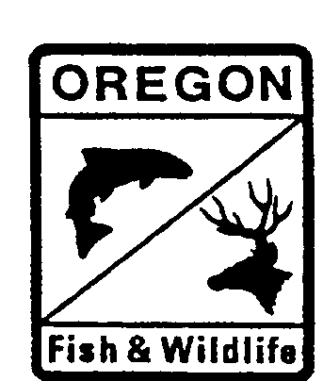

DEPARTMENT OF F
FISH AND WILDLIFE
Fish Research and Development
NE Region
211 Inlow Hall, EOU
One University Blvd.
La Grande, OR 97850
(541) 962-3777
FAX (541) 962-3067

Responses to ISRP comments by Jim Ruzycki.
Original Project ID: 199202604, Investigate Life History of Spring Chinook Salmon and Summer Steelhead in the Grande Ronde River Basin and Monitor Salmonid Populations and Habitat.

Dear ISRP Members:

Included, are responses to the comments provided on project # 199202604, objective 13 only. Here, we are only responding to objective 13 of project # 199202604 because we are resubmitting this objective as a separate proposal. We appreciate your efforts and the critical technical review provided. If you have additional questions or need additional information regarding this project, please feel free to contact me.

ISRP comment: Objectives 12 and 13 each should be submitted as new projects.

Following ISRP’s recommendation, we are now resubmitting objective 13 as a separate proposal entitled: Monitoring and evaluation of aquatic resources in Wallowa Lake for the conservation and reestablishment of native fishes.

ISRP comment: The issue at Wallowa Lake merits investigation. However, the goal of Objective 13 needs to be clarified. Is this a study in sockeye re-introduction or a study in kokanee assessment and restoration of the fishery?

The goal of the Wallowa Lake project is to provide scientific information that will aid in the management and conservation of native fishes, specifically for the Oncorhynchus nerka population and its related fishery. We believe we currently have insufficient information to guide decisions regarding management of a resident or anadromous O. nerka fishery. In the near-term, this study will collect much needed data that could be used for the preservation and restoration of the kokanee fishery. This proposal will also provide information to evaluate the potential for future sockeye salmon reintroduction, should reintroduction become a goal of co-managers. However, we believe an assessment of the sustainability of the resident kokanee population should precede any serious consideration of anadromous sockeye salmon reintroduction, especially if impacts from introduced species influence juvenile survival of kokanee. If kokanee recruitment to adults is significantly reduced by either predation or competition (or some synergistic combination) from introduced species, then similar impacts could also be expected for naturally produced sockeye juveniles if sockeye were to be reintroduced. Conversely, if predation and competition are primarily influencing adult kokanee, then reestablishment of sockeye may become an attractive alternative to restoring a fishery for O. nerka. Without further information on the trophic interactions currently manifested in Wallowa Lake we believe we cannot make informed decisions regarding management of the fishery for either resident kokanee or anadromous sockeye. Therefore, this is a proposal to study both kokanee restoration and sockeye reintroduction

Sincerely,

James R. Ruzycki

