Project ID: 9402600

Title: Pacific Lamprey Research and Restoration Project

Section 9 of 10. Project description

a. Abstract

The purpose of this study is to provide the critical information to restore Pacific lampreys Lampetra tridentata in the Umatilla River that is called for in the Umatilla Subbasin Summary. This information is essential for restoration of lampreys and to provide tribal members opportunities to practice cultural use and provide ecosystem function. Pacific lampreys are vital components of intact ecosystems that have been affected directly and indirectly by dams, habitat deterioration, and possibly food web shifts in the ocean. The project has objectives: (1) increase larval abundance in the Umatilla River, (2) determine reproductive success of adult lamprey outplants, (3) estimate the numbers of adult lampreys entering the Umatilla River, (4) monitor larval population trends in the Umatilla River, (5) estimate the numbers of recently metamorphosed lampreys migrating out of the Umatilla River, (6) Evaluate the potential role of bile salts released by larval lampreys as a migratory cue to upstream migrating Pacific lampreys, and (7) Describe genetic differences among Pacific lampreys.

b. Technical and/or scientific background

The Problem: The overall goal of this project is to restore natural production of Pacific lampreys in the Umatilla River to self-sustaining and harvestable levels. The Umatilla River basin was chosen by the Confederated Tribes of the Umatilla Indian Reservation as the initial pilot project for several reasons, 1) the Umatilla River historically produced fishable numbers of lampreys, 2) recovery efforts for salmonids in the basin may help with overall recovery of Pacific lampreys, and 3) current population levels of Pacific lampreys are extremely low. The purpose of this study is to: (1) increase larval abundance in the Umatilla River, (2) determine reproductive success of adult lamprey outplants, (3) estimate the numbers of adult lampreys entering the Umatilla River, (4) monitor larval population trends in the Umatilla River, (5) estimate the numbers of recently metamorphosed lampreys migrating out of the Umatilla River, (6) Evaluate the potential role of bile salts released by larval lampreys as a migratory cue to upstream migrating Pacific lampreys, and (7) Describe genetic differences among Pacific lampreys.
The Confederated Tribes of the Umatilla would like to restore Pacific lampreys to the Umatilla River basin (Figure 1.) as part of our ongoing efforts to rebuild ecosystem diversity, function, and traditional cultural opportunities in the system.
Background: Roughly 23 species of lampreys occur in North America (Vladykov and Kott 1980). Of this number only three species occur in the Columbia River Basin. These species are the western brook lamprey (Lampetra richardsoni), river lamprey (Lampetra ayresi), and Pacific lamprey (Lampetra tridentata). Pacific lampreys were an important component of the freshwater ecosystem in the Columbia River Basin. They continue to be an important cultural food for tribes in the interior Columbia River Basin. In the last 30 years, however, Pacific lampreys have declined in the interior Columbia and Snake Rivers (Figure 2). Recent radio-telemetry studies by NMFS have shown poor passage success at main-stem hydroelectric dams. These studies from 1996 to 1999 found that 59 to 79% of radio-tagged lampreys did not pass Bonneville Dam (pers. comm. M. Mosier, 2000, National Marine Fisheries Service).

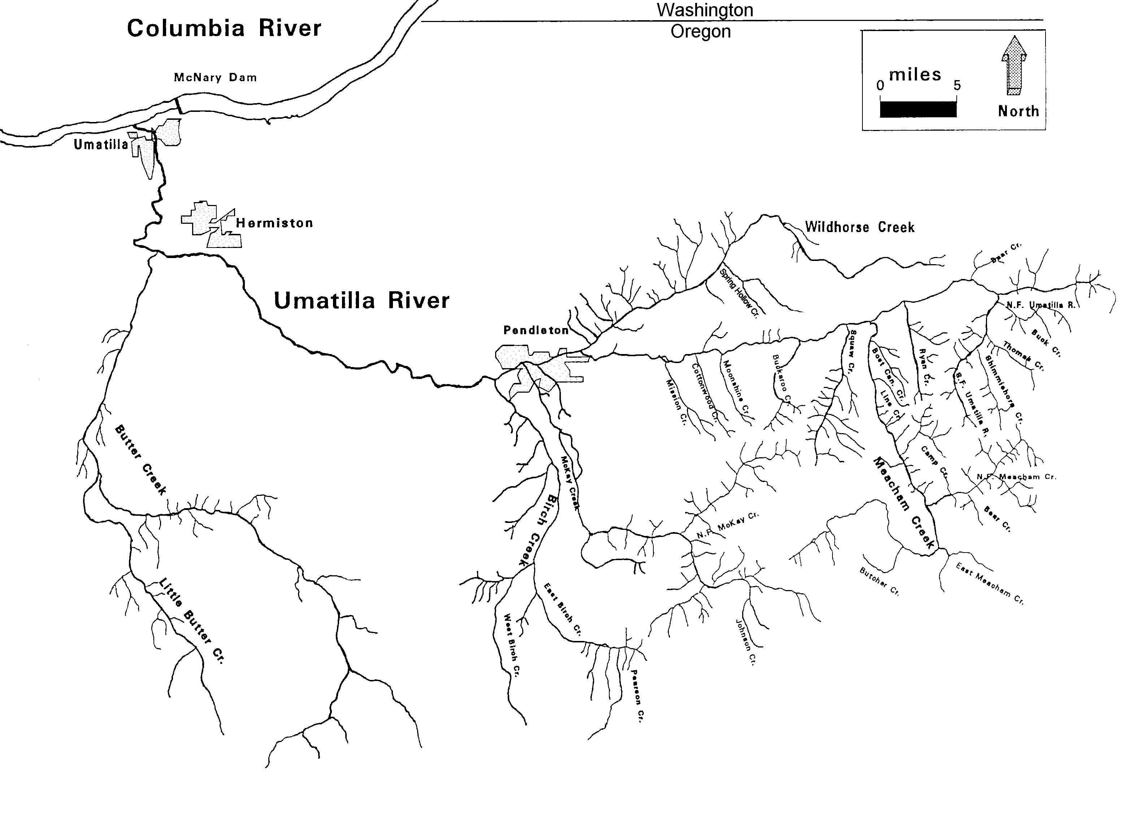

Figure 1. Umatilla River Basin.

Figure 2. Yearly counts of adult lampreys at selected mainstem dams on the Columbia, Snake, and Umpqua Rivers.

State, federal, and tribal agencies have voiced concerns for Pacific lampreys. In 1993, Oregon Department of Fish and Wildlife (ODFW) designated Pacific lampreys at risk of being listed as threatened or endangered. During 1994, the U.S. Fish and Wildlife Service (USFWS) designated Pacific lampreys as a Category 2 candidate species. The tribes have been concerned about lamprey declines (Close et al. 1995; Jackson et al. 1996; Jackson et al. 1997) and the lack of harvest opportunities in the Columbia Basin for years (Anglin et al. 1979). The Northwest Power Planning Council (NPPC) Fish and Wildlife Program supports lamprey restoration following identification of problems and approval of plans to accomplish restoration. The NPPC approved the Status Report in 1995 that initiated the Umatilla’s lamprey research and restoration project in the Columbia River basin.
To initiate the restoration effort, CTUIR began developing a restoration plan in 1998 and completed a working draft in 1999. During 2000, CTUIR began implementing the pilot project in the Umatilla River. CTUIR is using additional information, such as past and current lamprey abundance, factors limiting production, habitat requirements for each life phase, donor stock availability, genetic database, disease database, migratory pheromones, and homing information, to continue development of the Restoration Plan for Pacific Lampreys in the Umatilla River. Because our knowledge of the three species of lampreys that live in the Columbia River Basin is very limited, for the plan to work it must be flexible to allow changes as we gain new information on the population dynamics of Pacific lampreys. During 1998, CTUIR began to summarize data of historical abundance and distribution from tribal and ODFW interviews. Current larval abundance and distribution was completed in 1999 for the John Day, Umatilla, Walla Walla, Tuccannon, and Grand Ronde rivers. Staff from CTUIR developed the plan with cooperation and review from NPPC, Columbia River Intertribal Fish Commission (CRITFC), U.S. Geological Survey (Columbia River Research Laboratory, (CRRL)), USFWS, and ODFW. A monitoring and evaluation section is included in the plan for adaptive management. Experiments necessary to maximize the potential for the restoration of lampreys in the Umatilla River will began in 2000 after review from ODFW and other agencies.

Evaluation of the rehabilitation effort is a complex process requiring knowledge of the life history and behavior of Pacific lampreys. Since little is known about Pacific lampreys, research on another species of anadromous lamprey (Petromyzon marinus) should be considered a starting point. Evidence collected for sea lampreys suggests they may not home to natal streams (Bergstedt and Seelye 1995). Instead, they may use their olfactory ability to detect the presence of larval and adult lampreys as discrete migratory cues. Adult sea lampreys are attracted to the presence of larval lampreys (Bjerselius et al. 2000). This attraction is believed to be a response to bile salts released by the larval lampreys. Adult sea lampreys are attracted most strongly in the early period of upstream migration (Li et al. 1995; Li and Sorensen 1997). As the sea lampreys sexually mature, their olfactory sensitivity to other adult sea lampreys increases. Adult male sea lampreys are attracted to adult female sea lampreys and repulsed by other adult male sea lampreys (Bjerselius et al. 2000).
Preliminary data on Pacific lampreys shows that their larval forms produce bile salts as pheromones (Sorensen unpublished data). It is possible that these bile salts act as a migratory cue, drawing other upstream migrating lampreys into streams where healthy populations of larval lampreys exist. Pacific lampreys enter freshwater from the ocean over several months (spring through late summer), as much as twelve months before they are mature (Beamish 1980). Sea lampreys enter the streams and spawn within three to four months (Applegate 1950). The longer period Pacific lampreys spend in fresh water while they sexually mature suggests that they may show a longer period of sensitivity to bile salts than sea lampreys. If Pacific lampreys prefer to migrate into tributaries to the Columbia River due to their attraction to larval lampreys producing bile salts, knowledge of this behavior could aid in the rehabilitation of Pacific lamprey populations in the Umatilla River. Therefore, we have proposed to conduct several studies sequentially to determine the role of pheromones in the upstream migration of Pacific lampreys. In 2001, we will specifically address the relative sensitivity of upstream migrating Pacific lampreys to bile salts during the freshwater phase of their maturation. Pacific lampreys’ responses to various odorants, over the period that lampreys migrate up the Columbia River, will be examined.
Some of the Lamprey genetics work has already been completed. We would like to finish the genetics work by combining existing knowledge (mitochondrial DNA) with proposed genetics work (microsatellite DNA) in Pacific lampreys.

c. Rationale and significance to Regional Programs

This project is essential to evaluate recovery efforts for Pacific lampreys in the Umatilla River. The project addresses the needs outlined in the Umatilla Subbasin Summary and the provisions of the Fish and Wild Program. The Umatilla Subbasin Summary calls for strategies to “Develop and implement a Pacific lamprey restoration plan for the Umatilla Basin.” Our first objective addresses Action 10.1, which is to “Continue outplanting of adults as detailed in the Umatilla River Basin Pacific Lamprey Restoration plan (CTUIR 1999). Our second objective addresses Action 10.2, which is to “Determine reproductive success of adult outplants. Our third, fourth, and fifth objectives addresses Action 10.3, which is to “Monitor for increases in larval abundance, juvenile outmigration, and adult returns.” Our sixth objective is not mentioned in the subbasin summary, however CTUIR needs this research to better understand the lampreys ability to detect pheromones, which may be very important for management and restoration in the Umatilla Basin. Our seventh objective addresses Action 10.5, which is to “Continue genetic assessment of lamprey populations among and within the Umatilla and selected Columbia River subbasins.”
Pacific lampreys are also covered under Section III.C.2.a).1. of the 2000 Columbia River Basin Fish and Wildlife Program. This states “Obtain the information necessary to begin restoring the characteristics of healthy lamprey populations.”
Pacific lampreys are again covered in the National Marine Fisheries Service’s Biological Opinion (NMFS 2000), section 7.3 ‘Tribal Actions’ state, 1) Halt the decline of salmon, lamprey, and sturgeon populations above Bonneville Dam within 7 years, and 2) Increase lamprey and sturgeon to naturally sustaining levels within 25 years in a manner that supports Tribal harvest.

d. Relationships to other projects

This project is part of the overall goal to recover an intact, fully functioning ecosystem in the Umatilla River. The CTUIR has numerous projects focusing on recovery of the Umatilla River Basin for salmonids. These existing projects such as, structural passage improvements, instream flow enhancement, habitat enhancement are expected to increase the benefits for lamprey recovery efforts under this project. Two existing M&E projects on the Umatilla River are going to assist in capturing larvae and recording data.

e. Project history (for ongoing projects)

In 1995, the Status Report of the Pacific lamprey in the Columbia River Basin. These efforts urged the CTUIR to designate objectives aimed at mainstem abundance monitoring, NE Oregon tributary population abundance documentation (past and present), development of genetic baseline information, basic migratory behavior, and artificial propagation techniques (capture, transport, holding, spawning). The Status Report of the Pacific Lamprey in the Columbia River Project actions were focused on documenting historical distribution, current distribution, current status, and those potential factors affecting lamprey decline. The current status of Pacific lamprey was addresses through the analysis of trend data using dam counts (Figure 1). Through literature research and information exchange the CTUIR determined methods and tasks needed to address the distribution and status of Pacific lamprey. Due to limited information, time and personnel the CTUIR defined and outlined tasks associated with the above mentioned objectives to be implemented in subsequent years.

Objectives in 1996 are as follows: Objective 1: Document historic and current Pacific Lamprey abundance and possible reasons for population decline, based on oral interviews and review of records and literature, in CTUIR ceded areas of Northeast Oregon and Southeast Washington subbasins of the Columbia River. Based on oral interviews with tribal informants, current and former state and federal fisheries personnel, and review of records and literature it is apparent that lamprey were once abundant in ceded area streams of the Umatilla Indian Reservation ( John Day, Umatilla, Walla Walla, Tucannon, and Grande Ronde subbasins). Current population levels appear severely depressed in all subbasins except possibly the John Day, which could be classified as depressed. The most probable reasons for population declines include: dams, chemical treatment activities, declining habitat quality (e.g. high water temperatures, poor water quality, low instream flows), and angle-iron in fishways.

Objective 2: Determine the current abundance, passage trends, length frequencies,and life phases of juvenile and adult Pacific lamprey migrating past mainstem Columbia and Snake River dams. In 1996, the juvenile lamprey migration through the Columbia River system had concluded before this project began. Adult lamprey fish ladder passage estimates are presented from Bonneville, Ice Harbor, Lower Granite, Rock Island, Rocky Reach, and Wells dams for 1995 and 1996 in the 1996 Annual Report. Hydroelectric projects located upstream of Bonneville Dam had three times the number of lamprey in 1996 compared to 1995. Counting adult Pacific lamprey was very problematic, resulting in a net negative count at Bonneville Dam in 1996. Adult lamprey counts were hindered by poor viewing conditions in the floor of the fish counting chamber, and by the tremendous amount of up- and down movement displayed during nighttime periods. This objective was performed by the Columbia River Inter-Tribal Fish Commission.

In 1997, objectives were a continuation of past work. Objective 1: Document historic and current Pacific Lamprey abundance and possible reasons for population decline, based on oral interviews and review of records and literature, in CTUIR ceded areas of Northeast Oregon and Southeast Washington subbasins of the Columbia River. The addition of interviewees and intensive literature review indicated streams to be focused on for presence/absence surveys. Interviews concluded that Pacific Lampreys were found throughout the ceded lands. The John Day River primarily was utilized for salmon and trout fishing but harvest of Pacific lamprey did occur within the subbasin (A. Minthorn, personal communication). Surveys suggested, that the John Day Basin lamprey populations are probably a fraction of past abundance, the remaining population is thought to be the most abundant today relative to other subbasins within the ceded boundaries. The CTUIR will attempt to further document the current abundance of Pacific lamprey as a candidate for a donor stock in subsequent years of this study. Several tribal members were interviewed about the decline of Pacific lamprey in the Umatilla River Subbasin. All interviewees believe that lamprey populations drastically declined during times of fish poisonings. Most members interviewed also stated that they harvested Pacificlamprey adults at Three Mile Falls Dam as young children. Results suggested that John Day, Umatilla, Walla Walla, Grande Ronde, and Tucannon rivers historically supported Pacific lamprey populations, however, the current status of Pacific lamprey within each of the above mentioned systems is either near extirpation or rapidly declining.

Objective 2: Determine the current abundance, passage trends, length frequencies,and life phases of juvenile and adult Pacific lamprey migrating past mainstem Columbia and Snake River dams. Life history characteristics of transformed and untransformed juvenile Pacific lamprey were collected at Lower Granite, Little Goose, and Lower Monumental dams on the Snake River and at McNary Dam on the Columbia River during the 1997 migration season. Most outmigrant Pacific lamprey sampled were of the transformed silvery form known as macrophathalmia, although a substantial number of untransformed brown ammocoetes were also sampled. Juvenile lamprey were documented at all four dams throughout the sampling season (late March through October), although the preponderance of outmigrants passed during April through June. Similarly, lamprey passage at all projects declined sharply from July through the remainder of the passage season (November-December). This decline was most noticeable at the Snake River dams where passage from July through the end of the monitoring season was generally less than 100 outmigrants per month.

Three hundred and twenty-three adult Pacific lamprey were collected and tagged with 13 mm Petersen discs at the Bonneville Dam Fish Engineering Research Laboratory (FERL) from July through early October 1997. Forty tags were returned, all from Bonneville Reservoir or it’s tributary streams. Thirteen (33%) of the returned tags contained sufficient capture information to estimate travel time at large; stock identification was not possible since all recaptures occurred relatively soon after release and not in spawning locations. Time at large ranged from 1 to 13 d, with a mean of 3 d. Daily movements ranged from 0.2 to 65.4 Rkm/24 h period, with a mean of 15.6 Rkm/24 h. None of the tagged lamprey were captured or observed upstream of The Dalles Dam, although 69% of the 13 complete recaptures occurred within 0.5 km of The Dalles Dam.

Adult Pacific lamprey fish ladder passage estimates are presented from Bonneville, The Dalles, John Day, McNary, Ice Harbor, Lower Monumental, Little Goose, Lower Granite, Rock Island, Rocky Reach, and Wells dams for 1997. Major decreases in dam counts of Pacific lamprey were identified as the run progressed upstream. These decreases could identify tributaries where populations are returning or could be associated with difficulties in counting Pacific lamprey. Enumerating Pacific lamprey at fish count stations is very difficult as a result of lamprey behavior in ladders designed for salmonid passage. The overall success of Pacific lamprey ascending the two fish ladders at Bonneville Dam was compared using calculations of local efficiency. Local efficiencies differed significantly (P = 0.028) between Washington Shore (12.5%) and Bradford Island (32.8%) ladders. The Bradford Island estimate was similar to estimates reported in the literature for sea lamprey (35.4%). Length frequency data is presented from data gathered from video recordings and from hands-on sampling at Bonneville, Ice Harbor, Wells, and John Day Dams. A length-weight relationship was developed for Pacific lamprey sampled at Bonneville Dam over a 12 week period.

In 1998, objectives were a continuation of past work with the addition three objectives. Such as; the determination if adult Pacific lamprey captured at Willamette Falls and at Bonneville Dam will home back to these locations, collect habitat information relevant to lamprey production in the John Day, Grande Ronde, Tucannon, Walla Walla, and Umatilla Rivers, and to develop a genetic database for determination of lamprey population structure in the Columbia Basin .
Electrofishing surveys to collect densities and distribution of lamprey larvae in the Umatilla River were conducted in 1998. Electrofishing surveys in the Umatilla are useful for baseline comparison. Forty-two index sites were sampled from the mouth to river kilometer (RK) 124. Lamprey larvae were found in 4 of the 42 index plots. All sites with larvae were found at and below RK 9.3. Nine larvae were captured during the surveys. However, no larvae were caught on the second pass in each plot.

Pacific lamprey larvae and adult lampreys were studied to determine their ability to produce and detect pheromones. Larval gall bladders were removed and gall bladder fluid was extracted and analyzed by high performance liquid chromatography (HPLC). Adult lampreys ability to detect pheromones were tested using electro-olfactogram (EOG) methods. Fifteen compounds including Petromyzonol sulfate (PS), a migratory pheromone found in sea lamprey larvae (Petromyzon marinus) (Li et al. 1995) were tested. Larval lampreys produced large amounts of (PS). Adult Pacific lamprey can detect PS and have an olfactory sensitivity to pheromones that is similar to sea lampreys.

Pacific lamprey abundance, as indexed by fish ladder counts in 1998, was; Bonneville 37,478; The Dalles 7,665; John Day 12,579; McNary 3,393; Ice Harbor 763; Lower Monumental 69; Little Goose 90; Lower Granite 110; Rock Island 1,410; and Rock Reach 819 dams, respectively. Enumerating Pacific lamprey at counting stations remained extremely problematic. Excessive up- and downstream movement at the counting windows reduces the confidence in fish ladder passage estimates. This may be an indication of severe passage problems encountered by Pacific lamprey.

In-season homing of Pacific lamprey was studied using radio telemetry. Pacific lampery were captured at Willamette Falls and Bonneville Dam, implanted with radio transmitters and released approximately 26 km downstream of the Willamette River confluence. A total of 50 fish were instrumented. Results will be presented in next year’s report. Natal homing was also investigated using mtDNA analysis of fish captured at Bonneville Dam and from Willamette Falls. These results will also be in 1999 annual.

We collected lamprey tissues, from fish captured in several locations throughout the Columbia River Basin, to develop a genetic database for use in determining population structure. Additional samples for populations outside the Columbia River Basin were used to scale the results. Results from this investigation will be presented in 1999 annual.

The John Day River seems to have the highest abundance of Pacific lampreys of the five subbasins examined, based on preliminary electrofishing and observations of adults. The ODFW screen trap data in the John Day drainage may not reflect the numbers of larvae in the system. This could be due to design of screen traps and low trapping efficiency. Many of the traps have screen mesh large enough for larvae to escape. Both Pacific and western brook lampreys have been identified in the John Day drainage.

The Umatilla River has low lamprey production. Electrofishing surveys found very few larvae and they were found in the lower portion of the river. Oral surveys from tribal members and state fisheries personnel indicate that lampreys declined severely after the state chemically treated the Umatilla River with rotenone in 1967 and 1974. However, there seem to be a few adult lampreys that still enter the Umatilla River to spawn.

The Walla Walla River contains western brook larvae. No Pacific lampreys were sampled during our collections for genetic samples.

The Tucannon River has low lamprey production. The incidental catch of larvae in the rotary screw trap was less than the Umatilla River. However, it is difficult to say much more until we electrofish the river in 1999.

The Grande Ronde River either has very low numbers of lampreys or none. Even with all the salmonid trapping, no lampreys were sampled. We are also planning electrofishing surveys for this river in 1999.

We will continued in 1999 to work on the objective to describe the distribution of larvae in all five subbasins. We will also report all oral interviews and map the life history information gathered. Our second objective was to collect habitat information relevant to lamprey production in all five subbasins. Will be reported in 1999 annual.

In summary, The John Day River seems to have the higher levels of lampreys than the other rivers examined. The Umatilla, Walla Walla, and Tucannon Rivers have some level of lamprey production. However, the Walla Walla may not have Pacific lampreys. The Grande Ronde River does not appear to have any lamprey production currently.

In 1999, objectives were a continuation of past work with the addition three objectives with the consideration of those objectives in 1998. Additional objectives are as follows:
The assessment of genetic variation among Columbia and Willamette Basin lamprey, to develop age/length relationship of Pacific lamprey in the John Day River using statolith readings and length frequencies, and the development of a Pacific lamprey restoration plan for the Umatilla River in NE Oregon. Results of the 1999 field work and contract reports are pending review.

f. Proposal objectives, tasks and methods

The overall goal of this research is to provide essential information for recovery Pacific lampreys in the Umatilla River and other mid-Columbia River watersheds where lampreys may be declining or extinct.

Objective 1: increase larval abundance in the Umatilla River
Objective 2: determine reproductive success of adult lamprey outplants
Objective 3: estimate the numbers of adult lampreys entering the Umatilla River
Objective 4: monitor larval population trends in the Umatilla River
Objective 5: estimate the numbers of recently metamorphosed lampreys migrating out of the Umatilla River
Objective 6: Evaluate the potential role of bile salts released by larval lampreys as a migratory cue to upstream migrating Pacific lampreys.
Objective 7: Describe genetic differences among Pacific lampreys

Tasks and Methods

Objective 1: The scope of this objective is to out-plant adult lampreys to spawn and fill available habitat with larvae in the Umatilla River. The measurable objective will be graphs of increasing numbers of larvae in 7.5 m² index plots along the longitudinal profile of the mainstem Umatilla River.
Task 1.a. Outplant adult lampreys in Umatilla
The outplanting goal in the Umatilla River is approximately 500 adult lampreys each year. We will collect adult lampreys at the John Day Dam fish ladder during the winter dewatering and maintenance. All lampreys will be transported to Three Mile Falls Dam on the Umatilla River. Lampreys will be treated with oxytetracycline at a dose of 10 mg/kg for bacterial infections and treated with 37% formaldehyde (formalin) for external parasites. Fish will be maintained in the raceways located at Three Mile Falls facility. Lampreys will be checked weekly then daily for ripeness. Lampreys will be checked for disease by ODFW fish pathology in La Grande, before release into the Umatilla River. Upon maturation the adult lampreys will be released in Meacham creek and two different locations on the Mainstem Umatilla. Lampreys collected from the John Day Dam will be used to reestablish larval abundance by outplanting them close to spawning time in the Umatilla River. Time of release will depend on the degree of sexual development of the adults.

Task 1.b. Determine sampling locations for larvae.
Since 1998, we have been sampling for lamprey larvae in the Umatilla River. We have selected 40 fixed sites within the mainstem Umatilla River from the mouth to the confluence of the North and South forks (140 km). We have selected plots within the depositional areas along the littoral areas of the stream.

Task 1.c. Conduct larval survey.
At each plot, lamprey larvae will be assessed quantitatively. The Advanced Backpack Shocker Electrofishing Unit (AbP-2) will be used to sample the Umatilla River for larval lampreys. The AbP-2 has been used in assessing larval lamprey populations in the Great Lakes Region by various agencies since 1991 (Weisser 1994). The electroshocker will be operated with settings of 3 pulse per second with 25% duty cycle slow pulse to remove animals from the substrate (Hintz 1993). When larvae exit the substrate, 30 pulse per second with 25% duty cycle will be applied to stun and collect larvae. The peak voltage will be set at 125 volts. We will use depletion methods to estimate abundance of larvae in each plot. At each plot, larvae will be collected, identified by species, measured for length, and returned to the river.

Task 1.d. Analyze data
A population estimate will be conducted within each plot. The Two Catch method will be used to estimate abundance in area sampled.
Mathmatics: N_{O}=C₁²/(C₁-C₂)
P=(C₁-C₂)/C₁
q=1-p
Var N=C₁²C₂²(C₁+C₂)/C₁-C₂)^⁴
(SD)(Z_{α})=confidence interval
bias=q(1+q)/p³
Where: N_{o} = population to be estimated
C₁= catch at first fishing
C₂= 2nd catch
P= probability that any one fish is caught

Objective 2: The scope of this objective is to determine reproductive success of adult lamprey outplants. A measurable objective of this research is to produce a map of spawning locations of Pacific lamrpeys in the Umatilla River. The second measurable objective will be percent egg viability from redds.

Task 2.a. Conduct redd surveys.
Field crews will walk the Umatilla River during June through July. Once a spawning site is observed, it will be marked. Locations will be recorded by global positioning system then mapped.

Task 2.b. Document spawning activity.
If lampreys are building nests, field crew will continue monitoring until actual spawning activity begins. Location will be recorded and behavior of lampreys recorded. This may help to determine when to sample for the eggs.

Task 2.c. Estimate percent egg viabilty.
10% of all nests found will be sampled for eggs. A probe sample will be taken to determine stage of egg development. The probe sample of 10-20 eggs will be used to predict when stage 12 is reached. Nests will be probed with a weed picker. Eggs gently dislodged will be capture in a plankton netted kick net placed below the nest. Once eggs reach stage 12 a sample of 200 eggs will be sampled from each nest to determine percent viability.

Objective 3: The scope of this objective is to determine if numbers of adult lampreys increase through time after outplanting adults and increasing larvae in the Umatilla. Measurable objectives of this research are yearly estimates of adult lampreys entering the Umatilla River.

Task 3.a. Determine trapping locations.
We will survey areas to set up fyke traps below the Three Mile Falls Dam.

Task 3.b. Trap adult lampreys.
Fyke nets will be fished from July-September below Three Mile Falls Dam in the Umatilla River (Figure3). Lampreys caught in nets will be marked with a v-notch tool. Both dorsal fins will be used for marking fish. There will be different combinations of fin marks for each week. The anterior and posterior dorsal fins will be marked. Fish will be captured, removed, and sorted and marked from the traps daily. The first 50 will be marked appropriately, and then 10% of the remaining lampreys will be marked and released downstream. Release locations will be 100 yards downstream of traps at all locations. Lampreys will be sorted and marked fish recorded on recapture forms.
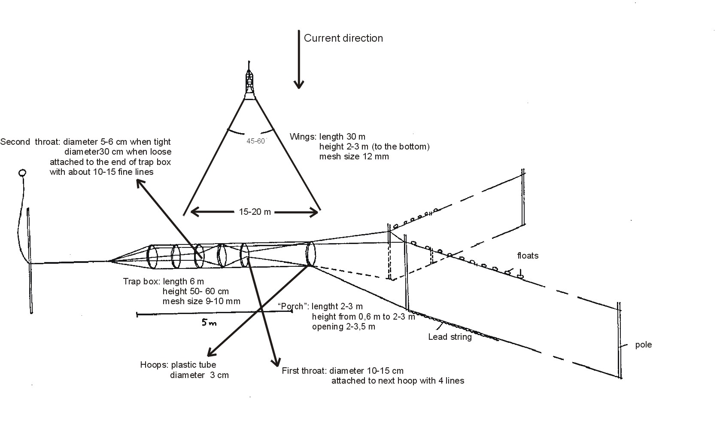
Figure 3. Fyke net trap.

Task 3.c. Analyze data.
Estimates of upstream adult lampreys numbers will be calculated weekly in the Umatilla River. We will use the modified Schaefer Estimate as described in Purvis and McDonald (1987) to estimate the mean number of upstream migrants with a 95% confidence interval. Population estimates will be used to examine trends in adult abundance entering the Umatilla River.

Objective 4. The scope of this objective is to determine if larval population trends increase after ouplanting treatment through time in the Umatilla River. The measurable objective is yearly estimates of larvae in plots. Completed by existing task 1.c.

Objective 5: The scope of this objective is to determine if trends increase for recently metamorphosed lampreys migrating out of the Umatilla River. The measurable objective will be yearly estimates of outmigrants.

Task 5.a. Determine trapping locations
We will survey the lower Umatilla River and choose good trapping locations.

Task 5.b. Trap outmigrant lampreys
Traps will be fished from Novermber through February during the night only. Trap nets will be tied to rope spanning the river (Figure 4). Trap nets will be checked and cleaned every two hours through the night. Lamreys will be measured and fin clipped then released up from traps for recapture. From recapture data we will develop trap effieciencies.
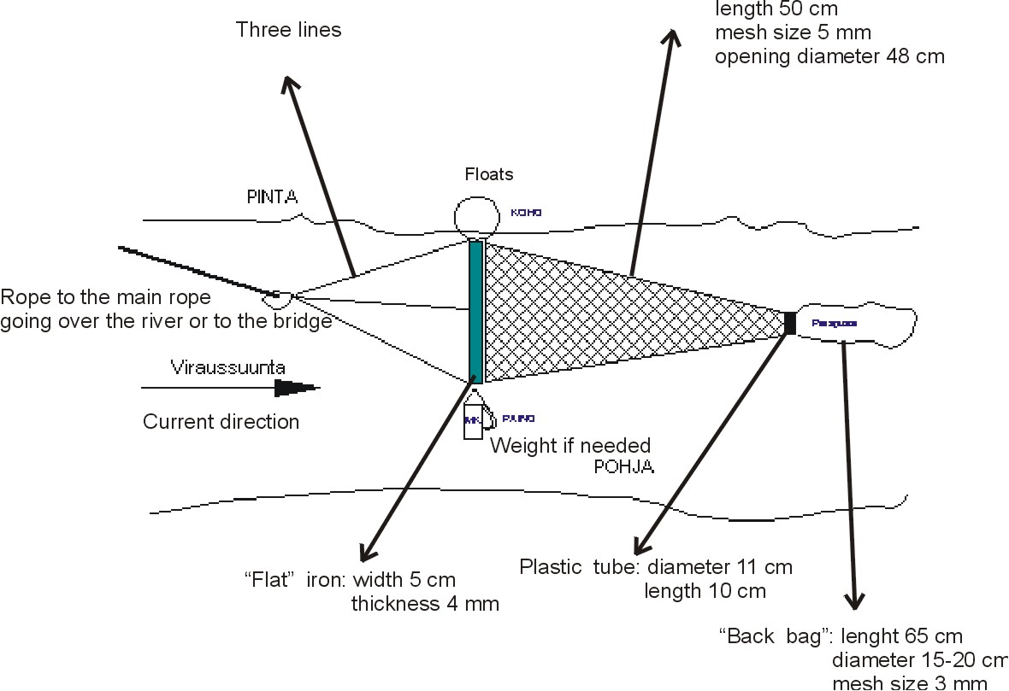

Figure 4. Outmigrant Trap nets.

Task 5.c. Analyze Data
We will use the Bootstrap method (Efron and Tibshirani 1986; Thedinga et al. 1994) with 1,000 iterations to determine the variance of all abundance estimates. Variances for abundance subtotals were summed. Confidence intervals (95%) for the abundance estimate were calculated using the square root of the Bootstrap variance estimate (CI = 1.96 x square root of the variance).

Objective 6: The scope of this objective is to: 1) To assay behavioral responses of upstream migrating Pacific lampreys to pheromones produced by larval lampreys; 2) To measure olfactory response of upstream migrating Pacific lampreys to pheromones produced by sexually mature lampreys using electro-olfactogram (EOG) techniques; 3) To assay behavioral responses of upstream migrating Pacific lampreys to pheromones produced by sexually mature lampreys.
Task 6.a. Collection of lampreys--Upstream migrating Pacific lampreys will be collected from the Columbia River. Lampreys showing no outward signs of the onset of sexual maturity will be sorted from those collected. Thirty to 50 Pacific lampreys will be marked with PIT tags and held in Little White Salmon River water at the CRRL.

Task 6.b. Source of bile salts--Petromyzonol sulfate will be purchased from Toronto Research Chemicals Inc. Washes from larval lampreys will also be tested. Other chemicals being tested will be purchased from reputable commercial vendors. Researchers at Michigan State University might also supply newly discovered sea lamprey pheromones for testing with Pacific lampreys.

Task 6.c. Measuring responses to bile salts--Using EOG recordings from the olfactory epithelium of lampreys, we will measure the response of lampreys during the process of sexual maturation. EOG measurements will be done according to methods described by Li et al. (1995). Data will be collected using a PC-based physiograph connected to a DC amplifier, in turn connected to a reference electrode and a recording electrode. Lampreys will be anesthetized and immobilized, and the electrodes will be attached. We will perfuse the gills and nose with flowing water at 15° C.

Each test will start with an exposure of the lamprey's olfactory tissue to a solution containing L-arginine (Li and Sorensen 1992). If a satisfactory response is measured from the L-arginine, the olfactory tissue will be exposed to water containing bile salts. The resulting responses will be recorded and compared. Quality assurance criteria will be developed for the apparatus and techniques we are using. Biologists conducting the measurements will collect information that will allow us to partition the error between the operator, the equipment, and the organisms. Sufficient testing will be done to minimize the error due to the operator. At least one dose-response measurement will be conducted for arginine and petromyzonol sulfate for each sampling period.

field seasons—Pacific lampreys will be collected in one large batch from the Bonneville Dam or Willamette Falls. Between 150 and 200 lampreys will be held at the CRRL as describe above. Every two weeks, 10 lampreys will be subjected to the EOG procedure, describe above, through the end of August. From September through the following May, 10 fish will be used each month. For the first 3 to 6 months of the migration, 10 pacific lampreys will be collected from the field on the same schedule. This will give us responses to odors from fish held in the laboratory as compared to those that were in the river during the same period.

Objective 7: The scope of this objective is to complete the investigation to determine whether genetic differences exist between Pacific lampreys in different streams of the Columbia River. Measurable objectives of this research are 1) microsatellite DNA profiles of Pacific lampreys. The approach is to compare genetic variation in lampreys from different locations (locations within the Columbia River and one from outside the basin) and an outgroup of a different species using microsatellite DNA markers. The null hypotheses, is that Pacific lampreys are widely dispersed, randomly mating population.
Genetics laboratory work will be performed at one or more laboratories under subcontract. Federal contracting regulations prevent us from knowing which laboratories will do the work until bidding is completed. Three potential subcontractors are 1) the Washington Department of Fisheries and Wildlife genetics laboratory under the supervision of Dr. James Shaklee, 2) the University of Idaho laboratory (Center for Salmonid and Freshwater Species at Risk) under the supervision of Dr. Madison Powell, and 3) Dr. Weiming Li at Michigan State University.
Task 7.a. Collect samples.
We will use samples already collected and preserved at the University of Idaho laboratory (Center for Salmonid and Freshwater Species at Risk).
Task 7.b. Analyze microsatellite DNA variation.
Task 7.b.1. Develop 6-8 microsatellite DNA primers specific for Pacific lampreys.
Because the scientific literature does not yet contain published descriptions of the DNA flanking sequences for microsatellite primers (the sequences bracket the gene of interest) we will need to develop them. Primers will be developed using published methods for cloning, and for universal linker and ligation procedures (Hamilton et al. 1999) directed at both tri- and tetra-nucleotide repeat microsatellite loci. Flanking sequences are usually conserved (they do not change much) between closely related species. We hope to use primers for sea lampreys to limit cost.
Task 7.b.2. Characterize microsatellite DNA genotypes.
We will use the following basic methods, although details such as equipment and brands may vary slightly by laboratory. We will extract genomic DNA from tissue using one of two methods, depending on which works best. Method I uses digestion with proteinase K at 65 C in 600 µL of cell lysis buffer consisting of 10 mM Tris, 100 mM EDTA, and 2% SDS. Extracts are cooled and soluble proteins are precipitated by the addition of 200 µL of 7.5 M ammonium acetate and removed by centrifugation. DNA is precipitated by the addition of 600 µL of cold 2-propanol, concentrated into a pellet by centrifugation, washed in cold 70% ethanol, and dried by evaporation. When needed the isolated DNA is rehydrated in 55 µL of low TE buffer for 12-72 hrs and quantified using a Pharmacia GeneQuant II spectrophotometer. Method II used digestion in a 5% chelex (BioRad Chelex 100 resin) solution containing Proteinase K (Sigma). Tissues are heated for 5 min at 95 C to denature proteins after extraction at 65 C for 30-180 min. The extracted DNA is diluted as needed for polymerase chain reaction (PCR) amplification of the microsatellite loci and the dilutions are stored at 5 C until all analyses are completed. We will amplify the microsatellite DNA loci of interest using PCR (Saiki et al., 1988) and fluorescently labeled primers. Wherever feasible, we will multiplex loci together at the PCR step and/or on gels to increase efficiency and decrease costs. After PCR amplification, DNA products will be mixed with loading buffer and a labeled GeneScan-500 size ladder (Applied Biosystems), denatured at 95 C for 4 min, and cooled in ice. 1.5 µL per sample of amplified product will be loaded onto a 4.4% polyacrylamide gel in an ABI-377 semiautomated DNA sequencer (Applied Biosystems) and electrophoresed for 2.5 h. Applied Biosystems software (ABI-Collection, GeneScan v.3.0, and Genotyper v.2.0) will be used to collect and analyze the raw data to determine genotypes at each locus. Alleles from the Genotyper output tables will be sorted into size bins based on the repeat motif of each microsatellite and the observed distributions.

Task 7.d. Analyze results.
From the microsatellite DNA data, we will calculate allele frequencies and genotype proportions from each collection. We will test for Hardy-Weinberg equilibrium using the exact test (Guo and Thompson 1992), and linkage disequilibrium using the Markov chain method (Raymond and Rousset 1995a). We will test for allele frequency differences among collection locations (Raymond and Rousset 1995b) and genotypic differentiation using Markov chain log likelihood ratio tests (Goudet et al. 1996). We will compute F-statistics for allele identity and population differentiation using the weighted analysis of variance method (Weir and Cockerham 1984). For the mitochondrial DNA data, we will align sequences, identify and test for differences in frequencies of unique mitochondrial haplotypes, and compare percent sequence differences among and within species.

g. Facilities and equipment

Objective 1,2,3,4&5: The Confederated Tribes of the Umatilla Indian Reservation has office space, computers, and software available.
Objective 7: The specific facilities and equipment used for the genetic analyses will depend on the subcontractor. We expect that at a minimum, the laboratories will be similar to that of the Washington Department of Fisheries and Wildlife genetics laboratory, which is described below. DNA data collection and processing (microsatellite analysis and sequencing) is done using an ABI-377 semiautomated DNA sequencer with Applied Biosystems Collection, GeneScan, and Genotyper software and Sequencher software. Four networked Apple Macintosh computers are dedicated to DNA data collection, processing and analysis. Two networked IBM-PCs are dedicated for DNA operations and statistical analysis. DNA amplification and fluorescent labeling via the polymerase chain reaction (PCR) is accomplished using three M-J Research thermalcyclers (two M-J Research model 200s and one M-J Research model 100). The lab is equipped with one high-capacity refrigerated centrifuge, an incubator, two water baths, agarose gel apparatus, a GeneQuant spectrophotometer, a UV transilluminator, and one heat block. Multiple sets of individual and multichannel pipettors are available for sample handling. The lab also contains a pH meter, two electronic balances, a chemical fume hood, two crushed ice machines, refrigerators, freezers, and ultrafreezers, and other common pieces of laboratory equipment.
Objective 6: Dr. Seelye at the Cook Washington BRD has the laboratory necessary to complete pheromone research. All experiments will be conducted at the Columbia River Research Laboratory (CRRL). Dr. Weiming Li at Michigan State University will provide assistance and advice in both the EOG and lamprey behavioral testing. Dr. Peter Sorenson at the University of Minnesota, St. Paul campus, will provide technical advice. Both of these researchers are respected experts in the field of olfactory responses in fish. Mr. David Close will provide the funding for this study through the Confederated Tribes of the Umatilla Indian Reservation (CTUIR). Lampreys will be collected cooperatively through the efforts of CTUIR and CRRL employees.

h. References

Reference (include web address if available online) | Submitted w/form (y/n)
Efron, B. and R. Tibshirani. 1986. Bootstrap methods for standard errors, confidence intervals, and other measures of statistical accuracy. Statistical Science 1(1): 54-77.

Thedinga, J.F., M.L. Murphy, S.W. Johnson, J.M. Lorenz, and K.V. Koski. 1994. Determination of smolt yield with rotary-screw traps in the Situk River, Alaska, to predict effects of glacial flooding. North American Journal of Fisheries Management 14: 837-851.

Applegate, V.C. 1950. Natural history of the sea lamprey (Petromyzon marinus) in Michigan. U.S. Fish and Wildlife Service Special Scientific Report to the Fisheries Service 55: 237p.

Beamish, R.J. 1980. Adult biology of the river lamprey (Lampetra ayersi) and the Pacific lamprey (Lampetra tridentata) from the Pacific coast of Canada. Canadian Journal of Fisheries and Aquatic Sciences 37:1906-1923.

Bergstedt, R.A., and Seelye, J.G. 1995. Evidence for lack of homing by sea lamprey. Transactions of the American Fisheries Society 124: 235-239.

Bjerselius, Rickard, Weiming Li, John H. Teeter, James G. Seelye, Peter B. Johnsen, Peter J. Maniak, Gerold C. Grant, Christine N. Polkinghorne, and Peter W. Sorensen. 2000. Direct behavioral evidence that unique bile acids released by larval sea lamprey function as a migratory pheromone. Canadian Journal of Fisheries and Aquatic Sciences. 57: 557-569

Li, W., and Sorensen, P.W. 1997. Highly independent olfactory receptor sites for naturally occurring bile acids in the sea lamprey, Petromyzon marinus. Journal of Comparative Physiology of Animals. 180: 429-438

Li, W., Sorensen, P.W., and Gallaher, D.G. 1995. The olfactory system of the migratory sea lamprey (Petromyzon marinus) is specifically and acutely sensitive to unique bile acids. Journal of General Physiology 105: 569-587
Hamilton, et al. 1999. Universal linker and ligation procedures for construction of genomic libraries enriched for microsatellites. Biotechniques 27(3):500-507.

Raymond, M. and F. Rousset. 1995b. An exact test for population differentiation. Evolution 49:1280-1283.

Guo, S. W., and E. A. Thompson. 1992. Performing the exact test of Hardy-Weinberg proportions for multiple alleles. Biometrics 48:361-372.

Weir, B. S., and C. C. Cockerham. 1984. Estimating F-statistics for the analysis of population structure. Evolution 38:1358-1370.

Section 10 of 10. Key personnel

Principal Investigator: Mr. David A. Close
Project Leader, Lamprey Research and Restoration Project, Confederated Tribes of the Umatilla Indian Reservation, Tribal Fisheries Program, Pendleton, Oregon.
Role: Project Leader
Education:
M.S. Fishery Science (2001). Oregon State University, Corvallis, Oregon.
B.S. Fishery Resources (1994). University of Idaho, Moscow, Idaho.
A.A. Liberal Arts (1991). Blue Mountain Community College, Pendleton, Oregon.
Experience:
Fisheries Biologist-Project Leader-Pacific Lamprey Research and Restoration Project, Confederated Tribes of the Umatilla Indian Reservation, Pendleton, Oregon (1998- present). Duties include developing research proposals, completing technical reports, designing experiments to gain information on Pacific lampreys, and developing Pacific lamprey restoration plan.
Graduate Research Assistant, Oregon Cooperative Fishery Research Unit, Department of Fisheries and Wildlife, Oregon State University (1994-1998). Duties included preparing proposals, experimental design, sampling, and laboratory experiments on Pacific lampreys to determine if classical stress indicators could be used to detect stress in lampreys.
Fisheries Biologist, National Biological Survey, Columbia River Research Laboratory, Cook, Washington (1994). Duties included Sampling zooplankton in reservoirs, tracking movements of Northern pikeminnow, and identification of aquatic macroinvertibrates and juvenile fish.
Fisheries Technician, Confederated Tribes of the Umatilla Indian Reservation (1988-1990; 1993), Intertribal Fish Commission. (1992), United States Forest Service (1991). Duties included sampling fall chinook in Hanford Reach; predation control of Northern pikeminnows; habitat surveys in the Umatilla National Forest; surveyed spawning distribution of spring chinook in the John Day River using snorkeling.

Selected Technical Reports
Close, D.A., M.S. Fitzpatrick, and H.W. Li., B.L. Parker, D.R. Hatch and G.A. James 1995. Status report of the Pacific lamprey (Lampetra tridentata) in the Columbia River Basin. Bonneville Power Administration, Portland, Oregon.
Manuscripts in preparation
P. Bradley, D.A. Close, and C. Langdon. Filtration of Giardia muris cysts by the freshwater mussel (Margaritifera falcata). submitted to Journal of Parasitology.
Close, D.A., M.S. Fitzpatrick, and H.W. Li. Status and importance of Pacific lampreys (Lampetra tridentata) in the Columbia River Basin. To be submitted to Fisheries.
Close, D.A., M.S. Fitzpatrick, G. Fiest, B. Siddens, H.W. Li, and C.B. Schreck. Effects of acute stress on the physiology of Pacific lampreys (Lampetra tridentata). To be submitted to General and Comparative Endocrinology.
Close, D.A., M.S. Fitzpatrick, C.M. Lorion, H.W. Li, and C.B. Schreck. The effects of intraperitoneally implanted radio transmitters on the swimming performance and physiology of Pacific lampreys (Lampetra tridentata). To be submitted to Journal of Fish Biology.

James G. Seelye
PRINCIPAL INVESTIGATOR & SUPERVISOR for proposed pheromone project
Duties on project: Supervision, technical expertise, administrative assistance
Present Position:
Supervisory Fishery Biologist, GS482-14
Laboratory Director
Columbia River Research Laboratory
5501A Cook-Underwood Road
Cook, Washington 98605
Phone: 509-538-2299 X263
Fax: 509-538-2843
E-mail: jim_seelye@usgs.gov
Education and Training:
Degree Date School
A.S. Science 1967 North Central Michigan College
B.S. Biological Science 1969 Lake Superior State College
M.S. Limnology 1971 Michigan State University
Ph.D. Limnology 1975 Michigan State University
Experience:
Research Assistant, Department of Fisheries and Wildlife, Michigan State University, 1969-1974
Research Limnologist, Project Manager, USACE, Waterways Experiment Station, 1975-1976
Supervisory Fishery Biologist (Research), Project Leader, FWS, Contaminant Dynamics, Great Lakes Fishery Laboratory, 1976-1982
Supervisory Fishery Biologist (Research), Station Chief, FWS, Hammond Bay Biological Station, 1982-1995
Supervisory Fishery Biologist, Laboratory Director, USGS/BRD, Columbia River Research Laboratory
Research Specialties:
Chemical Limnology
Aquatic toxicology
Anadromous fishes
Current Research Assignments:
I am currently the Director at the CRRL, a major fishery research lab on the Columbia River. I have provided advice and assistance to lamprey researchers in the US and Canada for almost 20 years. Members of my staff and I are funded to conduct studies of the physiological effects of the fish bypass facilities at the Bonneville Dam. I provide advice and assistance to Dave Close with the CTUIR on their studies on a regular basis. I maintain a working relationship with the staff working on sea lampreys in the Great Lakes.
Selected publications:
Bergstedt, R. A., and J. G. Seelye. 1995. Evidence for lack of homing by sea lampreys. Transactions of the American Fisheries Society 124:235-239.
Morket, Sidney B., William D. Swink, and James G. Seelye. 1998. Evidence for Early Metamorphosis of sea lampreys in the Chippewa River, Michigan. North American Journal of Fisheries Management. 18: 966-971.
Bjerselius, R., W. Li, J.H. Teeter, J.G. Seelye, P.B. Johnson, P.J. Maniak, G.C. Grant, C.N. Poldinghome, and P. W. Sorensen. 2000. Direct behavioral evidence that unique bile acids released by larval sea lamprey (Petromyzon marinus) function as a migratory pheromone. Canadian Journal of Fisheries and Aquatic Sciences 57:557-569.
Vandenbosche, J., J. G. Seelye, B. Zielinski. 1993. The morphology of the olfactory epithelium in the larval juvenile, and upstream-migrant stages of the sea lamprey Petromyzon marinus. Brain Behavior and Evolution. 15pp.
Youson, Y. H., J. A. Holmes, J. A. Guchardi, J. G. Seelye, R. E. Beaver, J. E. Gersmehl, S. A. Sower, and F. W. H. Beamish. 1993. Importance of condition factor and the influence of water temperature and photoperiod on metamorphosis of sea lamprey, Petromyzon marinus. Canadian Journal of Fisheries and Aquatic Sciences 50:2448-2456.

Jennifer M. Bayer
TEAM LEADER & PRINCIPAL INVESTIGATOR for proposed pheromone project
Duties on project: Responsible for all aspects of project implementation and management, including: technical, budgets, personnel (hiring and supervision), implementation of research, analysis and reporting of research, quality control/quality assurance oversight, and miscellaneous administrative tasks. As the “technical contact person”, I interact with our CTUIR COTR (Mr. David Close) as necessary.
Present Position: Fishery Biologist
Columbia River Research Laboratory
5501A Cook-Underwood Road
Cook, Washington 98605
Phone: 509-538-2299 X 273
Fax: 509-538-2843
E-mail: Jennifer_Bayer@usgs.gov
Education and Training:
Degree Date School
M.S. Biology 2001 Portland State University
B.S. Fisheries Science 1993 Oregon State University
Experience:
1997-Present USGS Student Career Education Program; Portland State University
1996-1997 Fishery Biologist, US Geological Survey
1994-1996 Fishery Biologist, National Biological Service1992-1994 Student Research Assistant, Stream Team, OSU, Corvallis, OR.
1991 Biological Technician, Oregon State University, Corvallis, OR.
1990-1991 Work-study student, Oregon Cooperative Fishery Research Unit, OSU.
1989 Technician II, Normandeau Associates, Inc., Peekskill, NY
1987-1988 Technician II, Prince William Sound Aquaculture Corporation, Cordova, AK
Research Specialties:
Early life history of fishes
Lamprey life history
Current Research Assignments:
I have proposed, planned, and implemented a number of research projects over the past seven years in my current position. Currently, I am the principal investigator/ team leader for a group of people working on a suite of projects focusing on lampreys of the Columbia River Basin. We are examining aspects of Pacific lamprey passage issues, including swimming performance, metabolic costs, and effects of exhaustive stress. We have a field project investigating upstream migration behavior and habitat use of Pacific lamprey in the John Day River Basin. With laboratory studies, we are evaluating temperature effects on early life history stages of lampreys, preparing morphometric descriptions of early life history stages, and validating statolith-based aging techniques for larval lampreys. We are also examining olfactory response of adult Pacific lampreys to pheromones released by larval lampreys, a possible migratory cue.
As team leader for these projects, I am responsible for all aspects of project management, including preparing proposals, budgets, personnel (hiring and immediate supervision), implementation of research, reporting of research, quality control/quality assurance oversight, and miscellaneous administrative tasks. As the “technical contact person”, I interact with our contract officer’s technical representatives as necessary.
Selected publications:
Bayer, J.M., T.C. Robinson, and J.G. Seelye. In review. Upstream migration of Pacific lampreys in the John Day River: behavior, timing, and habitat use. Report of research. Bonneville Power Administration, Portland, Oregon.
Bayer, J.M., M.H. Meeuwig, and J.G. Seelye. 2001. Identification of larval Pacific lampreys (Lampetra tridentata), river lampreys (L. ayresi), and western brook lampreys (L. richardsoni) and thermal requirements of early life history stages of lampreys. Annual Report to Bonneville Power Administration, 2001.
Mesa, M.G., J.M. Bayer, J.G. Seelye, and L.K. Weiland. 2001. Swimming performance and exhaustive stress in Pacific lampreys (Lampetra tridentata): implications for upstream migrations past dams: annual report of research. U.S. Army Corps of Engineers, Portland, Oregon.
Bayer, J.M. and J.G. Seelye. 2000. Technical assistance for Pacific lamprey studies: final report of research. Confederated Tribes of the Umatilla Indian Reservation, Pendleton, OR. Abstract published.
Bayer, J.M. and J.G. Seelye. 1999. Characteristics of upstream migrating Pacific lampreys (Lampetra tridentata) in the Columbia River: final report of research. U.S. Army Corps of Engineers, Portland, Oregon.

T. Craig Robinson
CREW LEADER for proposed pheromone project
Duties on project: assist with planning and implementation of project, including training and supervising less experienced employees, establishing protocols, conducting laboratory activities, procurement of supplies and equipment, data summary and preparation of reports
Present Position: Fisheries Biologist, 0482, GS-07
Columbia River Research Laboratory
5501A Cook-Underwood Road
Cook, Washington 98605
Phone: 509-538-2299 X324
Fax: 509-538-2843
E-mail: craig_robinson@usgs.gov
Education and Training:
Degree Date School
B.S. Biochemistry 1995 University of New Hampshire
Experience:
Fisheries Biologist (GS-07, 1/2001 to present)
Biological Science Technician (Fisheries) (GS-07, 5/1998 to 1/2001)
Contracted Biologist II (GS-07 equivalent, 4/1997 to 5/1998)
Contracted Biologist I (GS-05 equivalent, 6/1996 to 4/1997)
Research Specialties:
Fisheries applications of radio and acoustic telemetry
Monitoring of Gas Bubble Trauma (GBT) in anadromous and resident fish
Reproductive and comparative endocrinology of fish
Current Research Assignments:
Using radio telemetry to assess over-wintering and spawning habitat use by adult Pacific lamprey (Lampetra tridentata) in the John Day River Basin, OR
· Investigating trends in olfactory responses of adult Pacific lamprey to conspecific pheromones from early migration to spawning stages
Selected publications:
Robinson, T.C., S.A. Tobet, C. Chase, T. Waldron, and S.A. Sower (2000) Gonadotropin-Releasing Hormones in the Brain and Pituitary of the White Sucker. General and Comparative Endocrinology 117: 381-394
Bayer, J.M., T.C. Robinson, and J.G. Seelye. In review. Upstream migration of Pacific lampreys in the John Day River: behavior, timing, and habitat use. Report of research. Bonneville Power Administration, Portland, Oregon.
Venditti, D.A., T.C. Robinson, J.W. Beeman, B. J. Adams, and A.G. Maule (2001) Gas bubble disease in resident fish below Grand Coulee Dam. 1999 annual report prepared by U.S. Geological Survey, Biological Resource Division, Cook, WA for U.S. Bureau of Reclamation
Beeman, J.W., T.C. Robinson, P.V. Haner, S.P. Vanderkooi, and A.G. Maule (1999) Gas Bubble Disease Monitoring and Research of Juvenile Salmonids. 1998 annual report prepared by U.S. Geological Survey, Biological Resource Division, Cook, WA for U.S. Department of Energy, Bonneville Power Administration, Portland, OR, project number 96-021, contract number 96AI93279
Maule, A.G., J.W. Beeman, M.G. Mesa, K.M. Hans, L.K. Weiland, P.V. Haner, and T.C. Robinson (1998) Gas Bubble Disease Monitoring and Research of Juvenile Salmonids. 1997 annual report prepared by U.S. Geological Survey, Biological Resource Division, Cook, WA for U.S. Department of Energy, Bonneville Power Administration, Portland, OR, project number 96-021, contract number 96AI93279

