Project ID: 25002

Title: Protect, enhance, and maintain habitat on the Sunnyside Wildlife Area to benefit wildlife and fish assemblages.

Section 9 of 10. Project description

a. Abstract

Located in Yakima County, the Sunnyside Wildlife Area (SWA) encompasses approximately 4,265 ha (10,538 ac) along the Yakima River floodplain in the lower Yakima Valley and 2,510 ha (6,202 ac) of shrubsteppe habitat on Rattlesnake Ridge in Benton County. The Sunnyside, Byron, and I-82 management units (Units) are located on or near the Yakima River floodplain and adjacent to the Yakama Indian Reservation, while the Thornton and Rattlesnake Slope Units are located on Rattlesnake Ridge north of Benton City, Washington.

The SWA Units found within the Yakima River floodplain provide habitat for a host of wetland and riparian obligate species such as waterfowl and includes approximately 21 km (12.6 mi) of shoreline along the Yakima River, which supports ESA listed steelhead. In contrast, the Rattlesnake Ridge Units are dominated by shrubsteppe habitat and are managed primarily for shrubsteppe obligate wildlife species such as sage grouse.

Near term habitat enhancement, maintenance, and protection measures planned for the Sunnyside Wildlife Area include: seeding herbaceous cover, controlling introduced weedy vegetation including Russian olive trees, enhancing wetlands, increasing open water to cover ratios in lacustrine habitats, maintaining moist soil paddocks and fences, planting shrubs and trees, mowing goose pastures, and enhancing waterfowl feeding and loafing areas (WDFW 1998).

b. Technical and/or scientific background

This project addresses the loss and degradation of floodplain wetland and riparian habitats along the Yakima River, and subsequent negative impacts on the distribution and populations of wetland and riparian obligate wildlife species. As stated in the Yakima Subbasin Summary, wetland and riparian habitats have been negatively impacted throughout the lower Yakima River valley due to:

- Drainage of wetlands for agriculture and development purposes
- Flood plain constriction through diking and damming
- Livestock over-grazing
- Loss of native plant communities such as mature cottonwood forests

The Sunnyside Unit, I-82 Unit, and to a lesser extent the Byron Unit are located on the Yakima River floodplain (Figure 1). The Yakama Indian Nation (YIN) Reservation is located west of the Sunnyside and I-82 Units. Wetland and riparian habitat limiting factors are being addressed on the Sunnyside Unit through enhancing existing wetlands including re-watering dry river oxbows, eliminating livestock grazing and unneeded dikes and water control structures, removing invasive Russian olive trees, controlling herbaceous weedy vegetation, seeding herbaceous cover, and planting/protecting shrubs and trees.

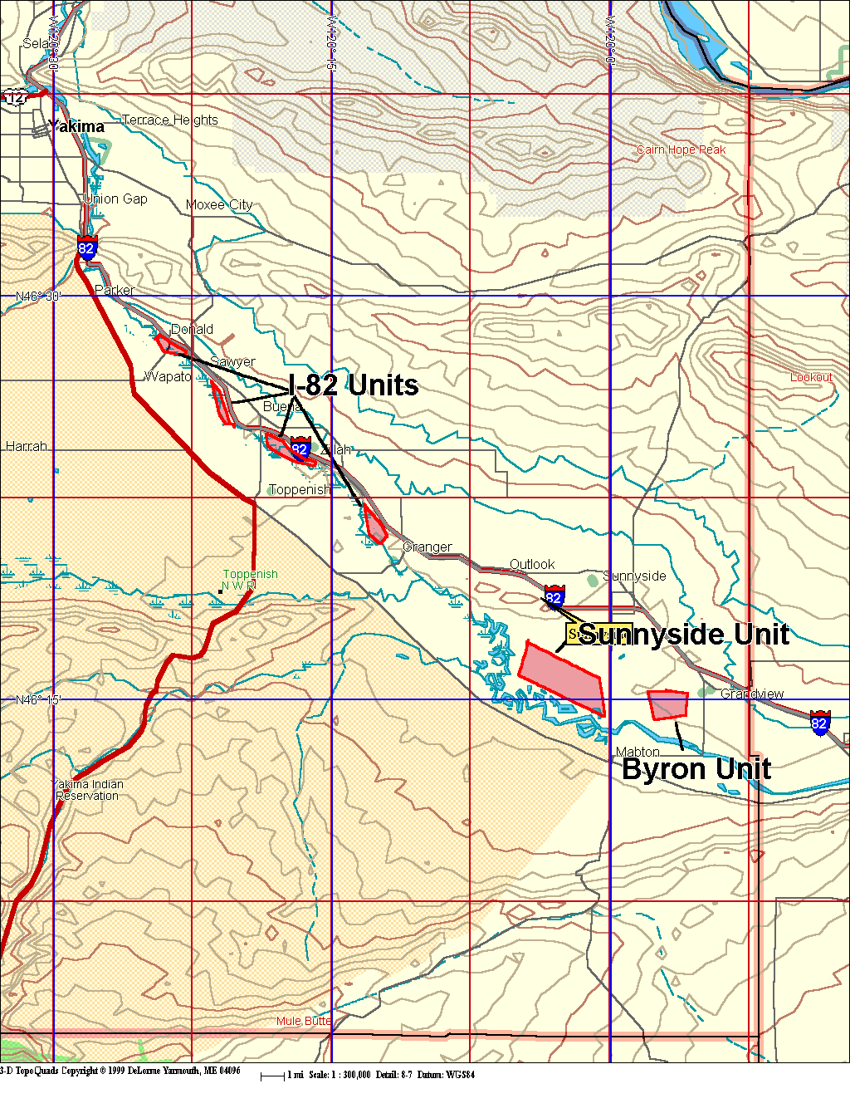
Figure 1. Location of the Sunnyside, I-82, and Byron Units.

In addition to addressing riparian and wetland habitat losses, this project addresses water quality issues associated with the Yakima River (Giffen Lake project described below). As stated in the Yakima Subbasin Summary, DOE standards set for DDT and DDT byproducts (including, in most cases, PCB’s and other agricultural pesticides and herbicides such as Endosulfan, parathion, Endrin, Aldrin and Dieldrin) were exceeded in 15% of the listed reaches. Six of these nine sites were located below the city of Yakima, and four of the nine were located in the Yakima River proper, ranging in distribution from Cle Elum to Horn Rapids. The site with greatest contamination was Horn Rapids. In essence, longitudinal linkage within the river has led to a downstream increase in contamination, with specific point sources entering from Snipes, Spring, Sulphur, Wide Hollow and Cherry creeks, and Granger and Moxee drains. Instream flows were cited as exceeding standards set by the State in 8 of the 72 reaches, including the Yakima River near Toppenish and Horn Rapids, plus Cowiche, Wenas, Big, Taneum and Manastash creeks, and the Teanaway River (Berg 2001).

The Giffin Lake project (Figure 2) is designed to control aquatic vegetation, reduce the amount of pesticide/sediment laded water flowing from agricultural lands into the Yakima River, increase waterfowl production, and recover the resident fishery within Giffin Lake. The project also includes construction of ponds and associated wetlands.

This multi-agency cooperative project is partially funded by BPA, Ducks Unlimited, Pheasants Forever, WDFW Duck Stamp Program, NRCS, and local irrigation/water quality districts. The largest share of the funding for this restoration effort comes from a North American Wetlands Conservation Act Grant (NAWCA), which is administered by the YIN (YIN 1996). The following three projects have been approved for NAWCA funding:

- Wetland enhancements and construction of catch basins and 17 culverts to treat and direct water flowing into Giffin Lake
- Installation of a lift pump and construction of "Bio Filters" to treat drain water flowing into Giffin Lake
- Installation of a pump station and pipeline below the outlet at Giffin Lake and construction of about 28 hectares of moist-soil management paddocks.

BPA mitigation funds will be used to dredge Giffin Lake and remove undesirable aquatic vegetation. In addition, BPA will provide funding for wetland enhancements and annual operation and maintenance costs.

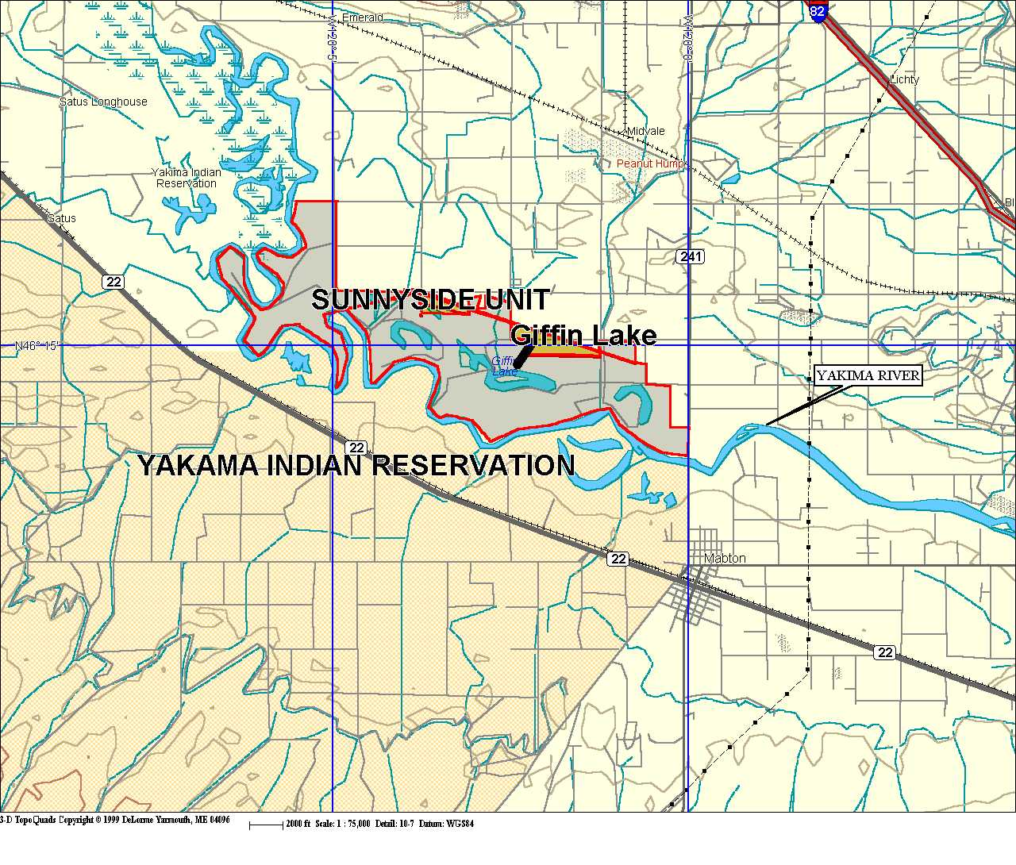
Figure 2. Location of the Giffin Lake project, Sunnyside Unit, and Yakama Indian Reservation.

Similarly, the SWA project addresses shrubsteppe habitat limiting factors described in the Yakima Subbasin Summary including:

- Conversion of shrubsteppe habitat to agricultural fields
- Urbanization and development
- Livestock grazing
- Invasion of introduced exotic vegetation
- Loss of the shrub component due to wildfire and/or herbicides

The Thornton and Rattlesnake Slope Units (Figure 3) are comprised of shrubsteppe habitat and are located adjacent to and/or near the Arid Lands Ecology site and the Hanford Nuclear Reservation. These lands are managed primarily for shrubsteppe obligate species such as sage grouse. Mule deer and elk are also present on these Units and are a WDFW priority species within the subbasin.

Subbasin limiting factors have been addressed on project lands by converting agricultural lands back to shrubsteppe habitat, restricting development and livestock grazing, controlling weeds, and replanting native shrubs following recent wildfires. Long term operations and maintenance (O&M) is required in order to protect and maintain habitat/wildlife values on all Units that comprise the Sunnyside Wildlife Area.

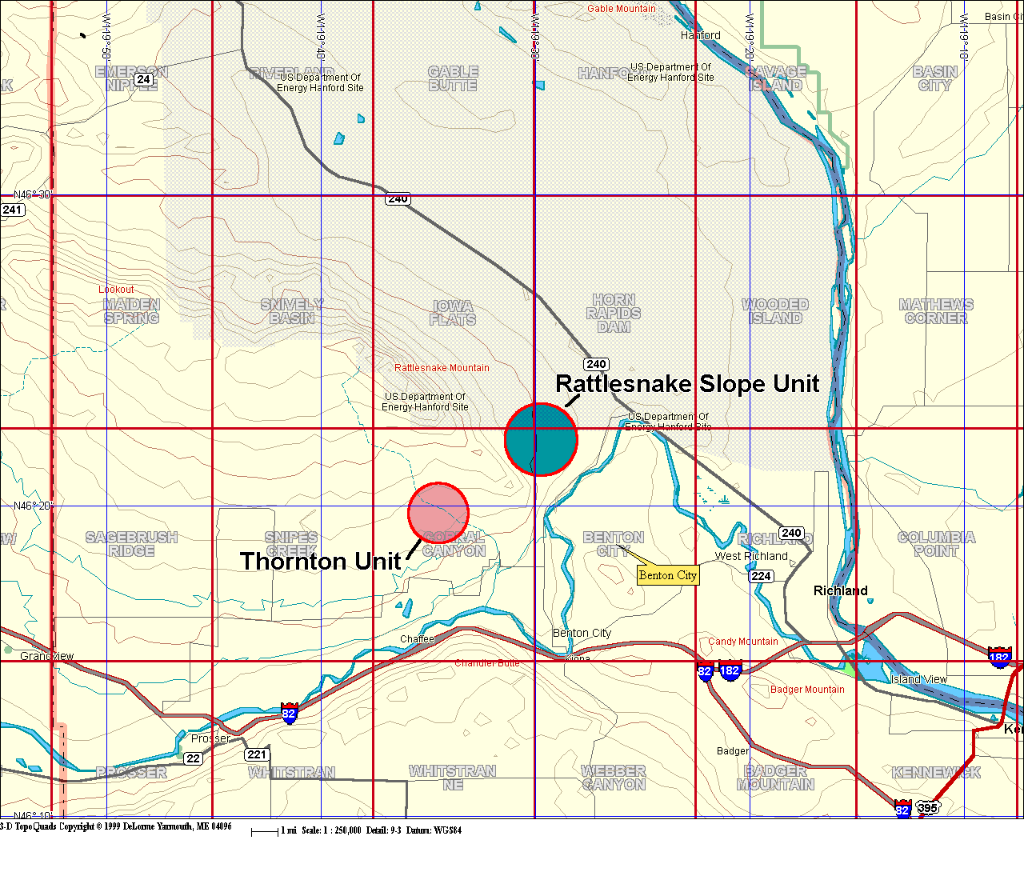
Figure 3. Location map for the Rattlesnake Slope and Thornton Units.

c. Rationale and significance to Regional Programs

The presence of Yakima River oxbow sloughs and 21 contiguous kilometers (13 mi) of lower-Yakima River frontage create a unique opportunity to provide quality wetland and riparian habitat in the subbasin. This project directly addresses the loss and/or degradation of floodplain habitat and shrubsteppe uplands, and partially addresses the following needs identified within the Yakima Subbasin Summary i.e., the need to:

- Restore the productivity of floodplain properties in priority mainstem reaches.
- Identify and repair, or remove, or relocate roads and culverts that are susceptible to mass wasting and bank failures; that negatively impact riparian areas, and inhibit connectivity and natural stream functions in all fish-bearing watersheds.
- Improve water quality throughout the Subbasin by addressing each of the factors contributing to impaired water quality.
- Restore sloughs, ponds, and side channels within to restore natural ecological processes and habitat of the area and help reduce water temperatures.
- Develop and implement adaptive livestock grazing management plans which include performance standards and targets for habitat and water quality conditions that grazing practices must meet. Plans should address excluding grazing from fish spawning grounds during times of the year that spawning occurs.
- Control noxious weeds along the lower Yakima River and replace exotic plants with native species (willows, roses, etc.) to restore wetland and riparian areas and functionality.

This BPA funded mitigation project provides habitat for both T&E and Priority Habitat Species (PHS) and is an important link in WDFW’s ongoing efforts to protect, enhance, and increase wetland and shrub-steppe habitats for associated wildlife species and to improve water quality for both anadramous and resident fish alike. The goals and strategies described for the Sunnyside Wildlife Area are consistent with subbasin goals, objectives, and strategies. SWA goals and strategies are compared to relevant subbasin goals and strategies on Table 1 (not all relevant subbasin goals and strategies are listed).

Table 1. Yakima Subbasin and Sunnyside Wildlife Area goals and strategies.

Yakima Subbasin Goal(s) | Sunnyside Wildlife Area Goal(s)
Maintain and protect existing high quality habitat areas (and the native populations inhabiting those areas). | Provide optimum habitat for T&E, PHS, waterfowl, upland bird, and shrubsteppe obligate species assemblages and maximize public recreational opportunities on the Sunnyside Wildlife Area.
Yakima Subbasin Strategies | Sunnyside Wildlife Area Strategies
Improve uplands for waterfowl nesting controlling weeds adjacent to wetlands, increasing amount of riparian shrub cover, and removing Russian Olive trees | Control the proliferation and spread of weedy vegetation on upland, riparian, and wetland habitats.
 | Protect, maintain, and enhance uplands, riparian areas, and wetlands as described in the Sunnyside Wildlife Area Implementation Work Plan.
Restore habitat for waterfowl and other species in wetland and riparian areas in the Yakima basin | Manage wetland paddocks using wet soils management practices.
Increase the amount of waterfowl wintering habitat and winter food resources in the Lower Yakima Basin to allow for the redistribution of wintering waterfowl back into the Yakima Basin | Maintain alfalfa fields and food plots to reduce waterfowl depredation on adjoining private croplands.
Increase access opportunities for public hunting, fishing and non-consumptive wildlife recreation. | Provide and promote public recreational opportunities and enforcement of wildlife and environmental laws.
Continue existing water quality and quantity monitoring and improvement programs and develop and prioritize new research, monitoring and implementation programs to improve the water quality and maximize beneficial use of current water supply. | Improve water quality in wetlands and water flowing into the Yakima River.
Form partnerships, and participate at all levels of government to assess and maintain quality fish and wildlife habitat. | Coordinate land management activities with the YIN, irrigation districts, NRCS, USFWS, Ducks Unlimited, Citizen Advisory Groups, local jurisdictions, landowners, and other interested stakeholders.
Monitor population response to protection, restoration and management efforts. | Monitor wildlife populations in conjunction with WDFW monitoring needs and established protocols.

As an ongoing mitigation project, the SWA project is also consistent with the Northwest Power Planning Council’s 2000 Program including, but not limited to the following sections: Overall Vision (Section III A-1) “Wherever feasible, this program will be accomplished by protecting and restoring the natural ecological functions, habitats, and biological diversity of the Columbia River ecostystem….”, Planning Assumptions (Section III, A-2) “This is a habitat based program, rebuilding healthy, natural producing fish and wildlife populations by protecting, mitigating, and restoring habitats and the biological systems within them…”, Scientific Principles (Section III, B-2) i.e., Principles one through eight, Biological Objectives (Section III, C-1) “Recovery of fish and wildlife affected by the development and operation of the hydro system that are listed under the Endangered Species Act,” (Section III, C-2a.4) “Develop and implement habitat acquisition and enhancement projects to fully mitigate for identified losses; Coordinate fish and wildlife activities throughout the basin…; maintain existing and created habitat values; and monitor and evaluate habitat and species responses to mitigation actions,” and Wildlife (Section III, D-7) “Complete the current mitigation program for construction and inundation losses and include wildlife mitigation for all operational losses as an integrated part of habitat protection and restoration”.

The Sunnyside Wildlife Area has been approved as a wildlife mitigation project by BPA. This project will partially meet BPA's mitigation obligation to compensate for wildlife losses resulting from the construction of Grand Coulee, McNary and John Day Dams. By funding the enhancement and reasonable operation and maintenance of the Sunnyside Wildlife Area for the life of the project, BPA will receive credit towards its mitigation debt. Mallard, Western Meadowlark, Canada Goose, Yellow Warbler, Downy Woodpecker, Mink, California Quail, Black-capped Chickadee, Great Blue Heron, Mule Deer and Sage Grouse were identified in the loss assessments and were used as HEP indicator species (Howerton 1986, BPA 1989, WDFW 1998).

d. Relationships to other projects

The Sunnyside Wildlife Area project compliments the Yakama Tribe’s “Yakama Nation Riparian and Wetland Restoration Project” (9206200) and “Yakima River Side Channels Project” (9705100). Like the Sunnyside Wildlife Area, both YIN projects are BPA funded mitigation projects. The SWA also compliments WDFW’s shrubsteppe enhancement, protection, and maintenance efforts on the Wenas, Swanson Lakes (199106100), and Sagebrush Flat (1994044) Wildlife Areas and also supports habitat protection and restoration and research activities conducted by the US Army on the Yakima Training Center (USDA 1999).

WDFW manages much of the east bank of the Yakima River as part of the SWA (Figure 4), and the YIN manages most of the west bank from Union Gap to Mabton (Figure 5). Combined, the two entities cover both sides of the river with their respective projects. The YIN’s “Yakima River Side Channels” project ‘s primary objective is to secure and restore riparian habitat above Union Gap, which compliments WDFW efforts below Union Gap.

Within the larger context of the Province, management strategies for shrubsteppe habitat and associated species of concern on the SWA are consistent with and compliment those for the Wenas, Swanson Lakes, and Sagebrush Flat Wildlife Areas. The protection, restoration, and maintenance of shrubsteppe habitat for obligate species such as sage grouse is a high priority for WDFW throughout the Columbia Plateau Province and associated subbasins as well as other areas throughout the state.

Management strategies for shrubsteppe habitats and sage grouse on the SWA also compliment habitat strategies developed by the US Army for the Yakima Training Center (YTC). YTC land managers and WDFW staff have collaborated on trapping and monitoring sage grouse, developing habitat suitability models for sage grouse, standardizing shrubsteppe habitat measurement techniques, and sharing habitat/wildlife management information. Similar studies and collaborative efforts also occur between WDFW and habitat managers on the Hanford Nuclear Reservation.

Figure 4. SWA project lands along the Yakima River.
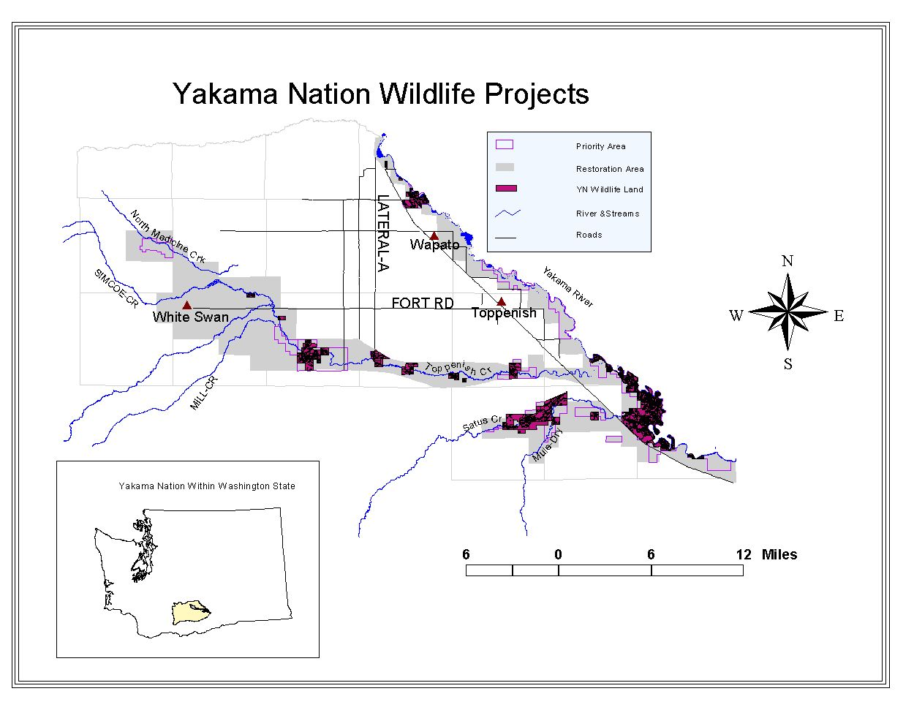
Figure 5. YIN habitat project lands along the Yakima River.

e. Project history (for ongoing projects)

The Sunnyside Wildlife Area (formerly Sunnyside Game Range) was first established in 1947 and was comprised of less than 725 ha (1,793 acres). WDFW has since expanded the SWA to include five disjunct management units (Table 2). The SWA became a BPA mitigation project in 1997. In its present configuration, the wildlife area is comprised of lands that are owned by WDFW, leased from Department of Natural Resources (DNR), donated to WDFW by the federal government, and/or purchased with Snake River Mitigation Program funds. Brief management unit histories and descriptions are summarized below.

Table 2. Sunnyside Wildlife Area management units.

SWA Management Unit | Hectares | Acres
Sunnyside | 1,128 | 2,786
I-82 | 397 | 980
Byron | 417 | 1,031
Rattlesnake Slope | 1,482 | 3,661
Thornton | 842 | 2,080
Total | 4,265 | 10,538

Management Unit Descriptions and Histories

Sunnyside Unit Description

The Sunnyside Unit is located in one of the state's most productive farming areas. The surrounding property is some of the most intensively managed agricultural ground in the nation. Major crops include corn, wheat, barley, alfalfa, asparagus, hops, grapes, apples, pears, peaches, apricots, cherries, mint, numerous seed crops and nursery stock. In addition, some of the largest dairy operations in the Northwest are found in the lower Yakima Valley.

This 1,128 hectare (2,786 acre) Unit is located on the Yakima River flood plain. Soils include silt-clay loam soils with some areas of high alkalinity. The Yakima River meanders forming oxbows, ponds, and impoundments and numerous wetlands. Spring flooding of pastures and fields adjacent to the river occur annually. The topography is relatively flat rising only 5 meters (17 feet) from the river surface to the highest point on the Unit. Cover types include: riparian forest, riparian shrub, lacustrine, palustrine, riparian shrubscrub, island, grassland, shrubland, shrubscrub, agriculture, and urban.

Prior to WDFW ownership, the Sunnyside Unit was farmed and extensively grazed. As a result, WDFW inherited a significant weed infestation problem consisting of knapweed (Centaurea spp.), pepperweed (Lepidium spp.), and cheatgrass (Bromus tectorum) to name a few. The weeds suppress and/or compete with native herbaceous vegetation in most cover types. Annual flooding events deposit weed seeds and creates a fertile seedbed in most areas adjacent to the Yakima River. High water tables, due to irrigation, and seasonal flooding contribute towards creating alkaline soil conditions rendering some sites incapable of supporting historic native vegetation.

There are six ponds or lakes on the Sunnyside Unit varying in size from 6 surface hectares (15 surface acres) to 40 hectares (100 surface acres). These offer excellent waterfowl nesting opportunities as well as resting areas for migrating waterfowl. Two of these lakes located on the Snipes waterfowl reserve attract and hold as many as 20,000 to 30,000 additional waterfowl in the lower Yakima Valley. Approximately 57 hectares (140 acres) of irrigated cropland within the Snipes Reserve is planted to cereal grains and alfalfa under a sharecropper agreement. WDFW's share of cereal grains are either left standing or used in upland bird winter feeders. In late winter and early spring, 10,000 to 15,000 Lesser Canada Geese heavily graze the alfalfa in this area. The sharecropper and/or WDFW pays all costs associated with this lease. No mitigation funds are used.

Sunnyside Unit - Lower Snake River Compensation:

Two parcels were purchased and developed with mitigation funds from the United States Corps of Engineers (COE) for off-site Lower Snake River Compensation. (BPA does not fund any activities associated with these sites.) The Brady property was purchased under the Element Z portion of the Snake River mitigation program to provide public fishing access to the Yakima River. The site encompasses approximately 35 hectares (86 acres) and provides about 0.8 kilometers (0.5 mile) of river frontage. The formal name for this site is the Sulphur Creek Public Fishing Area, named for an adjacent geographic feature. Development plans include a parking lot, fencing, well and irrigation development, and shrub plantings. Development activities are funded by the COE. The U.S. Fish and Wildlife Service (USFWS) funds all operation and maintenance activities on this parcel (Pittman-Robertson funds).

Similarly, the Vance property was purchased under the Element Z portion of the Lower Snake River Compensation Program to provide public fishing access to the Yakima River. This site encompasses approximately 47 hectares (116 acres) and provides access to about 1.2 kilometers (0.75 mile) of river frontage. The Vance property is located approximately 3.2 kilometers (2 miles) northeast of Mabton, Washington. Development plans include a parking lot, footpath and bridge, signs, fencing, habitat development, irrigation systems and shrub plantings. As with the Brady property, development activities are funded by the COE. Operation and maintenance activities are funded by USFWS.

I-82 Unit Description:

The I-82 Units are comprised of 17 separate parcels acquired in 1983 from the Department of Transportation (DOT) when Interstate 82 was built. The parcels are located in the riparian zone located between the Yakima River and I-82 and extend from Union Gap to the Zillah interchange. This Unit offers scattered public access to the Yakima River and nearby ponds. Although not located in prime farmlands, the area surrounding the Unit is primarily rural agricultural land interspersed with small communities along I-82.

The area provides public hunting and fishing with three improved boat launches and six maintained parking areas. Seven man-made ponds, developed during highway construction, provide fishing opportunities primarily for local anglers.

The riparian habitat along the river, sloughs, and ponds provides excellent waterfowl and upland bird nesting, brooding and winter habitat. Like many areas, purple loosestrife has become a problem in wetlands on this area. Upland habitat consists of open areas that were formerly agricultural fields and orchards. Most of these are infested by weedy vegetation and would benefit significantly if reseeded to native vegetation along with an aggressive weed control program.

Byron Unit Description:

The Byron Unit was acquired and is managed for waterfowl production and to a lesser extent upland birds. This Unit was the headquarters of the Sunnyside Wildlife Area from 1950 until 1975 when it was moved to the Sunnyside Unit. Two management agreements were instrumental in establishing the Byron Unit. In 1950, WDFW entered into an agreement with the Northern Pacific Railroad for 14 hectares (35 acres) and in 1955 an agreement was reached with the United States Department of Interior for an additional 130 hectares (320 acres).

A large irrigation pipeline called the Mabton Siphon bisects the area. WDFW property east of this pipeline (approximately 202 hectares/500 acres) was designated a wildlife reserve in 1948. In 1989, WDFW entered into an agreement with the City of Grandview and Ducks Unlimited to build a pipeline and allow the City to pump treated sewage water into a series of depressions located inside the Byron Reserve. This project created a sewage lagoon system with 11 surface hectares (27 surface acres) and 9.6 kilometers (6 miles) of riparian shoreline. The pumping operation is closely monitored by WDFW, Department of Ecology, and the City of Grandview

The 417 hectare (1,031 acre) Byron Unit is punctuated by numerous ephemeral wetlands and permanent ponds that provide waterfowl brood rearing habitat. Uplands consist primarily of shallow soils, and occasional basalt rock outcrops with deeper soils occurring in the bottom of swales. Topography is relatively flat with low, rolling hills leading down to wetland basins while the elevation varies from approximately 209 meters (685 feet) in the southeast portion of the Unit to 213 meters (700 feet) on the north side of the area. Cover types include grassland, shrubgrass, riparian shrubscrub, palustrine, lacustrine, island, agriculture, and urban.

Upland habitats include both grasslands and shrublands. Grasslands are predominantly cheatgrass stands interspersed with limited amounts of bluegrass, wildrye, and bluebunch wheatgrass. Like grasslands, shrubland understory vegetation is dominated by cheatgrass while sagebrush (Artemisia tridentata) and rabbitbrush (Chrysothamnus sp.) comprise the shrub canopy layer.

With the exception of annual flooding, the Byron unit is plagued by the same weed problems as the Sunnyside Unit. Knapweed, pepperweed, and cheatgrass are prevalent throughout the area along with a host of other exotic weed species. Although cheatgrass is found within most cover types, knapweed and pepperweed infestations are concentrated primarily along wetland shorelines, in ephemeral ponds, and other sub irrigated/wet micro-sites. Riparian shrub areas are dominated by Russian Olive trees with an occasional clematis vine (Clematis ligusticifolia), rose (rosa spp.), or red-osier dogwood (Cornus stolonifera) shrub present. Opportunities to increase the amount of riparian shrub cover are limited on some portions of this unit due to shallow soils. Limited soil depth also eliminates establishment of cottonwood trees on most of the site.
.
Unlike the Sunnyside Unit, palustrine and lacustrine cover types exhibit near optimum open water to cover ratios for waterfowl brood rearing. These cover types are most likely being under utilized at present due to poor waterfowl nesting habitat conditions on uplands.

A major drain, carrying ground water and irrigation water, runs through the area creating a series of ponds extending approximately 3.2 kilometers (2 miles) and nearly 162 surface hectares (400 surface acres) in size. The Byron Ponds and adjacent uplands provide waterfowl nesting and brooding areas. Public access to the area is closed from February 1 to August 1 to reduce disturbance to nesting waterfowl. Canada geese graze on green cheat- grass on upland sites in late winter and early spring, which helps reduce crop depredation on surrounding agricultural lands.

There are 12 hectares (30 acres) of irrigated grain cropland currently farmed. It is under a lease agreement with 25% of the crop going to WDFW. Portions of the WDFW’s grain are left standing, and the remaining share goes into upland bird winter feeders. Alfalfa production and sharecrop activities including staff, irrigation, and utilities are not funded by BPA. These activities will continue to be funded by USFWS through a Pittman-Robertson federal aid contract.

Rattlesnake Slope Unit Description:

The Rattlesnake Slope Unit was designated surplus property by the Federal government (Bureau of Reclamation and the Department of Interior) and granted to WDFW in 1973. This Unit is located in Benton County, 11 kilometers (7 miles) north of Benton City on the lower east slopes of Rattlesnake Peak. Horn Road is the east boundary and the only public access to the unit. The remainder of the Unit is bordered by private property and/or land owned by the United States Department of Energy (DOE). DOE lands are managed by Battelle Laboratories as the Arid Lands Ecology Reserve (ALE). Public access is not allowed on the ALE.

Elevations range from 122 meters (400 feet) to 610 meters (2000 feet) along the crest of the Rattlesnake Hills. The terrain is gently rolling with abrupt inclines on the west side and on the immediate slopes of Rattlesnake Hills. The Unit is comprised largely of bluebunch wheatgrass and other native perennial bunchgrasses along with scattered patches of sagebrush and cheatgrass. The cheatgrass patches are possibly the result of historic sheep bedding grounds, small abandoned fields, or some other intensive land use.

Lightning and man-induced fires have removed much of the sagebrush cover on this Unit. This Unit provides critical habitat for shrubsteppe obligate species such as sage grouse and other wildlife species including T&E and PHS assemblages. Both game and non-game species are limited on this area because of the lack of water (WDFW 1998).

Rattlesnake Slope Unit - Hanford Atomic Power Plant 1 and 2 Mitigation:

The Washington State Energy Facility Site Evaluation Council (EFSEC) in its Site Certification Agreement for the Washington Public Power Supply System Nuclear Projects Number 1 and 2 at Hanford provided for the protection and mitigation of wildlife impacted by the projects. In 1987, EFSEC accepted a mitigation plan that would improve wildlife habitat on the nearby Rattlesnake Slop Unit of the Sunnyside Wildlife Area.

In 1987 the WDFW entered into mitigation with the Washington Public Power Supply System (WPPSS) for habitat loss in the construction of atomic power plants. A project agreement was developed and approved. Project activities included:

1. Upgrading and use of the existing well located in the northwest corner of the area.
2. Installing a drip irrigation system consisting of:
A. Approx. 16 km (10 mi) of PVC under ground water line plead out on three sections.
B. Several miles of wire and eleven electric valves that run off an automatic timer.
C. Forty-one shrub plots approx. 0.04 ha (0.1 ac) each.
D. Approx. one mile of above ground drip irrigation tube.
E. 14,000 shrubs.
F. 14 wildlife-watering devices throughout the Unit.

In 1989, the system was completed and 2500 shrubs were planted that fall. The remainder of the shrubs was planted in the spring and fall of 1990. Extensive range fires during the summer of 2000 burned thousands of hectares including the Rattlesnake Slope Unit. All enhancement efforts were reduced to ash. Some areas were reseeded in the fall of 2000. Rehabilitation efforts will continue for several years and include herbaceous seedings, shrub plantings, and weed control efforts. This portion of the Rattlesnake Unit is excluded from BPA mitigation. Through EFSEC, WPPSS funds the development, operation, maintenance, and monitoring activities.

Thornton Unit Description:

The 842 hectare (2,080 acre) Thornton Unit was acquired by WDFW in 1996 as part of a land exchange between the WDFW and Elliot Thornton. The unit is located 9.6 kilometers (6 miles) north of Prosser, Washington on the west side of Benton County and is approximately 8 kilometers (5 miles) southwest of the Rattlesnake Slope Unit.

Phisiography and edaphic features include six south facing parallel ridges separated by one permanent stream (Snipes Creek) and several intermittent waterways, and steep canyons that rise from just under 457 meters (1,500 feet) in the southern most part of the Unit to ridge top elevations of 732 meters (2,400 feet) on the north side of the Unit. Soils range from bare rock to over 1 meter (3 feet) deep allowing for the establishment of sagebrush stands and grasslands. This Unit is largely shrubsteppe habitat.

Thornton was acquired and is presently managed for mule deer, upland birds, transitory elk (the Hanford herd), sage grouse, and other shrub-steppe obligate species. When purchased, the unit consisted of 526 hectares (1,300 acres) of dryland cropland (small grains) with the remainder in shrub-steppe habitat. In 1997, 242 hectares (598 acres) of agricultural land was seeded to grass under the Conservation Reserve Program (CRP). In 1998 an additional 276 hectares (683 acres) were approved for inclusion into the CRP program. By the end of 1999, all croplands were converted to native-like vegetation.

Enhancement Descriptions/Major Results

General: Enhancements are based on WDFW management/mitigation goals, objectives, and HEP results. In general, enhancements are comprised primarily of the following activities:

- Weed control
- Herbaceous seedings
- Shrub/tree plantings
- Russian Olive eradication
- Aquatic vegetation control
- Goose pasture maintenance
- Fencing
- Establishment of small food plots

Weed control activities include both chemical and mechanical methods. Wildlife area staff apply herbicides in accordance with product label, federal, state, and local rules, regulations, and guidelines. Mechanical actions include mowing, disking and reseeding, and hand control methods. Exotic weeds such as knapweed and pepperweed are well dispersed throughout the SWA especially on disturbed mesic sites. The concentration and distribution of weeds throughout the Yakima River flood plain Units has significantly reduced habitat quality for target wildlife species. As a result, weed control is considered both an O&M and an enhancement activity. Controlling noxious vegetation is paramount to improving habitat conditions on the Sunnyside Unit.

Chemical/mechanical weed control activities were initiated in 1998. To be effective, weed control requires a long-term commitment after initial treatments. As managers start weed control measures on new sites, previously treated areas must also be re-sprayed and/or mechanically treated. Eventually, however, after several annual treatments weed infestations should begin to decrease and subsequently require only long-term O&M spot treatments. To date, weeds control activities have taken place on1,055 ha (2,607 ac).

Native-like herbaceous seedings were established on former cropland on most Units and used as a post weed control measure where applicable. Herbaceous seedings consist of native wild rye, bluebunch wheatgrass, fescue spp., and other species based on local site soil/precipitation conditions, seed availability etc.

Grasslands require intensive management for a minimum of two years after planting (primarily weed control and spot reseeding). Periodic mowing, spraying, or other form of manipulation is required for the life of the stand to maintain plant vigor and productivity and suppress weed competition. From 1997 through 2000, 786 ha (1,942 ac) were seeded to native-like herbaceous vegetation.

Shrubs and trees were planted primarily in riparian zones in order to improve and/or increase the amount of riparian shrub and riparian forest cover types. Most riparian shrub areas are infested with Russian olive trees that are of little benefit to wildlife. Russian Olive is removed where possible and replaced with native shrubs i.e., dogwood, willow, cottonwood, and rose. Reestablishing native cottonwood galleries in areas adjacent to the Yakima River is a high priority and will eventually provide black-capped chickadee, downy woodpecker, mink, and heron habitat. Historically, cottonwoods grew along most stretches of the Yakima River. Today, however, few occur on the Sunnyside Unit. Past land use/farming practices, floods, and competition from Russian olive trees have severely restricted the current range of cottonwoods on this unit.

Shrubs and trees have been planted on 3 ha (7.4 ac) since 1997. Shrub/tree seedlings were planted at recommended spacing intervals using plastic mulch to suppress weed competition. Irrigation was used on some sites to aid seedling establishment. Once established, irrigation will cease. Supplemental watering, weeding, fertilizing, and replacement of dead seedlings may occur for at least four years after planting. Periodic maintenance of the plantings will be required after establishment.

Sagebrush seed was incorporated into herbaceous seed mixes for use on burned shrubsteppe sites at Rattlesnake Slope and at rehabilitated agricultural fields on the Thornton Unit. Spot weed control treatments are planned for these sites.

Russian Olive eradication involves manual removal of olive trees on uplands and, where practical, riparian sites. Russian olive trees are prolific and are adapted to a wide range of conditions and habitats. As a result, most native trees and shrubs are crowded out by the more aggressive olive stands. In addition, few herbaceous species grow within Russian olive thickets.

Removal involves either bull dozing or pulling out individual trees and then stacking the debris into brush piles for burning. Injection chemicals are also available to eradicate individual olive trees. After removal, the area is treated either mechanically or with chemicals to control olive seedlings sprouting from copious amounts of seed and root structure left in the ground. Follow-up control measures are conducted at each site for up to three years after which the site is seeded to native-like herbaceous vegetation or planted with shrubs and trees. Due to the high water table, profuse amounts of residual seed, and alkali soils, (olive trees have adapted to alkali soils whereas most potential plant competitors have not), present on the Yakima River flood plain, Russian olive trees continue to colonize new sites. Therefore, removal is a continuous, long-term activity. Approximately 72 ha (178 ac) of Russian olive have been removed on the SWA.

Aquatic vegetation control consists of either chemically and/or physically removing/suppressing excessive emergent vegetation within lacustrine and palustrine cover types. The primary objective of aquatic vegetation control is to achieve optimum cover to open water ratios (50:50) for waterfowl.

Chemical control involves aerial application of EPA approved herbicides to unwanted emergent vegetation such as lily pads for several consecutive years. Once undesirable vegetation is controlled, managers will open water control structures to lower water levels in order to expose undesirable emergent vegetation to further desiccation by the sun and wind. Exposed areas will be dredged to develop and deepen open water areas. The spoils will be used to develop island habitat for waterfowl.

Aquatic vegetation will also be controlled on ephemeral ponds where needed. Vegetation may be controlled by either ground herbicide applications and/or mechanical methods as described above. Further indirect aquatic vegetation control will occur in conjunction with the NAWCA grant through the use of water settling ponds and flooded cottonwood stands. Sediments and nutrients will settle out in settling ponds and become trapped in successive layers of mud covering the bottom of the ponds. Additional nutrients will be absorbed by cottonwood tree roots and stored in tree fiber. This two tiered approach will lower the amount of sediment and nutrient load flowing into waterways resulting in improved water quality, reduced dredging, and less nutrients which promote undesirable emergent vegetation growth. This will also benefit anadromous fish runs and resident fish populations in the Yakima River basin by keeping sediments and nutrients out of the river.

Goose pasture maintenance involves mowing selected grassland areas to approximately four inches in height to accommodate grazing geese. Goose pasture sites are alternated annually and are limited to less than 8 ha (20 ac) in size. Utilization of the pastures is monitored annually and modifications to this practice are made as adaptive management warrants. Supplying goose pasture is secondary in importance to providing waterfowl and upland bird nesting/brood rearing habitat. Keeping geese on the SWA reduces crop depredation on adjacent agricultural lands.

Small food plots composed of wheat, barley, millet, sorghum, and corn, less than 0.8 ha (2 ac) in size, are scattered throughout the Sunnyside Unit to provide temporary, supplemental food sources for waterfowl and upland birds. Food plots are either dryland, sub irrigated, or irrigated (irrigated food plots are incidental to other planned irrigation i.e., the outside corner of an irrigation circle etc.). This enhancement activity will be phased out after five years in favor of less intensively managed food plot mixtures.

The following additional accomplishments have been completed:

- Completed the baseline HEP analysis.
- Established initial HEP/vegetation transect photo points.
- Restored and enhanced 10 ha (25 ac) of wetlands and installed a pump and associated water control structures.
- Repaired 5.2 km (3.25 mi) of fence; removed 4 km (2.5 mi) of fence.
- Completed cultural resource surveys.
- Developed 49 ha (120 ac) of wetland moist soils management cells.

The estimated annual implementation cost from 1997 through 2001 is $325,000 for BPA and $42,000 for WDFW. These cost estimates are all inclusive.

f. Proposal objectives, tasks and methods

SWA objectives and tasks for fiscal years 2002 through 2004 are consistent with Yakima Subbasin and WDFW wildlife program/mitigation goals, objectives, and strategies and support the overall project goals and strategies described below.

SWA Project Goal(s) and Strategies

Goal 1: Provide optimum habitat for T&E, PHS, waterfowl, upland bird, and shrubsteppe obligate species assemblages (WDFW 1998) and maximize public recreational opportunities on the Sunnyside Wildlife Area.

Strategy 1.1: Control the proliferation and spread of weedy vegetation on upland, riparian, and wetland habitats.

Strategy 1.2: Protect, maintain, and enhance uplands, riparian areas, and wetlands as described in the Sunnyside Wildlife Area Implementation Work Plan (WDFW 1998).

Strategy 1.3: Manage wetland paddocks using wet soils management practices.

Strategy 1.4: Maintain alfalfa fields and food plots to reduce waterfowl depredation on adjoining private croplands.

Strategy 1.5: Provide and promote public recreational opportunities and enforcement of wildlife and environmental laws.

Strategy 1.6: Improve water quality in wetlands and water flowing into the Yakima River.

Strategy 1.7: Coordinate land management activities with the YIN, irrigation districts, NRCS, USFWS, Ducks Unlimited, Citizen Advisory Groups, local jurisdictions, landowners, and other interested stakeholders.

Strategy 1.8: Monitor wildlife populations in conjunction with WDFW monitoring needs and established protocols.

SWA Project Objectives and Tasks: FY 2002 –2004

Objective 1: Increase the quantity of optimum waterfowl/upland bird nesting habitat by at least 809 ha (2000 ac) by the end of 2004.

Task 1.1: Seed 238 ha (700 ac) of native-like herbaceous cover.

Task 1.2: Control weeds on at least 202 ha (500 ac) annually.

Task 1.3: Maintain moist soils management cells and water delivery systems as required.

Task 1.4: Remove at least 14 ha (35 ac) of Russian olive trees annually.

Objective 2: Reduce sediments and agricultural chemicals entering the Yakima River from Giffin Lake and project area streams, canals, and wetlands by 25% by the end of 2004.

Task 2.1: Complete the Giffin Lake project.

Task 2.2: Maintain wetlands and water filtration pond(s).

Task 2.3: Plant 4 ha (10 ac) of riparian shrubs and trees in 2003 and 4 ha (10 ac) 2004.

Objective 3: Complete and maintain tasks described in the Sunnyside Wildlife Area Implementation Work Plan (WDFW 1998).

Task 3.1: Maintain equipment, facilities, vehicles, water delivery systems, fences, and infrastructure to the extent necessary to complete work plan activities.

Task 3.2: Maintain fire control contracts and DNR leases.

Task 3.3: Maintain existing enhancements.

Objective 4: Monitor species/habitat response to project activities annually.

Task 4.1: Conduct waterfowl brood production transects annually in conjunction with WDFW, YIN, and USFWS surveys.

Task 4.2: Conduct vegetation transects, maintain/establish photo plots and monitor results of weed control activities annually.

Task 4.3: Survey neo-tropical birds annually on project lands.

Task 4.4: Reconnoiter the Thornton and Rattlesnake Slope Units for evidence of sage grouse use annually.

Methods – Monitoring

Background (vegetation)

The following standardized vegetation/HEP monitoring protocols were developed for use at the SWA and other WDFW mitigation project sites within appropriate cover types. As new information becomes available and/or monitoring needs change, the following protocols will be modified to meet the new challenges.

Monitoring is a tool for detecting change and identifying problems in the early stages before they become obvious or a crisis. If detected early, problems can be addressed while cost effective solutions are still available. For example, an invasive weed species is much easier to eradicate/control at the initial stages than attempting to eradicate it once established. Monitoring is also critical for measuring management success. Good monitoring can demonstrate that management strategies are working and provide evidence supporting the continuation of management. Conversely, monitoring can also show a need to change current management strategies.

Monitoring is a key component of “adaptive management,” in which monitoring measures progress towards or away from meeting management goals and objectives and provides evidence to continue or change current management strategies (Ringold et al. 1996). In practice, most monitoring measures change or condition of the resource whether it is a plant community, or a wildlife species. If objectives are being met, management is considered effective.
Figure 6. The adaptive management cycle.

The adaptive management cycle, illustrated in Figure 6, consists of four basic steps:

- Resource objectives are developed to describe the desired condition.
- Management is designed to meet the objectives, or existing management is continued.
- The response of the resource is monitored to determine if the management objective has been met.
- Management is adapted (changed) if objectives are not reached.

Monitoring, as part of the adaptive management cycle, has two primary components. The first is that monitoring is driven by management objectives. What is measured, how it is measured, and how often it is measured are defined by how an objective is described. The objective describes the desired condition. Management is designed to meet the objective. Monitoring is designed to determine if the objective is met. Objectives form the foundation of the project.

The second component is that monitoring is only initiated if opportunities for management change exist. If no alternative management options are available, expending resources to monitor something is almost futile. For example, since vegetation management (with exception of weed control measures) on shallow lithosols soils is impractical, it is not wise to use limited monitoring resources on these areas (this does not preclude general plant community inventories). In such cases, monitoring resources should be directed towards opportunities where management solutions are available.

Measuring change over time is the main characteristic of monitoring, but change can be measured as trend studies, baseline studies, long-term ecological studies, and inventories as well. Monitoring on WDFW Wildlife mitigation projects is tied to management objectives and includes plant community surveys similar to those conducted in conjunction with the baseline HEP analysis.

WDFW Wildlife Area staff, Vegetation Management Team personnel, and volunteers on a periodic basis will accomplish basic monitoring on mitigation lands (wildlife areas). M&E protocols and techniques are subject to change as new information becomes available. The following four monitoring surveys will be conducted:

- HEP surveys (five year intervals)
- General cover type/vegetation surveys (five year intervals)
- Site specific enhancement and maintenance activity surveys (one to five year intervals)
- Wildlife species response/trend surveys (one to three year intervals)

Monitoring falls under two general categories i.e., habitat monitoring and resource monitoring. Replicating HEP surveys is an example of habitat monitoring which describes how well an activity meets the objectives or management standards for a particular cover/habitat type. “Optimum” (1.0) habitat suitability for each HEP model variable is the standard against which the effectiveness of management is measured.

In contrast, resource monitoring focuses on vegetation and/or wildlife and describes some aspect such as height, percent cover, density, frequency, population characteristics, and/or species response. Both general cover type/vegetation surveys and monitoring of site specific enhancement and maintenance activities are examples of resource monitoring.

Wildlife area staff, WDFW wildlife biologists, and volunteers will conduct wildlife population and species response surveys. Monitoring includes both vegetation and wildlife resources.

Specific Monitoring and Evaluation Protocol

The primary concept behind establishing M&E transects is to detect change. Permanent transects are recommended over temporary transects because the statistical tests for detecting change from one period to the next in permanent sampling units are much more powerful than on temporary sampling units. This advantage usually translates into a reduction in the number of sampling units that need to be sampled to detect a given magnitude of change. The monitoring and evaluation protocols described below reflect the minimum monitoring necessary to ensure project goals and objectives are being met. These protocols, developed by Columbia Basin Fish and Wildlife Authority (CBFWA) members will be modified as new techniques are developed. Wildlife area staff and WDFW Vegetation Management Team members will collect additional plant community and wildlife population data as needed.

Habitat Evaluation Procedures Surveys

A minimum of 25 percent of the baseline HEP transects, located in areas not directly effected by enhancements or maintenance activities, will be replicated by wildlife area staff every five years to monitor general habitat trends. At least two baseline transects will be replicated in each cover type. Evaluators will use the same measurement techniques/instruments described within specific HEP models or used on baseline HEP transects to measure habitat variables. In general, HEP transects in shrub-steppe, riparian, and forested habitats are established as follows:

Transect starting points and azimuths (direction) are randomly selected for each cover type and recorded on data sheets along with transect identification, cover type, HEP Team, and global positioning system (GPS) information. If possible, transects are established at least 100 meters from ecotones, roads, and other anthropogenic influences.

Transect start and end points are marked with a 36-centimeter (14-inch) long 0.6 centimeter (¼ inch) rebar stake painted fluorescent orange or red. GPS positions are also taken at both start and end points. If cover types change, either another transect azimuth is randomly selected, or the original azimuth is varied by 45 degrees. The method selected is based on which technique maintains the transect within the cover type. Compass azimuths (headings) are corrected for local declination.

Shrubland transects are divided into 30 meter (100 foot) sampling units. Similarly, grassland transects are also divided into 30 meter (100 foot) sampling units (n).

The process for determining transect length (sample size) varies based on what variable was being measured. In general, a “running mean” is used to estimate variance on cover pole readings (95% probability of being within ± 10 percent of the true mean). On the other hand, shrub cover sample size is estimated by first tallying total shrub cover within each 30 meter (100 foot) sampling unit and dividing that sum by sample unit length to obtain percent shrub cover per sample unit (i.e., 10 feet of cover/100 feet = 10 percent shrub cover). The standard deviation is then calculated from the percent shrub cover data for each sample unit. The sample size is determined through use of the following equation:

n = t²s²
B²

where: t = t value at the 95 percent (0.05) confidence interval for the appropriate degrees of freedom (df); s = standard deviation; and B = bounds (± 10 percent). The same equation is used to determine sample size for plot frames based on total percent cover for herbaceous species.

Specific transect establishment protocols are described below. Additional information can be found in Estimating Wildlife Habitat Variables (USFWS 1981).

- Establish transect starting point 300 feet within cover type (if possible). Record shrub intercept in 10ths of feet by shrub species for each sampling unit (100 foot segments) for entire transect length. Using a graduated rod, measure shrub height (10ths of feet) at the highest point where shrub foliage/stems intercept transect line.

- Facing line of travel (transect azimuth), walk on left side of transect line to avoid trampling vegetation on both sides of transect. Place first rectangular plot frame at the 25 foot mark and at 25 foot intervals thereafter (four per 100 foot sampling unit). Place the lower right hand corner of the plot frame on the 25 foot interval mark on the right side of the transect line with the long axis of the plot frame perpendicular to the transect line of travel. Make ocular estimates of: herbaceous cover by plant species, percent of plot comprised of total herbaceous cover, and percent of herbaceous cover composed of grass as described by Daubenmire (1970).

- Measure height of herbaceous cover by species in each plot frame with a graduated rod/tape measure (10ths of feet).

- Take two Robel pole measurements per sampling unit i.e., one at the 50 foot mark and the other at the 100 foot interval. Four observations are taken and averaged per point to obtain a single visual obstruction reading or VOR (two measurements are taken four meters from the point on the transect line on opposite sides of the cover pole from a height of one meter; two measurements are taken from the point perpendicular to the transect line of travel).

HEP surveys will be conducted within the same general time frame and location as the original baseline transects to ensure results are comparable (the phonological state of key plants are noted on baseline transects and are subsequently used to initiate follow-up transects rather than specific calendar dates). Photo points will be re-photographed and/or established as needed. If time/funding constraints allow, more detailed plant community inventories will be conducted concurrent with collection of HEP variable information.

General Vegetation Monitoring - Shrubland/Grassland Cover Types

Vegetation sampling on shrub-steppe plant communities will focus on detecting changes in frequency of bluebunch wheatgrass, needle-and-thread grass, Idaho fescue, cheatgrass, and knapweed. Bluebunch wheatgrass, needle-and-thread, and Idaho fescue are native perennial bunchgrasses that are highly susceptible to grazing pressure and competition from non-native plant species. As a result, these species are good indicators of general habitat quality.

Likewise, cheatgrass, mustards, Russian thistle, and knapweed are indicators of past/present disturbance. Frequency/percent cover of sagebrush spp. and bitterbrush will also be monitored to assess shrubland habitat quality/trends (evaluators should review HEP transect results and/or confer with Vegetation Management Team members prior to modifying the species recommended for frequency monitoring). The rationale for using frequency is explained below.

Percent frequency was selected as the monitoring technique because it is appropriate for any plant species’ growth form. It is appropriate for monitoring some annuals, whose density may vary year to year, but whose spatial arrangement of germination remains fairly stable such as cheatgrass. Rhizomatous species, especially graminoid species growing with similar vegetation, are often measured by frequency because there is no need to define a sampling unit such as percent cover or density. Frequency is also a good measure for monitoring invasions of undesirable species as well as increases/decreases in desirable species.

Another advantage of frequency methods over methods for measuring cover is the longer time window for sampling. Once plants have germinated, frequency measurements are fairly stable throughout the growing season as compared to cover measurements which can change considerably from week to week as plants grow. The biggest advantage of frequency methods, however, is that the only decision required by the observer is whether or not a species occurs within the plot. Technicians can be easily taught to measure frequency with minimal training on methodology and species identification. If the species is easy to recognize, frequency plots can be evaluated quickly.

Frequency data only provides information on the number of individuals, or the change in that number relative to the size of the plot frame or its subsections. It is a good methodology to determine if a site has more or less plants of a specific species; however, it does not provide other information that may be useful for habitat or plant community characterization (C. Perry, pers. comm. 2000)

Both spatial distribution and the density of the population also affect frequency Greig- Smith 1983). Because of this it is difficult to interpret changes biologically since it is not known if a change is due to density, distribution, or both. As a result, frequency data will be augmented with abundance and density information.

Frequency is a measure dependant upon plot size and shape. Plot size should be such that plants being measured fall between the 20 percent to 80 percent range (Perry, pers. com.). Therefore, the plots used to determine frequency must be identical to compare different studies. Herbaceous cover and frequency data, collected during the HEP baseline analysis, was obtained using the same 0 .5 meter² rectangular microplot as recommended for use in this M&E protocol. Frequency data from baseline transects can be used, rather than a pilot study, to estimate M&E transect sample size.

Transect Procedures
A minimum of two transects will be established for each cover type. Transect locations/start points will be determined using standard procedures (this can be accomplished as a pre-field activity). Transects will be established at least 100 meters from the edge of the cover type and away from roads and other anthropogenic factors (unless the disturbed area is the target site) as follows:

- Select a random azimuth (direction) from a random numbers table or other suitable device/technique. Stretch and secure a 100-meter tape along the random azimuth to establish the 100-meter baseline transect (document compass azimuth and declination on transect data sheets).

- Document the location of baseline transects with Global Positioning System (GPS) equipment and plot on field maps (record GPS coordinates and other pertinent location information on transect forms).

- Establish ten perpendicular transects (90 degrees off baseline), 30 meters in length, along the baseline transect (record azimuth on data forms). The location of the first perpendicular transect is selected at random and placed between 0-10 meters from the start point (0 meter mark). Place the following transects systematically at ten-meter intervals. For example, if the first perpendicular transect is positioned at the 5 meter mark, the second transect is placed at the 15 meter mark, the third at the 25 meter mark and so on until 10 perpendicular transects are established. Permanently mark the start and end points of the baseline and perpendicular transects.

- Position ten microplots (0.5 meter² rectangular microplot) systematically along each perpendicular transect from a random start point. The placement of microplots is determined by selecting a random number between 0 and 3 (the first data collection point for the transect). Starting at the first data collection point, place the microplot at 3 meter intervals along the perpendicular transect until 10 microplot measurements are taken. For example, if the first data point is 2 meters, the second data point is at 5 meters, the third at 8 meters and so forth (10 perpendicular transects x 10 microplots = 100 per survey).

- Photo-document transects. Take three photographs per transect from transect start point. Position the camera one meter above the ground (use one meter cover board or similar device for camera rest); set 1.5 meter cover board on 10-meter mark of baseline transect along with transect photo board and photograph. Repeat procedure half way between the baseline and first perpendicular transect (45 degrees off baseline). Take the third picture along the first perpendicular transect using the same procedure. Record camera type, aperture, distance and azimuth to cover board, cover board dimensions, date, time of day, transect/location identification, GPS coordinates, and photographer (cover boards will be supplied by WDFW mitigation staff).

- Facing towards the end point of the perpendicular transect, data recorders walk on the left side of the transect line, to avoid trampling vegetation, and take measurements on the right side of the transect line. The long axis of the microplot is placed perpendicular to the transect azimuth with the lower right hand corner of the microplot at the data collection point. This procedure is repeated for each perpendicular transect. If possible, microplot data points should be permanently marked. Transect layout is illustrated in Figure 7 while microplot placement and shrub intercept “point” count intervals are shown in Figure 8.

Figure 7. Monitoring and evaluation transect layout.

Figure 8. Microplot and shrub “point” placement on perpendicular transects (not to scale).

Herbaceous vegetation frequency, abundance, and density measures are collected using a 0 .5m ² rectangular microplot as the sampling unit. The microplot is divided into 20 percent increments to facilitate collection of abundance and percent cover data (Figure 9). Frequency is determined by simply noting whether or not a given species is rooted within the microplot. For example, if 100 microplots are laid out and species “A” occurs in 25 of the plots, frequency is 25 percent.

Abundance, ranging from one to five, is the number of 20 percent increments within a microplot a species is rooted in. Figure 10 illustrates an example of an abundance factor of three (count the number of 20 percent increments a species is rooted in, not the number of individual plants).

Density, in contrast, is the number of individuals of a given species rooted within the entire microplot. Density is divided into 5 classes: Class 1 - 1 to 5 individuals, Class 2 - 6 to 10 individuals, Class 3 - 11 to 15 individuals, Class 4 - 16 to 20 individuals, Class 5 - above 20 individual plants. Classes may be adjusted based on target species growth form i.e., if the plant species of interest is very small, 20 individuals may not be significant (always document changes to protocols). Density measurements are most sensitive to changes caused by mortality or recruitment. Figure 11 depicts a microplot with a density factor of three.

Figure 9. A microplot divided into 20 percent increments.

Figure 10. A microplot with an abundance factor of three (plants are rooted in three segments.

Figure 11. A microplot with a density class of three (11 to 15 plants per microplot).

Whether measuring frequency, abundance, or density, plants that are partially rooted both in and outside of the microplot are counted in and out alternately along the boundary i.e., count every other plant. Plant community inventories will be conducted on at least one transect per cover type in conjunction with the M&E microplot surveys if time and funding is available. In addition to frequency, abundance, and density information, plant inventory data includes species composition, height, and percent cover for each microplot.

Shrub data collected on each perpendicular transect includes: species, frequency, percent cover, height, and age. Shrub frequency and cover are determined using “point” counts at two meter intervals (systematically) starting at the 2 meter mark on each transect (15 points per transect, or 150 total). The line intercept method is an alternative technique for collecting percent cover for shrubs (this technique will add to the time required to complete each transect, but is hard to beat).

Shrub height is measured at the highest vertical projection a shrub extends directly above the data point. Shrub age classes are broken down into 5 categories: Young-non flowering/seed bearing (includes seedlings), Mature-generally flowering and/or seed bearing, less than 25% of the plant is dead, Decadent- 25-50% is dead material, Very Decadent- more than 50% is dead, Dead-no living material remains on the shrub.

General Vegetation Monitoring - Forest and Riparian Cover types

Forest and riparian cover type transects are established as previously described under HEP protocols. Snag and/or tree basal area information is collected from within 0.04 ha (0.10 ac) circular plots located at 30 meter (100 foot) intervals along each transect. Tree canopy cover is determined using a GRS densitometer (similar to a moose horn) at 3 meter (10 foot) intervals (10 per 30 meter/100 foot sampling unit; 100 per 300 meter/1,000 foot transect). Diameter breast height (DBH) measurements are taken on forest and riparian forest transects if needed. Due to the linear juxtaposition of most riparian forest areas, 300 meter (1000 foot) line intercept transects will be established for monitoring purposes. Baseline HEP transects may be replicated instead of establishing new transects. M&E will occur at five year intervals, or earlier if required. At least one M&E transect will be established in riparian, riparian forest, and forest cover types and a minimum of two M&E transects will occur on xeric forested sites in each management unit.

In forest and riparian cover types the following habitat attributes will be documented/measured:

- Tree stratum: species, percent canopy cover, mean height, number snags 4 inches DBH, mean DBH, basal area, and stems per acre/hectare (on treated sites).
- Shrub stratum: species, percent cover, and mean height
- Herbaceous stratum: dominant grass, forb, and weed species, frequency, abundance, density, and/or percent cover.

Transect procedures

- Establish random 300 meter (1,000 foot) baseline transects within cover type (ten 30 meter/100 foot sampling units).
- Measure tree canopy cover at 3 meter (10 foot) increments along transect (identify species).
- Measure tree height of over-story canopy at 30 meter (100 foot) intervals.
- Take herbaceous vegetation measurements at 7.5 meter (25 foot) intervals with microplot.
- Measure/estimate shrub intercept, height, and age class by species.

- Establish ten 0.04 hectare (0.10 acre) circular plots at 30 meter (100 foot) intervals (Figure 12).
- Count the number of snags ≥ 10 cm (4 in) DBH.
- Measure DBH (identify species)
- Measure basal area
- Count the number of tree stems per plot on treated sites

Photo-document transects from transect start point. Photograph along baseline transect as described for shrubland and grassland transects. If vegetation is too dense, photograph from a point perpendicular to the transect. Mark location with a permanent monument and describe and record GPS coordinates.

Figure 12. Forest and riparian cover type transect layout

Site Specific Enhancement and Maintenance Activity Monitoring

Enhancement and operation and maintenance activities are monitored to ensure that management strategies are accomplishing project objectives. If necessary, adaptive management strategies will be implemented to modify existing enhancement/O&M activities to meet specific objectives.

Evaluators will follow procedures described in previous sections to establish monitoring transects in shrubland, grassland, forest, and riparian cover types. Two monitoring transects will be established at each grassland/shrubland enhancement site more than 81 ha (200 ac) in size (if less than 81 ha, only one monitoring site will be established). A minimum of one monitoring transect will be established in enhanced forest and riparian areas. Roadside weed control projects will be monitored using linear transects with microplots set at three-meter intervals (a minimum of two transects per management unit).

Enhanced grassland/shrubland cover type vegetation will be monitored at five-year intervals. Roadside weed control projects will be monitored at two-year intervals. Weed control monitoring will involve monitoring both desirable and undesirable species. For example, if an area has diffuse knapweed and the objective is to reduce this and develop a higher quality native plant community, evaluators would monitor both the decline of the knapweed and the increase of a desirable species such as bluebunch wheatgrass (Perry, pers. com. 2000).

Pre-enhancement/maintenance photo-documentation and vegetation surveys will occur where possible. Enhancement/maintenance activity results will be photographed one year after enhancement/maintenance activities are implemented and every two years thereafter (after five years, photographs will be taken at five year intervals for the life of the project).

Vegetation Monitoring/Sampling Objectives

As previously stated, monitoring objectives are linked to management objectives. M&E focuses on detecting change and determining habitat trends. The following examples illustrate how management objectives, monitoring/sampling objectives, and management response are inter-related to form a comprehensive management plan. Wildlife managers may modify these examples to fit specific needs and will develop similar objectives as part of general M&E protocols. Habitat variables and suggested measurement techniques are described on Table 3.

Example 1:
Management Objective: Decrease percent frequency of diffuse knapweed by 50 percent along field roads throughout the project site by the end of FY 2005.

Sampling Objective: Be 90% certain of detecting a 20% change in frequency of diffuse knapweed with a false change rate of 0.10.

Management Response: If diffuse knapweed frequency fails to decrease, additional research of potential management options will be initiated and adaptive management strategies will be implemented by end of FY 2006.

Example 2:
Management Objective: Maintain mean frequency of bluebunch wheatgrass within the shrubland cover type on the Roloff Unit within 20% of the 1999 mean frequency (85%) between FY 2000 and FY 2005.

Sampling Objective: Be 95% certain of detecting a 20% change in frequency of bluebunch wheatgrass with a false change rate of 0.10.

Management Response: Failure to maintain the minimum frequency will trigger a study examining interactions between “rest” and “disturbance” management regimens, climatic factors, and deer/herbivore grazing in the area; with alternative management measures implemented within four years after the first year the unacceptable level of decline is measured.

Example 3:
Management Objective: Increase mean stem density and percent cover of quaking aspen and water birch trees by 30% within ephemeral and permanent wetlands on the Roloff Unit by end of FY 2008.

Sampling Objective: 90% certain of detecting a 20% change in stem density and percent cover of aspen and cottonwood trees with a false change rate of 0.10.

Management Response: Failure to meet the objective will result in more intensive monitoring to determine the cause of the failure, and implementation of adaptive management by end of FY 2010

Example 4:
Management Objective Restore 80 acres of abandoned cropland to native like shrub-steppe habitat on the Finch Unit by the end of FY 2003.

Sampling Objective: Establish pre and post photo plots and photo-document at target years 0, 1, 3, 5, 10. Conduct pre and post planting surveys at target years 0, 1, 5, 10. Conduct weed surveys annually.

Management Response Reseed and control weeds as necessary on an annual basis.

Table 3. Habitat variable measurement techniques for HEP surveys and vegetation monitoring transects.

Variable | Measurement Technique
Percent sagebrush cover (mean) | Line intercept
Mean sagebrush height | Graduated rod/tape measure
Shrub species | Ocular identification
Topography/topographic diversity | Topographic map/GIS map
Aspect | Compass/topographic map
Size of wintering area | Aerial photograph/GIS map
Percent grass cover (includes residual vegetation) | ½ square meter rectangle plot frame  (0.5x1.0 meter)
Percent forb cover (includes residual vegetation) | ½ square meter rectangle plot frame  (0.5x1.0 meter)
Mean height herbaceous/residual vegetation | Tape measure
Percent shrub cover (mean) | Line intercept
Mean shrub height | Graduated rod/tape measure
Percent slope | Clinometer/topographic map
Visual obstruction reading (VOR) for general area | Robel pole (Robel et al.)
Percent of area with VOR 2 decimeters | Robel pole
Percent herbaceous plant cover | ½ square meter rectangle plot frame  (0.5x1.0 meter)
Percent herbaceous cover composed of grass | ½ square meter rectangle plot frame  (0.5x1.0 meter)
Distance to perch sites | Estimated/tape measure
Percent cover preferred/all shrubs 1.5 meters | Line intercept
Number of preferred shrub species | Line intercept/direct count
Presence of agricultural crops | Aerial photographs/direct observation
Road density | Topographic/county maps
Percent evergreen canopy 1.5 meters in height | Line intercept

Vegetation Monitoring Statistics

Background

The following paragraphs are intended to provide a cursory review of the statistical concepts needed to analyze M&E data. The references and computer software/shareware programs listed at the end of this section provide detailed statistical theory and/or can be used to determine sample size and interpret data.

If management objectives require detecting change from one period to another in some average value such as a mean or proportion, then statistical analysis consists of a significance test, also called a hypothesis test. This situation occurs in monitoring and involves analysis of two or more samples from the same monitoring site at different times (generally two or more years of data), (BLM 1998).

The primary question asked is whether or not there has been a true change in the parameter of interest over a particular period of time. In other words, significance tests are used to assess the probability of an observed difference being real or the result of the random variation that comes from taking different samples to estimate the parameter of interest. The parameters of interest are usually means and proportions.

A hypothesis is a prerequisite to the use of a significance test. In monitoring, this hypothesis is usually that no change has occurred in the parameter of interest. The “no change” hypothesis is known as the “null” hypothesis (H_{O}). If after applying a significance test the conclusion is that the observed change in a parameter between two or more years is not likely do to stochastic variation, then the null hypothesis is rejected in favor of an alternative hypothesis (H_{A}) i.e., that there has been a change in the parameter of interest (if change is detected it also important to note the direction of change).

To test the null hypothesis the difference between the two sample means must be quantified with a “test statistic” (Glantz 1992). When the test statistic is sufficiently large, the null hypothesis of no difference between population means is rejected. Evaluators specify, in advance, how large the test statistic must be in order to reject or accept the null hypothesis by specifying a critical or threshold significance level (P value).

The P value is the probability of obtaining a value of the test statistic as large or larger than the P value computed for the data when in reality there is no difference between the two populations. For example, if through the analysis a P value of 0.18 is derived and the chosen test statistic threshold value is 0.20, then we conclude that the true population mean has changed. There is an 18% chance that the conclusion is wrong (that no true change has occurred and that a false change error has been committed). In contrast, if the P value from the analysis were 0.85, we would conclude the true population mean has not changed, because the calculated value is larger than the threshold P value of 0.20 (there is a possibility that a missed change error has occurred). Actual data analysis P values should be reported (instead of reporting: P < 0.20, report P = 0.18).

It is recommended that evaluators use a P value of 0.10 or 0.05 for threshold values in this M&E program (evaluators will consult with Vegetation Management Team members before changing the recommendations). Furthermore, evaluators will document the rationale for selecting P values other than 0.10 or 0.05.

Statistical Tests

Significance tests used to analyze data for the differences between the means and proportions of two or more samples are listed on Table 4. Means include measures such as percent cover, density, and height while proportions refer primarily to frequency measurements. The tests listed in Table 4 are not all inclusive. If used as recommended, however, data analysis will be standardized and consistent between mitigation projects.

Table 4. Significance tests/recommendations for monitoring and evaluation data analysis.

Significance Test | Analyzes: |  | Used to Analyze: | Recommended for use:
 | Means | Proportions
One-tailed t test | Yes | No | Independent samples | Limited
Two sample t test | Yes | No | Independent samples | Yes
Paired t test | Yes | No | Paired samples | Yes
Analysis of variance | Yes | No | Independent samples | Limited
Chi-square test | No | Yes | Independent samples | Yes
McNemar’s test | No | Yes | Paired samples | Yes

Statistical software packages to determine sample size and conduct significance tests are commercially available (Pass 2000, NCSS, Statistix etc.), or through shareware programs such as “STPLAN” at (click on “Free computer code from the Section of Computer Science,” click on “Software” then go to “STPLAN” and follow instructions). In addition, both Microsoft and Corel spreadsheets include significance test programs.

Two excellent hard copy publications that are readily available are BLM Technical Reference 1730-1, Measuring and Monitoring Plant Populations (copies available from: BLM National Business Center, BC-650B, P.O. Box 25047, Denver, Colorado 80225-0047), and Biostatistical Analysis, 4th edition by J.H. Zar (published by Prentice Hall available through most book stores).

Monitoring – Wildlife

Limited staff availability has restricted wildlife monitoring to just waterfowl surveys on the Sunnyside Wildlife Area in recent years. Monitoring efforts, however, will be increased beginning in summer 2001 to fulfill the tasks described under Objective 4. Wildlife monitoring protocols developed by WDFW, YIN, and USFWS will be followed to ensure data consistency. The following protocol will be used to survey passerines in shrubsteppe habitat.

Shrubsteppe Birds
Shrubsteppe birds will be surveyed as part of a larger study examining the effects of habitat fragmentation on populations of shrubsteppe-obligate passerines (Base, Hickman 1999). Surveys will be repeated once each month in April, May, and June. Birds are counted on 5, fixed-diameter point counts (100m diameter) established 200m apart in a big sagebrush/bunchgrass community. All birds seen or heard during each 10 minute point-count are tallied by sex and distance from the survey point.

g. Facilities and equipment

The SWA is equipped with suitable farm equipment including tractors, implements, spray trucks, 4 wheeler ATVs, and vehicles. In addition, adequate storage and minimum shop facilities are present as is an on-site office and manager’s residence. The shop is equipped with small and medium size hand tools along with power equipment including drill presses and compressors. The office is equipped with necessary computer hardware and software along with email and fax capabilities. Future potential equipment purchases include replacement vehicles, ATVs, spray equipment, and farming implements.

h. References

Reference (include web address if available online) | Submitted w/form (y/n)
Berg, Laura. 2001. Yakima subbasin summary (draft). Northwest Power Planning Council. Portland, OR. 402p. | N
BLM Bureau of Land Management. 1998. Measuring and Monitoring Plant Populations, BLM Technical Reference 1730-1. BLM, Denver, CO. 477 p. | N
BPA. 1989. Wildlife impact assessment Bonneville, McNary, The Dalles, and John Day projects. Annual Report 1989. Bonneville Power Administration. Portland, Oregon. | N
Daubenmire, R. 1970. Steppe vegetation of Washington. Bulletin EB 1446. Washington State University Cooperative Extension. Pullman. 131p. | N
Glantz, S. A. 1992. Primer of biostatistics, 3rd edition. New York, NY: McGraw-Hill. | N
Greig-Smith, P. 1983. Quantitative plant ecology. 3rd edition, Berkeley: University of California Press. | N
Hintze, J. L. 1999. NCSS/PASS 2000. Number Cruncher Statistical Systems. Dr. Jerry L. Hintze. Kaysville, Utah. | N
Howerton, Jack. 1986. Wildlife protection, mitigation,and enhanment planning for Grand Coulee Dam. WDFW. Olympia WA.121pps. | N
Ringold, P.L., Czaplewiski, R.L., Mulder, B.S.; Tolle, T., Burnett, K.1996. Adaptive monitoring design for ecosystem management. Ecological Applications 6 (3): 745-757. | N
Robel, R.J., J. N. Dayton, A.D. Hulbert. Relationship between visual obstruction measurements and weight of grassland vegetation. Journal of Range Managemnent. 23: 295. | N
USDA. 1999. Fusing vegetation data sets to provide a spatial analysis of sage grouse habitat on the army’s Yakima training center. USDA Forest Service Proceedings RMRS-P-11. Portland, OR. 210-205p. | N
USFWS United States Fish and Wildlife Service. 1981. Estimating Wildlife Habitat Variables, FWS/OBS-81/47, U.S. Department of the Interior, Washington, D.C. 111p. | N
WDFW. 1998. Sunnyside wildlife area implementation work plan. Washington Department of Fish and Wildlife. Olympia, WA. 84p. | N
YIN. 1996. North american wetlands conservation act proposal. Lower Yakima basin enhancement and restoration project. Yakama Indian Nation. Toppenish, WA. 20p | N

Section 10 of 10. Key personnel

Don Larsen
3030 W. Clearwater Ave. Suite 115
Kennewick, WA 99336
(509) 734-7444

Summary of skills:
- Large scale shrub-steppe, wetland, and riparian restoration projects
- Management of wildlife populations

Professional Experience:

1999 – present, District Wildlife Biologist, Washington Department of Fish and Wildlife (WDFW)
- Coordinate restoration projects on the Sunnyside Wildlife area to mitigate for wildlife habitats impacted by construction of the Columbia River hydropower system.
- Manage wildlife populations within WDFW District 4.
- Assist with management and restoration of shrubsteppe habitats throughout eastern Washington.

1993 –1999, Wildlife Biologist, Yakama Nation
- Coordinated restoration projects within a 50,300 acre Wetland and Riparian Restoration Project area to mitigate for wildlife habitats impacted by construction of the Columbia River hydropower system.
- Evaluated potential impacts to wildlife habitat resulting from improvements made to Yakima River Basin irrigation systems.
- Coordinate Tribal sage grouse and shrub-steppe restoration efforts.
- Collect wildlife population trend and hunter harvest data through field collection and questionnaire mailings.
- Develop cooperative habitat projects with conservation organizations, and state and federal agencies.
- Supervised habitat technicians in the field.

1990 – 1993, Research Assistant, South Dakota State University
- Evaluated factors associated with ring-necked pheasant use of food plots on private lands.
- Involved computer data analysis, habitat assessments, wildlife surveys, vegetative sampling and mapping, private landowner contacts, technical writing, and oral presentations.
- Supervised technicians in field data collection.

1989 – 1990, Conservation Technician, Nebraska Game and Parks Commission
- Checked compliance on Wildlife Habitat Improvement Program projects on private lands.
- Evaluated grass and legume establishment success of a public roadside seeding program.

Education:
MS, Fish and Wildlife Science, 1992, South Dakota State University
BS, Natural Resources, 1990, University of Nebraska - Lincoln

Shawn Myers

130 Northstone Parkway

Zillah, WA 98953

(509) 829-3051

Summary of skills:

- Operation of various types of farm and construction equipment.
- Office administration including monthly reports, Order payment forms, mileage and fuel reports, etc.

Professional Experience:

1997- present, Wildlife habitat Tech. 2

Washington State Dept. of Fish and Wildlife

- Plant and cultivate native grasses and small food plots, mow weeds, removed Russian olive trees, trim trees and shrubs to provide better habitat.
- Applies herbicides and pesticides requiring an applicators license to control and eradicate noxious weeds.
- Operates, cleans, greases, oils, services and makes minor repairs of tools and equipment; makes emergency adjustments.
- Monitors public use of wildlife area, has continuous contact with the public responding to a variety of fish and wildlife inquires or complaints and advises enforcement personnel of potentially illegal or disruptive actions on the wildlife area.
- Monitors the terms of existing share crop agreements.
- Perform any other duties as required.

1996-1997, Wildlife Habitat Asst. 2

Washington State Dept. of Fish and Wildlife

- Participated in and was responsible for wildlife feeding of Elk, deer and Bighorn sheep.
- Repaired elk and stock fence damaged by elk.

1995-1996, Wildlife Habitat Asst. 2

Washington State Dept. of Fish and Wildlife

- Participated in and was responsible for the production alfalfa hay for the winter elk feeding program
- Changed hand lines and wheel lines for irrigation of alfalfa and wheat.
- Applied pesticides to alfalfa and wheat fields to control noxious weeds.
- Performed minor repairs to irrigation and farming equipment

Education:

B.A. in law and justice, 1995

Central Washington University, Ellensburg, WA

No new project enhancement funds are required for this project.
It is assumed that if bluebunch wheatgrass and needle and thread bunchgrasses are well represented within the plant community, general habitat quality and vegetation diversity is good.
Grass and shrub species recommendations provided by WDFW Vegetation Management Team member Chuck Perry on May 2, 2000.
Approximately a 37 foot radius.
Analysis of variance (ANOVA) is used when three or more years of data is analyzed.

