Project ID: 25003

Title: FORREST RANCH ACQUISITION

Section 9 of 10. Project description

a. Abstract

Acquire approximately 820 acres of land, 8.6 cfs of water rights, and 6.0 miles of river habitat on the upper Middle Fork John Day River and 3,503 acres of land, 16.6 cfs of water rights, and 6.2 miles of river habitat on the upper mainstem John Day River known as the Forrest Ranch, which is currently in private ownership.

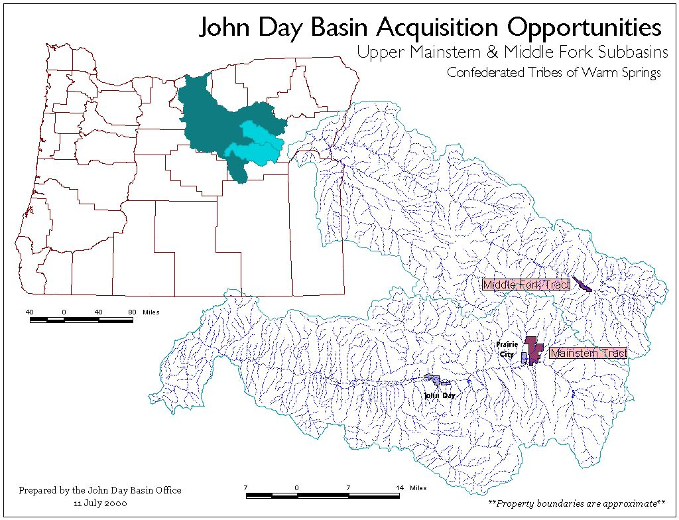
The Middle Fork tract has been the highest priority restoration project in the John Day basin since 1971 and contains the highest density of spawning spring chinook salmon in the entire basin and critical spawning habitat for summer steelhead, a federally listed species. The John Day tract represents over 1.5 miles of mainstem habitat, one of the last remaining “gaps” in the riparian fencing program above Prairie City, and currently is the downstream distribution of any significant spawning and rearing for spring Chinook and summer steelhead. Due to historic degradation of rearing area, both parcels remain critical limiting factors for anadromous fish production.
Figure 1. John Day Basin Map

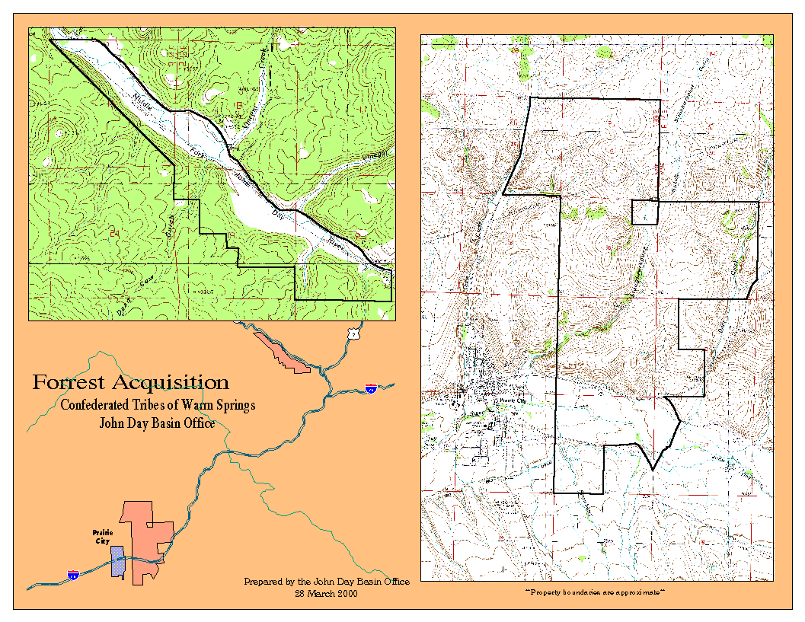
Figure 2. Property Location Map. Middle Fork tract is on left, mainstem tract on right.
b. Technical and/or scientific background

The Forrest Ranch contains some of the highest value habitat for spawning anadromous fish in the John Day basin. However, degraded stream conditions have dramatically reduced the productivity of habitats, primarily with regards to rearing habitats. Species at risk within the basin, which reside for all or part of their life history on the property, include spring chinook salmon (ChS), summer steelhead trout (StS), bull trout (BuT), Pacific Lamprey (Lam), Redband Trout (Rb), and Westslope Cutthroat Trout (WCt; mainstem tract only). Limitations to existing production for these species are discussed below at Risks Addressed. Table 1 and Table 3, below, list the distribution of fish species on the property and the miles of available habitat. Both steelhead and bull trout are listed species under the Federal Endangered Species Act.

The risks to these species from failing to acquire the property are extremely high given that:
- the property ranks the highest in the entire John Day Basin from the standpoint of current productivity and recovery potential,
- the property is available to other, non-conservation buyers, and
- the landowner has rejected all other long-term conservation alternatives—excepting sale of the ranch.
Stream | Miles | Species | Use
Middle Fork | 3.43 | ChS, StS  BuT  Rb | migration, spawning & rearing  isolated sightings  spawning & rearing
Unnamed creek | .23 | unknown
Dead Cow Gulch | .38 | unknown | likely ChS and StS rearing
Vincent Cr | .13 | ChS  StS, Rb | rearing  spawning & rearing
Vinegar Cr | .10 | ChS  StS, Rb  BuT | rearing  spawning & rearing  historic
Davis Cr | 1.42 | ChS  StS, Rb  BuT | rearing  spawning & rearing  historic
Placer Gulch | .28 | unknown
TOTAL | 5.97
Table 1. Fish Distribution and Miles of Available Habitat on the Middle Fork Tract of the Forrest Ranch
Middle Fork Tract: The Middle Fork parcel contains the single highest density of spawning ChS in the entire John Day basin comprising, on average, over 40% of the spawning in the entire Middle Fork subbasin (Figure 3). Although only preliminary estimates have been completed, over 450 adult salmon likely spawned on the Middle Fork tract during the 2000 spawning year. In addition, the five tributaries to the Middle Fork that are currently inventoried for steelhead spawning have some of the highest redd densities of any tributary to the Middle Fork (Table 2, below).

Bull trout in the Middle Fork are limited to three or possibly four metapopulations in the Middle Fork and are considered to be the most vulnerable and at the highest risk of extinction (Knapp et al. 2001). A single population is at the upper reach of the Forrest Ranch in Clear Creek. The nearest downstream population is in Granite Boulder Creek, which enters the Middle Fork on the Warm Springs Tribes’ Oxbow Ranch property. In 2000, a single fish was sampled in Vinegar Creek, which enters the Middle Fork on the Forrest Ranch and adults (probably fluvial) have been sampled on the Forrest property during the winter. Vincent Creek and Davis Creek, which also enter the Middle Fork on the property, are both potential bull trout reintroduction streams (Buchanan et al. 1997). Current distribution of bull trout on the property is limited to times when water temperatures are relatively low (fall, winter, spring) due to degraded habitat conditions.
 | 5-Year Average
Stream | Total Redds | Redds/Mile
Camp | 39 | 8.0
Beaver | 3 | 2.6
Ruby | 5 | 4.7
Granite Boulder | 0 | 0.0
Cougar | 4 | 3.5
Deep | 4 | 2.8
Deerhorn | 17 | 11.3
Lick | 17 | 7.6
Caribou | 3 | 7.4
Placer Gulch | 16 | 4.6
Vincent | 14 | 4.7
Vinegar | 6 | 5.2
Clear | 30 | 14.6
John Day River, Middle Fork | 21 | 6.5
Grand Total | 16 | 5.6
Table 2. Steelhead Redd Densities on the Middle Fork John Day and Selected Tributaries. Streams which flow through the property are highlighted in gray.

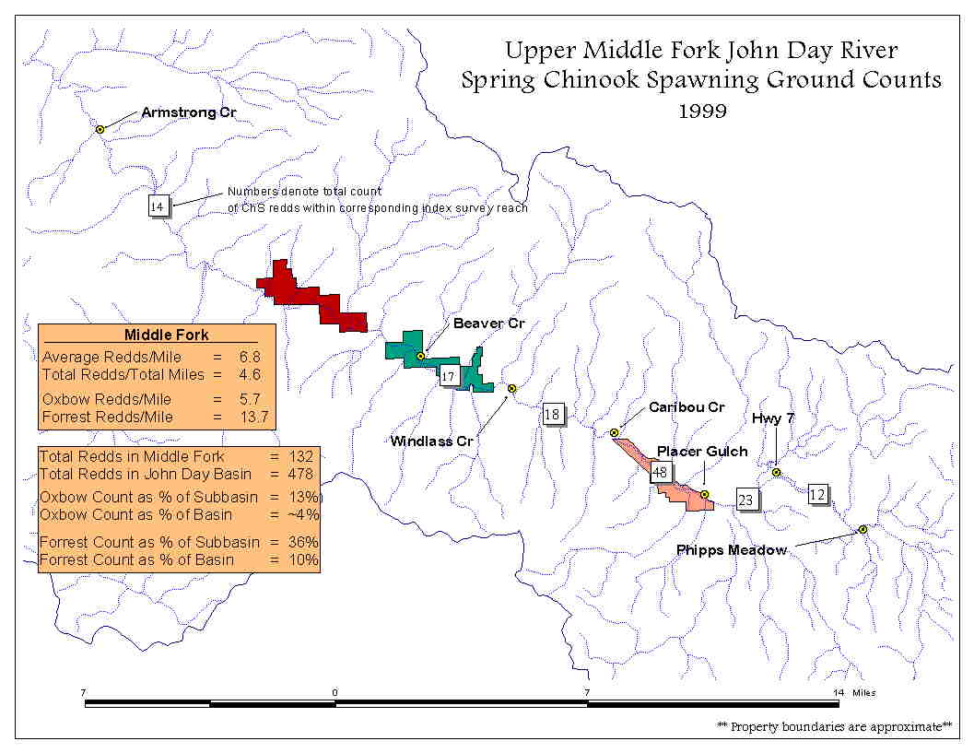
Other than the extremely high spawning densities, this property is similar to other mainstem reaches in terms of the habitat it provides for various life history stages. Although spawning at different times of the year, both steelhead and Chinook juveniles emerge following high water in the spring. Juveniles appear to predominantly stay near spawning areas following emergence, although some have been sampled far below known spawning distribution. As water temperatures begin rising in the summer, juveniles typically move upstream in the mainstem and into tributaries to escape poor rearing conditions. In the fall, after water temperatures have dropped, juveniles outmigrate to mainstem reaches where they overwinter prior to smoltification and outmigration in the spring.
Figure 3. Spawning ground count summary for the Middle Fork John Day River (1999)
Although spawning habitat conditions on the Middle Fork tract are excellent (primarily a function of gravel quality and water depth and velocity), juvenile rearing densities are severely limited by high summer water temperatures (Lindsay et. al. 1985). One factor that influences these temperatures is the complete lack of riparian shading vegetation (Photo 3). Tributary habitats, originating from one of two protected areas on the Malheur National Forest (Figure 6), are generally in good condition above the property boundary. However, these tributaries almost completely lack any riparian vegetation and structural habitat as they move onto the private land (Photo 3).

Sometime in the early 1940’s, the Middle Fork parcel was cleared of all overstory riparian and floodplain vegetation (Photo 2), however, the stream channel was never straightened or channelized (excepting two minor reaches) (S.Robertson pers. comm. with Orrin Forrest, 1989). In addition, the wetlands and sloughs on the floodplain were annually filled with waste wood materials from the nearby Bates mill (S.Robertson, pers. comm. with J. Forrest, 1999).

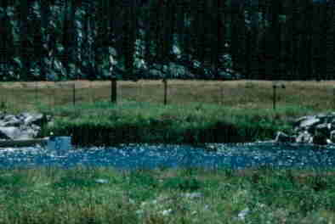
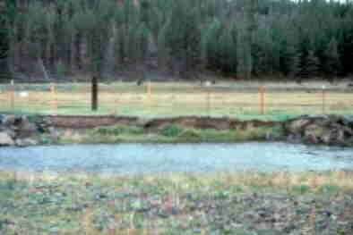
From 1977 until 1985, approximately 1.0 miles of corridor fence was in place on this ranch to exclude grazing of riparian areas. Analysis of photopoints taken annually within and outside of the excluded area display a marked improvement in riparian vegetation, bank stability, and a narrowing of the wetted channel width within the enclosure (in some places to less than one-half of the pre-fence channel width). In addition, spawning densities doubled within the area excluded from grazing during this seven-year period (S.Robertson 1999, pers. comm. with E. Claire, 30 year district fish biologist in John Day).
Photo 1. Photopoint taken in 1977 soon after a corridor fence was installed on a portion of the Middle Fork.
Photo 2. The same site in 1981 showing dramatic improvement in bank and point bar vegetation.
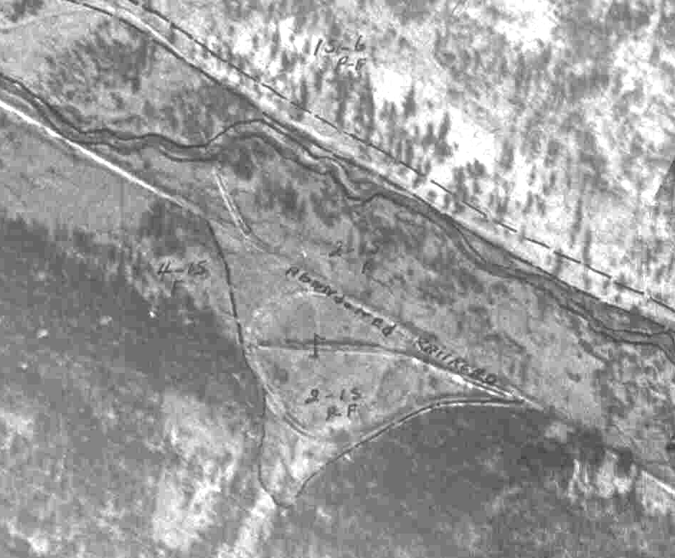
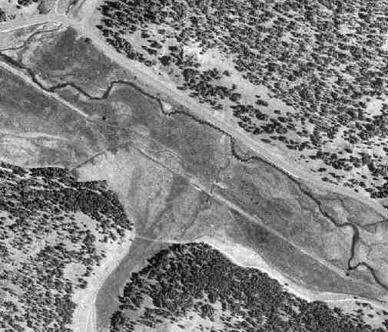
Photo 3. 1939 Aerial Photo of the Middle Fork at the Confluence with Placer Gulch. The dark patches along the river are likely to be dense stands of cottonwood, alder, willow, and hawthorne.
Photo 4. 1989 Aerial Photo of the same location as Photo 1. This photo shows the results of complete land clearing, riprapping, and minor channel adjustments.

In the early 1980’s a chemical treatment of the Middle Fork, which included the Forrest property, was conducted to remove all non-desirable fish species. Post-treatment evaluations noted up to a 300% increase in juvenile salmonid survival due to improved rearing conditions (S.Robertson 1998, pers. comm. with E. Claire).

Based on the prior demonstrations of improvements in riparian areas and juvenile salmonid production on the property and the extent of historic riparian vegetation the Tribes assert that the production and restoration potential of this property is probably the highest of any single private parcel in the John Day basin.
Mainstem Tract: The mainstem tract spawns, on average, approximately 10% of the ChS in the mainstem John Day River and is the current downstream extent of any significant spawning and rearing on the mainstem. In contrast, the property upstream (which has had the river corridor excluded from grazing for over ten years) spawns 30 to 40% of the total ChS adults in the mainstem (data on file in the JDBO). Three-quarters of the length of the river corridor was cleared of all riparian vegetation at the same time as the Middle Fork, however, most of the river channel was also dredged and diked in 1965 (Figure 4).
Table 3. Fish Distribution and Miles of Available Habitat on the Mainstem Tract of the Forrest Ranch

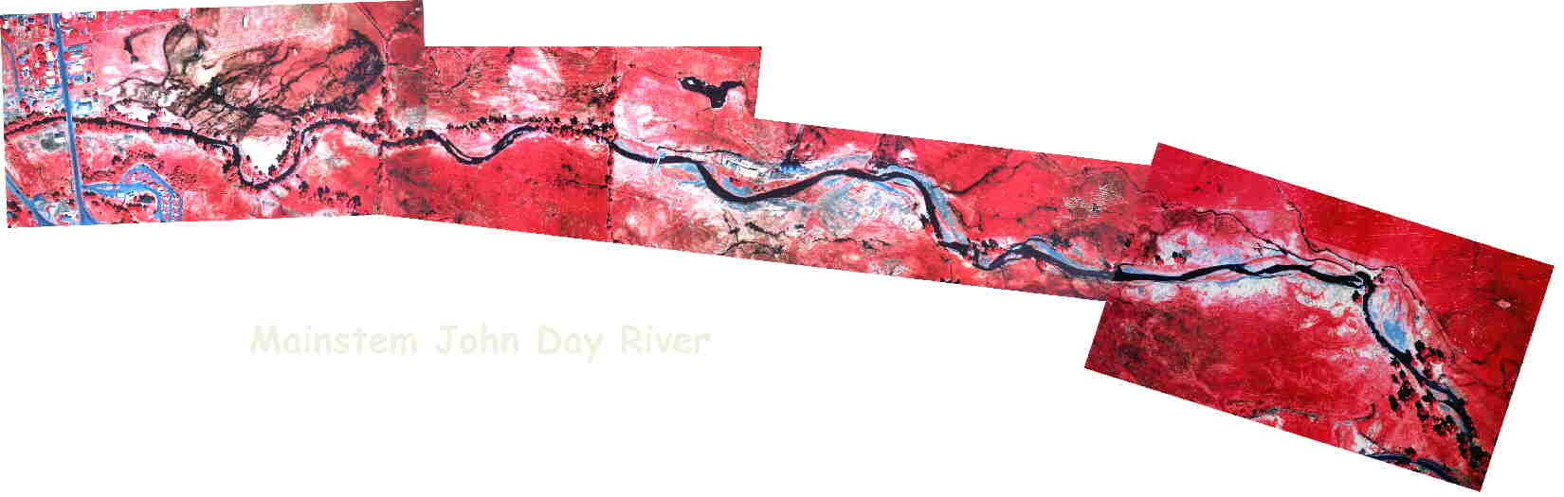
Habitat concerns in this reach are similar to those in the Middle Fork with high summer water temperatures and low stream flows limiting the distribution and production of juveniles. Based on analyses of historic aerial photos and interviews with local, long-time residents, this stretch of the river was likely similar to the upper Middle Fork, with extensive riparian/wetland communities.
lower property boundary
Stream | Miles | Species | Use
John Day River | 1.34 | ChS, StS  BuT  Rb | migration, spawning & rearing  isolated sightings  spawning & rearing
Dixie Cr | .09 | ChS  StS, Rb  BuT | rearing  spawning & rearing  isolated sightings
Slaughterhouse Gulch | 1.8 | Unknown
Strawberry Cr | .66 | StS, Rb | spawning & rearing
Dad’s Cr | .99 | StS, Rb  BuT | spawning & rearing  isolated sightings
unnamed creeks | 1.32 | unknown
TOTAL | 6.2
Figure 4. Infrared Aerial Photograph of Forrest Mainstem Tract
N
Boundary of channelized section
NOTE: Lighter colors represent higher surface temperatures
Due to the current lack of riparian vegetation, water temperatures are at exceedingly high levels throughout this reach. However, the Tribes and agencies believe this river reach to have a high restoration potential for the same reasons as expressed in the Middle Fork discussion. In addition, based on comparison to adjacent, upstream reaches that have been recovered through construction of corridor fences to exclude cattle grazing, the Tribes believe that the likelihood of recovering this reach is extremely high. An improved riparian community may maintain relatively cool water entering the property from the upstream boundary to the lower reaches of the stream. This would not only create habitats on the property that are more conducive to adult spawning and juvenile rearing but also benefit downstream habitats that already have a functioning riparian community.

The availability of suitable spawning gravel is also limited throughout the mainstem reach. This may be due to the historic channelization and existing dike system that creates a lack of hydrologic modifiers within the stream channel. Recovery of channel and streambank hydrologic features is anticipated to address this issue and provide for sorting and maintenance of favorable spawning gravels. A similarly channelized reach upstream has realized considerable gravel recruitment simply from recovery of the riparian area (S. Robertson 2000, pers. comm. with J. Neal, assistant district fish biologist)

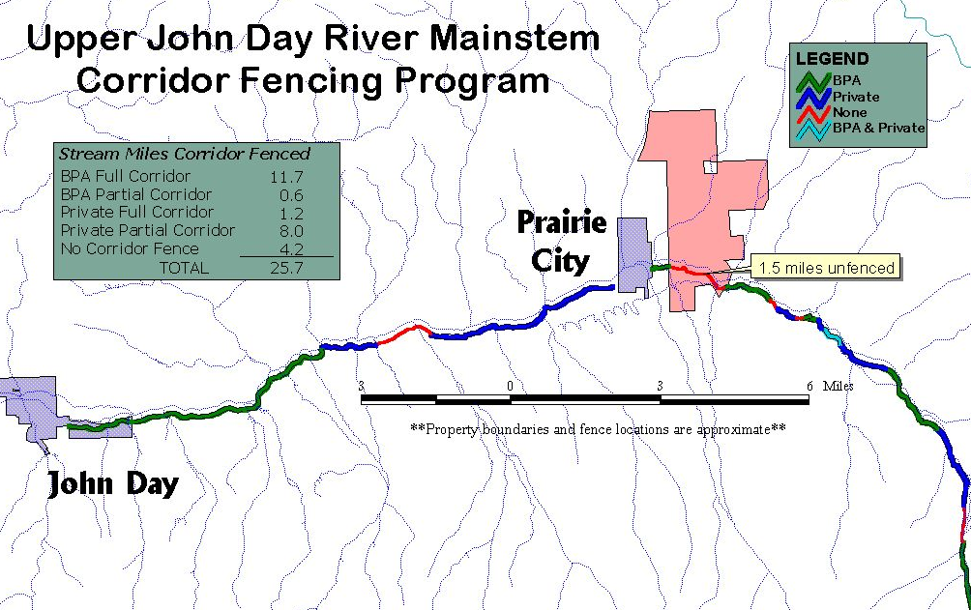
Of the 25.7 miles of mainstem habitat above John Day, 4.2 miles are lacking some form of a corridor fence to control or exclude cattle from riparian areas (Figure 5). The Forrest mainstem tract represents over 1.7 miles of the remaining “gap” and is likely the most important since it is on the extreme downstream boundary of any significant spawning and rearing areas and is the most degraded of all the unfenced reaches.
Figure 5. Riparian corridor fence above John Day, Oregon.

In 2000, the Tribes secured an interim conservation agreement with the landowner to allow temporary exclusion of cattle from the most sensitive habitats and an option to purchase the entire property. Recently, the landowner has been approached by other potential buyers, including one representing developmental interests. This buyer will, in all likelihood, subdivide the property into summer home and recreational ranch type properties. Of particular concern, other than sale of the entire ranch, the landowner has rejected all other long-term conservation alternatives over a 30-year period, including the most recent proposals from the Tribes. The landowner has sold his cattle on shares and will have only minor involvement in the ranch until it is sold. The risks of losing this property and the interim conservation investments are potentially severe as it may mean forgoing all long-term conservation options.

Risks Addressed: The primary risk to be addressed is to remove the property from the open market and place the entire ranch in a permanent conservation status. Our overarching resource concern in the Middle Fork and mainstem has always been high summer water temperatures that limit the distribution and production of juvenile salmonids. To evaluate this concern, the JDBO has conducted annual water quality monitoring, with a focus on water temperatures, on the Middle Fork and mainstem, including the Forrest property. The Tribes also supported the Oregon State University research team in conducting forward-looking infrared radar (FLIR) imaging on both the Middle Fork and mainstem.

Results of this monitoring reinforce our concerns with water temperatures. Seven-day moving averages of daily maximum water temperatures exceed 70ºF throughout much of the summer months and show a general trend towards increasing from upstream to downstream monitoring stations (Table 4). However, this trend is interrupted by significantly cooler tributaries and off-channel springs which enter the mainstem all along its length and provide a cooling effect for the localized stream reach. This cooling effect is apparently negated by the complete lack of riparian vegetation that would serve to maintain those cooler water temperatures along a greater stream reach.
Year | Given Temp  (deg F) | MF2 | MF3
1999 | 50-54 | 0 | 0
1999 | 55-59 | 2 | 4
1999 | 60-64 | 22 | 23
1999 | 65-69 | 19 | 13
1999 | 70-74 | 37 | 40
1999 | 75-79 | 0 | 0
Table 4. Middle Fork Stream Temperature Summary

Monitoring elsewhere in the basin has indicated a correlation between the extent and condition of the riparian corridor and the maintenance or improvement of mainstem stream temperatures (JDBO unpublished data 1994-2000). Recovery of the historic, extensive riparian and wetland features on this property is anticipated to address concerns regarding summer water temperatures both on the property and in downstream, suitable rearing habitats.

The Tribes and others have also identified instream flows during spawning and rearing periods as a factor limiting production (Lindsay et. al. 1985). The Oregon Department of Fish and Wildlife (ODFW) has established a flow target of 47 cfs during adult ChS spawning for the Middle Fork (ODFW 1977). Actual flows are estimated at less than 10 cfs and the flow target is probably never met during the summer rearing and spawning periods. The 8.6 cfs of water rights certificated for the Middle Fork parcel are expected to help meet flow targets through a conversion of some or all of the water rights to dedicated instream flows. The flow target for the mainstem is anticipated to benefit from conversion of all or part of the over 16 cfs of water rights allocated to the mainstem tract. Water rights for both parcels include both tributary and mainstem rights with priority dates extending back to 1868, which are among some of the most senior rights in the basin.

Priority Recognition of the Property: Projects planned and supported by the Tribes have been analyzed and modeled under a comprehensive watershed assessment completed in 1990 by the Bureau of Reclamation (BOR 1990). This assessment as well as the subsequent stream restoration plans for the Middle Fork and mainstem (OWRD 1991, BOR 1992) resulted in the preparation of a restoration strategy, including an acquisition plan, for the basin. Parcels on the upper Middle Fork were recognized as some of the highest priorities for purchase, although they were generally not available at the time that the planning process was initiated.

Since at least 1971, the Forrest Middle Fork tract has been recognized as the highest priority for restoration by the ODFW and following that time by many others (OWRD 1991). The mainstem tract is recognized as a key limiting factor in extending distribution and production downstream from existing critical habitats to currently suitable, but unoccupied, spawning and rearing areas. For almost 30 years, ongoing efforts have been made to secure this property within one of the agency restoration programs, with little or success.

The Northwest Power Planning Council, Bonneville Power Administration, Warm Springs Tribal Council, ODFW, Nature Conservancy, Oregon Water Trust, Oregon State University, Natural Resource Conservation Service, Grant Soil & Water Conservation District, North Fork Watershed Council, and many private landowners recognize this property as the highest priority in the basin for salmon and quite possibly one of the most beneficial acquisitions in the region.

Each of these agencies is familiar with the property from either their independent review of the acquisition proposal, from their attempts to work on the property, or both. These agencies concur with the habitat benefits that have been estimated by the Tribes and ODFW. Further, the Tribes and ODFW have predicted at least a doubling of spawning escapement to the entire Middle Fork subbasin from recovery of the Middle Fork tract. While improvements in the John Day mainstem are difficult at present to quantify, linking upstream critical habitats with downstream suitable, but currently unoccupied habitats is expected to have dramatic improvements in survival and production. Parameter monitoring to further evaluate these predictions is discussed below at Objective 4, Task F (Monitoring).

Permitting and Other Agreements: An appraisal report, timber cruise, Level I hazardous materials assessment, cultural resource survey, plat mapping, preliminary title report, and right of first refusal have either been completed or will be completed by late spring 2001. A preliminary offer and draft sales contract will follow in early summer. Depending upon acceptance of an offer, and barring any extraneous issues related to taxes, estate planning, discovery of hazardous materials, or other similar delays, the fee title transfer could occur as early as September 2001. However, if any issues arise, purchase may not occur until sometime in early 2002.

c. Rationale and significance to Regional Programs

- NPPC Columbia River Basin Fish and Wildlife Program
  - Measure: (7.8G.2) “Provide funding for the acquisition and management of critical water rights for rebuilding and maintaining Columbia River salmon and steelhead populations.”
  - Response: The property contains significant water rights that can be used to meet instream flow targets within some of the most critical spawning and rearing habitats in the John Day basin.

- 2000 FCRPS Biological Opinion: (http://www.nwr.noaa.gov/1hydrop/hydroweb/docs/final/2000biop.html). The BiOp recommends that the upper John Day be treated as a high priority subbasin. While the BiOp listed goals and objectives, which are essentially consistent with the John Day Subbasin Summary, it also specifically identified actions to be undertaken by the three federal “action” agencies. Pertinent actions (RPAs) are listed below, with our response as to how the Oxbow Management and Implementation Project assists BPA and the federal agencies in meeting these actions.

  - Action 149 – BOR shall initiate programs in three priority subbasins (identified in the conceptual Recovery plan) per year over 5 years, in coordination with NMFS, FWS, the states and others, to address all flow, passage, and screening problems in each subbasin over 10 years…Under the NWPPC program, BPA addresses passage, screening, and flow problems, where they are not the responsibility of others. BPA expects to expand on these measures in coordination with the NWPPC process to complement BOA actions described in the action above.

    - One of the three priority subbasins identified in the Conceptual Recovery Plan is the upper John Day. This project addresses passage, screening, and flow issues by acquiring critical water rights, removal of push-up dams and excluding grazing from key riparian corridors (under the interim conservation agreement), and other watershed conservation measures.

  - Action 150 – In subbasins with listed salmon and steelhead, BPA shall fund protection of currently productive non-federal habitat, especially if at risk of being degraded…

    - The property provides spawning and rearing habitat for listed steelhead. Maintenance actions proposed under this project respond to the need to continue protection of critical habitats to prevent further degradation and loss of habitat units.

  - Action 151: BPA shall, in coordination with NMFS, experiment with innovative ways to increase tributary flows by, for example, establishing a water brokerage.

    - The project supports action 151 by converting all or some of the property water rights to instream flows, which enhances tributary flows. Although this may not be the “innovative” approach intended under action 151, we assert that it still supports the requirement to move towards enhanced instream flows.

  - Action 152: The Action Agencies shall coordinate their efforts and support offsite habitat enhancement measures undertaken by other Federal agencies, states, Tribes, and local governments by the following: (See RPA)

    - Ongoing property management is organized by the Tribes, in cooperation with the ODFW and others, to improve offsite habitat conditions. BOR also funds part of the Tribal base program, which supports management activities on the Forrest Ranch.

  - Action 153 – BPA shall…negotiate and fund long-term protection for 100 miles of riparian buffers per year…

    - The Project provides long-term protection for over twelve miles of riparian corridor, which assists BPA with meeting Action 153.

- John Day Subbasin Summary: The overall goal for the subbasin is to “restore the health and function of the ecosystem to ensure continued viability of [its] important populations”.

  - Need to restore, protect, and create riparian, wetland, and floodplain areas within the subbasin and establish connectivity; need to especially restore floodplains in areas degraded by dredge mining.

  - Need to restore and protect riparian habitat and structure, channel function and form, flows, and water quality for primarily bull trout, spring Chinook salmon and summer steelhead; habitat and water quality improvements needed for other resident trout species as well.

  - Need to restore in-stream habitat to natural conditions and protect as much as possible to provide suitable holding, spawning, and raring areas for anadromous and resident fish.

  - Need to protect and restore…cottonwood sites where they currently exist in riparian areas to restore roosting habitat for wintering bald eagles and great blue herons.

  - Need to increase the number of tools associated with irrigation water management, including headgates and flow measuring devices on both private and public lands.

  - Need to determine nature and extent of upland noxious weed invasions.

  - Action: Improve habitat on the Middle Fork John Day River and selected tributaries from Mosquito Creek (RM 39) to Summit Creek (RM 72). Stabilize banks and exchange or purchase land to create natural riparian areas.

  - Strategy: Reduce mining impacts by mitigating for impacts of mine tailings…

Tribal Restoration Plan: The Tribal Restoration Plan (Wy-Kan-Ush-Mi Wa-Kish-Wit,CRITFC 1995) does not recommend specific objectives for the basin, but rather describes benefits from implementing specific actions, while identifying other “needs” in the basin. However, a described benefit, which we view as a numeric objective, is to achieve a run size of 7,000 ChS (1,050 harvest) and run size of 45,000 StS (11,250 harvest) to the John Day basin. These run size objectives are supported by the John Day River subbasin plan (ODFW et. al. 1990), for which the Tribes were a coauthor.

NPPC Subbasin Plan: The John Day subbasin plan (IBID) further identifies habitat protection objectives as:
“Protect existing anadromous fish habitat by preventing further watershed degradation and the resulting changes in water quality, quantity, and instream habitat. Provide optimum habitat for all life history stages of anadromous salmonids.”
In addition, the subbasin plan recommends a strategy, with specific actions, to meet this objective. This strategy includes ‘protecting and preventing further loss of riparian systems, instream habitat, water quality and quantity’ by various methods including the acquisition of land and water rights.

Middle Fork Stream Restoration Plan: The stream restoration plan for the Middle Fork (OWRD 1991), for which the Tribes were a cosponsor, describes general goals and specific objectives and strategies within reaches of the Middle Fork. These objectives include:
  - Increase 80 percent exceedence flows from the present 4 cfs to 35 cfs above Camp Creek.
  - Reduce peak daily summer water temperatures so that they do not exceed 65--68ºF.
  - Increase mean monthly winter temperatures by 2 to 4ºF.
  - Improve quality and quantity of riparian and instream habitat (increase hiding and rearing cover, abundance and diversity of food resources, pool/riffle rations, large wood debris, number of boulders, sinuosity) and improve fish passage.
  - Reduce watershed soil erosion, improve streambank stability and meet or exceed water quality standards for total dissolved solids (500 mg/L).

Specific actions were also recommended under this assessment/plan which include:

- Lease/purchase of water rights on top priority streams – Middle Fork (6 cfs), Vinegar Creek (3.6 cfs)…Placer Gulch, Davis Creek (1.36 cfs) [and] Vincent Creek (2.14 cfs)…
- Corridor fencing, controlled livestock use…on private lands on top priority streams---Middle Fork (20 miles)…Davis (3 miles)…Vincent, Caribou Creeks…
- Purchase up to 17 miles of property on the Middle Fork.

The plan further recommends additional actions, such as riparian plantings and diversion improvements, which are directly applicable to the property, without listing the property specifically.

Mainstem Stream Restoration Plan: The Upper Mainstem Stream Restoration Plan (BOR 1992) recommended similar goals, objectives, and strategies for the mainstem as were established for the Middle Fork. Additional objectives were set such as:

- Increase 80 percent exceedence flows at John Day in August and September from the present 17 cfs in August and 24 cfs in September to 30 cfs.
- …Improve quality and quantity of riparian habitat to achieve 80 percent coverage of lineal length of streams with at least half of the vegetation in excess of 8 feet in height where site potential exists.
- Enhance the local economy…Tribal ceremonial, subsistence, and [the] commercial fishery.

Specific actions were also recommended under this plan that included:

a. Lease and purchase of 1,500 acres of late-season rights above John Day…Focus on…Strawberry Creek.

Creation of Self-Sustaining Habitats: Historic photos (stills and aerials) taken prior to the 1940’s era of land clearing and channelization display a remarkable riparian community, which is assumed to have provided high quality fish and wildlife habitats. Further, interviews with local residents recalling the condition of the river channel and riparian, and salmon densities support the hypotheses that these habitats provided all the conditions for self-sustaining populations of fish and wildlife. Our proposal is to return these reaches to a natural condition or as close to natural condition as possible, which would provide for those habitats to be again self-sustaining in perpetuity.

The Middle Fork, which although cleared along its entire length of riparian trees and shrubs, was never channelized and still provides the highest quality spawning habitat in the entire John Day basin. Almost the entire length of the river property is composed of gentle glide/riffles over appropriately sized gravels. The feature most noticeably absent from this reach, is the complete lack of any riparian shrubs and almost total annual utilization of riparian grasses by cattle (Photo 3). In fact, along over four miles of river, there currently exists less than thirty shrubs or trees over four feet high (estimated).

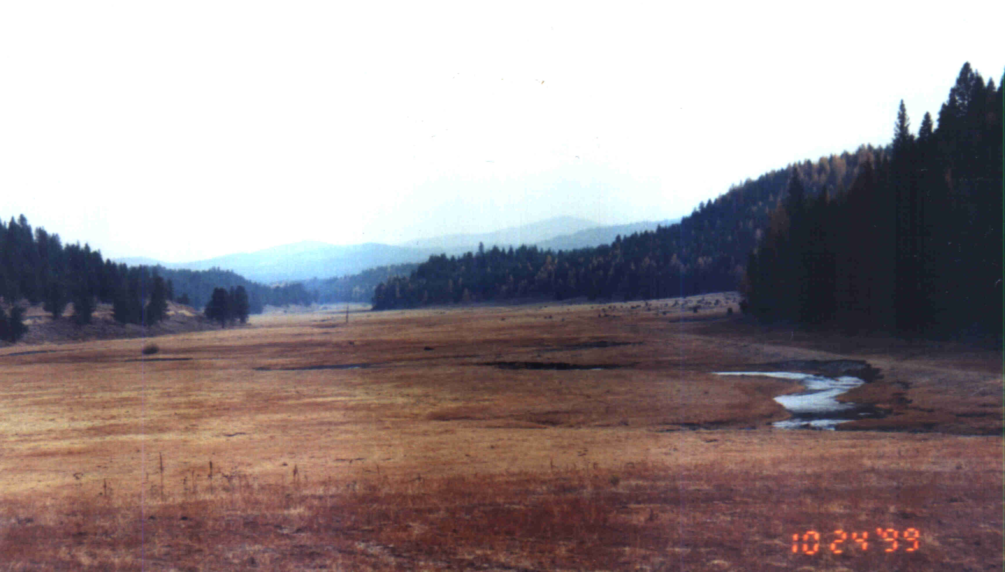
However, even with over six months of current use (May—November) by over 120 cow-calf pairs, the stream banks are in a remarkably intact condition. We assert that this is an indication of:
Photo 5. Middle Fork John Day River, Forrest Ranch
- the current productivity of the near-bank corridor (well-sodded banks); and
- the lack of scouring, destabilizing flows due to the property’s close proximity to the headwaters of the Middle Fork.

Additionally, in the early 1980’s, a short (<1 mile) reach of the river was fenced and excluded from grazing. Photopoints taken annually within this project area display a striking improvement in bank condition, riparian vegetation, and channel structure.

For these reasons, we believe that the restoration potential of this tract is probably the highest of any single private property in the basin and that these habitats can be recovered without any significant additional restoration efforts.

The mainstem tract is somewhat more problematic regarding the ability of restored habitats to be self-sustaining. While historic photographs and resident interviews bear witness to the mainstem being highly conducive to supporting productive fish and wildlife populations, the addition of dredging and diking on the mainstem indicates a potential need for further restoration work (other than simple removal of grazing) to provide conditions of self-sustaining habitats. However, what is encouraging is that recovery of riparian communities on adjacent properties, without any further instream project work, has led to direct improvements in channel condition and gravel recruitment. The result has been the creation of highly productive spawning habitats without drastic channel modification projects.

This proposal is for the acquisition of the property and removal of livestock from riparian areas and other critical habitats only, and does not propose breaching of dikes or creation of in-channel features to restore the river hydrology. It is likely that self-sustaining habitats can be created through implementation of the proposed project only, albeit at a possibly slower rate of recovery, however, we are proposing that additional activities (such as dike breaching) be identified and analyzed through the property management plan to ensure that long-term sustainability can be achieved.

Addressing the immediate risks to existing habitats and species and capturing the highest priority in the basin is not dependent upon self-sustaining habitats being created. However, acquiring the property is a prerequisite to creating self-sustaining habitats on the Forrest ranch.

Survival and Quantitative Biological Objectives: Survival and potential production increases were estimated under the 1985 Spring Chinook Study (Lindsay et. al. 1985) and the watershed restoration plans (BOR 1992 and OWRD 1991). Benefits to the watershed and species survival were also further assessed under modeling completed for the water optimization study and stream restoration plan (BOR 1990 and OWRD 1991). Measurable, quantitative biological objectives related to cfs of streamflow, acres of riparian and upland habitats, miles of stream channel, and production of species have been established. These are detailed and discussed below, under Objectives.

Benefits to ESA Listed Species: Improvements in ChS habitat provide immediate direct benefits to StS and BuT, federally listed threatened species, as rearing habitats generally overlap on both parcels. Restoration of spawning, rearing, and migratory habitats will benefit all species and are measurable in terms of direct benefits to survival at each life history stage. While the focus is on aquatic species, other listed terrestrial species are anticipated to also benefit from improvements in upland and riparian habitats (e.g., maintenance of bald eagle roost sites).

Habitat Expansion: The project benefits multiple species by improving and expanding core, critical habitat areas and by connecting existing high quality habitats. Downstream habitats are generally suitable for spawning and rearing but may be unoccupied or underseeded due to the upstream limitations created by conditions on the property.

Critical spawning and rearing habitats on the mainstem Middle Fork are either owned or managed by the U.S. Forest Service or four private landowners (Figure 6).
Of those habitats, a private landowner owns 1.5 miles involved in the Tribal restoration program, 4.4 miles by The Nature Conservancy, 4.1 miles by the Tribes, 4.0 miles by John Forrest, and 3.2 miles by JoAnn Vidondo. The USFS lands, which are the remainder of the critical mainstem habitats, have not been grazed for 11 years and seem to be recovering from historically poor grazing management. The properties owned by the Nature Conservancy and Tribes are managed for the primary benefit of fish and wildlife.

The Vidondo property, which has the second highest spawning density in the Middle Fork, is immediately upstream of the Forrest property and is adjacent to USFS. While spawning densities are relatively high on the Vidondo reach, rearing densities are low due to the complete lack of riparian vegetation and resultant high water temperatures. The Nature Conservancy has pursued an acquisition of the Vidondo property and the North Fork Watershed Council is conducting a restoration project on part of the same property. The Forrest property connects the USFS habitats above the Vidondo property with USFS, Tribal, and TNC conservation properties below.

Properties below the Forrest Ranch, as well as tributaries above, below, and throughout the parcel, contain core areas for rearing. Restoration of the Forrest property, which is currently rearing habitat limited, would not only connect existing core rearing habitats, but also expand and improve them as well.

Of the 25.7 miles of mainstem habitat above John Day, 4.2 miles are lacking a corridor fence or exclusion from grazing (Figure 5). The Forrest parcel represents over 1.7 miles of the remaining “gap” in the river corridor and is probably the most significant due to its being the downstream limitation of spawning and rearing and its proximity to high quality habitat above and below the property.

303(d) Listed Waterbodies: All mainstem stream reaches and the key tributaries on the property are included on the State of Oregon list of water quality impaired stream. Based on our monitoring activities we estimate improvements in water quality from an overall reduction in temperature, nutrients, and other contaminants and an increase in dissolved oxygen. This would result from the restoration of aquatic habitats and wetland/riparian areas but may not be sufficient to bring the entire stream reach below threshold State values.
Figure 6. Middle Fork landownership.

We anticipate, that through a combination of riparian and wetland restorations, water temperatures should decrease from cool-water tributary and off-channel contributions and the cool water should be maintained through the reach by productive riparian areas.

Monitoring: Project and basin level monitoring programs are conducted by the ODFW and JDBO as part of our ongoing watershed restoration programs and receive support from BPA, BOR, and others. The JDBO commits to an annual monitoring program as part of our annual work plan, carrying out activities in cooperation with the ODFW, OSU, and others. The ODFW and OSU specifically, and others generally, have already committed to assisting with monitoring efforts (including preparation and analysis of a monitoring plan) and with carrying out or continuing their own monitoring. All of this work will be done on a cooperative basis and will be organized towards collecting information which describes baseline conditions, tracks trends in recovery, and evaluates the objectives we have established for interim property management and those that will be developed under the property management plan. Specific tasks related to the monitoring program are described in the proposal Objectives section, below.

d. Relationships to other projects

Ongoing watershed restoration and research programs in the basin are conducted by the ODFW (John Day district office, habitat office, and research program), soil and water conservation districts, watershed councils, Natural Resource Conservation Service, USFS, BLM, and many other agencies, organizations, and landowners. Each of these groups performs various activities based upon their particular funding source, authorities, capabilities, and other similar constraints and available opportunities. The Tribes participated heavily in an effort in the early 1990’s called the John Day Water Optimization study. That comprehensive assessment reviewed many of the watershed restoration programs and activities of the basin agencies, rated those programs as to their benefits, and identified gaps in both agency programs and project efforts. Further, that study recommended a complement of projects and programs, including land acquisition, that would best provide the highest benefit to fish and wildlife in an effective, feasible, and efficient manner.

The base Tribal program (John Day Watershed Restoration, BPA Project No. 199801800) was organized to follow the recommendations of the BOR study and an analysis of ongoing agency efforts. This program focuses on water conservation (irrigation conversions and upgrades), passage improvements, land acquisitions (Acquire Oxbow Ranch, BPA Project No. 200001500), and other similar efforts. Generally, our programs address resource issues with approaches not necessarily considered by other agencies. For example, the ODFW, NRCS, and others have an active riparian fencing program (Protect and Enhance Anadromous Fish Habitat in the John Day Subbasin, BPA Project No. 198402100), while our riparian protection efforts have focused primarily on land leasing, conservation easements, and fee title acquisitions. Rather than duplicate the efforts of other agencies, the Tribes have organized programs to address riparian concerns through other types of projects (e.g., promoting riparian protection through leasing, conservation easements, and fee-title acquisitions). Our programs have been analyzed by the BOR to optimize their success in delivering positive benefits to fish and wildlife, relative to other projects (e.g., Eliminate Gravel Push-up Dams in the Lower North Fork John Day, BPA Project No. 199801700 which is downstream of the project) and programs, while recognizing the realities of available opportunities and structured funding source availabilities.

As discussed above, this project directly complements other agency efforts by addressing some of the remaining limiting factors and gaps in the upper mainstem and Middle Fork. Downstream areas, which have been previously restored or are proposed to be restored through other agency programs, will benefit from the removal of an upstream “bottleneck” to production. Other agency monitoring and research programs currently work on the Forrest property and their access to long-term monitoring sites will be secured (Upstream Migration of Pacific Lampreys in the John Day River: Behavior, Timing, and Habitat Preferences, BPA Project No. 200005200; Monitor Natural Escapement & Productivity of John Day Basin Spring Chinook, BPA Project No. 199801600 and others). Other agency programs will be used on this property (e.g., County weed control and grassland restoration, wetland and continuous conservation reserve) and consequently both the property and their programs will benefit.

e. Project history (for ongoing projects)

This project actually begins in the early 1940’s as the property began being impacted from land clearing, dredging, channelization, and riprapping. As early as the 1970’s it was identified by the ODFW as the top priority in the John Day basin, with a small instream habitat and corridor-fencing project in the mid 1980’s. After the corridor fence was removed in the late 1980’s, many agencies attempted to work with the property owner throughout the decades, with little or no success.

The Tribes approached the landowner in 1999, with the interest in promoting an innovative solution to implementing a large-scale conservation program on the ranch, while ensuring that the lands remain in agricultural production. In late 2000, following lengthy negotiations between the landowner and John Day Basin Office coordinator, the landowner agreed to a short-term lease-option and an interim conservation agreement. The intent of the lease-option was to hold the property until acquisition funds could be secured. The Bureau of Reclamation agreed to fund the lease based upon the property’s obvious importance to anadromous fish.

In early 2001, the JDBO has completed the early phases of implementing the conservation agreement and lease. A full corridor fence is being constructed and four gravel push-up diversions are being replaced. The project has received considerable attention from regional groups and organizations as well as the local and regional media.
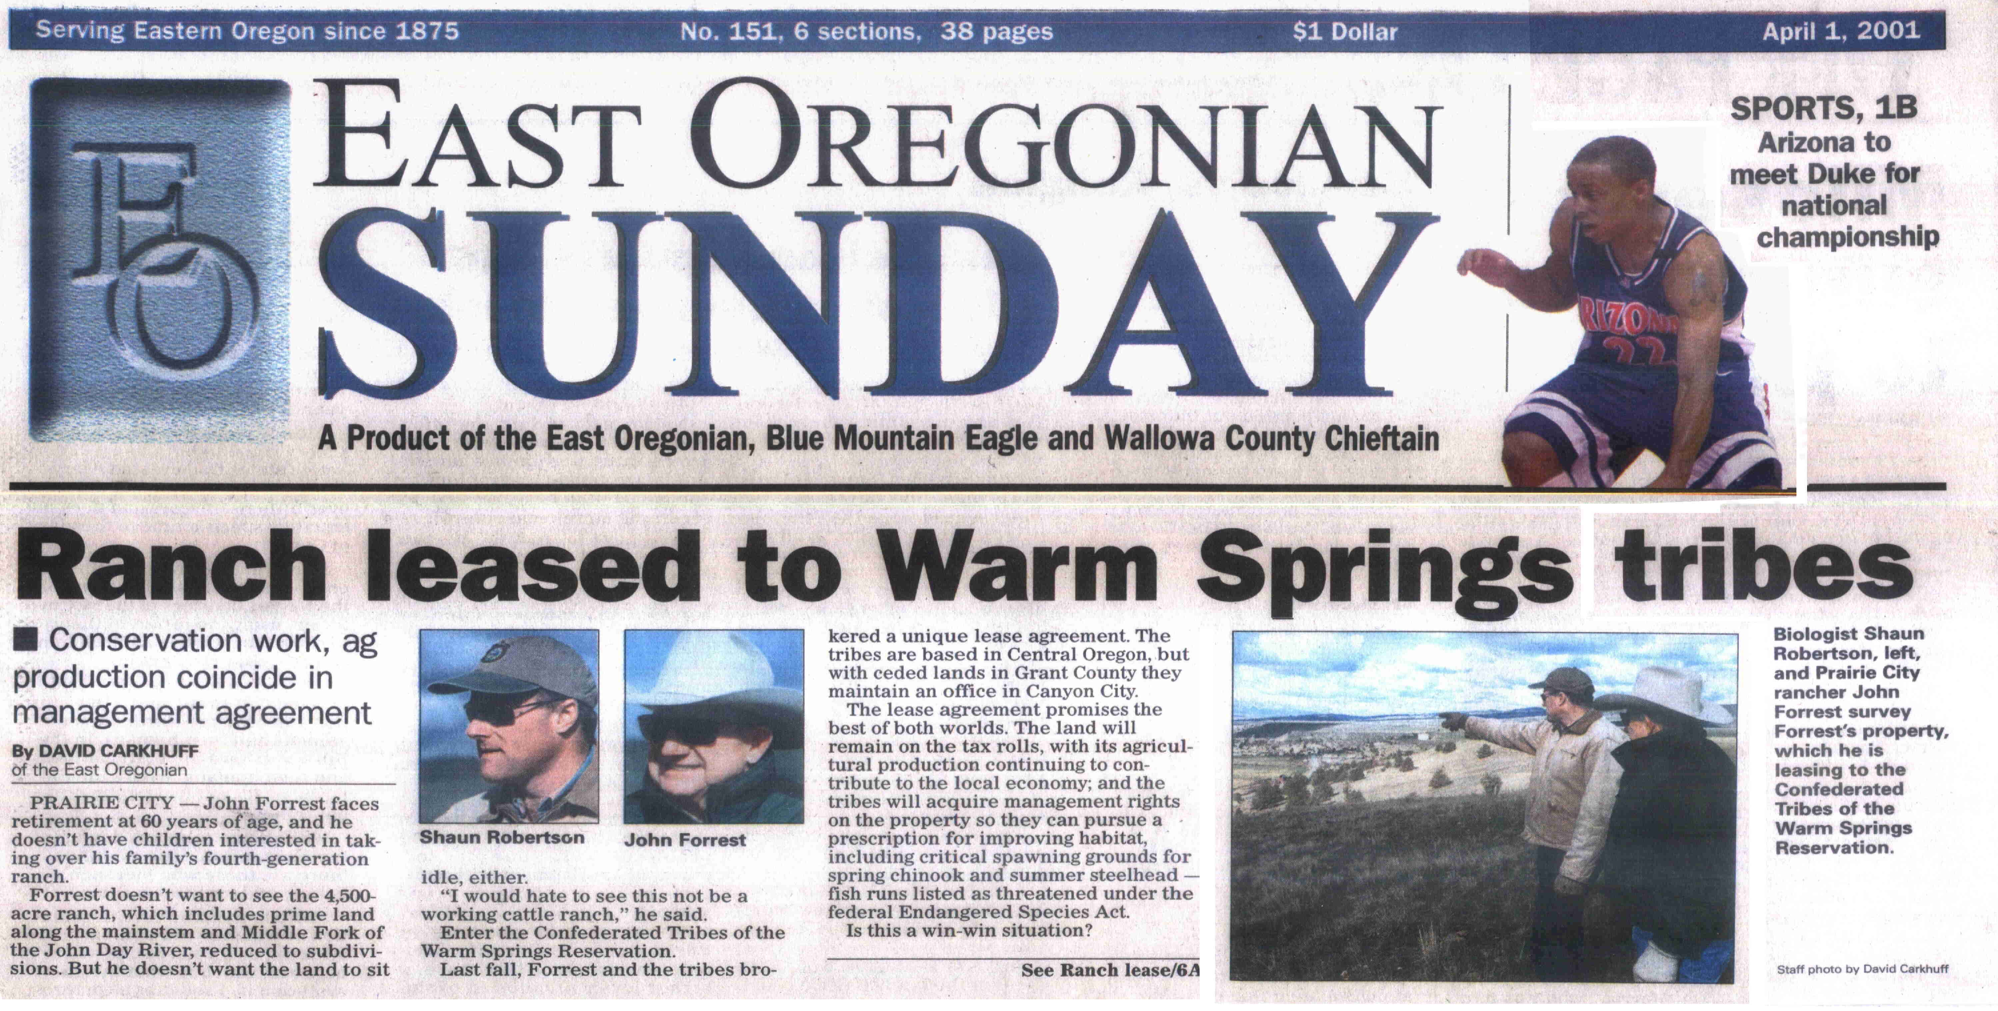
The Tribes submitted the Forrest Acquisition as a high priority project. However, since the provincial review proposals were due prior to a final decision on the high priority projects, this proposal is being submitted to ensure funding of the project if the BPA determines not to fund it as a high priority.

This proposal is being prepared as the current lease is expiring. It is unknown whether the Tribes will have sufficient funds to continue the lease-option for another year.

f. Proposal objectives, tasks and methods

Project Objectives: Following our stated objectives, strategies, and needs as expressed in other plans for the basin, our general desired future condition for the property is:

Provide and maintain self-sustaining habitat conditions that satisfy requirements for native and desirable fish and wildlife populations, given the constraints of the property (if any), while considering the interests of the local community regarding grazing and recreation to the extent possible.

Long-term, we believe that this condition will be satisfied by creating conditions on the land that approximate the “natural” (pre-development) condition of the property as we understand it. Consequently, we desire to provide for conditions on the ground that will serve to maintain a naturally functioning ecosystem within the upstream/downstream constraints of the property and the local community’s interest in continuing management activities. These conditions will be specifically defined during preparation of the property management plan. However, we have identified specific project objectives from our own planning efforts and our cooperation with other agencies on their planning efforts:

Objective 1: Acquire land and water rights on the Middle Fork and the upper mainstem John Day Rivers and implement restoration actions to double the current production of spring chinook in the entire Middle Fork subbasin (16.0 redds/mile within index areas) and improve survival on the mainstem to double spawning escapement (8.5 redds/mile) to-- and rearing densities on --the Forrest property. Accomplish the initial acquisition objective by September 2001 and attain production objectives within 15 years.

Objective 2: Initiate baseline property assessment(s) to characterize the existing condition of the property. This assessment will further define specific property objectives while providing a baseline to evaluate trends in recovery and identify previously unknown issues (if any).

Objective 3: Prepare a property management plan to define long-term resource condition objectives and the methods to achieve those objectives.

Objective 4: Conduct interim management actions and begin implementation of a management plan.

Tasks and Methods

Objective 1: Capital acquisition of 4,295 acres, 25.2 cfs of water rights, equipment, and appurtenances.
Task A: Complete pre-acquisition surveys and compliance documents.

Over two years of planning by the Tribes have gone into this acquisition. Many preliminary documents have been generated which describe the property, resources, and the project as currently proposed. However, some specific, process-related activities must be completed, which generate documents used in the actual acquisition. These include conducting an appraisal, timber cruise, Level I hazardous materials survey, and cultural resource report.

Appraisals are conducted by certified appraisers and follow procedures that conform to the Appraisal Standards found in the Uniform Standards of Professional Appraisal Practice (FR Vol. 55, No. 164, p. 34542, §564.4). The entire property, water rights, improvements, and equipment will be appraised for the highest and best use fair market value.

Timber cruises are conducted by a certified forester to appraise the immediate harvest value of stumpage on the primary use forest lands of the property and are a requirement to complete this appraisal. Valuations follow generally accepted appraisal review methods using survey plots on a grid pattern. Required “leave volumes” are excluded from the valuation.

A Level I hazardous materials assessment is required by the BPA prior to acquisition of any property. This assessment will be conducted consistent with guidelines described in The American Society for Testing and Material Standard for Environmental Site Assessments for Commercial Real Estate (E 1527-94 and E 1528-93).

The BPA also requires a cultural resource overview for each property to be acquired. A review and survey process will be conducted which is consistent with National Environmental Policy Act and National Historic Preservation Act standards, generally accepted survey procedures, and with protocol conducted on previous land acquisition projects funded by the BPA. This protocol is detailed in a proposed Plan of Work, prepared by Tribal Cultural Resource staff, and includes a literature review, field visit, site survey, mapping, and consultation.

These tasks are NOT being proposed under this project and are being funded separately by the Tribes through other sources. They will progress regardless of how this proposal is received, however, they are described here due to their critical nature regarding completion of other acquisition tasks.

Task B: Complete the closing, negotiate a MOA with the BPA, prepare the title report, and complete the fee title transfer.

Following the appraisal and other surveys an offer and sales contract will be negotiated with the landowner. Upon acceptance, various land transaction documents, such as the title report, must be prepared and recorded. In addition, a budget, statement of work, contract, and memorandum of agreement need to be consummated with the BPA. These activities follow generally accepted land transaction procedures and are primarily based upon other land acquisitions that we have successfully completed in the past with the BPA.

Task C: Prepare a NEPA document and complete required consultations with the SHPO, USFWS, and NMFS.

The BPA requires an environmental checklist to be completed prior to approving a contract and statement of work. This exclusion document is completed consistent with standards described in the Watershed Management Program—Final Environmental Impact Statement (DOE/EIS—0265).

As part of this checklist, the Tribes will be required to complete a consultation with the Oregon State Historic Preservation Office, United States Fish and Wildlife Service, and National Marine Fisheries Service. The consultation with SHPO will occur during the cultural resource review and will follow those standards listed above in Task A. Consultations with the USFWS and NMFS will follow standards established for the preparation of biological assessments (USFWS 1998, NMFS 1996) as well as successful consultations completed by the Tribes with these agencies in the past.

Objective 2: Initiate Baseline Property Assessment(s)
Task A: Complete a HEP evaluation.

The BPA requires an assessment of existing resource conditions on each property that it proposes to acquire. In addition, the Tribes and cooperators desire to gather information to assess the baseline condition of the property, to identify additional areas for restoration, and to monitor trends in recovery.

A tool recognized by the BPA and agencies as being appropriate to assess and rank existing condition, is the Habitat Evaluation Procedure developed by the USFWS. Upland habitats will be mapped, inventoried, and assessed according to the preferred habitat conditions of terrestrial species, by a qualified team trained in HEP protocol.

Task B: Complete Hankin and Reeves aquatic survey

The Tribes also desire to inventory and assess existing aquatic habitats for similar purposes to the HEP evaluation. A recognized procedure is the Hankin and Reeves survey method. However, the Tribes and agencies typically modify this evaluation to gather additional information (primarily production and riparian related) that we have found to be more appropriate to our management questions. Both the HEP and Hankin and Reeves survey methodology will be detailed in a solicitation package provided to interested agencies and contractors.

Objective 3: Prepare property management plan

Task A: Conduct additional field assessments to evaluate current conditions and identify restoration and management needs.

The BPA requires, and the Tribes have identified as a need on each of their other properties, management plans, which guide long-term management, short-term restoration projects, and monitoring and evaluation efforts. A precursor to this planning is the gathering of baseline information on various resources that are not covered under the other tasks listed above. Among these, the location of noxious weeds, fence locations and condition, springs and wetland locations and conditions, and other similar basic information will be gathered, mapped on GIS, and included where appropriate in the management plan.

Task B: Complete literature and plan review

A brief literature and management plan search and review will be completed to identify pertinent management policies, strategies, and information that may be useful to the planning process. These documents will be summarized, if appropriate, and included within the plan bibliography and reference materials.

Task C: Prepare draft plan, distribute for review, revise and prepare and distribute final plan.

Property management plans for each of the Tribes’ properties are prepared using an interdisciplinary team composed of individuals with particular areas of expertise from agencies, academia, organizations, and the general public. The plan is drafted by the Tribes, in cooperation with the management team, and widely distributed for comment. Following review and revision, the final document is approved, filed with the BPA, and distributed prior to implementation.

Objective 4: Conduct interim management actions and begin implementation of the management plan
Task A: Regularly patrol and monitor the property

Certain habitats and structures on the property are relatively sensitive to disturbance. In order to discourage vandalism of habitats and structures, the Tribes propose to regularly patrol the property and monitor the extent of these effects.

Task B: Maintain fences

A significant amount of fences currently exist on the property, which are necessary to control livestock and eliminate unauthorized grazing. These fences will require upgrading and maintenance, which will be performed by an on-site manager.

Task C: Construct/reconstruct 5.0 miles of boundary fence

Approximately 5.0 miles of new fence construction and/or reconstruction is required in order to control grazing and eliminate unauthorized grazing from adjacent properties. The Tribes utilize fence construction standards recommended by the ODFW for the protection of wildlife migration.

Task D: Noxious weed inventory and control

Agency experience within the basin on properties where grazing has been excluded shows that an initial response from noxious weeds can be expected. Grant County has an ordinance, and the Tribes and agencies desire, to control weeds on areas that have been excluded from grazing. Many of the locations are known but are still not mapped. Consequently, we propose to inventory noxious weed locations, map using a global positioning device and a geographical information system (ArcView), and begin a control program on some locations using a combination of techniques. Control measures will include mechanical means, such as hand pulling, and spraying with herbicides. All herbicides are applied by a certified applicator and all label directions are followed.

Task E: Initiate spray/reseeding program on 25% of known Medusahead Rye concentrations

The Tribes, landowner, and Grant County Weed District are aware of a known concentration of Medusahead Rye on the upland portion of this property. These uplands are critical big game winter range and provide important habitat and watershed functions. Medusahead is recognized as a serious problem in native bunchgrass habitat types and often reduces production of grasslands to 30% of potential.

The Tribes cooperate with the Grant County Weed District, Natural Resources Conservation Service, Grant Soil and Water Conservation District, and ODFW on a program to restore native bunchgrass rangeland that has been overtaken with Medusahead, to its former productivity. This program involves spraying with an herbicide (burning and removal of grazing has been shown to be ineffective) and reseeding with native or preferred rangeland species. The Tribes propose to include this property in the ongoing, cooperative program. Only 25% of the known concentrations are proposed to be treated in 2001, to allow for big game utilization on remaining non-treated areas.

Task F: Update existing monitoring program and conduct monitoring in cooperation with ODFW, OSU and others.

Many groups and organizations conduct monitoring and research on this property due to its importance to anadromous and resident fish. The Tribes prepare an annual monitoring plan that details our monitoring efforts on our properties, projects, and other areas of interest. We propose to include this property in our 2001 monitoring plan and conduct the appropriate activities in cooperation with the other agencies conducting studies on the property.

The ODFW and Tribes perform annual spawning ground counts on the property for spring chinook (see above at Relationships to Other Projects). The Tribes propose to continue these efforts, and propose to expand the survey efforts by 1) marking redd locations each year using a GPS receiver and 2) evaluating redd scouring on the property using techniques described in the fisheries literature.

The Oregon State University stream team (representatives from the fisheries, range, and forestry departments) has conducted considerable research within the basin and on this property. Inquiries have already been made by the OSU as to the opportunity for conducting additional research. The Tribes have extended an invitation to OSU to discuss potential research projects to be conducted next summer, however, at this point we only have general ideas as to what those studies would include. The specific activities will be included in the Tribes 2001 monitoring plan, which will be prepared in the following months.

The ODFW also conducts evaluations of bull trout and Westslope cutthroat on the property (BPA Project No. 199405400). The Tribes cooperate in these efforts and will continue to do so as the property owner and manager. No changes in scope are proposed at this point.

Task G: Continue riparian plantings

The Tribes currently have a conservation agreement with the landowner that provides for some preliminary activities in anticipation of purchasing the property. One of these is planting native riparian shrubs that have been secured from local materials and grown in a local native plant nursery, funded by the Tribes. The Tribes propose to continue this activity to address the complete lack of riparian shrubs on the Middle Fork and portions of the mainstem.

Objective 5: Pay Other Management Costs
Tasks A-D: Appropriate funds for management costs such as fringe and indirect benefits, travel, materials, supplies, and equipment.

Considerable management overhead and material costs are associated with the acquisition of a property of this nature. The Tribes will be covering most of those management costs through our other programs. In fact, Task C (Objective 1), Tasks A-C (Objective 2), Tasks A-D and F-G (Objective 3), and Tasks A-C (Objective 5) will either be paid for entirely by the Tribes or the majority will be paid for by the Tribes through our other programs in the John Day basin. However, we are requesting that a minor amount of indirect costs, as well as some materials and supplies related to conducting tasks specifically on the property, be provided under this proposal.

g. Facilities and equipment

The Tribes maintain a fully staffed and generally fully equipped office in John Day. The office possesses or has access to all equipment and materials necessary for completing these projects and managing properties. This includes--in addition to professional staff--computers, vehicles, flow meters, GPS units, sampling and survey equipment, and other similar equipment and supplies. In addition, the property has some available equipment necessary for property management such as hydraulic post drivers, flat bed trailers, and hand tools.

The Tribes also manage and maintain a property in close proximity to the Forrest Ranch. We propose to use the on-site manager and some of the equipment and materials to service the subject property.

h. References

The John Day basin has had a long period of evaluation, planning and restoration. Many documents, including comprehensive plans and assessments, have been written by various agencies. Not all of those plans, documents, or reports are cited in this proposal. However, some of the most pertinent plans are referenced below, with a brief summary of objectives, needs, and strategies (in addition to those described in the body of our proposal, above) following the short citation (see also Knapp 2001, Subbasin Summary, pgs 52—56 for a description of watershed assessments and management plan documents).

Reference (include web address if available online) | Submitted w/form (y/n)
Columbia River Intertribal Fish Commission. 1995. Wy-Kan-Ush-Mi Wa-Kish-Wit, Spirit of the Salmon, The Columbia River Anadromous Fish Restoration Plan of the Nez Perce, Umatilla, Warm Springs and Yakama Tribes. Vol. I and II.  “Historically, the John Day River was one of the most significant anadromous fish producing rivers in the Columbia River Basin. The management policy for the John Day Basin is designed to maintain native, wild stocks of salmon and steelhead, and to preserve the genetic diversity of the native salmon and steelhead stocks for maximum habitat use and fish production…Riparian habitat degradation is the most serious habitat problem in the John Day River Basin with approximately 660 degraded stream miles identified.  Recommended Habitat Enhancement Actions:  - Purchase, exchange, lease, or seasonally rent water rights for selected fish habitat during critical low flow periods.  - Increase shade cover to reduce stream temperatures…  - Reduce sediment from agricultural practices…  - Reduce [contaminants] related to agricultural practices.  - Acquire, lease or implement management agreement [sic] to restore natural floodplain habitat and function.” | N
Oregon Department of Fish and Wildlife, Confederated Tribes of the Umatilla Indian Reservation, and Confederated Tribes of the Warm Springs Reservation of Oregon. 1990. John Day River Subbasin Salmon and Steelhead Production Plan.  “The highest priority problems affecting salmon and steelhead in the John Day are directly related to degradation of riparian habitat…Based on information from stream habitat surveys, the John Day spring chinook research study [citation omitted], and the [ODFW] district fish biologist, factors limiting anadromous production are 1) poor quality juvenile rearing habitat and few adult holding areas for spring chinook and 2) juvenile rearing areas for summer steelhead…  Factors affecting fish production are…1) passage barriers, 2) lack of riparian cover (increased water temperatures, changes in timing and rate of peak and minimum flows, decreased bank stability and adverse channel geomorphic changes, decreased abundance and diversity of aquatic organisms and food resources for salmonids, increased sedimentation, and increased winter ice conditions), 3) lack of habitat diversity, and 4) water withdrawals.” | N
Oregon Water Resources Department. 1991. Stream Restoration Program for the Middle Fork Subbasin of the John Day River.  This document promotes acquisition of land and water rights, in combination with other efforts including riparian restoration and irrigation efficiencies, when describing a strategy for the Middle Fork Subbasin. Priority areas include the mainstem Middle Fork above Mosquito Creek, Placer Gulch, Vincent, and Davis Creeks, all of which are on the subject property.  Specific watershed needs identified for the Forrest Ranch included:  “Incised riverbanks. Need to narrow channel and build banks through sediment deposition. Lack of riparian vegetation. Areas of high erosion. Water temperature problems. Limited fish cover.”  and objectives specific to this property were identified as:  “Desire water rights to Caribou Creek…Senior water rights (1983) create problems for junior 1986 Middle Fork water rights. Plant shade trees.” | N
National Marine Fisheries Service. 1996. Making Endangered Species Act Determinations of Effect for Individual or Grouped Actions at the Watershed Scale. | N
U.S. Fish and Wildlife Service. 1998. A Framework to Assist in Making Endangered Species Act Determinations of Effect for Individual or Grouped Actions at the Bull Trout Subpopulation Watershed Scale. | N
Lindsay R.B., W.J. Knox, M.W. Flesher, B.J. Smith, E.A. Olsen, and L.S. Lutz. Study of Wild Spring Chinook Salmon in the John Day River System. 1985 Final Report. BPA-DE-A179-83BP39796. | N
Oregon Department of Fish and Wildlife. 1977. Fish and Wildlife Resources of the John Day Basin, Oregon, and their Water Requirements. Federal Aid to Fish Restoration, Completion Report. P-69-R-7. | N
Bureau of Reclamation. 1990. Upper John Day River Basin Master Water Plan Working Paper. Prepared for the John Day Basin Council. Boise, ID. | N
Bureau of Reclamation. 1992. Stream Restoration Program for the Upper Main Stem of the John Day River. Report prepared for the John Day Basin Council. Boise, ID. | N
Knapp S. et al. 2001. Draft John Day subbasin summary. Document prepared for the Northwest Power Planning Council. | N
Buchanan D.V., M.L. Hanson, and R.M. Hooton. 1997. Status of Oregon’s bull trout. Oregon Dept. of Fish and Wildlife. | N

Section 10 of 10. Key personnel

Shaun W. Robertson. Watershed Restoration Coordinator and manager of the John Day Basin Office. B.S. Oregon State University 1990. Over fifteen years experience working in areas of land management, fish and wildlife biology, habitat restoration, land acquisition, tribal treaty rights protection, and other. Responsible for project development, planning, sales negotiation, interim property management, and management coordination.

Terry Luther. B.S. Wildlife Science, Oregon State University, 1976. Fish, Wildlife, and Parks Manager, Confederated Tribes of the Warm Springs Reservation of Oregon. Currently responsible for the management and supervision of Fisheries, Wildlife, and Parks programs on- and off- the Reservation. This involves the oversight of 18 different programs and contracts included two ceded area offices.

Patty O’Toole. B.S. Zoology, Oregon State University. Fishery Manager, Confederated Tribes of the Warm Springs Reservation of Oregon. Eight years experience in fisheries management, project planning, and implementation (production management and habitat).

Jennifer Stafford – Fish and Wildlife Biologist. Confederated Tribes of Warm Springs, John Day Basin Office. B.S. Environmental Ecology, Grand Canyon University, AZ (1995); M.S. Biology-Ecology, Utah State University (2000). Duties include project planning and design, implementation, monitoring, and data collection, analysis, and report composition. Seven years experience in wildlife risk assessment in agricultural settings.

Wendi Leeper – Administrative assistant and data entry clerk. Confederated Tribes of Warm Springs, John Day Basin Office. Assists with project information dissemination and public relations, data entry, and administration. Experience with Microsoft Access, Excel, Word, Work Publications, and various Internet search engines. Lifelong resident of John Day.

Only five other streams were listed as high priorities for water rights acquisitions. The Nature Conservancy or the Warm Springs Tribes has previously acquired almost all of those other water rights.
The Nature Conservancy has acquired approximately 4.3 miles and the Warm Springs Tribes have acquired approximately 4.1 miles (not including tributaries) of mainstem Middle Fork properties.

