Response to Comments:

Project 25011

Assess Riparian Condition Through Spectrometric Imaging of Riparian Vegetation

Oregon Department of Environmental Quality

Prepared by:

Brian Kasper
Water Quality Analyst
kasper.brian@deq.state.or.us
503-229-5074

June 26, 2001
ISRP Comment: The necessity of using multispectral imaging to establish scientifically defensible TMDLs is unclear. More details should be provided concerning how the data will be used in the model that relates riparian conditions to water quality and anadromous fish.

ODEQ Response:

Salmonids, often referred to as cold water fish, and some amphibians are highly sensitive to temperature. In particular, Chinook salmon (Oncorhynchus tshawytscha) and bull trout (Salvelinus confluentus) are among the most temperature sensitive of the cold water fish species. Oregon’s water temperature standard employs logic that relies on using these indicator species, which are the most sensitive. If temperatures are protective of these indicator species, other species will share in this level of protection.

If stream temperatures become too hot, fish die almost instantaneously due to denaturing of critical enzyme systems in their bodies (Hogan, 1970). The ultimate instantaneous lethal limit occurs in high temperature ranges (upper-90ºF). The mid-70ºF range (mid- to high-20ºC range) can cause death of cold-water fish species during exposure times lasting a few hours to one day. The exact temperature at which a cold water fish succumbs to such a thermal stress depends on the temperature that the fish is acclimated and on particular development life-stages. This cause of mortality, termed the incipient lethal limit, results from breakdown of physiological regulation of vital processes such as respiration and circulation (Heath and Hughes, 1973).

The most common and widespread cause of thermally induced fish mortality is attributed to interactive effects of decreased or lack of metabolic energy for feeding, growth or reproductive behavior, increased exposure to pathogens (viruses, bacteria and fungus), decreased food supply (impaired macroinvertebrate populations) and increased competition from warm water tolerant species. This mode of thermally induced mortality, termed indirect or sub-lethal, is more delayed, and occurs weeks to months after the onset of elevated temperatures (mid-60ºF to low-70ºF). Table 1 summarizes the modes of cold water fish mortality.

- Modes of Thermally Induced Cold Water Fish Mortality
(Brett, 1952; Bell, 1986, Hokanson et al., 1977)

Modes of Thermally Induced Fish Mortality | Temperature Range | Time to  Death
Instantaneous Lethal Limit – Denaturing of bodily enzyme systems | > 90ºF  > 32ºC | Instantaneous
Incipient Lethal Limit – Breakdown of physiological regulation of vital bodily processes, namely: respiration and circulation | 70ºF - 77ºF  21ºC - 25ºC | Hours to Days
Sub-Lethal Limit – Conditions that cause decreased or lack of metabolic energy for feeding, growth or reproductive behavior, encourage increased exposure to pathogens, decreased food supply and increased competition from warm water tolerant species | 64ºF - 74ºF  17.8ºC - 23ºC | Weeks to Months

With a few exceptions, such as in cases where violations are due to natural causes, the State must establish a Total Maximum Daily Load or TMDL for any waterbody designated on the 303 (d) list as violating water quality standards. A TMDL is the total amount of a pollutant (from all sources) that can enter a specific waterbody without violating the water quality standards. TMDLs are designed to protect the most sensitive beneficial uses, such as anadromous fish spawning, rearing, and passage. The Oregon DEQ has developed a methodology for developing TMDLs that utilizes multispectral imaging analysis of riparian vegetation. Following is a brief discussion of the application of such data in stream temperature modeling, TMDL development, and ultimately, anadromous fish protection.
Many water quality models use broad-scale inputs that generalize the results and create a large margin of error. Demands from the United States EPA and subbasin stakeholders have prompted ODEQ to develop high-resolution water quality analytical methods. Longitudinal stream temperature profiles are extremely dynamic and depend heavily upon riparian vegetation conditions. ODEQ has developed a methodology for stream temperature modeling (Heat Source) that uses a 100-foot distance step and requires riparian vegetation classification at a 1:5,000 maximum scale. Multispectral imaging, whether from standard aerial photography or satellite imagery, is the highest resolution riparian vegetation data source available.

Multispectral imaging has an approximate pixel size of one meter, facilitating visual riparian classification down to a single standing tree. Furthermore, various visual bandwidths makes species type (i.e., conifer versus deciduous) identification possible. Listed below are the steps involved with riparian condition assessment and incorporation of that data into the stream temperature model and TMDL:

- Map the stream at 1:5,000 or less.
- Map the riparian features 300 feet transverse from each stream bank at a 1:5,000 scale or smaller, using multispectral imagery and ground level data.
- Use TTools within ArcView to automatically sample the riparian vegetation every 100 feet down the stream.
- Incorporate the riparian vegetation data into the stream temperature model and calibrate it to the existing conditions.
- Use the model to predict stream temperatures under a variety of future potential conditions (i.e., if riparian vegetation were left undisturbed and allowed to grow to its maximum potential condition).
- Use the modeling results to develop the TMDL, which includes Waste Load Allocations for point sources and Load Allocations for non-point sources.
- A Water Quality Management Plan (WQMP) will be developed based upon the TMDL, and designated management agencies and stakeholders will be responsible for meeting the TMDL allocations (i.e., establishing healthy riparian conditions to prevent stream heating and to protect anadromous fish).

Figure 1 illustrates how TTools samples the riparian vegetation mapped from multispectral imaging. Both the longitudinal and transverse heterogeneity of riparian conditions is quantified in the sampling procedure. Figure 2 is a graphical example of the sampled riparian conditions. Dark green is on the left bank, and light green is on the right bank. Riparian vegetation was sampled 120 feet from each bank, at 15-foot intervals. Samples were taken every 100 feet down the stream.

Figure 1. TTools Riparian Sampling Methodology

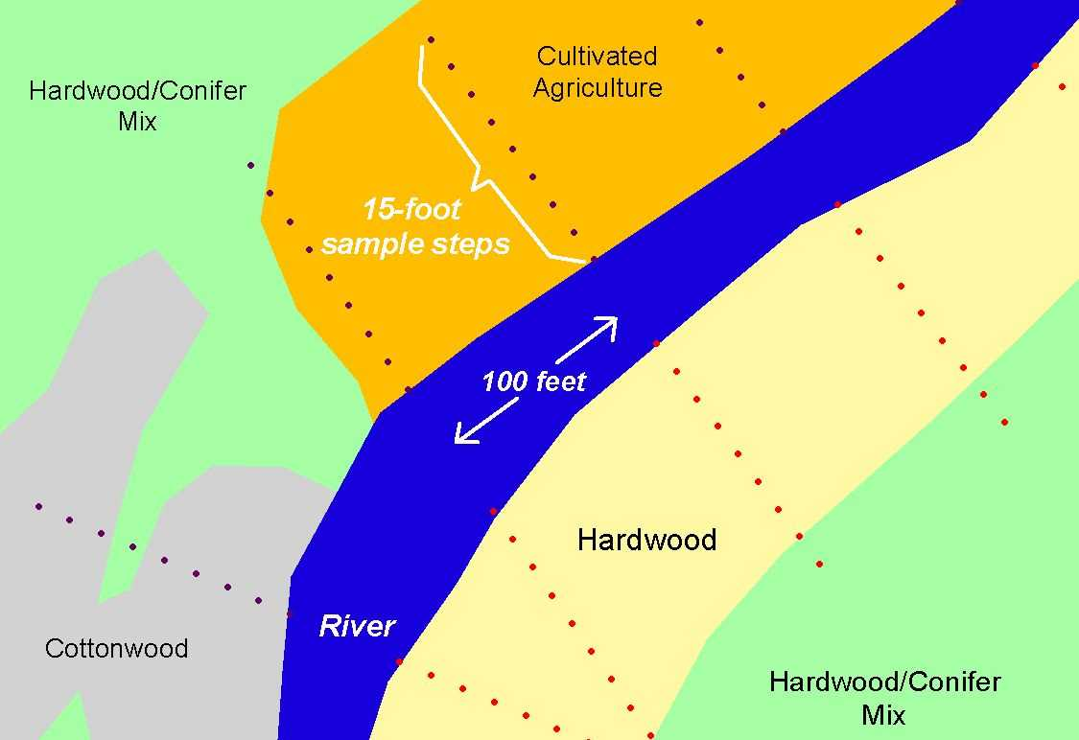

Figure 2. Vegetation Heights Sampled from Multispectral Imaging of Riparian Conditions

The existing riparian conditions data derived from the multispectral imaging is then used as model input. The riparian vegetation data sampled every 100 feet longitudinally, and every 15 feet transversely is applied. Effective shade simulations incorporate riparian geometry, solar positions, and stream channel morphology conditions.

Figure 3 illustrates the longitudinal current condition stream shade (Red) versus the potential stream shade (Blue). As part of the TMDL process, system potential vegetation conditions are determined and modeled in order to examine the magnitude of water quality improvement that is possible.

Figure 3. Existing Effective Shade (Red) versus Potential Effective Shade (Blue).

In addition to simulating effective shade, ODEQ simulates stream temperatures. Temperature modeling incorporates riparian geometry, channel morphology, hydrology, climate, and solar conditions. TMDL allocations are based upon the predicted potential stream temperatures, which are a much more suitable habitat for anadromous fish.

Figure 4 is an example of simulated stream temperatures. Red is the current condition, and blue is the potential condition. Model inputs at a 1:5,000 maximum scale help describe the longitudinal heterogeneity of stream temperature. Such a detailed stream temperature profile enables ODEQ to perform an accurate assessment of pollutant sources. This information can in turn be used by designated management agencies and stakeholders to direct riparian restoration efforts.
Figure 4. Existing Stream Temperatures (Red) Versus Potential Stream Temperatures (Blue)

Ultimately, TMDLs prescribe pollutant load allocations that will prevent a water body from exceeding State water quality standards, and thus protecting anadromous fish species. In the case of stream temperature, pollutant load allocations are translated into a riparian vegetation target (channel morphology and flow targets may also be included within the TMDL). The riparian vegetation target is determined through the stream temperature modeling process, which requires high-resolution data inputs. Multispectral imaging has proven to be the most effective method of assessing current riparian conditions. The stream temperature modeling results allow ODEQ to develop site-specific load allocations that account for landscape heterogeneity, thus maximizing protection of anadromous fish, and ensuring attainment of State water quality standards.
ISRP Comment: Why is the proposed scale the most appropriate for establishing TMDLs?

ODEQ Response:

Classification of Landsat Thematic Mapper (TM) satellite data is one method of riparian vegetation assessment, but the resolution only allows analysis of buffers 90 meters or larger. Such low resolution will not see narrow bands of vegetation along a stream bank, and the classification will not be representative of the heterogeneous riparian vegetation composition.

Geospatial data sets, such as riparian vegetation maps, should be at a 1:5,000 scale or smaller in order for ODEQ to accurately simulate and quantify solar radiation loading patterns. High-resolution riparian vegetation assessment results in very detailed and site-specific source assessment and TMDL load allocations. The ODEQ response to the previous ISRP comment illustrates the longitudinal heterogeneity and site-specific classification of stream shade and stream temperature that results from using 1:5,000 maximum scale data sources.

Figure 5 illustrates the spatial accuracy endowed by using multispectral imaging for riparian mapping. The red line indicates a 1:100,000 stream coverage, while the yellow line indicates a 1:5,000 stream coverage. In some cases, the 1:100,000 stream may be over 200 feet from the actual location. Multispectral imagery not only allows precise stream mapping, but it also facilitates spatially accurate riparian classification. The 1:5,000 stream is used as a reference point for sampling the riparian vegetation data.

Figure 5. Comparison of 1:100,000 and 1:5,000 Scales

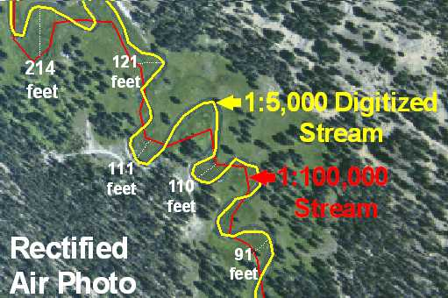

An additional benefit of using multispectral imaging to map riparian vegetation is that it allows ODEQ to predict stream temperatures under a variety of potential scenarios. For example, individual roads can be replaced with vegetation and the effect on stream temperature can be quantified. Another example would be identifying the effects of certain clearcuts on stream temperature.
ISRP Comment: What information transfer is planned?

ODEQ Response:

Water quality modeling results will be published in TMDLs and submitted to the United States EPA for approval. TMDLs will have been developed in conjunction with local subbasin (4th field watershed) management agencies and stakeholders. As a result, the TMDLs will contain water quality modeling scenarios that address the primary concerns of the subbasin stakeholders.

The final product of assessing riparian condition through spectrometric imaging of riparian vegetation will be a georeferenced 1:5,000 scale map, with each polygon coded for riparian species, height, and canopy density. These riparian vegetation maps and associated data will be made publicly available on a 4th field watershed scale, base upon completion of the respective TMDL.

The data will either be made available for download via the internet, or distributed on CD.

ISRP Comment: What is the sensitivity of TMDLs to the margin of error expected within multispectral imaging compared to actual vegetative data?

ODEQ Response:

Riparian assessment through multispectral imaging will rely heavily upon ground level data in order to minimize the margin of error between mapped and actual values. ODEQ has used multispectral imaging to assess riparian condition in TMDLs that have been approved by the EPA. For example, the proposed methodology has been used in the Upper Grande Ronde Subbasin TMDL (ODEQ, 2000) and the Umatilla River Subbasin TMDL (ODEQ, 2001). In both of these efforts, the riparian vegetation assessment was used as input data for high-resolution stream temperature modeling.

One component of stream temperature modeling is to calculate the percent effective shade on the stream surface. This incorporates purely mathematical algorithms based on stream orientation, solar aspect, solar azimuth, riparian geometry, and channel morphology. As part of the ground level data collection effort, a Solar Pathfinder® is used to measure the percent effective shade at the stream surface. These ground-level measurements are then compared to the model-calculated values for quality assurance.

Figure 6 illustrates the validation of effective shade values calculated from the riparian assessment (y-axis) versus the ground level measurements (x-axis). This particular example is from the Sprague and Williamson River subbasins in southern Oregon, where riparian conditions were assessed through multispectral imaging on nearly 400 stream miles. ODEQ simulation was compared to 346 ground level sites, and the standard error was less than 8%.

Figure 6. Simulated and Measured Effective Shade in the Sprague and Williamson Subbasins.

ISRP Comment: What are the implications of this uncertainty in TMDLs for anadromous fish?

ODEQ Response:

Since percent effective shade simulations based upon the riparian vegetation classification is the driving factor for determining stream temperatures, the level of uncertainty has proven to be relatively small in past efforts. In addition, the stream temperature models are calibrated to instream measurements, further validating the riparian classification data.

The overriding intent of TMDLs is to protect the most sensitive beneficial uses of a waterbody. Anadromous fish are typically the most sensitive beneficial use. If a fish is federally listed as threatened or endangered, the Oregon stream temperature standard allows no anthropogenic stream temperature increase. This translates into a load allocation that requires riparian vegetation to be left undisturbed and allowed to grow to its maximum potential height, density, and species composition.

Using multispectral imaging to assess riparian conditions results in high-resolution and spatially accurate effective shade and stream temperature simulations. Subbasin scale stream network modeling for Oregon TMDLs has thus proven to be extremely robust and scientifically defensible. It is believed that such robust water quality modeling efforts result in TMDL Load Allocations and Wasteload Allocations designed to attain maximum aquatic species protection.

One component of the TMDL is a margin of safety. The margin of safety may be implicit or explicit, as described in Table 2. It is the ODEQ’s obligation to incorporate a margin of safety within the analytical techniques in order to attain adequate protection of aquatic species.

- Approaches for Incorporating a Margin of Safety into a TMDL
Type of Margin of Safety | Available Approaches
Explicit | 1. Set numeric targets at more conservative levels than analytical results indicate.  2. Add a safety factor to pollutant loading estimates.  3. Do not allocate a portion of available loading capacity; reserve for MOS.
Implicit | - Conservative assumptions in derivation of numeric targets.  - Conservative assumptions when developing numeric model applications.  - Conservative assumptions when analyzing prospective feasibility of practices and restoration activities.

References

Bell, M.C. 1986. Fisheries handbook of engineering requirements and biological criteria. Fish Passage Development and Evaluation Program, U. S. Army Corps of Engineers, North Pacific Division. Portland, Oregon, 290 pp.

Brett, J.R. 1952. Temperature Tolerance in Young Pacific Salmon, Genus Oncorhynchus. J. Fish. Res. Bd. Can., 9(6):265-323.

Heath A.G. and G.M. Hughes, 1973. Cardiovascular and respiratory changes during heat stress in rainbow trout (Salmo gairneri). J. Exp. Biol., 59:323-338.

Hogan, J.W. 1970. Water temperature as a source of variation in specific activity of brain acetylcholinesterase of bluegills. Bull. Environment. Contam. Toxicol., 5:347-353.

Hokanson, K.E.F., C.F. Kleiner and T.W. Thorslund. 1977. Effects of Constant Temperatures and Diel Temperature Fluctuations on Specific Growth and Mortality Rates and Yield of Juvenile Rainbow Trout, Salmo gairdneri. J. Fish. Res. Bd. Can., 34:639-648.

Oregon Department of Environmental Quality (ODEQ). 2001. Umatilla River Subbasin TMDL.

Oregon Department of Environmental Quality (ODEQ). 2000. Upper Grande Ronde River Subbasin TMDL.

TTools is an ArcView extension developed and maintained by ODEQ that automatically samples a variety of geospatial data sets for water quality modeling and analysis.

