Project ID: 25020

Title: Acquire Rattlesnake Slope Addition

Section 9 of 10. Project description

a. Abstract

The Rocky Mountain Elk Foundation aims to acquire, protect and help enhance the nearly 11,000-acre McWhorter property, also known as the Rattlesnake Slope Addition (RSA), in Benton County, Washington. Acquisition and conveyance of the property to the Washington Department of Fish and Wildlife will protect a significant stretch of the region’s declining shrub-steppe habitat; facilitate more comprehensive management of wildlife habitat in the Yakima Subbasin; link publicly owned wildlife habitats in a region largely made up of private land; and, allow for the protection and expansion of threatened and endangered species populations, particularly sage grouse and pygmy rabbit.

b. Technical and/or scientific background

Prior to settlement in the 1800s, 10.4 million acres of shrub-steppe existed in the Columbia Basin Ecoregion of Washington. More than 60 percent of this habitat has been lost to urban sprawl, agriculture and other changes.¹ The National Biological Division of the U.S. Geological Service has identified native shrub and grassland steppe in Washington as an endangered ecosystem.² A direct relationship exists between the loss of these shrub-steppe habitats and the decline of shrub-steppe-dependent species like the sage grouse and pygmy rabbit. As more and more shrub-steppe habitat disappears, the options for restoring their populations also wane.
Comprised largely of shrub-steppe habitat, the Rattlesnake Slope Addition sits under the shadow of several threats, the most significant of which is urban sprawl. Given the property’s proximity to the Tri-cities (Richland, Pasco and Kennewick), growth will eventually bring subdivision and development. The current landowner is getting older and has concerns about what his heirs may choose to do (or be forced to do because of estate taxes) with the property. Its large size and link to large stretches of public land make it unique at a time when the opportunities to protect such significant contiguous blocks of shrub-steppe habitat are few and far between.
To date livestock grazing has been well managed on the property, however any changes in grazing practices (a distinct possibility with a change in ownership) could also threaten the health of the land’s high-quality bunchgrass communities. Range fires and noxious weeds are the other threats to the health of this land, both of which could be addressed under comprehensive management by the Washington Department of Fish and Wildlife. Last year, a wildfire severely burned the neighboring Arid Lands Ecology Reserve on the Hanford Site, displacing wildlife. The U.S. Fish and Wildlife Service believes that many of those animals will depend on the Rattlesnake Slope Addition for refuge until ALE’s burned habitat recovers (see letter of support from USFWS).
In this region, land ownership patterns also restrict the options for managing wildlife populations. The growing herd of approximately 400 elk that resides mainly on the Hanford Site has caused conflict with neighboring agricultural landowners. The abundance of private land in the area makes managing this herd through harvest and habitat enhancement a challenge. To date, the Washington Department of Fish and Wildlife has been limited to extremely expensive options, like fencing, and trapping and transferring animals.
The combination of high ecological and biological quality and immediate threats to this habitat make the RSA a high-priority acquisition for the Elk Foundation and Washington Department of Fish and Wildlife (see attached letter of support from Director Koenings). The land’s multiple values include its large size, its native plant community, its potential to provide deep-soil shrub-steppe habitat, the presence of a natural spring, and its juxtaposition to other public lands. In addition to the pygmy rabbit and sage grouse, the wildlife that could benefit from this habitat protection and enhancement effort range from mule deer and elk to songbirds and raptors. All of these species face an uncertain future without large blocks of healthy, secure shrub-steppe habitat.

c. Rationale and significance to Regional Programs

The acquisition, protection and enhancement of the Rattlesnake Slope Addition will help meet many of the goals and objectives of the Fish and Wildlife Program overall, as well as those for the Yakima Subbasin. At its broadest level, the property is comprised of one of the Columbia Plateau’s most key, but rapidly declining habitats. The province and subbasin plans both include the general goal to identify, protect and enhance such habitats, including the shrub-steppe type that makes up much of this property.
The location of the Rattlesnake Slope Addition also makes it a top priority. In an area faced with immediate fragmentation threats, the property will link to and expand state and federally managed habitats. On the property’s east border lies the state-managed Sunnyside Wildlife Area. To the north is the Arid Lands Ecology Reserve, part of the Hanford Site, now managed by the U.S. Fish and Wildlife Service. Combined, these three adjacent properties will maintain more than 300,000 acres of habitat for diverse wildlife, and support more comprehensive, collaborative management.
Protecting the Rattlesnake Slope Addition does more than just solidify a contiguous block of shrub-steppe habitat; it also provides key lands for the protection and expansion of several state species of special status. On the neighboring Hanford Site, The Nature Conservancy documented 30 rare plant taxa, 35 bird species of conservation concern, and six mammal species of conservation concern.³ The RSA property itself is home to one state threatened species, eight state species of concern, five federal species of concern, and six state monitored species. For the state of Washington, the RSA’s target species include pygmy rabbit and sage grouse. A state threatened species, the sage grouse has been sighted on the Rattlesnake property, as well as on neighboring state and federal land. A change in management on the Rattlesnake Addition would enhance the property’s ability to support increased sage grouse populations. With as few as 100 individuals left, the pygmy rabbit is a state endangered species in need of protected habitats for recovery. The Washington Department of Fish and Wildlife believes that the Rattlesnake Slope Addition is one of the few places statewide where a successful reintroduction of pygmy rabbits could occur. This is due largely to the fact that the property contains the deep-soil shrub-steppe habitat that the rabbits need and which has in most places been converted to agricultural use. Other species of special status that would benefit from this project include the sage sparrow, sage thrasher, loggerhead shrike, burrowing owl, ferruginous hawk, white-tailed jackrabbit and black-tailed jackrabbit.
In addition to providing for species of special status, this acquisition would facilitate improved elk management and relieve ongoing depredation conflicts with private landowners. Because most lands in this area are privately owned, elk management options have been limited and relatively expensive. Elk harvest has depended on private landowners allowing public access and hunting opportunity. Meanwhile, landowners have claimed hundreds of thousands of dollars annually in crop damages from elk. The current solutions – trapping and moving elk or building a fence along the Hanford Site border – both carry significant cost. Acquisition of the Rattlesnake Slope Addition would allow greater flexibility with elk harvest and management. Habitat enhancements would encourage elk to remain on the Rattlesnake lands and refrain from straying onto private agricultural lands.
Water resources play a key role on the RSA, contributing to the good health of its habitat. Several important springs with riparian vegetation are on the property. The natural springs serve an important function for habitat health in this arid ecosystem and will be actively managed to the greatest benefit of wildlife. Wildlife have also benefited from the property’s agricultural component. Approximately 1,400 of the RSA’s 3,200 acres of farm fields have been enrolled in the federal Conservation Reserve Program and planted back to permanent grass cover.
To support ongoing efforts to conserve the Columbia Ecosystem’s dwindling shrub-steppe habitat, public education and appreciation of this habitat type’s values will also be key. The acquisition of the RSA will facilitate this goal by opening up more lands for public recreation, exposing more people to the habitat and its wildlife, and generating new educational opportunities.

d. Relationships to other projects

9609400 Washington Dept. of Fish and Wildlife Habitat Units Acquisition
Restoration, enhancement, and acquisition of more than 100,000 acres of key wildlife habitat in the Lower Columbia Mainstem, Upper Columbia Mainstem, Lower Mid-Columbia Mainstem, Okanogan River and Yakima River subbasins, including the Sunnyside Wildlife Area adjacent to the Rattlesnake Slope Addition.

9603501 Satus Creek Watershed Restoration Project
A project sponsored by the Yakima Indian Nation, this effort involved the restoration of shrub-steppe habitat in the Yakima River drainage. The management goals complement those for the RSA acquisition.

9803300 Restore Upper Toppenish Creek Watershed
Also sponsored by the Yakima Indian Nation, this project involved the enhancement of shrub-steppe habitat, with similar management goals as those for the RSA.

Rattlesnake Slope Unit Shrub-steppe Restoration
Following wildfire, the Washington Department of Fish and Wildlife used BPA funding to assist with reseeding 1,000 acres of grass and sage on the Rattlesnake Slope Unit of the Sunnyside Wildlife Area.

Wenas WMA Habitat Restoration
The Elk Foundation, BPA and Washington Department of Fish and Wildlife jointly funded this multi-year effort to reseed and restore shrub-steppe habitat for elk and other wildlife on the 90,000-acre Wenas Wildlife Management Area. The WMA itself is funded primarily through BPA mitigation dollars.

McCabe Ranch Habitat Enhancement
Related to the Wenas WMA enhancements, this project involved the eradication of noxious weeds and rehabilitation of 250 acres of native winter range for elk. The project was a cooperative effort of the Elk Foundation, BPA and Washington Department of Fish and Wildlife.

e. Project history (for ongoing projects)

N/A

f. Proposal objectives, tasks and methods

Objective 1: Protect a large stretch of the Columbia Basin’s rapidly diminishing shrub-steppe habitat.

Tasks & Methods:
- Complete fee title acquisition of the 11,000-acre McWhorter property (Rattlesnake Slope Addition) by fall 2001. (The Elk Foundation began discussing this project with the landowner several months ago and has started the purchase process.)
- Convey ownership of property to Washington Department of Fish and Wildlife.
- Incorporate the RSA into the state’s Sunnyside Wildlife Area and include it in the wildlife area’s comprehensive management plan to ensure the habitat’s long-term protection. That plan will address grazing, fire management, noxious weed control, restoration and enhancement of shrub-steppe habitat, long-term monitoring, and public access.

Objective 2: Provide habitat protection and expansion to ensure sustainable populations of state sensitive, threatened and endangered species.

Tasks & Methods:
- Within six months of the acquisition, Washington Department of Fish and Wildlife will develop comprehensive management plan for the RSA and adjacent state lands that addresses the habitat needs of state species of special status.
- Washington Department of Fish and Wildlife will cooperate with the U.S. Fish and Wildlife Service to ensure complementary management practices to meet the needs of species that exist on the neighboring RSA and Hanford Site.
- Washington Department of Fish and Wildlife will determine the need for and implement habitat enhancement projects necessary to provide the habitat required by sensitive, threatened and endangered species.
- As called for by Washington’s state management plan for sage grouse, the department will work to expand sage grouse populations into Management Zone 5, which includes the RSA.
- As stated on the state’s Pygmy Rabbit Recovery Plan, the department will evaluate the RSA as a potential pygmy rabbit reintroduction site, and return the species to the area if deemed feasible.

Objective 3: Address current wildlife management concerns in the Rattlesnake Hills area, while offering improved public recreational opportunities.

Tasks & Methods:
- Address elk management concerns by coordinating with wildlife managers at the Hanford Site. The RMEF and Washington Department of Fish and Wildlife will explore new options made available by the RSA acquisition, including opening the property up to elk harvest and implementing habitat enhancements to keep elk on the RSA and neighboring Sunnyside Wildlife Area.
- To facilitate public education and appreciation of shrub-steppe communities, incorporate public access and recreational opportunities into management plans for the RSA.

Objective 4: Determine the need for and implement habitat enhancement projects to provide the highest quality habitat possible for the diverse species that utilize or could potentially utilize the RSA.

Tasks & Methods:
- The RMEF and Washington Department of Fish and Wildlife will identify and prioritize habitat enhancement needs on the RSA.
- Conduct a species inventory similar to that done on the neighboring Hanford Site.
- All habitat restoration activities will be consistent with shrub-steppe enhancement taking place on the adjacent Hanford Site. (Federal programs like the Conservation Reserve Program, have been successfully used to cost-share shrub-steppe restoration on state lands before, and could be utilized again on the RSA.)
- Through its annual Project Advisory Committee process in Washington, the Elk Foundation will review and fund proposals to implement habitat enhancement projects on the RSA.

g. Facilities and equipment

N/A

h. References

Reference (include web address if available online) | Submitted w/form (y/n)
¹ Dobler, F.C., J. Eby, C. Perry, S. Richardson, and M. Vander Haegan. 1996. Status of Washington’s Shrub-steppe Ecosystem: Extent, ownership, and wildlife/vegetation relationships. Research Report. Washington Dept. of Fish and Wildlife, Olympia. 39 pp.  ² Noss, R.F., E.T. LaRoe III, and J.M. Scott. 1995. Endangered Ecosystems of the United States: A Preliminary Assessment of Loss and Degradation. Biological Report 28. U.S. Department of the Interior, National Biological Service, Washington D.C. 58 pp.  ³ Biodiversity Inventory and Analysis of the Hanford Site. Final Report. The Nature Conservancy of Washington. 1999. | N  N  N

Section 10 of 10. Key personnel

Alan G. Christensen
Vice President of Lands
Rocky Mountain Elk Foundation

EDUCATION
B.S. Wildlife Sciences, Oregon State University
M.S. Wildlife Sciences, Oregon State University

WORK EXPERIENCE
After serving as an officer in the U.S. Navy, Alan launched a diverse career, including state, federal and private nonprofit employment as a wildlife biologist. In 1985, Alan was hired as the Rocky Mountain Elk Foundation’s first field director. In 1988, he returned to the U.S. Forest Service to serve as Northern Region Wildlife Program Leader, where he was responsible for all aspects of the wildlife program in a 25-million-acre region, coordinated the fisheries and wildlife budget, and served on numerous special committees and interagency work groups. Alan also served as acting Forest Supervisor on the Deerlodge National Forest in Butte, Montana. In 1995, Alan rejoined the Elk Foundation staff as director of the Lands Department, moving up to the vice president of Lands a year later.

PROJECT ACCOMPLISHMENTS
In his capacity with the Elk Foundation’s Lands Department, Alan has negotiated and completed a number of complex lands conservation transactions. Those include:
- the 32,500-acre Watershed acquisition near Anaconda, Mont., taking place over several years, in several phases, with multiple partners and multiple funding sources;
- an assembled land exchange with the BLM involving the 18,000-acre Two Crow Ranch in the Missouri Breaks of eastern Montana;
- the 2,400-acre Pope and Dimond acquisitions, involving the purchase of two neighboring ranches, subsequent transfer to the BLM, and substantial modification of grazing management;
- the 2,500-acre Murderer’s Creek project in eastern Oregon, comprised of land trades and conservation easements involving the state and private landowners; and,
- in central California, the nearly 1,000-acre North Fork Cache Creek acquisition and resale to the BLM.

Thom Woodruff
Lands Program Manager
Rocky Mountain Elk Foundation

EDUCATION
B.S. Biology, University of Wisconsin, LaCrosse

WORK EXPERIENCE
After college, Thom worked for the Wisconsin Department of Natural Resources, doing research on the Mississippi River. In 1980 he changed careers with a move to Denver to become a petroleum landman, developing land prospects throughout the Rocky Mountain West and the southeastern United States. He moved to Missoula, Mont., in 1989 to manage a right-of-way project for AT&T. In 1992, Thom joined the Elk Foundation staff as a lands program manager, and has since worked on land acquisitions, exchanges and conservation easements across the United States.

PROJECT ACCOMPLISHMENTS
As a lands program manager for the Elk Foundation, Thom Woodruff has negotiated and completed dozens of land acquisitions and conservation easements in diverse states ranging from Pennsylvania to California. Those projects include:
- the several-thousand-acre, multi-phase Payne Ranch acquisition in central California;
- the 1,800-acre Bordeaux Creek acquisition in Nebraska, comprised of a land donation made through a charitable gift annuity;
- the 4,200-acre New Garden acquisition in the heart of Pennsylvania’s elk country, working in concert with two state agencies;
- the 200-acre Dixie Point acquisition in the Ozarks of Arkansas – a key parcel for the state’s growing elk herd; and,
- the 9,300-acre Mountain Fir project near Oregon’s Mount Hood, involving acquisition, conservation easements, resale and habitat enhancements.

Additional Materials:

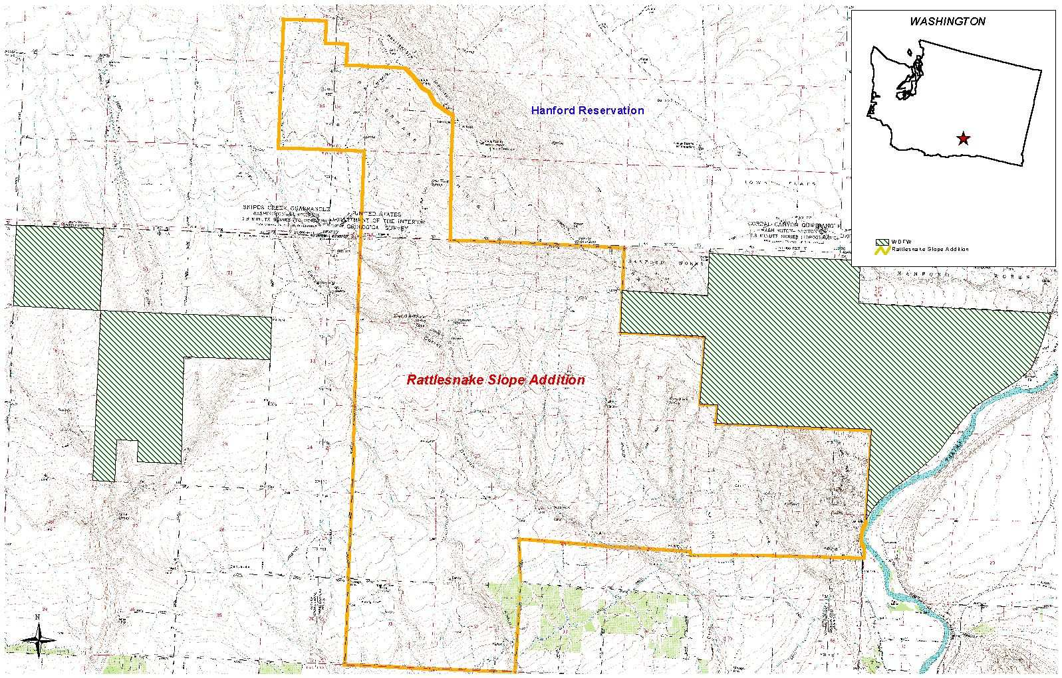

April 11, 2001

Mr. Gary Wolfe
Rocky Mountain Elk Foundation
Post Office Box 8249
Missoula, Montana 59807-8249

Dear Mr. Wolfe:

The Washington Department of Fish and Wildlife (WDFW) is extremely pleased about your decision to submit the purchase of the McWhorter Ranch as a funding proposal to the Bonneville Power Administration. This project in the Yakima Subbasin of the Columbia Plateau Province matches perfectly with our efforts and those of others to protect and restore a functioning shrubsteppe ecosystem in eastern Washington. It has been and still is an acquisition priority for WDFW.

Although we know this acquisition is important for elk, we are very excited about the effect it will have on helping to restore a badly fragmented shrubsteppe ecosystem across the large landscape of eastern Washington. In addition to elk, this project will benefit a myriad of declining species including jackrabbits, sage grouse, pygmy rabbits, sage sparrow, sage thrasher, ferruginous hawk, loggerhead shrike, and many other lesser-known but equally important wildlife that exist only in high quality shrubsteppe habitats.

One thing we have learned from our study of shrubsteppe habitats and wildlife is that the scale at which the habitat functions is much larger than for most habitats. This may be due to the arid conditions under which is exists or the recovery time required when this habitat is destroyed by fire or otherwise converted. In addition to the conversion that has occurred (more than 60 percent of Washington’s original shrubsteppe is gone), the remaining shrubsteppe is fragmented by highways, development, reservoirs, canals, agriculture, and urban developments.

This acquisition proposal is both large (22 sq. mi.) and strategically situated to help reconnect some of eastern Washington’s remaining high quality shrubsteppe. It addresses the two most limiting factors for shrubsteppe habitat in the Columbia Province, size and fragmentation. This acquisition borders portions of the Hanford site that was declared a national monument in July 2000 and connects it with the Rattlesnake unit of WDFW’s Sunnyside Wildlife Area, also a BPA funded wildlife mitigation site.

Mr. Gary Wolf
Page 2
April 11, 2001

The WDFW has always viewed RMEF as an important partner in elk management and wildlife conservation and I compliment you on your decision to pursue funds for the McWhorter Ranch. We are excited about the possibility to help with this acquisition in any way we can and we too will continue to seek funding sources for purchase and operations and maintenance of this important habitat.

Thank you for your efforts on behalf of Washington’s wildlife and please give me a call if you have any questions.

Sincerely,

Jeff P. Koenings, Ph.D.
Director

cc: Jennifer Knox, RMEF
Dave Brittell, WDFW
Jeff Tayer, WDFW

