Project ID: 25075

Title: Monitoring and Evaluation of Buck Hollow Hydrology

Section 9 of 10. Project description

a. Abstract
Active implementation of the Buck Hollow watershed project which began in 1991 will be essentially complete in 2003. Total investment in watershed health improvements stands at $2.8 million and is expected to reach about $3.4 million by the end of active implementation.
An extensive list of observed problems in the watershed was developed during initial planning. Measurable objectives were established and an action plan developed to meet those objectives. One key and overarching goal was to restore Buck Hollow Watershed’s hydrologic function as reflected in its ability to capture, store, and safely release water over an extended period of time. The 10-year, 24-hour precipitation event has been used as a yardstick to model affects of treatment activities. TR-20 modeling predicted that structural practices would reduce peak events by about 25%. Improvements in vegetation and range condition have a potentially greater beneficial effect. Reduction in peak flows should be mirrored by increased base flows later in the season.
This project seeks to establish the monitoring system needed to evaluate the hydrologic function of Buck Hollow Creek and other conservation effects. As the active implementation phase of the Buck Hollow Watershed project nears completion an opportunity arises to measure the results of full watershed treatment.
This project proposes to install a gauging station and environmental data monitoring system, to fully measure the watershed’s hydrologic response to environmental variables. Data will be collected over at least a 5-year period and analyzed. Results will be published.

b. Technical and/or scientific background
Buck Hollow Watershed is a tributary to the Deschutes River, which enters the Deschutes just downstream from Sherar’s Falls. It is one of the five tributaries which provide the majority of spawning and rearing habitat for summer steelhead below Pelton and Round Butte Dams at river mile 100. The Pelton/Round Butte hydroelectric complex eliminated all upstream anadromous fish runs in the upper watershed in the 1960’s. Deschutes River summer steelhead are currently at a moderate to high risk of extinction according to ODFW, and are listed as threatened under the ESA. Below RM100, the Deschutes River summer steelhead population has declined due to harvest, ocean conditions, development and operation of the Columbia River hydro system, unscreened or inadequately screened diversions, low stream flow, water temperature extremes, reduced habitat diversity, sedimentation, and fish passage obstacles.
When project implementation began on the Buck Hollow Watershed in 1991, anadromous fish populations had reached an all time low. Annual summer steelhead production was about 100 returning adults out of an estimated potential of 1600 per year. The root cause for the decline was overgrazing by the sheep and cattle since the late 1800's, which set the watershed up for repeated severe damage from exaggerated runoff events. Land management practices precluded vegetative recovery following the runoff events. When active implementation began in 1991, the watershed exhibited one of the key indicators of degraded watershed health: a hydrologic response curve showing rapid runoff and low late season flows.
Figure 1. Idealized hydrograph comparing a degraded watershed with a recovered watershed.

The Buck Hollow Project set out to address all factors for decline starting in 1991. In 2003, major implementation throughout the watershed will be completed, offering an opportunity to carefully observe the results of a holistic watershed restoration and management effort.

Deschutes Subbasin Limiting Factors
The Deschutes River Subbasin Summary describes the following limiting factors of listed anadromous and native fish and wildlife.
Excessive summer water temperatures. Maximum summer water temperatures in excess of 64 degrees Fahrenheit impair salmon production. Riparian areas on agricultural lands are degraded due to livestock grazing and insufficient buffers maintained between cultivated fields and the stream channel.
Low summer flows. Low summer flows are associated with agricultural and other use and impaired hydrologic behavior of the watersheds. Reduction of riparian vegetation decreases the moisture-holding capability of riparian soils and further diminishes summer base flows.
Lack of habitat diversity. Channelization and lack of large woody debris input from the riparian zone leads to a lack of pools and cover for rearing habitat.
Channel instability. Channel instability has increased sediment loading and channel width while decreasing effective cover and the quantity of pool habitat. Channelization has reduced or eliminated the natural floodplains and channel sinuosity resulting in higher stream velocities, accelerated bank erosion, and down-cutting.
Sediment Loading. Land use activities within the basin have increased sediment deposition to the stream channel. Fine sediment entombs incubating salmon in redds, reduces oxygen flow to eggs, alters the food web, and reduces pool volumes and rearing space for adult and juvenile salmon. Unstable banks add further sediment to the stream. Pools provide thermal refuge, velocity refuge during storm events resting habitat for migrating salmon and important rearing habitat for juvenile salmon. Unstable banks can lead to stream incision that can reduce baseflow contributions from groundwater and increase water temperature. Bank instability can also cause channel widening that can significantly increase seasonal water temperature and reduce large woody debris.
The Oregon Department of Environmental Quality has listed numerous streams in the Deschutes Subbasin for temperature and sediment impairment. Map 1: Deschutes Subbasin 303 d Listed Streams on the next page identifies the location of the streams.

Limiting Factor in Buck Hollow Watershed
Limiting factors in Buck Hollow include degraded riparian zone, wide shallow channels, low base flows, high summer and low winter water temperatures, inadequate riparian vegetation for shading and cover, lack of structure in the stream, lack of pools and pool quality, and stream bank erosion. These factors stem from agricultural practices, range condition and watershed hydrology. Conversion of substantial areas of the watershed to wheat/summer fallow cropping substantially altered the runoff characteristics of the watershed and limited its ability to capture, store, and slowly release water through the dry season. Current runoff events are about seven times historic levels (NRCS TR-20 Model). Conservation plans and grazing management plans to improve the vegetative condition of the uplands and structural methods are being used to reduce peak runoff events and meet the following objectives from the Buck Hollow Watershed Enhancement Plan/EA (Wasco and Sherman SWCDs, 1994a) and Monitoring Plan (1994b) identify the following objectives:
1. Reduce peak flows during 10-year 24-hour storm events by 25 to 50%.
- Increase base flows by .75 cfs with a decrease in dry reaches. USF&WS estimates that up to .71 cfs baseflow can be gained by restoration of riparian zones and raising water tables. OSU studies on juniper water use point to a potential increase of .4 to .6 cfs through juniper control.
- Reduce high summer water temperatures to no higher than 56 F during summer.
- Eliminate barriers to fish passage, through narrowing and deepening of channel and elimination of Rosgen "D" class channels,
- Increase pools to 40% of wetted area.
- Reduce stream bank erosion and sedimentation. Increase bank stability to 80 - 90% stable, maintain less than 15% inorganic sediment covering substrate.
- Restore and enhance riparian sedges, forbs, shrubs, and trees. Observe increases in water surface shading to 60 - 100% June - September, 10 a.m. to 4 p.m.
- Improve upland habitat and control riparian grazing through improvement in range condition and development of off stream water sources.
- Restore stream structure. Observe channel condition improvements, increase in the number and quality of pools.
- Improve land management and resource stewardship. Observe improving condition trends in upland range and in riparian zones related to conservation planning and practice implementation.

c. Rationale and significance to Regional Programs
Buck Hollow Watershed has been the subject of an intensive, integrated watershed restoration project, addressing both upland and riparian land management practices with 100% landowner participation. The project began implementation in 1991 and is expected to complete active implementation in 2003, having spent nearly $3.4 million on upland and riparian restoration and management projects. The opportunity now exists to closely monitor this watershed, and compare its actual behavior to the predictions of the TR-20 models and the objectives of the Buck Hollow Plan. This proposed study will continuously monitor flow at the mouth of Buck Hollow and weather conditions throughout the watershed. Automatic data loggers will be used in order to collect data on a daily or even hourly schedule. Water quality and stream cross-section monitoring will continue at four existing sites, as will annual spawning surveys. Analysis will search for correlations between the watershed’s hydrologic behavior and its productivity. The project will also allow for evaluation of the accuracy of current watershed modeling techniques, in particular TR-20, the modeling program used by NRCS, which formed the basis for many of the assumptions and objectives in the Buck Hollow Project.
This proposed study directly implements the goals of section 9.6.5.3.3 of the reasonable and prudent alternatives (RPA) of the FCRPS Biological Opinion (NMFS 2001, p9-170). The Biological Opinion calls for studies to evaluate changes in environmental factors, and effectiveness of actions (NMFS 2001, p9-161). RPA Action 183 on page 9-170 calls for implementation of detailed studies of the effects of habitat management activities no later than 2003. The proposed study will evaluate the effectiveness of a holistic watershed restoration project in terms of the watershed’s hydrologic behavior, water quality and habitat quality and will observe whether spawning populations responded to changes in overall land management in the entire watershed.
The Northwest Power Planning Council in its 1994 Fish and Wildlife Program emphasizes the need to “learn from the implementation of the program.” (NWPPC 1994, Section 2.2H, p2.5) The NWPPC further states that the purpose for monitoring and evaluation activities is to “ensure that the region systematically improves its knowledge of what measures work, and what measures do not and why.” (NWPPC, 1994 p3-8) Section 3.3D calls for development of a habitat database that includes information on carrying capacities, survival rates and habitat-related human activities( p3-13).
Return to the River (ISG 1996) states that “an integrated ecosystem monitoring and evaluation program with emphasis on suitable habitat is badly needed, in addition to monitoring of fish.” (p442) They go on to state that best management practices must be evaluated for their long-term effectiveness. “Long term comparisons of undisturbed and managed areas (small catchments) are needed to properly evaluate BMPs and should be required of all land management agencies and corporations with salmonid production zones.” (p443) The proposed study will evaluate the behavior of a watershed in which BMPs have been applied throughout the watershed against the predictions of current models. It will provide data as to the long-term response of the watershed to the initiation of BMPs.

Map 1: Deschutes Subbasin 303 d Listed Streams
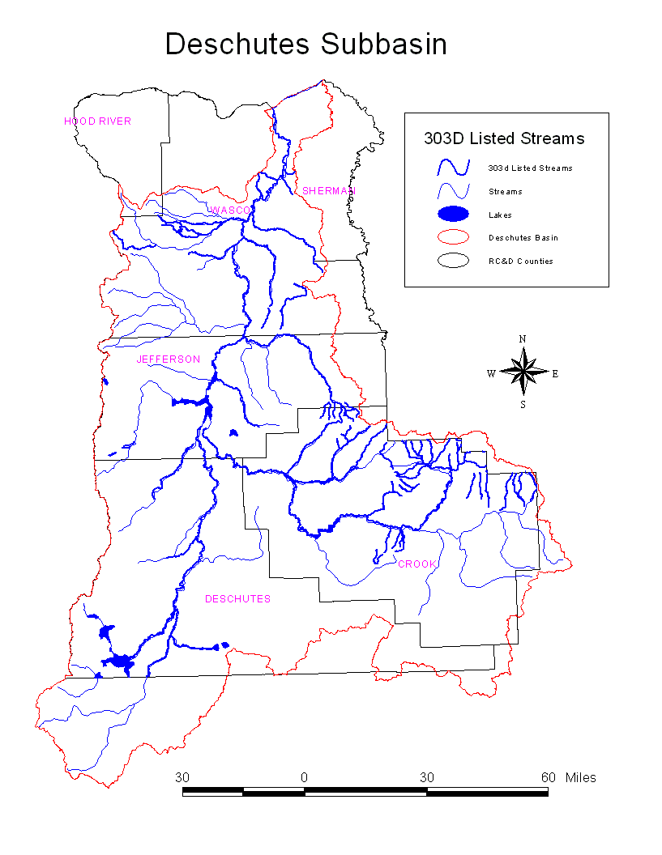
Buck Hollow

d. Relationships to other projects
This project will provide effectiveness monitoring for the Buck Hollow Watershed Enhancement Project (OWEB #90-005, 91-006, 92-030, 93-015, 95-030, 98-171), which implemented best management practices and both passive and active restoration activities throughout the 126,000 acre watershed. Buck Hollow is the first holistic watershed restoration and management project on a watershed of this scale to be completed in the province. It will allow watershed restoration projects throughout the Deschutes Subbasin, and in fact, throughout the Southern Columbia Plateau Province to learn from the results of the Buck Hollow Watershed Project. As such, the proposed study would be an incredible tool for adaptive management.
The project is related to a proposal turned in by Wasco SWCD for emergency flow augmentation in Buck Hollow Creek. That proposal calls for installation of a gauging station at the mouth of Buck Hollow, as well as implementation of periodic water quality and flow measurements in the upper reaches of the watershed. This proposal also calls for installation of a gauging station at the mouth of Buck Hollow. Objectives of both projects could be met by that single action.
Weather stations will be established in Buck Hollow for the purpose of relating weather events to flow events. These weather stations will serve double duty as units of a larger county-wide weather station network called the Environmental Data Network (EDN). EDN is a collaborative project of the Wy’East Resource Conservation and Development Council, OSU Extension, Wasco County, and private agricultural producers from Southern Wasco County. EDN will be closely tied into a similar weather station network funded partially by BPA in the Fifteenmile Subbasin under proposal number 21016: Accelerate the Application of Integrated Fruit Management to Reduce the Risk of Pollution in Fifteenmile Sub-basin Orchards. All three projects will be tied together in a single website, offering detailed weather information to agricultural producers, scientists, and public lands managers.
Water quality and stream morphology data will be collected on private lands by Wasco SWCD, and on public lands by BLM, through ongoing programs. Spawning data will be collected by cooperative arrangement between Wasco SWCD, ODFW and BLM. This collaboration is well established and dates back to the first years of the Buck Hollow Watershed Project.

e. Project history (for ongoing projects)
This proposed study provides for long-term evaluation of a major watershed restoration (OWEB #90-005, 91-006, 92-030, 93-015, 95-030, and 98-171) project initiated in 1990 and terminating in 2003. Buck Hollow Watershed encompasses 126,000 acres in Wasco and Sherman Counties, Oregon. Buck Hollow Watershed originates near the town of Shaniko in Wasco County and flows into the Deschutes River below Sherars Bridge about eight miles downstream from Maupin, Oregon and 43 miles upstream from the Columbia River. The land use is 60% range (76,600 ac), 36% cropland (46,200 ac), and roads and communities make up 4% (4000 ac).
This project is coordinated by Sherman and Wasco County Soil and Water Conservation Districts, in partnership with Oregon Department of Fish and Wildlife, Confederated Tribes of the Warm Springs Reservation, USDA Natural Resources Conservation Service, USDI Bureau of Land Management, Oregon Department of Agriculture Natural Resources Division, 52 landowners in Buck Hollow Watershed, and numerous other organizations including sportsmen's groups, boy scouts, high school and middle school classes, and private companies.

Finance Summary
To date a total of $2,700,000 has been spent to restore fish and wildlife habitat in Buck Hollow Watershed. BPA invested 34 % of the total cost through project number 1993-030-00, USDA cost shared 22%, OWEB 19%, landowners and others 12% and in-kind contributions from all sources 43%. A more detailed accounting is included in Appendix 2.

Project Scope
This project treats the entire Buck Hollow watershed from the top down including both uplands and riparian areas. The project uses multiple funding sources to develop conservation plans and grazing management plans with watershed landowners and put structural and non-structural conservation practices on the ground. An explanation of the NRCS Planning Process and a list of typically prescribed practices is included as an appendix to this document. Bonneville Power Administration funding (#1993-030-00) has been used for riparian and aquatic habitat restoration and enhancement and for those practices that provide direct benefit to the riparian and aquatic habitat.

Project Goals
The Buck Hollow Watershed Plan and Environmental Assessment (NRCS, 1994) and later modifies in the Buck Hollow Watershed Monitoring Plan, 1994; established a goal for late season stream flows at the mouth of 5.0 cfs minimum; water temperature, limit the maximum temperature to 66 degrees; reduce sedimentation, obtain 80-90% stable banks, maintain less than 15 percent inorganic sediment in substrate. Other project goals can be found in Buck Hollow Watershed Monitoring Plan (Wasco SWCD 1994) beginning on page 11 (see also section b, above).

Cumulative Accomplishments Through January 2001
Since 1991 a total of 105,000 watershed acres have conservation practices applied on the ground. NRCS Resource Management Systems have been applied on all private farms and ranches in the watershed. Map 1: Buck Hollow Watershed Project shows the location of conservation practices.

Sediment Basins 152 each
Terraces 137,397 ft.
Grassed waterways 2 acres
Range Improvement Seedings 1,254.9 ac.
Tree plantings >6,350 trees
Fencing 266,362 ft. (50.45 miles)
Juniper & Brush Control 1,240 acres
Spring Developments 13 each
Livestock wells 5 ea.
Solar powered livestock water facility 2 ea.
Pipeline 12,490 ft.
Livestock Trails 12.2 miles
Streambank stabilization 5.2 miles (deflectors & rip-rap)
Rosgen 'D'class stream segments treated 1 for 1.75 acres
Riparian plantings 11.5 miles

Riparian Pastures 13
Riparian Exclosures 2
Wildlife & upland tree plantings 5 acres
Conservation & grazing plans 114,000 acres
Watershed Area Treated ~105,000 acres (through ph 6)

Map 2: Buck Hollow Watershed Accomplishments
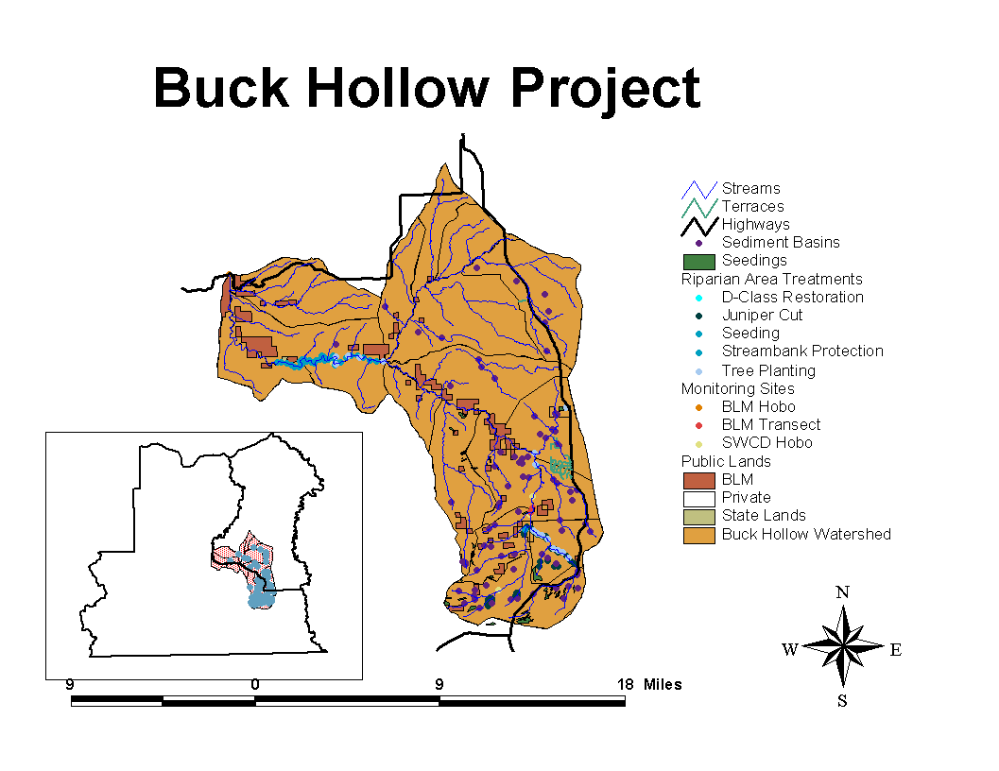

Monitoring & Evaluation Results
Buck Hollow 2000 Watershed Enhancement and Fish Habitat Project Monitoring Plan (Wasco SWCD 1994) outlines the monitoring activities of Wasco SWCD in Buck Hollow. Wasco SWCD annually monitors water quality, stream cross-section and photopoints at ten sites on private lands. Sites are located from the confluence of Buck Hollow and Thorn Hollow down to the mouth of the creek. Water quality parameters include air and water temperature, stream flow, pH, and dissolved oxygen. Not all parameters are taken at all sites. HOBO temperature loggers are located at four sites (see map 2). BLM monitors temperature at several sites on public lands (see map 2). Wasco SWCD also takes annual stream cross sections at several permanent sites
Flow data from the mouth of Buck Hollow (See Table 1., below), is sporadic and insufficient to enable conclusions to be drawn. The same data is displayed by month of year (Figure 2).

Table 1. Buck Hollow Discharge Measurements at mouth.

Date | CFS |  | Date | CFS
22-May-91 | 3.89 |  | 23-Mar-95 | 6.43
17-Jul-91 | 2.36 |  | 11-Jan-96 | 33.54
4-Sep-91 | 0.58 |  | 30-Sep-97 | 6.26
10-Dec-91 | 7.85 |  | 7-Oct-98 | 6.77
12-Feb-92 | 6.54 |  | 26-Aug-99 | 1.87
13-Apr-92 | 4.70 |  | 22-Nov-99 | 10.40
8-Oct-92 | 4.17 |  | 13-Sep-00 | 3.60
2-Nov-92 | 2.14 |  | 30-Oct-00 | 4.34
28-Sep-93 | 1.02 |  | 6-Apr-01 | 9.00
8-Sep-94 | 0.17

Buck Hollow Stream Flow Summary

Kelsey Spring |  |  | Below Livestock Exclosure |  |  | Spears Canyon
DATE | CFS |  | DATE | CFS |  | DATE | CFS
11-Jan-96 | 3.5 |  | 1996 | na |  | 26-Jul-96 | 5 gal/min
1997 | na |  | 4-Sep-97 | 0.3535 cfs |  | 1997 | na
1998 | na |  | 2-Oct-98 | 0.304 cfs |  | 1998 | na
1999 | na |  | 1-Nov-99 | 0.6139 cfs |  | 1999 | na
Bronx Canyon |  |  | Mays Canyon |  |  | Mouth of Buck Hollow
DATE | CFS |  | DATE | CFS |  | DATE | CFS
1-Jul-96 | 1.0 cfs |  | 1996 | na |  | 11-Jan-96 | 33.54 cfs
8-Sep-97 | 2.479 cfs |  | 2-Sep-97 | 3.139 cfs |  | 30-Sep-97 | 6.2555 cfs
2-Oct-98 | 2.316 cfs |  | 6-Oct-98 | 3.804 cfs |  | 7-Oct-98 | 6.77225 cfs
22-Nov-99 | 3.33 cfs |  | 3-Nov-99 | 4.265 cfs |  | 22-Nov-99 | 10.4025 cfs
"D" Class Site |  |  | Finnegan/Buck Hollow Confluence
DATE | CFS
1996 | na |  | Buck Hollow Creek |  |  | Finnegan Creek
3-Sep-97 | 0.3415 cfs |  | DATE | CFS |  | DATE | CFS |  | Total CFS
5-Oct-98 | 0.2753 cfs |  | 2-Jul-96 | 4.0 cfs |  | 2-Jul-96 | 5.0 cfs |  | 9.0 cfs
1-Nov-99 | 0.6745 cfs |  | 2-Sep-97 | 1.889 cfs |  | 2-Sep-97 | 1.702 cfs |  | 3.591 cfs
 |  |  | 6-Oct-98 | 2.3269 cfs |  | 6-Oct-98 | 3.959 cfs |  | 6.2859 cfs
 |  |  | 3-Nov-99 |  |  | 3-Nov-99 |  |  | 3.368 cfs
Figure 2. Buck Hollow Creek Discharge in CFS at Mouth vs. Month of Year.
Steelhead redd counts since 1994 have shown positive trends. The number of redds counted in 1998 was abnormally high due to the large numbers of hatchery strays. Even though 4 miles of Buck Hollow remain to be reported (surveyed April 12), a record-breaking 354 redds have already been counted, and 90% of steelhead identified have been wild fish. Figure 3 below shows available redd count data for the past 40 years.
Figure 3. Buck Hollow Redd Counts 1961-2000 (2001 data off the scale)

f. Proposal objectives, tasks and methods

PLANNING
Objective 1. Perform project planning, coordination and management activities.
Task a. Examine and select site for gauging station and obtain landowner permission.
A1. Coordinate requirements with supporting agencies, such as Water Resources Department and others.
A2. Examine potential for integration of weather station and gauging station with Environmental Data Network (EDN). EDN will provide weather data to private and public land managers and scientists through a county-wide network of weather stations linked to a user-friendly website.
Task b. Solicit bids for equipment and installation.
B1. Prepare bid package and specifications.
B2. Publish solicitation.
B3. Award contract.
Task c. Budget tracking and progress reporting.
IMPLEMENTATION
Objective 2. Install equipment by July 2002.
Task a. Supervise and assist contractor as necessary.
OPERATION AND MAINTENANCE
Objective 3. Operate and maintain installed system.
Task a. Perform periodic maintenance.
MONITORING AND EVALUATION
Objective 4. Continuously collect, display, evaluate and disseminate data.
Task a. Collect data at 10 preexisting monitoring sites.
Task b. Retrieve data from installed system.
Task c. Evaluate data, analyze & compare to modeling predictions.
Task d. Prepare annual monitoring reports with analysis of data to date. Post these reports through StreamNet, Deschutes River Information Database, Bonneville Power Adminstration, and other appropriate venues.

g. Facilities and equipment
Wasco County SWCD has access to a full set of both office and field equipment. The SWCD office boasts a computer network with scanner, color printers, laser printers, plotter, and a shared server with over 80 MB memory. Each technician has a desktop or dockable laptop computer with ArcView GIS 3.1. Including both SWCD and NRCS, there are eight employees with ArcView expertise. The SWCD, NRCS and other USDA agencies share a Geographic Information Systems database that includes soils, elevation, streams, rainfall, watershed boundaries, land use, farm-field boundaries, geo-referenced aerial photos, digitized USGS topographic maps, population statistics, roads, and other factors. In addition, Wasco County shares tax lot layers, complete with ownership, updated every six months. The internet can be accessed by a LAN/WAN connection, allowing high speed access to the Oregon Geospatial Data Clearinghouse, Streamnet, and other information sources.
Wasco SWCD leases a 4WD pickup and owns two all-terrain vehicles, allowing access to remote locations. Field equipment includes modern surveying equipment, laser range-finder, water quality test kits, GPS units and digital cameras.

h. References

Reference (include web address if available online) | Submitted w/form (y/n)
Independent Scientific Group. September 10, 1996. Return to the River: Restoration of Salmonid Fishes in the Columbia River Ecosystem. | n
Natural Resources Conservation Service. November 1994. Buck Hollow Watershed Plan and Environmental Assessment. | n
National Marine Fisheries Service. January 2001. Federal Columbia River Power System Biological Opinion. | n
Nelson, Leslie. 1994. Deschutes River Subbasin Summary DRAFT. March 2, 2001. | n
Northwest Power Planning Council. 1994. Columbia Basin Fish and Wildlife Program. | n
Wasco SWCD. 1994. Buck Hollow Watershed Enhancement & Fish Habitat Project Monitoring Plan. | n

Section 10 of 10. Key personnel

Ron Graves: District Manager: 0.08 FTE
Education: - BS Oceanography, University of Washington 1977
- MS Meteorology and Oceanography,
Naval Postgraduate School Monterey 1982
Employer: Wasco County Soil and Water Conservation District
May 1990 to present
Duties: District Manager with responsibilities for all aspects of District Operations, Administration, and Project Management

Recent United States Navy
Employment
1966-1977 Naval Communications Technician
1977-1990 Naval Surface Warfare Officer
Expertise:
Extensive leadership and management experience in the U.S. Navy combined with operational planning experience. High visibility project management experience at Naval Weapons Center, China Lake as project manager for the NATO Anti-Air Warfare System where the Center was Missile Design Agent. Systems engineering was the watchword for that program, where direction was provided to 21 scientists and engineers at the Center and efforts of 5 other nations and 3 U.S. laboratories were coordinated.
Eleven years experience in planning and implementing full-scale, holistic watershed health improvement projects using a variety of funding sources.
Recent project completions include the phase 7a of 8 Buck Hollow project phases in July 2000; a combined Oregon Dept. of Agriculture Planning and Implementation Grant and DEQ Water Quality (319) grant to implement best management practices to reduce erosion and runoff in the Fifteenmile Watershed completed in June 1997; a bio-engineering demonstration project on lower Fifteenmile Creek using multiple funding sources, completed in November 1997; FEMA funded Hazard Mitigation Project completed Oct. 1999; two Oregon Watershed Enhancement Board grants in Fifteenmile Watershed (one completed in 1999 and one in 2000); and two additional DEQ 319 grants in Fifteenmile Watershed, both completed during 1999; and two Oregon Watershed Enhancement Board grants in Bakeoven Creek Watershed, both completed in 2000.

Ryan Bessette - District Technician 0.10 FTE
Education - BS Rangeland Resources, Oregon State University
with minor in Natural Resources, 1992
Employer: Wasco County Soil and Water Conservation District
November 1996 to present
Duties: District Technician, assigned full time to local
Watershed Projects with responsibilities, in planning, implementation, monitoring, compiling data
Recent United States Forest Service
Employment 4/93 - 11/96 Range Technician Mt. Hood NF
6/92 - 2/93 Range Technician Malheur NF 6/91 - 9/91 Range Technician Mt. Hood NF
Oregon State University
6/90 - 9/90 Research Assistant

Expertise:
Has collected baseline and monitoring data on water quality, flows, and stream geomorphology in Buck Hollow and other watersheds for the past five years. Has experience conducting stream surveys for vegetative cover and stream bank stability. Surveyed mountain streams for fish habitat and livestock impacts. Conducted juniper debris loading operations on various streams. Coordinated several range projects on Mt. Hood NF and Columbia Gorge Scenic Area. Has worked on watershed analysis for White River and Environmental Assessments for various grazing allotments. Supervised and managed cattle grazing activities and monitored vegetative conditions of grazing allotments. Has supervised Youth Conservation Corps and Youth Forest Camp crews in fence construction and provided oversight and inspector duties on fencing contracts and bioengineering contracts. Has supervised AmeriCorps crews in riparian planting and grass seeding activity. Collected data on research plots of various seeded grasses. Plant identification of forbs, grasses, and shrubs. Has supervised construction projects, including riparian fencing, and bioengineering.

Appendix: NRCS Planning Process

The NRCS provides assistance to locally led soil and water conservation districts to plan and implement conservation practices on private land. The conservation plan is voluntary, site-specific, comprehensive and action oriented. A conservation plan contains natural resource information and a record of decisions made by the client. It describes the schedule of operations and activities needed to solve identified natural resource problems and take advantage of opportunities. Using the planning process to develop conservation plans helps ensure that the needs of the client and resources will be met, and that federal, state, and local requirements will be achieved. Conservation plans should include all contiguous and non-contiguous land that is a part of the client's enterprise, including owned and rented land.
The conservation planning process provides the framework for developing conservation plans on the basis of ecological, economic, social and policy considerations. All natural resource problems and opportunities should be addressed during the planning process. They include those identified by the client, those identified through the inventory process, those affected by existing regulatory and program requirements, and based on the desires of the client, those which would help meet natural resource objectives of an area wide conservation plan and assessments.
The NRCS objective in conservation planning is to help the client achieve sound use and management of soil, water, air, plant and animal resources to prevent their degradation, and assure their sustained use and productivity, while considering economic and social needs. Planning to a resource management system level is necessary to meet sustained use of the resources.
A resource management system (RMS) is a combination of conservation practices and resource management, identified by land or water uses, for the treatment of all resource concerns for soil water, air plants, and animals that meets or exceeds the quality criteria in the Field Office Technical Guide (FOTG).

Cropland Resource Management System
These are defined as combinations of conservation practices that target the reduction of water, sediment, and nutrient runoff from cropland.
The primary focus of cropland management in uplands will be soil retention and improvement of the hydrologic condition of cropland. Conservation practices identified below will have significant and positive impact on reducing the high peak flows that have scoured the streambeds in many of the tributaries. Improved hydrologic condition will also result in reduced erosion, sediment and nutrient runoff. Sustained productivity of cropland will be a result of these systems. The NRCS conservation practices to be included under Cropland RMS include:
328 Conservation Cropping Sequence
350 Sediment Basin
344 Crop Residue Use
329 Conservation Tillage
342 Critical Area Planting
586 Field Strip-cropping
324 Chiseling and Subsoiling
327 Conservation Cover
600 Terraces
393 Filter Strips
412 Grassed Waterways
330 Cross-slope Farming
363 Divided Slope

Grazing Resource Management System
Grazing RMS is defined as combinations of practices that target the improvement of the ecological condition of the plant community in those areas of the watershed where livestock graze. This can be subdivided into upland grazing and riparian area grazing. Many landowners manage both types of forage production areas.
The primary focus of grazing systems within the riparian area will be to manage livestock utilization timing and duration to the extent that vegetative recovery will occur. This will have a direct and relatively rapid impact on riparian condition. Incr43ased vegetation within the riparian area will facilitate stream shading and improve the water holding capability of the stream system, which in turn will augment low flows. Improved grazing management within the riparian zone will also have a beneficial impact on streambank erosion.
The focus of grazing systems in the uplands will be to improve the hydrologic condition and productivity of grazed lands. Vegetative improvements in the uplands will have a significant and positive impact to reduce high peak flows that scoured many of the tributaries. Improved grazing management in the uplands of the watershed will also allow systems rest or defer grazing the riparian areas, when upland grazing systems are integrated with riparian grazing systems.
Both riparian and upland grazing systems will promote an increase in forage production and have a positive impact on the incomes of the ranching community. The NRCS conservation practices to be included under Grazing System RMS include:
528 Prescribed Grazing
472 Livestock Exclusion
516 Pipeline
550 Range Planting
642 Well
382 Fencing
314 Brush Management
614 Trough or Tank
574 Spring Development
378 Pond

Riparian Corridor Resource Management System
These practices directly impact the biological and physical structure of the riparian corridor and floodplain. The primary focus of riparian corridor improvements will be recovery of vegetation and streambank stabilization. The primary focus of floodplain management will be to improve the ability of the floodplain to accommodate flood events without sustaining damage.
As part of riparian corridor improvements, landowners will be encouraged to use floodplains for the production of perennial crops, pasture, and trees, to avoid vulnerable fallow fields in flood prone areas. The NRCS conservation practices to be included under the Riparian Corridor Improvements RMS include:
580 Stream Channel Stabilization
584 Streambank and Shoreline Protection
233 Channel Vegetation
612 Tree Planting
644 Wildlife Wetland Habitat Management
391 Riparian Buffer Strip

Implementation of conservation plans may then be facilitated by utilizing technical, educational, and financial assistance programs from NRCS or other sources. Conservation plans are normally developed with an individual decision maker. An areawide conservation plan or assessment reflects the desired future conditions developed in conjunction with the stakeholders in the area.

