Project ID: 25096

Title: Determine Quantitative Values for the Perpetual Timber Rights on the Washington Department of Fish and Wildlife (WDFW) Oak Creek Wildlife Area and Wenas Wildlife Area.

Section 9 of 10. Project description

a. Abstract

This project will establish quantitative values for the Perpetual Timber Rights (PTRs) that Boise Cascade Corp (BCC) owns on certain lands owned by WDFW within the Oak Creek and Wenas Wildlife Area (WA). Contracted professional firms will perform technical quantitative analysis of existing timber volume. They will cruise standing timber on the PTR lands, and on other potential exchange lands that WDFW owns to establish market values. Contracted firms and WDFW staff will complete appraisals to determine values of the PTRs. A Habitat Evaluation Process and wildlife surveys will be completed by WDFW personnel or contract labor on the PTR lands to establish baseline data. WDFW staff will also provide sub-contractor coordination, appraisal summaries, final project report(s), and presentation(s) of findings.

Defining these values is a necessary prerequisite to future negotiations WDFW will undertake with BCC and will allow WDFW, through additional project proposals, to eventually re-acquire these rights by purchase or exchange of comparative value parcels.

The final objective of this project is to return the BCC PTRs to WDFW to manage for improved forest and riparian habitat conditions in the Yakima River sub-basin, as identified in the 2001 Yakima Sub-basin Summary (YSbS) under Goals and Objectives (pg 319-335) (www.cbfwa.org). A subordinate objective is to reduce WDFW management complexity by eliminating BCC objectives from consideration.

b. Technical and/or scientific background

Watershed and riparian habitat degradation is identified as “…one of the most significant factors in the decline of fish and wildlife populations in the Yakima sub-basin”(YSbS pg 362). The YSbS also states that “logging and grazing have altered watershed function” and that a management objective of NMFS, YN, and WDFW is to protect through conservation easements or outright purchase riparian habitats along anadromous and other fish-bearing streams in the Yakima sub-basin (YSbS pg 362).

The original document (Governor’s Quitclaim Deed) conveyed perpetual timber rights on WDFW Oak Creek WA and Wenas WA lands from WDFW to the Cascade Lumber Company (CLC) in 1951. These rights, in addition to a cash settlement, were conveyed by WDFW in exchange for ownership of certain CLC lands adjacent to the Oak Creek
WA. CLC conveyed ownership of their land to WDFW (Yakima County Warranty Deed
1951), but retained perpetual timber rights. Their corporate descendent, the Boise Cascade Corporation (BCC), has continued to aggressively manage the forestlands on the Oak Creek and Wenas WAs for maximum timber production.

BCC has removed most of the harvestable timber from PTR lands in thin shelter woods or clear cuts. This is contrary to WDFW goals for optimum forest habitat conditions. (Oak Creek WA Management Plan 1996, WDFW Priority Habitats and Species (PHS) Recommendations 1991)(www.wa.gov/wdfw/) Logging and road-building activities adjacent to streams and riparian corridors increase sedimentation, resulting in loss of spawning habitat and reduction of aquatic food diversity. This negatively impacts salmonid species such as resident cutthroat and rainbow trout, spring Chinook salmon, and Federally and State listed summer steelhead and bull trout that occur in Oak Creek, the Tieton River, the Naches River and Rattlesnake Creek, all of which flow through lands included in the BCC PTR agreement. Wenas Creek has potential for resident bull trout. (WDFW Salmon and Steelhead Stock Inventory-SASSI 1992) (Washington Salmonid Stock Inventory – Bull Trout Appendix 1998)(www.wa.gov/wdfw/)

BCC logging operations on Oak Creek PTR lands have removed significant wildlife habitats (particularly snags and cavity trees) and nearly all large diameter overstory trees. Habitat degradation for upland species, particularly those dependent on large diameter trees (e.g. white headed woodpecker, flammulated owl, spotted owl, goshawk) is extreme. Based upon current BCC harvest practices that remove all high dollar value, large diameter trees, maintenance and recruitment of these habitat features for wildlife use does not occur (2000 Oak Creek PHS survey, Forest Practice Applications, 1999-2000).

The following listed species are known to occur in the PTR area, or are likely to occur, and could be further impacted by continued BCC timber harvest activities (YSbS pg 43-221).
Species WA State Status Fed Status
- Townsend’s big eared bat C SC
- Northern goshawk C SC
- Flammulated owl C
- Spotted owl E T
- White-headed woodpecker C
- Black-backed woodpecker C
- Pileated woodpecker C
- Olive-sided flycatcher SC
- Willow Flycatcher SC
- Vaux’s swift SC SC
- Cascades frog SC
- Westslope cutthroat trout SC
- Steelhead (middle Columbia) C T
- Bull trout C T
- Lewis’ woodpecker SC
- Western Gray Squirrel T SC
Key: E=Endangered, T=Threatened, C=Candidate, SC=Species of Concern
(WDFW list updated June 21, 2000)(www.wa.gov/wdfw/)

The problem is that BCC, a publicly owned corporation, has as its long-term goal and management objective optimum timber production to maximize bottom-line profits to corporate shareholders. This goal obligates BCC to utilize harvest practices on WDFW PTR lands that are the most economical for timber extraction. This need to maximize economic return can be in conflict with protection of habitat for fish and wildlife values. Objectives such as maintaining vegetative cover to slow runoff, minimizing soil disturbance and erosion, and retaining high-value priority habitats including snags, talus, large woody debris, and riparian corridors, are secondary objectives to BCC timber harvest, even though the land is owned by WDFW. The YSbS identifies shading, slow spring runoff, intact riparian corridors, less fine sediment loading, and the presence of large woody debris as important components for healthy salmonid habitat, and especially critical for bull trout. Bull trout is identified as a high priority management species in the Oak Creek WA Management Plan (1996). As stated in the YSbS on pg. 197, “restoration potential” denotes the improvement in salmon or steelhead populations if environmental conditions in a specific reach were to be fully restored to pristine, normative conditions. Table 32 on pg. 208 shows channel stability and sedimentation as two of the three highest impacts to secondary life stages of spring chinook. Poor forest management contributes to detrimental fish impacts by increasing road densities and resultant sedimentation, removal of large woody components and disruption of riparian corridors, and increasing surface runoff and “flashiness” of the hydrograph.

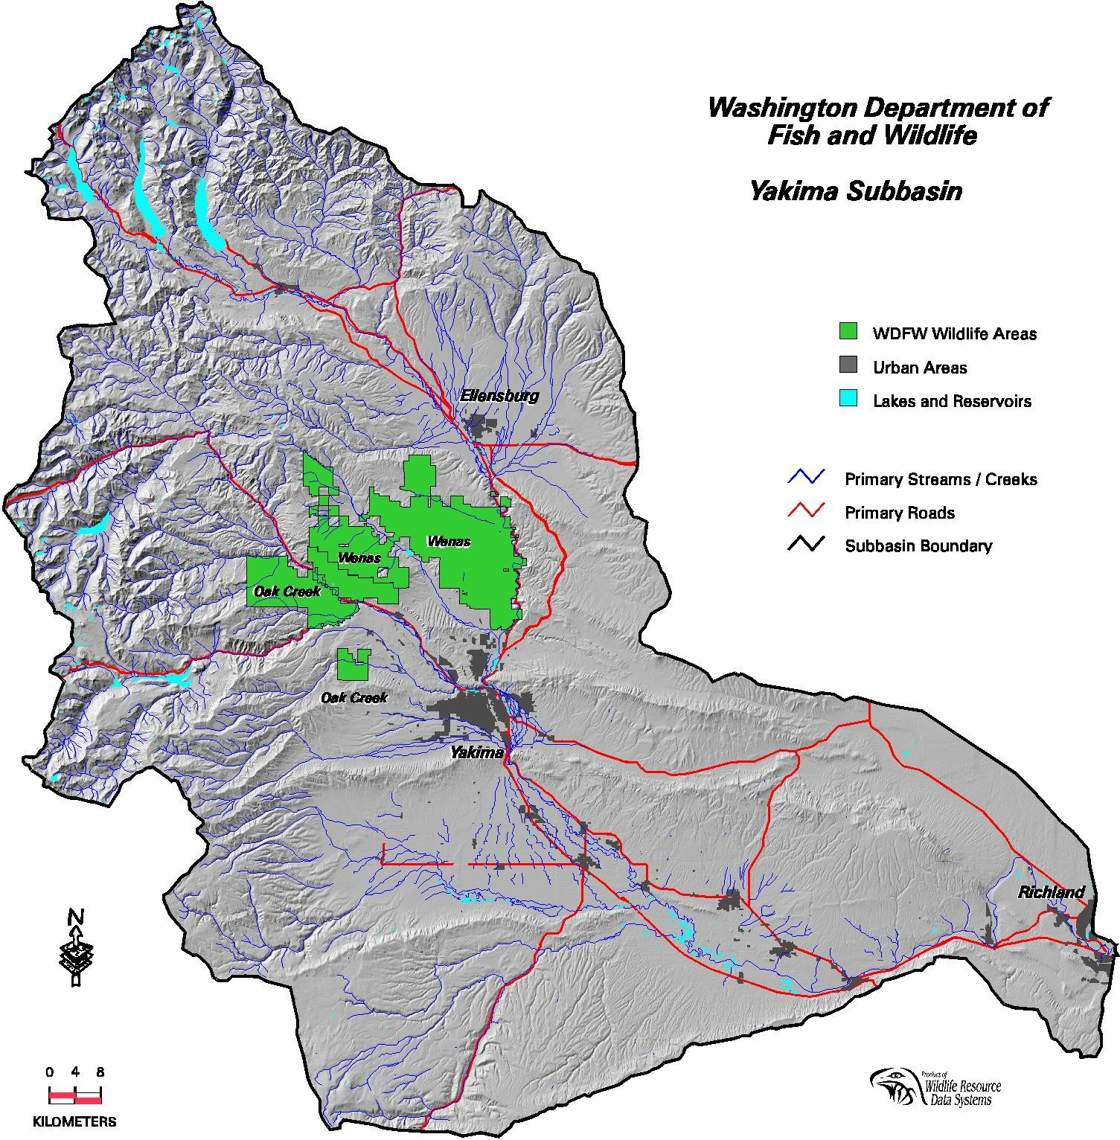

Map 1. Yakima Subbasin showing relationship of project.

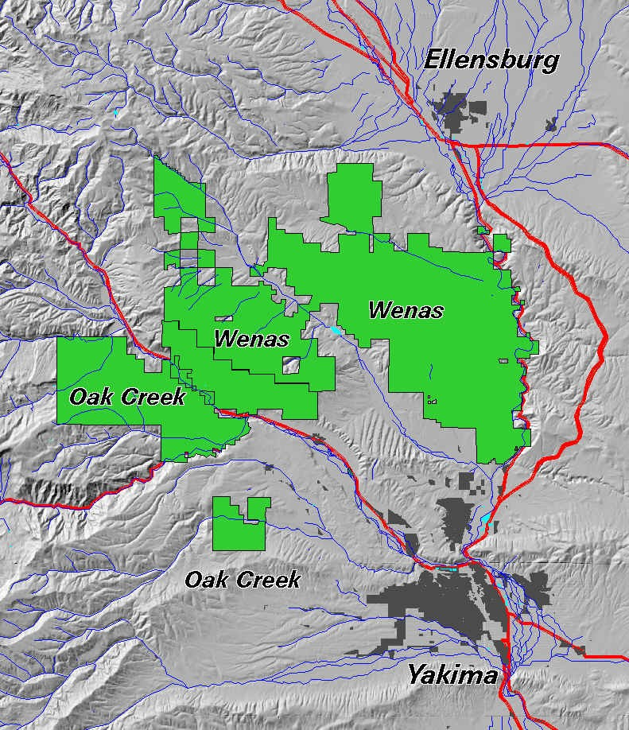

Map 2. Oak Creek and Wenas WA project area.

c. Rationale and significance to Regional Programs

By re-acquiring timber ownership from BCC, WDFW will be able to move towards restoration of pristine conditions by reducing future logging activities such as road-building, log skidding, construction of crossings through riparian drainages, and other soil disturbances associated timber extraction methods. This will reduce delivery of fine sediments to the upper Naches, Oak Creek, Tieton River, and Rattlesnake Creek drainages. By restricting timber removal, winter snow cover will be retained longer into the spring, allowing for slower runoff and providing cooler stream temperatures into the summer. More large woody debris will be retained within undamaged riparian corridors, adding to habitat complexity and structure.

Acquisition of the PTRs has been identified as a priority goal by WDFW for many years, and is identified as an objective in the Yakima Sub-basin Summary (pg 324). It is assumed that WDFW will manage forest habitats on the Oak Creek and Wenas WA’s for optimum fish and wildlife values, and by re-acquiring the PTRs overall ecosystem health will improve. Watershed health is a long-term habitat strategy within watersheds that support Federally listed salmonid stocks (2000 NMFS Biological Opinion pg 9-133, www.nwr.noaa.gov, 2000 NWPPC Columbia River Basin Fish and Wildlife Program pg 39 www.nwpcc.org). Acquisition of the PTRs by WDFW should qualify under BPA wildlife mitigation strategies as habitat enhancement credits (HUs) within the Yakima sub-basin (2000 NWPPC Program pg 40).

The Oak Creek WA and Wenas WA are key elements of WDFW regional operations. They hold significant benefits to the public for recreational and wildlife viewing opportunities. Protection and maintenance of high quality habitats is of regional and sub-basin wide significance.

In the Yakima Sub-basin Summary, acquisition of the Oak Creek PTRs is supported in the habitat needs section as follows:
- Wildlife Habitats: “…key habitat areas need to be identified, protected, enhanced, restored and managed to provide ecological, cultural and sociological benefits.” (p. 369). Acquisition of Oak Creek PTRs would enable this goal.
- Amphibians: “ Protection of habitats” (p.369). This project would enable protection of large woody structures needed by amphibians that are lost under current management.
- Beaver: “Restoration of …riparian habitats, especially in higher elevation areas..” (p. 371). PTR acquisition would help provide beaver habitat.
- Forest Carnivores: “Protection of habitats”. (p. 371). Acquisition of PTRs would help to provide the large woody structures required by marten and other of these species.
- Forest raptors (flammulated owl, goshawk): “Protect mature forest nesting habitats”. “Provide habitats that include major components of large diameter trees” (p. 371). Acquisition of PTRs would enable WDFW to manage habitats on their lands for the retention of large trees.
- Migratory Songbirds: “Protect and manage nesting habitat to ensure reproductive success of breeding populations.” “Identify key lands for conservation easements and/or acquisition” (p. 372). Under current management wherein WDFW does not control the trees, songbird habitat for many species that are of long-term conservation concern (warblers, flycatchers, etc) is being continually degraded on WDFW lands.
- Big game: “Protection of habitats, especially winter range and riparian habitats”. (p. 372). Without the PTRs, big game habitats have been degraded by logging adjacent to and in riparian zones, cover has been removed, and road densities have increased.
- Bats: “Protect key roost and hibernacula habitats…” (p. 374). These animals are known to extensively utilize large snags and cavities, which are lost under current management.
- Forested Habitats: “Protect remaining old forest stands, particularly ponderosa pine”, “Maintain large tree components”, “Decrease road densities”, “Reduce fragmentation of forest habitats”. All of these needs for forest habitats in the Yakima sub-basin can be addressed by the acquisition of the PTRs on the Oak Creek and Wenas WAs.
- Fish Habitat: Protection of riparian habitats, retention of cover to slow snowmelt and reduce runoff, and reduction of sediment inputs to water bodies are identified as fish habitat needs for the Yakima sub-basin. Acquisition of the PTRs would help protect steelhead and bull trout (Federally listed), cutthroat trout, rainbow trout, and Chinook salmon in the waters in and adjacent to these PTRs. Under current management, only the Washington Forest Practices standards are implemented on these lands, which provide no protection for non-fish bearing, dry channels, and slight protection for non-fish bearing perennial waters, and limited protection on fish bearing waters (Washington Forest Practices, 2000)(www.wa.gov/dnr). Acquisition of the PTRs would enable WDFW to best provide fish habitat protection on these lands. Actions that relate to protection of currently productive non-Federal tributary habitat have a high priority (2000 NMFS BiOp, Action 150 pg 9-134).

d. Relationships to other projects

Re-acquisition of BCC PTRs would allow optimum management of both the forested and sagbrush-steppe habitats found on the Cleman Mountain unit on the Wenas WA, a BPA-funded project. This will allow WDFW to maximize wildlife habitat values over the landscape, instead of maintaining BCC’s focus on economic gain from sustained timber production, and will enhance management of Rocky Mountain mule deer, Black-capped Chickadee, and Sage Grouse, Mink, Western Meadowlark, and Yellow Warbler, priority keystone species on the Wenas WA (Wenas WA Workplan 2001)

The acquisition of PTRs by WDFW with the objective of improving watershed conditions and forest health is supported by the Yakama Indian Nation (Jim Matthews, pers. conv.) and the USFS Naches Ranger District (Peter Forbes, pers. conv.)

e. Project history
This is a new project proposal.

f. Proposal objectives, tasks and methods

The proposal objective is to determine the volume, by species, and value of the PTRs held by BCC on lands owned by WDFW, together with the current net value of the standing merchantable timber and pre-merchantable timber. These same activities may also be necessary on other WDFW owned lands that may be proposed as potential exchange with BCC, together with real estate appraisals. The tasks will be undertaken by independent contractors who are experts in their field.

A timber cruise of those portions of the subject property that are currently timbered covered will be the first activity. The timber cruise will utilize industry sampling standards that will determine the height and diameter, by species and grade, of the trees. Then an appraisal will be completed to determine the fair market value of the standing merchantable timber and pre-merchantable timber, together with the fair market value of the perpetual timber cutting rights. The appraisers will rely on the data collected in the timber cruise and complete an analysis and opinion of value based upon other comparable sales of land and timber, cost approach and/or income approach to value.

Planning & Design
1. Establish biological parameters that will be required to accurately measure and quantify needed data to determine values of PTRs.
1a. Review aerial photography, maps, existing data from BCC, and other relevant information to plan project.
2. Assess biological impacts of project.
2a. Determine if SEPA or NEPA requirements apply to activities associated with project completion and perform the necessary documentation to secure permits, if required.

Construction & Implementation
1. Determine habitat goal required to establish values.
1a. Cruise percentage of timber resources on PTRs required to estimate total merchantable volume. Establish economic value through comparative appraisals.
1b. Establish economic value of future timber production potential on PTRs through comparative appraisals.
1c. Establish economic value of non-commercial PTR acres through comparative appraisals.
2. Determine habitat goal required to establish values.
2a. Cruise percentage of timber resources on WDFW exchange parcel(s) required to estimate total merchantable volume. Establish economic value through comparative appraisals.
2b. Assess real estate value of WDFW exchange parcel(s) through comparative appraisals.
3. Assess priority habitats desired for partial acquisition.
3a. Establish economic value(s) of selected high-priority wildlife habitats for partial acquisition, if required.
4. Establish a biological baseline of resource values.
4a. Perform a Habitat Evaluation Process on the PTR lands to determine habitat conditions prior to acquisition by WDFW. This will provide data to evaluate any increase or decrease in future habitat conditions.
4b. Perform wildife surveys on PTR lands to document numbers and diversity of species. This will provide data to evaluate any increase or decrease in future wildlife populations.

Operation & Maintenance
There are no operation or maintenance activities planned under this project.

Monitoring & Evaluation
There are no monitoring or evaluation activities planned under this project.

g. Facilities and equipment

Oak Creek WA and the Wenas WA are staffed with permanent WDFW employees that will provide time and facilitation throughout the project. Four-wheel drive vehicles, ATV vehicles, hand tools, incidental supplies, and some temporary housing is available on-site.

h. References

Reference (include web address if available online) | Submitted w/form (y/n)
2001 Yakima Sub-basin Summary / draft  Oak Creek PHS Survey 1999-2000  Oak Creek Wildlife Area Management Plans - 1996  WDFW Salmon & Steelhead Stock Inventory (SASSI) – 1992  Washington Salmonid Stock Inventory – Bull Trout Appendix 1998  WDFW PHS Recommendations – 1991  Wenas WA Workplan – 2001  Governors Quitclaim Deed – 1951  Yakima County Warranty Deed #1383325 – 1951  NMFS Biological Opinion – 2000  NWPPC Fish & Wildlife Program – 2000  Washington Forest Practices - 2000 | N  N  N  N  N  N  N  N  N  N  N  N

Section 10 of 10. Key personnel

Key (potential) WDFW Personnel:

John McGowan, Oak Creek Wildlife Area Manager (general project oversight, facilitation)
Cindi Confer, Wenas Wildlife Area Manager (general project oversight, facilitation)
Del Peterson, Regional Lands Coordinator (processing of proposal and activities through Region)
Cindy McMinn, Regional Lands Agent (processing of proposal and activities through Region)
Todd Walker, Acquisition Coordinator (lead negotiator and coordinator of real estate functions through Olympia)
Don Miller, Chief Appraiser (supervises contracted consultants and performs Appraisal Review)
Ken Bevis, Forestlands Habitat Biologist (biological and habitat needs facilitation)
Doug Kuehn, Assistant Forester (review of contractors, scope of work and sampling techniques, review of timber cruise)

Key (potential) Contractors:

Atterbury Consultants, Inc.
International Forestry Consultants, Inc.
Western Appraisal

