Project ID: 25092
Title: RESTORATION OF HEALTHY WATERSHED TO THE PALOUSE RIVER DRAINAGE, IDAHO

Section 9 of 10. Project description

a. Abstract

The Palouse Prairie may be the rarest prairie ecosystem in North American (Noss 1997). Since 1870, 94 percent of grasslands and 97 percent of wetlands in the Palouse Bioregion have been converted to crops, hay, or pasture (Black et al. 1998). Twenty one percent of previously forested lands have been converted to agriculture or urban areas. Conversion of grasslands. wetlands, and forested lands to agricultural, in addition to stream channelization, livestock grazing, and other land use practices, have contributed to the long-term degradation of water quality in the Palouse River system. Many Palouse River tributaries are listed on the water quality limited 303 (d) stream list. Fire suppression has contributed to the loss of mature pondersosa pine habitat (CNF 1998). Native fish and wildlife communities have been significantly impacted by past land use practices.

This project proposal is to improve terrestrial and aquatic habitats in the Palouse River watershed, in order to improve water quality and associated fish and wildlife communities. Water quality improvements in the upper watershed will also benefit aquatic communities in the lower Palouse River. Primary actions are expected to include the protection and enhancement of riparian and wetland areas through conservation easements or long-term agreements, and the protection and expansion of native plant communities (e.g. native prairie, ponderosa pine). A variety of other measures designed to improve water quality will also be evaluated. All activities will be closely coordinated with existing federal and state programs and will be designed to add value to those actions.

b. Technical and/or scientific background

The Palouse River drainage encompasses 2.1 million acres of southeastern Washington and north-central Idaho (Figure 1). Approximately 17 % of the drainage lies in Idaho as headwaters of the main Palouse and South Fork Palouse rivers. The Palouse River flows into the Snake River between Lower Monumental and Little Goose dams. Palouse River Falls occurs a few miles upstream of the confluence of the Palouse River and the Snake River. The Falls is significant with the fact that it is a complete blockage to upstream migrating fish, chinook salmon (Oncorhynchus tshawytscha), steelhead trout (O. mykiss), and bull trout (Salvelinus confluentus).

Since 1870, 94 percent of grasslands and 97 percent of wetlands in the Palouse Bioregion have been converted to crops, hay, or pasture (Black et al. 1998). The Palouse Prairie may be the rarest prairie ecosystem in North American (Noss 1997). Two of the native plant communities, bluebunch wheatgrass-snowberry and bluebunch wheatgrass-rose are globally rare, and eight plant species are theatened globally (Lichthardt and Moseley 1996). With the near elimination of native prairies, species dependent on grasslands such as sharp-tailed grouse, white-tailed jack rabbit, and ferruginous hawk have been nearly extirpated as breeding populations (Black et al. 1998). The USDA Natural Resources Conservation Service (NRCS) has designated the Palouse Prairie as a Critically Endangered Ecosystem under the Rare and Declining Habitat Practice, a practice designed to restore the functions and values of critically endangered and threatened habitats.

Twenty one percent of previously forested lands have been converted to agriculture (Black et al. 1998). Disturbance regimes have been altered on remaining forests. Fire suppression has resulted in a loss of mature pondersosa pine habitat (CNF 1998). The loss of mature and late seral vegetation on forested lands has had a negative affect on those species dependent on them, such as pileated woodpecker, marten, fisher and northern goshawk (CNF 1998).

There have been major efforts historically to straighten and keep stream channels void of vegetation to assist the drainage and control of flooding. Livestock grazing has altered stream channel stability. Farm practices and the removal of wetlands have dramatically reduced upland water storage capacity of the subbasin

Forest grounds, primarily in Idaho, have been historically clear-cut reducing water storage potential. Mining has occurred in varying degrees in upper watersheds. Mining activities in upper Palouse River, Mountain Gulch, Gold Creek, Treasure Gulch, and E.F. Gold Creek have resulted in constricted and unstable channels. All of these factors have contributed to a ‘spiky’ hydrologic curve, and several tributary streams becoming intermittent in the summer months (Palouse D.C., 2000). Precipitation tends to enter the streams quickly and drain to the Snake River quickly.

In the Palouse River, and its associated tributaries, water quality conditions may be related to degradation of aquatic and riparian conditions. Elevated water temperatures, low dissolved oxygen concentrations, elevated pH concentrations, high turbidity, and elevated levels of nutrients and pesticides all are parameters of water quality within the subbasin which adversely affect aquatic resources.

The Palouse River and its tributaries are currently listed on Washington’s 303(d) list for metals, pesticides, fecal coliform, dissolved oxygen, pH, ammonia-N, sediment, nutrients, temperature, and flow. In Idaho, the Palouse River tributaries of Deep creek, Flannigan Creek, W.F. Rock Creek, Gold Creek, Hatter Creek, Big Creek, and the S.F. Palouse River are listed as water quality limited for bacteria, nutrients, sediment and temperature (PCWAG 1999). Cow Creek is listed for nutrients and temperature. Paradise Creek is the only Idaho stream where a Total Maximum Daily Load (TMDL) Implementation Plan has been developed (IDEQ 1997).

Low base flows are a result of altered land use practices in headwater areas. Land uses over the last 100 years have resulted in an increasing number of seasonal runoff events resulting in peak flows that occur relatively rapidly rather than a more gradual runoff with lower peak flows. The situation creates low summer base flows, limiting habitat diversity and area.

Due of the extensive agricultural or livestock practices, logging, road construction, stream channelization in the subbasin, there has been substantial decrease in quality aquatic and riparian habitat and subsequent degradation of water quality and quantity. Low base flows, increased sedimentation and transport, high water temperature, and reduced dissolved oxygen certainly effect aquatic resources in the upper reaches of the drainage and have more profound and compounded effects as Palouse River flows enter the Snake River. Degraded water quality and quantity deleteriously effect the drainage which is magnified in the lower reach below Palouse Falls.

Because of Palouse Falls, the fish communities above and below the falls are significantly different. The fish community below Palouse Falls was composed of anadromous and resident species, while above the falls the community was lacking presence of anadromous species. Resident species above and below the falls include cyprinids, cottids, and catastomids, while below the falls native species observed include chinook salmon, steelhead trout, and bull trout. All of the Snake River spring, summer, and fall chinook were officially listed by the National Marine Fisheries Service as ‘threatened’ species in April, 1992. Snake River steelhead trout were listed by the National Marine Fisheries Service as '‘threatened’ species in 1996. The bull trout was officially listed by the U.S. Fish and Wildlife Service as ‘ threatened’ under the Endangered Species Act (ESA) in June, 1998.

The Palouse River provides diverse fish and wildlife populations and habitats that are significant ecologically, aesthetically, and economically to the citizens of Idaho and the Pacific Northwest (Palouse Subbasin Summary). The overgoal of projects like this one is to provide for healthy, sustainable populations of fish and wildlife that provide benefits to the region. The Palouse Subbasin Summary identifies a myriad of goals, objectives and strategies to achieve stated goals to restore the Palouse River to a healthy status. This project will initiate the process to identify and implement strategies to achieve those goals.
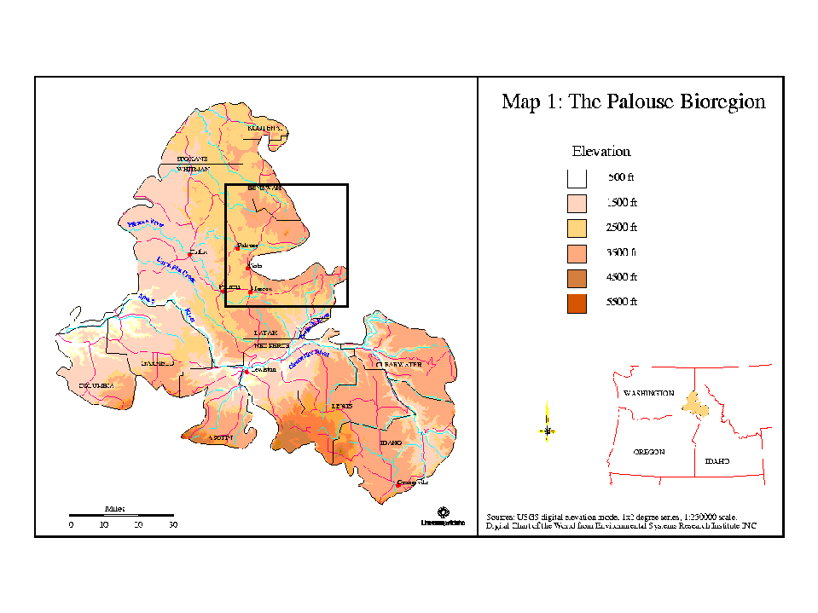

c. Rationale and significance to Regional Programs

The Northwest Power Planning Council’s 2000 Fish and Wildlife Program calls for maintenance and restoration of healthy ecosystems and watersheds to ensure the continued persistence, health and diversity of all species including game fish species, non-game fish species and other organisms. This proposed project is designed to restore degraded habitat and protect natural habitat in the Palouse River drainage in Idaho. Restoration of degraded habitat and protection of native-natural habitat in respect to the improvement of water quality and quantity entering the lower Palouse River and subsequently the Snake River address four reasonable and prudent actions listed in the FCRPS.

High water temperatures have been linked to stress and disease. Reducing water temperatures in tributaries can influence water temperature in main migratory corridor and provide cooler water sanctuaries for migrating juvenile fish (RPA141).

To increase tributary water flow, comply with water quality standards, watershed health (RPA 149). This project will address both water quantity and quality in the lower Palouse River and influence conditions in the main migratory corridor of the Snake River.

Provide protection and restoration of non-Federal habitat that is severely degraded (RPA150). This project will address both water quantity and quality in the lower Palouse River and influence conditions in the main migratory corridor of the Snake River.

Provide opportunity to fund long-term protection of riparian buffers in concert with existing federal programs (RPA 153).

d. Relationships to other projects

The Palouse Subbasin Summary chronicles existing and past project efforts and associated agencies and entities. Following is a brief summary of some of the key entities involved in past and future restoration activities in the Palouse.

USFS—The U.S. Forest Service has recently completed the Palouse Subbasin Ecosystem Analysis (Clearwater National Forest 1998). This project will support recommendations in the Analysis, including road obliteration, reclamation of mined areas, and restoration of stream channel integrity

NRCS—Several important federal programs exist to help establish permanent cover and reduce soil erosion and water quality degradation. The Continuous Conservation Reserve Program is on of the key programs to improve water quality and riparian areas. Other programs include the Wildlife Habitat Incentive Program (WHIP), the Environmental Quality Incentives Program (EQUIP), and the Wetland Reserve Program (WRP). Activities under this project proposal will support and enhance on-going NRCS programs.

Soil Conservation Districts – This proposal will support and enhance the SCD collaborative approach to improve water quality in streams adjacent to Animal Feeding Operations (AFO’s).

IDEQ---Idaho Department of Environmental Quality is in the process of developing an interstate TMDL process for the upper Palouse River in Idaho and eastern Washington. Project activities will assist DEQ in achieving water qualilty goals and will enhance Clean Water Act 319 projects.

University of Idaho- The Idaho GAP Analysis Lab has been instrumental in summarizing the Biodiversity and Land Use History of the Palouse Bioregion (Black et al 1998). The Lab has worked with IDFG personnel to map critical wildlife habitat in Latah County. Under a pending grant, the lab will work with the Palouse Land Trust to identify important conservation opportunities in Latah County. University personnel, in coordination with IDFG staff and othersd are currently developing a model to predict the location of historic wetlands on the Palouse Prairie.

e. Project history (for ongoing projects)

No History

f. Proposal objectives, tasks and methods

Objective 1. Establish position to coordinate activities of all participating entities and implement BPA sponsored programs.

Task 1. In cooperation with state and federal agencies and private land owners, develop water quality and quantity goals for the Palouse River and its tributaries in Idaho.
Task 2. Identify site specific habitat protection and restoration needs to address water quality and quantity issues in the drainage, in concert with state and federal agencies and private land owners.
Task 3. Develop long range comprehensive plans to prioritize identified projects to meet stated goals for water quality and quantity.
Task 4. Identify and seek funding sources for implementation of identified projects.

A fishery/wildlife biologist will be employed to work with the various state and federal agencies and private land owners in the drainage to identify and implement various activities that will restore or protect habitats. Identified projects will be cataloged on a GIS system. The individual will, in cooperation with these entities, develop a long range plan to identify areas in need of restoration and protect, and develop strategies to the achieve the goal of a healthy watershed. In addition, the biologist will seek funding sources for implementation of projects. Because of the ongoing projects of the Natural Resources Conservation Service, Soil Conservation Districts, Idaho Department of Environmental Quality, projects identified will be coordinated those agencies and cost share when appropriate.

Objective 2. Initiate aquatic and riparian habitat improvement activities on private land with the Palouse River drainage in Idaho.

Task 1. Acquire conservation easement to remove livestock use of riparian area along Deep Creek in 2002.

Task 2. Construct fencing along ten miles of Deep Creek to remove livestock use in riparian area in 2002.

Task 3. Restore native vegetation along ten miles of riparian area of Deep Creek in 2002.

Task 4. Restore natural channel location of approximately one mile of Deep Creek in 2002.

Task 5. Acquire conservation easements, fee-title, and/or long-term cooperative agreements with landowners on additional key riparian/wetland areas along the mainstem Palouse and tributaries.

Deep Creek has been identified as a high priority for the year 2002 as the Idaho Department of Transportation Department is undertaking major road construction of the major highway that parallels most of Deep Creek. The identified activities will complement the efforts of the Transportation Department. For the initial year of the project the stream mileages noted are within reason to accomplish. In coordination with NRCS, willing landowners will be approached for implementation of the projects noted.
NRCS has determined that based upon aerial photos and designated farms, about 23 of 28 operators in Deep Creek are potential contacts.

Beginning in year 2003, additional riparian and wetland areas within the Palouse drainage will be protected with the acquisition of easements, fee-title, or long-term cooperative management agreements. These actions will be closely coordinated with University of Idaho staff involved in the modeling and delineation of historic wetlands, NRCS staff and others. In some cases, project funds will be utilized in riparian areas not eligible for the continuous CRP program or to enhance the land base in important habitats already under Continuous CRP.

Objective 3. Protect remaining native prairie remnants and threatened ponderosa pine stands through the acquisition of conservation easements, fee-title, or long-term cooperative agreements with private land owners.

Implementation of objective 3 will be delayed until year 2003 as priority lists are completed. Acquisition of easements, fee-title, or long-term management agreements will be closely coordinated with the University of Idaho GAP Analysis Lab and the Palouse Land Trust.

Objective 4. Identify and develop BMP’s for high nutrient sources.

Implementation of objective 3 will be delayed until year 2003 as priority lists are completed.

g. Facilities and equipment

The project’s coordinator will be stationed at IDFG’s Clearwater Region Office in Lewiston, ID. At the Lewiston facility, the necessary clerical staff, office space, computers, etc., are available.

h. References

Reference (include web address if available online) | Submitted w/form (y/n)
Black, A.E., J.M. Scott, E. Strand, R.G. Wright, P. Morgan and C. Watson. 1998.  Biodiversity of Land-use History of the Palouse Bio-region: Pre-European to Present.  Chapter 10 in Land Use History of North America. USGS Biological Survey | n
Clearwater National Forest. 1998. Palouse Subbasin Ecosystem Analysis at the  Watershed Scale. Upper Palouse, Lower Palouse and Meadow Creek Watersheds | n
Idaho Division of Environmental Quality. 1997. Paradise Creek TMDL. Water Body  Assessment and Total Maximum Daily Load. | n
Lichthardt, J. and R.K. Moseley. 1996. Status and Conservation of the Palouse  Grassland in Idaho. U.S. Fish and Wildlife Service, Idaho Department of Fish  And Game, Lewiston, ID | n
Noss, R.F. 1997. Endangered Major Ecosystems of the United States. Wild Earth  Summer 1997 | n
Palouse Subbasin Summary, 2001. Prepared for the Northwest Power Planning Council by the Palouse subbasin summary technical team, Trevor Cook team leader. | n
Paradise Creek Watershed Advisory Group. 1999. Paradise Creek Total Maximum  Daily Load Implementation Plan. Latah County Soil and Water Conservation  District. Moscow, ID. | n

Section 10 of 10. Key personnel

The principal investigator will be a fishery/wildlife biologist to be assigned on initiation of the project.

Project Manager: Tim Cochnauer, PhD

Postion: Regional Fish Manager, Idaho Department of Fish and Game, Clearwater Region, Lewiston, ID 83501

Address: Idaho Department of Fish and Game
Clearwater Region
1540 Warner
Lewiston, ID 83501

Phone: 208-799-5010
FAX: 208-799-5012
e-mail: tcochnau@idfg.state.id.us

Education: Doctorate in Fishery Resources, 1983, University of Idaho, Moscow, ID
MS in Zoology, 1973, University of Oklahoma, Norman, OK
BS in Zoology, 1967, University of Oklahoma, Norman, OK

Current responsibilities:

As regional fish manager, the project manager has responsibility for both anadromous and resident fish populations and fisheries within the Clearwater Region of north central Idaho. The area encompasses the entire Clearwater River drainage, the Snake River drainage upstream to Hells Canyon Dam, the Palouse River drainage, the Salmon River drainage (north side) from its mouth upstream to Horse Creek (rkm 300), and the entire Palouse River drainage within Idaho. The IDFG Clearwater Region has a staff of four fishery scientists conducting a variety of activities including data collection, creel census, fish management decisions, establishing and implementing fishing seasons, etc., throughout the region.

The project manager has over twenty-five years experience with Idaho Department of Fish and Game working in fish research, fish management and the hatchery system. Experience includes working with a variety of fish species as well as addressing aquatic habitat needs. Daily work responsibilities include cooperating with federal land management agencies as well as private landowners to protect and restore aquatic habitat for sustainable aquatic communities.

Publications:

Cochnauer, T.G. 1983. Abundance, Distribution, Growth and Management of White Sturgeon in the Middle Snake River, Idaho. Doctoral Dissertation. University of Idaho. Moscow, ID.

Cochnauer, T., J.R. Lukens, and F.E. Partridge. 1985. Status of white sturgeon, Acipenser transmontanus, in Idaho. In: North American Sturgeons: Biology and Aquaculture Potential. Dr W. Junk Publishers.

Cochnauer, T., E. Schriever, and J. Brostrom. 1993. River and Stream Investigations. F-71-R-17. Federal Aid in Sport Fish Restoration. Idaho Department of Fish and Game.

Cochnauer, T., E. Schriever, and J. Brostrom. 1994. River and Stream Investigations. F-71-R-18. Federal Aid in Sport Fish Restoration. Idaho Department of Fish and Game.

Cochnauer, T., E. Schriever, and J. Brostrom. 1995. River and Stream Investigations. F-71-R-19. Federal Aid in Sport Fish Restoration. Idaho Department of Fish and Game.

Cochnauer, T., E. Schriever, and J. Brostrom. 1996. River and Stream Investigations. F-71-R-20. Federal Aid in Sport Fish Restoration. Idaho Department of Fish and Game.

Cochnauer, T., E. Schriever, and J. Brostrom. 1997. River and Stream Investigations. F-71-R-21. Federal Aid in Sport Fish Restoration. Idaho Department of Fish and Game.

Cochnauer, T., E. Schriever, and J. Brostrom. 1998. River and Stream Investigations. F-71-R-22. Federal Aid in Sport Fish Restoration. Idaho Department of Fish and Game.

