Bonneville Power Administration

FY 2002 Provincial Project Review

PART 2. Narrative
Project ID: 198709900

Title: Dworshak Dam Impact Assessment and Fisheries Investigation

Section 9 of 10. Project description

a. Abstract

Dworshak Reservoir was built in 1973 by the Army Corps of Engineers. This 718' high dam completely blocked the North Fork of the Clearwater River for anadromous fish and greatly changed the composition of the resident fishery. The project goal is to improve the resident sport fisheries in the reservoir as partial mitigation for these impacts. Our objective is to minimize entrainment losses of fish into the turbine intakes and reservoir outlets so that a density of 30 to 50 adult kokanee/ha can be maintained on an annual basis. Our efforts to reduce entrainment losses of kokanee may also benefit other species by: lessening entrainment of other resident fish, providing more prey (small kokanee) for bull trout, and allow nutrients (in the form of kokanee spawners) to move upstream into the tributaries. We also propose to monitor the kokanee population annually and relate changes to the operation of the dam. This empirical information can then be used to assist in the development of rule curves for the reservoir.
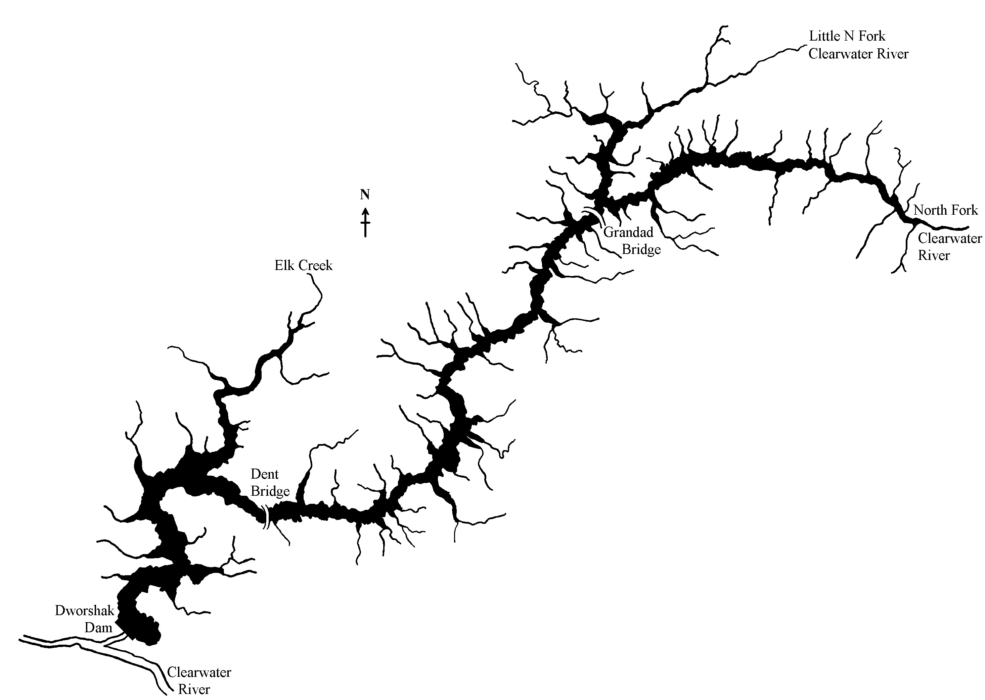
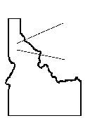
Our methods are to test behavioral avoidance devices to see if kokanee, and other fish, can be diverted away from the intakes to the dam. Strobe light testing was conducted off-site in 1997 and 1998. Kokanee avoided the strobe lights for the entire night and remained 30 to 40 m away from them in an open lake environment. Lights were found to be even more effective during winter (the season of highest entrainment losses) and repelled kokanee in excess of 100 m. Lights were installed on a floating research platform in front of one turbine on the dam in 2000. On-site testing began in 2001 and will continue in 2002. Paired tests will be conducted between lights on (test group) and lights off (control group) to determine if entrainment losses can be reduced. Our objective is to see a >50% reduction in fish entrainment during the tests. If this objective is achieved, additional strobe lights will be purchased and installed in front of the remaining two turbine intakes. Then testing will progress to the reservoir outlets and spillway, which are only used a small portion of the water year, yet likely contribute significantly to the entrainment losses.
Figure 1. Map of Dworshak Reservoir and its major tributaries, North Fork Clearwater River, Idaho.

b. Technical and/or scientific background

Dworshak Dam blocked the access to hundreds of miles of tributaries for anadromous fish spawning as well as flooded 54 miles of river habitat. The resident fisheries that developed in the reservoir were intended to mitigate for some of these losses. Thus, our project to improve reservoir fisheries serves to mitigate losses “in place” but “out-of-kind”. Although twenty-one species of fish are found in the reservoir, only three species provide important fisheries (Maiolie, et al. 1992). Of these species, kokanee have become the most dominant and have provided approximately 80% of the total catch (Maiolie et al. 1992). Kokanee are uniquely suited to this rapidly fluctuating reservoir since they spawn in the tributaries and live in the pelagic region of the reservoir.
Unfortunately, losses of fish into the turbines and reservoir outlets (entrainment) have caused kokanee populations to vary widely (See figure). These entrainment losses were shown to be the main factor limiting kokanee populations in the reservoir (Maiolie and Elam 1995). During 1994, fluctuations in kokanee abundance and kokanee survival rates were found to correlate with the amount of water discharged from the dam. In 1996, kokanee entrainment exceeded 95% of the all of the kokanee in the reservoir (Maiolie and Elam 1998). Over 1.3 million kokanee were lost from the dam during a period of high discharge. In 1997, no age 1 or older kokanee were found in the reservoir during annual trawl sampling and counts of spawning kokanee in index streams dropped from 30,000 to 144 fish (Maiolie et al. 1997). Thus, controlling entrainment losses is a critical problem and it is the focus of this project. The kokanee population has recovered now in 2001; however, high spring and summer discharges will likely occur again, triggering high entrainment losses.
Figure 2. The number of age 2 and 3 kokanee in Dworshak Reservoir, Idaho from 1988 to 2000.
The problem of entrainment losses is a critical concern throughout the Columbia Basin. Even more specifically, entrainment loss of kokanee has been a major problem in Libby Reservoir (Skarr et al. 1996) and Lake Roosevelt. If these losses could be minimized by a means such as strobe lights, then the operation of dams for flood control, power production, providing anadromous fish flows, etc. could be done with less of an impact on resident species. Thus, this project could help to increase the flexibility of dam operations, or to allow a better integration of resident and anadromous fish needs.
Strobe lights have achieved good success at moving fish in a number of different studies. Patrick (1982) found strobe lights worked well to divert alewife. Patrick (1980) found that American eels strongly avoided strobe lights with no behavioral adaptation over a 48 hour period. Nemeth and Anderson (1992) found that juvenile coho and chinook salmon avoided strobe light. At the York Haven Hydroelectric Project on the Susquehanna River, American shad were “strongly and consistently” repelled from the turbine intakes (Winchell et al. 1994). Ploskey and Johnson (1997) found that strobe lights elicited consistent displacement of juvenile salmonids both vertically and horizontally. Field experiments at the Seton Hydro-Electric station in British Columbia tested the response of sockeye smolts to strobe lights at a current velocity approaching 1 m/sec. Strobe lights were found to be 56% effective at guiding downstream migrating fish (McKinley and Patrick 1986). The U.S. Army Corps of Engineers is currently conducting work with strobe lights at the Hiram M. Chittenden Locks in Seattle (Johnson et al. 1998, in press). Their work in 1998 shows that smolt entrainment into the locks was reduced 87% when the lights were turned on even though the water velocities were 5.5 feet/sec.
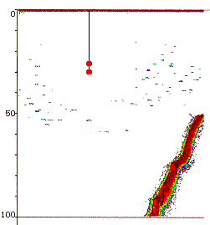
Our testing of strobe lights began in 1997 and will continue in 2002. Testing was conducted off-site in lakes with high densities of kokanee. Results are very encouraging. Flash rates of 300 to 450 flashes/minute were highly successful at repelling kokanee in excess of 30 m (Maiolie et al. 1999, in press). Kokanee also did not become accustomed to the lights, nor move closer to them, even after a whole night of operating the lights in the same location (Maiolie et al. 1999, in press). We tested the lights over shallow water (25 m deep) and deep water (300 m deep). Strobe lights worked equally well in both situations. We also found that strobe lights worked particularly well during winter, which is the season of our highest entrainment losses. Tests during February 1998 documented that kokanee were repelled more than 100 m by the lights. Testing in 2001 was conducted on Dworshak Dam to resolve how kokanee react to the light under a variety of field conditions. This will allow us to study the effects of strobe lights on fish that are in a current of water and are schooled near the dam for a period of several months. Preliminary results indicated that kokanee were repelled from the area in front of the turbines under low flow conditions (Figure 3).
Location of strobe lights
Depth (m)
Figure 3. Echogram of fish locations around an array of flashing strobe lights. Lights are positioned directly in front of an operating turbine on Dworshak Dam. Note the dispersion of fish near the strobe lights.
Fish
Reservoir bottom

Please see IDFG BPA Proposal: “Evaluation of Bull Trout Life History In Dworshak Reservoir, North Fork Clearwater River Drainage, ID”, for a detailed technical and scientific background with regard to Dworshak Reservoir bull trout concerns with regard to the operation of the Dam (Objective 2).

c. Rationale and significance to Regional Programs

How this project relates to the goals of the FWP can best be stated by comparing it to the criteria used by the CBFWA. The project does address specific Council Program measures specified in 10.3C. It is also consistent with management objectives of the State of Idaho and the Nez Perce Tribe. These objectives are spelled out in Idaho Fish and Game’s 5 year management plan for Idaho. It also conforms to Council prioritization process according to program measure 10.1B. This measure gives a high priority to “resident fish substitution measures in areas that previously had salmon and steelhead, but where anadromous fish are now irrevocably blocked by federally operated hydropower development”; this is the case with Dworshak Reservoir.
In addition, in regard to native threatened species, objective 2 of this project addresses Reasonable and Prudent Measure (RPM) # 10.A.3 of the U.S. Fish & Wildlife Service’s 2000 Biological Opinion to implement monitoring and studies to provide critical information on bull trout entrainment and distribution, timing and usage of Dworshak Reservoir for modifying facilities and/or operations.
This project work also provides a direct benefit to anadromous fish. The reservoir is lowered about 80 feet each summer to provide flows in the lower Snake and Columbia Rivers. By avoiding entrainment losses of fish, the continuation of these flows would be much more palatable to the public, and could be done with little impact to resident fish. Biological objectives of the Dworshak Research project have been developed (see section 4), but they have not been adopted into the Council’s Program at this time. Data on entrainment losses, and methods to avoid them, will be used in the development of biological/integrated rule curves for this (and possibly other) storage reservoirs. Being able to avoid entrainment will make the biological rule curves for fish much more flexible. We are not, however, developing the actual rule curves, that task has been lead by the Nez Perce Tribe.
Our findings will hopefully benefit several species of fish within the reservoir. Kokanee are the primary species that will benefit. They are the largest resident fishery in the Clearwater drainage with up to 140,000 hours of fishing effort. But the project also provides direct benefit to non-target species. Avoiding entrainment losses of kokanee could also minimize the losses of cutthroat, rainbow trout, and/or bull trout (the effect of strobe lights on these species has not been tested). An improved kokanee population provides forage for the reservoir’s bull trout and smallmouth bass. Also, having 300,000+ kokanee run up tributary streams and die each fall could add significant nutrients to these stream systems, thereby potentially enhancing the reservoir productivity.
Rational for the project: Entrainment losses of resident fish are a major concern in the Columbia Drainage. Entrainment losses of kokanee have been shown to be the main factor causing wide fluctuations in the abundance of kokanee in Dworshak Reservoir (from less than 2 adults/ha to 100 adults/ha). Strobe lights have shown positive benefits for other species such as Atlantic salmon, coho, chinook, and American eels (Patrick 1982, Nemeth and Anderson 1992 Winchell et al. 1994, Ploskey and Johnson 1997). Strobe lights were found to repel kokanee to a distance of 30 m or more, with no habituation in our own studies. On site testing of strobe lights on Dworshak Dam is the logical next step in solving the problem of entrainment losses.
How this project furthers the goals of the FWP: One goal of the FWP was to “address the loss of salmon and steelhead in those areas permanently blocked to anadromous fish as a result of the construction and operation of hydroelectric dams”. This project falls into this category. The native river habitat has changed into a fluctuating reservoir. This project attempts to improve sport fisheries on the native and introduced fish within this new habitat. It is also a principle of the FWP to “Protect, mitigate and enhance resident fish in hydropower system storage projects to the fullest extent practical from negative impacts associated with water releases”. Our work on avoiding entrainment losses clearly does this.

d. Relationships to other projects

The U.S. Army Corps of Engineers is currently conducting work with strobe lights at the Hiram M. Chittenden Locks in Seattle (Johnson et al. 1998, in press). Their work in 1998 shows that smolt entrainment into the locks was reduced 87% when the lights were turned on even though the water velocities were 5.5 feet/sec. Their work and ours will help to demonstrate the potential for avoiding entrainment losses by using strobe lights.
This year another BPA funded project for strobe lights was approved for Grand Coulee Dam. This project was based on the success of our project, and is trying to prevent kokanee entrainment by using strobe lights. Preventing kokanee entrainment at Grand Coulee Dam will be much more difficult due to the number of turbines and the higher flows that are involved. Both of our projects present findings annually at International Kokanee Workshop meetings, and so are kept well informed of each other’s progress.
Idaho Department of Fish and Game, Region 2 – Fish Management is currently investigating bull trout in Dworshak Reservoir; the Little North Fork Clearwater and North Fork Clearwater Rivers (previously USACE study code BT-W-00-Xc, now current BPA proposal to continue investigations: “Evaluation of Bull Trout Life History In Dworshak Reservoir, North Fork Clearwater River Drainage, ID”). Their project objectives include: determining bull trout temporal and spatial distributions within Dworshak Reservoir Project Area by non-intrusive methods and evaluating the effects of project operation on the distribution of bull trout and their prey. We are proposing additional research on bull trout, which will utilize Fish Management’s current capturing and tagging efforts to gain knowledge of potential bull trout entrainment through Dworshak Dam and fate of any entrained fish. We will be working together with fish management to accomplish our objective. They will continue to conduct the sampling and tagging of bull trout, while we will assume the lead on monitoring for potential entrainment of acoustic and radio tagged fish, and their distribution and movement in the forebay of the reservoir. We will then use our findings to direct research towards preventing potential entrainment of bull trout, likely starting with ongoing effectiveness testing of strobe lights as a method of deterrence.
This project also complements the work being done by the Nez Perce Tribe. Their project goal is to develop rule curves for the reservoir that would improve populations of resident fish. Our projects have similar goals of improving the reservoir’s fisheries, but they each operate independently.

e. Project history (for ongoing projects)

- The project number has changed from 1987-099-00 to 0001739.

- Adaptive management implications: Our off-site testing of strobe lights in 1997 was very successful. The next step was to put this technology to use on the dam and learn how well it works on-site. This adaptive process was far more successful and quicker than trying to learn all the answers by working on the dam initially. Current testing is being conducted in front of one turbine on the dam. If this is successful, we will expand the scope of testing to include multiple turbines. If we are successful there, the testing will be moved to the reservoir outlets. If that is successful, we will recommend full implementation on the dam.

- Project reports and technical papers: The following reports are available at the BPA web site.

Dworshak Dam Impact Assessment & Fishery Investigation & Trout, Bass, & Forage Species [Maiolie, Statler, Elam] | Completion  Report | 1987-1992
Dworshak Dam Impacts Assessment & Fishery Investigation [Maiolie] | Annual | 1987
Kokanee Entrainment Losses at Dworshak Reservior, Dworshak Dam Impacts Assessment & Fisheries Investigation Project, Period Covered: January - December 1996 [Maiolie, Elam] | Annual Progress | 1996
Dworshak Dam Impact Assessment & Fishery Investigation [Cannamela, Mauser] | Annual | 1988
Dworshak Dam Impact Assessment & Fishery Investigation [Cannamela, Mauser] | Annual | 1989
Dworshak Dam Impacts Assessment & Fisheries Investigation [Elam, Maiolie] | Annual | 1992
Kokanee Impacts Assessment and Monitoring on Lake Pend Oreille, Idaho-Chapter 1, Kokanee Impacts Assessment and Monitoring on Dworshak Reservoir, Idaho-Chapter 2 Annual Progress Report: January - December 1994 [Elam, Fredericks] | Annual | 1994
Dworshak Dam Impacts Assessment and Fisheries Investigation Project [Elam] | Annual | 1993
Dworshak Dam Impacts Assessment and Fisheries Investigation-Kokanee Depth Distribution in Dworshak Reservoir and Implications Toward Minimizing Entrainment [Elam, Maiolie] | Annual | 1994
Strobe Light Testing And Kokanee Population Monitoring Dworshak Dam Impacts Assessment And Fisheries Investigation Project, 87-99 Period Covered: January - December 1997 [Ament, Maiolie] | Annual Progress | 1997
Strobe Light Testing And Kokanee Population Monitoring Dworshak Dam Impacts Assessment And Fisheries Investigation Project, 87-99 [Ament, Maiolie] | Annual Progress | 1998
In addition, the project has a publication in press titled "Response of Free-Ranging Kokanee to Strobe Lights, by Maiolie, Harryman, and Ament." It is being published in an AFS symposium on Behavior Technologies and is due out shortly.
- Years underway: 11 years, although objectives have changed substantially through time.

- Major results achieved: Early work showed that Dworshak Reservoir was capable of supporting a harvest of over 200,000 kokanee/yr, and also support fisheries for rainbow trout and smallmouth bass. Studies in the late 1980's to early 1990's showed that entrainment was controlling the kokanee population. Hydroacoustic studies in 1994 and 1995 tracked the movements of kokanee up and down the reservoir. They showed that kokanee congregated near the dam during winter and were much more vulnerable to entrainment in late winter and early spring. They also showed that kokanee were least susceptible to entrainment during the early fall when water releases for anadromous fish often take place. Research work in 1994-96 utilized the selector gates on the dam to try to avoid fish losses. Three record year classes were achieved, but in 1996 high entrainment losses occurred when large amounts of water were released during late winter. Selective water withdrawal was impossible because the selector gates need to be raised when the reservoir elevation is low. Off-site studies in 1997 showed that kokanee are strongly repelled by strobe lights at a flash rate of 300 to 450 flashes per minute and that no habituation to the lights occurred after an entire night of operation. During 2000, a floating research platform was built upstream from the dam, which housed the strobe light gear and propane generator (Figure 4). Strobe lights were also rebuilt by the manufacturer to prevent leaking. Studies in 2001 showed that kokanee were moved to depths of over 200 ft (well below the depth of the turbine intakes) when strobe lights were turned on. Strobe light testing is ongoing.

- Past costs: 1988- $111,000 , 1989- $129,000, 1990- $153,000 , 1991- $137,000, 1992- $124,000, 1993- $145,000, 1994- $141,000, 1995- $133,000 , 1996- $169,000, 1997- $167,000, 1998- $180,000, 1999-$120,000, 2000-$285,000, 2001- $285,000.
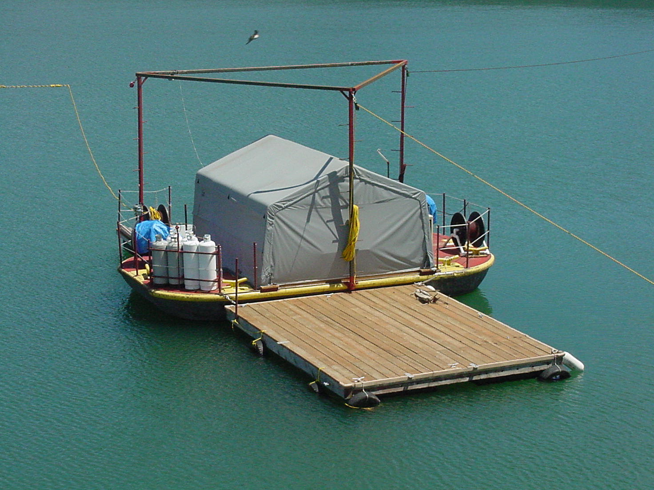

Figure 4. Floating research platform.
f. Proposal objectives, tasks and methods

Objective 1. Maintain a kokanee population of 30 to 50 adult kokanee/ha on an annual basis by reducing entrainment losses of fish. [Rieman and Maiolie (1995) documented that densities in this range would optimize the kokanee fishery in Dworshak Reservoir.] These densities should be attainable if entrainment losses can be reduced by 50%.

Task 1. Monitor seasonal entrainment rates under a broad range of dam operation conditions and conduct strobe light effectiveness testing in front of a single turbine intake of Dworshak Dam to determine if kokanee can be deterred, and thus reduce entrainment losses.

Task 2. Monitor seasonal entrainment rates under a broad range of dam operation conditions and conduct strobe light effectiveness testing in front of multiple (2 of 3) turbine intakes of Dworshak Dam to determine if kokanee can be deterred, and thus reduce entrainment losses.

Task 3. Monitor entrainment rates of fish into the three reservoir outlets (R.O.’s) while in operation under high discharge (spill).

Task 4. Subcontract 3-D acoustic Doppler current profiling (mapping) of reservoir outlets while in use to determine spatial extent of critical water velocities.

Task 5 Test effectiveness of strobe lights to deter kokanee and thus decrease entrainment losses through the R.O.’s during maximum discharge periods.

Task 6 If strobe light prove effective at substantially decreasing entrainment losses through the turbine intakes and R.O.’s develop and recommend an implementation plan to the Army Corps of Engineers.

Methods
Strobe light testing will center on assessing their effectiveness in front of a single turbine, and then progress to testing in front of multiple turbine intakes, and eventually in front of the reservoir outlets and the spillway. Testing will be emphasized during winter, which is a key time for entrainment losses because kokanee congregate near the dam during this season (Maiolie and Elam 1997).
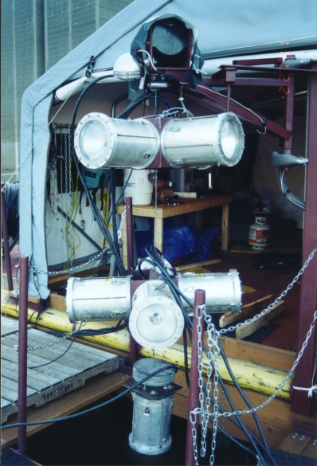
Nine strobe lights will be suspended by a steel cable below a floating platform (Figure 4). Four of these lights will be suspended as the first, shallower whorl and will be pointed horizontally at 90º angles to each other (Figure 5). Four more lights will comprise a second whorl in a similar arrangement as the first whorl of lights. The last light will be attached 1 foot below the second, deeper whorl and pointed downward. The spacing between light whorls and depth to which they are lowered will be dependent upon the current operating conditions (pool elevation, selector gate location, turbidity, etc…). Off-site testing in 1998 used this 90º arrangement of four lights with good success (Maiolie et al. 1998, in press). Testing with four lights during winter virtually eliminated kokanee from 3.1 ha of open lake within 20 minutes of starting the lights. Our hypothesis is that 9 lights can achieve similar results in front of the turbine intake where flows will be approximately 1,200 cubic feet per second (cfs) during the primary winter test period.
We will evaluate the effectiveness of the strobe lights with hydroacoustic technology using two different sampling methods or techniques. The first method will utilize stationary hydroacoustic sampling with the echo-sounding gear placed on a floating dock secured to the dam, directly in front of the operating turbine. A Simrad split-beam echosounder will be used to track fish in three dimensions as they approach the turbine intakes (Figure 6.). The transducer will be mounted on a pole 0.5 m below the surface. Both the distance of the transducer from face of the dam and the angle of the transducer beam will be adjusted accordingly to sample at least 50% of the total intake area with the acoustic beam, depending on the selector gate setting and pool elevation. In a quiet environment, this echosounder is capable of tracking a 5 cm fish at a distance of 210 m, so optimizing the coverage by changing the angle and distance from the dam should make 50% coverage easily obtainable under most operating conditions. Conducting stationary hydroacoustic sampling in-between the turbine intake and the strobe lights and perpendicular to the direction of primary fish movement will enable us to estimate ‘real-time’ changes in the rate of entrainment with or without the lights operating. Sampling closer to the intake may include more acoustic noise from the operating turbines; however, these surveys will also allow for a more accurate estimation of the length frequency distribution (target strength) of entrained fish.
Figure 5. Strobe light whorls and associated hardware suspended from floating research platform
The second technique will utilize mobile hydroacoustic transects to assess both the effective reduction in fish density and distance strobe lights may deter fish, which will help to determine optimal placement of lights under different dam operation conditions when implemented. A minimum of three mobile hydroacoustic transects will be conducted within the log-boomed area of the forebay. The survey boat with the transducer pole mounted 0.5 m below the water surface, will travel along transects parallel, perpendicular, and at 45° angles to the face of the dam. The straight line transects will pass as close as possible past the lowered strobe lights from one side of the log boom to the other or from the face of the dam to the outside log boom. Thus, the lights are as close as possible to the same axis as the center of the acoustic beam, thereby making estimation of fish distance from the lights much simpler.
A Paired Student’s T-test experimental design will be used to statistically test the effectiveness of strobe lights to both deter kokanee (distance and density) and reduce entrainment. Each ‘test’ with the lights flashing will be paired with a ‘control’ sample with the lights off. Each stationary sample or group of three mobile transects will last thirty minutes in duration with a minimum of thirty minutes break time between the end of a test and the start of a control period. A minimum of three replicates of paired control/test sample periods will comprise a single testing stint.
Stationary entrainment surveys will also be conducted, independent of strobe tests, to provide estimates of seasonal entrainment under varying dam operations. Both nighttime and daytime entrainment surveys will be conducted bimonthly and more frequently if dam operations necessitate, to document the full range of conditions. Surveys will be conducted in the same manner as described above for stationary strobe light tests, except lights will not be involved (Figure 6). The echosounder will simply be used to document the quantity and timing of fish entrainment through the dam, which will help to determine the seasonal and operational conditions under which entrainment is high and therefore when operation of the strobe lights is most crucial.
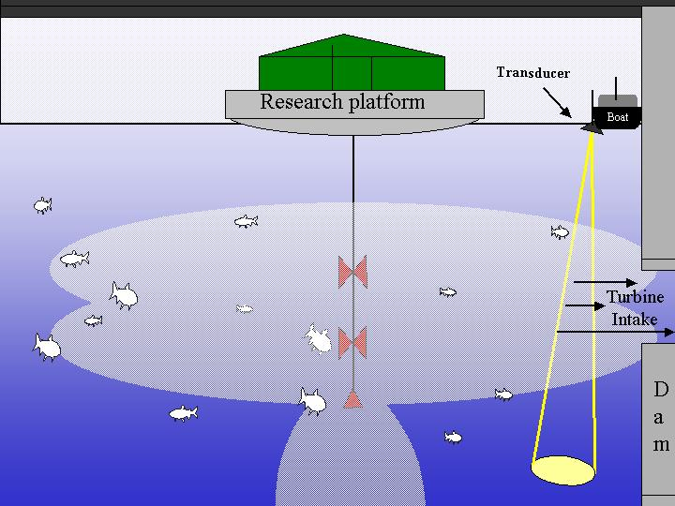
Entrainment surveys will also be used to estimate the variance in entrainment rates so that more accurate sample sizes (duration) can be determined for subsequent strobe tests. A sample size will be chosen which will give us 90% confidence in determining a 40% change in kokanee entrainment. Our sub-objective for this test is to achieve a 50% reduction in kokanee entrainment under low flow conditions during winter. Testing will be considered successful at that point.
In addition, a new multiplexed hydroacoustic transducer system will be purchased which will allow the monitoring of entrainment at multiple intakes simultaneously for both strobe tests and entrainment surveys. In the future, this new technology will also allow us to monitor fish entrainment more effectively in front of the three reservoir outlets.
Figure 6. Stationary strobe light test sampling design.
Should testing in 2001 prove successful, subsequent efforts will expand to testing the effectiveness of the strobe lights in front of multiple turbine intakes. Testing will gradually encompass higher discharge rates as more turbine intakes are “screened”. Should strobe light tests on the turbines prove to be successful, studies will then begin on the reservoir outlets which are used under high flow conditions; 10,000 to 25,000 cfs. Potential tests in front of the reservoir outlets will be substantially more difficult logistically, because of the problems the water velocities create with maintaining the position of lights in the water column. Engineering and design challenges will be addressed as we encounter them.

Sub-objective: To monitor kokanee abundance in the reservoir and relate their abundance and survival rates to operation of the dam that year. This will enable us to determine the effects of low or high water years, changes in dam operation, and drawdowns for anadromous fish flows on kokanee. In the future, it will also tell us the “population effects” of operating the strobe lights on the dam.

Methods:
Kokanee in the reservoir are monitored using three different methods: trawling, spawner counts, and hydroacoustics. These methods are described in Maiolie and Elam (1995). Trawling is conducted using a 28' diesel powered boat. It pulls a mid-water trawl net that is 10' x 10' at the mouth. The net is towed at a relative fast speed of 1.5 m/sec. Fifteen trawl hauls are made in the reservoir in a stratified random approach (Scheaffer et al. 1990). The sample size of 15 trawls is justified since this level of sampling was shown in the past to produce confidence limits of +/- 25%.
Spawner counts are made by walking up a minimum of four tributary streams to Dworshak Reservoir on September 25 of each year (+ or - 2 days). These streams are walked from their mouth up to the end of the kokanee run. They have been conducted each year since 1983 and correlate well to our trawl estimates of the adult kokanee population. Thus, they serve as a check for our other population indices as well as a long-term monitoring tool.
Kokanee estimates based on hydroacoustics are made using a Simrad split-beam echosounder. We use a stratified uniform sampling design where the reservoir is divided into three sections and transects across the reservoir are run at 2 mile intervals (Scheaffer et al. 1990). Data is analyzed using EP-500 software to provide fish density estimates. This approach has been shown to produce population estimates of kokanee that are within +/- 20% (90% confidence interval). Hydroacoustics is the preferred method to estimate the kokanee population when the amount of debris in the reservoir is low. Trawling will be used when there are large amounts of debris in the water column.
Our hypothesis is that entrainment losses of kokanee can be reduced by using strobe lights during the winter and spring to repel fish away from the turbine intakes. This assumes that reducing entrainment losses will result in a high adult kokanee population and will not cause other forms of natural mortality to increase enough to mask this benefit. If strobe lights are successful, we would see at least a 50% reduction in number of fish entrained. This would allow the kokanee population to build to the objective of 30-50 adults/ha and increase fishing pressure to 140,000 hrs of angling/year. Also, at the end of our testing there will be strobe lights and platforms that could be used for a permanent installation on the dam.
Objective 2. Increase the bull trout population to greater than 2000 adults, thereby allowing de-listing of the isolated Dworshak/North Fork Clearwater River population from ‘threatened’ to ‘a species of special concern’ (sensitive).

Sub-objective: Determine what level of reduction in entrainment may be biologically meaningful to increase bull trout abundance (e.g. reduce entrainment through Dworshak Dam by 50%). This can be obtained by first determining baseline bull trout entrainment rates and then utilizing strobe lights to repel fish away from the turbine intakes, reservoir outlets, and spillway. Abundance, redd counts (production), and survival rates of bull trout, will also be related to annual dam operational conditions.
Entrainment losses of bull trout may exceed 30% of the population per year. Our hypothesis is that entrainment losses of bull trout can be reduced by 50% using strobe lights during the winter and spring (when kokanee concentrate in the forebay of the reservoir) to repel fish away from the turbine intakes. The assumption is that bull trout are vulnerable to entrainment when kokanee are concentrated near the Dworshak Dam forebay, since kokanee serve as their primary prey. It is also assumed that bull trout behavior in the presence of strobe lights will be similar to kokanee, and will result in effective deterrence from critical entrainment velocity areas in the forebay of Dworshak reservoir.
This research will help us to gain an understanding of the effects of Dworshak Dam operations on bull trout abundance, spatial and temporal distribution in the reservoir, and potential entrainment into the dam. In addition, if entrainment losses prove to be substantial and strobe light testing is successful at decreasing entrainment, we will realize an increase in bull trout abundance as indexed by mark-recapture sampling, redd counts, or by potential population estimates. When reliable population estimates are obtainable these numbers will allow managers to more closely monitor bull trout in Dworshak Reservoir and more appropriately incorporate them in management plans.

Task 1. Monitor bull trout abundance and survival trends as indexed through annual electro-fishing catch per unit effort (CPUE), rod and reel mark-recapture efforts, redd counts (spawners), weir counts, and snorkel surveys.

Methods 1.

(For details on methods, please see Objective 1, Task 1.1 of:

IDFG BPA Proposal: “Evaluation of Bull Trout Life History In Dworshak Reservoir, North Fork Clearwater River Drainage, ID”.)

Task 2. Monitor bull trout movements and utilization of the reservoir, specifically within the forebay area of the dam, and their spatial and temporal vulnerability to entrainment.

Methods 2.
In coordination with Idaho Fish & Game – Region 2, Fish Management investigations (previously USACE study code BT-W-00-Xc and current BPA proposal to continue study), IDFG will continue to capture and tag as many adult bull trout as possible each year. Bull trout will be captured by hook-and-line sampling methods and electro-fishing in the spring (March - June) in upper reservoir tributaries and especially the Little North Fork and North Fork arms of while fish stage prior to their spawning migration. Weirs will also be installed on a few primary spawning tributaries where feasible, and will be used to collect downstream migrating (spawned-out) fish prior to entering the reservoir in the fall. Hook-and-line sampling will also be used again in the fall to capture adults returning to the reservoir.
All fish will be individually anesthetized with MS222 (tricaine methanesulfonate). Fish will be weighed to the nearest 10g and measured to the nearest mm. A scale sample will be removed from each bull trout between the lateral line and the posterior insertion of the dorsal fin for age estimation. All captured bull trout will be marked with a passive integrated transponder (PIT) tag containing a unique 10-digit alphanumeric code and fin clipped for later identification. PIT tags will be laterally inserted into the muscle tissue on the operculum.
Radio or acoustic/radio tags will only be implanted into a given fish if the tag is no more than 2% of the fishes body weight (Marty and Summerfelt 1986). Therefore, minimum fish weights for implanting will be 475 g for the coded radio transmitters [model code MCFT-3EM (9.5g)] and 815 g for the combined acoustic/radio coded transmitters [CART model 16_1 tag (16.3 g)] (Lotek Engineering Inc. Newmarket, Ontario, Canada) respectively. Minimum battery life is 395 days for the 9.5 g tag and 663 days for the 16.3 g tag. All fish too small to be surgically implanted with the above transmitters will only be PIT tagged.
If, and when smaller, lighter tags are available in the future they will certainly be utilized in order to obtain a better sample size of transmitter implanted fish, since the number of larger tag-able size bull trout will likely be limited. Burst rates and duty cycles of all transmitter tags and therefore the tracking schedule will be determined at the time of purchase, and will be customized to provide the optimal combination of detectability and operational life of the tags. The CART tags will be programmed for radio detection for the early part of the tag life and acoustic thereafter for fish implanted in the spring and the opposite configuration for the fall tagged fish, thereby allowing acoustic detection of fish during periods when likely be utilizing the reservoir.
Surgical implantation of the radio transmitters requires anesthetizing the fish for not more than 10 minutes, which allows for the surgical procedure and data collection. Bull trout will be anesthetized in a MS222 solution ranging between 60 and 80 mg/l. The appropriate amount of MS222 will be dissolved in 5 to 10 gallons of water and a battery-operated pump will re-circulate and re-oxygenate the water. Working with only one bull trout at a time, the fish will be placed in the anesthetic for 3 minutes or until the fish is sufficiently anesthetized, which will be determined by the inability of the fish to right itself when tilted on its side. The bull trout will then be placed in a foam cradle ventral side up and the MS222 solution water will be pumped over the gills of the fish throughout the surgery.
All surgical tools and transmitters will be disinfected before each surgery. Radio transmitter implantation will include the following steps. The ventral surface of the fish will be disinfected with an iodine solution. A 3-cm incision will be made 3 mm to the side of and parallel to the ventral line, and 4-cm posterior to the pectoral girdle. To prevent organ damage, an initial incision will be made only deep enough to cut the peritoneum and long enough to insert a scalpel guide. The scalpel guide will be inserted into the body cavity running parallel to the ventral line. The incision will then be enlarged to 3-cm by placing the scalpel blade perpendicular to the scalpel guide and running the scalpel posterior towards the pelvic girdle. To provide an exit for the antenna, a puncture will be made 1 cm posterior to the pelvic girdle slightly off the ventral midline. A needle guide will be inserted into the antenna incision and moved anterior to the pectoral girdle, to protect the internal organs from the needle. Then a 10 cm, 12-gage hypodermic needle will be inserted through the body muscle layer and rest on the guide. The needle will follow the guide to the incision opening were the transmitter antenna tail will be inserted into the needle until the antenna tail is seen extending out the needle end. The needle and guide will then be removed leaving the antenna extending out of the puncture.
The transmitter will be placed in the abdominal cavity and the excess antenna wire will be pulled out the exit hole. The incision will be closed using three interrupted sutures evenly spaced across the incision. Iodine solution will again be applied to the incision and antenna exit. The antenna wire will be clipped at a length even with the caudal peduncle concluding the surgery. The fish will then be placed in a 15ppm salt bath for 5 minutes, to initiate production of the mucus layer. The tagged fish will then be transferred to fresh water for not less than 15 minutes or until fully recovered from the anesthesia.
Mobile and fixed station telemetry receivers will be employed for tracking tagged bull trout in the upper reservoir and into spawning tributaries by IDFG Region 2 Fish Management personnel as part of their study (previously USACE study code BT-W-00-Xc and current BPA proposal to continue study). This information will help determine the timing and extent of migration into the North Fork and Little North Fork Clearwater Rivers and tributaries. Bull trout migration routes will then also be used to develop monitoring areas for annual redd counts to establish trends in spawning success and production.
In the lower reservoir (forebay), acoustic tagged fished will subsequently be detected using a system of wireless hydrophones installed approximately 1.5km from the dam, which will re-transmit the acoustic signals as radio signals via the air to a fixed station radio telemetry receiver/data logger on or near the dam (Figure 8). The wireless hydrophones, when precisely placed, will detect individual fish as they enter the forebay area, which are then potentially vulnerable to entrainment into the dam.
An additional mobile receiver will be used to conduct mobile tracking of radio tagged fished and will also be utilized in conjunction with a wired hydrophone to detect and mobile track acoustically (CART) tagged fish. The ability to mobile track acoustic tagged fish within the forebay will establish bull trout movement and behavior near the dam. Fish actually entering the turbine intakes, reservoir outlets, or spillway will be detected with multiple radio telemetry antennas installed on the dam at depth in order to detect radio signals from fish at the depths of the intakes. Detection of acoustic signals from tagged fish in close proximity to the dam will not likely be feasible since acoustic noise from the operation of the dam itself will interfere with detection. In addition, the USFWS will to scan all bull trout incidentally captured in the spillway of Dworshak Dam, while electrofishing as part of their steelhead smolt residualization study. This information will further corroborate radio receiver data documenting fish entrainment.
Data collected from bull trout radio and acoustic tracking will then be analyzed and mapped throughout the year to determine spatial and temporal vulnerability of bull trout to entrainment. Entrainment estimates will then be calculated from the fixed station data logging radio telemetry receiver at the dam and PIT tag detections in the spillway.

Task 3. Depending on severity and duration of bull trout entrainment (results of task 2), conduct strobe light testing in front of turbine intakes to determine effectiveness to deter bull trout and reduce entrainment rate through Dworshak Dam.

Methods 3.
Strobe light testing will follow methods outlined in Objective 1 above. Again testing will likely center on testing strobe lights in front of a single turbine, and then in front of multiple turbines. Testing will be emphasized during winter, which may be a key time for entrainment losses since kokanee, their primary prey, congregate near the dam during this season (Maiolie and Elam 1997). In addition, we will investigate the potential use of new and evolving acoustic tracking transducer technologies in order to more effectively document bull trout behavior near the dam and their potential deterrence since(Hedgepeth et al. 2000).

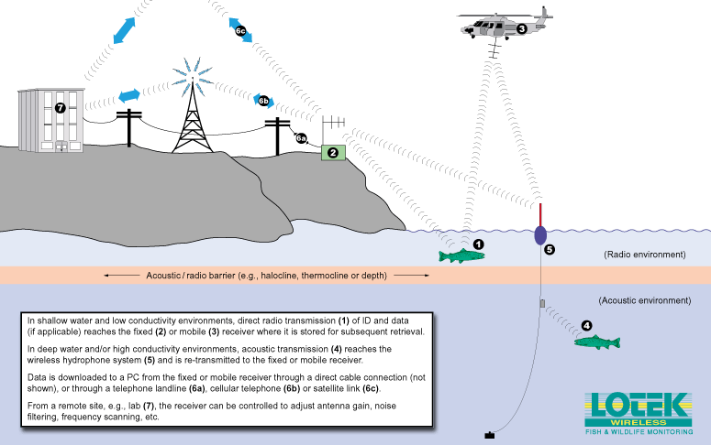
Figure 8. Lotek™ remote telemetry and combined acoustic/radio system versatility, and overcoming the radio signal depth transmission barrier in Dworshak Reservoir.
Objective 3. Improve kokanee size to 380 mm (15 inches) at densities of 30 to 50 adult kokanee/ha.

Task 1 Collect reservoir limnological samples to determine input values for mass balance equations (bioenergetics) to model changes in primary and secondary production; and kokanee fecundity, average size, and density with changes in nutrient concentrations.

Methods 1.
Twelve limnological stations will be sampled at least monthly from April through November (Figure X). Six stations will be spread throughout the main body of the reservoir and six stations will be located in the major tributary arms of the reservoir, including the Little North Fork and North Fork Clearwater River arms of the upper reservoir. Since sampling all stations in the same day will not be possible, the 2-4 day interval to complete all stations will be referred to as a “sampling period”.
At each station, dissolved oxygen, turbidity, and temperature measurements will be taken at the surface, 1m, and at even meter depths to 60 m. Transparency will be measured at each station with a 20 cm Secchi disk. Water samples will also be collected from each station and will be analyzed for total dissolved solids; nitrate nitrogen (NO₃); orthophosphorous and total phosphorous (TP); phosphates; algae composition, numbers, & biomass; chlorophyll a, and primary production.
Zooplankton will be sampled at each station with a 0.5 m Wisconsin plankton net with 130-150 micron mesh (size 10) equipped with a pygmy flowmeter. Three vertical tows will be taken from a depth of 2x the secchi depth (euphotic zone) to the surface and the net will be retrieved at 0.5 m/sec. Samples will be preserved in 60% Ethanol. In the laboratory, zooplankton will then be classified by family, enumerated, and recorded as organisms/liter. A sub-sample of organisms will also be measured to the nearest 0.1 mm with the ocular micrometer of a dissecting scope at 30x power. Length-weight relationships will then be used to calculate average zooplankton weight and will be multiplied times density to obtain estimates of zooplankton biomass/sample period by station (Culver et al. 1985).
Length, weight, scale, and stomach samples from kokanee will be obtained from anglers, hook and line sampling, or trawling as needed to obtain sufficient sample sizes. Kokanee will be collected from representative limnological site locations within each reservoir section, as described in the section on kokanee population estimates above in objective 1. The relationship of the scale radius to total fish length will be determined by linear regression. Readable scales will be pressed and magnified for reading on a microfiche projector, and scales will be read by at least two individuals to resolve discrepancies. Distances in mm from the focus to the outer edge of the scale (radious) and from the focus to the outer edge of each annulus will be measured. The y-intercept of the body-scale regression will be used for back-calculation of length at age, Li, following the Lee formula as described by Carlander (1981). Mean length at age will then be determined from back-calculated lengths. These data will then be used to fit a von Bertalanffy growth equation for each year class of kokanee.
Stomach samples will also be collected from a sub-sample of 3 kokanee from each 5 cm size class per collection site during each sample period. Stomachs will be cut out of specimen kokanee, labeled, and preserved whole in ethanol until analyzed. In the laboratory, stomachs will then be cut open and washed free of all contents, and examined under a microscope. Food items will be identified, enumerated, and a subsample of each genera will also be measured to the nearest 0.1 mm to calculate average weight of ingested taxa. Thus biomass of each taxa ingested will be calculated for each stomach sampled, based on the length-weight relationships established from zooplankton sampling as described above. Caloric values of food items will be used from established values in the literature to calculate average caloric intake as well.
Information summarized from limnology; zooplankton; and kokanee food habit, age at length, growth, and density samples and estimates will then be used to develop bioenergetics and or production models to determine kokanee growth and density with changes in nutrient concentrations. Specifically, data summarized from the above limnological sampling will then be used to calculate the current annual phosphorous load (L_{p}) for the reservoir, the epilimnetic water renewal rate, and the mean NO₃ and TP concentrations, and NO₃:TP ratios. These values will be critical in determining hypothetical enrichment rate increments to be used in predictive models. Estimates of fish growth will be incorporated into models of population dynamics to predict changes in stock biomass. In addition kokanee food habits and caloric intake will be used in consumption, egestion, metabolism, and excretion rate input values.

Task 2 Determine feasibility of nutrient enhancement of Dworshak Reservoir to improve kokanee growth and average size based on results of bioenergetics modeling and cost-benefit analysis of fertilization rate and catch to the creel.

Methods 2.
No methods have been developed at this time, but will be determined in the future as the above objectives are met and knowledge base and opportunities expand.

g. Facilities and equipment

Currently on the project we have some of the needed equipment. We have kokanee monitoring equipment such as a 28' mid-water trawler, a Simrad split-beam echosounder, and a 20' survey boat. We also have a crew of 3.5 FTE's that is trained in the use of this equipment. We have two vehicles and two computers with word processing and statistical software. The project is currently renting office space and a garage in Ahsahka (very near Dworshak Dam). We now have a set of 10 strobe lights that are hooked to a computer, which can flash the lights in multiple different sequences. These lights are on a platform upstream of the dam along with a propane-powered generator which powers the lights. We also have 4 individual strobe lights which can be used by themselves, and are ideal for off-site testing on bull trout.
Radio and sonic gear for tracking bull trout would also need to be purchased. We anticipate needing at least 2 fixed-site radio/datalogging receivers, at least 2 wireless hydrophones, a mobile radio receiver, and a mobile wired hydrophone. However, a mobile radio receiver and mobile hydrophone may be available through the Department.
There is a considerable amount of other equipment within the Department of Fish and Game, which is available for our project to borrow. The Department also can provide volunteer workers, additional trucks, administrative and computer help, manpower, equipment and storage space, bunk facilities at the Clearwater fish hatchery, and expertise on many subjects. The Department’s accounting section keeps track of our billing and our budgets. The Department also provides the assistance of a technical typist.
h. References

Reference (include web address if available online) |  | Submitted w/form (Y/N)
 | Culver, D.A., M.M. Boucherle, D.J. Bean, and J.W. Flether. 1985. Biomass of freshwater crustacean zooplankton from length-weight regressions. Canadian Journal of Fisheries and Aquatic Sciences. 42:1380-1390.
 | Falter, C. M. 1982. Limnology of Dworshak Reservoir in a low flow year. United States Army Corps of Engineers. Walla Walla, Washington. |  | n
 | Fredericks, J. P. 1995. Kokanee impacts assessment and monitoring on Dworshak Reservoir, Idaho. Idaho Department of Fish and Game, Annual Progress Report, Prepared for Bonneville Power Administration, Project number 87-099, Portland, Oregon. |  | n
 | Hedgepeth, J., D. Fuhriman, G. Cronkite, Y. Xie, and T. Mulligan. 2000. A tracking transducer for following fish movement in shallow water and at close range. Unpublished. 9pp.
 | Horton, W. A. 1980. Dworshak Reservoir fisheries investigations. Idaho Department of Fish and Game. Job Performance Report, Prepared for United States Army Corps of Engineers, Contract Number DACW68-79-C-0034, Boise. |  | n
 | Horton, W. A. 1981. Dworshak Reservoir fisheries investigations. Idaho Department of Fish and Game. Prepared for United States Army Corps of Engineers, Contract Number DACW68-79-C-0034, Boise. |  | n
 | Johnson, P. N., G.A. Frederick, and G.R. Ploskey. 1998 (in press). The  effectiveness of strobe lights for vertically displacing juvenile salmon out of flow entering a 4.3 x 4.9 km filling intake at Hiram M. Chittenden Locks, Seattle. Anadromous Fish Evaluation Program, U.S. Army Corps of Engineers, Walla Walla, Washington. |  | n
 | Maiolie, M. A. 1988. Dworshak dam impacts assessment and fisheries investigation. Idaho Department of Fish and Game, Annual Progress Report, Prepared for Bonneville Power Administration, Project number 87-99, Portland, Oregon. |  | n
 | Maiolie, M. A., D. P. Statler, and S. Elam. 1992. Dworshak Dam impact assessment and fishery investigation and trout, bass and forage species. Idaho Department of Fish and Game, and Nez Perce Tribe, Combined completion report, Prepared for Bonneville Power Administration, Project numbers 87-99 and 87-407, Portland, Oregon. |  | n
 | Maiolie, M. A., and S. Elam. 1993. Dworshak dam impacts assessment and fisheries investigations. Idaho Department of Fish and Game, Annual Progress Report, Prepared for Bonneville Power Administration, Project number 87-99, Portland, Oregon. |  | n
 | Maiolie, M. A., and S. Elam. 1995. Dworshak dam impacts assessment and fisheries investigations project. Idaho Department of Fish and Game, Annual Progress Report, Prepared for Bonneville Power Administration, Project number 89-99, Portland, Oregon. |  | n
 | Maiolie, M. A., and S. Elam. 1996. Dworshak dam impacts assessment and fisheries investigations project. Idaho Department of Fish and Game, Annual Progress Report, Prepared for Bonneville Power Administration, Project number 89-99, Portland, Oregon. |  | n
 | Maiolie, M. A., and S. Elam. 1998. Dworshak dam impacts assessment and fisheries investigations project. Idaho Department of Fish and Game, Annual Progress Report, Prepared for Bonneville Power Administration, Project number 89-99, Portland, Oregon.
 | Maiolie, M. A., B. Harryman, and B. Ament. 1999. Dworshak dam impacts assessment and fisheries investigations project. Idaho Department of Fish and Game, Annual Progress Report, Prepared for Bonneville Power Administration, Project number 89-99, Portland, Oregon. (In Press) |  | n
 | Mauser, G., D. Cannamela, and R. Downing. 1989. Dworshak Dam impact assessment and fishery investigation. Idaho Department of Fish and Game, Annual Progress Report, Prepared for Bonneville Power Administration, Project number 87-99, Portland, Oregon. |  | n
 | Mauser, G., D. Cannamela, and R. Downing. 1990. Dworshak Dam impact assessment and fishery investigation. Idaho Department of Fish and Game, Annual Progress Report, Prepared for Bonneville Power Administration, Project number 87-99, Portland, Oregon. |  | n
 | McKinley, R.S. and P.H. Patrick. 1986. Use of behavioral stimuli to divert sockeye salmon smolts at the Seton Hydro-Electric station, British Columbia. Ontario Hydro Research Division. Toronto, Ontario. |  | n
 | Nemeth R.S. and J.J. Anderson. 1992. Response of juvenile coho and chinook salmon to strobe and mercury vapor lights. North American Journal of Fisheries Management 12:684-692. |  | n
 | Patrick, P.H. 1980. Responses of American eels to strobe light. Progress Report number 80-86-K. Ontario Hydro Research Division. |  | n
 | Patrick, P.H. 1982. Responses of alewife to flashing light. Progress Report number 82-305-K. Ontario Hydro Research Division. |  | n
 | Ploskey, G.R. and P.N. Johnson. 1997. Development of Behavioral technologies to improve the efficiency of surface collection and bypass structures on the Lower Columbia River. USAE Waterways Experiment Station, Stevenson, Washington. |  | n
 | Rieman, B. E., and M. A. Maiolie. 1995. Kokanee population density and resulting fisheries. North American Journal of Fisheries Management 15:229-237. |  | n
 | Skarr, D., J. Deshazer, L. Garrow, T. Ostrowski and B. Thornburg. 1996. Investigations of fish entrainment through Libby Dam, 1990-1994. Montana Department of Fish, Wildlife and Parks. Prepared for Bonneville Power Administration, Project Number 83-467, Portland, Oregon. |  | n
 | Scheaffer , R. L., W. Mendenhall, and L. Ott. 1990. Elementary survey sampling, 4th edition. Duxbury Press, Belmont, California. |  | n
 | Stober, Q. J., R. W. Tyler, C. E. Petrosky, K. P. Johnson, C. F. Cowman, Jr., J. Wilcock, and R. E. Nakatani. 1979. Development and evaluation of a net barrier to reduce entrainment loss of kokanee from Banks Lake. Fisheries Research Institute, Final Report, Prepared for United States Bureau of Reclamation, Contract Number 7-07-10-50023, University of Washington, Seattle.
 | Winans, G. A., P. B. Aebersold, and R. S. Waples. 1996. Allozyme variability of Oncorhynchus nerka in the Pacific Northwest, with special consideration to populations of Redfish Lake, Idaho. Transactions of the American Fisheries Society 125:645-6663. |  | n
 | Winchell, F.C., S.V. Amaral, E.P. Taft. 1994. Research update on fish protection technologies for water intakes. Final Report for Electric Power Research Institute. Palo Alto, California. |  | n
 | Wydoski, R. S., and D. H. Bennett. 1981. Forage species in lakes and reservoirs of the western United States. Transactions of the American Fisheries Society 110:764-771. |  | n

Section 10 of 10. Key personnel

Eric Stark is the full-time research biologist on the project. He received a B.S in Fisheries Biology and Aquatic Ecology from the University of Wisconsin – Stevens Point (1995) and a M.S. degree in Fisheries Resources from the University of Idaho (2001). Eric started on the project in November of 2000 and has taken the lead in conducting project activities. His M.S. work also investigated the impacts of fluctuating water levels due to hydropower operations, but specifically on the benthic macroinvertebrates in the Hanford Reach of the Columbia River, Washington. Eric brings a broad background to the project.
Dr. Melo A. Maiolie is a Principal Fishery Research Biologist for the Idaho Department of Fish and Game. He has been working for the Department for 16 years, with 12 of those years in fisheries research. He received a B.S. degree in Fisheries and Wildlife Management from West Virginia State University (1973), and a M.S. and Ph.D. in Fisheries and Wildlife Management from Colorado State University (1977,1985). Dr. Maiolie works half time on this project and half time on the Lake Pend Oreille Fishery Recovery Project. He has been working on reservoir projects, and projects involving the federal hydropower system for over 22 years. His Ph.D. work was on the impacts of a pumped-storage power plant on the fish community of a high mountain lake in Colorado. Examples of his publications can be seen in the literature cited section of this proposal.

Richard (Ric) Downing, Sr. Fisheries Technician, works 8 months per year on this project. Ric has worked as a temporary employee for the Department of Fish and Game for 14 years. He worked for 6 years on Dworshak Reservoir during the late 1980’s and early 1990’s investigating the nutrient dynamics and determining angler preferences. He has a tremendous amount of experience and knowledge of Dworshak Reservoir and it’s fishery. Ric also worked at the Clearwater Fish Hatchery for 8 years. His areas of expertise include: conducting hydroacoustic test transects, stationary entrainment surveys, trawling, and has been involved with strobe light testing for the last year. Ric is a certified scuba diver and experienced field technician.
Larry Jones, Biological Aide, also works on the project part-time, 8 months per year. He has just started with the Department of Fish and Game and has no previous experience in the fisheries field; however, he is quickly learning a great deal and shows tremendous promise and motivation to continue to do so. Larry’s particular expertise on this project include: excellent repair and maintenance skills with all equipment, but especially outboard motors, handling work boats, and has been involved with strobe light testing for the last 4 months.

