Appendix C. Corps of Engineer’s Current Projects (continued)

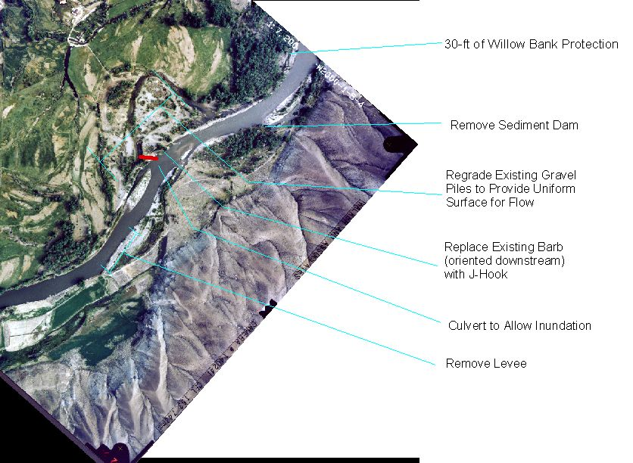
Figure 7. The project on the Thornock property.

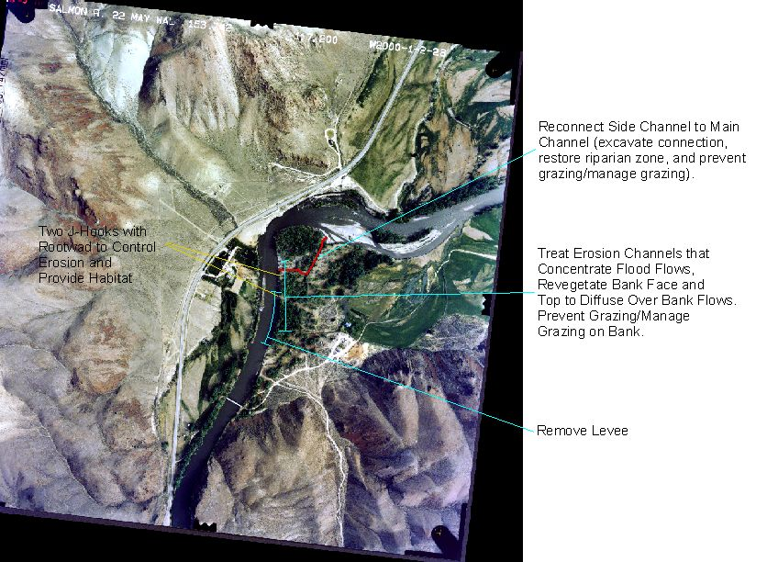
Figure 8. The project on the Hutchison property.

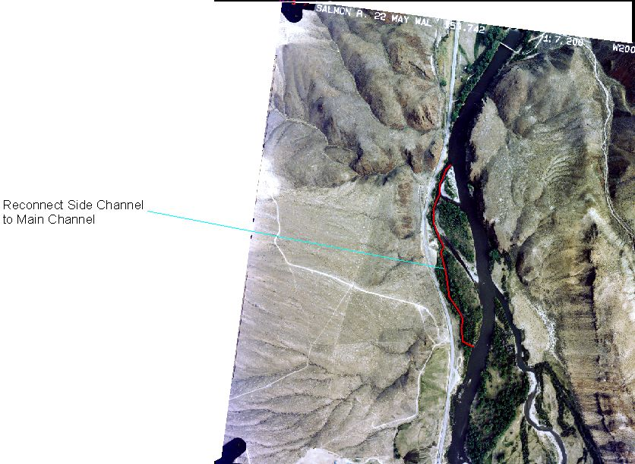
Figure 9. The project on BLM property.

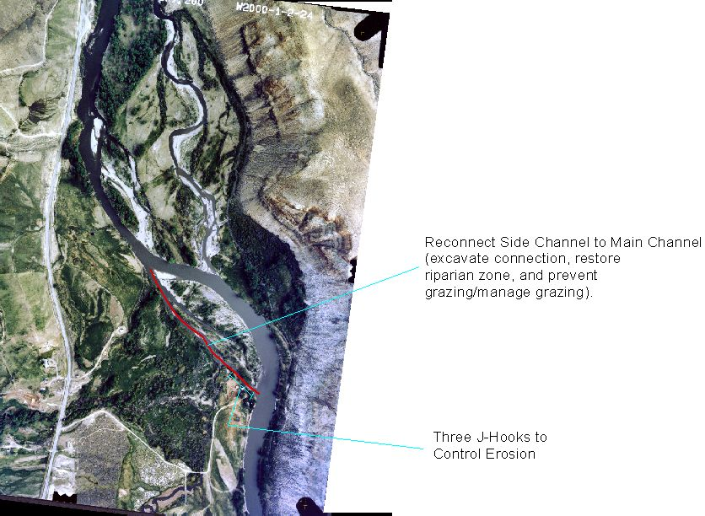
Figure 10. The project on the Alder property.

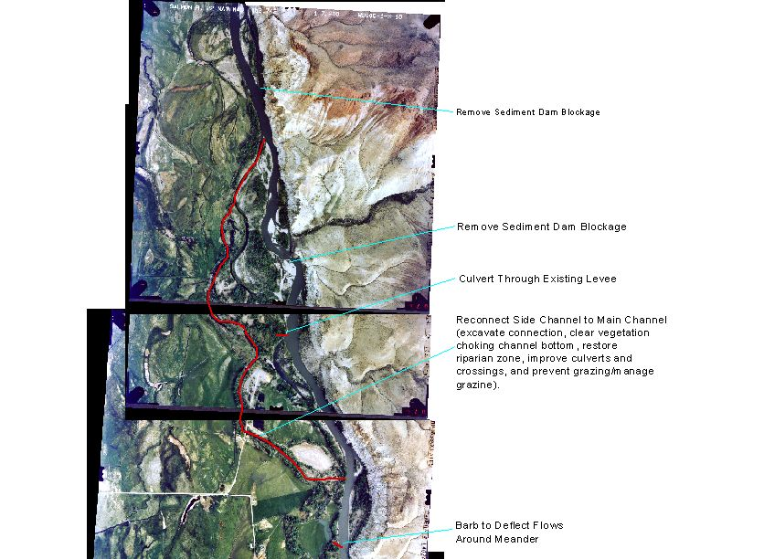
Figure 11. The project on the M&M Ranch and Phillips property.

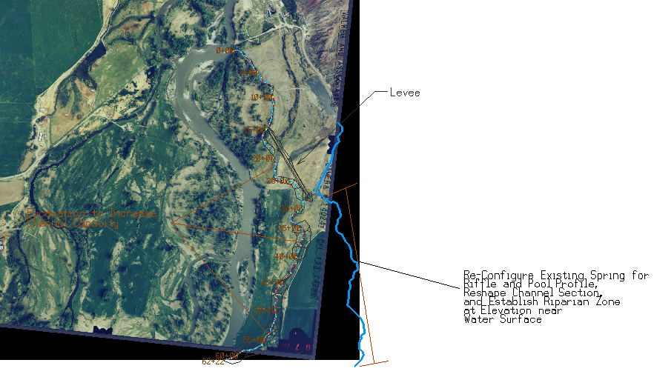
Figure 12. The project on the Hammond and Stark’s property.
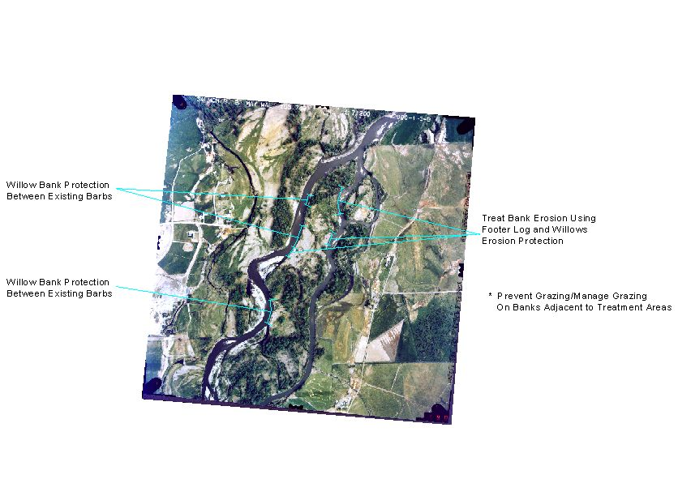
Figure 13. The project on the Hansen property.

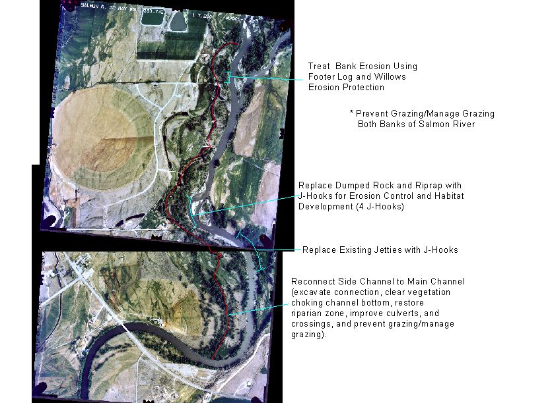
Figure 14. The project on the Chester property.

